

9B17M083

femu advertising: the expansion opportunity

Cathy Chen wrote this case under the supervision of Professor Eric Morse solely to provide material for class discussion. The authors do not intend to illustrate either effective or ineffective handling of a managerial situation. The authors may have disguised certain names and other identifying information to protect confidentiality.

*This publication may not be transmitted, photocopied, digitized, or otherwise reproduced in any form or by any means without the permission of the copyright holder. Reproduction of this material is not covered under authorization by any reproduction rights organization. To order copies or request permission to reproduce materials, contact Ivey Publishing, Ivey Business School, Western University, London, Ontario, Canada, N6G 0N1; (t) 519.661.3208; (e)* [*cases@ivey.ca*](mailto:cases@ivey.ca)*;* [*www.iveycases.com*](http://www.iveycases.com)*.*

Copyright © 2017, Richard Ivey School of Business Foundation Version: 2017-06-16

It was May 16, 2016 and Birhanu Abate had just completed his last exam in the School of Commerce at Addis Ababa University (AAU) in Ethiopia. At AAU, undergraduate programs were three years long, and Abate had just completed his final year. With graduation coming soon, it was time for him to think about the future.

For the past five years, Abate had been running an advertising business, called Femu Advertising, out of his own house. It provided him with supplemental income, and he worked on it in conjunction with his studies. However, with graduation just around the corner, Abate was thinking about how to expand his business and what his action plan would be.

Addis Ababa, Ethiopia

Ethiopia was a landlocked country in the northeast African region known as the Horn of Africa. Ethiopia’s capital was Addis Ababa, a growing city that housed the headquarters of the African Union, the United Nations Economic Commission for Africa, and several other non-governmental organizations focused on Africa. As of 2013, more than 90 million people lived in Ethiopia, although lifestyles varied greatly, depending on the region of residence. The Addis Ababa subdivision known as Bolé was a tourism hub and home to the international airport. The AAU’s School of Commerce was just 10 minutes away in the Mexico sub-district.

Ethiopia had the largest economy—measured by gross domestic product in 2013—in East and Central Africa, and it continued to grow as a result of the country’s Growth and Transformation Plan (GTP). Introduced in 2009, the plan focused on eliminating poverty through a strategy of rapid, sustainable, and equitable economic growth. In 2015, GTP II was released. Among the many priorities, micro and small enterprises were identified as an area of focus to spur economic growth:

[Micro and small enterprises] are critical in generating employment, serve as school for entrepreneurship, and broaden the . . . domestic private sector. [The government will take] actions . . . to enhance their productivity, technology, learning, and growth. Micro, small, and medium enterprises will be supported to transform to the next level of industry in accordance with their level of development.[1]

**Entrepreneurship in Addis Ababa**

In Ethiopia, micro businesses were abundant. Most new businesses in Addis Ababa were started by “necessity” entrepreneurs—individuals who were motivated by the need to survive. The businesses were generally quite small, offering goods or services to small neighbourhoods. Many were sole proprietorships and not fully incorporated.

To facilitate the realization of goals set out in the GTP, the government established the Entrepreneurship Development Center (EDC). The EDC offered many resources, coaching, and consulting services to help local entrepreneurs launch their businesses.

**Advertising in Addis Ababa**

With the abundance of small businesses in Addis Ababa, small-scale print and advertising services were in high demand. Small-scale shops existed, which attracted clients through word-of-mouth marketing and referrals. Although these shops did not tend to have a public web presence, locals estimated that anywhere from 10 to 15 print and advertising businesses operated in the Mexico sub-district alone. In Bolé, there were many more. Despite the business being so fragmented, opportunities were abundant with no major large competitor.

Print advertising was the most prominent type of advertising in Ethiopia. Web advertising (such as Google AdWords) was severely limited since many people did not own computers or have access to Wi-Fi connectivity throughout the country. However, mobile phone use was increasing and the state-controlled Ethio Telecom had good infrastructure to support data use. Thus, social media marketing was a growing sector in the Ethiopian advertising industry.

**Femu Advertising**

Femu Advertising was a print advertising company based in Addis Ababa, in the Mexico sub-district. It was run by Abate, a young, enterprising individual who had taught himself to use computer design software such as Adobe Photoshop in order to create posters.

Femu Advertising serviced several clients around the city, producing various designs for print and web (see Exhibit 1). Small businesses such as local clothing shops would hire Abate to design and create custom posters, banners, business cards, and so on. Since he had no office, the only costs Abate incurred each year were Br36,000[2] for an advertising licence and Br12,000 for insurance. Over the years, Abate had built up a strong roster of repeat clients through word of mouth and referrals, which brought in enough income to live comfortably. Abate paid himself an annual salary of Br300,000 out of the business, and paid a 30 per cent tax rate on net profits.

Femu Advertising had several revenue streams based on different custom products. Since each order was unique, Abate quoted the jobs independently of each other. He did not have a set pricing method and simply quoted above what it would cost him. Since he did not have his own production equipment, he had to outsource much of the actual printing and production to local vendors. Clients would place their order with Abate, who would then design and create the artwork in Photoshop and get it printed at a local shop. Demand varied for each product. Femu Advertising offered a variety of products, with corresponding variable costs of production and estimated demand (number of orders) for each year (see Exhibit 2).

**Expansion Opportunity**

At the start of May 2016, Abate had participated in an entrepreneurship boot camp run by the LEADER Project at the Ivey Business School at Western University, in London, Ontario. After speaking with his coaches from Ivey, Abate began to realize that there were many options for him to grow his business.

Physical Office Location

For the past year, Abate had been thinking about getting a physical office for Femu Advertising. He realized that the business was growing its client base year over year, to the point where some clients had to be turned down. Without school next year, Abate knew he would have much more capacity, and an office could double as a storage area while adding a degree of professionalism to his business. Moreover, if his office were located in a central area, Abate thought he could get more business through walk-ins. After assessing different possibilities, Abate set his sights on a small storefront in a plaza within the Mexico neighbourhood. It was owned by his friend, who offered to give him a discounted rent of Br20,000 per month.[3]

Electricity for this office would cost Br500 per month, other utilities would cost Br100 per month, and a telephone would cost another Br500 per month. To furnish the office, Abate would need to buy three chairs at Br1,000 each, two tables at Br1,000 each, a computer at Br15,000, and a telephone at Br5,000.

Printing and Cutting Machines

For the past couple years, Abate had been outsourcing the print operation of his business to local specialty shops. He would design and create all the artwork and, depending on the type of product, contact the appropriate printer. Abate knew that if he purchased a printing machine for large posters, he would be able to bring this operation in-house and save 10 per cent on the variable cost per banner, his most popular product line. He considered buying an appropriate machine with the size and functions he needed, and determined that the cost would be Br300,000. He would also have to buy a cutting machine at Br150,000 to cut the printed banners. Finally, to operate the machines, he would have to hire one additional part-time employee to work at a salary of Br5,000 per month.

**Financing**

Abate knew that if he were to expand now, he would need to seek additional funds to pay for the investments. However, finding investors in Addis Ababa to support such a localized business was incredibly difficult. Moreover, getting a loan from the bank was nearly impossible, as Abate had no fixed assets to offer as collateral. His best hope would be to ask family and friends, but he wondered whether that would be enough.

Abate also wondered whether it would be possible to self-finance the expansion organically by boosting revenue or profit. He knew that he did not have to make all the investments at once, since the printing and cutting machines could fit into his garage. However, his garage was not secured, so it would expose the machines to potential damage and theft.

**looking ahead**

Abate was passionate about entrepreneurship and wanted to be a job creator in Addis Ababa. He wondered whether this would be the right time to move the business out of his house and into a real office location. He knew there were many fixed investments to be made and that he would need to grow his business to sustain additional costs and, potentially, more workers. He wondered whether his business model could adapt to take on more orders or become more profitable. He also wanted to know how long it would take to pay back investments if he made them.

After grabbing a quick lunch of *injera* and *shiro*, Abate sat down and started working on his action plan. He needed to know whether the numbers would add up for him to expand his business. If so, he needed to determine an action plan to get things going.

**Exhibit 1: Examples of Femu Advertising’s Work**

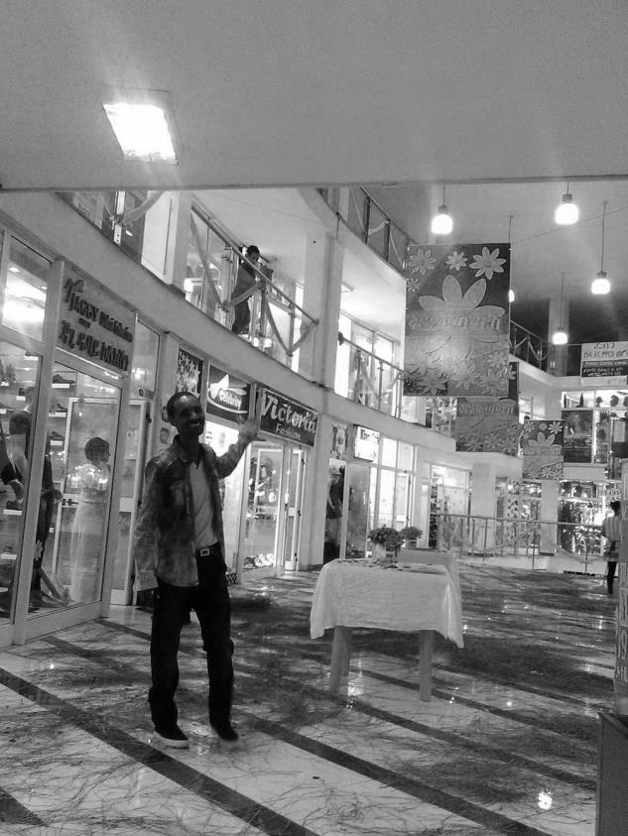

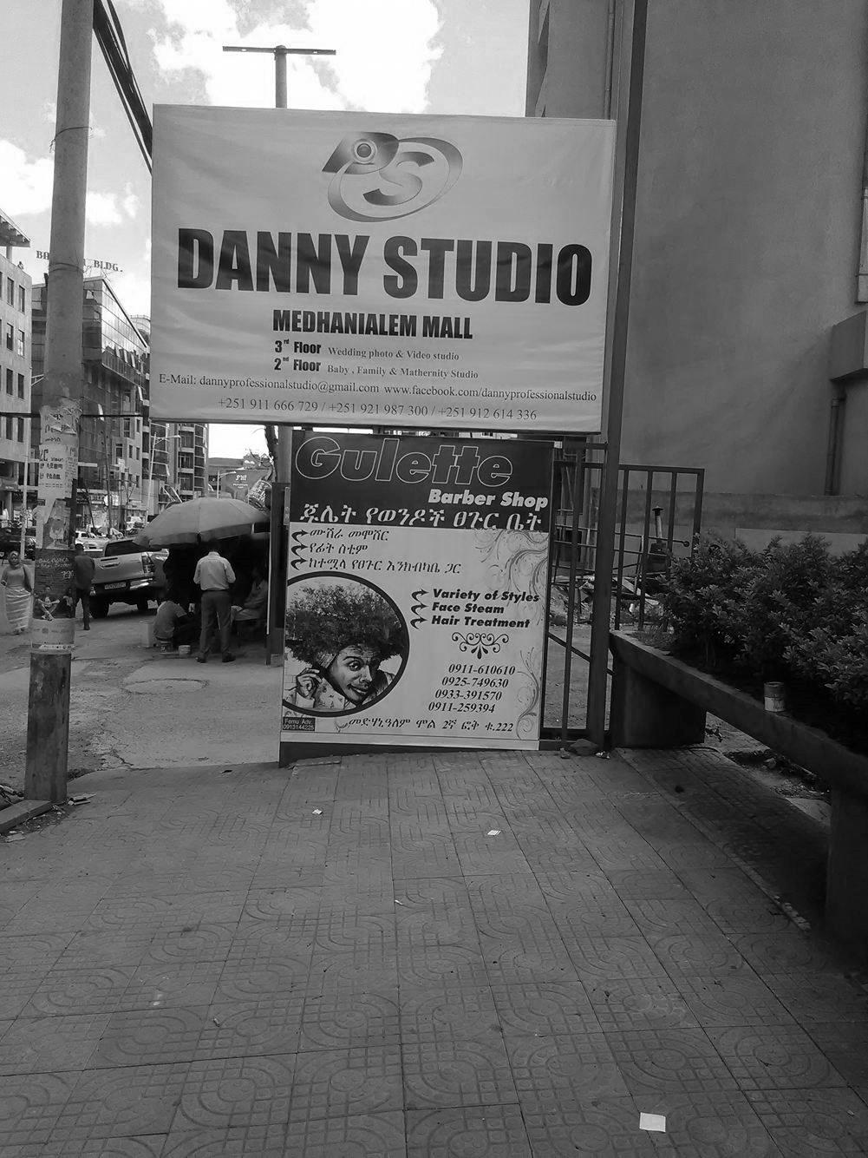

(Abate with posters in a mall) (Sidewalk banners)

Source: Company files.

**Exhibit 2: Product Lines**

|  |  |  |  |  |  |
| --- | --- | --- | --- | --- | --- |
| **Product** | **Selling**  **Price (in Br)** | **Variable**  **Cost (in Br)** | **Units** | **Orders per Year** | **Average**  **Order Quantity** |
| Stickers | 20 | 10 | per sticker | 50 | 600 |
| Banners | 1,500 | 500 | per banner | 50 | 10 |
| T-shirts | 60 | 32 | per t-shirt | 15 | 50 |
| Business cards | 8 | 5 | per business card | 10 | 30 |
| Postcards | 10 | 6 | per postcard | 10 | 100 |

Source: Company files.

1. The Federal Democratic Republic of Ethiopia, National Planning Commission, *The Second Growth and Transformation Plan (GTP II)*, September 2015, accessed January 29, 2017, www.africaintelligence.com/c/dc/LOI/1415/GTP-II.pdf.
2. Br = ETB = Ethiopian birr; all currency amounts are in Br unless otherwise specified; Br16.60 = CA$1 on May 16, 2016.
3. Most businesses use the Gregorian (12-month) calendar to be consistent with international counterparts. This price is based on the 12-month calendar.