

9B17M085

managing a severe crisis: pharmacorp in ukraine

Professor Phillip C. Nell, Renate Kratochvil, and Patricia Klopf wrote this case solely to provide material for class discussion. The authors do not intend to illustrate either effective or ineffective handling of a managerial situation. The authors may have disguised certain names and other identifying information to protect confidentiality.

*This publication may not be transmitted, photocopied, digitized, or otherwise reproduced in any form or by any means without the permission of the copyright holder. Reproduction of this material is not covered under authorization by any reproduction rights organization. To order copies or request permission to reproduce materials, contact Ivey Publishing, Ivey Business School, Western University, London, Ontario, Canada, N6G 0N1; (t) 519.661.3208; (e)* [*cases@ivey.ca*](mailto:cases@ivey.ca)*;* [*www.iveycases.com*](http://www.iveycases.com)*.*

Copyright © 2017, Richard Ivey School of Business Foundation Version: 2017-06-05

It was a freezing cold morning in snow-covered Kiev on January 2, 2015. The weather fit the sentiments of Federica Santos, country head of PharmaCorp Ukraine, a global pharmaceutical company’s local unit in Ukraine. “Sales down by 40 per cent and 25 per cent loss of market share. . . . that is the worst performance ever,” Santos sighed, while scanning the latest figures of her firm. “When will the war stop?”

Santos was suddenly interrupted by her phone ringing. It was the Ukrainian Secretary of State for Health telling her that it would not renew PharmaCorp Ukraine’s licence to participate in public tenders. “That’s really bad news,” she thought. “Being excluded from public tenders will cause a 10 per cent slump in sales.”

After all Santos had experienced during the past few months in crisis-ridden Ukraine, this kind of message no longer surprised her. She had always known it would be a tough task to steer PharmaCorp Ukraine through the ongoing political and economic crises. Still, she felt stuck and frustrated. So far, she had not found a way to avoid further damages and boost sales. Now, with the annual meeting with the regional headquarters (RHQ) fast approaching, she was under even more pressure. During this meeting at the end of January, Santos would need to present her ideas for strategic moves to revive sales at PharmaCorp Ukraine.

PharmaCorp

PharmaCorp was incorporated in 1896 and had its corporate headquarters (CHQ) in Munich, Germany. In 2014, it employed about 54,000 people worldwide and generated €20 billion[1] in sales. Its portfolio covered more than 40 drugs in human-, animal-, and bio-pharmaceuticals.

As one of the leading global pharmaceutical companies, PharmaCorp ranked second, in 2014, in terms of the percentage of its total revenue spent on research and development (R&D). It conducted R&D in Germany, Austria, France, Japan, and the United States, had production in more than 11 countries, and operations in more than 150 countries.

In 1991, PharmaCorp started its operations in Ukraine, and since then had been a premium brand, recognized in the market for its high-quality drugs. Owing to the economic development of Ukraine and Ukrainian patients’ demand patterns, PharmaCorp’s product portfolio was relatively small in Ukraine and contained mainly long-established, well-proven drugs.

PharmaCorp Ukraine was founded as an operating unit (see Exhibit 1), which meant that the office in Ukraine was an extension of PharmaCorp’s RHQ in Milan, Italy, and conducted local sales activities, in comparison with a full-fledged subsidiary that was relatively independent. The RHQ issued all documents (e.g., working contracts, legal documents, and invoices) and was liable for the PharmaCorp transactions in Ukraine. PharmaCorp Ukraine was responsible for local operational tasks, whereas most of the tasks related to strategic decision-making were located at the RHQ, to which PharmaCorp Ukraine reported.

The RHQ was responsible for 30 affiliates in Central and Eastern European (CEE) countries, as well as five Central Asian countries. In its intermediary position between the CHQ in Germany and the 35 affiliates, the RHQ had a bridging function: It reported to the corporate CHQ in Germany, and communicated the targets set by the CHQ to its own regional affiliates. In doing so, the RHQ aligned the corporate strategy with the regional strategy and acted on regional opportunities. It also undertook intra-regional coordination and control activities. Intense co-operation between the RHQ and the Ukrainian operating unit was encouraged after the onset of the Ukrainian crisis in late 2013, which was marked by riots and the escalation of protests in Kiev (known as “Maidan”) and the Crimean crisis in early 2014 (followed by war in parts of Eastern Ukraine). The crisis pushed both the RHQ and the operating unit in Ukraine beyond their usual work practices and patterns.

A New Manager Arrives

As of August 1, 2014, Barbara Haas, the head of the RHQ in Milan, faced major challenges in Ukraine, which led her to assign a new country head for the operations in Ukraine. Haas felt that Federica Santos was the right person for the job. Even though she was fluent in neither Ukrainian nor Russian, Santos had proven her ability to handle difficult markets. For example, Santos had started working for the RHQ after graduation and, soon after, was given the chance to establish PharmaCorp’s subsidiary in Croatia after the war in the 1990s. Later, she assumed responsibility for the whole Balkan region. When Haas offered Santos the chance to head the Ukrainian unit, Santos enthusiastically agreed.

Briefing by the RHQ

“We entered the Ukrainian market in 1991 and we always made profits,” said Haas, as she briefed Santos on the situation in Ukraine. The local unit’s function was to manage marketing and sales activities. “And we always encourage our units to come up with initiatives. The RHQ might support them financially, as well as with experience gained in other markets.” Santos knew the autonomy of the local units was restricted, meaning that constant communication with the RHQ was necessary.

So far, Ukrainian health-care professionals and patients had appreciated PharmaCorp’s high-quality drugs. Therefore, although PharmaCorp faced severe competition in Ukraine, it had steadily gained market share. In fact, the unit managed to outperform other PharmaCorp units in the CEE region in terms of sales and profitability. Even in 2008, when the economic downturn had severely hit businesses in Ukraine, PharmaCorp managed to meet its internal targets.

This time, however, the crisis was different. PharmaCorp Ukraine was going through the most difficult time since its establishment: All of a sudden, the company was in the red. Furthermore, PharmaCorp Ukraine’s responsibility for Crimea (a local region with a population of approximately 2.3 million) had been shifted to the Russian subsidiary, and due to war, some regions in Eastern Ukraine were cut off from supply. “We are losing ground in Ukraine,” Haas emphasized. “Our performance in the market is devastating. And it is highly irritating that most of our global peers in the Ukraine are suffering from a slump in sales of only 10 to 15 per cent. Imagine, some local competitors have even increased their sales.”

Haas also informed Santos that PharmaCorp Ukraine’s local management team had recently made a request for an adjustment to the internal targets for Ukraine and for more local decision-making autonomy. However, the RHQ did not see any need to change the internal targets (see Exhibit 2), which were identical across all RHQ affiliates. The RHQ was convinced that Ukraine would again be an attractive market once the crisis was over. RHQ did not expect profitability to continue to decrease in the medium and long run, and it predicted that sales would soon return to their pre-crisis levels (referring to the growth rate of the gross domestic product: 5.2 per cent in 2011 and –6.8 per cent in 2014; see Exhibit 3).

Santos was well acquainted with PharmaCorp’s procedures and standardized processes. She was also aware of the multinational corporation’s preference to act in accordance with the global strategy in order to maintain the established global reputation. Legal or any other issues in one single market could quickly spill over and cause damage to PharmaCorp as a whole. She also knew that, at the very same moment, other PharmaCorp operations were also struggling with major challenges resulting from unstable environments, economic or political crises, and turbulences.

First Impressions: Assessing PharmaCorp Ukraine’s Situation

On September 21, 2014, as Santos entered the modern building where PharmaCorp Ukraine had its offices, someone called across the entrance hall, “Wow—now the currency is up to 16.5.” (This value referred to the exchange rate between the euro and the Ukraine hryvnia (₴)).[2] The atmosphere in the building was extremely chaotic, and it took Santos a while to make her way to the elevators. She squeezed into one of them and learned that international exchange markets had started to fluctuate wildly after that day’s morning break in the ceasefire in Luhansk. Although she was aware of those turbulences, when she exited the elevator, Santos was stunned to hear that the exchange rate had risen to €17.4 per hryvnia, up from 15.8 when they had started from the ground floor. She immediately started to check her smartphone for updates.

During the past 30 minutes, Santos’s inbox had been flooded with messages about the latest happenings in Ukraine—and at PharmaCorp Ukraine. While scanning the subject lines, she read: “Massive bombings again,” “Two distributors vanished in Eastern Ukraine,” “Head of the Law Department resigned,” “Inflation up at 15 per cent,” “Today’s price of Silovma ₴295 (+ 50 per cent of last week’s level),” and “New health minister assigned.” Santos was overwhelmed by this news and eager to learn about the sentiments of her local management team in its first meeting.

Unfortunately, this meeting turned out to be chaotic: Everybody was talking at the same time, providing different opinions and solutions to the topics Santos had addressed, while constantly checking their phones for messages or answering calls. It dawned on Santos that finding a solution to PharmaCorp’s struggles amid the turmoil in Ukraine was now only a remote possibility.

During her first weeks in Kiev, Santos had met with numerous people, from employees to business partners, to get an idea of all the problems the crisis had brought about.

Since the onset of the crisis, health-care professionals, including doctors, heads of the medical centres, and pharmacists, had decreased the amount of PharmaCorp drugs being prescribed. In a meeting with the product manager, Santos was told,

Our best seller, Silovma, accounts for 20 per cent of total sales and was available for ₴100 before the crisis. Now, purchasing power has dropped dramatically and Silovma has become a kind of luxury drug. Depending on the currency rate, the price was between ₴180 and 250. One pharmacist stressed this in an amusing way, talking about “Coco Silovma.”

Salespeople were concerned about the future of their jobs. Those working in Eastern Ukraine were afraid of being attacked because of pro-Russians’ hatred for people who had Kiev licence plates on their cars. These fears were aggravated after some distributors of PharmaCorp’s drugs in the Eastern region of Ukraine had disappeared without a trace.

During her first week in Kiev, Santos had an odd experience. She went to a pharmacy to buy a pack of vitamin pills and was surprised when she was asked, “How many blisters do you need?”[3] Answering that she wanted to buy a full pack, the pharmacist explained that pharmacies had started to sell single blisters on their own initiative in an effort to accommodate local demands.

Santos also learned that the sharp devaluation of the Ukrainian hryvnia against the euro (see Exhibit 4) had led to severe consequences for PharmaCorp Ukraine, which imported its products from the RHQ in prices that were denominated in the euro. The devaluation of the hryvnia, combined with increasing inflation, had led to decreases in local consumers’ purchasing power, which made it more difficult for them to afford PharmaCorp’s drugs. The situation had been further aggravated because of rising unemployment, more careful spending behaviours, and a new value-added tax of 7 per cent on drugs. In addition, PharmaCorp Ukraine incurred a duty of 5 per cent on import. In sum, it was not only patients who were struggling to afford to pay for drugs; wholesalers were also struggling to pay.

One wholesaler stated, “I can’t afford to transfer money to you unless I have collected money from my customers, the pharmacists.” Santos also heard that banks did not concede liquidity to their clients and granted loans only rarely. In response, some firms had started to modify their terms of payment in favour of wholesalers, for example, by extending dates of payment. If Santos wanted to change the terms, she would need the RHQ’s agreement.

Santos was bothered by some additional issues, including corruption, and laws and regulations that continually changed. Since the political situation had been unstable, several different people had held—and subsequently been removed from—the very same public office at short intervals. Public offices were characterized by a generally high fluctuation. For example, between November 2013 and September 2014, three different people had held the position of health minister. Each one had a different idea about how to organize the health-care system, and therefore each one had initiated new rules concerning manufacturing standards, price regulations and registrations, drug authorization, advertising restrictions, and much more. To counter these issues, the local unit of PharmaCorp introduced some minor initiatives. To revitalize operations, for example, it granted more and higher discounts. Yet, profits continued to fall.

One sales manager, who had been with PharmaCorp Ukraine for more than 10 years, expressed her concerns about the structure of the global organization, which hampered local decision-making. The operating unit in Ukraine lacked flexibility and autonomy. Only recently, she had to talk to several people in Milan, Italy, just to get approval for granting a higher discount to a long-time customer. Furthermore, she had to wait for two weeks to get a signature from the RHQ so she could hire new drug distributors.

Santos also worried about her unit’s expenditures. For example, she had learned that the rent for PharmaCorp’s office space in Kiev accounted for a high share of total fixed costs; she also discovered that the operating unit’s number of employees was relatively high compared with its profits and that spending on internal training was much higher than the RHQ average. She was particularly surprised about the high number of internal training sessions. Santos understood that the daily workload of her employees had risen due to the crisis, so she asked herself, “Why additionally strain them with internal training sessions?”

What was Next?

Facing the upcoming annual meeting with the RHQ at the end the month, Santos needed to develop ideas for further strategic moves. She therefore found herself in a tight position: She needed to find an approach that responded to local challenges while also conforming with PharmaCorp’s global strategy. Identifying such an approach was tricky in itself. Yet, Santos and her employees were continuously busy responding to local events, encouraging short-term thinking rather than focusing on the development of medium- or long-term solutions. She had thought of some solutions already, but she had thus far not deliberated all their pros and cons. One of the first major decisions Santos needed to make was whether PharmaCorp Ukraine should stay in the market, or, because the situation in Ukraine had worsened recently, she should recommend to the RHQ that the organization exit the market.

EXHIBIT 1: FLOW OF PRODUCTS AND PAYMENTS BETWEEN PHARMACORP, HEALTH-CARE PROFESSIONALS, AND WHOLESALERS

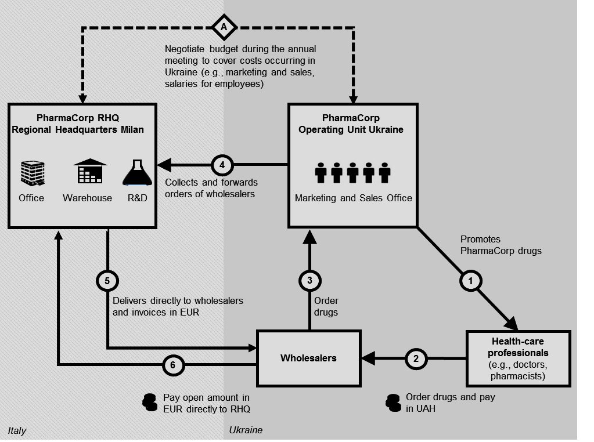

Note: RHQ = regional headquarters; R&D = research and development; EUR = euro; UAH = Ukrainian hryvnia

Source: Created by the authors.

EXHIBIT 2: PHARMACORP UKRAINE INTERNAL DATA AND FORECASTS, as of the END OF 2014 (in Thousands of EURos)

|  |  |  |  |  |  |  |  |
| --- | --- | --- | --- | --- | --- | --- | --- |
|  | Actual Data | | | | Forecast Data | | |
|  | **2012** | **2013** | **2014** | **2015** | | **2016** | **2017** |
| **Sales PharmaCorp** |  |  |  |  | |  |  |
| PharmaCorp Ukraine | 130,882 | 158,469 | 94,127 | 85,000 | | 90,000 | 100,000 |
| *Target RHQ* | *130,000* | *146,000* | *187,200* | *110,000* | | *120,000* | *130,000* |
| **Market Share [%]** |  |  |  |  | |  |  |
| PharmaCorp Ukraine | 1.9 | 1.9 | 1.4 | 1.2 | | 1.3 | 1.4 |
| *Target RHQ* | *1.8* | *1.9* | *2.0* | *1.7* | | *1.8* | *2.0* |
| **Profit/Loss Net Income** |  |  |  |  | |  |  |
| PharmaCorp Ukraine | 20,620 | 26,346 | –4,459 | *–5,000* | | *0* | *0* |
| *Target RHQ* | *20,000* | *25,000* | *26,000* | *0* | | *9,000* | *15,000* |

Note: RHQ = regional headquarters

Source: Authors’ estimates.

EXHIBIT 3: UKRAINE ECONOMIC DEVELOPMENT Overview, 2010–2015

|  |  |  |  |  |  |  |
| --- | --- | --- | --- | --- | --- | --- |
|  | **2010** | **2011** | **2012** | **2013** | **2014** | **2015\*** |
| Population (in millions) | 45.6 | 45.5 | 45.4 | 42.9 | 45.3 | 45.2* |
| GDP growth rate in % (in US$) | 4.2 | 5.2 | 0.2 | 0.0 | –6.8 | –7.5* |
| GDP per head (in US$) | 2,983 | 3,590 | 3,883 | 4,435 | 3,051 | 2,109* |
| Inflation rate (%) | 9.4 | 8.0 | 0.6 | -0.3 | 12.1 | 50.0* |
| Public debt (% of GDP) | 40.1 | 36.9 | 37.5 | 40.7 | 71.2 | 94.4* |
| Unemployment (% of labour force) | 8.1 | 7.9 | 7.5 | 7.3 | 9.3 | 11.5* |

Note: * = forecast figures; GDP = gross domestic product

Source: National Bank of Ukraine, “Official Exchange Rate of Hryvnia against Foreign Currencies,” 2016, accessed December 15, 2016, https://www.bank.gov.ua/control/en/curmetal/detail/currency?period=daily; International Monetary Fund, “IMF Data,” 2016, accessed December 15, 2016, www.imf.org/en/data; World Bank, “World Bank Open Data,” 2016, accessed December 15, 2016, <http://data.worldbank.org/>.

**GDP and Consumer Prices, % Change, Compared with a Year Earlier, 2006–2015**

Source: International Monetary Fund, “IMF Data,” 2016, accessed December 15, 2016, www.imf.org/en/data; World Bank, “World Bank Open Data,” 2016, accessed December 15, 2016, <http://data.worldbank.org/>.

EXHIBIT 4: DAILY CHANGE AND ABSOLUTE CURRENCY EXCHANGE RATE for the EURo AND the Ukrainian Hryvnia, January 1, 2014–August 30, 2014

Jan 1, 2014

May 7, 2014

Aug 4, 2014

**01/09/2014 – 30/09/2014**

Note: EUR = euro; UAH = Ukrainian hryvnia

Source: National Bank of Ukraine, “Official Exchange Rate of Hryvnia against Foreign Currencies,” 2016, accessed December 15, 2016.

Sep 1, 2014

Sep 29, 2014

Sep 15, 2014

Source: National Bank Ukraine, “Official Exchange Rate of Hryvnia against Foreign Currencies,” 2016, accessed December 15, 2016; International Monetary Fund, “IMF Data,” 2016, accessed December 15, 2016, www.imf.org/en/data.

1. € = euro; all currency amounts are shown in € unless otherwise stated; US$1 = €0.7277 on January 1, 2014.
2. ₴ = UAH = Ukraine hyrvnia; US$1 = ₴13.4340 on September 21, 2014.
3. In this context, “blisters” referred to blister packs, a packaging in which individual pills were sealed in formed pockets and backed with a seal of thin paper, plastic, or aluminum foil.