|  |  |
| --- | --- |
|  | **完整版院徽.png** |

9b17m086

Red star Macalline: strategic evolution

Professors Jie Li and Jean-Louis Schaan wrote this case solely to provide material for class discussion. The authors do not intend to illustrate either effective or ineffective handling of a managerial situation. The authors may have disguised certain names and other identifying information to protect confidentiality.

*This publication may not be transmitted, photocopied, digitized, or otherwise reproduced in any form or by any means without the permission of the copyright holder. Reproduction of this material is not covered under authorization by any reproduction rights organization. To order copies or request permission to reproduce materials, contact Ivey Publishing, Ivey Business School, Western University, London, Ontario, Canada, N6G 0N1; (t) 519.661.3208; (e)* [*cases@ivey.ca*](mailto:cases@ivey.ca)*;* [*www.iveycases.com*](http://www.iveycases.com)*.*

Copyright © 2017, SJTU Antai College of Economics and Management and Richard Ivey School of Business Foundation Version: 2017-06-08

It was the evening of June 18, 2016. Che Jianxin (CheChe), founder, chairman, and chief executive officer of Red Star Macalline Group Corporation Ltd. (RSM), was providing the finishing touches to a growth-oriented action plan he termed the “1001 Strategy.” RSM was the largest home improvement and home furnishings shopping mall operator in China. CheChe was to unveil the plan at RSM’s upcoming 30th-anniversary celebrations.

While preparing to host the event at the sprawling New International Expo Center in Shanghai, CheChe was also weighing his options on implementing the strategy:

The “1001 Strategy” is about two action plans: building 1,000 brick-and-mortar shopping malls, focused exclusively on home-centric business, all over China, and integrating them into a seamless ecosystem of our offerings and their end-users, through a single overarching Internet platform. The goal, in the short term, is to convert RSM into a technology-driven enterprise that leverages data in real-time. In the long term, the strategic intent is to make RSM an O2O [online to offline] leader in China. Our guiding post in the imminent journey will be to take all complexities out of the ecosystem. We want to make it easy, as a result, for our customers and vendors to transact with one another and for our employees to facilitate those transactions.

RSM had, for many years, considered physical stores as its core medium for reaching customers in its shopping malls. In 2012, however, it launched online shopping with what was known in China as O2O (online to offline) functions. Targeted at individual consumers, O2O enabled shoppers to order and pay for goods online and receive delivery at their nearest store, offline. In 2015, RSM launched an upgraded version of O2O at selected shopping malls. It was targeted at business customers who would use the same functionality. However, in both formats, the model encountered two specific problems: the online service was not always consistent with the offline service, and the prices displayed online often differed from those displayed offline.

As a result of his pursuit of an integrated and interactive model, CheChe was now moving towards an omni-channel strategy, as his “1001 Strategy” was generally known worldwide. An omni-channel strategy provided an environment wherein customers shopped through a variety of online and offline channels while also switching easily and seamlessly between them.[1] It was challenging, in the age of the Internet, for a home improvement and furnishings company to operate in a standalone mode of either brick-and-mortar stores or e-commerce. Building a new Web 2.0 mode integrating the two channels was crucial to exploiting business synergies. CheChe was keen that RSM should be the first to do so in its industry in China, in an effort to stay ahead of its competitors.

RSM had been listed on the H-share[2] market in 2015, mobilizing ¥5.6 billion.[3] In mid-2016, it announced an initial public offering (IPO) on the A-share[4] market to mobilize an additional ¥3.95 billion. The company had set aside ¥1.45 billion toward the construction of an exhibition mall, ¥600 million for the construction of a unified logistics service system, and ¥500 million for upgrading projects to the O2O platform. To execute its strategies, RSM had also recruited a team of 200 professionals from top Internet companies such as Google and Microsoft. Bin Li (Lao Li), the new president of the company, was to orchestrate the projects. Lao Li had previously worked as executive president at Suning Commerce Group Co. Ltd., a large home appliances retailer in China, where he had headed its O2O project.

THE OMNI-CHANNEL STRATEGY

Historically, retailers displayed their products in brick-and-mortar stores, and walk-in customers could examine the products and buy them. The launch of the commercial Internet in 1995 led to numerous channels in addition to the physical channel. For example, customers could log on to company websites to buy their products online. They could order through designated kiosks and call centres, and, more recently, through social media and mobile devices. Also launched were online pure-play companies in categories that did not require customers to touch and feel the products before buying—for example, books, movies, music, and office supplies. Their end prices were lower because the online distribution costs were lower.

Very soon, two trends had become evident. One was “showrooming,” wherein customers would visit a physical store to examine merchandise, and then make their purchase online. The other trend was “webrooming,” wherein customers would research products online but visit a physical store to make their purchase. The latter was particularly evident in such categories as shoes, sports equipment, and cosmetics. Omni-channel retailing was the result of the convergence of the two ongoing trends.

In omni-channel retailing, a customer could switch channels—buy online and pick up in-store, or use a mobile device in-store to research a product or make a purchase, or buy in-store and make a return online. The retailer also gained a 360-degree view of a customer’s purchases across all channels. Two retailer capabilities were thus crucial to the success of omni-channel retailing: enabling the customer to order online and pick up in-store; and enabling the customer to buy in-store and return online. In building those capabilities, technology came into play.

Online retailers were establishing what were known as “storefronts” in their attempts to build customer relationships, engage in real-time market research, and provide hands-on assistance to those wary of shopping online. These retailers saw a storefront not just as a store but also as a space where opinions, reviews, social media, and technology combined to create “connections.” A storefront was particularly relevant for products where the customer experience associated with touch and feel were crucial to closing the sale. Said CheChe:

The proposed omni-channel platform will allow our customers to view design scenes for their home interior ideas, examine the products of their choice, write reviews, save and share images with family and friends, and purchase those products online. It will provide our tenants with an additional point of contact with potential customers. It will enhance our customer stickiness and increase their conversion rate, resulting in higher gross sales at our shopping malls. The first-hand consumer data collected through the omni-channel platform further improves our data pool for analysis of and research on customer tastes and industry trends, providing us and our tenants with valuable market intelligence.

The HOME IMPROVEMENT AND HOme FURNISHINGS INDUSTRY in china

China’s home improvement and home furnishings industry had recorded sales revenue of ¥3,704.1 billion in 2015. It was forecast to grow at a compound annual growth rate (CAGR) of 10 per cent over the next five years.[5]

The growth was being driven by four factors. First, urban per capita disposable incomes were rising in China—having increased at a CAGR of 10.3 per cent during the period 2010 to 2015—leading to individual families demanding larger and well-furnished living spaces.[6] Second, the rate of urbanization in China was rising steadily: at 771 million, the urban population had exceeded the rural population of 603 million in 2015, leading to demand for home improvement and furnishings products as migrants from the interior settled into their new urban locations.[7] Third, with the gross floor area having increased, and the refurbishing cycle of existing homes having decreased to six years, both the furnishing of new homes and the refurbishing of existing homes were on the rise in China.[8] Fourth, notwithstanding the rate of growth of the industry, China’s per capita expenditure on home improvement and furnishings was lower at US$425.50 in 2015, as compared with $1,033.40 in the United States and $867.10 in the United Kingdom, indicating potential for market expansion.

The industry had two major segments: business-to-consumer (B2C) and business-to-business (B2B). The B2C segment consisted of households and individuals purchasing home improvement and home furnishings products for their own use, and represented 64.1 per cent of the market in 2015. The B2B segment consisted of centralized procurement by real estate developers and wholesale purchases by contractors, and represented 35.9 per cent of the market.[9]

The home improvement and home furnishings industry consisted of three broad product categories: furniture, home decoration products, and light building materials. Furniture was the largest subsector by retail sales value. The demand for light building materials was tied to new home sales, and was therefore cyclical.

China had more than 14,000 home improvement and home furnishings manufacturers. Some were located along coastal export hubs, serving as offshore manufacturing centres for overseas firms. Among those manufacturers, some focused on the domestic market and manufactured and marketed products under their own brands. The majority of the brands had limited recognition among consumers because home improvement and home furnishings products were, typically, low-frequency and low-quantity purchases. The companies themselves had limited marketing expertise and low marketing budgets. Said CheChe:

Raw materials such as wood, plastic, and metal are available in China in plenty. But because they are also commoditized, low cost is the basis of differentiation at that phase of the industry’s value chain [see Exhibit 1]. The most important element of the value chain is distribution at the downstream end. That is where the source of competitive advantage lies. That is where a lot of innovation has also been happening. Other key success factors include brand recognition, the location of the shopping mall, the product mix offered by tenants, and the ability to understand customer needs. The quality of customer service is also a differentiator.

China’s home improvement and home furnishings industry was highly competitive. Prominent foreign players included B&Q plc (the United Kingdom’s largest home improvement and garden centre retailer) and IKEA (a Swedish company, which had located eight of its 10 biggest stores in China). Prominent domestic players included Easy Home (a furniture retailer with approximately 50 stores that marketed high-quality brands from around the world) and Ayd Home Furnishings (one of the largest retail furniture mall operators). Many other local operators worked in the brick-and-mortar space. Major competitors in the e-commerce space included Jia.com (which sold home furnishings and decoration), and the home improvement retail businesses of Tmall.com (the country’s largest B2C platform) and JD.com (another online B2C company).

An important characteristic of the home improvement and furnishings industry in China was that Chinese consumers preferred the do-it-for-me (DIFM) model over the do-it-yourself (DIY) model. The latter was typical of retailers in North America and Western Europe, which offered semi-finished products and simple tools to go with them, thereby enabling customers to complete the work in their own homes. Chinese preferred finished products that were ready to go with no additional work needed. Their preference was both historical (i.e., driven by the low availability of tradespeople, low labour costs, and the need for convenience) and cultural (i.e., the DIFM model carried a premium in the mindset of a Chinese consumer).

Another characteristic was aggregation, at the point of sale, of diverse product categories from diverse manufacturers. The system had evolved in China because product manufacturers had found it expensive to develop their own distribution channels or invest heavily in their own brands. They pooled their resources to build a one-stop shop, a mall in its own right, to attract foot traffic and generate sales volumes that would justify large investments in marketing. As a result, the mall, rather than the company, was the brand. Consumers recognized and trusted mall brands over individual product brands. This approach was in contrast to the North American and Western European trends of standalone firms such as Home Depot becoming brands in their own right and marketing diverse products under a single brand.

A recent trend was that many home improvement and home furnishings retailers in China were moving beyond their traditional brick-and-mortar presence and launching online shopping; however, the transition was creating tensions for many of these retailers. For a majority of the industry products, physical factors such as touch were important at the point of sale. Retailers were struggling with providing the suitable customer experience.

China’s CHANGING CONSUMER PROFILE

China was in a state of transition from investment-led growth to consumption-led growth. The transition had been triggered by several government actions aimed at increasing national incomes. For example, the Chinese government was progressively increasing the retirement pension coverage in urban areas (it had increased by 40 per cent from covering 250 million people to covering 350 million by 2015). It was also launching several financial-sector and industrial reforms, which would lead to new job creation countrywide. The process of urbanization was also fuelling consumption-led growth.[10] The consumption of upper-middle-class and rich families was estimated to account for 55 per cent of all consumption, and to contribute 81 per cent to the total consumption increment by the end of 2016.[11]

An important trend in China’s consumer profile was the growing weightage of the “mainstream” consumer (defined as having an annual income of between $16,000 and $34,000) accompanied by a shrinking weightage of the “value consumer” (defined as having an annual income of between $6,000 and $16,000). The percentage of value consumers among the urban population was expected to decrease, from 82 per cent in 2010 to 36 per cent in 2020, while during the same period, the percentage of mainstream consumers was to increase, from 6 per cent to 51 per cent of the urban population (see Exhibit 2).

The mainstream consumers would comprise 167 million households, or nearly 400 million people, who would be the trendsetters for consumption. In terms of spending patterns, three broad shifts had already become evident in China. First, mainstream consumers would be more willing to spend on discretionary items (which included home improvement and home furnishings), as a result of those items becoming affordable to increasing numbers of consumers. Discretionary categories were forecast to show the strongest overall growth, at 13.4 per cent, between 2010 and 2020 (see Exhibit 3). Second, mainstream consumers would be trading up to high-priced goods because they were aspirational about the way they lived and their perceived social standing. Third, mainstream consumers would be among the most dedicated and sophisticated of online shoppers, and would seek such shopping conveniences as easier price comparisons, unique assortments of products, freshness of goods, quality of service, and a social networking experience.

China’s online retail market was already the world’s largest, with e-commerce accounting for more than 13 per cent of the country’s total retail sales of consumer goods. In top-tier cities, roughly 90 per cent of Internet users and 70 to 80 per cent of consumers as a whole were shopping online. As Chinese consumers enjoyed the options and transparency available online, they were also becoming increasingly choosy, often visiting four to five sites before reaching a purchase decision, according to McKinsey research.[12]

Overview of RED STAR MACCALINE

RSM had been listed on the H-share market in 2015. In mid-2016, it announced an IPO on the A-share market. By the end of 2016, RSM had opened its 200th mall. It had, in fact, announced in 2012 its goal of opening its 200th mall by 2020. The goal had been accomplished four years ahead of schedule. By June 20, 2016, RSM had become China’s largest home improvement and home furnishings shopping mall operator in terms of three metrics: number of shopping malls (181); operating area (11,814,928 square metres), and geographical coverage (129 cities). The company had generated revenue of ¥8.76 billion and net profits of ¥4.37 billion for the year ending December 2015 (see Exhibit 4). RSM had 17,086 full-time employees. Its mall tenants had their own employees only at the sales counters.

CheChe had founded the company in June 1986 with capital of ¥600. A high-school dropout, CheChe had taken up carpentry with his apprentices in the city of Changzhou in the province of Jiangsu. By 1988, they had put together 500 sets of furniture and sold them for $80,000, before setting up a furniture warehouse in 1992. It was a year later that CheChe thought of leasing a shopping mall focused on furniture. He rented a decrepit building, divided it into small shops, and rented them out to small, individual furniture traders. The idea became so successful that he replicated the model to establish 20 similar malls in cities, big and small, in Jiangsu Province. Within a year, he had progressed to purchasing freehold land in metropolitan cities such as Beijing and Shanghai, on which he built malls.

In 1998, CheChe switched to the franchise business model. Franchising required less capital on his part because the investment was shared with the franchisee. The model ensured faster geographical expansion nationwide. Said CheChe:

In 2003, we launched garden-style malls which are environment-friendly, and followed it up in 2005 with what we called “experience shopping” by combining the Chinese traditional store mode with the Western shopping mall mode. In 2008, we opened a new park-style home furnishings mall in Shanghai as a flagship store for home furniture brands from around the world. Built on an investment of $1 million and housing more than 2,500 individual stores, the mall has a monorail, the first of its kind in the world, spiralling its way up and down six floors, ferrying shoppers. In 2014, we brought in the concept of “spatial art,” wherein live theatre performances, averaging 40 per annum, are held at RSM malls for shoppers to enjoy free of cost.

The business model of RSM was built on a combination of portfolio shopping malls and managed shopping malls. By June 30, 2016, RSM had 56 portfolio shopping malls and 125 managed shopping malls (see Exhibit 5). The former were spread over a total area of 4,457,050 square metres at an average occupancy rate of 95.4 per cent. The latter were spread over a total area of 7,357,877 square metres at an average occupancy rate of 92.2 per cent.

Portfolio shopping malls offered comprehensive services to their tenants, including designated shopping space, staff training, sales and marketing, daily operations and management, and customer services. In exchange, RSM received a fixed monthly rent and management fees. Managed shopping malls provided full-scale operating services to their business partners, including site selection, construction consultation, design and decoration, tenant sourcing, and daily operation and management. In exchange, RSM received fees during different stages as part of the contract management agreements.

Most of the portfolio shopping malls were located in Tier 1 and Tier 2 cities, providing recurring and predictable operating income through rent and management fees. Most of the managed shopping malls were located in Tier 3 and other cities. They were asset-light. Said CheChe:

Our hybrid expansion model is one of a kind in the Chinese home improvement and furnishing industry. It has created high barriers to entry. It is difficult to replicate. We have firmed up prime locations in Tier 1 and Tier 2 cities for our portfolio shopping mall footprint. There is nothing left for our competitors, present or potential, to source. We also have deeply entrenched industry relationships supporting our managed shopping mall footprint. Our success with the hybrid model has led to a virtuous growth cycle for us, our partners, our tenants, and our customers.

RSM was shifting its focus from Tier 1 and Tier 2 cities, where most of its malls were located, to smaller, county-level areas where urbanization was accelerating.

RSM had expansion plans for the future in its core business of mall development. It had identified attractive market opportunities in the 2,500 Tier 3 and other downstream cities across China. According to RSM, each such city could support at least one branded shopping mall. RSM would have a first-mover advantage on the strength of its asset-light strategy, which could generate rapid growth and high returns on capital without straining the company’s cash flow. It had already shortlisted the cities it planned to expand into in the next three years based on size, population, local market conditions, and the disposable income of residents. The company was working on launching a “mini mall” format of 15,000 to 30,000 square metres in some of those cities.

Since its inception, RSM had positioned itself as a trading platform for the home improvement and home furnishings business. The imminent launch of the 1001 Strategy had led to the company being repositioned as a “home-centred” enterprise that was extending its reach to five interrelated industries: residential real estate, home decoration, home commodities (e.g., appliances, vases, and curtains), finance, and service.

The company was also entering into three non-core sectors aimed at reinforcing its core offerings. The first was consumer and vendor financing. Customers were in need of financing because of the high costs of home improvement and home furnishings products. Vendors were in need of financing to cover their rental expenses and procurement costs. RSM had taken the first step in this regard by establishing a consumer financing joint venture with Haier and Greentown in December 2014. It had applied for its own consumer financing licence.

The second non-core section was logistics and fulfilment services. By leveraging the company’s existing nationwide footprint, these services were meant to provide so-called “last-mile services”[13] such as warehousing, assembly, and delivery. These services helped vendors manage their inventory better and reduce their costs of operations, and enabled customers to track their shipments from the comfort of their homes. The services enabled RSM, as a company, to aggregate its orders and deliveries, leading to better control over resources. It also enhanced the stickiness of manufacturers, vendors, and customers.

Another potential area of related diversification was home design services, which prevailed at the upstream end of the industry value chain. RSM was planning to identify talented home design professionals, invest in their start-ups, and endorse their business with its premier brand. In exchange, the start-ups would agree to purchase 80 per cent of their home improvement and home furnishings products from RSM shopping malls. The move was aimed at promoting agile and nimble innovators within a large organization.

In addition, RSM was also expanding into bulk procurement services, connecting home improvement and home furnishings suppliers and vendors with construction contractors and real estate developers. It was focusing on small- to mid-sized developers who did not have the scale to set up their own centralized procurement.

RSM was the first in the home improvement and furnishings retail industry in China to implement a comprehensive enterprise resource planning system, which was known internally as “Star Cloud.” It had been rolled out across the group at a cost of ¥80 million. Star Cloud was serving two objectives: it enhanced operational management, particularly with regard to inventory, and it helped commercialize the data collected through its system to better analyze consumer preferences. Said CheChe:

The home improvement and furnishings industry is characterized by product offerings where physical touch remains a valued aspect of the purchase decision. Hence, an online strategy will be successful only when combined with a physical mall network. The shopping experience is an integral part of our brick-and-mortar stores. Our online platform will be designed around the customer experience and our strategy is to leverage our shopping mall network to offer a synchronized shopping experience for our consumers.

THE WAY FORWARD

RSM’s 1001 Strategy had two components: building 1,000 malls as physical infrastructure and building one Internet platform.

On the physical front, RSM had shown evidence that it could deliver. Having already built a total of 181 malls by mid-2016, RSM opened its 200th mall at the end of 2016. The company had then set a new target of building 1,000 malls.

The new malls would still be part of either portfolio shopping malls or managed shopping malls. They would be designed to upgrade from home malls to family malls, permeating not only Tier 3 and Tier 4 cities but also key counties from Tier 1 and Tier 2 cities. The new malls would be integrated into the local business community infrastructure and the public facilities serving local residents and consumers.

On the digital front, RSM had already designed a mobile application (app) for its malls in Shanghai, and a peer-to-peer platform for furniture buyers, commercial tenants, and factories partnered with the malls. The way ahead would involve replicating these offerings enterprise-wide. Lao Li, the company’s president, had outlined three 100-day plans for implementing the omni-channel strategy: launch the fundamental platform in the first 100 days; launch the full chain product in the second 100 days; and open for sharing and collaboration in the third 100 days.

In deploying the digital medium, Lao Li needed to manage the tension between the traditional brick-and-mortar model and the e-commerce model.

Executing the 1001 Strategy would also be an opportunity for RSM to take a fresh look at determining its core competitiveness. Lao Li saw the emerging competitive advantage in terms of three components: RSM as a brand, RSM as a repository of omni-channel talent, and RSM as a digital enterprise.

Lao Li was keen that the user interface be easy and convenient to handle and that all the complexity should be limited to the back end. Simplicity should be the hallmark of the 1001 Strategy. He was keen on having no more than four layers of reporting relationships (i.e., President → Person in charge of the business unit → Person in charge of department → Common employee). This reporting structure was in contrast to the approximately 17 to 18 layers prevalent in traditional enterprises of the size of RSM.

Exhibit 1: red star macalline group corporation ltd.’s home furnishings INDUSTRY VALUE CHAIN

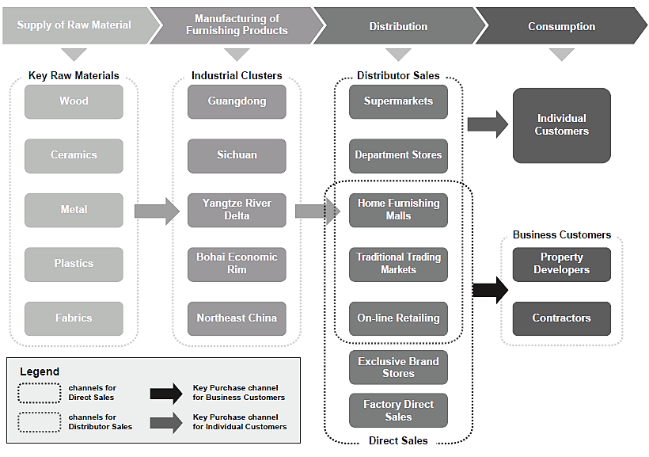

Source: Red Star Macalline Group Corporation Ltd., *Global Offering*, 90, 2016, accessed October 25, 2016, http://corpsv.etnet.com.hk/data/documents/ipo/20150616/HKEX-EPS_20150616_002232180_0.PDF.

Exhibit 2: RISE OF MAINSTREAM CHINESE CONSUMERs, 2000, 2010, and 2020-estimated (in millions of households)

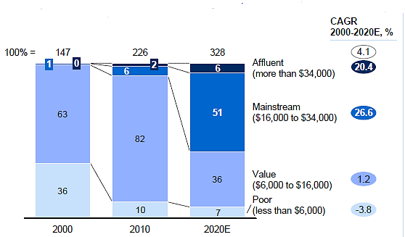

Note: CAGR = compound annual growth rate.

Source: “Macroeconomic Model Update (March 2011)” in Yuval Atsmon, Max Magni, Lihua Li, and Wenkan Liao, *Meet the 2020 Chinese Consumer (*McKinsey Insights China, March 2012), 14, accessed March 27, 2017, www.mckinseychina.com/wp-content/uploads/2012/05/McKinsey-China-Meet-The-2020-Chinese-Consumer.pdf. Used with permission.

Exhibit 3: chinese URBAN HOUSEHOLDS’ ANNUAL CONSUMPTION BY CATEGORY

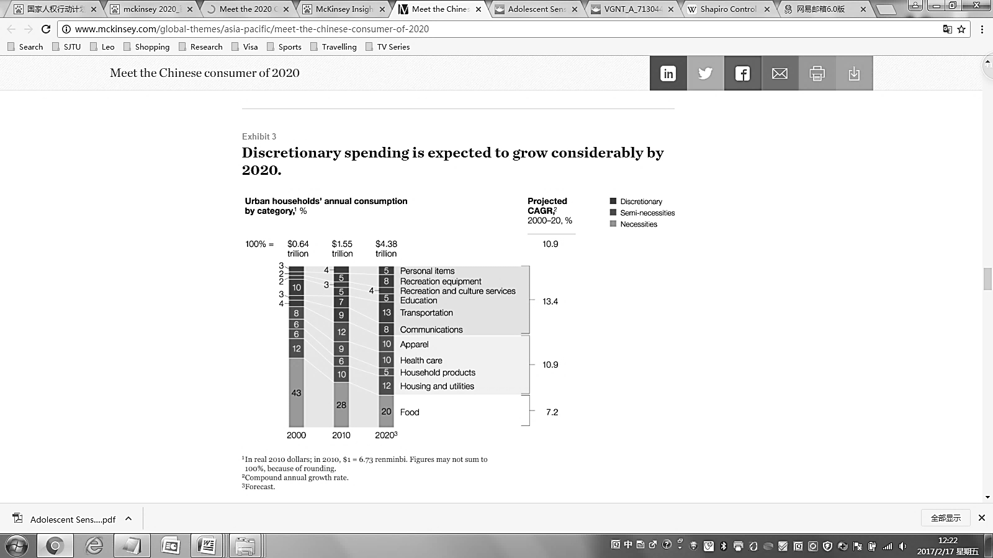

Note: CAGR = compound annual growth rate.

Source: “Macroeconomic Model Update (March 2011)” in Yuval Atsmon, Max Magni, Lihua Li, and Wenkan Liao, *Meet the 2020 Chinese Consumer* (McKinsey Insights China, March 2012), accessed March 27, 2017, www.mckinseychina.com/wp-content/uploads/2012/05/McKinsey-China-Meet-The-2020-Chinese-Consumer.pdf. Used with permission.

Exhibit 4: Red Star Macalline group corporation ltd. INCOME STATEMENTs,

2012–2015

|  |  |  |  |  |
| --- | --- | --- | --- | --- |
| (in millions of RMB) for the year ending December | **2012** | **2013** | **2014** | **2015** |
| Revenue from Portfolio Shopping Malls  Revenue from Managed Shopping Malls   * Initiation and Entrance Fees * Annual Management Fees * Construction Consultancy and Management Fees   Other Revenues | 3,852  527  719  154  2 | 4,199  988  855  272  47 | 4,884  1,014  1,093  679  265 | 5,260  1,410  1,268  464  354 |
| Total Revenues | 5,254 | 6,361 | 7,935 | 8,756 |
| Cost of Sales and Service | (1,452) | (1,789) | (2,054) | (2,242) |
| Gross Profit | 3,801 | 4,571 | 5,881 | 6,514 |
| Other Income  Changes in Fair Value of Investment  Other Gains and Losses  Selling and Distribution Expenses  Administrative Expenses  Other Expenses  Share of Profits of Associates  Share of Results of Joint Ventures  Finance Costs | 222  1,112  (48)  (809)  (654)  (6)  45  (14)  (554) | 192  2,055  (30)  (922)  (771)  (27)  42  (10)  (631) | 170  2,415  (187)  (1,055)  (923)  (113)  14  4  (856) | 194  2,382  (206)  (1,197)  (882)  (121)  62  50  (854) |
| Profit before Tax | 3,095 | 4,469 | 5,350 | 5,942 |
| Income Tax | (839) | (1,200) | (1,428) | (1,573) |
| Net Profit | 2,257 | 3,269 | 3,922 | 4,370 |

Note: RMB = Chinese renminbi; US$1 = ¥6.2037 as of January 1, 2015.

Source: Company audited financial reports.

Exhibit 5: Red Star Macalline group corporation ltd. SHOPPING MALLS

(as of June 30, 2016)

|  |  |  |  |  |
| --- | --- | --- | --- | --- |
| Region | Self-Operational | Mandatory Administration | Total Number | Percentage |
| Beijing | 4 | 1 | 5 | 2.8 |
| Shanghai | 7 | 0 | 7 | 3.9 |
| Tianjin | 4 | 1 | 5 | 2.8 |
| Chongqing | 3 | 0 | 3 | 1.7 |
| North-East | 8 | 8 | 16 | 8.8 |
| North-China | 3 | 20 | 23 | 12.7 |
| East-China | 13 | 69 | 82 | 45.3 |
| Central-China | 7 | 9 | 16 | 8.8 |
| South-China | 3 | 3 | 6 | 3.3 |
| North-West | 1 | 8 | 9 | 5.0 |
| South-West | 3 | 6 | 9 | 5.0 |
| **Total** | 56 | 125 | 181 | 100 |

Source: Company audited financial report, 2016.

1. David R. Bell, Santiago Gallino, and Antonio Moreno, “How to Win in an Omni-Channel World,” *Sloan Management Review* 56, no. 1 (fall 2014): 45–53. Available from Ivey Publishing, product no. SMR56115.
2. H-shares referred to a Chinese company’s shares that were listed on the Hong Kong Stock Exchange or other non-Chinese stock exchanges. H-shares were regulated by Chinese law, but denominated in Hong Kong dollars.
3. ¥ = CNY = Chinese renminbi (yuan); all currency amounts are in ¥ or U.S. dollars; US$1 = ¥6.2037 as of January 1, 2015.
4. A-shares referred to the shares of Chinese companies that were publicly traded on mainland Chinese stock exchanges.
5. Based on a study conducted by Frost and Sullivan for Red Star Macalline and cited in the company’s initial public offering (IPO) prospectus, accessed September 12, 2016, http://corpsv.etnet.com.hk/data/documents/ipo/20150616/HKEX-EPS_20150616_002232180_0.PDF.
6. Ibid.
7. Ibid.
8. Ibid.
9. Ibid.
10. “National Human Rights Action Plan of China (2016–2020),” China State Council Information Office, 2016, accessed March 27, 2017, http://english.gov.cn/archive/publications/2016/09/29/content_281475454482622.htm.
11. Yuval Atsmon, Max Magni, Lihua Li, and Wenkan Liao, *Meet the 2020 Chinese Consumer* (McKinsey Insights China, March 2012), accessed March 27, 2017, www.mckinseychina.com/wp-content/uploads/2012/05/McKinsey-China-Meet-The-2020-Chinese-Consumer.pdf.
12. *China’s iConsumer 2015: A Growing Appetite for Change* (McKinsey & Company, February 10, 2015), accessed March 27, 2017, http://mckinseychina.com/chinas-iconsumer-2015-a-growing-appetite-for-change.
13. Last-mile services referred to the final processes before delivering products to consumers.