

9B17M103

success tastes bitter: POLMOS LUBLIN (A)

Krzysztof Obloj and Tomasz Obloj wrote this case solely to provide material for class discussion. The authors do not intend to illustrate either effective or ineffective handling of a managerial situation. The authors may have disguised certain names and other identifying information to protect confidentiality.

*This publication may not be transmitted, photocopied, digitized, or otherwise reproduced in any form or by any means without the permission of the copyright holder. Reproduction of this material is not covered under authorization by any reproduction rights organization. To order copies or request permission to reproduce materials, contact Ivey Publishing, Ivey Business School, Western University, London, Ontario, Canada, N6G 0N1; (t) 519.661.3208; (e)* [*cases@ivey.ca*](mailto:cases@ivey.ca)*;* [*www.iveycases.com*](http://www.iveycases.com)*.*

Copyright © 2017, Richard Ivey School of Business Foundation Version: 2017-07-07

The first quarter of 2005 was looking just fine from the perspective of the executive board of Polmos Lublin, a mid-size company in Poland’s liquor market.[1] The company had benefited from the Polish transformation after the fall of communism, and with several strategic moves had achieved a dominant position in the flavoured (coloured) vodka segment with the brand *Bitter*.[2] It was still, however, only a marginal participant in the country’s much larger pure vodka segment. Nonetheless, sales were steady and margins growing. The public offering, completed at the end of the previous financial year (in February 2005), had been successful, and Polmos Lublin now had funds for future development and growth.

As the board continued their analysis, they identified several strategic options that the company could pursue to achieve growth in the near future. Their four core choices were acquisitions, internationalization, diversification, and focused continuation of their current strategy. It was time to decide what to do next.

Polish transformation: from planned to market economy

Following the electoral victory of theIndependent Self-Governing Labour Union (Solidarity) in Poland and the fall of the Berlin Wall in 1989, Central and Eastern European countries underwent significant change. Poland’s political and economic transformation from a planned to a market economy was radical and widely seen as “shock therapy.” The process was based on major institutional changes: (a) An austerity program was introduced to fight raging inflation of almost 900 per cent, and interest rates were raised tenfold to 120 per cent; (b) The currency was made internally convertible to Western currencies; (c) A privatization program of state-owned firms was started, a stock exchange established, and subsidies for state-owned enterprises abandoned; (d) Price controls and custom duties were lifted; (e) A new commercial code was introduced; and (f) New trade agreements were signed with Western European countries.

During the first year of transformation, following the radical change of commercial law, almost 1 million new ventures were established in a country with a population of roughly 39 million. In parallel, existing enterprises came under pressure as a result of dramatically increased competition and the lack of state protection, the liberalization of imports, restricted access to capital, and a surge of entrepreneurship. Managers of both state-owned (about 12,000 state-owned firms in 1988) and private companies faced the “adapt or die” dictum. Many companies were successful and, in general, the Polish case was praised as a fast and holistic, if radical, transformation from a communist to a market economy.

Privatization of state-owned firms was one of the key elements of the transformation. This process occurred in waves because the government dealt with industries on a case-by-case basis, trying to manage social and political concerns while also maximizing budget revenues.

Polish alcoholic beverages industry and market

Poland targeted the liquor industry for privatization at the beginning of 2000. The revenue expected from privatization was high; the alcoholic beverages market had huge potential in terms of size and expected growth. In 2000, the three largest alcoholic beverages markets were the United States (approximately US$80 billion),[3] Japan (approximately $60 billion), and Germany (approximately $28 billion), followed by France, the United Kingdom, and Russia. Poland, with a market of $7.5 billion, was the seventh largest market in the world. Poland was also recognized as the producer of the best vodkas in the world.[4] Pablo Picasso was a true fan of Polish vodka and once (apparently) declared his devotion by stating, “The three most astonishing things in the past half-century were the Blues, Cubism, and Polish vodka.”

Until 1989, all 25 producers of alcoholic beverages in Poland—each with the generic name “Polmos”—were state-owned; production was a state monopoly. In 1989, ownership of over 200 popular brands was consolidated in one state-owned enterprise, which then licensed these brands to the state-owned producers at no cost. As a result, products were decoupled from brands. Also, the state monopoly of vodka production was terminated and firms could apply for a special license and enter the alcoholic beverages market.

Various Polmos enterprises produced vodkas of varying quality, but used the same brands. This led to intense competition, consumer confusion, and subsequent depreciation of brand values. In parallel, the industry saw a wave of new producers who focused on the development of completely new (and hence proprietary) brands. However, most of these new brands were unsuccessful, for primarily two reasons: First, there were still many strong incumbent brands and customers were used to them, even if quality was an issue. Second, reaching customers was difficult because direct marketing of liquor was not allowed. Therefore, the only two ways to successfully enter the market were with strong international brands like Absolut, Bols, Smirnoff, or Finland (all four of which had gained a strong foothold in the premium segment of the Polish market), or through imaginative marketing strategies.

Two noteworthy entries using imaginative marketing strategies were pure vodkas branded as *Sobieski* and *Absolwent* (Graduate). Belvedere Distribution Company introduced the first brand, Sobieski. The company leveraged the historic connotation of a Polish king, Jan III Sobieski, who commanded the famous Battle of Vienna when Holy League troops defeated the invading Ottoman Empire forces, thus ending the Ottomans’ efforts to conquer Europe. The second successful entry, Absolwent, was from the biggest state-owned producer, Polmos Bialystok, and targeted young people graduating from high school and college. Thanks to a good combination of brand, design, price, and superb distribution, Absolwent quickly became widely popular and the vodka of choice at major events such as weddings and graduations.

There were three major segments in the market. The pure vodka segment was by far the largest, the flavoured vodka segment was smaller, and the third, very small segment (just a few per cent of the total market) consisted of specialized alcoholic beverages such as gin, brandy, and whisky. The market was further divided into four main segments with price as the main criterion: economy, mainstream, premium, and top premium. In 2002, the largest segment was mainstream (approximately 61 per cent of sales value), followed by premium (25 per cent of value). The economy segment was relatively small (approximately 11 per cent of value) and the top premium segment was of marginal importance because it consisted mostly of expensive imported products.[5]

There were four types of participants in the vertical supply chain of the liquor market. First, there were the suppliers, providing liquors usually manufactured from rye or potatoes. Operating under strict state control, this market was very fragmented, with hundreds of local and small producers. Most of them did not have any bargaining power because their product was considered a commodity and so was often mixed across producers upon delivery.

Second, there were about 25 producers of branded liquors. Five of these producers were clearly dominant: Sobieski Company, Polmos Bialystok, Unicom Bols, Wyborowa, and Polmos Zielona Gora (see Exhibit 1).

The third group in the market was distributors. Distribution of alcoholic beverages was based upon state licences and carried out by 600, mostly private, firms. Many of them were small and served local or regional markets. The 10 largest distributors operating across the whole country controlled 47 per cent of the market. Two foreign investors led a visible tendency toward consolidation in the market. The former U.S. golfer, William V. Carey, set up large distribution operations (Central European Distribution Corporation, commonly known as CEDC International), and a French company, Belvedere S.A., established Belvedere Distribution Company. Both of these companies focused initially on the development of countrywide distribution and consolidation of small local distributors. CEDC International and Belvedere Distribution directly or indirectly controlled about 30 per cent of distribution, and aimed to increase their hold further.

There were two additional important distribution vehicles. Large beer companies used their own proprietary distribution systems to reach shops and *horecas*,[6] and used small distributors only to fill the gaps. Several large producers of sparkling wine used existing alcoholic beverages distributors, but also tried to develop their own separate sales force to deliver product to modern retail channels and large stores. The prime example was Ambra S.A. (Ambra), a private company that controlled about 60 per cent of the sparkling wine market and had two national brands (Cin-Cin and Dorato) and several regional brands. Ambra also was an important wine importer and, over time, had developed a large sales force to distribute its products all over Poland.

The fourth group of participants in the supply chain consisted of the retailers. Sales of alcoholic beverages were dominated by many thousands of small and medium-size local shops that had to apply for a licence to sell liquors, wine, or beer. They controlled almost 80 per cent of the market in terms of volume and value. Large stores, supermarkets, and hypermarkets sold the rest. The general trend favoured a growing number of supermarkets and hypermarkets as modern retail systems, but because vodka and beer were impulse and convenience purchases, they were still primarily bought in local stores. Modern retail systems were gaining only 1–2 per cent of the market per year in these categories. Hypermarkets such as Auchan, E.Leclerc, and Carrefour were buying products directly from producers, but small and medium-size shops relied on cooperation from two to four distributors that competed on price, conditions of payments, and additional services such as merchandising and promotions.

This market architecture posed a particular financial challenge for producers of the final product. Big, modern retail chains were placing large orders directly with the producers and had substantive bargaining power for prices and payment terms. Smaller retailers did not have the same bargaining power, but together they held the dominant market share.

The fragmented and long retail and distribution system was under-capitalized and partially financed itself with accounts receivables, which did not allow for quick collection of payments. In other words, each actor in the supply chain postponed the payments as long as legally possible and sometimes even longer. Hence, the market norm was 60–70 days for collection from the traditional retail channel, and 70–90 days from the modern retail channel. At the same time, producers had to pay the value-added and excise taxes—which in the case of vodka, could reach up to 60 per cent of the cost of goods sold—within 25 days of the *production* date. Without a developed financial market for receivables and with no factoring services, producers had to finance this gap themselves, which proved to be a daunting task for smaller participants. As a result, both smaller distributors and producers were constantly cash short.

Polmos Lublin S.A.

One of the state-owned vodka producers that the Polish government privatized was Polmos Lublin. The company was situated in the city of Lublin in the southeast of Poland, one of the poorest regions in the country. With a turnover of zł172 million (about €43 million),[7] the company was the sixth largest vodka producer and held about 4 per cent of the total Polish vodka market in 2001. It held a marginal share of the pure vodka market (about 2 per cent) but was a leader in the flavoured vodka segment with a 14 per cent market share.

Sales were largely dependent on one major brand: Bitter (Żołądkowa Gorzka), a bittersweet, orange-tasting, liqueur-type vodka. It was very popular in Poland, especially among women who drank it as a sweet, orange liqueur in the evenings, and among alcoholics who drank it as hangover medicine, usually in the mornings. (It did not work as such.) The company product portfolio was heavily skewed toward the Bitter brand, which constituted slightly more than 70 per cent of sales. While Polmos Lublin carried multiple other brands of flavoured vodka, no single one accounted for more than 3 per cent of sales.

The company also produced five pure vodkas in the premium and top premium segments (Commander Vodka, Captain Vodka, and Boss), mainstream segment (Ideal), and economy segment (Bison), which together were responsible for 23 per cent of sales. Boss was a new and relatively successful product, but sales stagnated at 1.5 per cent of the pure vodka market. It had been introduced in 1998 with strong merchandising support and a smart marketing strategy, imitating a popular premium vodka, Bols (also produced in Poland, but under Dutch license). The bottles for both brands were similar, as was the pronunciation of the brand names, but Boss had a lower price than Bols (see Exhibit 2). As part of the marketing plan for Boss, Polmos Lublin had given a license to Lublin Tobacco Producers, which introduced Boss cigarettes. Producers of the original Bols vodka and the brand’s owner sued Polmos Lublin for imitating Bols’ packaging, brand, and product. The company eventually settled the conflict and abandoned production of Boss vodka for an undisclosed sum.

When it was privatized, Polmos Lublin employed 200 people. Production buildings and stores were located on a relatively large lot close to Lublin’s city centre. The company had several industrial installations spread across different buildings, warehouses for supplies and finished goods, and its own railway system that included small cars and diesel locomotives. The railway was rarely used because liquor was increasingly transported by trucks and less by cargo trains. The company’s assets also included a yeast production facility that occupied one large production building and employed about 25 people. (Yeast was also sold to bakeries in the Lublin region.) The company sold its products directly through its store to supermarkets (e.g., Macro Cash & Carry, Leclerc), but otherwise mostly relied on regional distributors.

The state agency preparing the Polmos firms for privatization decided to depart from the existing free-for-all brand usage policy. In order to increase the firms’ value, the agency allocated each popular brand to two or three Polmos companies through a bidding system. Polmos Lublin bid for Bitter and was awarded 58 per cent ownership. Polmos Starogard (acquired by Belvedere Group) was allocated the remaining 42 per cent of the brand. However, while Bitter was a crucial brand for Polmos Lublin, it was less significant for Belvedere Group, which focused on the pure vodka segment with its popular brand, Sobieski.

In 2001, the 3 million shares that constituted 95 per cent of Polmos Lublin’s equity were sold for zł27 million (about €7.2 million), to be paid in three instalments. The buyer was a private investor, Janusz Palikot, an entrepreneur and specialist in the alcoholic beverages market, and the former chief executive officer and co-owner of Ambra, the largest sparkling wine producer in Poland. The government kept the remaining 5 per cent stake and one seat on the supervisory board. The new investor became chief executive officer and, with the help of a new supervisory and executive board, immediately prepared a restructuring plan. It was a difficult time, as one of the managers recollected:

It was a weak company, the investor was leveraged to the hilt and did not have any money for development, and the duty to pay excise and value-added taxes before we collected any money from distributors was killing us.

After intense and difficult negotiations with the trade unions, the company scaled down its workforce to 150 people. A portion of the land and installations was sold. The yeast production facility, which had been losing money, was sold for zł3.5 million despite a book value of zł6.5 million. The deal triggered a legal investigation into company management at the state’s initiative; the officials just could not understand how a company could sell assets for less than book value. It took some time for everybody to understand the concepts of “sunk costs” and “loss-creating assets.” The internal railroad system was abandoned and locomotives sold. Installations were moved as close as possible to each other to save on media and transportation costs.

Another major challenge was the company’s distribution system. The existing inefficient system of cooperation with hundreds of distributors was radically changed in 2002. Polmos Lublin signed an agreement with Ambra and outsourced all of its distribution. In this way, the company shed its problem with collecting receivables and gained a larger reach of retailers. Ambra benefitted by adding liquors to its portfolio, thus offering distributors and retailers a wider range of products. This, in turn, led to new contracts, especially with large hypermarkets, horecas, and gas stations. The alliance benefited both partners for some time, but when the distribution system was consolidated, the transaction costs of distribution fell and the time for cash collection was shortened. In order to avoid total dependence upon Ambra and to take advantage of the marketplace changes, Polmos Lublin terminated the agreement in 2004 and Ambra became a major distributor, but not the sole distributor.

Palikot also decided to gain full control over the firm’s core brand, Bitter. In 2002, Polmos Lublin paid Belvedere Group almost €9 million to acquire the remaining 42 per cent of the brand (some analysts considered this an excessive price), giving Polmos Lublin full production and quality control.

Subsequently, Palikot turned his attention to market research in order to evaluate where, what, and how customers would drink in the coming years, and to determine what new customer segments and distribution channels could be leveraged for growth. Based on this analysis, the executive board decided to implement the following changes:

* Rejuvenate the main brand, Bitter, by reshaping the design of the bottle and labels, and by introducing frequent (bi-monthly), systematic—even if marginal—innovations that created value for customers (e.g., packaging a glass, metal canteen, or lighter with the bottle of vodka).
* Extend Bitter’s customer reach by introducing the liquor to pubs and clubs, positioning Bitter as a “cool” drink for the young generation in that segment.
* Distribute Bitter in bottles of several sizes, especially in the very small 100-millilitre bottles that were very popular in the rapidly growing economy segment and in the new distribution channel of gas stations.
* Grow in the economy segment of pure vodkas by introducing a new brand, 1906 (named after the year Polmos was established), and growing the existing brand Bison. It was consistent with the market trends, as in 2004, the total economy segment increased to 29 per cent (of the total vodka market value) while the mainstream segment of pure vodkas shrank to 46 per cent.

The results were encouraging. Without marketing and promotion (forbidden by law), but with skilful merchandising and cooperation with distributors, Polmos Lublin almost doubled its revenues between 2001 and 2004 (see Exhibit 3), with growth driven mostly by sales of Bitter. Its share in the company’s revenues grew from 61 per cent in 2001 to 94 per cent in 2004. Bitter grabbed 43 per cent of the flavoured vodkas market, followed by Żubrówka (Bison Grass Vodka, owned by Polmos Białystok) holding 25 per cent of the market, then Sobieski’s Krupnik (Honey Vodka) at 3.8 per cent.

Successful but careful repositioning allowed Polmos Lublin to keep its traditional customers while Bitter became the favourite drink of the young generation, especially to begin and finish nights of clubbing and pubbing. The gas stations—a new distribution channel—generated huge revenue and margins. As sales grew, Bitter became a favourite among distributors, who pushed it hard in the retail channels (see Exhibit 4). Overall, the company became the fifth largest producer of vodka in Poland.

In spite of all these successes, the company still faced some problems. Its equipment and machinery were old, and although the company ran three shifts daily, it struggled to meet the growing demand. Also, the company depended heavily on sales of one core product. Due to the extraordinary success of Bitter, sales of pure vodkas in the growing economy segment became irrelevant and the company’s market share in that segment dropped to almost zero.

In 2004, the company’s supervisory board decided to search for new growth drivers. It installed a new executive board with a chief executive officer who had extensive experience in managing large multinational companies, a new marketing vice-president, and a manager responsible for international operations. The team’s mandate was to develop a strategic plan for the company’s future and growth, and to prepare a successful public offering.

The new growth strategy

In the process of preparing a new strategic plan, the company performed an in-depth analysis of the strengths and weaknesses of the current business model. The search for a frame of reference was difficult. The company did not have one direct competitor. Two major competitors were much larger than Polmos Lublin, together holding about 52 per cent of the market; however, they produced mainly pure vodkas and owned part of the distribution system. Small competitors were fragmented and in poor financial shape. Finally, the board used “ideal” competitors as a frame of reference, merging the main competitors into one ideal type. In that context, evaluations of strengths and weaknesses revealed that brand was considered a crucial strength, while the company’s scope of offerings and capacity were major weaknesses (see Exhibit 5).

Based on this analysis and in-depth discussions, the new executive board considered four ways forward:

* Continue with the existing strategy, focusing on gaining additional market share in the flavoured vodka segment and developing a stronger position for the company’s pure vodka brands. This approach would limit investment expenses, was low-risk, and, from the owner’s perspective, could be very profitable. Both financial investors and international alcoholic beverages producers had already indicated their interest in acquiring a mid-size producer with a very good brand and a leading position in the flavoured vodka market.
* Growth through acquisition. The largest and relatively successful state-owned enterprise, Polmos Bialystok, was being prepared by the state for privatization. It was an attractive acquisition target as the owner of the largest pure vodka brand, Absolwent, and the internationally recognized flavoured Żubrówka. The estimated value of the deal was at least €150 million.[8] The acquisition route seemed particularly promising, because it would solve immediately the problems of scope and capacity, catapulting Polmos Lublin to the position of a leading producer in Poland. However, all the major companies wanted to participate in the bidding for Polmos Bialystok; as a result, its price could reach €200 million or more. Financing such an acquisition with debt could be a daunting and risky endeavour even for cash-rich investors.
* Growth through internationalization. Almost every market worldwide had large segments in flavoured vodkas and liquors. Polmos Lublin could leverage its experience by entering new market segments and distribution channels in foreign markets. There were potential risks and problems; internationalization could be very expensive and could be hampered by regulations and strong competition from local companies. Also, while Poland was world famous for pure vodkas, it did not have a very strong national reputation for flavoured vodkas and other alcoholic beverages.
* Growth across market segments. Polmos Lublin’s sales were almost exclusively generated with Bitter. With Bitter’s reputation among customers, retailers, and distributors, Polmos Lublin could introduce other brands in the same segment (flavoured vodkas) as well as target all segments of the larger pure vodka market. The company already had good prior experience in the pure vodka segment with its 1906 and Bison brands.

In the meantime, the company completed a public offering. In February 2005, Polmos Lublin sold 2,500,000 shares on the Warsaw Stock Exchange at the price of zł50 per share (€11). The initial investor (Palikot) retained effective control of the company and the right to nominate three out of six supervisory board members, including president. After the deduction of capital gains taxes, the company had zł75 million in additional capital available to implement its strategic options.

Exhibit 1. Leading Companies and brands in Poland’s Liquor Segment, 2004

|  |  |  |
| --- | --- | --- |
|  | Short description | Main brands |
| Sobieski Company | Initially, a company distributing wines and liquor, owned by the French company Belvedere Distribution Company. In 2001, it acquired mid-size Polmos Starogard, thus extending its value chain by adding production to distribution. After developing new brands, became the market leader in Poland’s liquor segment with 31 per cent market share. | * Sobieski (mainstream brand) * Starogardzka (Old Castle) and * Krakowska (Cracow Vodka), both having strong positions in an economy segment * Krupnik (Honey Vodka), a traditional, honey-flavoured vodka |
| Polmos Bialystok | Large, state-owned, and well-managed company that controlled two powerful brands in the pure and flavoured vodka segments. Also had a good portfolio of other brands. Total market share 21 per cent. | * Absolwent (Graduate), mainstream brand pure vodka with leading market share in Poland * Żubrówka (Bison Grass Vodka), lightly flavoured, well-known premium vodka with unique taste; exported from Poland for decades; known for a long blade of grass, a favourite food of the Polish bison, placed in each bottle |
| Wyborowa | Polmos company located in the city of Poznan, acquired by Pernod Ricard in 2001 and renamed Wyborowa; market share 11.5 per cent. | * Wyborowa, probably the most famous Polish brand of vodka, present in international markets since the beginning of the twentieth century; lost its reputation and market share in Poland as a result of intense competition * Lodowa (Iced Vodka) * Premium |
| Unicom Bols | Producer and importer of popular mainstream and premium brands controlled by Dutch group Royal Bols Destilere; market share 11.5 per cent. | * Bols pure vodka, well recognized international brand, produced in Poland under licence |
| Polmos Zielona Gora | Owned by Vin & Sprit, a Swedish company (later acquired by Pernod Ricard in 2008); market share 7.2 per cent. | * Absolut, famous Swedish premium brand * Luksusowa (Luxury Vodka), traditional Polish premium brand |

Source: Polmos Lublin, Prospectus: Initial Public Offering, 2004.

Exhibit 2: 1906 and Żołądkowa Gorzka (BITTER) vodka brands

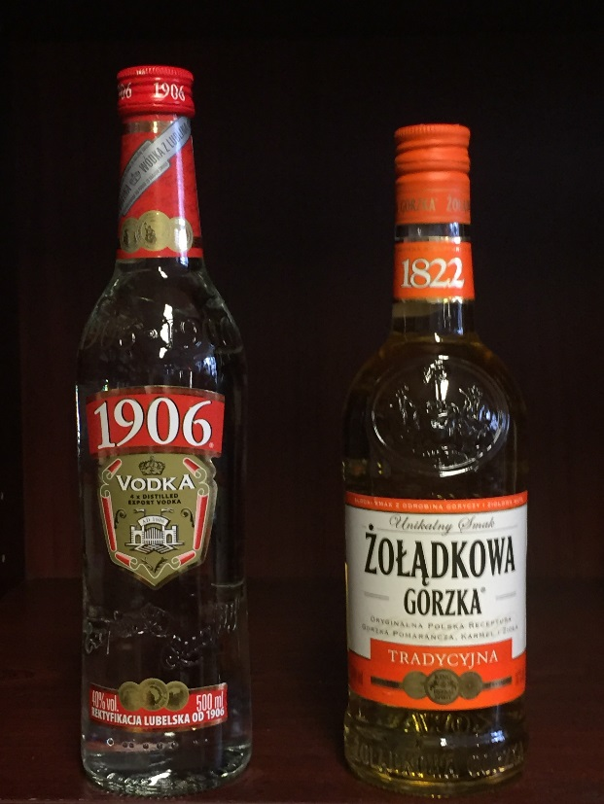

Source: Case authors’ photograph.

Exhibit 3: Financial data for Polmos Lublin (in zł‘000)

|  |  |  |  |  |
| --- | --- | --- | --- | --- |
|  | **2001** | **2002** | **2003** | **2004** |
| Revenues | 172,460 | 231,642 | 304,775 | 337,728 |
| Operating income | 2,744 | 9,342 | 10,854 | 26,309 |
| Net income after interest | (1,103) | 8,719 | 8,727 | 23,434 |
| Net income after interest and taxes | (1,128) | 4,795 | 6,416 | 17,705 |
| Amortization | 1,652 | 1,486 | 1,994 | 2,971 |
| EBIDTA | 4,396 | 12,828 | 12,848 | 29,280 |
| Assets (including intangible assets) | 54,809 | 106,280 | 95,306 | 175,995 |
| Equity | 22,790 | 28,585 | 37,002 | 66,149 |

Note: zł = PLN = Polish zloty; € = euro; €1 = zł3.67 in 2001, zł3.83 in 2002, zł4.39 in 2003, and zł4.50 in 2004; EBIDTA = earnings before interest, taxes, depreciation, and amortization.

Source: Polmos Lublin, Prospectus: Initial Public Offering, 2004.

Exhibit 4: Typical small alcoholic beverages retail store in Poland

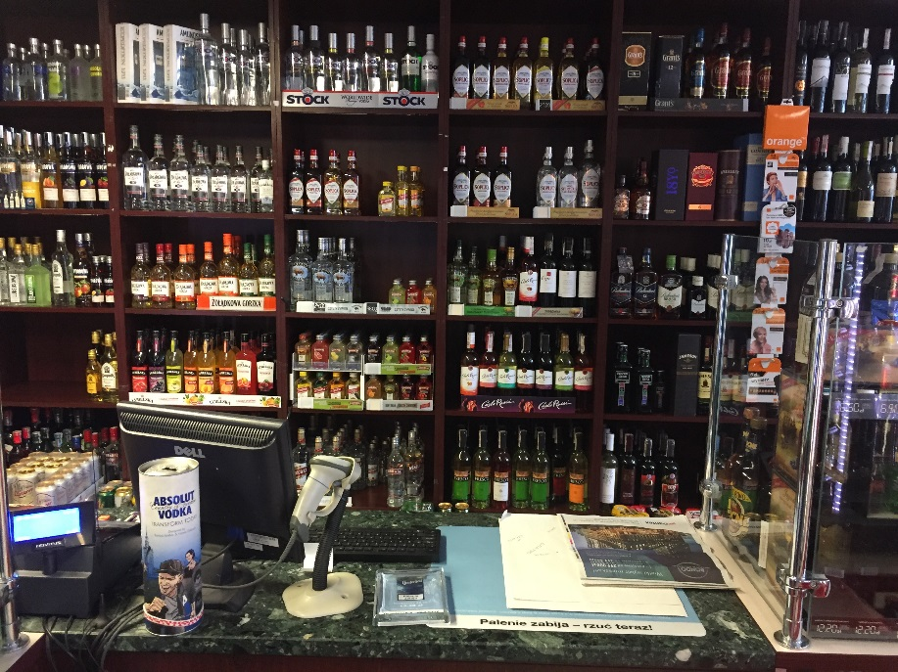

Source: Case authors’ photograph.

Exhibit 5: Analysis of Polmos Lublin’s strengths and weaknesses

(as performed by the in-company task force, 2004)

|  |  |  |  |
| --- | --- | --- | --- |
|  | **STRENGTH LEVEL** | | |
|  | LOW | MEDIUM | HIGH |
| Brand recognition |  |  | X |
| Merchandising and distribution support |  | X |  |
| Scope of offering | X |  |  |
| Numerical distribution |  | X |  |
| Weighted distribution |  | X |  |
| Quality of product |  | X |  |
| Production scale | X |  |  |
| Machinery and installations | X |  |  |
| Capacity utilization |  |  | X |
| Technology |  | X |  |
| Relations with vendors |  | X |  |

Note: *Numerical distribution* indicates the percentage of all retail outlets that sold spirits in which the company’s products were present. Polmos Lublin used *weighted distribution* as a measure of the distribution reach, weighted by the importance of the particular retail system or outlet in the total sales of spirits.

Source: Company documents.

1. Companies in Poland typically had a dual structure of governance: a supervisory board, chosen by the company’s stockholders to govern the company and hire and supervise the executive directors, and an executive or management board, composed of the hired executive directors (including the company director or chief executive officer), responsible for delivering the strategic plan and managing operational issues. Alcoholic beverages—beer, wine, cider, and liquor—were made by fermenting grain, fruit, or vegetables. *Liquor*, also referred to as *spirits*, was an alcoholic beverage that had been distilled—a process following fermentation to remove diluting components such as water to increase the proportion of alcohol in the beverage.
2. The direct translation from the Polish version of the brand (Żołądkowa Gorzka) would be Stomach Bitter— a name without much literal sense in English or Polish. Throughout the case we use Bitter to denote this brand.
3. All dollar amounts are in US$ unless otherwise specified.
4. At the time discussed in the case, beer was the largest component of the alcoholic beverages market in terms of value (approximately 50 per cent), then liquors (approximately 42 per cent), and finally wines (approximately 8 per cent). There were different producers in each segment and some overlap in distribution of liquors and wines. Polmos Lublin operated almost solely in the liquor segment of the market.
5. Polmos Lublin Prospectus, Warsaw 2004, ch.5. The prospectus was approved by PFSA (Polish Financial Supervision Authority) before the initial public offering.
6. HoReCa referred to the International Union of National Associations of Hotel, Restaurant, and Café Keepers; *horecas* were establishments that prepared and served food and beverages.
7. zł = PLN = Polish zloty; € = euro; US$1 = zł3.7617 on June 30, 2015.
8. US$1 = €0.8984 on June 30, 2015.