

9B17M105

success tastes bitter: POLMOS LUBLIN (c)

Krzysztof Obloj and Tomasz Obloj wrote this case solely to provide material for class discussion. The authors do not intend to illustrate either effective or ineffective handling of a managerial situation. The authors may have disguised certain names and other identifying information to protect confidentiality.

*This publication may not be transmitted, photocopied, digitized, or otherwise reproduced in any form or by any means without the permission of the copyright holder. Reproduction of this material is not covered under authorization by any reproduction rights organization. To order copies or request permission to reproduce materials, contact Ivey Publishing, Ivey Business School, Western University, London, Ontario, Canada, N6G 0N1; (t) 519.661.3208; (e)* [*cases@ivey.ca*](mailto:cases@ivey.ca)*;* [*www.iveycases.com*](http://www.iveycases.com)*.*

Copyright © 2017, Richard Ivey School of Business Foundation Version: 2017-07-07

It the middle of summer, 2005, Marek Malinowski, the new chief executive officer of Polmos Lublin, presented his strategy of renewal to three people: Waldemar Wasiluk, chief financial officer, and two supervisory board members. Malinowski’s plan addressed all of the company’s recent challenges:

* Resolve immediately the conflict over distribution with Central European Distribution Corporation (CEDC). One of the board members noted, “[CEDC] should realize that after their acquisition of Polmos Bialystok, we are no longer any threat to them. They are the market leader.”
* Respond to Sobieski Company’s (Sobieski’s) challenge using their own strategy: introduce an even cheaper substitute to Balsam Pomorski with a similar name, *Balsam Kresowy*. This would squeeze Balsam Pomorski between the higher priced and still powerful Bitterand the new and even cheaper Balsam Kresowy.
* Restore the full strength of the company’s core product, Bitter, and its previously introduced flankers (offerings of Bitter in different tastes, e.g., with mint or honey) by working with the traditional distributors and retailers, thus bypassing distribution controlled by CEDC and Sobieski.
* Pursue a more aggressive strategy with the brands Bison and 1906in the growing economy segment of pure vodkas. The pure vodka market was roughly seven times larger than the flavoured vodkas market, and the main producers had no incentive to engage in a price war with smaller companies.
* Introduce premium products in both the pure and flavoured vodka segments. Even with small sales, the premium segment offered large margins and would use some of the company’s excess capacity.

Later, when Malinowski recalled the execution of his plan, he noted that a clear focus changed everything:

We performed classic moves. We focused on sales, sales, and sales. When we lowered the price of pure vodkas, they started to sell well. The large producers did not react because, for them, we were just marginal in this segment. But for us, it was a big deal in two ways. First, we gained some economies of scale by using new excess capacity. Second, in addition to sales of our pure vodkas, we worked with distributors and retailers on the renewal of Bitter’s position. I personally visited all distributors and many retail outlets. We persuaded them that flankers of Bitter were a good and innovative idea. As the results improved, people became more optimistic and business partners more helpful.

The new strategy worked wonders. In spite of a mediocre first half of 2005, the company completed the year with solid revenues of zł349,304,000 (€86,820,000),[1] and operating profits of zł10,562,000 (€2,627,363). 2006 was very successful for Polmos Lublin. The revenues exceeded zł560 million (€143 million) and operating profits doubled to over zł21 million (€5.5 million).[2] Sales of pure vodkas grew considerably; their share of the company’s total volume of sales was 40 per cent (compared to 10 per cent in 2004). Subsequently, the company’s share of the total market volume grew from 5.5 per cent to 9.7 per cent in just one year. Polmos Lublin clearly dominated the flavoured vodka segment again with a 35 per cent market share and a restored profitable growth pattern.

These trends caught the interest of Oaktree Capital Management (Oaktree), which was using its equity fund to buy mid-size producers of alcoholic beverages in Central and Eastern Europe. Its plan was to consolidate the producers and sell the group to one of the global industry leaders. After brief negotiations, Oaktree bought a large portion of Polmos Lublin’s shares in 2006. In 2007, Oaktree bought the rest of the shares and delisted the company, making it private once again.

Malinowski recalled something Karim Khairallah, an Oaktree representative, had said during a discussion with the management board:

You did very well last year. But we bought the company to grow it. You are here and we want you to be three times larger. So what is the plan for the growth of the company? Ah, and don’t mind the costs, we’ll recover them in the long run.

It was an epiphany for Polmos Lublin’s management board. After a full night’s meeting, the board came back with a plan to enter the pure vodka market with the Bitter brand. The idea was not completely new in the company, but it had never been seriously considered. Risks related to brand equity had been too difficult to evaluate, costs could be high, and, importantly, no one had ever moved brands between segments.

Once the decision was made, preparations followed. Focus groups were used to establish the taste profile of the new vodka, which was another innovative approach in the marketplace. It took almost a year to develop the new, original taste, which was a bit sweeter than traditional Polish pure vodkas and closer to the taste of traditional Ukrainian vodka. The chosen name was *Czysta de Luxe Zoladkowa Gorzka* (Pure Bitter de Luxe), drawing on linguistic research that showed that the phrase *de luxe* connoted luxury and high quality. The new product was priced at zł18 per bottle (approximately €4), which positioned it slightly below the average price in the mainstream segment. However, the bottle and labels were designed to place the product in the upper tier of this segment (see Exhibit 1). Finally, the decision was made to introduce the new product through traditional distribution and retail channels (small and medium-size shops), thus bypassing powerful distributors and retailers such as CEDC and Sobieski.

Pure Bitter de Luxe made its debut in 2008. It was an instant hit and rode the waves of a growing market (see Exhibit 2). Malinowski recalled the successful entry of the new brand:

We were an underdog. We persuaded everybody that we had a better vodka. It was different, period. But we persuaded everybody that it was new, different, *and* better. And the market started to support us. Distributors were happy that we gave them the new product. Traditional retailers loved the new product that looked elegant, was not expensive, and could not be bought in supermarkets. Both sets of actors therefore promoted it heavily. After two months, we knew that we had a winner. It simply disappeared from the shelves. Large retailers were knocking on our doors to get the product as well. Sales grew like crazy and my only worry was to produce and keep the taste profile intact. In 2009, the product became the market leader in Poland, and we moved from fourth to second position in terms of total market share. Of course, large players reacted with time. Sobieski launched Krupnik Pure vodka, and its parent company Belvedere [Distribution Company] hired Bruce Willis to promote the Sobieski vodka brand globally. CEDC put Pure Zubrowka on the market, a new version of their leading brand Absolwent, and a new premium brand, Palace. But it was too late. In 2010, we overtook both of them and became a market leader.

Polmos reinforced the success of Pure Bitter de Luxe with two additional bold strategic moves. In 2009, it introduced a new luxury pure vodka, Stock Prestige, and decided to invest more effort and attention in its Lubelskie brand, an economy-segment flavoured vodka. Malinowski explained:

After the success with Old Bitter Pure, we decided to dominate all segments. We had Stock Prestige in the upper segment of pure vodkas and introduced new tastes of the economy flavoured vodka Lubelskie that became hugely successful, especially the lemon flavour, completely new in Poland.

Thanks to these moves, Polmos had pure and flavoured vodkas in all segments, from the premium to the economy (see Exhibit 2), and gained huge strategic momentum. Large players reacted but it was too late. Polmos became an incontestable market leader and started to increase its lead every year. In 2013, Oaktree listed their consortium of alcoholic beverages companies on the London Stock Exchange under the name *Stock Spirits*. By 2014, the Polmos Lublin branch of the company reigned over the Polish liquor industry with approximately 35 per cent of the total market share (see Exhibits 2 and 3).

Exhibit 1: The original, Flankers, and new Gorzka Brands

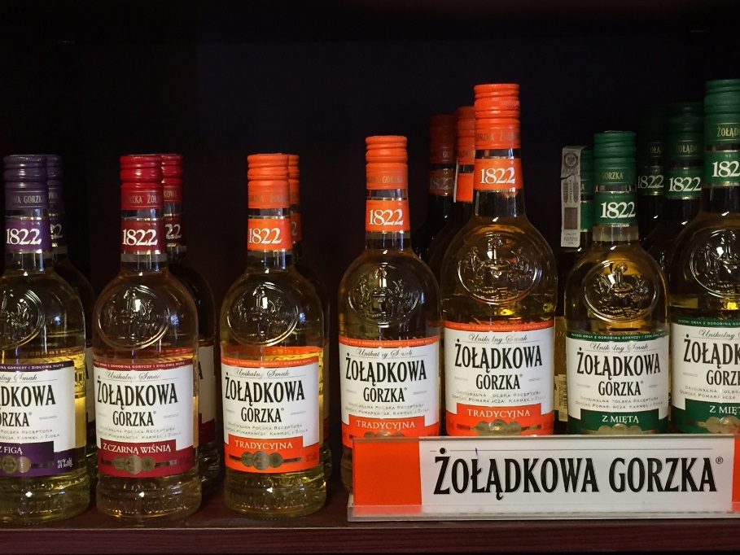

Figure 1: Brand labelling for the original Bitter brand (Zoladkowa Gorzka), and its flankers.

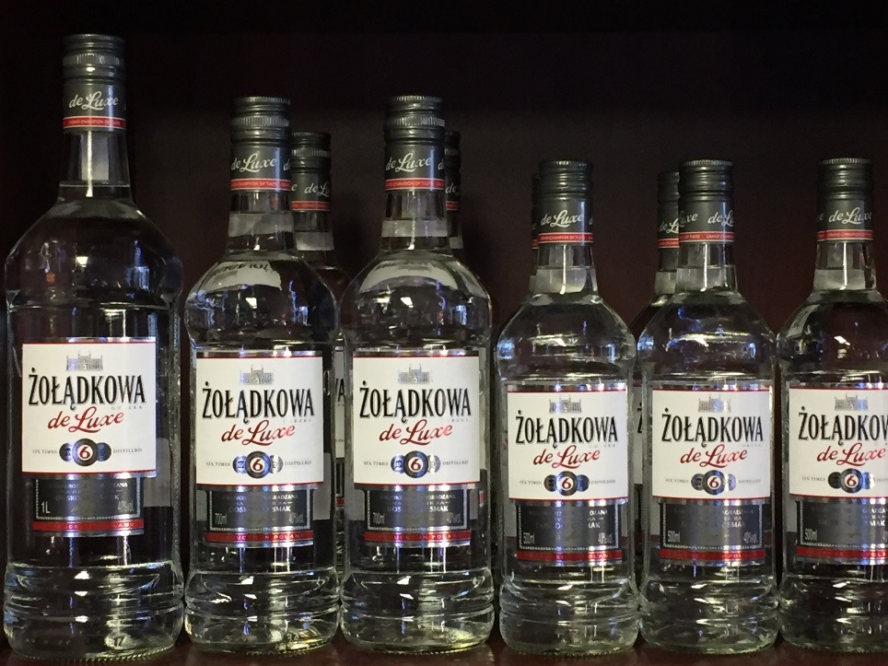

Figure 2: Brand labelling for the new Pure Bitter de Luxe (Pure de Luxe Zołądkowa Gorzka).

Source: Case authors’ photographs.

Exhibit 2: Sales of Polmos Lublin Brands and CEDC’s Balsam Pomorski, 2008–2014

(in million litres)

|  |  |  |  |  |  |  |  |
| --- | --- | --- | --- | --- | --- | --- | --- |
|  | **2008** | **2009** | **2010** | **2011** | **2012** | **2013** | **2014** |
| Total Sales | 54.6 | 94.8 | 122.5 | 105.9 | 106.8 | 116.7 | 108.3 |
| *Flavoured Vodkas* | *22.8* | *23.6* | *31.5* | *32.3* | *34.2* | *39.2* | *41.4* |
| Bitter | 17.1 | 16.5 | 15.6 | 12.0 | 11.9 | 13.3 | 12.6 |
| Balsam Pomorski | 0.9 | 1.1 | 1.2 | 1.0 | 0.9 | 0.8 | 0.8 |
| STOCK 84 | 0.2 | 0.4 | 0.5 | 0.4 | 0.5 | 0.6 | 0.7 |
| Lubelskie (economy segment) | 4.4 | 5.3 | 13.8 | 17.7 | 19.8 | 22.2 | 22.5 |
| Others | 0.2 | 0.3 | 0.5 | 1.2 | 1.2 | 2.3 | 4.8 |
| *Pure Vodkas* | *31.8* | *71.1* | *91.0* | *73.6* | *72.6* | *77.5* | *67.0* |
| Stock Prestige | 0 | 1.6 | 8.8 | 7.2 | 7.6 | 8.9 | 7.9 |
| 1906 | 7.6 | 12.9 | 14.9 | 14.5 | 13.3 | 13.5 | 10.7 |
| Żubrówka | 4.4 | 7.1 | 8.2 | 9.0 | 8.2 | 8.4 | 7.6 |
| Pure Bitter de Luxe | 18.7 | 48.5 | 57.4 | 40.7 | 38.7 | 42.1 | 36.6 |
| Others | 1.1 | 1.1 | 1.7 | 2.3 | 4.8 | 4.6 | 4.2 |

Note: CEDC = Central European Distribution Corporation

Source: Company documents.

Exhibit 3: Market share of vodka producers, 2006–2014 (in %)

|  |  |  |  |  |  |  |  |  |
| --- | --- | --- | --- | --- | --- | --- | --- | --- |
| **Producer** | **2006** | **2007** | **2008** | **2009** | **2011** | **2012** | **2013** | **2014** |
| Polmos Lublin (Stock Poland as of 2009) | 9.7 | 11.4 | 16.4 | 28.2 | 33.1 | 34.8 | 37.6 | 37.3 |
| Central European Distribution Corporation (CEDC) | 30.5 | 29.9 | 28.1 | 26.2 | 24.1 | 23.6 | 23.0 | 28.2 |
| Sobieski Company | 29.0 | 27.6 | 23.5 | 18.2 | 20.9 | 21.3 | 17.1 | 14.4 |

Note: Because value metrics are strongly influenced by changes in price, excise, and value-added tax, the data was calculated in a physical measure of million litres to ensure comparability.

Sources: Company documents; Grupa Polmos Lublin report 2006; archival issues of Rynki Alkoholowe (Alcohol Markets).

1. zł = PLN = Polish zloty; € = euro; €1 = zł 3.89 in 2006.
2. Company financial reports. http://biznes.pap.pl/espi/pl/reports/view/2,49861, accessed on 25 May 2017.