

9B17M109

a pathway for scotiabank’s innovation: leveraging fintech partnerships

Ying-Ying Hsieh wrote this case under the supervision of Professors Jean-Philippe Vergne and Mary Weil solely to provide material for class discussion. The authors do not intend to illustrate either effective or ineffective handling of a managerial situation. The authors may have disguised certain names and other identifying information to protect confidentiality.

*This publication may not be transmitted, photocopied, digitized, or otherwise reproduced in any form or by any means without the permission of the copyright holder. Reproduction of this material is not covered under authorization by any reproduction rights organization. To order copies or request permission to reproduce materials, contact Ivey Publishing, Ivey Business School, Western University, London, Ontario, Canada, N6G 0N1; (t) 519.661.3208; (e)* [*cases@ivey.ca*](mailto:cases@ivey.ca)*;* [*www.iveycases.com*](http://www.iveycases.com)*.*

Copyright © 2017, Richard Ivey School of Business Foundation Version: 2019-04-23

Financial services [are] in an era of unprecedented innovation. We are seeing fintechs taking advantage of many transformational technologies such as applied data analytics and blockchain. Scotiabank is seeking out partnerships in the global innovation ecosystem in order to create world-class customer-driven solutions.

Jeff Marshall, head of Digital Banking Canada, December 20, 2016

In February 2017, Kevin Stewart, Scotiabank’s vice-president, digital enablement, was sitting in his office at Scotiabank’s Digital Factory in downtown Toronto. Stewart was reflecting on his recent introduction to the financial technology (fintech) company Kabbage Inc. (Kabbage), and on how successfully the partnership was progressing. Stewart was considering what opportunities the bank should pursue next, specifically in the area of blockchain.

According to Jeremy Pallant, Scotiabank’s vice-president, retail and small business products, “the Kabbage partnership has helped us address gaps in both Canada and Mexico by digitizing small business lending to convert it to be more cost effective with a superior customer experience.” It also provided a very valuable learning experience for the digital banking leadership to use as a model.

The Scotiabank–Kabbage partnership provided a valuable guideline for future partnerships. At the partnership’s launch, James O’Sullivan, group head of Canadian banking at Scotiabank, said that the partnership with Kabbage set “an example of how banks and fintechs are working together to provide customers with a better banking experience.” Scotiabank’s top management certainly aspired to replicate this success story in other sectors and geographic markets.

**SMALL BUSINESS CUSTOMERS: FINTECH OPPORTUNITIES**

**Opportunities for Innovation in Small Business Lending**

Historically, small business lending was challenging for banks worldwide. Banks developed robust deposit and cash-management value propositions for small businesses but were not lending to them as frequently.[1] For example, in Canada, small businesses employed more than 8.2 million Canadians and represented 97.9 per cent of employers; however, borrowing had been falling continuously since the first quarter of 2016.[2] It was estimated that more than 80 per cent of Canadians financed their businesses using personal financing because of their lack of credit history or collateral to secure a loan.[3]

The situation was comparable in other countries such as Mexico, where Scotiabank had established a strong presence. In Mexico, small businesses accounted for 40 per cent of the country’s gross domestic product in 2014, but over 90 per cent of the five million enterprises were small businesses, according to the National Institute of Statistics and Geography.[4] Only 12 per cent of the small businesses in that country were granted loans from financial institutions, and only 8 per cent of medium-sized businesses received loans. Mexico’s figures were much lower than Brazil’s (43 per cent of small businesses and 68 per cent of medium-sized businesses) and Chile’s (65 per cent of small businesses and 62 per cent of medium-sized businesses).[5]

Traditionally, when Scotiabank issued loans to small businesses, the bank relied on paper-based manual adjudications and often took a week to process the loan. The bank also tended to target larger loans. However, in Mexico, this excluded a large number of applications, according to Stewart.

In addition, although the country had a credit bureau, “it did not contain a lot of information on small businesses,” Stewart noted. Assessing credit risk in developing countries such as Mexico was difficult, causing information asymmetry that could hinder a bank’s ability to lend.[6] These challenges made small business an attractive market for fintech companies, especially those businesses leveraging transformative technology.

**Scotiabank and Kabbage**

Scotiabank had 120,000 small business customers in Mexico. Stewart noted that “these customers have CA$2 billion[7] in deposits with us but limited loans—there was so much opportunity to help them grow their businesses.” Stewart felt that the bank was ready to scale this business and find creative ways to meet the challenge. Therefore, he decided to look at fintech firms. In May 2015, Stewart held the position of vice-president of international small business. Together with Pallant, Stewart travelled to Atlanta, Georgia, to visit Kabbage, a fintech company that had been successful at providing small business loans to U.S. customers.

According to Stewart, Scotiabank had previously dealt mainly with large institutions. The 185-year-old bank, the third largest in Canada, had 90,000 employees and 23 million customers and operated in approximately 50 countries.[8] For a major financial institution of that calibre, the prospect of partnering with a recently established, 200-person operation seemed unlikely. Stewart was unsure how this adventure would unfold.

Stewart and his colleagues met with Kabbage’s chief executive officer, Robert Frohwein, and the company’s chief financial officer, Kevin Phillips, as well as several risk officers. They toured the Kabbage operation and listened to a persuasive presentation that explained how the product and business model worked. Stewart and his colleagues were impressed. They decided that this was the type of firm Scotiabank needed to work with.

Their efforts came to fruition in June 2016, when Scotiabank announced a technology licensing partnership with Kabbage in Canada and Mexico. The Kabbage partnership created a new approach to small business lending, as Pallant explained:

Kabbage’s agile test-and-learn approach and use of non-traditional data and advanced analytics has proven to us that fully digitized lending is realizable for small business, in an economical way, which creates huge value for the client (in terms of turnaround times and convenience) and the bank (in terms of lower cost process and wider market presence).

The potential for great returns, as well as the promising early signs of growth, were encouraging. However, the initiative was still in its early days. According to Kabbage, the goal was to scale the platform over three years.

Beyond the business benefits, the learning experience had already proven valuable. Jeff Marshall, head of Digital Banking Canada, identified several major benefits arising from the partnership. Scotiabank gained the opportunity to learn how to work with a fintech partner. The bank was also able to test and learn an innovative way to lend money to small businesses and to catalyze broader customer experience improvements.

**Future Opportunities**

Scotiabank was eager to explore new partnership opportunities. Fintech partnerships could help resolve some the everyday issues small businesses encountered by “offering a holistic package of accounting, marketing, and bookkeeping services,” explained Haijin Lee, director of innovation at the Digital Factory.

Small businesses routinely suffered working capital and production constraints when buying and selling goods. Multiple parties were involved, including shippers, government entities, and insurance companies. As well, information and processes were fragmented, making the movement of goods inefficient and cumbersome.

To address these issues, fintech companies began exploring the blockchain digital database system as a means to provide all parties visibility into a common ledger and shared information. This process could significantly remove friction, improve operations, and increase transparency. Fintech companies also built ancillary financing capabilities and combined other technologies such as geo-tracking via the Internet of things to further enhance the value proposition.

**THE FINTECH DISRUPTION**

Fintech firms used new technologies such as blockchain, applied analytics, and machine learning algorithms to enhance the efficiency and performance of financial services. According to the Goldman Sachs Group investment firm, “over US$4.7 trillion of revenue at the traditional financial services companies [were] at risk for disruption by the new, technology-enabled entrants. Assuming a 10 per cent profit margin implies a US$470 billion total profit pool at risk [globally].” More specifically, fintech companies were looking for opportunities in a wide range of sectors including crowdfunding, wealth management, payments, and lending.[9] It was estimated that more than 20 per cent of financial services businesses were at risk for disruption by fintech competitors.[10]

As outlined in a World Economic Forum report on small business lending, marketplace lenders provided a good example of the disruptive nature of fintech companies. Marketplace lending entailed “lending money to borrowers without going through a traditional financial intermediary such as a bank.”[11] There were several reasons for the disruptive advantages that marketplace lenders enjoyed. First, marketplace lenders mostly operated based on unsecured lending that required no collateral. Second, they generally had a greater risk appetite involving various sources of investors. Third, they used proprietary data analytics technology for innovative credit scoring models. Data could come from all sources, such as social media or satellite data, which was not typically used by traditional banks. Fourth, marketplace lenders operated with lower operational costs, such as overhead and fixed costs. Finally, they were not subject to the same level of regulatory compliance requirements as banks. Therefore, they were better able to enjoy cost and speed-to-market advantages.[12] Overall, a successful marketplace lending model relied on the environment (i.e., regulations, data, and infrastructure), actors (i.e., borrowers, investors, and platforms), and a process facilitator (e.g., intermediating parties, third-party service providers, or corporate partnerships) that played a supporting role to connect all parties together (see Exhibit 1).[13]

**Fintech as a Global Phenomenon**

The rise of the fintech industry was a global phenomenon.[14] The industry had doubled in size between 2014 and 2015 and represented more than 1,000 start-ups with US$105 billion in funding and US$867 billion in value.[15] Innovations were found across many product and customer segments (see Exhibit 2). Fintech hub countries, such as the United States, Canada, the United Kingdom, China, Singapore, Switzerland, and Australia, had the highest fintech investment and customer adoption rates.[16] Fintech companies were finding success in countries where regulations were less restrictive and more welcoming to innovations. For example, the United Kingdom and Singapore had friendlier regulatory environments than other countries. The United States and Switzerland were also planning to issue national charters, or special banking licences, to allow fintech companies to offer banking services.[17] Latin America was an emerging market of opportunities for fintech companies, which could import proven global business models and customize them for each region.

**Blockchain and Distributed Ledgers**

Blockchain technology, with its distributed ledgers, was a big area of focus for fintech companies and the financial services industry in general. In simple terms, a blockchain was a distributed database “comprised of unchangeable, digitally recorded data in packages called blocks.”[18] Each block contained a timestamp and a link to the previous block. The records “are saved by each node in the network, which is owned, maintained, and updated by each node. It’s a peer-to-peer system. No central authority manages the transaction flow.”[19] Blockchain was first used in 2009 as the underlying technology for bitcoin. Although the terms “blockchain” and “distributed ledger” were sometimes used interchangeably, blockchains actually formed a subset of the broader category of distributed ledgers.

Open or closed, distributed ledgers could “record transactions between two parties efficiently and in a verifiable and permanent way,”[20] and could be programmed to execute transactions automatically. A set of protocols enabled the participants to collectively form a consensus on changes to the ledger, without the need for a central party. As a result, distributed ledgers (including blockchains) enabled a shift from centralized models (see Exhibit 3) with intermediaries, to decentralized models for the secure recording and value transfer of digital assets (e.g., loans, bonds, equity).

Blockchain and distributed ledgers were rapidly emerging technologies with the potential to transform financial markets. Sukrit Handa, a software developer at Scotiabank’s Digital Factory, explained that “maybe the industry thought cross-border payments would be the first use case to leverage blockchain, but they’re starting to actually see broader opportunities including capital markets.” For example, another exciting opportunity was trade finance, a segment with a huge potential for efficiency improvements. “The biggest challenge for trade finance was that there were a lot of parties involved: there’s the shipping, the port, there’s customs, there’s insurance,” stated Handa. Financial institutions, central banks, and financial market infrastructure firms globally were all actively researching and applying the technology to understand how it could be leveraged to change business models. Investments were growing significantly, with estimates ranging from $1 billion to $1.5 billion in 2016.

**SCOTIABANK’S DIGITAL FOOTPRINT**

Scotiabank had acted early to take advantage of digital banking. In 2012, Scotiabank acquired ING Bank of Canada—later known as Tangerine—a leading provider of online banking in Canada. In 2014, Tangerine was the first Canadian bank to launch biometric authentication through the trademarked technology Voice Banking and Touch ID.[21] In 2015, Scotiabank launched the first of its Rapid Labs to digitally transform products and services through lean and agile methodologies.[22] In the same year, Scotiabank launched the Digital Factory, a technology centre where innovation was used to redesign the customer experience.

Marshall believed that fintech start-ups were not intended to exist in conflict with banks, but rather “share the common goal of providing a better banking experience.”[23] These new teams, based on communities of practice, were composed of software designers, programmers, and product designers who worked together with research and development teams. The Digital Factory could play an incubating role in the development of external partnerships. Similar facilities were launched in Mexico, Peru, Chile, and Colombia. Within the Digital Factory, there was a dedicated team focused on research and development on blockchain and on distributed ledgers in general. The team was struck to identify and conduct proofs of concept and to better understand the business model benefits for this emerging technology.

**FUTURE POSSIBILITIES: PARTNERSHIP MODELS FOR BANKS AND FINTECH COMPANIES**

Increasingly, large banks were joining forces with fintech companies to address emerging needs from existing customers. However, all partnerships were not created equally, and various partnership models emerged for licensing contracts (e.g., technology licensing, referral agreements), capital investment, non-equity alliances, joint ventures, and acquisition.

**Licensing Contracts**

As the Scotiabank–Kabbage partnership showed, fintech firms often licensed technologies to financial institutions. Under the technology licensing model, there could be variations in arrangements for market presence. For example, Scotiabank was the brand facing the customers, with Kabbage’s logo displayed only as a technology provider operating in the background. Other banks worked with fintech companies under referral agreements that divided the responsibility for small business lending applications between the bank and the fintech company. In some cases, branding became more common, where customers would be referred to and serviced directly by the fintech firm’s website to apply for the loan.

Licensing had been a prevalent partnership model in small business lending and other sectors. In 2015, JPMorgan Chase & Co. worked with OnDeck Capital in the United States to serve its 4 million small business customers.[24] The product carried the JPMorgan Chase & Co. brand and aimed to provide faster loan approvals based on non-traditional data for credit assessment.[25] Working differently from Kabbage, OnDeck did not put up any capital, but sold off loans to investors.[26] Ripple, a fintech start-up, developed a protocol facilitating transactions across distributed ledgers and licensed its software to various banks (e.g., Banco Santander SA, UniCredit SpA, and UBS). Ripple later added new banking partners including Standard Chartered PLC and Shanghai Huarui Bank Co. Ltd.[27]

Fintech partnerships were not limited to large banks and small start-ups. For example, Microsoft licensed its Azure cloud platform to Bank of America Corporation in support of a trade finance application. ICICI Bank, India’s largest private sector lender, also partnered with Emirates NBD, a banking giant in the Middle East, to test a cloud-based distributed ledger.

Licensing partnerships for blockchain and distributed ledger technology were mostly at the proof-of-concept stage—scenarios were tested and validated before a full adoption. Large-scale commercialization had not yet taken place in this sector, perhaps because there was more ambiguity in the regulatory environment, especially when it came to the use of bitcoin and cryptocurrencies.[28]

**Capital Investments**

Traditional banks also funded fintech start-ups directly to gain a foothold in the space. According to a report by KPMG and CB Insights, the banks’ corporate venture capital arms had been leading the game in fintech investment. Corporate venture capitals consisted of 25 to 33 per cent of the investments in the second and third quarters of 2016.[29]

Goldman Sachs, Citigroup, and Banco Santander were among the most active fintech investors.[30] Goldman Sachs’s fintech investments covered a diverse range of sectors and geographic markets, including the Asian financial product comparison platform CompareAsia, the payment software Circle Internet Financial, and a Canadian point-of-sale start-up called Financeit.[31] For Citigroup, Citi Ventures invested in the Canada-based invoice funding start-up Blue Vine, a U.S.-based multinational working capital marketplace firm called C2FO, the permissioned ledger infrastructure firm Chain Inc., and various big data analytics start-ups.[32]

According to Alex Manson, global head of transaction banking at Standard Chartered, the British financial institution made a strategic investment in Ripple, aiming to “co-develop commercially viable applications to support the evolving needs of our clients and their ecosystems.”[33] The bank also invested in Socure, a biometrics firm that developed technologies for identity verification, and in SigFig, which offered guidance and best practices for wealth management.[34]

Investments served as great avenues to understand fintech. When the markets, technology, and regulatory levels faced high uncertainty, investing in fintech companies broadened the scope of future opportunities for banks.

**Non-Equity Alliances**

Non-equity alliances emphasized mutual benefits resulting from two parties bringing in complementary competencies and resources. At the time, most fintech alliances were concentrated in the business-to-consumer market. Two examples were the partnership between the start-up Simple and the Spanish bank Banco Bilbao Vizcaya Argentaria SA, and the partnership between Earthport and Bank of America. Fewer alliances were formed in the business-to-business market.[35] Standardized regulatory environments fostered a welcoming environment for alliances.[36]

Often, alliances were forged to establish relevance in a global ecosystem. For example, the Scotiabank and QED Investors partnership focused on those Latin American countries where Scotiabank was planning to grow its business (i.e., Mexico, Chile, Colombia, and Peru). The alliance was also designed to leverage both parties’ expertise. “QED Investors brought a wealth of industry experience to the table, including a deep understanding of the digital selling-space, cards, digital marketing, and lending,” explained Lee. The joint investment would create a venture capital platform that identified partnership opportunities.

**Joint Ventures**

A joint venture (JV) entailed “a business arrangement in which two or more parties agree to pool their resources for the purpose of accomplishing a specific task.”[37] JVs between banks and fintech companies were less common than JVs between multiple banks or multiple start-ups. In some cases, JVs were formed between governmental agencies. For example, Singapore’s Monetary Authority of Singapore formed a blockchain JV to explore opportunities in digital payments with an Indian region, represented by the Government of Andhra Pradesh.[38]

Other JV examples included the alliance between the Spanish bank Banco Santander and the British fintech company Monitise, which specialized in mobile money. They formed a 50:50 JV, managed by Santander and chaired by Monitise founder Alastair Lukies. This London-based JV would explore investment opportunities in Europe and Latin America. Interestingly, a licensing agreement was attached to the JV, granting Monitise a multi-million pound licence fee. Santander would have access to Monitise’s cloud-based platform that connected the bank with customers’ digital innovations.[39] Overall, JVs, which normally entailed very specific goals, had not been a common practice between banks and fintech companies.

Joint partnerships in the form of consortia had also been formed among banks. The most well-known large-scale joint project in fintech was R3 Limited (R3), “a consortium partnership with over 75 of the world’s leading financial institutions, [working] together to design and deliver advanced distributed ledger technologies to the global financial markets.” Formed in September 2015, R3 developed the Corda platform, designed to record, manage, and automate agreements between businesses.[40] Scotiabank was a member of R3 and contributed to the Corda code base.

**Acquisitions**

Ideally, an acquisition could give banks full control over the technological solution. However, acquisitions had not become as common as licensing or investment due to the greater uncertainty and risk they entailed. More fintech acquisitions were expected once start-ups passed the “testing stage.”[41]

The Spanish bank Banco Bilbao Vizcaya Argentaria, one of the first banks to acquire fintech companies,[42] bought Openpay, a Mexican online payment start-up;[43] Holvi Payment Services Ltd., a Finnish start-up; Spring Studio, a San Francisco-based UX design firm; Madiva Soluciones, a large data start-up; and Simple, a U.S. wealth management start-up.[44] Among other acquisitions, Standard Bank acquired Firepay in 2016;[45] PayPal acquired Xoom Corporation, an international money transfer services firm, in July 2015;[46] MasterCard acquired Pinpoint.GS in April 2014 and APT Systems, Inc. in May 2015; Visa bought TrialPay Inc. in Feb 2015; and TD Ameritrade acquired thinkorswim in April 2009.[47]

**Determining Factors for Partnership Models**

Determining how a bank should partner with a fintech company depended on various factors—both internal (between partners) and external (outside of the partnership). Internally, the overall compatibilities between the two firms in terms of technology, structure, culture, and brand all played an important role.[48] In the Scotiabank–Kabbage partnership, executive-level sponsorship was crucial to ensure that culture and vision were aligned between the two companies. According to one of the Kabbage executives, “You have to have that executive-level sponsorship. A lot of times, these things are very challenging for an organization of the bank’s size, so they have to be willing to challenge the status quo.” A lack of compatibility would increase costs of coordination and communication.

Externally, there was a question of whether customers knew or trusted the fintech brand. Ensuring accountability to the customer was critical to success. Different countries and regions varied in their regulatory frameworks, market demands, and institutional configurations. More validated success stories were seen in some fintech sectors such as lending, whereas technological uncertainty was still high in others such as blockchain.

**DECISION**

As Stewart reflected on Scotiabank’s early partnership with Kabbage, he knew that some of the learning outcomes from that partnership would benefit the bank’s approach for other fintech partnerships—especially in the all-important area of blockchain and distributed ledgers. Stewart wondered if Scotiabank should replicate the Kabbage partnership model and enter into exclusive arrangements in the blockchain sector. He also wondered if the bank should instead limit its efforts to activities within the R3 consortium or look for other consortia. How much investment should the bank make directly through the Digital Factory team, he wondered. Stewart knew that blockchain and distributed ledgers could be a game changer, and his experience with Kabbage made him an obvious choice to lead the bank’s efforts. But how should he proceed from there? The next steps would be essential to supporting the bank’s strategic agenda (see Exhibit 4) and digital vision (see Exhibit 5).

EXHIBIT 1: ENABLING FACTORS FOR MARKETPLACE LENDING



Source: Prepared by the authors with information from World Economic Forum, Global Agenda Council on the Future of Financing & Capital, *The Future of FinTech: A Paradigm Shift in Small Business Finance,* October 2015, accessed February 16, 2017, www3.weforum.org/docs/IP/2015/FS/GAC15_The_Future_of_FinTech_Paradigm_Shift_Small_Business_Finance

_report_2015.pdf.

EXHIBIT 2: FINTECH INNOVATIONS BY PRODUCT AND CUSTOMER SEGMENT

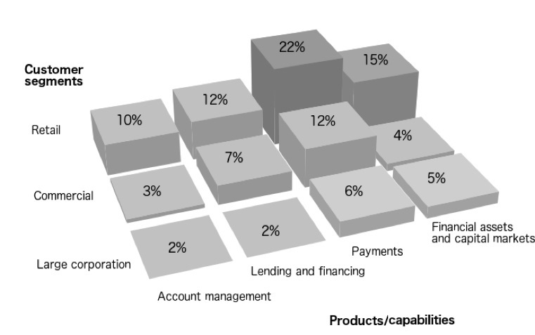

Source: Created by the authors with information from ICC Banking Commission, based on 2016 Rethinking Trade & Finance: An ICC Private Sector Development Perspective, accessed February 16, 2017, http://store.iccwbo.org/content/uploaded/pdf/ICC_Global_Trade_and_Finance_Survey_2016.pdf.

EXHIBIT 3: THE BLOCKCHAIN MODEL



Source: Company files.

EXHIBIT 4: SCOTIABANK’S STRATEGIC AGENDA

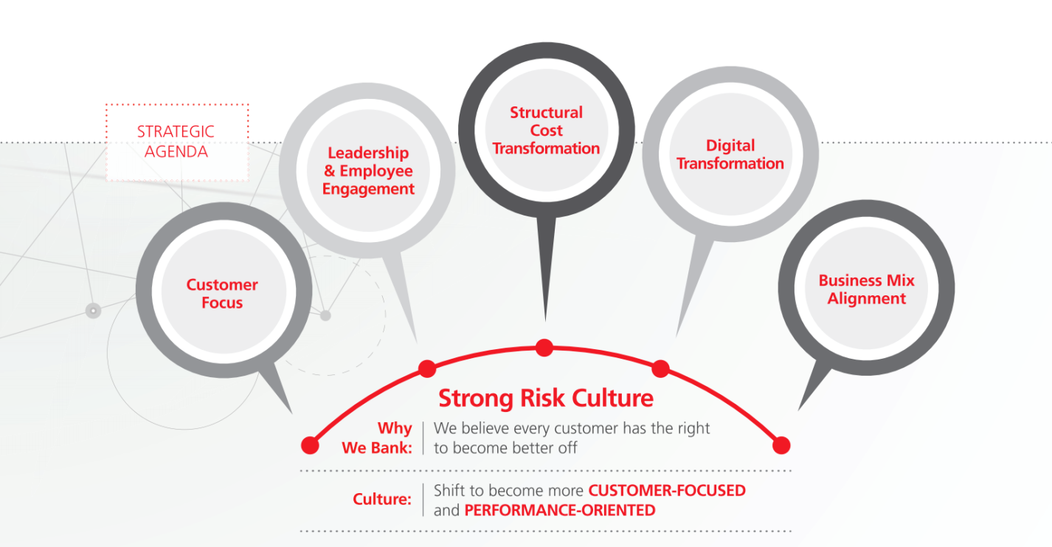

Source: Company files.

EXHIBIT 5: SCOTIABANK’S DIGITAL VISION

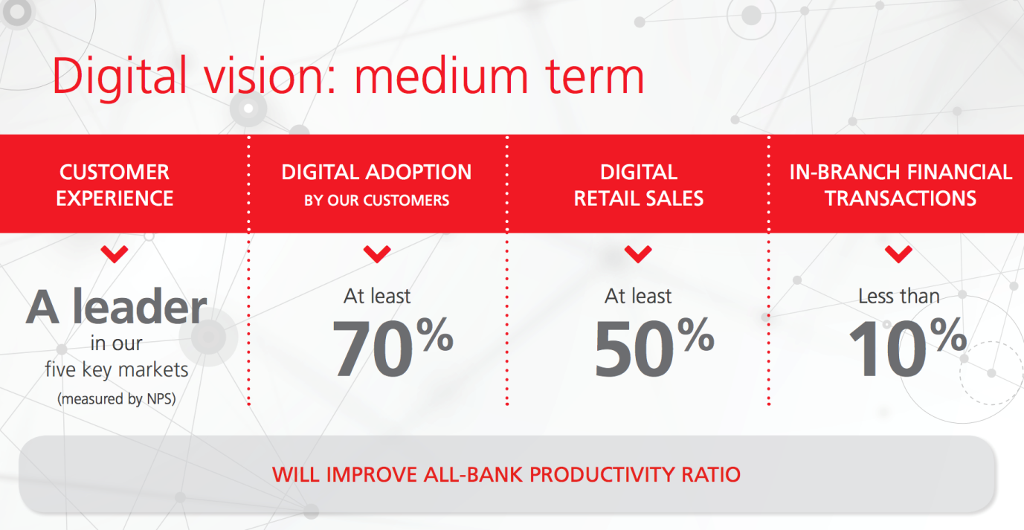

Note: NPS = net promoter score.

Source: Company files.

**ENDNOTES**

1. Erik Heirich, “Lendified Finds Niche in Serving ‘Ugly Duckling’ Segment,” *Financial Post,* April 4, 2016, accessed December 23, 2016, http://business.financialpost.com/entrepreneur/fp-startups/lendified-finds-niche-in-serving-ugly-duckling-segment.
2. Innovation, Science and Economic Development Canada, *Key Small Business Statistics: June 2016*, June 2016, accessed January 3, 2017, www.ic.gc.ca/eic/site/061.nsf/vwapj/KSBS-PSRPE_June-Juin_2016_eng.pdf/%24FILE/KSBS-PSRPE_June-Juin_2016_eng.pdf.
3. “Scotiabank and Kabbage Partner to Provide Small Business Customers with a New, Streamlined Digital Lending Experience,” Scotiabank, news release, June 22, 2016, accessed January 7, 2017, www.marketwired.com/press-release/scotiabank-kabbage-partner-provide-small-business-customers-with-new-streamlined-digital-2136528.htm.
4. Ibid.
5. “Share of Companies with Loans from Financial Institutions in Brazil, Chile and Mexico in 2011, by Company Size,” Statista, accessed December 16, 2016, www.statista.com/statistics/426372/firms-with-loans-from-financial-institutions-brazil-chile-mexico-by-size.
6. Arnaud Ventura, Michael Koenitzer, Peer Stein, Peter Tufano and Daniel Drummer, “The Future of FinTech: A Paradigm Shift in Small Business Finance,” World Economic Forum, October 2015, accessed December 8, 2016, www3.weforum.org/docs/IP/2015/FS/GAC15_The_Future_of_FinTech_Paradigm_Shift_Small_Business_Finance_report_2015.pdf.
7. All currency amounts are in Canadian dollars unless otherwise specified.
8. “Scotiabank Corporate Profile,” Scotiabank, accessed January 9, 2017, www.scotiabank.com/ca/en/0,,464,00.html.
9. Jean-Philippe Vergne and Parker Cumming, “Lending Loop: Fintech Disruption in Canadian Banking” (London, ON: Ivey Publishing, 2016). Available from Ivey Publishing, product no. 9B16M085.
10. “Blurred Lines: How FinTech Is Shaping Financial Services,” PricewaterhouseCoopers (PwC), March 2016, accessed October 10, 2016, www.pwc.com/gx/en/industries/financial-services/fintech-survey/blurred-lines.html.
11. Ventura, Koenitzer, Stein, Tufano, and Drummer, op. cit.
12. Ibid.
13. Ibid.
14. Heath P. Terry, Debra Schwartz, and Tina Sun, *The Future of Finance—Part 3: The Socialization of Finance* Goldman Sachs Global Investment Research, March 13, 2015, accessed June 22, 2017, http://docplayer.net/6624556-The-future-of-finance.html.
15. Jean Baptiste Su, “The Global FinTech Landscape Reaches Over 1000 Companies, $105B in Funding, $867B in Value: Report,” *Forbes,* September 28, 2016, accessed October 7, 2016, www.forbes.com/sites/jeanbaptiste/2016/09/28/the-global-fintech-landscape-reaches-over-1000-companies-105b-in-funding-867b-in-value-report/#7d98f7c34e86.
16. Joel Watson, “A Heatmap Showing the Investment into the World’s FinTech Hubs,” Hot Topics, accessed September 28, 2016, www.hottopics.ht/stories/finance/a-heatmap-showing-the-investment-into-the-worlds-fintech-hubs; EY FinTech Adoption Index, “Exploring a New Financial Services Landscape,” Ernst & Young Global Limited, accessed October 10, 2016, www.ey.com/gl/en/industries/financial-services/ey-fintech-adoption-index.
17. Nathaniel Popper, “Financial Technology Start-Ups to Get a License to Bank,” *The New York Times*, December 2, 2016, accessed January 8, 2017, www.nytimes.com/2016/12/02/business/dealbook/technology-start-ups-to-get-a-license-to-bank.html; J.P. Buntinx, “Switzerland to Introduce New Banking License For FinTech Startups,” NewsBTC, Bitcoin New Service, November 3, 2016, accessed January 8, 2017, www.newsbtc.com/2016/11/03/switzerland-introduce-new-banking-license-fintech-startups.
18. “Blockchain Technology Explained,” Blockchain Technologies, accessed February 16, 2017, www.blockchaintechnologies.com/blockchain-definition.
19. Alan Morrison and Subhankar Sinha, “A Primer on Blockchain (Infographic),” PricewaterhouseCoopers (PwC), accessed February 16, 2017, www.pwc.com/us/en/technology-forecast/blockchain/definition.html.
20. Ibid.
21. “Tangerine Brings the Future of Banking to Canadians with New Biometrics Offering,” Tangerine, October 1, 2014, accessed June 22, 2017, www.prnewswire.com/news-releases/tangerine-brings-the-future-of-banking-to-canadians-with-new-biometrics-offerings-277746431.html.
22. “Brian Porter Speech—March 31, 2016,” Scotiabank, news release, March 31, 2016, accessed January 15, 2017, www.scotiabank.com/ca/en/0,,10125,00.html.
23. Jeff Marshall, “Think Fintech and Banks Are Feuding? Think Again,” LinkedIn, June 21, 2016, accessed September 6 2016, www.linkedin.com/pulse/think-fintech-banks-feuding-again-jeff-marshall.
24. Hugh Son, “JPMorgan Working with OnDeck to Speed Small-Business Loans,” Bloomberg, December 1, 2015, accessed January 7, 2017, www.bloomberg.com/news/articles/2015-12-01/jpmorgan-working-with-on-deck-capital-for-small-business-loans.
25. Ibid.
26. Stephen Gandel, “Why Shares of FinTech Lenders OnDeck and Lending Club Are Getting Crushed,” *Fortune,* May 3, 2016, accessed January 6, 2017, http://fortune.com/2016/05/03/ondeck-lendingclub-shares.
27. David Patterson, “Ripple Adds Several New Banks to Global Network,” Ripple, September 15, 2016, accessed February 16, 2017, https://ripple.com/ripple_press/ripple-adds-several-new-banks-global-network.
28. Rupert Hackett, “Is Regulation Even Relevant to Bitcoin?” Bitcoin Bulls, May 7, 2015, accessed January 6, 2017, www.bitcoinbulls.net/is-regulation-relevant-to-bitcoin.html.
29. “The Pulse of FinTech, Q3, 2016,” KPMG & CB Insights, November 16, 2016, accessed January 7, 2017, https://assets.kpmg.com/content/dam/kpmg/xx/pdf/2016/11/the-pulse-of-fintech-q3-report.pdf.
30. “Goldman Sachs, Citi, Santander Most Active Among Largest Banks in FinTech Investing,” CB Insights, blog, June 12, 2016, accessed January 7, 2017, www.cbinsights.com/blog/bank-investor-fintech-startups.
31. Ibid.
32. Vitas Argimon, “The New Wave of Partnership Models between Banks and FinTech Startups,” Center for Financial Inclusion, September 8, 2016, accessed December 23, 2016, https://cfi-blog.org/2016/09/08/the-new-wave-of-partnership-models-between-banks-and-fintech-startups.
33. “Standard Chartered Completes Strategic Investment in Ripple,” Standard Chartered, news release, September 15, 2016, accessed January 8, 2017, www.sc.com/en/news-and-media/news/global/2016-09-15-standard-chartered-completes-strategic-investment-in-ripple.html.
34. “Socure Secures Santander Investment,” PYMNTS, June 23, 2016, accessed January 4, 2017, www.pymnts.com/news/security-and-risk/2016/socure-santander-investment.
35. “FinTech 2.0: Creating New Opportunities through Strategic Alliance,” Deutsche Bank, 2016, accessed January 7, 2017, www.gtb.db.com/docs_new/GTB_FinTech_Whitepaper_A4_SCREEN.pdf.
36. Ibid.
37. “Joint Venture—JV,” Investopedia, accessed January 5, 2017, www.investopedia.com/terms/j/jointventure.asp; To distinguish JVs from non-equity alliances, the discussion in this case is limited to JV partnerships involving equity ownerships and the creation of a stand-alone entity.
38. Jamie Redman, “Singapore’s Central Bank creates Financial Tech Partnerships,” Bitcoin, October 28, 2016, accessed January 5, 2017, https://news.bitcoin.com/singapore-central-bank-financial-tech.
39. “Banco Santander and Monitise to Launch FinTech Joint Venture,” Monetise, press release, July 1, 2015, accessed January 6, 2017, www.monitise.com/news-media/press-releases/santander-and-monitise-launch-joint-venture.
40. “About R3,” R3, accessed February 16, 2017, www.r3cev.com/about; “A Distributed Ledger with a Difference,” Corda, accessed January 5, 2017, www.corda.net/#intro; James Lambert, “R3 Tackles Trade Financing Challenges with Distributed Ledger Technology,” R3, press release, August 10, 2016, accessed December 23, 2016, www.r3cev.com/press/2016/8/10/r3-tackles-trade-financing-challenges-with-distributed-ledger-technology.
41. “25% of Global Banks Would Buy a FinTech Company,” BI Intelligence, September 19, 2016, accessed January 4, 2017, www.businessinsider.com/25-of-global-banks-would-buy-a-fintech-company-2016-9.
42. Bryan Yurcan, “Will Today’s Fintech Alliances Become Tomorrow’s Acquisitions?” American Banker, October 5, 2016, accessed January 1, 2017, www.americanbanker.com/news/bank-technology/will-todays-fintech-alliances-become-tomorrows-acquisitions-1091746-1.html.
43. “BBVA Buys Openpay, a Mexican Online Payments Startup,” Banco Bilbao Vizcaya Argentaria, news release, December 23, 2016, accessed January 29, 2017, www.bbva.com/en/news/economy/financial-and-commercial-services/fintech/bbva-buys-openpay-mexican-online-payments-startup.
44. Ibid.
45. “Standard Bank Acquires SnapScan Maker,” Techcentral, December 12, 2016, accessed January 8, 2017, www.techcentral.co.za/standard-bank-acquires-snapscan-maker/70630/?via=indexdotco.
46. Ruth Reader, “PayPal Acquires International Money Transfer Service Xoom for $890M,” Venture Beat, July 1, 2015, accessed January 8, 2017, http://venturebeat.com/2015/07/01/paypal-acquires-international-money-transfer-service-xoom-for-890m/?via=indexdotco.
47. “Fintech,” Index, accessed January 8, 2017, https://index.co/market/fintech/acquisitions.
48. Jurgen Hutter, “What Do Banks Look for in a Successful Fintech Partnership?” Fintech Finance, accessed January 3, 2017, www.fintech.finance/homebox/what-do-banks-look-for-in-a-successful-fintech-partnership.