

9B17M116

Copenhagen school of entrepreneurship: Business Incubation in the Danish Context

Rob Austin, Dana Minbaeva, and Demetra Dimokopoulos wrote this case solely to provide material for class discussion. The authors do not intend to illustrate either effective or ineffective handling of a managerial situation. The authors may have disguised certain names and other identifying information to protect confidentiality.

*This publication may not be transmitted, photocopied, digitized, or otherwise reproduced in any form or by any means without the permission of the copyright holder. Reproduction of this material is not covered under authorization by any reproduction rights organization. To order copies or request permission to reproduce materials, contact Ivey Publishing, Ivey Business School, Western University, London, Ontario, Canada, N6G 0N1; (t) 519.661.3208; (e)* [*cases@ivey.ca*](mailto:cases@ivey.ca)*;* [*www.iveycases.com*](http://www.iveycases.com)*.*

Copyright © 2017, Richard Ivey School of Business Foundation Version: 2017-08-10

In 2005, the Danish government launched an initiative intended to encourage innovation and entrepreneurship among young adults through improvements to the country’s educational system. As a result, the Copenhagen Business School (CBS) established an incubator program, the Copenhagen School of Entrepreneurship (CSE), on its campus in 2007. Martin Justesen, a business developer who helped found the school, summarized the school’s purpose as “taking the best ideas to action for a better world.”

By 2015, CSE had grown into the largest business incubator in Denmark. It had graduated more than 489 entrepreneurial teams spanning 91 nationalities, and had drawn talent from all major Danish universities and several international universities. Each year, it admitted an average of 100–125 new start-ups into its laboratory (the CSE lab). Since its foundation in 2007, CSE’s annual budget had gradually increased, reaching DKK3 million[1] (US$435,000) in 2015, which primarily covered staff salaries (for three full-time employees and three part-time student assistants), office expenses, and marketing expenses. Apart from this core funding, which was paid exclusively by CBS, some CSE programs and initiatives had applied for and successfully attracted external funding from organizations such as the Danish Confederation of Industry.

A 2015 survey showed that the collective revenue of the CSE start-ups amounted to DKK675 million (US$98 million). In total, they had managed to attract DKK225 million (US$33 million) in funding from various public and private sources.

CSE measured success in terms of “successful graduates,” by which it meant incubator participants who had both a business customer and a sustainable business model at the end of the nine-month incubation period. By this measure, the success rate in 2015 stood at 53 per cent. As with all incubators, though, questions remained about how to measure benefits. How should the 53 per cent success rate be compared to CBS’s investment?

Incubators around the world varied in terms of how they were designed and how they fit into their local entrepreneurial ecosystems. Naturally enough, CSE was designed for the Danish context, but it continued to look for ways to improve, and asked what changes the CSE leadership could make to create more value for Danish society.

University-based Incubators

According to one basic definition, entrepreneurship was “the process of creating value by bringing together a unique combination of resources to exploit an opportunity.”[2] An older definition that conveyed more about the experience of being an entrepreneur said it was “the pursuit of opportunity without regard to resources currently controlled.” Eric Schurenberg, the editor of Inc. magazine, called Howard Stevenson’s definition the “best answer ever” to the question “What’s an entrepreneur?” “They see an opportunity,” Schurenberg quoted Stevenson as saying, “and don’t feel constrained from pursuing it because they lack resources . . . . They’re used to making do without resources.”[3]

All around the world, budding entrepreneurs followed their visions and passions without regard to their current resources in efforts to create something innovative—to start a revolution, to change the world. However, history suggested that many of these new businesses would fail. Twenty-five per cent of start-ups failed within just one year.[4] Why? Because, while these entrepreneurs may have been engaged, eager, and passionate, they may also have lacked the business acumen to succeed in the early stages of the entrepreneurial process.

Business incubators were meant to help solve this problem by acting as “boot camps” for entrepreneurs, intending to foster accelerated development of crucial business acumen. In an incubator, entrepreneurs could find coaching to help develop their business ideas and eventually test their commercial viability in the market. According to the U.S.-based National Association of Business Incubators, incubators had three main purposes: to provide entrepreneurs with an entrepreneurial environment; to offer them access to training, mentorship, and investors; and to enhance their visibility in the market.

Incubators were categorized according to various criteria. They could be classified based on the source of their financing (e.g., state or private funding), their operational model (e.g., bricks and mortar or virtual storefronts), their main sector of focus (e.g., technological, cultural, social, or agricultural businesses), or their location (urban, suburban, rural, or in universities).

The first business incubator was established in 1959 in Batavia, New York. Since then, incubators had sprouted around the world. By 2012, Asia and North America each hosted more than 1,400 incubators. In the European Union, Germany, France, and the United Kingdom had 400, 200, and 300 incubators, respectively.[5]

Evidence suggested that incubators lowered failure rates for start-up companies. In the United States, 85 per cent of incubated companies continued to operate after two years.[6] In contrast, the failure rate of non-incubated companies at the two-year mark exceeded 36 per cent.[7]

University business incubators were set up as entrepreneurial environments to groom young entrepreneurs and germinate innovative ideas. Some were designed specifically to harvest ideas from the research activities of a university (e.g., to commercialize scientific findings or new technologies from the lab). These incubators provided a hands-on learning experience that complemented students’ educations.

A 2004 study of university incubators in the United States and Korea identified 14 factors that were linked to the effective operation of an incubator (see Exhibit 1).[8] The study broke these down into four categories: goal and operations strategy, physical and human resources, incubator services, and a networked program.

Incubators and EcoSystems

Daniel Isenberg, of Babson College, observed that activities related to entrepreneurship happened within an ecosystem that helped determine the viability of new ventures. Conditions within the ecosystem influenced whether entrepreneurial ventures would struggle or thrive. Isenberg identified six domains in the entrepreneurship ecosystem, within which supporting conditions could be more or less supportive of new ventures (see Exhibit 2): (1) a conducive culture, (2) enabling policies and leadership, (3) availability of appropriate financing, (4) quality human capital, (5) venture-friendly markets for products, and (6) a range of institutional and infrastructural supports.[9]

The idea that an ecosystem could either nurture or repress entrepreneurial ventures made the sensitivity of business-building activities to their contexts extremely clear. However, Isenberg also pointed out that the supports in each of these domains were unique to each instance of an ecosystem. How an ecosystem provided support for entrepreneurial activity in Israel or Taiwan would be different from how it did so in China or Denmark. What was important overall was that the activities in each of the domains (policy, finance, culture, supports, human capital, and markets) achieved what was needed for the success of new ventures—often in some way that was unique to the location. Factors also combined to reinforce each other so that the whole was greater than the sum of the parts. As Isenberg put it, “success breeds success,” and “failure breeds failure.” He noted that a successful ecosystem should reach a tipping point when it became self-sustaining; at this point, government supports “can and should be significantly reduced.”

Copenhagen School of Entrepreneurship

In 2015, CSE had four full-time executive team members: chief executive officer Karina Rothoff Brix; two business developers, Martin Justesen and Camilla Bartholdy; and Dorthea Haldrup Nielsen, a full-time employee from the Danish Confederation of Industry.

The CSE lab, located at CBS’s Porcelænshaven campus, generated more than 500 ideas a year and stood out among competitors by offering free office space to its participants as well as continuous support and development opportunities.

CSE’s “Proof” program was a nine-month incubation program that took entrepreneurs from idea to concept to business. Graduates of the Proof program, as well as external entrepreneurs at a more advanced stage in their businesses, were invited to apply to the “Go Grow” program, an accelerator that helped companies scale their businesses internationally. Successful graduates were invited to join CSE’s alumni club. CSE defined its success in terms of its ability to improve students’ employability, and it strove to complement curricular learning with practice-oriented learning at the CSE lab.

At least one CSE participant claimed that entrepreneurs at CSE often developed *themselves* more than their business ideas as they worked with mentors, coaches, and experts. Participants in the incubator process also benefited from working alongside like-minded individuals—and from the serendipity that often resulted from close proximity to people who could help each other. Many cited accidental learning as a highlight and benefit of the physical space that served as their headquarters.

“A lot of [the entrepreneurs] come in here, [and often] their starting point is that they have realized a pain in their environment,” Nielsen explained. She stressed that it was important for first-time entrepreneurs to look at their individual resource base to determine whether there was a customer “pain” or problem that needed a solution. First-time entrepreneurs with an ambitious but very general goal, such as “doing the next Facebook” were probably less likely to succeed. “But then once they’ve tried this entrepreneurial world, then maybe they go on to [their] second or third start-up, then perhaps it . . . doesn’t matter so much what [they’re] doing. It’s more of a way of working and style of life, how [they] attack a market and a product.”

Bartholdy looked for ambition and intelligence when screening teams for the incubator. She looked at the team’s process first, and then at the product. There were fundamental steps that each team had to go through to create a solid foundation, and Bartholdy believed that an entrepreneur should be able to say, “I have this idea based on a specific problem that I have tested out. I have designed my solution according to this problem.” When assessing teams, Bartholdy insisted that the idea and the market size would count for 40 per cent of the “grade,” while personality and skills made up the remaining 60 per cent. When asked about the most important trait for success, she answered that it was an ability to “kill your darlings” when a plan was just not working: “You need to shift tracks, and you need to be skilled at taking in loads of information, analyzing it, and then looking in the right direction.” She believed this mindset and discipline demonstrated adaptability and an understanding of the entrepreneurial process.

The Proof Program

Questionnaire

As a business developer at the CSE lab, Justesen recruited talent and managed CSE campaigns. He was the first point of contact for prospective participants in the Proof program (see Exhibit 3). An entrepreneur serious about starting or developing a business was invited to fill out CSE’s questionnaire, made up of 25 questions (see Exhibit 4).

The questionnaire asked entrepreneurs to define the customer pain they were trying to cure, analyze the market for their product, and describe the customer feedback to date. The answers to these questions allowed Justesen to screen for commitment, initiative, and idea potential. The questionnaire served as a screening method for the program because some entrepreneurs lacked the motivation to complete it or found that they were not able to answer all the questions. This allowed entrepreneurs to evaluate for themselves how much more work they needed to do before applying to the CSE lab.

Proof of Idea

Once Justesen determined that applicants had suitable ideas and were ready for the incubator, they were admitted as participants to the first stage of incubation: “proof of idea.” During this stage, which lasted approximately three months, participants were challenged to seek potential customers and get their feedback to determine whether they were headed in the right direction with their product. These entrepreneurs spent their time on the second floor at CSE, where they were free to use office space that was available on a first-come, first-served basis.

Proof of Concept: Graduation to the First Floor

After three months, participants discussed their learning process with Bartholdy, who asked them a variety of questions: “Are you on the right track?” “How many customers, industry experts, and venture helpers have you talked to?” “What is the feedback you are getting?” This “proof of concept” meeting determined whether participants were allowed to stay within the CSE facilities for another six months. It was a graduation of sorts, since participants who graduated moved from the second floor to the first floor, which came with its own perks and privileges: participants had access to their own working space in a room often shared with one or two other teams.

“When we get to the proof of concept [stage], I really want them to consider the market size and the business model,” said Bartholdy. “So if I don’t see—if I don’t feel they are getting what I’m saying—[if] they are all over the place and have too many target segments and they haven’t really checked out the data, then that’s when I refuse them.” Participants rejected at this stage had to vacate the premises. However, they were able to reapply with a new idea.

Proof of Business

At the “proof of business” stage, participants measured how far along they were in their business. The progress achieved by each team at this point varied. Some companies got customers within three months of incubation; others took nine months.

“You can’t put an entrepreneur in a box and say, ‘You have to get customers within the nine months,’” Bartholdy explained. “But you need to at least work towards . . . taking the right steps. We offer the ones that we think have potential to apply with Go Grow.” Go Grow was the accelerator program for more advanced entrepreneurial teams that were ready to scale their businesses internationally. “We only have 15 spots for university students in Go Grow, and 15 for companies outside of the university environment, with a maximum lifetime of seven years.”

Some Voices of CSE Entrepreneurship

On any given day in the Porcelænshaven complex at CBS where CSE was housed, you could meet various participants of CSE programs in an informal environment. Here are some stories that were told over coffee in the spring of 2015.

Tibor (a participant in the Go Grow program):

We came to Denmark for a reason not related to our business. My business partner’s girlfriend was already living here. So far, we have no regrets. The Danish government makes it very easy for entrepreneurs to land here and to test their business models, so we decided to stay here . . . this particular incubator especially, because of the free office space. It’s not something that is very common.

Also, the Danish government takes one day to incorporate your business and it costs less than €100.[10] In Spain, it would cost €3,000, and you would require a lawyer. In the Netherlands, it costs €500 or €600 to incorporate.

The atmosphere here is dynamic. It’s interesting. The place here is fantastic. We’re directly next to the park. We have free beautiful space, free coffee. It’s wonderful! I always find it interesting when Danish entrepreneurs leave at six in the evening. That’s not what I read about when I read about entrepreneurship. But it’s a cultural thing. You always hear the stories about people working 16-hour days and seven days a week. But not here! Here you go home to be with your family. It’s a very nice place to be.

It’s very nice being around other companies, when you have an environment where everyone is building their own ideas. You seem less crazy, right? Like working a year without a salary. You don’t seem insane when other people are doing the same. In that sense, . . . at least it’s not non-motivating. You see some success stories around here, so it’s nice.

Interviewer: Would you recommend this place going forward?

Yeah, yeah absolutely. Free coffee, free office space. I mean I’ve never heard of any place in the world that just gives that away. So yeah, it’s good. Very good.

Kamil (a participant in the Proof program):

My company is developing a grocery platform [Foopla] that is open source, which means that all the little independent food stores in Copenhagen can join in and start selling food online. Then, when customers come to our webpage, they pick the store, they pick the produce they want to purchase, they pay for it, and the shop gets an order confirmation through SMS. They pack it so it’s waiting for you. It’s a click-and-collect concept.

I have quite good knowledge of the food industry in Denmark, and it seems that it’s very oligopolistic, I guess. It’s dominated by two companies: Dansk Supermarked and Coop. They hold 80 per cent in total. That makes food prices in Denmark high.

It’s interesting to enter this industry because these companies are comfortable in what they do. This makes it kind of easy to disrupt them a little if you are smart enough.

I’m not too worried. After all, if the idea fails, we can always apply again with a new idea. There are no financial penalties here. We don’t owe them anything if we fail. We just start again. That’s another great thing about this country! It’s not like you have to mortgage your house.

Kris (a participant in the Go Grow program):

We [Match My Thesis] facilitate matchmaking between students and companies for doing thesis projects, other projects, [and] school projects. We are hearing what the students want and at the same time, we listen to the companies to see what would be the potential utilization of some bright-minded people or what would be the external business need of the company. . . . We’ve had great feedback so far.

It’s very good for us, personally: with this Go Grow, we’ve been here for a while so we know these people around. We know everyone here so it’s always like coming to a second home. But now with this Go Grow, 30 start-ups altogether, everybody’s spending some time together again, knowing each other. We’re partying together; we’re working together . . . .

So it’s Friday at 6:00; it’s opening the beer, everybody officially here. So I think from both the social aspect and [the] networking side, especially, that [it’s] a brilliant place, [and it’s] worth being here. [I’m] proud to be here.

LOOKING to the Future

As Isenberg noted, what worked for entrepreneurship was distinctly local. CSE had to work in the Danish context, which had many advantages. It offered free facilities, a community to learn from, and assistance with technical issues, such as incorporation. By 2015, CSE had logged a number of years and had launched many new ventures (see Exhibit 5)—but how sustainable was it? In any activity, there were always things that could be improved. The dedicated CSE staff would continue to look for ways to make things better.

Exhibit 1: factors linked to the effective operation of an incubator

**Goal/Operations Strategy**

(1) Goal (clarity, achievement)

(2) Operation strategy (concreteness, realization)

**Physical/Human Resources**

(1) Easy access to facility and equipment

(2) Common access to service space and office equipment

(3) Networking of entrepreneurial support

(4) Expert organization

**Incubator Services**

(1) Technology transfer and research and development

(2) Business and law consulting

(3) Financial support and consulting

(4) Entrepreneurial education program

**Networked Program**

(1) Institutional networking

(2) Networking of tenant/off-line firm

(3) Networking of financing/business consulting firm

(4) Government/local community support

Source: Sang Suk Lee and Jerome S. Osteryoung, “A Comparison of Critical Success Factors for Effective Operations of University Business Incubators in the United States and Korea,” *Journal of Small Business Management* 42, no. 4 (2004): 418–426, doi:10.1111/j.1540-627X.2004.00120.x.

Exhibit 2: The Entrepreneurship Ecosystem

Source: Daniel Isenberg © 2011, used with permission.

Exhibit 3: Model of CSE’s Proof Program

Source: Company materials.

Exhibit 4: Proof Process Questionnaire

1. What is the working title of your idea/company?
2. Who is on the team?
3. What is your idea?
4. How will you pitch the idea between two floors?
5. What is the problem you wish to solve?
6. How do people describe that they have this problem?
7. How will you solve the problem?
8. What are the key features of your solution?
9. What does it take to enable these key features?
10. Who are your customers?
11. How will you describe the solution to your customers?
12. How do your potential customers react to your solution?
13. Which similar solutions are there in your market?
14. How is your solution better than the existing ones?
15. Where is the business? How will you make money?
16. If needed, how can you attract means to start?
17. In the best case, how far can you take the business?
18. In three months, how far can you take the idea?
19. Who is the dream team?
20. Which partnerships should you engage in?
21. When is the best time to kick start this idea, and why?
22. Why would it not be a success? What are the three main challenges?
23. How will you approach the potential challenges?
24. How and when will you celebrate your first success?
25. What are the first three things you can do to test your idea, starting from today?

Source: Company materials.

Exhibit 5: CSE in Numbers

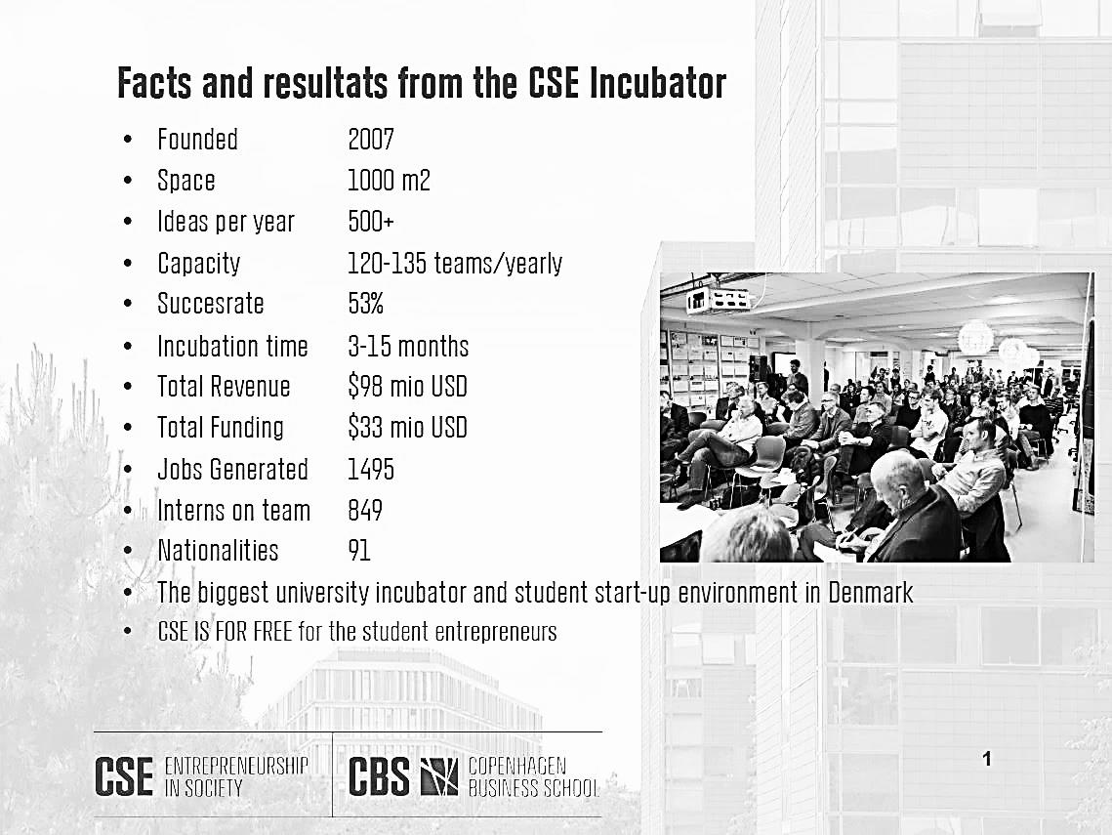

Source: Company materials.

1. DKK = Danish krone; all currency amounts are in DKK unless otherwise specified; DKK6.90 = US$1 (average) in 2015.
2. Donald F. Kuratko, Jeffrey G. Covin, and Michael H. Morris, *Corporate Innovation and Entrepreneurship: Entrepreneurial Development within Organizations*, 3rd ed. (Boston: South-Western Cengage Learning, 2011), 9.
3. Eric Schurenberg, “What's an Entrepreneur? The Best Answer Ever,” *Inc.*, January 9, 2012, accessed January 9, 2017, www.inc.com/eric-schurenberg/the-best-definition-of-entepreneurship.html.
4. Ilya Pozin, “How to Avoid Being a Startup Failure,” *Forbes*, November 28, 2012, accessed January 9, 2017, www.forbes.com/sites/ilyapozin/2012/11/28/how-to-avoid-being-a-startup-failure/#5bebb99562b7.
5. Camelia Moraru and Alexandru Rusei, “Business Incubators—Favorable Environment for Small and Medium Enterprises Development,” *Theoretical and Applied Economics* 5, no. 5 (2012): 169–176, accessed January 9, 2017, http://store.ectap.ro/articole/729.pdf.
6. Schurenberg, op. cit.
7. “Startup Business Failure Rate by Industry,” Statistic Brain, January 24, 2016, accessed January 9, 2017, www.statisticbrain.com/startup-failure-by-industry/.
8. Sang Suk Lee and Jerome S. Osteryoung, “A Comparison of Critical Success Factors for Effective Operations of University Business Incubators in the United States and Korea,” *Journal of Small Business Management* 42, no. 4 (2004): 418–426, doi:10.1111/j.1540-627X.2004.00120.x.
9. Daniel Isenberg, “Introducing the Entrepreneurship Ecosystem: Four Defining Characteristics,” *Forbes,* May 25, 2011, accessed January 9, 2017, www.forbes.com/sites/danisenberg/2011/05/25/introducing-the-entrepreneurship-ecosystem-four-defining-characteristics/#5fb7d6a738c4.
10. €0.95 = US$1 in 2015.