|  |  |
| --- | --- |
|  |  |

9B17M118

Kritikal Solutions: The big leap

Mita Brahma and Shiv S. Tripathi wrote this case solely to provide material for class discussion. The authors do not intend to illustrate either effective or ineffective handling of a managerial situation. The authors may have disguised certain names and other identifying information to protect confidentiality.

*This publication may not be transmitted, photocopied, digitized, or otherwise reproduced in any form or by any means without the permission of the copyright holder. Reproduction of this material is not covered under authorization by any reproduction rights organization. To order copies or request permission to reproduce materials, contact Ivey Publishing, Ivey Business School, Western University, London, Ontario, Canada, N6G 0N1; (t) 519.661.3208; (e)* [*cases@ivey.ca*](mailto:cases@ivey.ca)*;* [*www.iveycases.com*](http://www.iveycases.com)*.*

Copyright © 2017, Management Development Institute Gurgaon and Richard Ivey School of Business Foundation Version: 2017-08-10

In September 2016, the young leadership team of KritiKal Solutions Private Limited (KritiKal), a technology design company, was conducting its monthly business review at the company office in Noida, India. The autumn sky was grey and gloomy, but inside the room, the team was enthusiastic and full of energy. Revenues had doubled in the past two years, profits were up, and several bright young graduates had joined the team. The company specialized in research and development (R&D), product development, and innovation, and had a stable clientele. However, Dipinder Sekhon, the chief executive officer (CEO), was not satisfied. “Most of our customers have found us. We are selling because of word-of-mouth. We are also able to support our large clients well. While that is a good situation, should we not be able to reach out to a larger number of clients—to organizations who have not heard of us but may have a need for our services and products?”

His colleagues were in agreement. In the information technology (IT) sector, time was a critical resource. With several company products stabilizing and creating a name in the market, now was the time to acquire new clients and plan for doubling revenues each year, or growing even faster. The team was sure it could increase capacity on the delivery front, but it would have to ramp up on the sales front. A stronger sales force could result in a larger and more diverse clientele. Sekhon believed KritiKal could grow 10 times bigger in three years. With its unique innovation ecosystem, research-to-market capabilities, and niche products and client relationships, this was the time to take a big leap. But how were he and his team to prioritize their actions and make it all happen?

Indian IT business environment

The Indian IT industry had a market size of US$146 billion[1] in the financial year (FY) ending 2015, with a contribution of 9.5 per cent to the country’s gross domestic product (see Exhibit 1). The country provided a healthy ecosystem for start-ups and innovations. With 3,100 start-ups in 2015 alone, India was the fourth largest start-up hub in the world.[2] The industry employed a 10-million strong work force and was made up of four main segments: IT services, business process management, software products, and engineering services and hardware. These segments had a considerable ripple effect on technology-enabled applications in other industries such as education, health care, finance, defence, electronics, manufacturing, governance, and online information and commerce services.

In FY 2016–17, the industry was expected to continue growing at a rate of 12–14 per cent, with digitization, disruptive technologies, and innovation possibly fuelling higher rates of growth and return.[3] While this pace of growth in the IT industry had changed lives and the way the country worked and communicated, there were not many companies selling software products. Most IT companies that were commercially successful had built their empires almost entirely on service-based cost advantage models. There were some innovative product-based software companies, but none of them was a leader on the global stage like their software service counterparts.

Indian IT product industry

From 1999–2010, there were few IT product start-ups in India. However, in the years afterward, there was a steep rise in product companies fuelled by a maturation of ecosystems in the country, easier access to talent and investments, and a knowledge spillover from the R&D labs of larger companies (see Exhibit 2). The companies were generally clustered around Delhi and the national capital region, the Pune-Mumbai region, and the cities of Bangalore, Chennai, and Trivandrum.

Most companies said their top challenges were finding, hiring, and retaining talent and financing at the right time and with the right terms.[4] As the product companies evolved, there was accelerated growth of 28 per cent in their valuation between October 2014 and June 2015. It was expected that the IT product industry would be able to deliver a disruptive value to customers around the world, grow to provide thousands of jobs, drive foreign exchange earnings, and create billions of dollars of value for founders, investors, and employees.[5]

birth of Kritikal

KritiKal’s founders had all attended the same graduate school in India. In their final year, they attended an entrepreneurship talk on campus that was given by the director of the Foundation for Innovation and Technology Transfer, who helped incubate novel technology ideas into viable commercial products and services and facilitated the creation of business ventures around these ideas. As the students and some faculty members discussed the prospects, they became more and more enraptured by the idea of creating a venture focused on technology and innovation, and creating value for themselves and the world.

In April 2002, seven of the students, all from the computer science stream, and five of their professors decided to get together and start working in the campus incubation facility provided by the foundation. The name “KritiKal” was chosen for the venture after discussions about the work the team would do: “creations” (*kriti* in the Hindi language) that would be “critical” to customer needs in the world of the future or “tomorrow” (*kal* in Hindi). Dr. B. N. Jain, an eminent faculty member in the computer science department, was the first chairperson of the company and continued to guide it as it developed.

The company was registered as KritiKal Solutions Private Limited in August 2002. The foundation helped by providing the initial machines and servers and a small stipend for the founding students. All founding members—students, faculty, and the foundation—contributed to the small seed capital amount. Sekhon was chosen as the CEO. The initial period was one of hard work, intense discussions, and uncertainty. The company acquired some projects from large companies and government research, which engaged them and got them their initial cheques.

The team discussed future plans. One founder asked, “Which technologies should we focus on? What products should we make? How long should we stay in the incubator? By staying on campus, we had had easy access to student interns, faculty guidance, and some shared logistics support. By staying away, we would be forced to manage on our own and plunge deeper into the game.” Another founder noted, “What we were sure of was that we enjoyed working together, and we liked working in the areas of computer vision and embedded systems.” The team members knew they wanted to make amazing products.

Early achievements

In August 2003, KritiKal received an important project opportunity from the Indian government. The company delivered on the design and development of a product to scan the underside of vehicles and also on a vehicle authentication system. The team learned several lessons from these initial projects. A founding team member stated,

We realized one could know more about the customer and market needs by working on such R&D projects. And this knowledge would guide us for own product development as well. We decided we should maintain a mix of products and services in our portfolio for this purpose. We realized we needed to develop our own intellectual property rights and protect them for commercialization in future.

Another founder stated, “Currently, about 75 per cent of our valuation is from products. However, about 75 per cent of our revenue is from services. So both have their advantages.”

In 2005, the vehicle underside scanner was spun off into a separate business entity called KritiKal SecureScan. KritiKal not only further developed the vehicle scanning system, but also built and launched a suite of other products for traffic monitoring, surveillance, and security. Anoop Prabhu, a KritiKal founding team member, together with Kapil Bardeja, who had joined the leadership team at KritiKal in 2003, became the founders and promoters of KritiKal SecureScan. In 2005, this venture—which was renamed Vehant Technologies Private Limited (Vehant) in 2016—was registered as a subsidiary of KritiKal. Bardeja became the CEO of Vehant, and Prabhu became the chief technology officer. Vehant had a suite of products, as follows.

**Premises security solutions** consisted of a range of under-vehicle scanning systems (UVSS) and x-ray baggage scanners. The UVSS used a combination of high-end electro-mechanical assemblies, cameras, illuminators, sensors, and image-processing software to enable an efficient viewing of a vehicle. It detected any potentially harmful object that might be attached to the underbelly of a vehicle. The baggage scanning business line included a range of x-ray scanners to handle baggage of various sizes and types at airports, government offices, and mass transit systems.

**City/border surveillance solutions** were based on an automatic number plate recognition system to identify and track vehicles. The processed data could be stored and verified against any user-specified criteria for security purposes.

**Traffic enforcement solutions** included tracking traffic signal violations and speed-limit violations. A hand-held device for penalty imposition and collection of fines was also developed. The device could verify vehicle ownership against stored data for the purposes of security and control.

The turnover of Vehant was ₹230 million[6] in FY 2015–16 and was expected to be about ₹350 million in FY 2016–17. The nurturing of Vehant and successful spin-off was a source of pride for KritiKal and inspired confidence among the team to develop more of such product incubations and ventures.

Challenges

In August 2006, KritiKal moved out of the incubation facility. The team members faced their first major crisis midway through refurbishing a new facility when they realized they had been tricked into an illegal lease. The person dealing with the KritiKal team was not the owner of the property and had duped them. The team came face to face with challenges not foreseen during the campus period. They pitched in and managed to pull through, emerging stronger. The members renegotiated with the owner of the property, got the office ready, managed the cash flows, and started working with full enthusiasm.

They were also able to attract an angel investor—a technology entrepreneur—in this period. He helped the company with guidance and mentoring as well as with a network and new opportunities.

Solving the early issues of logistics, administration, team problems, payment delays, and client ambiguities, the team learned how to manage all aspects of the organization. The team members distributed the functional areas among themselves. They managed the responsibilities of finance, human resources, and technology support until the size of operations grew and each function required a dedicated team. They also worked hard on acquiring skills for managing a growing venture: managing the business life cycle, managing and developing team members, delegating effectively, managing clients, monitoring projects and cash flows, and creating ideas for future products and business.

Of the initial team of seven founding members, one member had left after the first year to pursue further studies related to his own personal vision. There were periods when other founders took short or long sabbaticals from day-to-day operations. The organizational structure was fluid and flexible, and team members took on additional responsibilities as required apart from their core functions of business acquisition and delivery. The leadership team drew compensation that was far less than market norms, wanting to invest as much cash back into the company as possible.

During 2012–14, the company went through a challenging period when it was in the red (see Exhibit 3). The top line was relatively stagnant, the future looked uncertain, and there was a lot of pressure on the leadership team. Amid discussions on how to cope with the situation, two more members of the founding team left, wanting to pursue alternate options and their own personal visions.

Through all of these challenges, the KritiKal team members enjoyed working in their areas of competence and passion: computer vision and image processing, embedded systems and the Internet of things, and software applications using web and mobile platforms. The core founding team members driving KritiKal were Sekhon, Nishant Sharma, and Ashwani Gautam. They decided to stick it out and put in another marathon effort in 2014, which was a turning point for the company. Revenues doubled between the financial years ending 2014 and 2016, and the company posted healthy profits. The positive financials were a result of some large successful accounts, new clients, and control over cash flow and expenses.

Innovation

KritiKal’s vision was to create technologies and products that were critical for applications and services of the future. Its core values were innovation, growth, customer focus, integrity, and quality. The company launched several innovative products. One of the first was a global mobile communication-based vehicle-tracking device. The device delivered location-based updates to the registered owner’s mobile number. It could be easily fitted into vehicles of all types. Once installed, the device would send information about the vehicle’s current location, speed readings, and route taken. In 2007, the product got visibility through a lucky turn of events when the local police used it to locate a stolen car that had recently been fitted with the device. The car was recovered within a day, and the entire process was covered in the national newspapers. The product was commercialized by Amsaki Homsafe Limited.[7]

A safety and load indicator device that KritiKal made for leading crane manufacturers could be used for a variety of cranes, providing load monitoring data and a graphical display of the required parameters and current status. This device helped prevent accidents at industrial and construction sites. The environment at such sites was quite demanding; hence, the team came up with several innovations to cater to the required rugged design.

KritiKal’s Cash-Hawk system could be used by banks and financial institutions to track counterfeit currency. Cash-Hawk integrated with existing note-counting machines and used high-speed digital image acquisition and processing technologies to give exact details about the currency and the currency depositor. It also gave the location and identification details for the transaction.

KritiKal successfully delivered several challenging projects in the defence sector. It developed an application software for a day and night surveillance camera that would detect any unauthorized movement over a range of several kilometres. The software provided enhanced quality images and raised appropriate alarms. It helped in surveillance over large territories with difficult terrain and rough weather conditions. KritiKal also delivered a system to transform input video from drones (unmanned aerial vehicles) and flight data into high-quality, wide-angle “panoramic mosaic” output. This system was again developed for the defence sector.

Customers

By mid-2016, KritiKal had worked with over 150 customers in India, North America, Europe, and Southeast Asia. The most profitable and value-generating streams of activity for these projects were developing product and intellectual property that went on to successful entrepreneurial commercialization and offering product-engineering services to clients in the United States and Europe.

Several of KritiKal’s clients had their own internal R&D teams. The advantage KritiKal brought to these clients was that, as a company focused on product design, it had expertise across domains, technologies, and businesses. It was able to assimilate and transfer this competence across domains. Also, the strong links with academia helped KritiKal stay up-to-date with current research.

KritiKal had advantages in working in a service mode with customers: (1) the team acquired learning that could be exploited for product development; (2) the cash flows helped in acquiring critical resources or infrastructure; (3) the company was able to expand its network for future alliances or sales; and (4) larger client processes often drove process improvements within the team.

There were some disadvantages, too, in working in a service mode: (1) as a small organization, KritiKal often had limited control over the use of its scarce resources, so managing changing client requirements or adhering to project timelines was difficult; (2) the company’s strategic plans, including new product development or product improvements, often went awry, which caused some damage in the high-technology, dynamic, and competitive space; and (3) KritiKal resources who were on site with the client sometimes became frustrated with unplanned work and conflicting demands of the parent organization and clients and were wooed away by competitors.

Customers were happy with KritiKal’s demonstrated expertise across technologies and businesses and its ability to support clients from the conceptual and architectural design stage to delivering prototypes and market-ready solutions. A customer said, “They have a dedicated team focused on R&D, striving to excel in the area of image and video processing. We look forward to working with them in future in product development.” Another client working in the embedded systems industry had this has to say about KritiKal: “Not only is their technical work of top quality but the team displays a real understanding of issues and comes to the table with suggestions and ideas that are very impressive. This has led to a better overall product.”[8] By this time, several clients had been working with KritiKal for several years and had developed long-term strategic relationships with the firm.

KritiKal continued to accept work in project/service modes as well as in developing and supporting its own products. The company had a challenging business mix of developing and selling product versions, conceptualizing and delivering client products, delivering services, and managing R&D alliances.

Moving ahead

The financial turnaround after 2015 had driven a special enthusiasm in the company. KritiKal employees were always a close-knit lot. They were happy about the work mix as well. Comments on the employee feedback site Glassdoor about KritiKal included the following: “Very good workplace—for engineering innovation, good work-life balance, positive work environment,” “Growing company with Startup like atmosphere allows personal creativity and innovation to be constantly engaged,” and “Hierarchy is very non-bureaucratic and even the top leadership is very approachable.”[9]

By mid-2016, KritiKal had grown to about 70 people and Vehant to about 100 people. Business and operational processes were fairly well documented. The structure and roles were defined. Sharma, who was one of the founding team members, summed things up as follows:

It felt good when three years back, we got a large overseas client, and the tide got turned. Last 1–2 years we have grown well. I think we can now grow faster . . . we had two main issues: we did not have a financial cushion. So we did not feel confident taking on slack resources. Without resources, we were not able to pitch for large projects. We ourselves were all engaged in delivery. We helped in pre-sales. . . . We need to be a good sales person. . . . The second thing we required was to standardize our processes, delegate . . . otherwise we could not focus on the big picture.

Gautam, Sharma, and Sekhon, members of the founding team, all shared business responsibilities. The organizational structure was well defined with business enabler functions in place (see Exhibit 4). There were still debates among the leadership team about prioritizing products or projects, but there were proven KritiKal products in the market and large projects to deliver; hence, the debates were more about the product mix and delivery priorities rather than an either/or discussion. “We have more than 50 products across 150 clients. Some of these clients and the industries they are in are doing really well, and our technologies are in great demand,” said the CEO (see Exhibit 5).

Revenues from embedded systems in India across industry verticals were estimated at US$4.97 billion units (see Exhibit 6). Globally, huge growth was expected in the installed base of interconnected devices known as the Internet of things. From a base of 15.41 billion in 2015, devices were expected to almost double to 30.73 billion by 2020 and further increase to about 75.44 billion by 2025.[10] The global video analytics market was US$2.3 billion in 2015. It was estimated to grow at a compound annual growth rate of 25.3 per cent, reaching a size of US$11.2 billion by 2022.[11]

taking the big leap

It had been a fabulous journey, thought Sekhon, as he looked at his colleagues. He outlined his thoughts to them for the way ahead: (1) The company would continue to focus on R&D and innovation. It would continue to build and grow an innovation ecosystem (see Exhibit 7). (2) It would maintain its strong product focus. (3) To support both of these areas, the team would develop an “incubator accelerator” function. All employees who had great product ideas could be encouraged. The company and clients could co-invest. (4) Time was of the essence, and the company needed to create an innovation fund. The members in charge of the fund could create value for company products, attract investments, manage the fund, receive proposals, decide on investment decisions, and provide support and funding to the ventures that they would incubate. “Now is the time to take a big leap, and we would like to increase our revenues 10 times within three years,” he said.

The leadership team knew innovation—sales and R&D were going to be their main engines. But how would they really go about taking the big leap? What should be the next priority? Who would fund their expansion plans, and how would they ensure sufficient cash flows? Should they diversify now or focus on the current business and grow it further before taking the big leap? What should they do with the offering mix, i.e., how much product and how much service? These were some of the questions for which Sekhon was seeking answers.

Exhibit 1: Market size of India’s IT industry

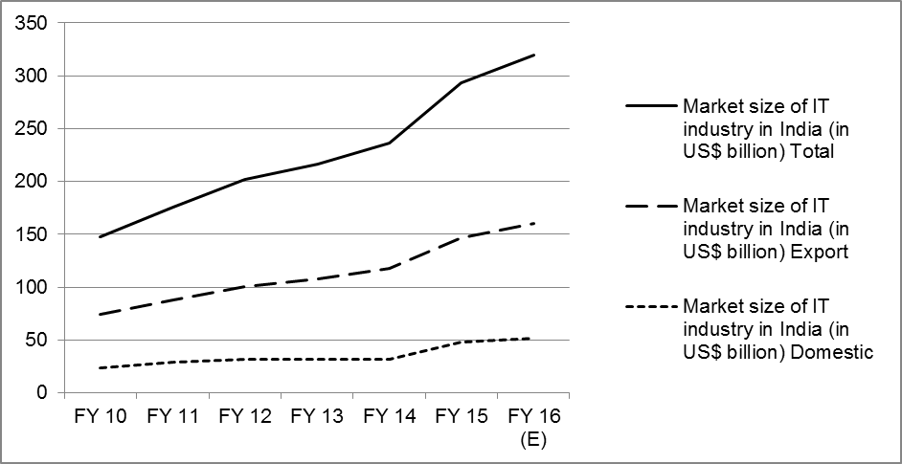

Note: “(E)” denotes estimates.

Source: “IT & ITeS Industry in India: India’s IT Market Size Growing,” India Brand Equity Foundation, January 2017, accessed February 27, 2017, www.ibef.org/industry/information-technology-india.aspx.

Exhibit 2: Export revenues for Indian IT and IT-enabled services

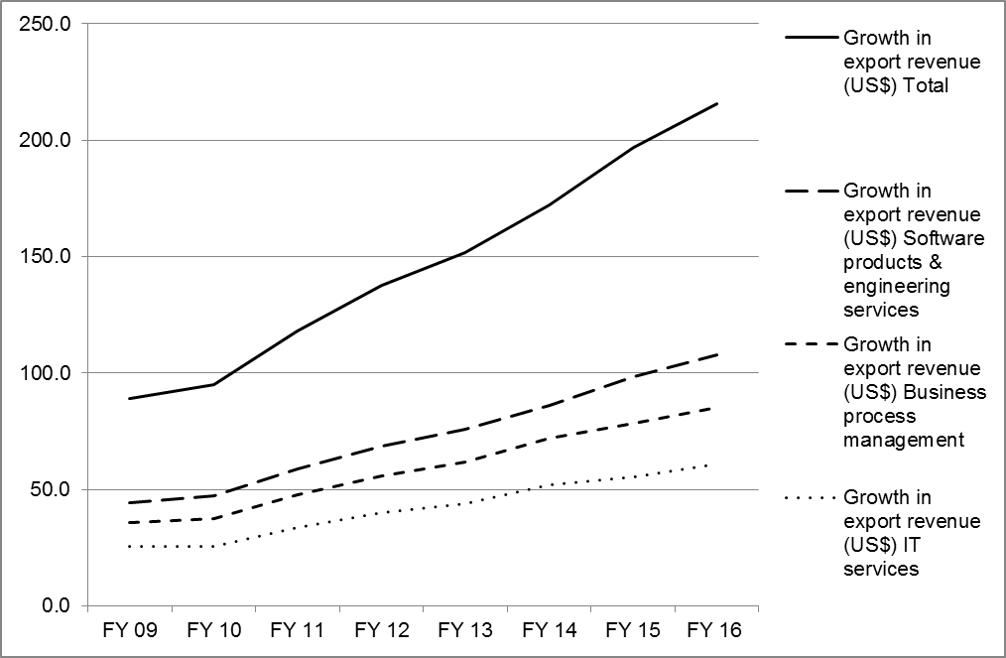

Note: Cumulated annual growth rate = 13.5%.

Source: “IT & ITeS industry in India,” India Brand Equity Foundation, January 2017, accessed February 27, 2017, www.ibef.org/industry/information-technology-india.aspx.

Exhibit 3: Summary of KritiKal financial results

|  |  |  |  |  |  |  |
| --- | --- | --- | --- | --- | --- | --- |
| **Key Profit and Loss Figures (in ₹)** | | | | | | |
|  | **2015–16** | **2014–15** | **2013–14** | **2012–13** | **2011–12** | **2010–11** |
| **Income** |  |  |  |  |  |  |
|  |  |  |  |  |  |  |
| Revenue from operations | 99,634,362 | 8,1054,820 | 52,006,629 | 53,790,665 | 47,430,954 | 52,575,291 |
| Other income | 2,047,508 | 2,133,395 | 460,802 | 300,355 | 397,877 | 220,136 |
| **Total revenue** | **101,681,870** | **83,188,215** | **52,467,431** | **54,091,020** | **47,828,831** | **52,795,427** |
|  |  |  |  |  |  |  |
| **Expenses** |  |  |  |  |  |  |
|  |  |  |  |  |  |  |
| Operating expenses | 17,026,774 | 11,863,334 | 8,437,227 | 5,715,569 | 1,558,077 | 741,931 |
| Employee benefit expenses | 55,903,068 | 40,958,845 | 31,850,832 | 34,633,388 | 29,237,043 | 27,970,513 |
| Interest and finance cost | 1,685,721 | 1,737,897 | 1,601,770 | 673,525 | 442,559 | 381,074 |
| Depreciation and amortization | 6,736,243 | 6,144,720 | 4,133,392 | 5,337,710 | 4,587,053 | 3,277,716 |
| Other expenses | 11,775,882 | 14,504,518 | 10,368,354 | 8,982,142 | 9,300,896 | 13,489,914 |
| **Total expenses** | **93,127,688** | **75,209,314** | **56,391,575** | **55,342,334** | **45,125,628** | **45,861,148** |
|  |  |  |  |  |  |  |
| **Profit before tax** | **8,554,182** | **7,978,901** | **–3,924,144** | **–1,251,314** | **2,703,203** | **6,934,279** |
|  |  |  |  |  |  |  |
| Tax expense | 2,118,522 | 1,914,381 | –1,047,990 | –371,230 | 828,260 | 2,621,994 |
|  |  |  |  |  |  |  |
| **Total profit (loss) for the year** | **6,435,660** | **6,064,520** | **–2,876,154** | **–880,084** | **1,874,943** | **4,312,285** |
|  |  |  |  |  |  |  |
| Earnings per equity share |  |  |  |  |  |  |
| Basic | 4.18 | 3.94 | –1.87 | –0.57 | 1.22 | 2.80 |
| Face value per equity share | 10 | 10 | 10 | 10 | 10 | 10 |

Source: Company documents.

Exhibit 4: Kritikal Organizational structure

Source: Company documents.

Exhibit 5: kritikal’s Service and Product offerings and verticals

|  |  |  |  |  |
| --- | --- | --- | --- | --- |
| **Key Intervention Areas** | **Business Segments** | **Technology Strength Areas** | **Organizational Strength Areas** | **Outcomes** |
| From client concepts to products | Automotive | Video analytics/ computer vision, and image processing | Reputation for quality | 250+ finished projects |
| From client products to business solutions | Energy | Internet of things/embedded systems | Strong academic links for talent | 150+ happy clients |
|  | Health/wellness | Web, mobile, and software applications | Client-oriented cross-functional teams | 50+ product realizations |
|  | Traffic and city surveillance |  | Innovation, R&D specialists | 14+ years of experience |

Source: Company documents.

Exhibit 6: estimated Revenues from embedded systems in India, 2009

|  |  |
| --- | --- |
| **Industry Verticals** | **Estimates**  **(in US$ Million)** |
| Telecommunications | 2,154 |
| Aerospace and defence | 803 |
| Consumer electronics | 640 |
| Automotive | 460 |
| Automation | 459 |
| Health care | 275 |
| Energy and power | 118 |
| Transportation | 61 |
| Total | 4,970 |

Note: By conservative estimates, and purely by building on existing capabilities, the market was expected to grow at a compound annual growth rate of 9.6 per cent. However, aggressive estimates put the estimated compound annual growth rate at 14.4 per cent.

Source: NASSCOM, *Embedded Systems Opportunity: Powering Indian IT up the Value Chain: Executive Summary,* 2010, 10–16, accessed April 8, 2017, www.nasscom.in/embedded-systems-opportunity-powering-indian-it-value-chain.

Exhibit 7: kritikal’s Innovation Ecosystem



Source: Company documents.

1. All currency amounts are in US$ unless otherwise specified.
2. Pressroom Statement, “Robust Growth for the Indian IT-BPM Industry,” NASSCOM, accessed January 30, 2017, www.nasscom.in/robust-growth-indian-itbpm-industry.
3. “IT & ITeS Industry in India,” India Brand Equity Foundation, January 2017, accessed January 30, 2017, www.ibef.org/industry/information-technology-india.aspx.
4. “iSPIRT Product Industry Monitor,” LinkedIn Slideshare, February 4, 2014, accessed January 30, 2017, www.slideshare.net/ProductNation/i-spirt-product-industry-monitor-feb-2014.
5. “India Software Products Industry Index—B2B,” LinkedIn Slideshare, September 3, 2015, accessed January 30, 2017, www.slideshare.net/ProductNation/india-b2b-software-products-industry-clocks-solid-growth-from-2014-to-2015.
6. ₹ = INR = Indian rupee; ₹1 = US$0.15 on March 31, 2016 and March 31, 2017.
7. “Home Page,” Amsaki Homsafe Limited, accessed January 31, 2017, www.amsaki.com/.
8. “Client’s Speak,” KritiKal Solutions, accessed January 24, 2017, www.kritikalsolutions.com/.
9. “Company Reviews: KritiKal Solutions,” Glassdoor, Inc., January 12, 2017, accessed June 29, 2017, www.glassdoor.co.in/Reviews/Employee-Review-KritiKal-Solutions-RVW13043181.htm.
10. Louis Columbus, “Round Up of Internet of Things Forecasts and Market Estimates, 2016,” Forbes Technology, November 27, 2016, accessed March 14, 2017, <https://www.forbes.com/sites/louiscolumbus/2016/11/27/roundup-of-internet-of-things-forecasts-and-market-estimates-2016/#32c37068292d5>.
11. Jay Bartlett, “Video Analytics Market 2016 Analysis and Forecast to 2022,” Security.World, October 4, 2016, accessed March 14, 2017, https://security.world/video-analytics-market-2016-analysis-and-forecast-to-2022/.