

9B17M124

Free Geek Toronto: Shaping a social enterprise

Ken Mark wrote this case under the supervision of Professor Simon Parker solely to provide material for class discussion. The authors do not intend to illustrate either effective or ineffective handling of a managerial situation. The authors may have disguised certain names and other identifying information to protect confidentiality.

*This publication may not be transmitted, photocopied, digitized, or otherwise reproduced in any form or by any means without the permission of the copyright holder. Reproduction of this material is not covered under authorization by any reproduction rights organization. To order copies or request permission to reproduce materials, contact Ivey Publishing, Ivey Business School, Western University, London, Ontario, Canada, N6G 0N1; (t) 519.661.3208; (e)* [*cases@ivey.ca*](mailto:cases@ivey.ca)*;* [*www.iveycases.com*](http://www.iveycases.com)*.*

Copyright © 2017, Richard Ivey School of Business Foundation Version: 2017-10-20

“What should Free Geek Toronto’s strategy look like?” wondered Ryan Fukunaga, executive director of Free Geek Toronto, a Toronto-based social enterprise focused on recycling and refurbishing used electronics. Funded primarily by the Toronto Enterprise Fund (TEF), Free Geek Toronto focused on its dual goal of running a business and working with individuals who faced employment barriers. Fukunaga explained:

Free Geek Toronto is a non-profit social enterprise that helps bridge the digital divide. We accept donations of electronic waste that we then refurbish and re-sell at an accessible price to help every Torontonian get connected. We also train and employ individuals who have struggled with employment to work in the day to day operations of the organization.[1]

Fukunaga had taken over the leadership of Free Geek Toronto in mid-November 2016. He was an instructor and educator with more than a decade of experience teaching in a variety of fields (e.g., adult literacy, technology, employment skills, wilderness/outdoor skills, and computer repair), and he had worked in the non-profit sector for the past five years. Fukunaga talked about his goals at Free Geek Toronto:

I’ve been working for social enterprises in the last two years, and have been able to be part of great working teams. I was given a mission to stabilize Free Geek Toronto’s operations. We’ve always wanted to expand, but we need to be able to achieve consistency on our processes before that can happen. These include, for example, our ability to forecast sales, develop plans that can be carried out, and achieve efficiencies in our operations. First we steady the ship, then we sail it forward.

All profits generated from the sales of refurbished electronic goods were reinvested into Free Geek. It was late November 2016, and Fukunaga was thinking about the challenge of bringing in volunteers to fill key roles in the organization:

We’re trying to run a viable enterprise and devote enough time to hire, train, and manage a unique workforce, many of whom have employment barriers. If we bring in volunteers, we will alter the work culture of the organization. Some say it might demotivate our current workforce to have these volunteers work alongside them. I need to analyze the situation and figure out what we should do about a potential volunteer recruitment strategy. Is it a good idea or not?

Social EnterpriseS

Private enterprises focused on profit generation, and not-for-profit entities aimed to achieve social goals. Social enterprises had dual missions: to sell goods or services, or both, in the marketplace to generate income; and to achieve social impact goals. Examples of social enterprises were thrift stores that sold recycled and donated goods, and apparel companies such as tentree, which planted 10 trees for every garment sold.[2] Fukunaga added,

Not-for-profits and charities can have social enterprise components to them. The YMCAs and YWCAs, for example, often offer low-cost recreation and hostel services, and will waive fees for those in need. Yet they have a mandate to be self-sustainable. There are other examples of social enterprises that we’ve looked at for inspiration. There was, for example, a food services training centre that helped provide training and experience for those looking to get a job in the food industry. There was a business aspect where the trainees were generating revenues for the training centre, with the proceeds helping to make the centre self-sustaining. Graduating employees were better off because they were able to find a job more easily.

In 2016, approximately 25,000 social enterprises were operating in Canada.[3] Awareness of social enterprises was increasing, with about CA$2.2 billion[4] in funds available in Canada for impact investing. The TEF was one of the sources of funds for social enterprises. The TEF was founded in 2000 as a partnership among four organizations: United Way Toronto and York Region; the City of Toronto; the Ontario Ministry of Community and Social Services; and the Homelessness Partnering Strategy, a federal government program administered by the City of Toronto. The goal of the TEF was to support the development of social enterprises that focused on providing “transitional or permanent employment, or training leading to employment, for people who are marginalized.”[5] Free Geek Toronto was a recipient of one of the TEF’s annual operating grants.

Free Geek

Founded in Portland, Oregon, in 2000, the first Free Geek enterprise was started with the goal of recycling and giving away computers to community members in need. Oso Martin, the founder of Free Geek, recalled the early days of the organization: “Some people have too many computers; others don’t have enough; and there is a glut of computers going to landfills. Mash them together, and the solution is Free Geek.”[6]

Martin had been helping to organize an Earth Day event in Portland, Oregon, when he commented that a collection of “junky, old computers” that had been donated should be refurbished. The next day, a director of a not-for-profit handed Martin a cheque for US$250 to create a social enterprise and file for 501(c)(3) status, and offered a further donation of 50 computers. Another supporter invested US$35,000, allowing Martin to start his social enterprise. Free Geek had three key goals:[7]

* Reuse computers and technology by giving them away for community service.
* Recycle in an environmentally responsible way those computers that were not reused.
* Provide education and training in the use of computers and technology.

By 2010, Free Geek in Portland, Oregon, had generated the majority of its revenues from the sales and recycling of computers and from disposal fees, with just 25 per cent coming from donations and fundraising efforts. In an effort to expand the concept, Free Geek made its business model, supported by documentation and plans, available online to anyone. By 2014, there were perhaps a dozen Free Geek organizations throughout the United States and Canada. In Portland, the original Free Geek continued to have an impact on its community. In 2013, a manager shared some facts:

Active volunteer count first broke 100 in 2001, 200 in 2004, 300 in 2005, 400 in 2008, 500 in 2009, 600 in 2010 . . . pretty steady. For the last two years we have been receiving about 6,000 computers per quarter. We broke 1,000 in 2003, 2,000 in 2004, 3,000 in 2005, 4,000 in 2007, and 5,000 in 2008. The 6,000 number has been pretty steady since 2010. Sales in dollars per quarter is around [US]$175,000 for the last full quarter. This is down from our high in 2010 ([US]$202,000). We started at [US]$1,000 a quarter in 2001 and worked up to [US]$100,000 a quarter by 2008.[8]

Free Geek Toronto

Free Geek Toronto was founded in 2009 and moved its offices to Queen Street West in 2014 (see Exhibit 1). Free Geek Toronto had two full-time staff (an executive director and an operations manager) and approximately five part-time staff who had employment barriers. In addition, Free Geek Toronto was able to work with 13 work placement participants in 2016. Fukunaga explained:

We work closely with other charities and work placement centres. On occasion, we are asked to provide temporary work placements—three to six months in length—for individuals being assisted by these other charities. We provide these individuals their first step in their employment journey. For example, we have individuals from hospitals and mental health centres who we welcome in. They come in to work and or to learn skills in a safe environment with low expectations. They may not have worked for months or years. They want to eventually work full-time, but they need us as a bridge to get there. Their limited time at Free Geek Toronto is a chance for them to get into a routine, to take on responsibility, to prepare themselves for full-time work.

There is a “social return on investment” for what we do for people and we would like to quantify this at some point. By providing individuals with work opportunities, we help them move away from a reliance on social assistance, we shorten the time to full-time employment and we hope that they find more suitable, perhaps even higher-paying, jobs. One of the training programs I was involved with before Free Geek Toronto showed that for every dollar invested in that training program, there was a social return on investment of nine dollars.

Free Geek Toronto had several programs that supported its key goals:

* Electronic waste recycling: A wide variety of electronic waste—amplifiers to MP3 players, tablets, computers, smartphones, and video projects, to name a few—could be dropped off at its office in downtown Toronto. It also offered a service whereby an employee would pick up electronic waste from a client’s location (at a nominal cost of $40–$100).
* Training: Employees and community members were trained on how to refurbish electronic equipment. Many trainees came from low-income families or had low digital knowledge, or both.
* Refurbishment: Equipment deemed salvageable would be refurbished on-site by Free Geek Toronto’s employees.
* Sales: Once refurbished, equipment was sold at a low mark-up to walk-in clients (see Exhibit 2).

Free Geek Toronto’s Human Resources Goals

“We’re hiring people who have been unemployed. And we don’t only look at what they can do for us when they’re working for us. While we do not have a social worker internally, we do our best to help our employees tap into support services that are available in the city,” said the operations manager. “Whether they need wellness programs, shelter support, or a food bank, we direct them to the right places.”

He continued:

One of the challenges we face is trying to support employees who are on disability [benefits]. This does not necessarily mean that they cannot work with us. They can’t have full-time paid work, meaning that we can only have them working for us up until a limit. When they surpass that limit, there is a clawback and the employee has to give a portion of it back to the government. Consider that disability [benefits] could pay $1,100 a month. If they’re only allowed to earn $200 before the clawback starts, then an employee earning $1,100 would have 50 per cent of the extra amount above $200 clawed back, or $450. There is some consideration for any child care or disability-related work costs that are eligible, but many of our employees do not have child care expenses or disability-related work costs to claim.

Another former operations manager commented:

We’re also quite flexible with the way we manage our employees. You can come in to participate on one single day with us, to help us with recycling. You can come in and speak with us and we’ll accommodate you. If you’d like some privacy, to sit in a corner away from the noise and work away at a project, that’s fine with us as well. What we’ve done successfully is that we don’t have a prescribed idea of what it means to be successful at a job.

Fukunaga explained how Free Geek Toronto approached the issue of performance management:

Honestly, we manage by starting from a point of caring and respect. We have a small staff and I can individualize how we treat people. We set expectations for job roles and we have learning updates—we do not call them reviews—every six months. This allows us to have conversations with our staff about progress. If an issue comes up, then we hope that it will not be a surprise. We have to be careful here—the traditional “carrot and stick” approach to incentives and discipline does not work because our employees can still be in a sensitive position in their time with us.

For example, in a traditional environment, punctuality is important. If you’re working in retail or in a warehouse and are late three times, it is likely you will be reprimanded and let go. With us, we notice you’ve been late and we will sit down with you to find out if anything is going on. We are willing to support you and tweak our schedule so that it works for you. If it continues to be a problem, we just continue to talk about it. It’s more akin to a coaching relationship, the way we manage our people.

Managing Operations: Creating More Flexible Roles

Free Geek Toronto’s operations manager oversaw the programs that generated funds for the enterprise—sorting, refurbishing, training, and sales. He needed to strike a balance between offering training sessions and carrying out refurbishing tasks. A former manager noted, “Every additional hour we devote to working with participants takes an hour away from refurbishing computers for sale. One is not more important than the other: we just have to find the balance between our activities.”

Over the years, Free Geek Toronto had modified its skill requirements to be able to accept a broader range of employees. In the past, it had tried to hire individuals who could refurbish a computer from start to finish. Free Geek Toronto would invest in training those individuals and then put them on a phased-in program, with the end goal of graduating a technically skilled employee. Starting in 2012, Free Geek Toronto began dividing the work processes into more manageable segments, so that employees could choose to specialize on any one task. They recognized that much was expected of an individual to be able to sort through e-waste, identify valuable pieces for refurbishing, carry out the refurbishing, and prepare the item for sale.

Another plan—not yet implemented—was for Free Geek Toronto to document on paper all the processes related to each job. For example, training on customer service and sales in the retail storefront was typically provided verbally. Fukunaga was thinking about documenting each step, creating “work manuals” for each position. Taken one step further, Fukunaga wanted to also have pictorial diagrams and “how-to” videos.

Free Geek Toronto’s Next Steps

Fukunaga had recently taken over as executive director, and he had a few issues to consider. Free Geek Toronto generated approximately $120,000 in revenues from grants, recycling materials, and selling refurbished computers and equipment. The total cost of running Free Geek Toronto was approximately $130,000 annually. He added,

I’m the third executive director in the past 18 months. We’re working full-time but we don’t seem to be able to get all of the strategic and operational pieces in place. For example, we still do not have a reliable way to forecast what our sales will be in the next year. Our operations are labour-intensive. Training a new sales associate to manage the retail side of the shop takes two to three months: a manager provides one-on-one training with that associate, walking him or her through each operation several times. Providing training to employees refurbishing computers and other electronic equipment still takes two to three months. A lot of the training is hands-on, meaning that the trainer demonstrates to employees how to take apart, diagnose, and refurbish equipment. We need to augment our resources if we want to do more.

The Possibility of Using Volunteers

Fukunaga wondered whether he could develop a volunteer program at Free Geek Toronto, just as the Portland office had done. A few committed supporters had reached out to Fukunaga to consider a comprehensive volunteer program that would include college or university placements and a volunteer director (unpaid, to start with) who could marshal a team of volunteers to support profit-generating programs at Free Geek Toronto. A set of volunteers could also add capacity for Free Geek Toronto to offer a broader set of training programs.

On the other hand, Fukunaga realized that recruiting volunteers could affect the culture at Free Geek Toronto:

Remember that we are helping to train individuals with work-related barriers. These individuals know that they do not yet function at the same productivity as does an average volunteer. An average volunteer could be university-educated and . . . passionate about helping out. They’re enthusiastic and usually very productive. I’m sensitive that placing a highly skilled volunteer alongside our employees could be demotivating for the latter group. Yet I need more assistance in all aspects of the business, from strategy, project planning, marketing, operations, and human resources.

Many Free Geek Toronto employees had barriers such as autism, or health concerns such as anxiety or stress, that had prevented them from finding full-time employment. Their employment at Free Geek Toronto was a way to regain their self-confidence in a safe environment, with people similar to themselves. A task that could take a volunteer 10 minutes to complete—such as adding a few refurbished computers to inventory—might take a Free Geek Toronto employee an hour or two to grasp. In addition, many employees were in fragile emotional states when at work, and Free Geek Toronto’s management team tended to take extra care to ensure that they were given as much support and accommodation as possible. Previous executive directors had thought that introducing volunteers to work alongside Free Geek Toronto employees would change the work culture.

A former operations manager recalled,

Volunteers can be trained, and this sensitivity training might take weeks. Remember that volunteers can elect to leave us a few weeks after joining us and in that case, we would have invested that training for very little return. There is also the challenge of volunteers overstaying their welcome if they are unsuitable. Then we would have to find a way to ease them out of our company. In the past, the thought of adding a volunteer program was believed to be too much to manage. It would have taken away resources from helping our employees.

Other Challenges

Another related issue was that Free Geek Toronto had a bulging warehouse of product waiting to be refurbished for sale. “The issue is resources. We have valuable computer equipment but we do not have enough employees to help us,” Fukunaga said. “I would like to consider ramping up our current employment program to double the number of participants to 26. What will that do to my budget? Where can I find the shortfall? Can I spare the managerial resources to train and manage a larger group?”

Fukunaga was focused on ensuring operations ran smoothly. He heard a story, from a former manager, that Free Geek Toronto had been, on one occasion, late issuing cheques to its part-time employees. “I can’t eat until I get that cheque,” one employee had lamented. “I can’t go to McDonald’s tonight if I don’t have any money.” The employee had no savings, no place to live, and counted on Free Geek Toronto’s payments to survive. The former manager added, “We had to get our board members to rush from their downtown Toronto jobs—these are senior executives—to sign the cheques so that we could hand them out before the end of the day. That’s when it became real to me.” Fukunaga took a look at the issues Free Geek Toronto faced and wondered what a viable strategy for the next two years would look like. He concluded,

Ultimately, I think Free Geek Toronto can do more, but our limitation is resources. Even on the product side, we’ve got people calling all the time and asking for free computers. Now if we gave out free computers, it would definitely add to our social impact. But if we gave away our computers, we won’t be able to recoup the time and resources we spent refurbishing them. Without money, we cannot continue to operate.

The Ivey Business School gratefully acknowledges the generous support of the K.W. Lemon Fund in the development of this case.

Exhibit 1: Free Geek Toronto’s webpage

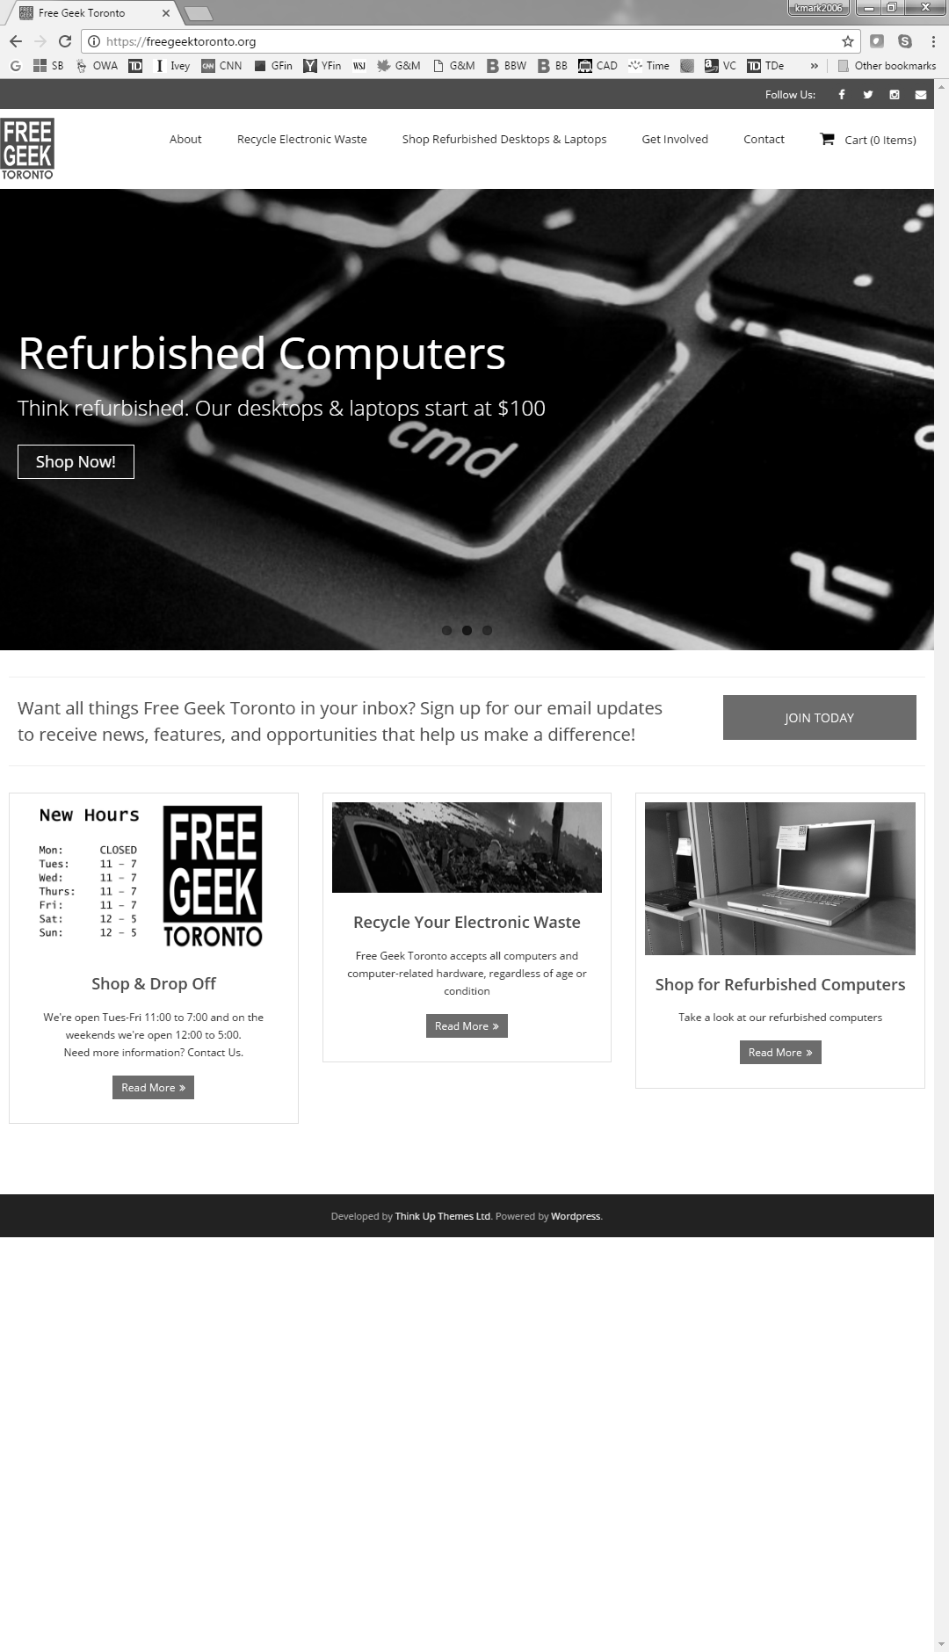

Source: Company files.

Exhibit 2: Free Geek Toronto—examples of Refurbished Products For Sale

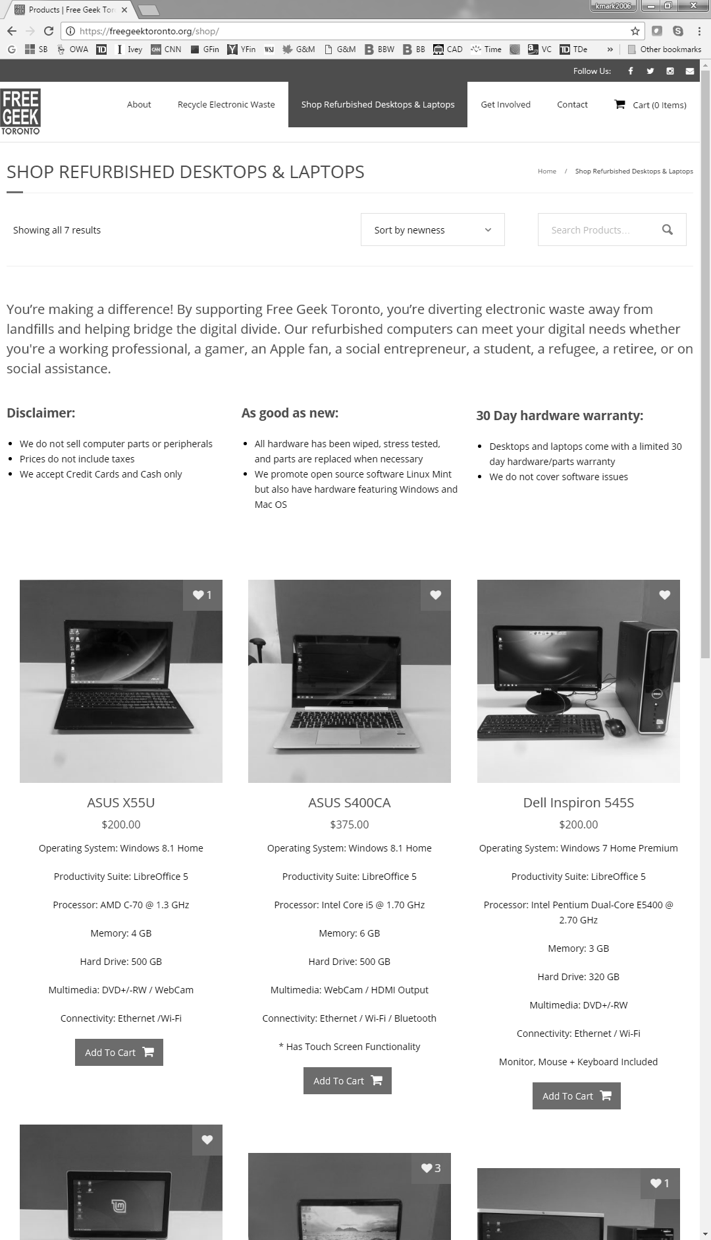

Source: Company files.

1. “Ryan Fukunaga: Free Geek Toronto—Bridging the Digital Divide,” Centre for Social Innovation, accessed July 28, 2017, https://socialinnovation.org/member_auto/ryan-fukunaga/.
2. Peter W. Moroz, Simon Parker, and Edward Gamble, *Growing tentree: Social Enterprise, Social Media and Environmental Sustainability* (London, ON: Ivey Publishing, 2014). Available from Ivey Publishing, product number 9B14M030.
3. Toronto Enterprise Fund, “What is a Social Enterprise,” accessed July 28, 2017, www.torontoenterprisefund.ca/about-tef/what-is-a-social-enterprise.
4. All currency amounts are in Canadian dollars unless otherwise specified.
5. Toronto Enterprise Fund, op. cit.
6. Greg Bloom, “Case Studies of Cooperative Development: Free Geek,” December 15, 2013, accessed July 28, 2017, http://gregbloom.org/2013/12/15/case-studies-of-cooperative-development-free-geek/.
7. Ibid.
8. Ibid.