

9B17M147

BMB GROUP: A Dubai Confectioner Sweetening the World

Yusaf Akbar, Alexander Urquhart, Amit Dahiwadkar, and Dileepa Peiris wrote this case solely to provide material for class discussion. The authors do not intend to illustrate either effective or ineffective handling of a managerial situation. The authors may have disguised certain names and other identifying information to protect confidentiality.

*This publication may not be transmitted, photocopied, digitized, or otherwise reproduced in any form or by any means without the permission of the copyright holder. Reproduction of this material is not covered under authorization by any reproduction rights organization. To order copies or request permission to reproduce materials, contact Ivey Publishing, Ivey Business School, Western University, London, Ontario, Canada, N6G 0N1; (t) 519.661.3208; (e)* [*cases@ivey.ca*](mailto:cases@ivey.ca)*;* [*www.iveycases.com*](http://www.iveycases.com)*.*

Copyright © 2017, Richard Ivey School of Business Foundation Version: 2017-11-28

Mohamad Khachab, chief operating officer and partner of the BMB Group (BMB), had just finished his daily walk around the chocolate and sweets production floors and was returning to his office in BMB’s factory on the outskirts of Dubai. It was July, 2016—the hottest part of another sweltering Dubai summer—and reminiscing about his journey thus far with BMB, he felt both satisfied and proud. In just 10 years, BMB had gone from its foundations as a start-up baking goods supplier to being the biggest producer of gourmet chocolates and Middle Eastern confectionery in the United Arab Emirates (UAE).

Private-label, highly customized confectionery made for other brands had proven to be a winning strategy in Gulf Cooperation Council (GCC) countries that comprise most of the Arabian Peninsula. However, Khachab and his cousin—BMB’s founder and chief executive officer, Bilal Ballout—felt it was time to transition to a business-to-consumer (B2C) model. Establishing BMB brands was essential to continued growth because the partners felt the private-label space would soon fill up with competitors. Ballout was thinking even bigger; their most recent conversation echoed in Khachab’s mind: “We dream of expanding into new markets. [Our] ‘Mely’s’ brand will make that dream come true.”

Now Khachab considered the main question facing the partners: which market should BMB enter? As Khachab saw it, there were three options: (1) go where Middle Eastern sweets were already popular, but compete with many producers; (2) target Arab expatriate populations that might embrace the products and partner with local distributors; or (3) focus on markets where the population showed a preference for sweets but had relatively limited exposure to or preference for Middle Eastern sweets, and use BMB brands to set the standard. “New markets,” Khachab repeated to himself. “We have a popular product in the GCC. How will the rest of the world embrace it?”

The BMB Story

BMB began in 2006 when Ballout was looking for a professional opportunity after completing his Master of Science in Finance in the United Kingdom. Having given up a position with a global consulting firm, he returned to Dubai, UAE, to work in his family’s small confectionery shop. Focusing on the shop’s supply chain, he identified a major business niche going unexploited: providing high-quality ingredients and equipment to chocolatiers and bakers in the UAE. Accordingly, at the age of 22, and with his brother’s support, Ballout established a baking goods trading company called BMB. This trade business soon became a runaway success, and Ballout decided that BMB should also open its own facility to produce private-label chocolates and Middle Eastern sweets, including baklava and other traditional snacks like halva, nougat, and a popular date-filled biscuit called ma’amoul (see Exhibit 1).

As BMB grew, Middle Eastern sweets were at the forefront of its expansion strategy. BMB supplied these private-label products to hypermarkets, duty-free shops, and hospitality partners throughout the Emirates. By 2009, Khachab had joined the company. BMB was growing quickly and had even begun exporting products to its GCC neighbors, Qatar and the Kingdom of Saudi Arabia (see Exhibit 2).

By 2016, BMB was producing roughly 2,000 tonnes of chocolates and 2,500 tonnes of Middle Eastern sweets per year, with annual sales above US$68 million.[1] From its humble beginnings, BMB had grown to comprise more than 1,000 employees with offices in Dubai, Riyadh (Saudi Arabia), and Doha (Qatar). In addition to the chocolate and sweets factory, BMB also operated a raw materials factory and a printing and packaging facility.

Despite such rapid growth, BMB leadership focused on trying to preserve the company’s original culture. Core values such as teamwork, innovation, development, and a passion for quality were at the core of the firm’s day-to-day operations. It was especially imperative for the partners to maintain these values as the organization grew. With the company’s higher-than-average turnover rate, instilling these values in all workers was an ongoing challenge. The human resource (HR) team was interested in programs to increase worker retention, and management was investing heavily in employee development, working with the region’s industry and thought leaders.

THE Confectionery Industry in the GCC

The confectionery industry had enjoyed years of fast growth in the Middle East (and especially in the UAE and Saudi Arabia), due in part to the exponential growth in incomes of the people living in the UAE and Saudi Arabia. In 2014, the overall Middle Eastern and African snacks market was roughly $7 billion and growing at 5 per cent per year; this number included $1 billion in biscuit sales and $2 billion in confectionery sales.[2] The chocolate market in the UAE was expected to grow at about 6.1 per cent compound annual growth rate (CAGR) until 2019, compared to 2.3 per cent globally.[3] The confectionery market in Saudi Arabia—BMB’s biggest sales area—was expected to grow at 12 to 14 per cent CAGR until 2018.[4] Throughout the Middle East, the confectionery market was expected to top $3 billion by the end of 2017,[5] and to reach $6 billion in the Middle East and North Africa region.[6]

Confectionery sales in the Middle East were dominated by major corporations such as Nestlé S.A. (Nestlé), Mars, Inc. (Mars), and Mondelēz International. These multinational corporations were attracted to the fast-growing markets of the GCC. Facilities in Dubai could easily serve markets in the Middle East, Africa, and Europe. Access to fast-growing emerging markets was especially important for mature companies that aimed to maintain growth. In 2015, for example, Nestlé saw 1.9 per cent growth in developed markets, compared to 7 per cent growth in emerging markets.[7]

The regional importance of the Middle East was evident in the large investments it attracted. Snack manufacturers and confectioners were spending hundreds of millions of dollars to access the surrounding markets. In 2010, Mars and Nestlé each opened a factory in Dubai, for a combined $176 million worth of investments.[8] Four years later, Mars undertook a $60 million investment expansion and built an $80 million factory in Saudi Arabia.[9] Over the same period, Nestlé invested $400 million.[10]

Mars and Nestlé dominated the market with “countline” snacks (i.e., candy bars and cookies sold to retailers in large boxes, and then individually resold to customers). Yet with the overall Middle Eastern snacks market growing by 20 per cent per year, there was abundant potential for smaller gourmet manufacturers such as BMB.[11] The gourmet chocolate market was worth almost $300 million in 2016.[12] Gourmet snacks in general were bolstered by a tradition of gifting in the Middle East. Sharing gourmet treats during the Ramadan holiday had become very common;[13] individuals would buy fancy chocolates and Middle Eastern sweets for family and friends, as well as to give to charities.

There were two other trends that gave BMB a sales advantage. In line with rising affluence in the region, young adult customers were increasingly demanding customization and quality, as well as healthier and more ethically sourced products.[14] A mass-produced chocolate bar was less likely to appeal to these consumers as much as a treat with a unique package, taste, or story. Many gourmet producers had taken note of this trend, and they began to target the UAE market.[15] Dozens of foreign luxury brands (e.g., Forrey & Galland, Godiva, and Patchi, among many others) were establishing upscale boutiques, and the competition was growing.

As snacking habits matured in the Middle East, so too did consciousness about healthy eating. Because of various social and economic conditions, diabetes and obesity had emerged as serious health concerns throughout the region. In response, consumers began to demand more sugar-free, low-fat, and even organic snack options.[16] To respond to this demand, BMB developed sugar-free and low-fat treats.

Baklava

With origins in the Ottoman Empire, baklava was a popular delicacy made from crispy layers of phyllo pastry with a nut filling, baked in clarified butter and soaked in honey (or agave syrup, in the case of sugar-free baklava). The final treat came in many forms and sizes, but was usually cut or folded into a bite-sized snack. In the Middle East and Turkey, it was commonly served to guests, especially during cultural and religious celebrations. Baklava’s popularity and many regional variations were captured by a few well-known lines:

Ask the Greeks and they will say, “The Lebanese stole the recipe.”

Ask the Lebanese and they will say, “The Greeks stole the recipe.”

Ask the Turkish and they will say, “Our pashas and viziers owned the recipe.”

Ask the Armenians and they will say, “We invented and improved the recipe.”

Ask any of them and they will say, “Our baklava is the best and our pronunciation is the correct pronunciation.”

BMB produced many variations of baklava, which sold well throughout the GCC. Saudi Arabia was the biggest consumer, and the biannual Eid feasts were the busiest periods for sales of baklava. There was also high demand throughout the month of Ramadan, when Muslims were encouraged to give to the poor and hungry, and to fast daily until sunset, when friends and family gathered to break the fast.

BMB Brands

BMB had recently developed four brands as part of their exploration of a B2C model: “Asateer,” “Al Qamar,” “Petit Gourmet,” and “Mely’s” (see Exhibit 3). Only baklava and chocolate-covered dates were sold under the Mely’s brand; the other brands sold BMB’s full range of Middle Eastern sweets.Khachab and Ballout hoped that these brands would help them pivot strategically, both at home and abroad.

The Asateer (meaning “legends”) brand emphasized ethnic Arab culture and tradition. The packaging combined stylized Arabic calligraphy with classical Middle Eastern design elements. The product boxes (up to 1,000 grams (g)) were heavy duty and had a luxurious feel that made them ideal for gifting. Asateer’s target market comprised tourists looking for souvenirs and Arab communities seeking a high-end sweets experience. Asateer had a premium price and was primarily sold in duty-free and souvenir shops, as well as select grocery stores in the UAE and Qatar.

The Al Qamar (meaning “the moon”) brand was also geared toward Arab communities, but with emphasis on local sales as a common household good—a pantry dessert staple that the whole family could enjoy, rather than an extravagant treat. To appeal to everyday shoppers, Al Qamar had a more minimalist design concept: modern but distinctly Middle Eastern, it featured simplified Arabic text (akin to a sans serif font in the Roman alphabet) and solid colour schemes. The brand was competitively priced in large boxes (up to 800 g) and found in major grocery stores throughout the UAE.

Petit Gourmet (meaning “small gourmet”) appealed to European tastes. The brand’s smaller boxes (mostly 500 g or less) were designed with modern packaging and pen-and-ink script in the style of a signature. The brand dispensed with Middle Eastern motifs to better capture the European bakery tradition. Petit Gourmet products carried a premium price and were found primarily in smaller grocery stores and duty-free shops in the UAE and Qatar.

The Mely’s brand focused on single servings of baklava and dates. It was perhaps BMB’s most original concept, “the Lindt of Middle Eastern sweets,” according to BMB’s chief innovation officer. Mely’s dispensed with the common practice of packing rows of sweets into wide, flat boxes. Instead, each date or piece of baklava was individually wrapped in plastic pillow packaging and sold in boxes of up to 24 pieces. This was meant to appeal to health-conscious Western consumers as an anytime, single-serving snack that could compete with cookies and sweet and salty snacks. Like Petit Gourmet, Mely’s used packaging designs that were modern and free of traditional Middle Eastern motifs. Marketing for these products centred around the slogan, “Be the joy,” and encouraged consumers to share the treat with friends. Inside the box were pouches that could hold three or four pieces at a time, to be brought to work or sent to school or given as a small gift. As a brand, Mely’s was still in development, and Ballout and Khachab were very excited about its potential.

Potential New Markets

Khachab kept returning to a fundamental question: Should the company bet on unproven markets with no tradition of baklava (and thus, no major competition), or should it target consumers who were known to love baklava (and therefore fight for space in an increasingly competitive environment)? While there was no obvious answer, he could nevertheless make an informed decision. Khachab picked up a folder containing market analyses of 12 countries. He had commissioned them from a local start-up consulting firm of recent MBA graduates, more to test their competence than anything. Yet now these analyses were proving to be surprisingly useful. At a late-night meeting earlier in the week, he and Ballout had pored over the study and narrowed the field to three countries: Turkey, the United States, and India (see Exhibit 4).

Turkey: The Birthplace of Baklava

Turkey was the quintessential example of a saturated market. Anyone who had visited Istanbul was familiar with the common window displays featuring towering stacks of baklava. The country’s $3 billion baklava industry produced nearly 1,000 tonnes of the delicacy per day, with per capita consumption at roughly 4.4 kilograms (kg) per year.[17] Accordingly, Turkish consumers and retailers had hundreds of suppliers to choose from, and prices were extremely competitive: $8.42 per kg on average, compared to an average of $17.06 per kg in the UAE.[18] Khachab believed that in order for BMB to bring its baklava to Turkey, branding would be critical to differentiate its product from the many local sources; perhaps it could be sold as a premium import. Then again, it would be difficult to distinguish BMB’s products as premium products in the birthplace of baklava, so perhaps a more successful strategy would simply be to supply a high-end local partner.

The United States: An Opportunity to “Plant the Flag”

The United States had a relatively small population of Middle Eastern expatriates—approximately 1.5 million[19]—with a median household income of around $56,000.[20] BMB could play to the nostalgia of this population, which was clustered in a handful of population centres, including New York City, Los Angeles, Chicago, and Detroit.[21] While commercial and market risk would be low, because the population would undoubtedly recognize and appreciate the product and the competition would be less intense than in Turkey, Khachab also knew that BMB was not the first to bring baklava to these expatriates. Did that make a differentiator even more important, or was the need for branding diminished? Why go to the trouble of establishing a brand and earning loyalty if BMB could work through local players that were already trusted by local consumers?

In some ways, undertaking this kind of relationship would represent a regression for BMB, a step backward to its early business-to-business (B2B) model. Yet while a B2B opportunity appeared unexciting, this had been BMB’s core strategy from the beginning, and the company was adept at handling such relationships. There was also the appeal of the vast American market, but this came with many challenges. The United States did not have a strong tradition of baklava. It was seen as a delicious but uncommon curiosity—something purchased in a Middle Eastern café or store. American consumers were also increasingly health conscious, and might not want boxes of honey-soaked treats. Appealing to these consumers would take careful planning, and brand image could be critical.

India: A Market Extension Wager

Indians in the UAE may have developed a taste for baklava, but there was little familiarity with the treat in India itself. Still, Indians clearly enjoyed sweets. The large expatriate population living and working in Dubai had familiarized Khachab with India’s many sweet and rich desserts; this was promising for the prospects of baklava in India. In India’s large cities, it would take only a small percentage of devotees to turn over high sales volumes. If BMB entered aggressively with a well-designed brand, it could set the standard for baklava—an upscale, imported, “special occasion” kind of dessert with a bit of ostentatious flair.

Indeed, where it was sold in India, baklava went for prices close to those in the United States, despite Indians’ relatively lower purchasing power. India’s numerous religious and cultural festivals, such as Diwali, could also drive sales, much as Ramadan did in the Middle East. India’s Muslim population totalled roughly 200 million—four times the population of the UAE, Saudi Arabia, Oman, Qatar, Bahrain, and Kuwait combined.[22] Simply establishing itself could present BMB with a challenge, however; the World Bank ranked India 130th out of 190 countries for overall ease of doing business, and the country was ranked even lower (172nd) when it came to enforcing contracts.[23]

The Global Arab Diaspora

Middle Eastern and North African expatriates were estimated to number approximately 20 million worldwide.[24] England and Wales had an Arab population of around 300,000 in 2011.[25] In Canada in the same year, roughly 400,000 people claimed full or partial Arab heritage; many of these people were clustered in Ontario.[26] The Arab population in Mexico was estimated to be about 1 per cent of the population, or roughly 1.3 million people.[27] Meanwhile, the Brazilian Ministry of Foreign Affairs reported 7–10 million Brazilians of Lebanese ancestry, giving Brazil possibly the largest Arab population outside the Middle East.[28]

Where to Globalize?

Expansion plans for Turkey, the United States, or India were all attractive due to various respective factors, such as a common language, overlapping cultures, geographical proximity, or market size. Ballout and Khachab had successfully navigated BMB through the dangerous waters of its infancy, weathering the 2008 global financial crisis along the way. They were proud of their rapid expansion and regional footprint. As they looked forward to the next decade, how could they build on BMB’s early success? Could they push for global growth? If so, where and how? The B2B model had been the engine of their success thus far, but the prospect of increasing competition in the private-label business had driven them into the B2C model as well.

Ballout’s plan for expansion centred on bringing baklava to new markets; this could be done either through the B2B model or with a B2C model using the new brands. Either way, expansion would be a major strategic pivot. BMB previously exported only to business partners in nearby countries with similar culinary traditions and tastes. To establish a foothold in new markets would require new thinking and new strategies.

Khachab’s job, then, was to determine how and in which markets BMB’s baklava would thrive. Could BMB outcompete other producers in baklava-loving markets? Or should the company aim for volume in a risky market where baklava was not well known? Maybe BMB could capture the best of both worlds by targeting large expatriate populations around the world. Alternatively, perhaps the firm should pursue another strategy altogether.

|  |
| --- |
| Yusaf Akbar and Alexander Urquhart are adjunct faculty members at Hult International Business School. Amit Dahiwadkar and Dileepa Peiris are independent consultants and alumni of Hult. Pedro Costa contributed valuable market research to this case. We would like to thank Bilal Ballout, Mohamad Khachab, and the BMB staff for inviting us into their facility and being generous with their time. Yusaf Akbar’s ORCID is orcid.org/0000-0001-9453-8773 and Alexander Urquhart’s ORCID is orcid.org/0000-0002-3953-0880. |

Khachab and Ballout both felt that BMB’s primary tool was branding, but it was not clear where or how this tool could or should be used. BMB had earned a regional reputation for quality goods, but this could not be relied on in new markets. Would BMB’s brands—especially Mely’s and Petit Gourmet—aid the company’s ambitious plans for expansion? Or was the firm biting off “more than it could chew?”

Exhibit 1: BMB’s Middle Eastern sweets (baklava and ma’amoul)

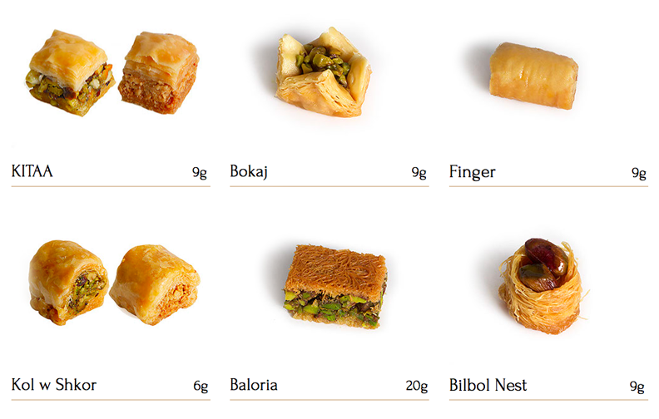

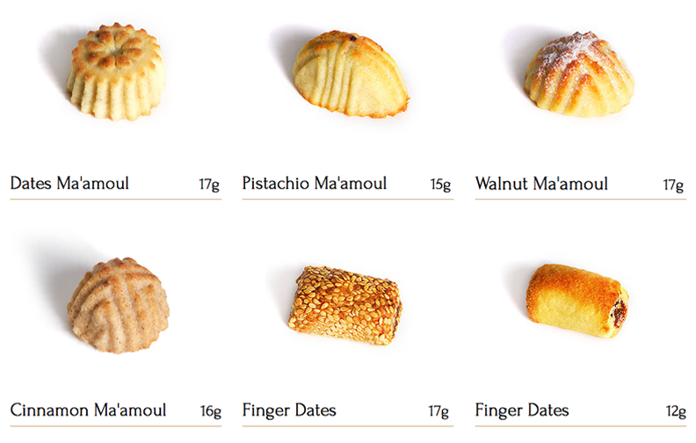

Source: Company materials.

Exhibit 2: Countries of the GCC (Shaded/in yellow)

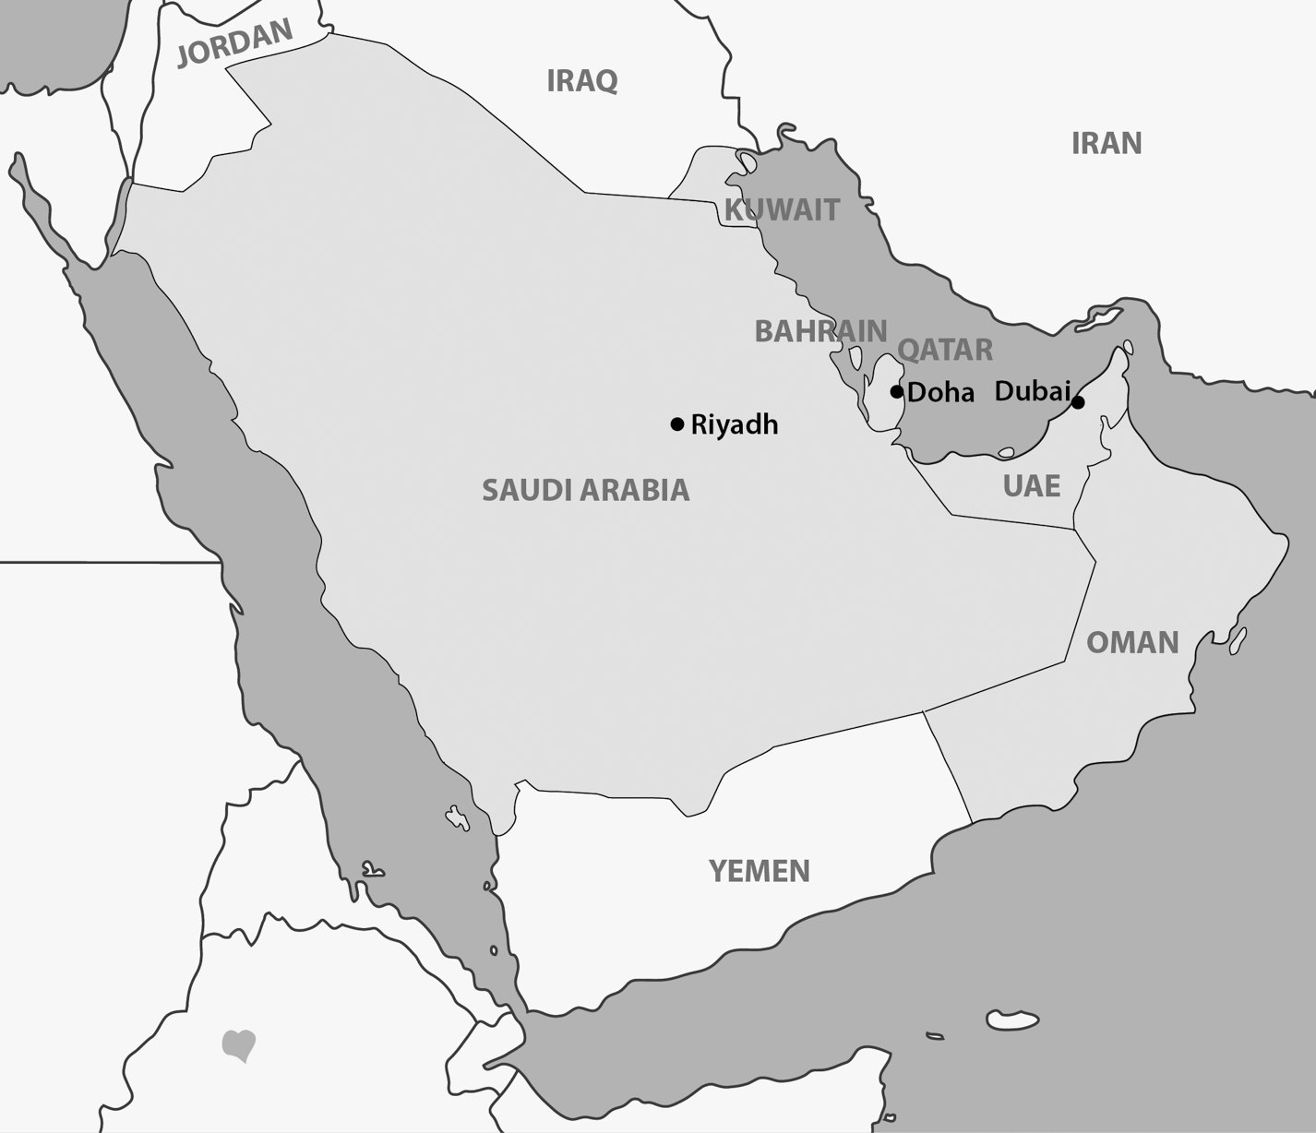

Source: Company documents.

Exhibit 3: BMB’s B2C brands and sample packaging

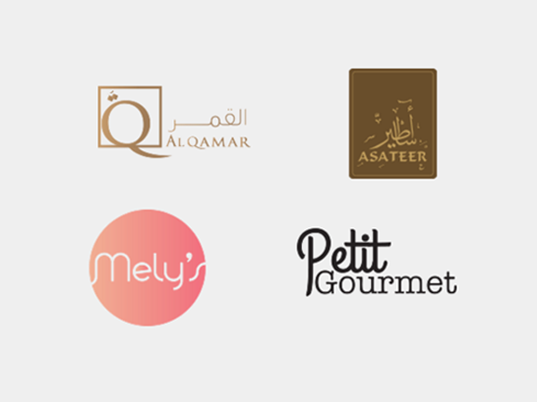

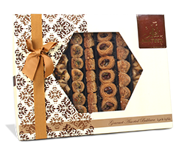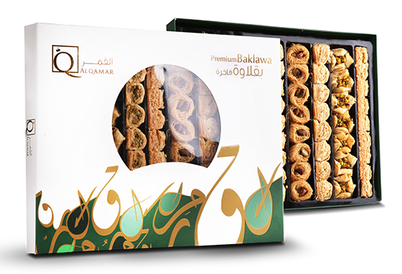

Source: Company materials.

Exhibit 4: Executive summary of potential new international markets FOR BMB

|  |  |  |  |
| --- | --- | --- | --- |
|  | **Benefits** | **Challenges** | **Country Statistics** |
| **Turkey** | * $3 billion baklava market* * Strong cultural taste for baklava * Shared cultural characteristics, such as an overwhelmingly Muslim population that also observes Ramadan | * Saturated market, uncertain brand power * Competitive prices * Not considered a special food, so no luxury angle * Because they live in the “birthplace of baklava,” Turkish customers could see imported baklava as lower quality | * Population: 75 million * Urban population: 73% * Per capita GDP (PPP):** $22,721 * Ease of business: 69/190 * Diabetes prevalence: 14.6% * Baklava price (October 2016): $8.58/kg |
| **United States** | * Less competition than Turkey * Exoticism of baklava is a potential selling point * Middle Eastern expatriates are clustered in a few locations | * Not an “everyday” purchase—more of an adventurous/exotic treat * Many health-conscious consumers who may not eat rich sweets * Small Middle Eastern expatriate population | * Population: 319 million * Urban population: 82% * Per capita GDP (PPP): $57,344 * Ease of business: 8/190 * Diabetes prevalence: 10.9% * Baklava price (November 2016): $36.50/kg |
| **India** | * Large potential market * Few existing competitors * Many cultural and religious festivals and celebrations * Brand power of an extravagant Middle Eastern treat could be strong * Cultural taste for sweets | * Low familiarity with or demonstrated taste for baklava * BMB unfamiliar with the local culture * Poor ease of doing business | * Population: 1.252 billion * Urban population: 33% * Per capita GDP (PPP): $6,586 * Ease of business: 130/190 * Diabetes prevalence: 8.6% * Baklava price (November 2016): $40.39/kg |

Note: * All currency amounts have been converted to US$; **GDP (PPP) = gross domestic product (purchasing power parity).

Sources: Amazon.com, “Baklava 1 kg,” Amazon, accessed December 1, 2016, https://www.amazon.com/s/ref=nb_sb_noss?url=search-alias%3Daps&field-keywords=baklava+1+kg; Amazon.in, “Baklava 1 kg,” Amazon, accessed December 1, 2016, www.amazon.in/s/ref=nb_sb_noss?url=search-alias%3Daps&field-keywords=baklava+1+kg; International Diabetes Federation, “Global Diabetes Scorecard: Tracking Progress for Action,” 2014, Brussels: International Diabetes Federation; International Monetary Fund, “World Economic Outlook Database, April 2016,” 2017, accessed August 9, 2017, https://www.imf.org/external/pubs/ft/weo/2016/01/weodata/weoselgr.aspx; Mithai4All, “Oasis Baklava,” 2017, accessed August 9, 2017, www.mithai4all.com/c/Baklava/Delhi/Oasis-Baklava/40/37.aspx; Turkish Statistical Institute, “2003 Based Consumer Price Index – Basket and Average Prices,” TurkStat, 2016, accessed December 1, 2016, www.turkstat.gov.tr/PreTablo.do?alt_id=1014; World Bank, “GDP per Capita, PPP (Current International $),” The World Bank Data, 2017, accessed August 9, 2017, http://data.worldbank.org/indicator/NY.GDP.PCAP.PP.CD?; World Bank, “Population, Total,” The World Bank Data, 2016, accessed December 1, 2016, http://data.worldbank.org/indicator/SP.POP.TOTL; World Bank, “Ranking of Economies, Doing Business,” The World Bank Data, 2016, accessed December 1, 2016, www.doingbusiness.org/Rankings; World Bank, “Urban Population (% of Total),” The World Bank Data, 2016, accessed December 1, 2016, http://data.worldbank.org/indicator/SP.URB.TOTL.IN.ZS?year_high_desc=true.

Endnotes

1. All currency amounts have been converted to US$.
2. The Nielsen Company, “Snack Attack: What Consumers Are Reaching for around the World,” September 2014, accessed November 23, 2016, www.nielsen.com/content/dam/nielsenglobal/kr/docs/global-report/2014/Nielsen%20Global%20Snacking

   %20Report%20September%202014.pdf, 4–5.
3. Oliver Nieburg, “UAE Set for Torrent of New Entrants as Chocolate Market Excels,” Confectionerynews.com, September 9, 2014, accessed November 23, 2016, http://mobile.confectionerynews.com/Markets/UAE-chocolate-market-growth-prospects.
4. TechSci Research “Saudi Arabia Confectionary Market Set to Grow with 12% CAGR,” press release, 2013, accessed November 23, 2016, www.techsciresearch.com/news/80-saudi-arabia-confectionary-market-set-to-grow-with-12-cagr.html; TechSci Research, “Saudi Arabia Confectionery Market Forecast and Opportunities, 2018,” press release, 2013, accessed November 23, 2016, www.techsciresearch.com/report/saudi-arabia-confectionery-market-forecast-and-opportunities-2018/311.html.
5. William Reed Business Media SAS, “Nestlé Opens $136 Million Dubai Factory,” Confectionerynews.com, December 13, 2010, accessed November 23, 2016, www.confectionerynews.com/Manufacturers/Nestle-opens-136m-Dubai-factory.
6. Aarti Nagraj, “Chocolate Maker Mars Invests $60m to Expand Dubai Factory,” Gulf Business, December 8, 2014, accessed November 25, 2016, http://gulfbusiness.com/chocolate-maker-mars-invests-60m-expand-dubai-factory/#.V47Gc5ODGko.
7. “Full-Year 2015: 4.2% Organic Growth, Trading Operating Profit Margin up 10 Basis Points in Constant Currencies,” Nestlé press release, September 18, 2016, accessed November 25, 2016, www.nestle.com/media/pressreleases/allpressreleases/full-year-results-2015.
8. Andy Sambidge, “Mars GCC Opens $40m chocolate factory in Dubai,” *Arabian Business*, May 27, 2010, accessed November 23, 2016, www.arabianbusiness.com/mars-gcc- opens-40m- chocolate-factory- in-dubai-

   271385.html#.V8yFbJN96Pl; “Nestlé Opens $136 Million Dubai Factory,” op. cit.
9. Nagraj,op. cit.
10. “Nestlé in the Middle East,” Nestlé, accessed November 23, 2016, www.nestle-me.com/en/aboutus/history/home.
11. “Sweets and Snacks Middle East: MENA Means Dubai,” Candyindustry.com, January 19, 2015, accessed November 30, 2016, www.candyindustry.com/articles/86581-sweets-snacks-middle-east-mena-means-dubai?.
12. Lucy Barnard, “UAE Chocolatiers Brace for Heavy Demand over Ramadan and Eid,” *The National*, July 12, 2014, accessed November 30, 2016, www.thenational.ae/business/industry-insights/retail/uae-chocolatiers-brace-for-heavy-demand-over-ramadan-and-eid.
13. Nieburg, op. cit.
14. Ibid.
15. Barnard, op. cit.
16. TechSci Research, “UAE Chocolate Market Forecast and Opportunities, 2019,” August 2014, accessed November 23, 2016, www.techsciresearch.com/report/uae-chocolate-market-forecast-and-opportunities-2019/374.html; Nieburg, op. cit.
17. Anadolu Agency, “Baklava, the Favorite Pastry for Turkish Feasts,” *Hurriyet Daily News*, January 6, 2016, accessed November 27, 2016, www.hurriyetdailynews.com/baklava-the-favorite-pastry-for-turkish-feasts.aspx?pageID=238&nID=93436&NewsCatID=377.
18. Statistics Center of Abu Dhabi, *Consumer Price Index Statistics: 2013*, Government of Abu Dhabi, 2013; “United Arab Emirates Food Inflation,” Trading Economics, 2016, accessed November 27, 2016, www.tradingeconomics.com/united-arab-emirates/food-inflation#.
19. Maryam Asi and Daniel Beaulieu, *Arab Households in the United States: 2006–2010* (Washington DC: US Census Bureau, 2013), 2.
20. Ibid, 5.
21. American Arab Institute Foundation, “Quick Facts about Arab Americans*,*” accessed November 29, 2016, https://d3n8a8pro7vhmx.cloudfront.net/aai/pages/9843/attachments/original/1432919063/quickfacts.pdf?1432919063; Heather Brown, Emily Guskin, and Amy Mitchell, “Arab-American Population Growth,” Pew Research Center, Journalism and Media, November 28, 2012, accessed November 29, 2016, www.journalism.org/2012/11/28/arabamerican-population-growth/#_ftnref1.
22. Government of India, *Religion Census 2011,* 2011, accessed November 29, 2016, www.census2011.co.in/religion.php; Gulf Research Center, “Gulf Labour Markets, Migration, and Population Programme,” April 20, 2016, accessed November 29, 2016, http://gulfmigration.eu/gcc-total-population-percentage-nationals-foreign-nationals-gcc-countries-national-statistics-2010-2016-numbers/.
23. The World Bank, “Doing Business: Measuring Business Regulations: India,” The World Bank Data, 2016, accessed November 29, 2016, www.doingbusiness.org/data/exploreeconomies/india.
24. World Bank Group, *Mobilizing the Middle East and North Africa Diaspora for Economic Integration and Entrepreneurship*, 2016, accessed July 29, 2017, http://documents.worldbank.org/curated/en/251661484064811210/pdf/111806-REVISED-PULIC-4530-MENADiasporaPaper-March29-5pm.pdf, pg. XI.
25. HM Government Office for National Statistics, “2011 Census Analysis: Ethnicity and Religion of the Non-UK Born Population in England and Wales,” June 2015, accessed August 9, 2017, http://webarchive.nationalarchives.gov.uk/20160106070721/http://www.ons.gov.uk/ons/dcp171776_407038.pdf, 4; The National Association of British Arabs, “Report on the 2011 Census – May, 2013: Arabs and Arab League Population in the UK,” 2013, accessed August 9, 2017, http://naba.org.uk/library/reports/census_2011.html.
26. Statistics Canada, *2011 National Household Survey*, Catalogue no. 99-004-XWE, 2013, accessed August 9, 2017, www12.statcan.gc.ca/nhs-enm/2011/dp-pd/prof/details/page.cfm?Lang=E&Geo1=PR&Code1=01&Data=Count&SearchText=Canada&SearchType=Begins&SearchPR=01&A1=All&B1=All&Custom=&TABID=1.
27. Encyclopædia Britannica, “Mexico: Ethnic Groups,” 2017, accessed August 9, 2017, https://www.britannica.com/place/Mexico/Ethnic-groups; World Bank, “Population, Total,” The World Bank Data, 2016, accessed August 9, 2017, http://data.worldbank.org/indicator/SP.POP.TOTL.
28. Brazil Ministry of Foreign Affairs, “Lebanese Republic,” 2016, accessed December 1, 2016, www.itamaraty.gov.br/index.php?option=com_content&view=article&id=7223:lebanese-republic&catid=155&lang=en&Itemid=478.