

9B17M153

Ergonomica consulting and solltram hotels: An Ethical Dilemma

Christopher Williams wrote this case solely to provide material for class discussion. The author does not intend to illustrate either effective or ineffective handling of a managerial situation. The author may have disguised certain names and other identifying information to protect confidentiality.

*This publication may not be transmitted, photocopied, digitized, or otherwise reproduced in any form or by any means without the permission of the copyright holder. Reproduction of this material is not covered under authorization by any reproduction rights organization. To order copies or request permission to reproduce materials, contact Ivey Publishing, Ivey Business School, Western University, London, Ontario, Canada, N6G 0N1; (t) 519.661.3208; (e)* [*cases@ivey.ca*](mailto:cases@ivey.ca)*;* [*www.iveycases.com*](http://www.iveycases.com)*.*

*Copyright © 2017, Richard Ivey School of Business Foundation Version: 2018-08-16*

In April 2017, Kawun O’Hara, senior manager at Ergonomica Consulting (Ergonomica), was under pressure to demonstrate within the next month, to her employer, as well as to key account Solltram Hotels (Solltram), that Solltram’s investment in high-frequency (HF) fluorescent lighting would meet or exceed the expected payback for the client. A lot depended on her being able to do this: winning an extension of the contract with Solltram, developing a new specialist practice area within Ergonomica, improving her chances of promotion, and cementing her reputation. Besides this, she was passionate about helping businesses with their environmental strategies.

However, at a critical moment, O’Hara had discovered that a previously hidden error in her main spreadsheet, which contained over two million data points, had resulted in her overestimating the cost savings for the client. The error would be virtually impossible for the client to discover. Should O’Hara conceal the mistake and win the important contract, improving her chances of promotion? After all, there could be other errors in the data or in the spreadsheet, and the client would still achieve cost savings and other positive outcomes from the project, including great publicity. Or should she own up to the mistake and risk losing the account, her promotion, and her reputation?

SOLLTRAM HOTELS GROUP

Solltram was founded in 1947 in Tacoma, Washington State, by Antony Solltram. The first hotel was a budget 40-bedroom motel off the main route between Tacoma and Seattle. The business grew steadily, and by the time Solltram handed it over to his son in 1974, it had 17 motels across Washington State. Antony Solltram Jr. took the brand upmarket, expanding into executive downtown hotels, as well as into California. The 1980s and 1990s was a period of tremendous growth for the company, with a new hotel opening practically every other month. By 2005, Solltram had 210 hotels in operation.

It was at that point that Solltram Jr. decided to sell the business to the executive through a US$320[1] million leveraged management buyout (MBO). The lender’s conditions stipulated that each of the five directors had to personally contribute $1 million. The balance came through a $315 million loan note payable in 2020. The executive included Andy Levitt, who had become chief executive officer (CEO) after having served as finance director, and Tom Chaparro, who was chief operating officer.

Levitt was a corporate finance high flyer who had made enough money on Wall Street to be able to retire by age 35. However, he found that playing golf every day became rather boring; he needed something to keep his mind occupied but without the 18-hour days he had worked on Wall Street. Through a friend, Levitt was introduced to Solltram Jr. in 2002. Solltram Jr. persuaded Levitt to take up the role of finance director with a view to leading the MBO. Levitt had no problems finding the $1 million to invest in Solltram.

Levitt’s colleagues described him as a wolf in sheep’s clothing: Most of the time, he came across as a benign but optimistic leader who let his team make decisions without appearing to care what they did. But if anything went wrong, Levitt quickly become intolerant and unforgiving.

Chaparro had started his career as an engineering apprentice in the aviation sector. After 10 years, he became a team leader and eventually moved into production management. In 1987, at age 30, he responded to a job advertisement for regional maintenance manager with Solltram. By that time, he had a young family and needed the extra $3,000 per year. Chaparro did not regret his decision, and over the next 15 years, he rose steadily in the ranks until he became chief operating officer in 2002.

Chaparro’s colleagues described him as a methodical and cautious person by nature. He would double-check anything and everything before making a decision. Although colleagues would criticize him for his slow and cautious decision making, he would counter by saying, “Look where I’ve gotten to; I think I’ve done alright, so why change?”

Not surprisingly then, it was a big deal for Chaparro when in 2005 he had to decide whether to invest $1 million in the MBO or leave Solltram and find a new job. After agonizing over the decision for weeks, Chaparro, with the support of his wife, decided to make the investment. This meant borrowing $1 million from the bank, a loan that was secured against his house. If it all went wrong, he would have to sell his family home.

Following the MBO in 2005, and under the guidance of Levitt, Solltram continued to grow. It opened 14 new hotels in 2006 and 16 in 2007. However, the global financial crash of 2008 hit the market hard. Either business travel was cut, or business travellers’ accommodation was downgraded to lower-cost accommodation. This forced Solltram to cut its prices and operating margin. Consequently, profits collapsed and Solltram had to sell or close 36 of its least profitable hotels through 2008 and 2009. This was a time of huge stress for Chaparro, who was all too aware of the consequences of the business failing.

By mid-2010, the business was stable once again, but there was little appetite for taking the risk of investing in new hotels. Instead, between 2010 and 2015, Levitt and his team focused on improving the profitability of Solltram’s existing hotels by cutting costs and increasing occupancy rates. They turned to outside help for advice on this. One of the advisory companies they engaged to support their cost-saving initiatives was Ergonomica, led by George Speed. Speed quickly became “a trusted adviser” to Chaparro on how to reduce energy costs through the design and specifications of the hotels’ heating, ventilation, and cooling systems. This advisory work resulted in a steady income for Ergonomica of around $95,000 per year.

At the start of 2015, Solltram had gross revenue of $800 million from 204 hotels. The average occupancy rate was 60 per cent, and the average hotel size was 125 bedrooms. The average revenue per occupied room per night was $100 from accommodation and $42 from food and drink. The company had done all it could to cut costs and now needed a new strategy.

A strategic review identified that increasing occupancy levels together with increasing the average revenue per night per room would be the most cost-efficient and lowest-risk route for returning to growth. To achieve this, Solltram needed to upgrade the standard of the accommodation by refurbishing the hotel’s portfolio. The average age of the company’s hotels was 25 years, and most were looking “tired” and in desperate need of a facelift. The company started on this new strategic path by borrowing $20 million to improve 39 hotels in Washington State. Solltram’s bank agreed to lend it the money to fund the program, which was given the name Project Jewel.

Project Jewel started in late 2015 with two pilot hotels that were completed by the end of that year. The change was impressive, and Solltram saw an immediate increase in occupancy, enabling it to start raising prices. In January 2016, Solltram held a Project Jewel Strategy Day that brought together its key suppliers, including Ergonomica, to review the two completed hotels and agree on a plan for rolling out refurbishments to the remaining hotels in Washington State. At the end of the meeting, Levitt approached Chaparro.

“Hey Tom,” Levitt said. “I’ve just had a very interesting conversation with Kawun O’Hara from Ergonomica about high-frequency lighting.”

“Oh, yeah?” replied Chaparro.

“Yeah, and I asked her to come along to our next board meeting with a proposal.”

ERGONOMICA CONSULTING

Speed had thought he was taking a risk when he started Ergonomica in 2002, but it was one with which he had felt comfortable. After all, having majored in engineering at Princeton University and accumulated 10 years’ experience in the automotive industry, an MBA, and 10 years working for a major engineering consultancy firm, if he could not make it, who could?

Speed considered there to be a gap in the market for a consultancy firm that could identify and deliver pragmatic and cost-effective environmental programs for businesses. He believed that the big consultancy firms that claimed to assist with environmental programs were composed of either accountants with no practical engineering skills, engineers with no communication skills, or environmentalists with no commercial skills. Ergonomica was going to fill that gap. Moreover, Speed felt passionately that, as well as having technical skills, Ergonomica would be a consultancy firm with a reputation for honesty—it would genuinely put the client first.

Speed quickly found a winning formula, and Ergonomica grew steadily between 2002 and 2007. This growth was in no small part because of Speed’s personality and charisma. He was a natural leader and a larger-than-life character; he was always smiling, always positive, and always reassuringly confident. People knew they could trust Speed. Clients liked engaging him, and his employees liked working for him. In the firm’s first six years, Speed employed two junior partners, six directors, 15 senior managers, and 24 managers—all who worked along the West Coast. The remaining employees were consultants and support staff.

In the fall of 2007, disaster struck. Financial markets crashed. Within weeks, Ergonomica had lost some of its longest-standing clients. Although the type of projects Ergonomica specialized in offered very good returns, cash flow was suddenly at the top of clients’ agendas. Capital investment abruptly stopped.

Up to that point, Speed had given his employees only good news, such as “positive sales growth,” “new projects,” “new clients,” and “bonuses.” Now there was no good news. He decided to try to ride out the storm and shield his employees from the reality of the situation. Speed hoped the crash was simply a short-term overreaction in the stock market and that the economy would be back to normal within a few months.

However, by spring 2008, there had been no uplift, and Ergonomica experienced a loss for the first time. Speed realized that if things did not improve by mid-year, he would be forced to let staff go. Until then, he wanted to keep a positive front for his employees.

“We’re nearly through this—there’s lots of new projects just around the corner,” he would tell his team.

To his partners, he would justify his approach to employees by explaining, “There’s no point in dishing out the bad news until it is absolutely necessary, otherwise people will start looking for new jobs. Unfortunately, it’ll be our best employees who find new jobs first, the ones we really want to keep. So let’s try to keep things positive.”

By summer of that year, things had not improved. Despite Speed’s best efforts to remain positive, rumours were rife within Ergonomica that there were going to be cuts. Morale dropped, and absenteeism increased through sickness and one-day holidays, which Speed suspected were used for job interviews. At the end of August, Speed and his partners decided to cut Ergonomica’s workforce by 35 per cent. Forty-eight non-billable and underutilized staff were let go, including a large portion of a program management and quality assurance office that had only been set up in 2006. Speed figured these job cuts might have been more than what was necessary, but he wanted to do only one round of cuts. As for the employees left behind, Speed wanted them to be utilized as much as possible on billable projects, and to “be really, really busy with clients, generating cash flow.”

Although the redundancy program was painful, Speed noted that it had the desired effect. Ergonomica returned to breakeven at the end of the year. During 2009, the Federal Reserve System’s quantitative easing started to take the pressure off corporate cash flow, and Ergonomica’s clients began to invest in new projects again. By the end of 2009, Speed felt positive about the company’s prospects, and at the company’s February 2010 board meeting, he and his partners decided to start recruiting again (see Exhibit 1). One of the partners asked Speed, “Have you thought of approaching Kawun O’Hara at the [California] Department of Public Health?”

KAWUN O’HARA

As O’Hara’s flight came in for a landing at the Los Angeles International Airport after a family holiday in Canada in 1990, she stared in amazement at the smog covering the great city. The family had just spent a week in the fresh air of the Canadian Rockies.

“Why have the clouds fallen on the ground?” she asked her father, who sat next to her. Despite his uncertainty, her father did his best to explain air pollution and exhaust emissions to his 11-year-old daughter. O’Hara never forgot her feeling of apprehension that day as the plane dipped into the grey–blue fog, nor the acrid air when the plane doors opened and the drive home through gloomy streets.

That day sparked in O’Hara, although she was young, an interest in the causes and effects of pollution that she pursued throughout high school. She was particularly inspired by Erin Brockovich, a woman who, despite a lack of formal education in law, was instrumental in building a successful lawsuit against the Pacific Gas and Electric Company of California in 1993 for contaminating drinking water. O’Hara subsequently became a supporter of the Erin Brockovich Foundation, and a lifetime member of Greenpeace.

At university, O’Hara majored in biology, after which she undertook research that involved developing a mathematical model to describe the relationship between fertilizer-intensive farming and freshwater algae blooms. Algae blooms occurred when algae grew out of control. This process produced toxins that were harmful to people, marine life, and birds, and was often related to the pollution caused by fertilizer runoff from intensive crop farming.

O’Hara could have happily spent the rest of her life working in the fascinating and stimulating—though poorly paid—world of environmental research. However, at age 27, she unexpectedly became a single mother, and reality hit. She wanted to get a better-paying job and earn more money to be able to support herself and her daughter Jasmine, and to afford a live-in nanny so that she could stay active in her career.

In 2006, O’Hara got a job with the California Department of Public Health. Her role was to promote an understanding of climate change and advise the public and local businesses on what they could do to prevent it; for example, she promoted the use of public transit and investing in renewable energy. O’Hara rose quickly through the ranks as she showed real talent, persuading people to change through a combination of her positive and engaging personality and her use of robust facts and data analysis to support her case.

By 2010, O’Hara had built an excellent local reputation as someone who could make a difference—someone who could help businesses to deliver environmental improvements without compromising their strategy for growth and shareholder returns. So it was no surprise when she received a call from Speed at Ergonomica.

O’Hara had heard of Ergonomica from some of the local CEOs she had advised. The company appeared to have a good reputation for guiding businesses on how to invest in new energy-saving technologies.

Over lunch in downtown Seattle, O’Hara was quickly persuaded by Speed to join Ergonomica as a manager. She liked Speed’s honest and pragmatic approach. Although the salary was slightly lower, the package from Ergonomica included a performance-related component and sales bonus, which meant she should be able to earn significantly more than she did in the state sector. This, she hoped, would be enough to allow her to afford the beach condominium she wanted for her growing daughter.

After O’Hara joined Ergonomica, she enjoyed a successful honeymoon period, when everything seemed to go her way. She was assigned to receptive clients with interesting projects, which she delivered on time and on budget. She also began to sell some small pieces of repeat business to existing clients, which helped raise her income above the income she had enjoyed at the California Department of Public Health. By 2012, O’Hara felt she had the best job ever. She was working hard, was well paid, had been promoted to the position of senior manager, and was helping to save the environment—her passion for the past 20 years. How could it get any better?

However, 2013 got off to a bad start. First, O’Hara’s live-in nanny, who had worked for her for seven years, notified O’Hara of her intention to leave the job, as she would be getting married and moving to the East Coast. Although O’Hara was able to get another nanny, Jasmine reacted badly to the change. She became more demanding and more intolerant of O’Hara working late at the office. This meant O’Hara had to cut back on her hours, and cut back on client and company social events. After six months, she noticed that her sales started to drop. Her income then started to drop, and she was worried she was no longer the rising star she had once been.

A LUCKY BREAK

In November 2013, Speed introduced O’Hara to Chaparro at Solltram. In a bid to expand Ergonomica’s business with Solltram, O’Hara was tasked by Speed to sell to Solltram an energy-saving, HF fluorescent lighting project. For the first time at Ergonomica, she felt she had a client who was going to be difficult.

O’Hara’s hunch was right. For two years, she made regular presentations to Chaparro on the case for investing in HF lighting, and Chaparro rejected these proposals every time on the basis of having limited capital expenditure (capex). He thought that the capex he did have available should be spent on replacing heating, ventilation, and cooling systems, because the failure of these systems meant having to close the whole hotel until they were fixed. He did not face this problem with lights.

HF lighting used high-frequency, solid-state electronic circuitry, called “ballast,” to start and run a standard fluorescent tube, and it replaced the original electromagnetic ballast. HF ballast had a number of benefits over electromagnetic ballast.

The tangible benefits of HF ballast were that it lowered electricity consumption, and therefore reduced carbon footprints. It also lowered maintenance costs by extending the ballast’s life.

The intangible benefits of HF ballast were its production of a higher light output from a standard florescent tube and its improved ambiance due to reduced flickering and noise (electromagnetic ballast was prone to producing light flickering and a humming noise, both of which could induce tiredness and headaches).

HF ballast had become the standard in new light fittings, but its initial high cost meant that it was not cost-effective for retrofitting to existing fluorescent lights. However, lower-cost imports from China and rising electricity prices made retrofitting an increasingly cost-effective option.

By October 2015, having conspicuously failed for two years to sell the low-energy lighting project to Solltram, and having failed to close a decent sale to any client for 30 months, O’Hara was starting to feel the pressure. Nothing had been said openly, but she was getting the impression that the promotion she was after had slipped from Speed’s agenda. He had started taking some of the other, less experienced senior managers to sales meetings instead of her. She needed a big win, and she needed it quickly.

In January 2016, O’Hara had a lucky break. During the Project Jewel Strategy Day with the Solltram board, she managed to briefly discuss her idea for low-energy lighting over coffee with CEO Levitt.

“Sounds interesting, Kawun,” he said. “Why don’t you put a proposal together for us to trial it in our Washington State portfolio, and come and present to the board? Let’s see what they think.”

**EVENTS LEADING UP TO APRIL 2017**

In February 2016, O’Hara commissioned several HF lighting suppliers to survey the existing lighting systems and tender costs for Solltram’s 39 hotels in Washington State. As the survey data started to come in, O’Hara began to build an asset register comprising 15,000 light fittings across the 39 hotels. She then added data on current levels of electricity consumption and costs, the material and labour costs for converting the lights to HF, and finally some assumptions around how many times each light was switched on and off and what the maintenance costs were likely to be. After a week of intense analysis with a large and complex spreadsheet, O’Hara finally had the headline numbers for the Washington State business case:

* Capex: $1.1 million
* Savings: $440,000 per year electricity savings + $100,000 per year maintenance savings
* Payback: Two years

Included in the $1.1 million was Ergonomica’s fee for project managing the delivery of the work, which was $120,000. Speed was delighted. “This’ll double our income from Solltram if they buy it!” he beamed.

In March 2016, following two weeks of preparation, O’Hara presented her proposal for investing $1.1 million in low energy lighting for the 39 hotels in Washington State. It was a very compelling case:

* Two-year payback from lower electricity and maintenance costs
* Improved ambiance in the “front of house” (guest areas) from the new lights
* Improved environmental credibility from a lower carbon footprint

“So what do you think?” Levitt asked the rest of the Solltram board after O’Hara’s presentation. Most looked at Levitt with glazed eyes—lighting was something they simply could not get excited about. They wanted to discuss the presentations on revenue, growth, acquisitions, and stock prices.

“To be honest, Andy,” piped up Chaparro, “I’ve heard this sort of pitch from a hundred salespeople, and the bottom line is that the savings never come through.” He continued, “With respect to Kawun, this is all smoke and mirrors, and even if it does deliver what’s promised, it is a drop in the ocean compared to our electricity bill—something like 4 per cent. In my opinion, we’ll never see these savings, but if you give me that $1.1 million I could facelift four hotels, and that’s where we should be spending our money.”

O’Hara’s heart sank upon hearing this, although she tried not to show it.

“Tom, you’re absolutely right,” Levitt said as he focused his gaze on Chaparro. He continued,“But as you know, we do precious little to support the green agenda: we talk the talk but never walk the walk. Now I’m not a tree-hugger, but equally I do think we need to do something for our environment, and this is a tree-hugging investment with a two-year payback. Kawun says so, and to be honest I’m inclined to believe her. The stuff you’re doing, Tom, is critical to the future of our business but the paybacks are all around three years.”

“But Andy,” pleaded Chaparro, “you’ve seen the figures; we’re hardly making a profit, cash is really tight, and more than anything we committed to the bank to focus our capex solely on the business strategy we presented to them last year. This pitch is way off-track; we need to put every cent into refurbishing our hotels, not on a pet ‘environmental’ project.”

“Fair point, Tom,” said Levitt. “Anyone else got a view?”

“I’d give this project my support,” responded Anna Frost, head of corporate social responsibility. “We could get some good PR out of this—perhaps some articles in the local papers, and we know our colleagues like to see us doing stuff for the local environment. I’d say $1 million is within our means.”

Levitt leaned back, paused, and summed up his thoughts: “We’re only talking 5 per cent of the capex budget for this year—and I’m sure if we went to the bank they would support an investment with a two-year payback, but if I did go to the bank we would get wrapped up in red tape amending the strategy, and before you know it the opportunity has gone. Having heard all points of view, I suggest we go with this project. It sounds like the right thing to do from so many points of view—except Tom’s.” He smiled as he winked at Chaparro. “Washington will be a trial, Phase 1 if you like, and if it goes to plan we can look at Phase 2, the California portfolio.”

Hearing this, Chaparro knew he was beaten.

Having received the green light to deliver the project, O’Hara appointed the contractor who had won the tender to install the lights, Lite-U-Like Inc. She worked hard with them to ensure the right lights were installed in the right place, at the right time, and at the right cost. As the project progressed, she was rewarded with positive feedback from the hotel managers and staff:

“These lights have transformed the place.”

“It is so much brighter—almost as if the place has been redecorated.”

“The engineers from Lite-U-Like were very good, really kept the place clean and tidy as they worked.”

“Good to see someone cares about our environment so much they’ve put their hand in their pocket.”

By November 2016, all 39 hotels had been converted to HF, on time and on budget. All O’Hara had to do then was to measure the reduced electricity consumption, and demonstrate that the savings were in line with the plan. Demonstrating this would be crucial to cementing the relationship with Solltram and winning the deal for Phase 2 in California.

“I’ll give it another month,” she thought, “before I download and analyze the data. That’ll mean all the hotels will have been operating with the new lights for at least two months.”

One evening in December 2016, after her daughter had gone to bed, O’Hara sat down with her laptop. “Time to concentrate,” she thought, as she downloaded the electricity consumption of each hotel from the supplier’s web portal.

O’Hara had always been a good mathematician, and she truly enjoyed analyzing complex data. She had seen in the past how it could reveal very powerful business insights. Analyzing electricity savings was a great example of this. The electricity meters fitted to each hotel measured consumption in half-hourly intervals and transmitted the data to a web portal for downloading and analysis. As the consumption varied on an hourly, daily, monthly, and yearly basis (see Exhibits 2, 3, and 4) by considerably more than the 4 per cent savings she was looking for, the analysis was going to be quite complex. A variation in consumption was caused by dependencies such as occupancy levels, outside temperature, hours of sunlight per day, and events in the hotels such as conferences and discos. O’Hara knew from experience that the strongest correlation would be with the outside temperature; the warmer it was outside, the less electricity was used to heat a hotel, until it became so warm that the air conditioning kicked in and the electricity consumption started to rise again (see Exhibit 5).

O’Hara decided to calculate the savings by looking over a long period—three years—to smooth out variables that had a limited correlation with consumption. These included, for instance, levels of hotel occupancy. She used linear regression to account for a range of control variables—other factors that could explain electricity consumption. She had used this approach many times over the years and it had always given very good results. This time, however, it was not so easy to analyze the data. Over three years, 39 hotels would produce around 2,000,000 data points (48 points per day × 365 days × 3 years × 39 hotels). She knew she had to take great care with her analysis. O’Hara had done this sort of analysis dozens of times before, and she took a great sense of satisfaction in knowing that she was one of the few people in Ergonomica who was able to do it. Indeed, since the re-organization in 2008, only two people in the company did this particular type of analysis on hotel data.

After four hours of careful and detailed work, O’Hara finally had her first insight into the actual savings that were being delivered for Phase 1, based on two months of data:

* forecast annual savings of $540,000 per year, and
* actual savings run-rate of $580,000 per year.

“Amazing!” she thought, hardly daring to believe what she saw. “We’re above target!”

Just to make sure of this, she spent the next half an hour going through her calculations and spreadsheet formulas again. She arrived at the same result, and thought, “Excellent. I can’t wait to tell Tom!”

She was so keen to share the good news that she immediately sent an e-mail, timestamped at 1:15 a.m., to Speed, Chaparro, Levitt, and Frost, and then went to bed smiling.

The next morning, Speed replied with, “Excellent news.” A couple of hours later, Levitt replied, “Good start.”

“Please, could you continue to monitor and issue an update after Christmas?” came the reply from Chaparro—three days later.

In February 2017, after a fantastic Christmas break, O’Hara relished the idea of sitting down once again in her home office to crunch another two months of data for Phase 1. Once again, she was delighted:

* forecast annual savings of $540,000 per year, and
* actual savings run-rate of $590,000 per year.

This was marginally up from the previous calculation, and O’Hara was very pleased. The savings were nearly 10 per cent ahead of plan based on four months of data. She was starting to become very comfortable with the results. Once again, she was keen to share the good news in a late-night email.

“Excellent,” Speed replied the next morning. “This really does look promising,” replied Levitt, a couple of hours later.

“Dear Kawun,” began Chaparro’s reply, “I have to confess that I may have been wrong—these savings really are good, much better than I would have thought. I have to also report that I have had some excellent feedback from our colleagues in terms of the improvement to the look of the hotels. I’m thinking that we should look at including this upgrade in my Hotel Refurbishment Program. Perhaps you could put some thought into that?”

“Hi all,” replied Frost. “Just to say the local newspaper has just done a nice little page-three article on this project. We tied it into a press release on the ‘Annual Litter Pick’ that a few of our managers do each year. I’m talking to a couple of TV stations later as well. We got some good feedback from our colleagues too—it seems they like to be associated with a business that does more than just think about the bottom line.”

On April 27, 2017, back at the office in Seattle, Speed approached O’Hara.

“Great news, Kawun: Tom wants us to deliver Phase 2 of the energy-saving lighting project in the California portfolio as part of his refurbishment program. That’s 165 hotels!” he beamed. “He’s been really impressed with the improved ambiance for residents as well, and you’ve convinced him that the savings are coming through. He wants you to put together a proposal by tomorrow; is that okay?”

“Wow,” replied O’Hara. “I imagine that’s going to be at least a $4 million project.”

“Well, with around 10 per cent for us that sure will help your case for promotion!” said Speed.

Later that evening, O’Hara made a coffee, and sat down to put together the business case for the investment. She had been anticipating this and so had most of the information ready to use. By 7:00 p.m., it was complete. All she had really done was conduct pro-rata calculations of the costs from the Washington portfolio, used the savings she had calculated back in February, and cut and pasted the text.

O’Hara was just about to e-mail the proposal to Speed for his approval when she thought, “It’s only 7 o’clock; I’ve actually got time to update the actual savings calculation for the Washington portfolio and put that in the business case instead of February’s calculation. It’s possible that the savings might be even better now, which would make the case even more compelling.” With renewed energy, she sat down to update the energy savings calculation. O’Hara was feeling very pleased; she was close to winning an important contract for Ergonomica, but more importantly for her, she had won over Chaparros’s skepticism and put herself back in contention for a promotion.

Everything was looking very rosy until O’Hara looked as the spreadsheet on her laptop a second time. She could not believe what she was seeing. Her heart rate increased and she shifted uneasily in her chair.

“How could I have been so dumb?” she asked herself.

She had just realized that the savings numbers for Phase 1 of the project, which she had presented to Levitt and Chaparro eight weeks earlier, were wrong—and they were wrong because of a simple error O’Hara had made linking cells from different sheets within her spreadsheet. This meant that, once corrected, the $1.1 million capex she had convinced Levitt to invest in HF lighting would take four years to payback, not the two years she had assured him. O’Hara winced as she remembered using phrases such as “low risk” and “predictable savings” in her business case, and the skepticism with which Chaparro had received it.

**OPTIONS FOR O’HARA**

O’Hara looked again at the error. She checked previous versions of the spreadsheet and found the error had always been there. She put her head in her hands. It was getting late and she could see only two options.

Option 1

Ignore the error and do not tell anyone about it. Issue the business case with the (incorrect) savings and secure a major piece of work and a promotion, and achieve something positive for the environment.

Option 2

Own up to the mistake and to the fact that the savings were only half of what was reported previously.

This could jeopardize everything—the firm’s relationship with Solltram, O’Hara’s promotion, and, perhaps more than anything, her reputation.

EXHIBIT 1: GROWTH OF ERGONOMICA CONSULTING (2002–2010)

|  |  |  |
| --- | --- | --- |
|  | Number of Employees at Year End | Utilization Rate of Billable Staff (%) |
| 2002 | 2 | 60 |
| 2003 | 18 | 74 |
| 2004 | 33 | 73 |
| 2005 | 64 | 81 |
| 2006 | 78 | 88 |
| 2007 | 138 | 56 |
| 2008 | 93 | 34 |
| 2009 | 89 | 61 |
| 2010 | 95 | 72 |

Source: Created by case authors.

EXHIBIT 2: Variation in Electricity consumption, Hour-to-Hour

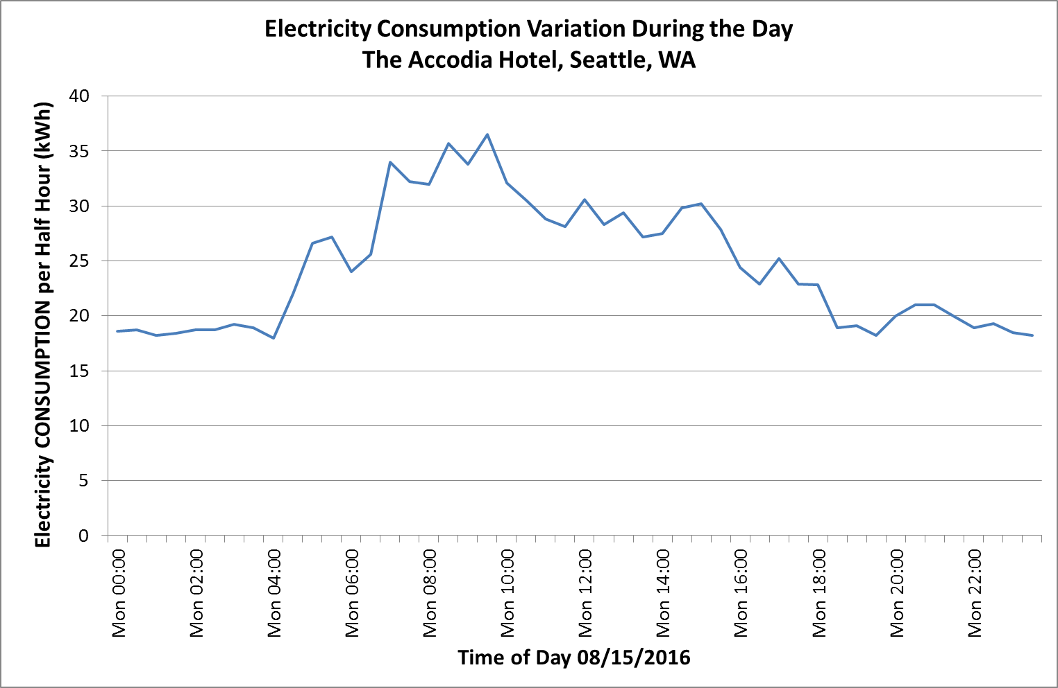

Note: WA = Washington State; kWh = kilowatt hours.

Source: Created by case authors.

EXHIBIT 3: Variation in electricity consumption, Day-to-Day

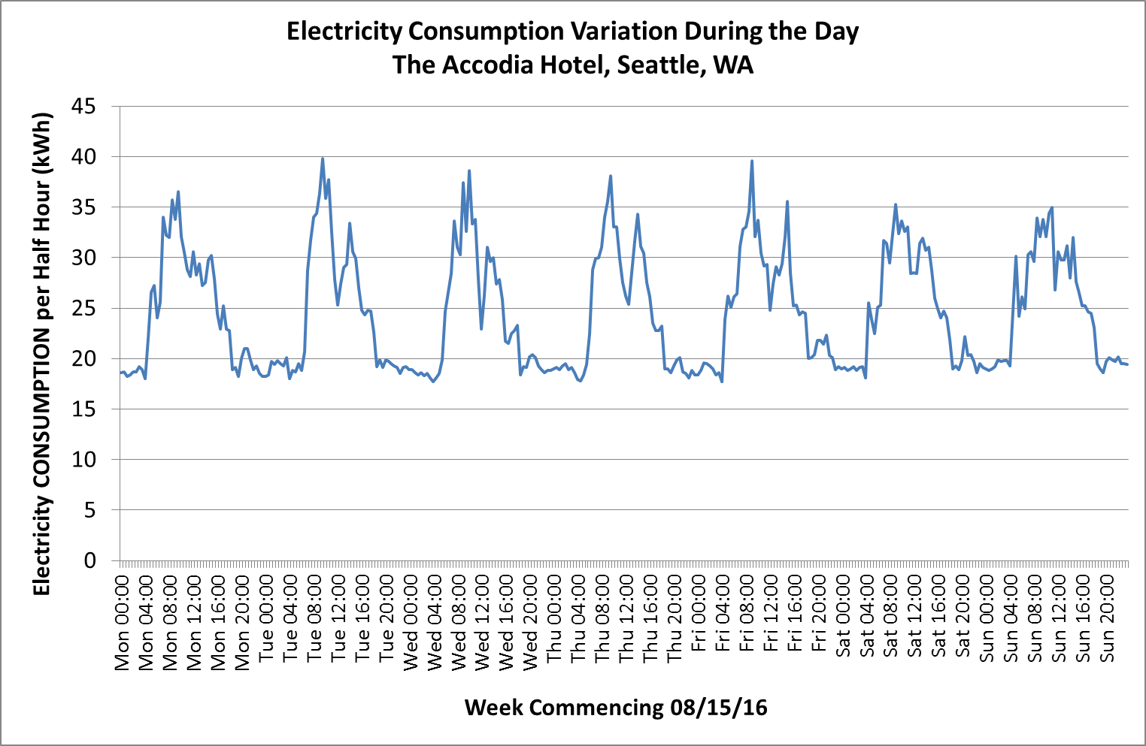

Note: WA = Washington State; kWh = kilowatt hours.

Source: Created by case authors.

Exhibit 4: Variation in electricity consumption AND OUTSIDE TEMPERATURE

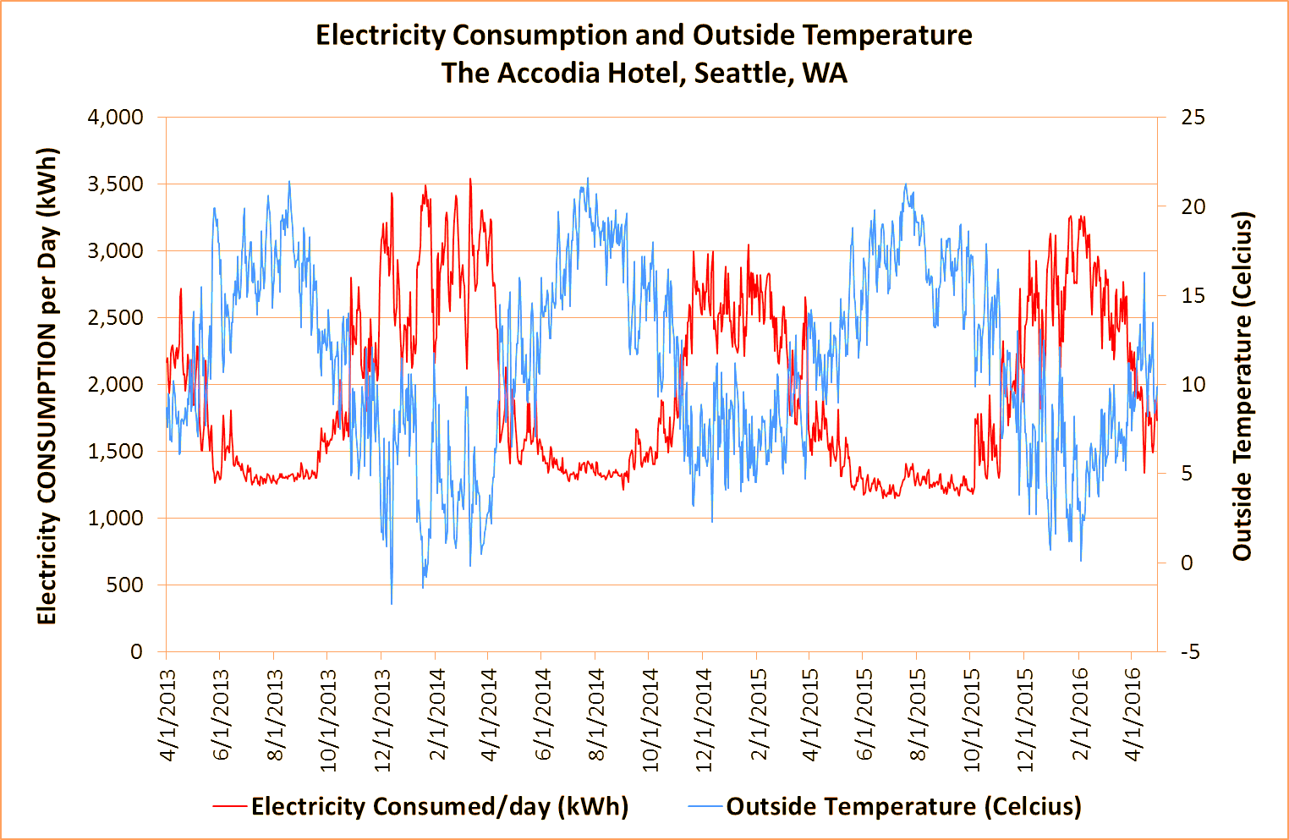

Note: WA = Washington State; kWh = kilowatt hours.

Source: Created by case authors.

Exhibit 5: Relationship between electricity consumption and outside temperature

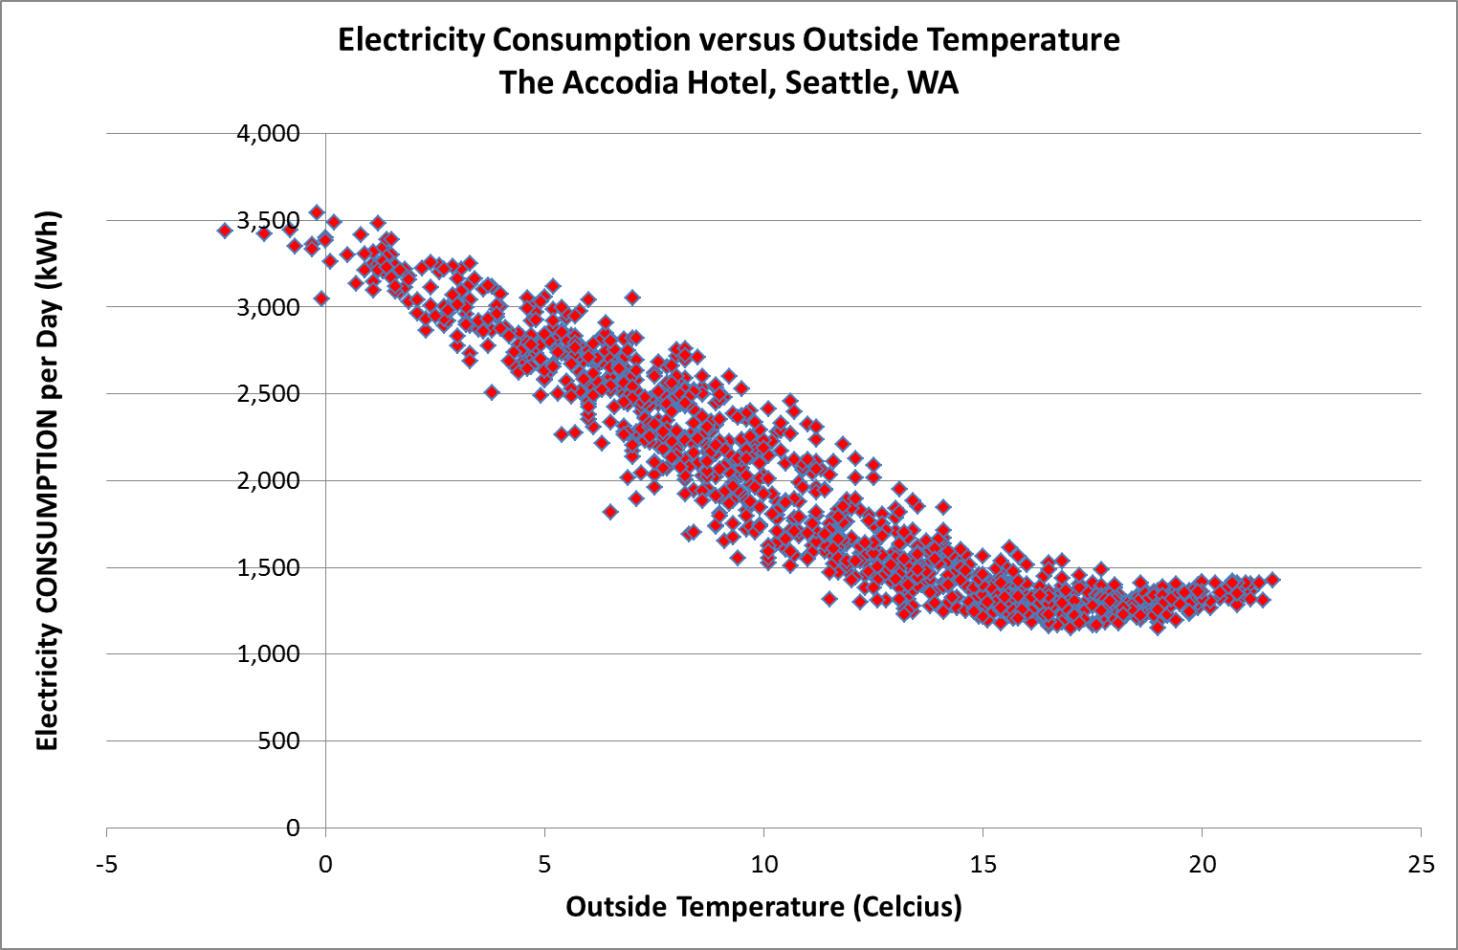

Note: WA = Washington State; kWh = kilowatt hours.

Source: Created by case authors.

1. All currency amounts in the case are in U.S. dollars.