

9B17M156

SOFAME TECHNOLOGIES INC.: REORGANIZING FOR GROWTH

Ken Mark wrote this case under the supervision of Professor Simon Parker solely to provide material for class discussion. The authors do not intend to illustrate either effective or ineffective handling of a managerial situation. The authors may have disguised certain names and other identifying information to protect confidentiality.

*This publication may not be transmitted, photocopied, digitized, or otherwise reproduced in any form or by any means without the permission of the copyright holder. Reproduction of this material is not covered under authorization by any reproduction rights organization. To order copies or request permission to reproduce materials, contact Ivey Publishing, Ivey Business School, Western University, London, Ontario, Canada, N6G 0N1; (t) 519.661.3208; (e)* [*cases@ivey.ca*](mailto:cases@ivey.ca)*;* [*www.iveycases.com*](http://www.iveycases.com)*.*

Copyright © 2017, Richard Ivey School of Business Foundation Version: 2017-10-19

It was November 5, 2015, and Robert Presser, the chairman of Sofame Technologies Inc. (Sofame), a Montreal-based manufacturer and marketer of environmentally friendly industrial flue gas heat-recovery systems, faced a dilemma. Sofame’s custom-engineered systems, which had won several international engineering awards, allowed firms to capture the waste heat generated by exhaust gases from boilers and turbines, turning the heat into usable energy in the form of hot water.

The firm had struggled for more than a decade as it tried to build on its early successes, but a weaker energy market and low natural gas prices, as a result of fracking,[1] had undermined the requisite two-year return on investment demanded by the corporate treasury managers. Sofame’s carbon credit management subsidiary had failed as a result of shifting government policies, and all these events culminated in the provincial securities commission, Quebec’s Autorité des marchés financiers, placing Sofame’s stock under a “cease trade” order until its 2014 financials were filed. In November 2015, Sofame was precariously close to insolvency. After having spent CA$18 million[2] of investors’ money and having issued 189 million common voting shares over the past two decades, the firm was almost bankrupt.

Presser, who was also the chairman of a Canadian Crown corporation, had a vested interest in seeing the firm survive without undergoing the bankruptcy process. Presser and Sofame’s chief executive officer, John Gocek, devised a plan to acquire a U.S. firm specializing in boiler room services and merge the two firms, thereby creating a vertically integrated business that generated cash flow (from sales of boiler parts and services) and offered upside potential for growth by cross-selling energy-recovery systems.

Presser saw value in the proven technology and was trying to put together a viable plan that would save the firm. But how could Sofame finance the acquisition? To whom could Sofame reach out for funding? Presser was considering a significant restructuring effort but wanted to consider his options.

The Market for Industrial Heat-Recovery Devices

Sofame had two trends working in its favour: its stakeholders’ increased environmental awareness regarding carbon footprint reduction that were coming into effect of stricter environmental regulations concerning fuel combustion emissions.

Sofame’s market included any institutional building, hospital, manufacturing plant, or government facility that had a steam boiler system and/or a turbine generating electricity. The U.S. industrial boiler market was a multibillion-dollar industry with growth forecast at 2 per cent per year for the next 10 years. The largest users of industrial boilers were food producers and the chemical industry. An estimated 163,000 industrial and commercial boilers were in operation in the United States.[3] Sofame estimated that its addressable core market in the United States encompassed at least US$2 billion of new boiler sales annually.

Sofame Technologies Inc.[4]

Sofame was founded in 1984 by Luc Mandeville and his partners, a group of mechanical engineers. They started the firm when they saw an opportunity to recover waste heat from industrial flue gases. Sofame’s products heated water for commercial-industrial applications. Sofame listed its shares in 1997 on what is known today as the TSX Venture Exchange. At about the same time, Gaz Métro, Quebec’s largest distributor of natural gas, took an equity interest in Sofame and introduced the company to Gaz de France. With these two industry partners, Sofame continued to develop new applications for direct-contact hot water heating and waste heat–recovery equipment. In direct-contact heat recovery, cool water was sprayed into the flue gases to absorb both sensible and latent heat, and then pumped through a loop to heat exchangers. The heated process water or potable water from the heat exchangers was then redistributed into the end-user’s system or process.

The heat source in a Sofame system could be an integrated burner firing natural gas, no. 2 heating oil, or waste heat from flue gases of existing steam boilers and turbines. The recovered energy was returned to the process or building as hot water or pre-heated make-up air. Sofame’s direct-contact water heaters were custom-engineered and custom-manufactured, and often achieved 99 per cent efficiency, compared with traditional indirect-contact alternatives, which were between 50 and 85 per cent efficient. More importantly, depending on the efficiency of the client’s existing heating system, Sofame’s products could reduce natural gas consumption and related costs by 10–30 per cent, while reducing greenhouse gas emissions. An example of a typical unit was installed in the Edmonton International Airport (see Exhibit 1).

With its industry partners, Sofame filed several joint patents, and projects were completed in France, Canada, Mexico, and the United States. From 2003 to 2007, Sofame had to renegotiate its debts and recapitalize itself with funds from the two utility partners. The company seemed to regain its footing from 2003 to 2007, riding the increase in world energy prices. From 2007 through 2009, Notre-Dame Capital Inc. and its clients initiated a follow-on investment of $5.6 million in Sofame. Notre-Dame Capital Inc. was joined by Soffimat SA, a diverse, private French power producer, which invested $1 million in Sofame common shares.

Sofame’s Heat-Recovery Products

From 1997 to 2007, Sofame’s products won eight engineering awards in the United States and Canada. Sofame’s technology was protected by several patents in North America, Europe, Japan, and Brazil. Sofame’s most successful products were the Hybrid Percomtherm and the Sofame Steam Pump, a patented direct-contact stack economizer that used boiler make-up air as a heat sink for recovered energy (see Exhibit 2). Sofame’s other products included Percomax, a water heater using direct-contact, heat-recovery principles, and Percotherm, a heat-recovery condensing economizer. The capacities of recovered energy in a Sofame system started at one megawatt (MW) per hour, which was the approximate requirement of a 150-room hotel. The prime target markets for Sofame’s high-efficiency technologies were large industrial boiler rooms, hospitals, and district heating plants. In industrial facilities, heating equipment generally had long service lives—25 years or more.

Sofame’s customers were looking for a 100 per cent return on capital invested within 24 months of the start of operations. After the 2008–2009 recession, customers tended to require shorter payback periods, closer to 12 months or less. The total capital required for an average Sofame system including installation was $750,000. While the value proposition seemed very attractive, Sofame’s sales cycle continued to be between six and 36 months as a result of the need for preliminary engineering, data collection, and capital spending approvals within a typical client’s organization. Sofame sold its heat-recovery units directly to owners and through manufacturers’ representatives who were given exclusive territories. Territories could be as large as several states and provinces or as small as a large metropolitan area. Gross margins per project ranged from 25–35 per cent.

Direct competitors included small, regional providers such as Quikwater in Oklahoma, Direct Contact in Washington, Thermal Energy International Inc. in Ottawa, and Kemco Systems Co. LLC in Florida. Despite the attractiveness of the opportunity and the lack of competition, Sofame’s financial results had been lacklustre (see Exhibits 3–5).

In 2011, Sofame outsourced virtually all of the manufacturing work required to produce its systems. As a result, its burn rate consisted of the salaries of management (the board worked on a pro bono basis—i.e., without payment), interest on debt, and public company costs of approximately $75,000 per year. In 2015, Sofame’s financial results declined further, with revenues dropping 15 per cent and net losses increasing by 15 per cent. In 2015, Sofame was working on delivering nine contracts in total. After years of downsizing,[5] Sofame employed minimal engineering and accounting staff, and three key employees: Luc Mandeville, chief technology officer; Gocek, chief executive officer; and Allan Ghetler, vice-president and general manager (see Exhibit 6).

Sofame’s Challenges

The heat-recovery equipment industry had not been growing rapidly, largely because natural gas prices and crude oil prices had fallen in the past few years. The price of natural gas had plummeted in 2008 from a peak of US$13.31 per dekatherm (one million British thermal units of 1,000 cubic feet) of delivered natural gas in July 2008 to US$1.92 on November 2, 2015. During the same period, the price of crude oil declined from US$145.15 per barrel to US$46.14 per barrel.[6] The drop in prices was a direct result of the U.S. revolution of hydraulic fracking, which used liquid at high pressure to facture rock and thereby extract oil or gas. Despite the significant decrease in prices, Sofame’s management noted in 2015 that there was still demand for heat-recovery technology and that customers were willing to change their expectations around capital investments:

Our customers who tend to be large corporations operating power plants and boiler rooms, insisted on a one year payback after the 2008 recession, or 100 per cent return on every dollar invested in capital spending. They are (now) willing to look at a two-year payback, 50 per cent return. This forced Sofame to look at large gas consumers, with a minimum $300,000 gas bill, who operate twelve months a year. To our surprise, many larger customers from food processing plants, ethanol production and other industries consuming consistently large quantities of hot water are still interested in heat recovery, while the delivered price of natural gas fuel remains at historic lows. The payback at large facilities can reach 50 per cent even today.

To finance its operations, Sofame had relied on shareholder advances and debt. From August 2012 to September 2014, it sold 25 million shares at $0.02 per share to bolster its working capital. Its stock price at the end of October 2015 was $0.01 per share (see Exhibit 7).

Since September 2014, the company had been trying to issue debt to acquire a complementary firm in the United States. Presser and Gocek believed that purchasing an operating company in the United States would allow Sofame to stabilize its operations and provide growth opportunities by cross-selling heat-recovery and boiler room maintenance services. In addition to stock issuances, Sofame had to resort to taking on secured debt. Sofame had no mortgage, having sold off its building to pay off a portion of its debts in 2014, but it had short-term debt (see Exhibit 8). Sofame was largely a “virtual” corporation, with most of its work outsourced and a low burn rate, although public company costs and reporting obligations remained a burden on management. It was believed that demand for heat-recovery units would increase once energy prices started to recover from their slump.

An outsider looking at Sofame’s financials might well wonder whether any bank—or similar financial institution—would be willing to grant long-term debt to a firm with Sofame’s checkered history, inconsistent management, and poor financial track record. Sofame had a bridge loan in place, but its interest rate was higher than it would have been as a standard commercial loan with a bank.

The company experienced several key events in 2015, all of which related to its financial position. First, in March 2015, Sofame issued 800,000 bonus shares at $0.05 per share as part of the revolving credit note with TCA Global Credit Master Fund established in 2014. The fund was administered by TCA Fund Management Group (TCA), an advisor to small firms in the United States, United Kingdom, and Australia. The fund was focused on offering senior-secured lending to small and mainly listed firms.

Next, on March 30, 2015, Sofame’s shares on the TSX Venture Exchange were suspended as a result of a “cease trade” order issued by Quebec’s Autorité des marchés financiers. Then on September 29, 2015, Sofame signed an agreement with TCA to renegotiate its short-term loan. The total outstanding amount would be set at US$600,000, and all covenants would be waived. Sofame had to pay US$150,000 by October 10, 2015, and US$10,000 per month toward this debt. Sofame continued to be in compliance with this agreement.

In mid-2015, management attempted a significant change in direction to secure the company’s long-term future:

As 2015 progressed, it became even more apparent that Sofame’s heat recovery technology could not consistently generate enough revenue to justify operating as a stand-alone company, let alone a public corporation with all the oversight and overhead that this status entails. The technology is good, but originating from Montreal with a negative working capital, in a slow economy marked by low energy costs, the business model is no longer viable.

The Partnership with Steam Plant Systems Inc.

In 2015, Sofame entered into a partnership agreement with Steam Plant Systems Inc. (SPS) of Clifton Park, New York. SPS was a 30-year-old engineering service firm focused on utility, industrial, and commercial power plants. It procured, installed, and supported industrial boilers and associated equipment (see Exhibit 9). It employed 31 individuals in engineering, field service, and sales. SPS’s decision-maker had been living in Florida and had entrusted the operations of the company to three key managers in upstate New York. In 2015, SPS was on track to achieve revenues of US$8 million and earnings before interest, taxes, depreciation, and amortization (EBITDA) of US$425,000 (see Exhibits 10 and 11). Within its market territory of upstate New York, western Vermont, western Connecticut, and western Massachusetts, SPS had, for the past three years, achieved revenues and EBITDA that were stable—within 3 per cent growth year-over-year. The industry, however, had grown by 5 per cent a year for the past decade.

While Sofame focused on the niche market of installing after-market heat-recovery systems, SPS was in the business of selling and maintaining boilers for companies—a significantly larger market opportunity that required a more straightforward sales process. Gocek had been approached by the owner of SPS and had negotiated a partnership agreement with Sofame where each would offer the other’s products and services in their own markets. In November 2015, Presser and Gocek wanted to deepen the relationship whereby Sofame would buy SPS.

When the opportunity was raised, the owner of SPS estimated that the business was worth between US$3 million and US$5 million. SPS’s owner was running the corporation remotely while living in Florida, and was a motivated seller as he was looking to retire. Presser and Gocek estimated that they would need to find about US$1.5 million in private equity to acquire SPS. The remaining funds could come from raising debt backed by SPS’s balance sheet. SPS had no debt and approximately $200,000 cash on hand. Presser and Gocek estimated that SPS, on its own, could achieve top-line growth of 3–4 per cent per year. “We believed that SPS was not maximizing its potential,” remarked Presser. Much could be done to improve the business, including improving sales and reducing costs. They believed that by combining Sofame’s heat-recovery technology with more assertive management, they could grow the company by 5–10 per cent per year. The first year could see cost reductions of 10 per cent, with subsequent cost reductions of perhaps 3 per cent per year.

A related option was to look at enlisting the help of SPS’s competitors as potential partners or even as subcontractors to manufacture water heaters. Two potential partners were Thermal Energy in Ottawa, Ontario, or Victory Boiler in Oklahoma. In exchange for subcontracted work, SPS could augment its capacity to accommodate additional orders. In addition, it could choose to downsize its Clifton Park, New York, operation to save on costs by outsourcing some or all of its manufacturing.

“The biggest challenge is this: How are we going to raise the initial equity to buy SPS?” wondered Presser. Sofame had consumed $13 million of investors’ money since 1998 when it went public, and it could prove difficult to obtain equity funding. Presser wondered whether the Sofame team could look at a broader range of investment possibilities, from distressed debt investors to government agencies, traditional lenders, or venture capital. Presser wondered whether Sofame could look to its competitors in the boiler industry as potential partners. “What could we offer to competitors, and how likely would they be to accept it?” he asked himself.

A related question was what, if anything, Presser and Gocek could do to convince Sofame’s debt holders to agree to any reorganization plan. “I would be loath for Sofame to enter the bankruptcy process,” noted Presser. He continued:

I need to find a way to satisfy all of our stakeholders at once, if that is possible. To whom should the board be accountable? To the corporation, based in Canada, or to employees based in the United States who would likely become shareholders in the transaction? But most importantly, should we proceed with the plan to take over SPS, and if so, on what basis?

The Ivey Business School gratefully acknowledges the generous support of the Ernst & Young Fund in the development of this case.

Exhibit 1: Sofame Technologies inc.’s Hybrid Percomtherm in the Edmonton International Airport

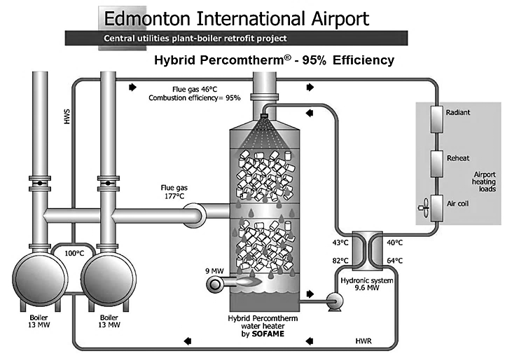

Notes: HWS = hot water supply; MW = megawatts; HWR = hot water return.

Source: Company documents.

Exhibit 2: Sofame technologies Inc.’s most successful Products

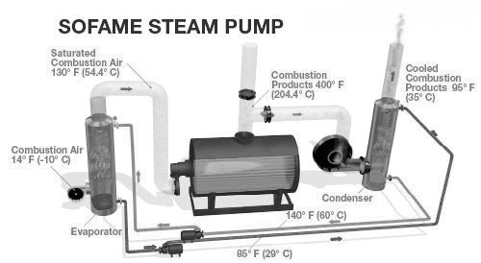

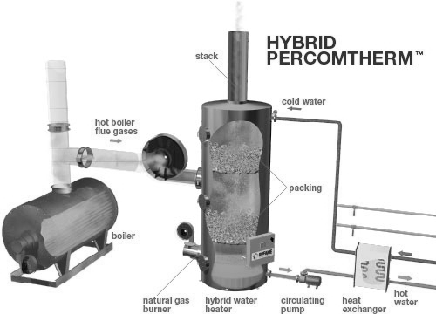

Source: Company documents.

Exhibit 3: Sofame TEchnologies Inc. Income Statements, 2013–2014

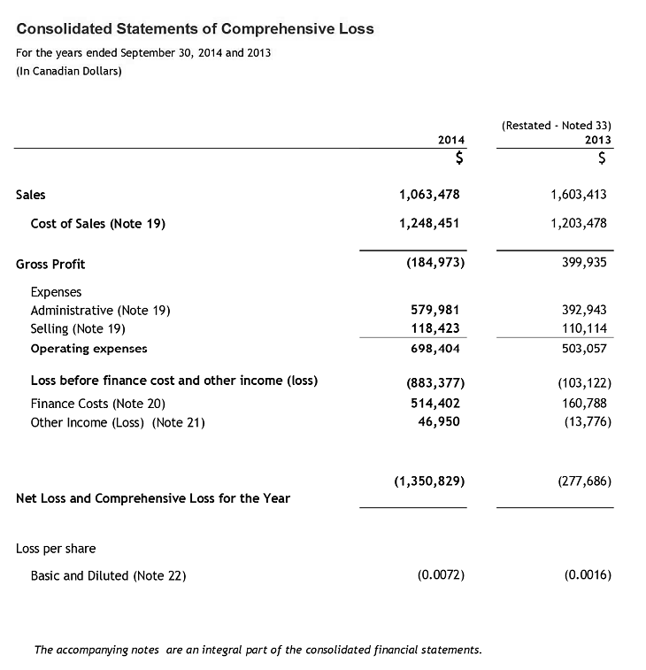

Source: Company documents.

Exhibit 4: Sofame technologies Inc. Balance Sheets, 2012–2014

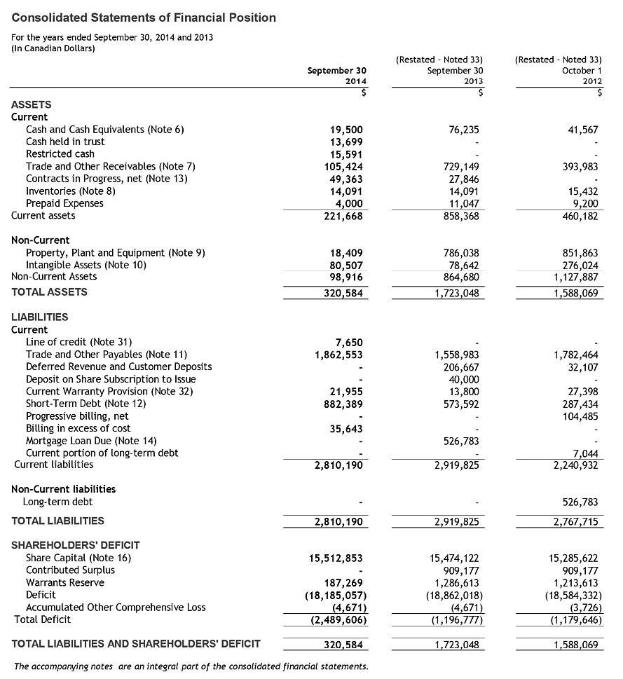

Source: Company documents.

Exhibit 5: Sofame technologies inc. Cash Flow Statements, 2013–2014

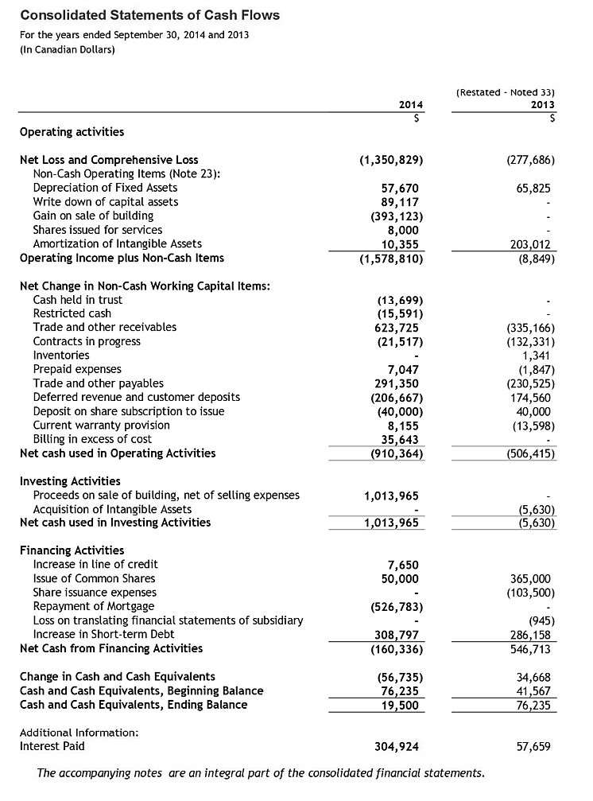

Source: Company documents.

Exhibit 6: SOFAME technologies inc. PRINCIPAL ROLES

* Robert Presser is the vice-president of Acme Engineering Products Ltd., where he is responsible for the recruitment, training, and support for Acme’s worldwide network of over 100 manufacturers’ representatives. Presser holds an MBA from the Richard Ivey School of Business at the University of Western Ontario and a bachelor’s degree in business from l’École des Hautes Études Commerciales at the University of Montreal. Prior to returning to Acme in 1993, he was a management consultant working on corporate governance and merger and acquisition mandates for large Canadian corporations. In 2007, Presser was appointed to the board of directors of Defence Construction Canada and became chairman of the board in June 2008. Defence Construction Canada is a Crown corporation that provides project management and administration services for all infrastructure projects required by Canada’s Department of National Defence. Presser is an experienced project manager, covering mechanical, electrical, and electronic engineering disciplines for Acme’s contracts with international engineering firms such as SNC Lavalin and Bechtel, and has presented papers and seminars on Acme’s process technologies at technical conferences in Europe and North America.
* John Gocek, Sofame’s chief executive officer, is a C-level executive offering 20+ years of experience in corporate finance, investment banking, and manufacturing operations, particularly in the HVAC (heating, ventilation, and air-conditioning) sector. Gocek is the co-founder of Ventrol Inc., a manufacturer of custom air-handling equipment and subsidiary of Nortek Holdings. Nortek was a New York Stock Exchange–listed company until August 2004. Gocek held the positions of chief financial officer and vice-president Finance and Controller of Ventrol from 1997 to 2007. Gocek also brings to Sofame hands-on experience in treasury management, information systems/information technology, and management consulting. He began his career at Marine Midland Bank in New York in money markets, moved to Montreal with Republic National Bank of New York, and then moved to lending with the Business Development Bank of Canada. Years of professional development have led to roles of increasing responsibility in finance, planning and forecasting, business strategy, and executive management. Gocek holds a bachelor’s degree in Honours Economics from McGill University, and completed Management Associate training on Wall Street with Marine Midland Bank in 1985. He is an advocate of performance-based metrics and web-based management systems and is a mentor, skilled at coaching others to understand the organization’s needs and to act constructively. John Gocek was a director of the corporation from October 24, 2007, until May 6, 2009.
* Luc Mandeville, chief technology officer, is a co-founder of Sofame and served as its president for over 20 years. He has been involved in every patent creation developed by Sofame. He is an owner in every one of these patents. Graduated from École Polytechnique of Montreal in 1973 in Industrial Engineering, he worked for 10 years in the water treatment field for Degremont before starting Sofame. Mandeville has developed markets in North America and Europe for Sofame products since the company’s founding in 1984. He has over 25 years of experience in the energy field.
* Allan Ghetler, vice-president and general manager, is a senior executive offering over 30 years of experience as a business leader, owner, and investor. Ghetler began his career as an industrial engineer and management consultant, and became widely acknowledged as an expert in plant layout and manufacturing engineering, packaging and warehouse design, specializing in the textile industry. He founded and was president of one of the first Canadian apparel companies to succeed in the U.S. market, achieving annual sales of over $50 million. Ghetler co-founded the first and largest Internet service provider in Quebec before the Internet was a household word. Ghetler has managed all internal affairs of a publicly traded company including logistics, communications, and investor and customer relations. He recently became part of the founding management team of the first concession for gold mining in Paraguay, supervising and coordinating the engineering and site preparation for the company’s greenfield ore-processing plant. Ghetler has been a first mover throughout a career that includes success with start-ups as well as directing new business developments. He has been instrumental in the success of a variety of other business ventures over the last 30 years, and recognized as trustworthy and someone who “gets the job done.”

Source: Company documents.

Exhibit 7: Sofame technologies inc. Historical Share Prices, March 2007 to October 2015

Source: Created by the authors using data from Yahoo Finance.

Exhibit 8: Sofame technologies Inc. Short-Term Debt, 2013–2014

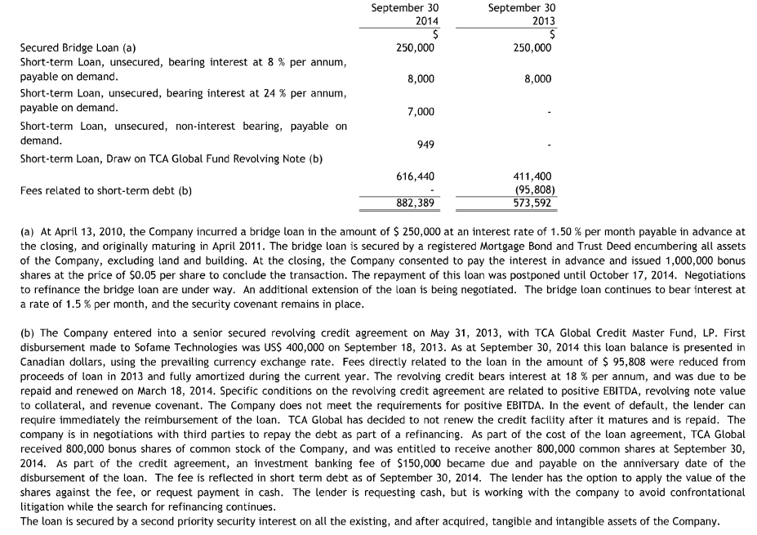

Source: Company documents.

Exhibit 9: Steam Plant Systems

|  |  |
| --- | --- |
| http://www.steamplantsystems.com/sps_fieldservice12.jpg | Steam Plant Systems, Inc. Corporate Offices |
| http://www.steamplantsystems.com/sps_mechfab7.jpg | http://www.steamplantsystems.com/sps_panelfab2.jpg |

Source: Company documents.

Exhibit 10: Steam Plant Systems, inc. Income Statements, 2012–2015

(Excluding Sofame and CHX Maritime Products)

2012

2013

2014

2015

U.S. Dollars—September 30th

**Revenue**

6,841,182

$

6,135,246

$

7,553,780

$

7,815,202

$

COGS

3,274,426

$

2,757,243

$

3,172,865

$

3,618,446

$

**Gross Margin**

3,566,756

$

3,378,003

$

4,380,914

$

4,196,756

$

Operating Expense

Sales and Marketing

253,955

$

220,592

$

282,441

$

217,480

$

General Administrative

2,740,337

$

2,543,781

$

3,419,285

$

3,249,542

$

Owner Compensation (SPS)

373,651

$

434,897

$

434,897

$

304,447

$

**Total Operating Expenses**

3,367,943

$

3,199,270

$

4,136,623

$

3,771,469

$

**EBITDA**

198,813

$

178,733

$

244,292

$

425,287

$

Depreciation & Amortization

15,912

$

19,020

$

14,266

$

17,674

$

**EBIT**

182,901

$

159,713

$

230,025

$

407,613

$

Tax

54,870

$

47,914

$

79,880

$

122,284

$

**Net Income**

128,031

$

111,799

$

150,145

$

285,329

$

Notes: COGS = cost of goods sold; SPS = Steam Plant Systems; EBITDA = earnings before interest, taxes, depreciation, and amortization; EBIT = earnings before interest and taxes.

Source: Company documents.

Exhibit 11: Steam Plant Systems, inc. Balance Sheets, 2012–2015

Notes: SPS = Steam Plant Systems; ST = short term.

Source: Company documents.

1. Hydraulic fracturing, or fracking, was a technique using high-pressure water mixture directed at underground rock to recover gas and oil.
2. All currency amounts are in Canadian dollars unless otherwise specified.
3. Energy and Environmental Analysis Inc., *Characterization of the U.S. Industrial/Commercial Boiler Population*, report submitted to Oak Ridge National Laboratory, May 2005, accessed May 30, 2017, https://www1.eere.energy.gov/manufacturing/distributedenergy/pdfs/characterization_industrial_commerical_boiler_population.pdf.
4. The text in the following section has been excerpted (and in some places has been updated and revised) from Simon Parker and Ken Mark, *Sofame Technologies Inc.: Sparking Growth in a Mature Manufacturing Company* (London, ON: Ivey Publishing, 2009), 2­–3. Available from Ivey Publishing, product no. 9B09M070.
5. See Simon Parker and Ken Mark, *Sofame Technologies Inc.: Sparking Growth in a Mature Manufacturing Company* (London, ON: Ivey Publishing, 2009). Available from Ivey Publishing, product no. 9B09M070.
6. U.S. Energy Information Administration, “Natural Gas Spot and Future Prices (NYMEX),” accessed May 30, 2017, www.eia.gov/dnav/ng/ng_pri_fut_s1_d.htm; U.S. Energy Information Administration, “NYMEX Futures Prices,” accessed May 30, 2017, www.eia.gov/dnav/pet/PET_PRI_FUT_S1_D.htm.