**`**

9B17M159

mogo: spearheading fintech adoption in canada

Nicole Miles wrote this case under the supervision of Professor Cara Maurer solely to provide material for class discussion. The authors do not intend to illustrate either effective or ineffective handling of a managerial situation. The authors may have disguised certain names and other identifying information to protect confidentiality.

*This publication may not be transmitted, photocopied, digitized, or otherwise reproduced in any form or by any means without the permission of the copyright holder. Reproduction of this material is not covered under authorization by any reproduction rights organization. To order copies or request permission to reproduce materials, contact Ivey Publishing, Ivey Business School, Western University, London, Ontario, Canada, N6G 0N1; (t) 519.661.3208; (e)* [*cases@ivey.ca*](mailto:cases@ivey.ca)*;* [*www.iveycases.com*](http://www.iveycases.com)*.*

Copyright © 2017, Ivey Business School Foundation Version: 2018-02-28

It was January 2018 in Vancouver, Canada, the home of Mogo Finance Technology Inc (Mogo), as the company’s co-founder and chief executive officer, David Feller, reflected on the decisions he would have to make to help Mogo provide Canada’s best digital banking experience. The online lender and payments solutions provider had achieved positive EBITDA for the first time in 2015, but still had yet to achieve profitability. Despite a 43 per cent growth in membership during 2017 and revenues of CA$49.9 million,[1] the company had incurred a net loss of $17.1 million. Having just closed a public offering of $26.25 million at year end 2017, Mogo faced pressure to create a clear roadmap towards profitability in order to deliver on shareholder expectations. In Feller’s mind, it was equally important to balance the prospect of short-term revenue gains with a longer-term focus on “the multi-billion-dollar opportunity” of financial technology (fintech) in Canada, as he described:

At the end of the day, we’re going up against big banks that compete on product variety and customer volume, but revenue and profitability are critical now that we’re public. As much as we want to commercialize new products, we have to find the right balance between investing money into our platform and moving towards profitability.

Mogo’s ability to provide loan and payments products through its “mobile-first” digital platform positioned the company as a convenient, millennial-friendly alternative to traditional banks. The company had acquired 500,000 users through the rapid development and deployment of its five product lines: loans, free credit score monitoring, mortgages, payments, and fraud detection services—the latter three were released in 2017. But, with big banks establishing digital offerings and competitive start-ups expanding equally as rapidly, Feller knew that the most critical decision he needed to make was that of Mogo’s overarching strategy: how could his team best deploy this capital to provide the best digital banking experience to customers while actively moving towards profitability?

Financial Services in Canada

As the second-largest sector in Canadian business by gross domestic product, the financial services industry was composed of seven distinct segments: banking, credit unions, insurance, asset management, securities, exchanges, and back office operations (see Exhibit 1). Within this, banking, insurance, and securities accounted for a combined 90.7 per cent of total business across the industry.[2]

Canada’s banking market was highly consolidated between the “Big Six” Canadian banks: Bank of Montreal (BMO), The Bank of Nova Scotia (Scotiabank), Canadian Imperial Bank of Commerce (CIBC), National Bank of Canada (NBC), Royal Bank of Canada (RBC), and Toronto-Dominion Bank (TD). With a collective market capitalization of $435.8 billion in 2016,[3] these banking giants offered a comprehensive mix of retail, commercial, and investment banking services to clients. Within their retail services, all of the Big Six offered savings and chequing accounts, mortgages, debit cards, credit cards, and personal loans, in addition to client services (see Exhibit 2).

Since 2002, Canadian banking had experienced revenue growth of 4.3 per cent.[4] Compared to average private sector revenue increases of 3.8 per cent over the same period, financial services growth was driven primarily by increased loan volumes due to low interest rates.[5] However, with Canadian household debt at an average of 167.8 per cent of disposable income, Moody’s Investors Service cut the credit ratings of the Big Six in 2016 to reflect concerns over increasing exposure to indebted customers.[6]

Shifting Customer Expectations

Since the 2008 global recession, global banks’ rankings in satisfaction surveys decreased across a number of dimensions, and Canadian institutions were no exception. In 2016, a Performance Against Customer Expectations (PACE) Index of Canadians identified that although banks excelled in terms of in-person banking support, significant expectation gaps existed between consumers’ perceptions of customization and ease of product use and understanding.[7] Even though one in four respondents believed that banks met customer needs in basic trust and relationship areas (e.g., fair pricing and transparency), a 20 per cent point gap existed between bank performance and customer expectations. In this context, customers equated fairness with absence of hidden charges and fees.

The demographic that experienced the greatest trust decrease was comprised of customers aged 22 to 34 (so-called “millennials”) with healthy credit scores, a segment that made up approximately 40 per cent of global banks’ customer bases. This segment was characterized by a preference for personalized service through convenient platforms. In fact, 69–75 per cent of customers in this demographic were twice as likely to prefer using online and Internet channels to perform transactions, view their balances, and receive information. The average customer in this segment owned 5.8 bank products, ranging from basic chequing and savings accounts to personal loans.[8]

Since the 2008 recession, the composition of the Big Six’s customer base had increasingly shifted towards clients with strong credit scores. Credit scores were issued by credit-reporting agencies such as Equifax and TransUnion. These institutions evaluated credit history and provided a score on a scale of 300 to 900 that could be used by financial institutions to judge creditworthiness. Customers with credit scores above 600 were typically considered “prime” clients with high probability of repaying loans. In contrast, scores below 600 fell in the “near-prime” and “sub-prime” categories; customers in these categories were considered more likely to default on credit obligations. Facing increased regulation following the 2008 financial crisis in the sub-prime lending market, the Big Six increasingly targeted customers with prime credit histories to the exclusion of their near- and sub-prime counterparts. For example, the average millennial using banking services had a median income of $35,348, against the national average of $32,790.[9]

Big Bank Innovation

In response to market trends, particularly increased competition for the millennial market, banks faced mounting pressure to develop more convenient, accessible, and intuitive services with strong technological backbones. It had been widely reported that Canadian banks’ primary challenge was upgrading legacy information technology systems that, in some cases, dated back to the 1970s and were ill-equipped to facilitate technological and product innovation. The Conference Board of Canada reported that 73.5 per cent of Canadian financial services companies undertook some form of organizational innovation, compared to 63.5 per cent for all sectors.[10] The bulk of this funding was spent on upgrading existing systems to cater to a market demanding more and better digital services. Despite efforts to increase digitization, The Boston Consulting Group reported that, globally, only one in five commercial banks offered consistent digitization for any given process.[11]

Since 2013, Canadian banks had increasingly turned to developing fintech offerings through acquisition, internal investment, or incubation programs aimed at fostering an agile start-up culture within the banks’ bureaucracy. For example, TD launched a real-time budgeting tool called “MySpend” in partnership with fintech start-up Moven.[12] Moreover, Scotiabank announced the development of a “Digital Factory” to serve as a fintech incubator scheduled for launch in late 2016.[13] Lastly, CIBC initiated a partnership with start-up Payfirma to allow its business clients to accept payments through their mobile devices.[14]

Financial Technology in Canada

Fintech was a burgeoning industry that used digital innovation to provide accessibility and convenience to a market that was becoming gradually dissatisfied with the inefficient and inflexible traditional banks. Within Canada, four major fintech segments competed with commercial banks: personal lending, digital payment systems, residential mortgages, and wealth management platforms. In addition, new digital innovations such as cryptocurrencies and blockchain were beginning to present opportunities for fintechs. In 2017, Canadian fintech firms typically specialized in one of these segments and rarely offered more than a single service type.[15] Regardless of segment, fintech companies achieved notoriety and early growth for their ability to offer similar products to those of commercial banks at lower rates, due to their lack of brick-and-mortar (B&M) branches.[16]

In 2017, the Canadian marketplace for fintech was lagging behind its global counterparts.[17] In a survey of the digitally active population, only 18 per cent of Canadians used a financial technology service against a global average of 33 per cent. Experts identified this low adoption rate as stemming from a lower awareness among consumers about the types of services Canadian fintech companies offered.[18] Predicting that media exposure and marketing efforts within this industry would increase significantly in the coming five years, Ernst & Young reported that global adoption could scale to 52 per cent.[19]

To achieve growth against a highly consolidated market for commercial banking products, fintech companies had leveraged their small scale to rapidly prototype and commercialize products at a faster rate than traditional banks. With lower regulatory restrictions on client type and limited shareholder pressure, fintech firms were able to offer customer-focused solutions to a wider client base. Feller summarized:

The advantage that [smaller fintech start-ups] had was that we were not yet traded to the wider market, and so were not wed to high profit margin products. People said that big banks had the most capital in the industry so it would be impossible to compete with them, but they’re spending billions of dollars trying to turn their legacy platforms digital. There’s almost no amount of money that can do that both effectively and efficiently.

Personal Loans

The Canadian personal lending market represented $587 billion in commitments, with market growth accelerating to 5 per cent in 2017.[20] Loans could take the form of business loans, residential mortgages, credit card loans, personal loans, and personal lines of credit. These products could be issued by a variety of institutions, from commercial banks to payday lenders.[21] Within this market, approximately $94.2 billion was credit card related in the fourth quarter of 2016 (see Exhibit 3).[22]

The personal lending market could be split into prime and sub-prime consumer segments: the Big Six banks and credit unions predominately engaged with prime customers, while “shadow banks,”[23] such as fintech companies and payday lenders, offered loans to both segments. Despite substantial growth as a result of low post-recession interest rates, analysts had warned of the eventual contraction of this market as Canadians faced record household debt levels.[24]

In addition to the Big Six Canadian banks and Canadian credit unions, a number of fintech companies had entered the personal lending space, including Canadian players Mogo, Borrowell, and Lending Loop. Though each lender’s business model was focused on providing affordable loans to clients, they differed in their methods of financing these transactions. Canadian online lenders financed their operations in two forms: on-balance sheet and peer-to-peer (P2P) lending. On-balance sheet lenders partnered with outside funding sources, such as financial institutions or secured credit facilities, and held the outstanding commitments on their balance sheets. Conversely, P2P lenders matched customers seeking loans with investors willing to provide these loans through an online platform. By 2020, the global online marketplace lending industry was expected to issue $376–$711 billion in loans.

As a customer-facing industry, online lending in Canada was heavily regulated. Due to un-harmonized provincial and federal legislation, a national online lending platform would have had to pay large annual fees to file documentation in each Canadian province. Though online lending had matured in the United States and the United Kingdom as a result of flexible regulatory systems, Canadian securities commissions limited the rapid evolution of local platforms and increased barriers for new entrants from international markets. As a result, national online lenders in Canada enjoyed a relatively captive market in comparison to their international counterparts.[25]

Payments

The payments industry contained four major segments: acquirers and processors, card networks, issuers, and gateways. Acquirers and processors were third-party businesses that worked with merchants to process credit and debit card payments from customers. In contrast, card networks, such as Mastercard Inc. and Visa Inc., provided physical credit card numbers that consumers could use to purchase goods. Issuers were originators of chequing and savings accounts associated with debit and credit cards, and gateways provided digital platforms through which debit and credit accounts could be connected to merchants. The industry’s largest gateways included PayPal and Apple Pay, which respectively commanded $377 billion[26] and $14.6 billion[27] in total transaction volume including both mobile and online payments.

Significant digital innovation had occurred in the gateway segment, particularly within mobile payments, a market projected to grow to $36 billion by 2020. Due to these promising projections, a number of Canadian fintech firms had entered the gateway segment through point of sale solutions, contactless payment technology, mobile wallets, and merchant payment platforms.

With various segments of the payments industry approaching saturation, Canadian fintech companies began to penetrate the issuer sector in partnership with financial institutions. Koho, a Vancouver-based fintech, partnered with the card platform of People’s Trust to provide customers with the ability to perform day-to-day banking transactions online for no fee. In turn, People’s Trust maintained partnerships with card network Visa and automated teller machine network DC Bank. Services offered through the Koho card included direct deposits, bill payments, money transfers, and an online budgeting and savings tool. The company did not directly charge consumers, and instead retained a percentage of each credit card transaction. Koho closed an $8 million cash injection in the third quarter of 2017 to facilitate national growth.[28]

Cryptocurrencies & Blockchain

In an effort to decentralize the creation and trade of currency, a self-regulated, peer to peer digital currency network was created as an alternative to “fiat” money[29]: bitcoin. Leading up to 2017, increased business and user acceptance of the currency spearheaded significant increases in both volume available and quoted value. Bitcoin’s path towards acceptance as a legitimate alternative to fiat money surged in 2017, when the currencies total market capitalization hit $96.7 billion,[30] twice the market capitalization of the next leading cryptocurrency, Ethereum. Having witnessed surges in value of up to 1,100 per cent in 2017, experts began questioning whether the price frenzy was indicative of a looming collapse in value.[31]

Bitcoins were mined through a computationally and energy intensive process whereby miners verified transactions that had occurred throughout the system, and added them to a public leger held on a blockchain. A blockchain was a de-centralized public repository of blocks of information that serve as a “transparent and incorruptible” source of truth for transactions. Bitcoin was purchased, sold, and converted to fiat money or goods through the use of exchanges. Due to intense regulations within the Canadian financial services industry, major global exchanges, such as Bistamp, did not directly serve Canadians; to trade, Canadian currency was converted to U.S. dollars by the exchange with the user paying fees on the conversion. Further, bitcoins could not be converted to Canadian dollars when using these globally recognized exchanges.[32] These restrictions created a complex and difficult to navigate environment for Canadian bitcoin traders.

The largest crypto-currency exchange in Canada was the Vancouver-based QuadrigaCX with a daily trading volume of $950,000; however, high demand had led to sub-par efficiency. In order to access an exchange, users must apply and have their identities verified, a process that, in late 2017, had a three week wait time.[33] Though competitor exchanges, including Coinsquare and Localbitcoins, offered rapid or no verification, bitcoins traded on them were typically priced higher than going market rate or were traded at higher fees.[34]

Though press coverage of crypto-currencies, including bitcoin, had increased immensely, a proportional increase of usage was not observed in Canada. At the end of 2017, the Bank of Canada reported that 64 per cent of Canadians had heard of bitcoin, but only 2.9 per cent owned it.[35] Within this, 29 per cent reported that their primary driver for owning bitcoin was an interest in new technology, while other reasons included investment and making international payments. Though Bitcoin was differentiated from fiat money due to its secure blockchain technology and ability to facilitate anonymous payments, few users cited these inherent properties as reasons for using the currency.

Canadians who did not own bitcoin cited two reasons for their lack of adoption: their current payment method met their needs, or they did not understand the advantages of the technology. With only 1 per cent of merchants in Canada accepting bitcoin as a payment alternative, the average consumer lacked options to translate the value of a bitcoin into tangible goods. Further, bitcoin’s historical use as the payment method of choice in shadow economies[36] attached it to illegal activity. In fact, a survey distributed by the Central Bank of Canada showed that 21 per cent of non-users were reluctant to purchase bitcoin because they did not trust a currency with no central regulation.

Residential Mortgages

The Canadian mortgage market was segmented between two channels: direct bank and mortgage brokers. Together they represented an outstanding loan volume of $1.47 trillion[37] with more than 74 per cent of originations made by commercial banks. The channel chosen depended heavily on the preferred method of purchase. The first channel involved customers directly negotiating with banks to achieve discounts from posted interest rates. Customers not wishing to involve themselves in this process could hire a mortgage broker to identify the best rate on their behalf.

By 2024, 82 per cent of millennials were projected to become first-time home purchasers.[38] With mortgages typically representing a customer’s first major independent financial decision, a client’s first mortgage was a prime milestone to be leveraged in client relationship development. Millennials’ mortgage acquisition experiences consisted of a three-stage process: social and online research, uncertainty, and outreach to bank representatives. In the first phase, millennials began their search for a mortgage by reaching out to their social network and performing independent research online. Next, after realizing the complexities of acquiring a mortgage, millennials often felt uncertain about their grasp of financial management. Finally, they engaged with bank representatives to obtain further information that was trustworthy and of high quality. On average, it took 25 person-hours to fill out the paperwork required to obtain a mortgage and between four and six weeks for a broker to make a final decision.[39]

Despite representing a large market, fintech firms had been slow to disrupt B&M operations with online platforms. IntelliMortgage, a start-up founded in 2014, allowed users to bypass both banks and brokers by comparing and selecting rates through their online platform.[40] In late 2016, Mogo launched MogoMortgage to provide market-leading rates combined with an industry leading digital mortgage experience.

As with online lending, mortgage brokers were subject to unharmonized provincial legislation. Fintech companies that operated as mortgage brokers were required to licenses from provincial securities commissions for each province that they operated within.

Wealth Management

The wealth management segment had experienced significant disruption from innovations in the robo-advisory field. A robo-advisor was a digital financial advisor that delivered objective, data-driven online portfolio management without the need for human interaction. Robo-advisors passively invested deposits in exchange-traded funds (ETFs) or low-cost mutual funds, which consisted of diversified assets such as stocks, commodities, or bonds. The core advantages of holding an ETF were the diversification it provided and the low costs associated with management. By removing the need for detailed investment advice and instituting automatic portfolio rebalancing, robo-advisors provided lower fees and investment minima to a wider variety of customers, many of whom would not have qualified for a financial advisor. It was generally expected that by 2019, robo-advisors would collectively manage $255 billion in assets across the globe.[41]

After selecting a robo-advisor, a customer’s onboarding process typically took less than 10 minutes. During this time, a customer filled out an online questionnaire about their investment knowledge and risk tolerance, with questions ranging from their reason for saving and current debt commitments to annual income and net worth. The robo-advisor then automatically recommended an investment allocation and portfolio mix using fixed income and equity ETFs. Subsequently, investors chose the type of accounts they would like to open, with typical options including tax-free savings accounts, registered retirement savings plans, personal accounts, locked-in retirement accounts, and registered retirement income funds. Lastly, the user’s funds were transferred into these newly created accounts, where they could be monitored in real-time using the robo-advisor’s online interface.

The Canadian regulatory framework for robo-advisors was considered one of the strictest environments to operate within globally. In Canada, robo-advisors were required to register as portfolio managers with each provincial securities commission in order to operate in a specific geographical area. Under recent guidance issued by the Canadian Securities Administrators (CSA), a live, licensed portfolio manager was required to review the results of each client’s information before recommending a suitable portfolio. According to the CSA, this review process involved a live discussion between a licensed portfolio manager and each client, though the conversation did not have to occur in person. The Ontario Securities Commission provided guidance on what this meant for human advising representatives (ARs) within robo-advisory firms:

The online advice model that we considered acceptable involved an interactive website used to collect [client] information, which will be reviewed by a registered AR. The AR should communicate with the client by telephone, video link, email, or Internet chats. The AR must ensure that sufficient [client] information has been gathered to support the [robo-advisory] firm’s obligation to make suitability determinations for the client.

As noted, this arrangement is not the so-called “robo-advice” model seen in the United States, where online advice had seen rapid growth in the last few years. The [robo] advisors operating in Ontario were offering hybrid services that utilized an online platform for the efficiencies they provided, while ARs remained actively involved in decision making.”[42]

Within the Canadian market, 11 robo-advisors competed against the financial advisory branches of big banks and wealth managers; of these, three competitors operated across the nation: WealthBar, Questrade Portfolio iQ, and WealthSimple (see Exhibit 5).[43]

Mogo

Company History

After graduating from Western University with a bachelor’s degree in economics and French, David Feller was drawn to the entrepreneurial community in Vancouver, British Columbia. Through this community, he gained exposure to payday lenders. These lenders did not perform credit checks, and so required interest payments averaging 30 per cent annualized percentage rate (APR)—a monthly figure that totaled nearly 400 per cent annually. These staggeringly high rates and the quick application times offered, some of which could be turned around in under one business day, established the perception that payday lenders predominately served sub-prime clients with low credit scores and an urgent need for funds.With minimal information, a customer could receive a loan from a payday lender. In contrast, the average loan application process with a commercial bank lasted between three and 14 days, provided the applicant had a prime credit score. Should the applicant be one of the 35 per cent of Canadians who fell in the near- to sub-prime credit score segment, it was unlikely that the loan would be approved at all. This significant disparity in time to process reflected a gap in the market that impacted “banked” and “underbanked”[44] customers across the credit spectrum. As Feller described:

Before Mogo entered the market, there was this mindset that prime customers were well served by the big banks. That left only underbanked customers with sub-prime credit scores for new entrants. We disagreed: our belief was that, with the right mix of convenience and accessibility, we would be able to access the full spectrum of consumers across Canada.

In addition to providing accessible services to underserved retail bank customers, Feller realized that payday lenders were capitalizing on a segment of consumers who were not receiving adequate banking services. For example, a traditional bank may offer clients credit card products and ancillary rewards programs to incentivize adoption. Subsequently, when credit card debt became unwieldy, customers could take out a consolidated loan to keep up with expenses. However, as interest payments on these outstanding commitments increased, clients could become unable to make payments. In this situation, payday lenders were one of the few alternatives underbanked customers could turn to. As Feller noted, “It was relatively easy to get into financial trouble, but banks did not offer solutions to these challenges.”

To capitalize on this unmet demand for convenient and fair financial services, Feller and his brother co-founded Mogo in 2003 as a B&M payday lender that offered loans at an average rate of $30 per $100 granted. In 2005, following early indications that financial services would trend towards digitization in the long term, Feller transitioned Mogo into an online service that would provide increased convenience at a significant discount: $1.83 per $100 at minimum. Though the company was embracing a cost leadership strategy that appealed to near and sub-prime customers, Feller emphasized that Mogo’s ultimate goal was to provide convenient services to consumers of all credit backgrounds: “The more I learned about this space, the more I was interested in the question: How do you bring this level of convenience that payday lenders provide across the entire lending spectrum?”

With aspirations to spearhead Canada’s transition from traditional banking to digital financial services, Mogo aimed to offer convenient financial products at competitive rates through its online and mobile platforms. By democratizing access to financial services, the company sought to build products that “made it easier for consumers to get in control of their financial wellbeing.” At the close of 2017, Mogo was a purely digital platform providing personal loans, mortgages, payments services, and free credit score assessments to customers. The company had raised $202 million in cumulative funding to support a rapid growth trajectory, and had recently surpassed 500,000 users. Though Mogo had yet to achieve positive enet income, it delivered annual revenues of $49.8 million—a 14.5 per cent increase from the previous year (see Exhibits 6A and 6B).

Product Strategy

Mogo’s product development strategy focused on identifying the most efficient and effective way to build new offerings. Due to the nature of the Canadian fintech industry, the majority of financial services products had to be executed in partnership with larger institutions. Thus, the company faced the challenge of balancing the need to quickly commercialize products through partnerships with its desire to invest both time and capital in creating differentiated financial services solutions.

Within its burgeoning loan segment, Mogo developed complementary products to achieve its vision of developing into a full-service digital financial services company. Each product was designed to appeal to a customer at a specific stage of the client’s lifecycle, and was accessible to consumers through Mogo’s online digital platform and mobile application (see Exhibit 7). Chantel Chapman, a personal financial fitness coach at Mogo, explained the company’s offerings:

Our goal was to become an inflection point business, which means we aimed to have products at each stage of the customer’s lifecycle. We offered a free credit score product for when you would become aware of the importance of your financial health. Later, when you wanted to refinance expensive credit card debt, we were there for you with MogoLiquid. If you had payday loan debt and needed to refinance it with lower cost options, we had MogoMini. After a few years, you’d return to us for additional services.

Mogo’s product development process centred on identifying where consumers were most underserved in the market. After identifying a niche, Mogo’s strategic team placed equal focus on alignment with the company’s overall vision and on financial measures, including total investment cost and payback periods. This logic resulted in the launch of two product lines: personal loans and credit score assessments.

Brand Strategy & Portfolio

To support Mogo’s goal of enabling customers to achieve financial fitness, the company set its sights on becoming an aspirational lifestyle brand. The core of Mogo’s brand strategy was its effective design: first, customers were attracted to the brand by millennial-focused marketing tactics; subsequently, their experiences within the mobile application and online platform were structured to reflect the company’s goal. To this end, Mogo dedicated $560,000 monthly in marketing spend to increase brand awareness, an expense that was primarily concentrated on digital tactics. In addition, the company inspired customers to achieve financial fitness through “gamification” principles.[45] Gamification at Mogo was reflected through both its online platform and unique product portfolio.

Online and Mobile Platforms

In Feller’s opinion, Mogo was a technology company before it was a financial services organization. The company’s online platform was designed to increase accessibility, transparency, and ease of use for clients. First, Mogo developed both an online dashboard and mobile application with similar functionality to enable seamless user experience. Though Mogo’s mission was to develop into Canada’s first digital financial brand, Feller stated, “We’re not licensed as a bank, and we don’t want to be one. We believe that it’s technology platforms like ours, though, which will ultimately be the banks of the future.”

Mogo’s platform developers built a step-by-step user experience that led customers through the process of applying for a loan. For example, the MogoMoney application clearly stated the biweekly payments, term, and monthly interest rates that consumers were committing to. Next, ease of use was achieved through an easy-to-navigate online and mobile dashboard that prompted users with simple instructions. Where possible, Mogo’s in-application experiences were gamified to increase engagement and generate loyalty. For instance, when viewing their credit scores, customers received notifications on how many points they needed until they could “level up.” Further, Mogo developed the potential to receive rewards for on-time payments to motivate customers to become financially fit.

MogoMoney

Having been the company’s core product since its beginnings as a payday lender, Mogo’s loan products were marketed as methods of refinancing higher-cost debt at a lower interest rate, regardless of credit score. To improve acquisition rates, the company offered a three-minute application process in which consumers entered their information and found out the interest rates they qualified for within three minutes. Mogo had developed three loan products: MogoMini, MogoZip, and MogoLiquid. With MogoMini, clients could access a “mini,” low-cost line of credit of up to $3,500 at 13 cents per day per $100; this product was intended as a payday loan alternative. MogoZip offered customers an immediate-term loan of $500–$1,500, payable within 14 days of issuance. Finally, MogoLiquid allowed consumers to take out $3,500–$35,000 with risk-adjusted rates starting at 5.5 per cent APR. These loan products were financed through a revolving credit facility in partnership with Fortress Credit Co LLC.

With Mogo’s positioning as an online lender that served customers across the credit spectrum, it was critical that the company developed an alternative to the in-person tactics that traditional banks used to evaluate the creditworthiness of their customers. Accordingly, Mogo developed a big data platform that analyzed more than 1,000 data sources when a client made a loan application. In addition to examining credit scores, the platform assessed consumers through analysis of their bank transactions, personal browsing history, and time spent viewing the loan disclosure form. Using these elements, the system provided a clear picture of the client’s likelihood to repay, and was also capable of detecting and limiting fraud.

Credit Score Assessment

The company’s next major development was its free credit score product, a partnership with Equifax that provided consumers with their credit score at no cost. When signing up to Mogo’s mobile application, customers were prompted to authorize a free credit score check as their first step towards becoming “financially fit.” Mogo’s “Level Up” program enabled customers to gradually lower interest rates on outstanding loans by improving their credit score. Though the company incurred a fee for providing monthly score monitoring (typically valued at a $200 annually), its ultimate goal was to “educate consumers on what a credit score means as well as strategies to improve it.”

MogoProtect

In 2017, Mogo’s fraud detection service was implemented to help customers avoid identity theft and fraud. When fraudsters obtained personal financial information, they sought to quickly convert it to liquidity by illegally applying for loans, mortgages, or opening bank accounts. In order to be approved for an account such as this in Canada, customers must consent to have banks, creditors, and insurance providers conduct credit checks. MogoProtect sent an alert to users when credit inquiries were submitted on their personal information, thereby immediately drawing attention to instances when a credit inquiry was submitted without the explicit permission of the user. For $8.99 a month against a going market price of up to $20, MogoMembers could protect themselves from this form of identity fraud.

MogoMortgage

Having noted the lack of fintech firms in the Canadian mortgage space in 2017, Feller and his team developed a new mortgage segment to compliment Mogo’s existing loan offerings. By partnering with an established mortgage broker, Mogo would receive a commission on mortgages completed through the service without assuming significant credit risk. By leveraging its limited operating costs and lack of B&M presence, Mogo could offer mortgage rates as low as 2.54 per cent APR, compared to Big Six rates of between 2.89 and 4.49 per cent.

In keeping with Mogo’s gamification principles, MogoMortgage was built to include special rewards that motivated users to meet their repayment goals. For example, at each milestone payment, users would be surprised with a reward such as a free dinner on Mogo or a gift card. Mogo was licensed to operate in British Columbia, Alberta, and Ontario with ambitions to expand across the country.

MogoCard

To help MogoMembers establish and maintain healthy spending habits, Mogo launched the reloadable MogoCard, a platinum prepaid VISA card. However, the instrument was not a traditional credit card. Instead of racking up debt, users added money to the card through Mogo’s mobile application. Then, they could set spending goals. As a result of this information, Mogo’s online platform would recommend a daily budget.

Unlike typical payment cards, Mogo enabled users to select the design of their MogoCard for a small additional fee.

Organizational Structure

Because Mogo was a lifestyle brand, Feller believed that it was critical that the company’s internal structure reflected its mission and goals. To empower customers to increase their “financial fitness,” Mogo developed an internal culture focused on maintaining two characteristics: agile decision making and internal education.

Mogo maintained a flat organizational structure that promoted collaboration and innovation. Its leadership team was comprised of three functions: finance, data, and legal (see Exhibit 8). Within this structure, the company’s largest team was its technology and data division, an area that consisted of over 100 product and platform developers. By encouraging employees—regardless of background—to contribute platform and product development ideas, Feller felt that Mogo maintained “the type of environment where anyone could and should feel able to contribute to the company’s success.”

Feller also cited the company’s internal education program as a core value for the organization at large. By hosting cultural events focused on equipping employees with the knowledge they needed to improve their credit scores and make sound financial decisions, Mogo incentivized the financial mastery it hoped to impart to clients. Each month, the company participated in an internal credit score improvement competition; once scores were updated, employees who reached Mogo’s coveted “Rockstar” credit score status received $1,000 in cash. Through this mechanism, Feller hoped to “further integrate financial literacy education into the company’s DNA.” As a result of this tactic, he felt that employees would be better equipped to spread Mogo’s mission of helping millennials achieve financial fitness.

Corporate Branding

The company launched its online blog in 2009, publishing targeted posts on educational topics related to personal wealth management. With publication titles ranging from “The Best Apps for Managing Money” to “Rick Ross Money: 6 Steps to Budget like Rozay,” Mogo’s content strategy—in combination with extensive search engine optimization tactics—aimed to make these posts a customer’s first interaction with the Mogo brand. Chapman noted, “Our goal was to position Mogo as a place to give millennials the information they needed to build their financial health. Our content spoke to our audience in a language that they could understand.”

Chapman expected that after reading the company’s educational blog posts, the average reader would be inspired to take action to increase their financial literacy, but may be unwilling to approach a financial advisor or bank representative. To increase engagement at this stage, the company established Mogo’s “Adulting 101” events. During a typical event, a group of 30–40 millennials would join a financial fitness coach at either Mogo’s lounge in Toronto, a restaurant, or a conference centre. These events were hosted three to four times per year across a number of different provinces, with each event costing approximately $3,000. Each event would be built around a theme, such as a four-round wine tasting. In between rounds, participants would play trivia games and answer questions about financial literacy for a chance to win $20 cash per question.

Looking Forward: Digital Financial Services for the Masses

Now that Mogo was a public company, it was more important than ever that the firm pave a clear path towards profitability. Having achieved positive cash flow for the first time in 2015, Mogo had made public promises that this would continue and that profitability would be soon attained. Two years later, these promises had yet to materialize.

What would Mogo’s evolution into a digital financial brand over the next five years look like, from both a marketing and product perspective? With $26.25 million available, Feller wondered which investments would best prepare Mogo and its shareholders for success. Feller reflected: “Investing assets in aggressively expanding our existing loan business would provide higher revenue and profitability in the short run. But not further diversifying outside of loans may cause us to miss out on the bigger opportunity of creating Canada’s first digital financial services platform.”

The Product Roadmap Dilemma

Feller knew that developing a compelling product roadmap would be critical to Mogo’s evolution from a loan company to a digital financial brand. With multiple segments across the industry evolving rapidly, potential opportunities ranged from building out its existing product portfolio to investing in wealth management or crypto-currencies.

To capitalize on rapid growth in the online investment management industry, Mogo could establish a robo-advisor; to do this, the firm would need to hire a team of portfolio managers to remotely manage client relations and portfolios as per federal and provincial regulations. Moreover, an online interface would need to be developed from scratch. Alternatively, Mogo could partner with an existing player to deliver more robust services to clients. Prior to investment or partnership, a number of questions would need to be answered. How could the company effectively position its service to compete with both established players and newer fintech start-ups? Was the development worth the risk of building the company’s internal capabilities? Would this path help pave Mogo’s way towards profitability in the next five years?

MogoMembers were also expecting the impending launch of a developed crypto-currency trading platform that would assist the average Canadian to navigate bitcoin investments. But, what would this look like? How could Mogo establish and maintain leadership in this fragmented space? Most importantly, Feller felt it was critical to answer: how could Mogo leverage the broader blockchain opportunity moving forward?

The Decision

As he sat in Mogo’s boardroom and waited for his executive team to join him, Feller wondered what was next for Mogo. Facing pressure to prove the viability of Mogo’s business strategy against a Canadian market that seemed hesitant to invest in technology start-ups, Feller reflected on his priorities.

Equipped with an extensive background of the competitive, rapidly evolving fintech landscape in Canada, Mogo’s senior management team had to answer a number of questions: Should the company focus on its fast-growing loan business to improve profitability in the immediate term? If not, which products or platform upgrades should it invest in? Just, what was the right path forward?

EXHIBIT 1: THE FINANCIAL SERVICES INDUSTRY

|  |  |  |  |
| --- | --- | --- | --- |
| **Segment** | **Share** | **Description** | **Canadian Players** |
| Banking | 39% | Commercial banks are licensed financial institutions that accept deposits and issue loans. Investment banks provide underwriting and merger and acquisition services to corporate clients. | RBC, CIBC, BMO, Scotiabank, NBC, TD |
| Insurance | 37% | Includes life, health, casualty, and property insurance. | Manulife Financial, Great-West Life, Sun Life Financial |
| Securities and Exchanges | 19% | Marketplaces that provide a platform in which securities, commodities, derivatives, and related financial instruments are traded. | Toronto Stock Exchange, Canadian Securities Exchange |
| Credit Unions | 3% | Not-for-profit financial cooperatives in which account holders are owners. Organizations provide lower interest loans and mortgages to members. | Desjardins, Meridian, Vancity |
| Other | 2% | Includes back office operations divisions and transaction processing across the financial sector. | N/A |

Source: Michael Burt, “An Engine for Growth: Report Card on Canada and Toronto’s Financial Services Sector,” The Conference Board of Canada, November 2016, accessed March 4, 2017, www.tfsa.ca/storage/reports/EngineforGrowthFinancialServicesStateoftheSector2016.pdf.

EXHIBIT 2: THE BIG SIX BANKS IN CANADA

|  |  |  |  |  |  |  |
| --- | --- | --- | --- | --- | --- | --- |
|  | **BMO** | **Scotia bank** | **CIBC** | **NBC** | **RBC** | **TD** |
| Total tier 1 capital ($ millions) | 32,236 | 45,066 | 21,666 | 9,265 | 55,270 | 49,397 |
| Net income before tax ($ millions) | 4,600 | 7,400 | 4,300 | 1,300 | 10,500 | 8,900 |
| Full-time employees (FTEs) | 46,778 | 86,932 | 44,424 | 17,056 | 73,498 | 81,137 |

Source: PwC, “Canadian Banks in 2016: Embracing the FinTech Movement”, January 2016, accessed March 4, 2017, www.pwc.com/ca/en/banking-capital-markets/publications/5056-01-canadian-banks-2016.pdf.

EXHIBIT 3: PERSONAL LOAN TYPE BREAKDOWN

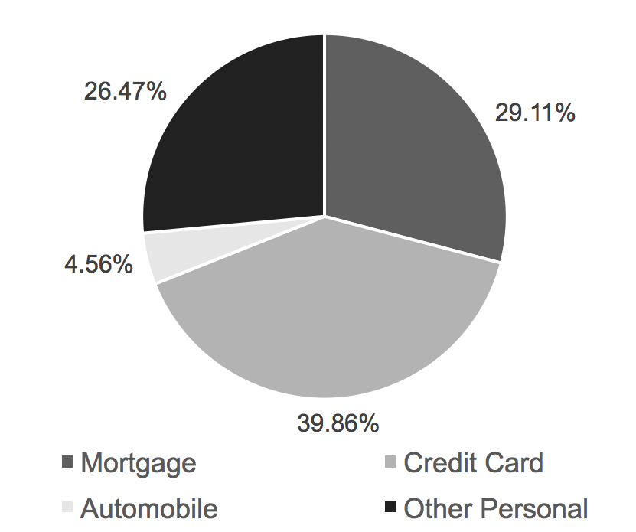

Source: Bank of Canada, “Banking and Financial Statistics,” July 2016, accessed March 12. 2017, http://www.bankofcanada.ca/wp-content/uploads/2016/07/bfs_july16.pdf

EXHIBIT 4: KOHO CARD BREAKDOWN

|  |  |
| --- | --- |
| **Service** | **Cost** |
| New Card | $0/Free |
| Account Activation Fee | $0/Free |
| Monthly Account Fee | $0/Free |
| Purchases | $0/Free |
| Interac e-Transfer | $0/Free |
| Automatic Paycheque Load | $0/Free |
| Live Customer Service | $0/Free |
| ATM Withdrawal - Domestic, in network ATM | $0/Free |
| ATM Withdrawal - Domestic, out of network ATM | $2.00 |
| International ATM Withdrawal | $3.00 |
| Foreign Exchange Transaction Fee | 1.50% |
| Card Replacement Fee | $0/Free |
| Card Cancellation Fee | $0/Free |

Source: Koho website, accessed March 5, 2017, www.koho.ca.

EXHIBIT 5: NATIONAL ROBO-ADVISORS

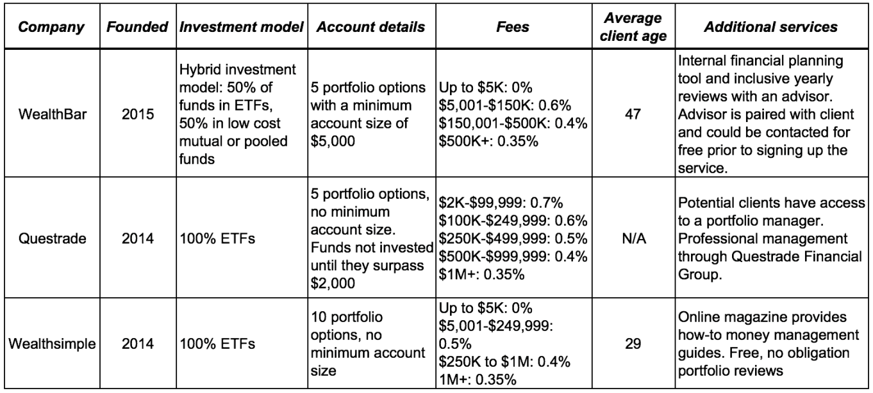

Source: Rob Carrick, “The 2016 Robo-Advisor Round-Up,” *Globe and Mail,* October 2016, accessed March 4, 2017, https://www.theglobeandmail.com/globe-investor/funds-and-etfs/etfs/everything-you-need-to-know-about-robo-advisers/

article32302639/.

EXHIBIT 6A: INCOME STATEMENT FOR MOGO, 2014–2016

Years Ended December 31 (in thousands, CA$)

|  |  |  |  |
| --- | --- | --- | --- |
|  | **2016** | **2015** | **2014** |
| **Revenue** |  |  |  |
| Loan fees | $25,942 | $30,391 | $19,413 |
| Loan interest | $15,593 | $8,064 | $1,318 |
| Other revenue | $8,333 | $5,077 | $2,669 |
| Total | $49,869 | $43,532 | $23,400 |
| Cost of revenue | $19,160 | $16,406 | $8,575 |
| **Gross profit** | $30,708 | $27,126 | $14,825 |
|  |  |  |  |
| Technology and development | $10,144 | $7,596 | $3,904 |
| Customer service and operations | $7,299 | $8,779 | $5,841 |
| Marketing | $6,723 | $10,792 | $4,642 |
| General and administration | $10,335 | $10,532 | $4,911 |
| Operating expenses | $34,403 | $37,699 | $19,298 |
| Income (loss) from operations | $(3,694) | $(10,573) | $(4,473) |
| Funding interest expenses | $6,120 | $3,468 | $1,343 |
| Corporate interest expense | $6,259 | $6,259 | $6,086 |
| Unrealized foreign exchange loss | $(217) | $1,143 | $486 |
| Unrealized gain on derivative liability | $(89) | $(106) | $- |
| Store closure and related expenses | $1,506 | n/a | n/a |
| Other financing expense | $(181) | $12.00 | $680 |
|  |  |  |  |
| **Net loss** | $(17,091) | $(21,351) | $(13,073) |
|  |  |  |  |
| **Share metrics** |  |  |  |
| Basic and fully diluted | $(0.936) | $(1.626) | $(0.58) |
| Weighted average number of basic and fully diluted common shares | 18,251,248 | 13,132,745 | n/a |

Source: Company files.

EXHIBIT 6B: BALANCE SHEET FOR MOGO, 2015–2016

Years Ended December 31 (in thousands, CA$)

|  |  |  |
| --- | --- | --- |
|  | ***2016*** | ***2015*** |
| **Assets** |  |  |
| Cash and cash equivalents | $18,654 | $31,723 |
| Loans receivable | $61,875 | $61,768 |
| Prepaid expenses, deposits, and other assets | $1,379 | $1,143 |
| Deferred cost | $819 | n/a |
| Investment tax credits | $157 | $1,616 |
| Property and equipment | $3,921 | $4,239 |
| Intangible assets | $12,248 | $6,851 |
| **Total assets** | $99,026 | $107,342 |
|  |  |  |
| **Liabilities** |  |  |
| Accounts payable and accruals | $5,594 | $5,057 |
| Other liabilities | $1,205 | $1,419 |
| Credit facility | $45,943 | $40,384 |
| Debentures | $40,092 | $40,326 |
| Derivative financial liability | $489 | $129 |
| **Total liabilities** | $93,325 | $87,316 |
|  |  |  |
| **Shareholders' equity (deficit)** |  |  |
| Share capital | $45,654 | $45,314 |
| Contributed surplus | $3,945 | $1,517 |
| Deficit | $(43,898) | $(26,806) |
| **Total equity** | $5,701 | $20,025 |
|  | $99,026 | $107,342 |

Source: Company files.

EXHIBIT 7: MOGO WEBSITE AND APPLICATION

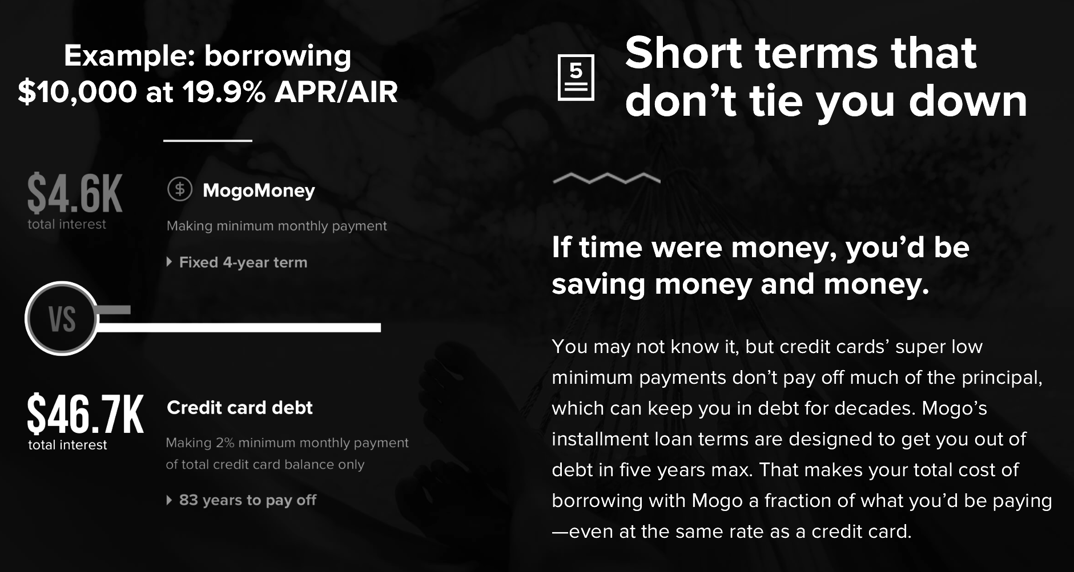

EXHIBIT 7 (continued)

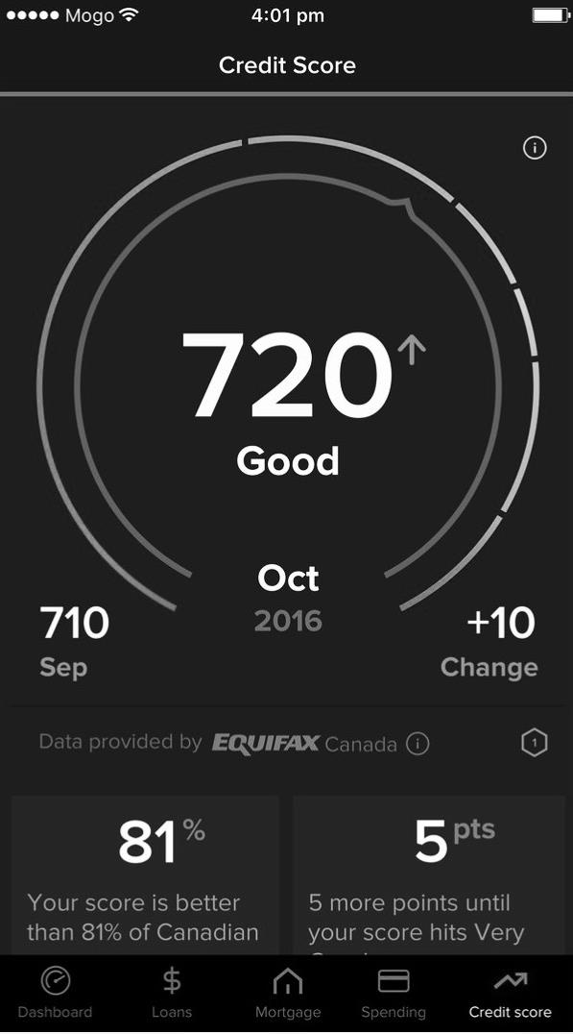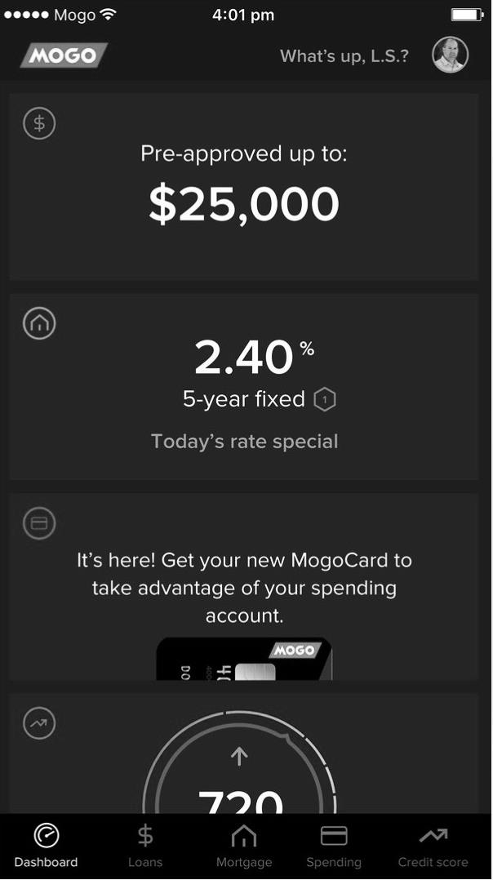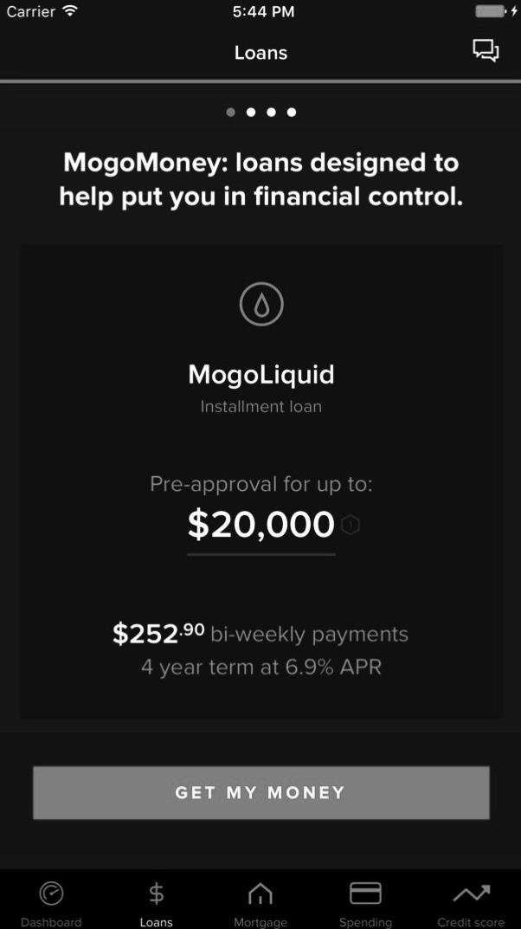

Source: Company files.

EXHIBIT 8: MOGO’S ORGANIZATIONAL STRUCTURE

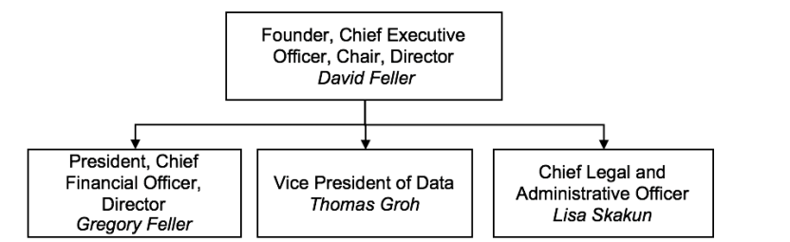

Source: Company files.

Endnotes

1. All currency amounts are in CA$ unless otherwise specified; CA$1 = US$0.0.81 on January 31, 2018.
2. Michael Burt, Kristelle Audet, and Greg Sutherland, “Ensuring the Future: Understanding the Importance of Toronto’s Financial Services Sector,” The Conference Board of Canada, 3-33, November 2013, accessed March 4, 2017, www.tfsa.ca/storage/reports/Ensuring%20the%20Future%20-%20Understanding%20the%20Importance%20of%20Toronto’s%20Financial%20Services%20Sector.pdf.
3. PricewaterhouseCoopers, Canadian Banks 201, 2017, accessed February 3, 2018 https://www.pwc.com/ca/en/industries/banking-capital-markets/canadian-banks-2017.html
4. Michael Burt, “An Engine for Growth: Report Card on Canada and Toronto’s Financial Services Sector,” The Conference Board of Canada, 1-23, November 2016, accessed March 4, 2017, www.tfsa.ca/storage/reports/EngineforGrowthFinancialServicesStateoftheSector2016.pdf.
5. The Conference Board of Canada, “The Financial Services Sector: A Source of Growth for Canada’s Economy,” November 26, 2015, accessed March 8, 2017, www.conferenceboard.ca/press/newsrelease/15-11-26/the_financial_services_sector_a_source_of_growth_for_canada_s_economy.aspx.
6. Wong. Craig, “Canada’s Household Debt Burden Hits Record,” *Globe and Mail*, September 15 2017, accessed February 2018, https://www.theglobeandmail.com/report-on-business/economy/canadas-household-debt-to-disposable-income-ratio-climbs/article36275898/.
7. “FIS Consumer Banking PACE Index 2016”, 2016, accessed February 3, 2018, https://www.fisglobal.com/closethegaps.
8. Ernst & Young, Understanding Customer Behavior in Retail Banking: The Impact of the Credit Crisis across Europe, February 2010, accessed March 8, 2017, 1-18, www.ey.com/Publication/vwLUAssets/Understanding_customer_behavior_in_retail_banking_-_February_2010/$FILE/EY_Understanding_customer_behavior_in_retail_banking_-_February_2010.pdf.
9. Ernst & Young, Winning through Customer Experience: EY Global Consumer Banking Survey 2014, 2014, accessed March 8, 2017, 3-15, www.ey.com/Publication/vwLUAssets/EY_-_Global_Consumer_Banking_Survey_2014/$FILE/EY-Global-Consumer-Banking-Survey-2014.pdf.
10. Amanda Reaume, “How Canada’s Big Five Banks Are Investing in FinTech,” RateSupermarket.ca, November 3, 2015, accessed March 10, 2017, www.ratesupermarket.ca/blog/how-canadas-big-five-banks-are-investing-in-fintech.
11. Roman Regelman, Derek Hayes, Olivier Morbé, Julia Lingel, and Michal Reshef, “How Digitized Customer Journeys Can Help Banks Win Hearts, Minds, and Profits,” BCG Perspectives, June 2, 2016, accessed March 8, 2017, www.bcgperspectives.com/content/articles/financial-institutions-technology-digital-how-digitized-customer-journeys-help-banks-win-hearts-minds-profits/.
12. Brad Bergan, “TD Bank Launches Moven-Powered MySpend to Help Canadians Spend Wisely,” Bank Innovation, April 15, 2016, accessed March 8, 2017, http://bankinnovation.net/2016/04/td-bank-launches-moven-powered-myspend-to-help-canadians-spend-wisely/.
13. Alexandra Posadski, “Scotiabank Launches ‘Digital Factory,’” *Globe and Mail*, October 16, 2015, accessed March 4, 2017, https://theglobeandmail.com/report-on-business/scotiabank-launches-digital-factory-that-will-house-350-tech-jobs/article26843317.
14. Jonathan Woods, “How Banks are Making Friends with Fintech,” BetaKit, August 29, 2016, accessed March 4, 2017, http://betakit.com/how-banks-are-making-friends-with-fintech/.
15. Murad Hemmadi, “How Canadian Startups Are Changing the Way We Bank,” *Canadian Business*, June 15, 2015, accessed March 14, 2017, www.canadianbusiness.com/innovation/how-canadian-startups-are-changing-the-way-we-bank/.
16. Digital Finance Institute; McCarthy Tétrault LLP, FinTech in Canada: British Columbia Edition 2016, 2016, accessed March 17, 2017, www.digitalfinanceinstitute.org/wp-content/uploads/2016/09/Fintech-Report-2016-1.pdf.
17. Anderson, Tyler, “Canadian Fintechs Shine as Venture Capital-Backed Investments Hit Highest Level in Nearly Two Decades,” *Financial Post*, January 3, 2017, accessed March 25, 2017, http://business.financialpost.com/fp-tech-desk/canadian-fintechs-shine-as-venture-capital-backed-investments-hit-highest-level-in-nearly-two-decades?__lsa=2b78-d9d5.
18. Madhvi Mavadiya, “Does the 2017 Canada Hype Include Fintech?” Forbes, February 23, 2017, accessed March 4, 2017, www.forbes.com/sites/madhvimavadiya/2017/02/23/canada-hype-fintech/#1d16b58d7517.
19. Ernst & Young, “Fintech Adoption Index,” ey.com, 2017, accessed February 3, 2018, http://www.ey.com/Publication/vwLUAssets/ey-fintech-exec-summary-2017/$FILE/ey-fintech-exec-summary-2017.pdf.
20. Statistics Canada, “Consumer Credit, Excluding Mortgages”. November 27, 2015, accessed February 3, 2018, http://www.statcan.gc.ca/tables-tableaux/sum-som/l01/cst01/fin20-eng.htm.
21. Payday lenders were companies that offered small, short-term, unsecured loans at high interest rates. Applicants did not require prime credit scores and could obtain the funds in one business day.
22. Bank of Canada, “Household Credit,” 2017, accessed March 25, 2017, http://credit.bankofcanada.ca/householdcredit.
23. Shadow banks were financial intermediaries; they were not subject to the same regulations as traditional banks because they did not accept deposits.
24. Benjamin Tal, “Household Borrowing: Elevated, but Slowing,” CIBC; In Focus, February 2, 2017, accessed March 10, 2017, https://economics.cibccm.com/economicsweb/cds?ID=2272&TYPE=EC_pdf.
25. Borden Ladner Gervais, Regulating Fintech in Canada, October 2016, accessed March 12, 2017, http://blg.com/en/News-And-Publications/Documents/Publication_4717.pdf?utm_source=Mondaq&utm_medium=syndication&utm_campaign=View-Original.
26. PayPal Holdings, Inc, 2015 Form 10K, January 2015, accessed March 12, 2017, https://investor.paypal-corp.com/secfiling.cfm?filingID=1633917-16-113&CIK=1633917.
27. Apple Inc., 2015 Form 10-K, January 2015, accessed March 12, 2017, http://investor.apple.com/secfiling.cfm?filingid=1193125-14-383437.
28. Geoff Zochodne, “Koho Locks Down $8M Investment from Desmarais-Backed Venture Fund,” *Financial Post,* September 25, 2017, accessed February 3, 2018, http://business.financialpost.com/business/koho-locks-down-8m-investment-from-desmarais-backed-venture-fund.
29. Currencies recognized by a government as legal tender.
30. Arjun Kharpal, “Bitcoin’s Market Value is Now Larger than Goldman Sachs and Morgan Stanley,” CNBC, October 13, 2017, accessed February 3, 2018, https://www.cnbc.com/2017/10/13/bitcoin-market-cap-bigger-than-goldman-sachs-and-morgan-stanley.html.
31. Lewis, Michael, “Is Bitcoin a Boon or a Bubble?,” *The Toronto Star*, December 1 2017, accessed February 3, 2018, https://www.thestar.com/business/wealth/2017/11/30/is-bitcoin-a-boon-or-a-bubble.html.
32. Finder, “Bitstamp Bitcoin Exchange Review—February 2018, January 29, 2018, accessed February 3, 2018, https://www.finder.com/ca/bitstamp-exchange-review.
33. CryptoCompare, QuadrigaCX Exchange, accessed February 3, 2018, https://www.cryptocompare.com/exchanges/quadrigacx/overview.
34. CryptoCompare, “Exchanges Overview,” accessed February 3, 2018, https://www.cryptocompare.com/.
35. Bank of Canada, “Bitcoin Awareness and Usage in Canada,” December 2017, accessed February 3, 2018, https://www.bankofcanada.ca/wp-content/uploads/2017/12/swp2017-56.pdf.
36. “Black markets” unconnected to official economies that typically facilitate illegal activity, such as the trading of illicit goods and services.
37. Statistics Canada, “Residential Mortgage Credit,” Janaury 2018, accessed February 3 2018, http://www.statcan.gc.ca/tables-tableaux/sum-som/l01/cst01/fin21-eng.htm.
38. HSBC, “Millennial Home Ownership,” February, 2017, accessed March 25, 2017, 1-5 www.about.hsbc.ca/~/media/canada/en/news-and.../170228-new-global-study-en.pdf.
39. Evry, Whitepaper: First Home Buying for Millennials, November 2014, accessed March 14, 2017, www.evry.com/globalassets/insight/bank2020/first-home-buying-for-millennials---labs-whitepaper.pdf.
40. intelliMortgage, accessed February 3, 2018, https://intellimortgage.com
41. Daniel Kobler, Felix Hauber, and Bernjamin Ernst, Millennials and Wealth Management: Trends and Challenges of the New Clientele, Deloitte, June 2015, accessed March 14, 2017, www2.deloitte.com/content/dam/Deloitte/lu/Documents/financial-services/lu-millennials-wealth-management-trends-challenges-new-clientele-0106205.pdf.
42. Ontario Securities Commission, “CSA Staff Notice 31-342: Guidance for Portfolio Managers Regarding Online Advice,” 2016, accessed March 25, 2017, www.osc.gov.on.ca/en/SecuritiesLaw_csa_20150924_31-342_portfolio-managers-online-advice.htm.
43. Rob Carrick, “The 2016 Robo-Advisor Guide: Find out Which Firms Deserve Your Business,” *Globe and Mail*, October 7, 2016, accessed March 26, 2017, www.theglobeandmail.com/globe-investor/funds-and-etfs/etfs/everything-you-need-to-know-about-robo-advisers/article32302639/.
44. Underbanked customers had limited access to financial products from retail banks due to lower or nonexistent credit scores. As a result, they relied more heavily than the average banked consumer on loans or credit card funding.
45. Gamification referred to the process of imbuing products and marketing tactics with typical elements of a game that inspired competition and improved engagement.