|  |  |
| --- | --- |
|  | **完整版院徽.png** |

9B17M161

linkfluence: building on actsocial’s relationships

Wei Lu, Ying Zhou, and Jianfeng Chai wrote this case under the supervision of Professor Darren Meister solely to provide material for class discussion. The authors do not intend to illustrate either effective or ineffective handling of a managerial situation. The authors may have disguised certain names and other identifying information to protect confidentiality.

*This publication may not be transmitted, photocopied, digitized or otherwise reproduced in any form or by any means without the permission of the copyright holder. Reproduction of this material is not covered under authorization by any reproduction rights organization. To order copies or request permission to reproduce materials, contact Ivey Publishing, Ivey Business School, Western University, London, Ontario, Canada, N6G 0N1; (t) 519.661.3208; (e)* [*cases@ivey.ca*](mailto:cases@ivey.ca)*;* [*www.iveycases.com*](http://www.iveycases.com)*.*

Copyright © 2017, SJTU Antai College of Economics and Management and Richard Ivey School of Business Foundation Version: 2019-04-05

In November 2015, Liu Kai, Benjamin Duvall, and Marc Rivoira were filled with mixed feelings as they sat together in the ActSocial conference room in Shanghai. They had just returned from Paris, and the excitement had not fully faded from the announcement of a successful acquisition of their company by Linkfluence, a leading global social media monitoring and research company headquartered in Paris. Linkfluence had been attracted to ActSocial’s technical capabilities, market knowledge, and the growth that it achieved in its short existence.

The management team of ActSocial talked about what the next few years would be like as part of a larger company. Would they still have an influence over the direction of the product? How would they make hiring decisions and continue to build their team? Would they be able to smoothly execute on the global integration and next two years’ growth plan? To fully take advantage of the opportunity to bring Linkfluence’s global client base to the Asia-Pacific (APAC) region, Rivoira, Duvall, and Liu needed to overcome a few challenges.

THE Social Media Marketing Industry in China

The media available to online marketers fit into three broad categories: owned media, paid media, and earned media. Owned media were defined as communication channels that were within one’s control, such as websites, blogs, and email, whereas paid media referred mostly to traditional advertising. Earned media, on the other hand, were generated when content received recognition and a following outside of traditional paid advertising, through communication channels such as social media and word of mouth.

Earned media often referred specifically to publicity gained through editorial influence, whereas social media referred to publicity gained through grassroots action, particularly on the Internet. Media included any mass media outlets, such as newspaper, television, radio, and the Internet, and could include a variety of formats, such as news articles or shows, letters to the editor, editorials, and polls on television and the Internet. Critically, earned media could not be bought or owned, and could be gained only organically, hence the term “earned.” Social media represented one of the most important ways to earn media.

China was one of the earliest and most fragmented social media environments to develop in the world, in the mid-1990s. It started with a vibrant Bulletin Board System (BBS) ecosystem driven by university communities such as Peking University, Tsinghua University, and Fudan University. Major media portals and BBSs such as NetEase, Sina, and VeryCD were also prominent. However, there were many contributors and the ecosystem for social media was fragmented.

Rather than adopting the major global social media sites such as Facebook, Twitter, Instagram, and Snapchat, China developed its own search and social media ecosystem, which was now dominated by Baidu, Alibaba, and Tencent, which operated most of China’s websites such as Renren, QQ, Sina Weibo, WeChat, and Yizhibo.

Due to the specificities of the Chinese market, paid media were expensive and rapidly increasing in price. According to a report by e-Marketer, total national digital ad spending in China had increased at an average of 28.6 per cent per year from 2009 to 2014, compared with 13.7 per cent in the United States. In 2014, online ad spending in the United States was expected to be US$45 billion[1] compared with $9.5 billion in China.[2]

Due to the locally specific and expensive nature of both paid and earned media in China, social listening (i.e., the technology and process of finding out what people were saying about a brand, product, person, topic, or campaign on the Internet) became a key marketing research tool for brands to track their reputations and understand consumers quickly and cost-efficiently, relative to traditional research methods.

Additionally, using influencers became a key tactic for major brands to reach consumers. Commonly referred to as key opinion leaders (KOLs) in China, these influencers were celebrities and popular bloggers who were paid to post content about brands on social networks.

One of China’s most popular online KOLs was M鹿M, whose real name was Lu Han. As of June 16, 2017, he had more than 33 million followers on Weibo, where people could find his selfies, working schedules, and commercials. His post of KFC’s in-store campaign could easily lead to more than 100,000 reposts and commendations, and nearly one million likes from his loyal fans.[3] He also cooperated with Adidas and Ofo (a Chinese start-up bike-sharing company).

Gogoboi was another popular fashion blogger who, as of June 16, 2017, had more than seven million followers on Weibo. He often shared his opinions about fashion, comments on the dress style of celebrity stars on the red carpet, and tips about what to wear. Design brands such as MiuMiu and D&G would invite him to their fashion shows in exchange for his blog articles and interactions with his fans.[4]

Given the rapid growth and fragmented nature of the Chinese market, marketing consultancies had many opportunities to enter the market to help companies understand how to dedicate their many resources within the social media space.

ActSocial

In 2008, Christoph Zrenner and Benjamin Duvall founded Wildfire, which they renamed ActSocial in 2014. Later, Kai, the first technology employee, and Rivoira, an experienced advertising executive, joined as equal partners.

Zrenner had previously founded Ostrakon, a Chinese survey company based in Shanghai, which helped universities to incorporate student feedback on faculty and curriculum. Zrenner had a degree in neuroscience from Cambridge University and was a self-taught programmer. Duvall had eight years of experience in social and product management, including roles with location-based services company LoJack in China, Hong Kong, and Argentina, and was an early member of influencial marketing pioneer BuzzAgent. He held a bachelor’s degrees in East Asian studies and political science from Oberlin College, and an MBA from INSEAD, and had been in China on and off since 1998. Duvall met Zrenner while Duvall was completing his MBA at INSEAD.

Liu had experience in software development and a master’s degree from Jiao Tong University in software engineering. His first job was at Zrenner’s company, Ostrakon, where he gave up many more prestigious offers for the opportunity to build a product and a company. Rivoira had 14 years of experience in marketing and information technology. For three years, Rivoira had been managing director at Saatchi and Saatchi X China, one of the biggest global shopper marketing agencies. He had been in China since 1995 and had worked across South East Asia, Europe, and America.

From January 2009 to January 2010, ActSocial raised SG$550,000[5]seed round funding in rolling investments in Singapore, and in August 2010, the company raised SG$780,000 Series A round investment from Innosight Ventures, a Singapore venture investment firm. In the same year, the launch of Sina Weibo (see Exhibit 1) unveiled the era of exponential growth of online social media and digital content marketing. At that time, the advertising industry would not accept word-of-mouth (WOM) conversations as a form of media and therefore did not allocate significant budgets, regardless of the efforts of the ActSocial team to hire independent auditors to measure the impact of WOM campaigns on brand equity, sales, and conversion (see Exhibit 2).

In 2010, ActSocial started to focus on providing online social media and digital content marketing services. This job was not easy, as the team needed to act quickly by shifting its initial offline WOM business model and organization configuration to the emerging opportunity in online social media marketing. At the same time, the team was expected to communicate on a regular basis with the company board in Singapore, using management accounting processing typically used by large established companies.

In 2011, ActSocial launched Influencer Media for online conversation scanning and social customer relationship management. It attained online survey data of 2.5 million individuals and tracked the online conversation posts of five million. ActSocial then extended its social listening service from identifying influencers to engaging them through a platform, thereby differentiating itself from other pure-play social listening companies, and providing an additional revenue stream.

From 2012 to 2015, the company continued to deliver WOM marketing programs for a client base of mostly multinational corporations (MNCs), using its combination of social listening and influencer management technology.

In 2013–14, ActSocial did a half-year project for Barilla, the Italian pasta brand. Although the Chinese market for noodles was large, Italian-style pasta was not popular. Barilla, a major global pasta company, wanted to learn how to drive awareness and adoption of Italian-style pasta in China. Working with ActSocial, Barilla learned how social listening and influencer activation could generate powerful consumer insights. Italian food was perceived as being expensive and suitable for special occasions, not for cooking at home. To get consumers to cook pasta at home, the project came up with an idea of “the Barilla pasta exchange.”

Through this campaign, more than 1,000 pasta exchange requests were published to Weibo, picked up by millions of their friends, and spread to more than 3.2 million people online and offline. In three months, Barilla’s Weibo fans had doubled: 78 per cent of the people reached wanted to recommend Barilla to friends and families, which created a $220,000 media value. During the six-month project period, 500 tons (454 tonnes) of pasta products were sold in China.[6]

ActSocial built a toolset to take brands from insight to influence, using data processing, visualization technology, and a network of tens of thousands of volunteer influencers. Starbucks, DSM, Diageo, Carrefour, Barilla, and Omnicom were just a few companies who had adopted ActSocial technologies and services in the first few years of its business.

In 2014, ActSocial launched IAP—the mobile version of the Influencer Media website, with a mobile app for influencers, a modern user interface, gamification, and a key feature of social pairing, whereby influencers were directed to online conversations where others were seeking advice or feedback related to products the influencers were trying.

Exhibit 3 shows the evolution of ActSocial’s technology. In the first few years of its development, ActSocial launched Influencer Media and Influencer Insight products, focused on offline consumer WOM activation and research.

As ActSocial continued to develop, it started to work more extensively with international brands to help them access the Chinese market. For example, ActSocial worked with the Campbell Soup Company (Campbell’s) on a new product launch in an offline campaign project. ActSocial first identified that the best occasion for Campbell’s was a weekday when families returned home and began preparing dinner. ActSocial then designed an integrated marketing communication (IMC) plan based on the core idea of “rich soup real meat start dinner earlier.” The IMC plan comprised a television commercial, in-store sampling, and WOM sharing by 1,000 influential mothers to convince mid- to high-income mothers who cooked soup several times each week to spend less time in the kitchen, and more time with their families. The project resulted in thousands of friend-to-friend conversations and product experiences that were shared both online and offline.

Through these projects, ActSocial had accumulated an influencer community of 50,000 segmented consumers who were willing to share their product experiences with friends, family, and colleagues, online, and in the physical world of offices, homes, and schools. These consumers were well-educated office professionals and college students working and living in Tier 1 and Tier 2 cities[7] along the east coast of China. Most were females aged 20–35, who regarded themselves as passionate for life, pioneers of a new lifestyle, and natural leaders in social networking. ActSocial’s various consumer product projects offered an excellent platform for companies to express and reinforce their identities, values, and KOL status.

The company focused on providing social media intelligence and influencer marketing for major brands. By 2015, ActSocial’s tagline, “from insight to influence,” summarized a value proposition of first helping brands to understand consumers on social media, and then identifying and engaging with influencers with appropriate content to affect consumer attitudes and behaviours online and offline.

The ACQUISITION BY LINKFLUENCE

Founded in 2006 in France, Linkfluence was a leading social data intelligence company that specialized in analyzing conversations on the social web (i.e., Facebook, Twitter, online media, blogs, forums, and social networks) to create business opportunities for brands. Linkfluence offered client solutions to monitor, measure, understand, and engage efficiently on the social web. Its flagship product, the Radarly Product Suite, a software as a service (SaaS), collected relevant social media conversations around client brands (e.g., 110 million posts were harvested in 60 different languages daily) to provide actionable insights applicable across the client organization.

In 2015, the company had a diverse team of more than 200 employees in France, Germany, United Kingdom, Spain, and Singapore. As an experienced player in social analytics, Linkfluence had more than 250 clients globally, including brands, agencies, and public organizations. These clients included AccorHotels, EDF Energy, Ford, ING Group, LVMH, Publicis, Roche Holding AG, Sanofi, and World Wildlife Fund, to name a few.

The stated goal of Linkfluence’s leadership was to become the number-one global social media intelligence company. The latest round of €12 million[8] raised capital was just another footnote of Linkfluence’s growth ambitions.[9] While Linkfluence had taken strides in this direction, it had limited knowledge of the Chinese market and—for the most part—its expertise was focused on traditional global platforms, not those used in China.

Linkfluence’s senior management contacted the ActSocial management team, and after a series of negotiations, an agreement was struck. Linkfluence would purchase 100 per cent of ActSocial in November of 2015, and ActSocial would become Linkfluence Asia. As an independent brand, ActSocial would cease to exist.

The acquisition was conducted based on strong value creation rationale, which could yield a new growth roadmap for both Linkfluence Asia and its holding company, Linkfluence:

* Linkfluence had a global customer base, and many of its customers had established large operations in China (see Exhibit 4). Understanding Chinese customers through online social media monitoring was neither trivial nor easy to achieve, given the vast number of conversations online every day, challenges in processing the Chinese language, and the complexity of demographic and economic development differences across the country.
* ActSocial had been running social media business in China and other South East Asian countries for the past seven years. Its technology for local language and data sourcing, as well as its market knowledge and project delivery team, presented a valuable asset for Linkfluence to extend its market reach to Asia.

The Creation of Linkfluence Asia

As Rivoira, Duvall, and Liu sat in the meeting room, it struck them that it was no longer the ActSocial meeting room. It was now the meeting room of Linkfluence Asia’s office. In their opinion, Linkfluence was the only global social listening firm fully localized in China and APAC. At their disposal, they had approximately 45 researchers and engineers located in Shanghai and Singapore, dedicated to serve a portfolio of MNC clients across diverse verticals in Asia.

While some details still needed to be worked out, the new management structure had been decided. Rivoira would be chief operating officer, Duvall would take a role as chief evangelist officer, and Liu would become the chief technology officer. They would be joined by Christophe Randy as vice-president Sales for Asia.

Randy had more than 15 years of experience in the high-tech industry, including five years in Asia. His résumé included work at Microsoft and PayPal, as well as in fast-growing international start-ups in the broadband and digital music spaces. Before joining Linkfluence, Randy had been responsible for growing PayPal’s business with key accounts in Southeast Asia and India, and he had launched strategic sales excellence programs in APAC. At Linkfluence Asia, his responsibilities included APAC sales strategy, execution, and revenue, through direct and channel sales activities.

While competition in the Chinese and APAC markets was fierce (see Exhibit 5), the market still seemed to be vastly underserved; most brands and media agencies still focused on brand reputation and content performance, and social media teams manually tracked the market with little awareness of the value benefits of applying social media listening to consumer research.

Major social media companies were positioning themselves around the following four key elements:

* Software functionality: Cloud-based, social media account performance tracking, publishing process management, and social listening were industry norms. Real-time analytics, automatic reports, alerting, and client self-service query configuration represented value-added services that few players offered.
* Data source: The choice of a data source had a high correlation with industry players’ market coverage, given that only relevant social media data could generate insightful intelligence.
* Service offering: Among the four major types of service offerings, quantitative research and crisis monitoring were derivative services of software functionalities, which were easy to automate or semi-automate. Unlike these two “threshold” services, qualitative research and strategic planning were more consultative-oriented, which required close interactions with client organizations, a deep understanding of clients’ business needs, and insightful interpretations of client industry trends. On the other side of this service-offering spectrum, two global players, Hootsuite and Radian6 (owned by Salesforce.com) positioned themselves as pure cloud-based SaaS companies and offered only software functionalities.
* Market coverage: An understanding of local cultural subtleties and the vast content on local social media was almost the requisite entry ticket to the local market, which explained why all major players were Chinese firms, while global players stayed out of the China market, with just APAC-originated ActSocial and Brandtology enjoying a market presence.

Scale was quickly becoming an issue for firms providing advice in this area. Scale was required to cover the market. Sophisticated tools for data analysis also required a significant upfront investment. These were key reasons why it made sense to incorporate ActSocial into Linkfluence. However, there was still a need to recognize the distinctions of the Chinese market. Clearly, there was an opportunity for a global player with local capabilities.

CONCLUSION

Rivoira, Duvall, and Liu realized a new day had arrived. They turned to the whiteboard on the office wall and thought about how they could leverage the acquisition and synergies across the organization to achieve the growth targets. They thought about their own career growth and how it was tied to the growth of Linkfluence Asia. The future promised to be both exciting and challenging.

Exhibit 1: SOCIAL NETWORK SITES WORLDWIDE AS OF DECEMBER 2013, RANKED BY NUMBER OF ACTIVE USERS (IN MILLIONS)

Source: Marcelo Ballve, “Our List Of The World's Largest Social Networks Shows How Video, Messages, And China Are Taking Over The Social Web,” *Business Insider: Tech Insider*, December 17, 2013, accessed July 30, 2017, www.businessinsider.com/the-worlds-largest-social-networks-2013-12.

Exhibit 2: the impact of Word-Of-Mouth marketing campaigns, 2010

|  |  |  |
| --- | --- | --- |
|  | **TV Only Campaign** | **TV + WOM Campaign** |
| Spend (in RMB) | ¥5,000,000 | ¥5,600,000 |
| Target Population | 1,000,000 | 1,000,000 |
| TV Reach % | 60 | 60 |
| WOM Reach % | 0 | 25 |
| TV Trial % | 25 | 25 |
| WOM Trial % | 0 | 35 |
| Total Trial lists | 150,000 | 175,000 |
| Cost per Trial | ¥33.3 | ¥32.0 |

Note: WOM = word of mouth; ¥ = RMB = Chinese renminbi; US$1 = ¥6.59 to ¥6.83 in 2010.

Source: Company files.

Exhibit 3: The Evolution of ActSocial Technology

ActSocial Technology

2009: The Influencer Website

This website provided the first web browser influencer community where offline influencers could register to receive free products and report word-of-mouth conversations. The site was based on BzzAgent.com.

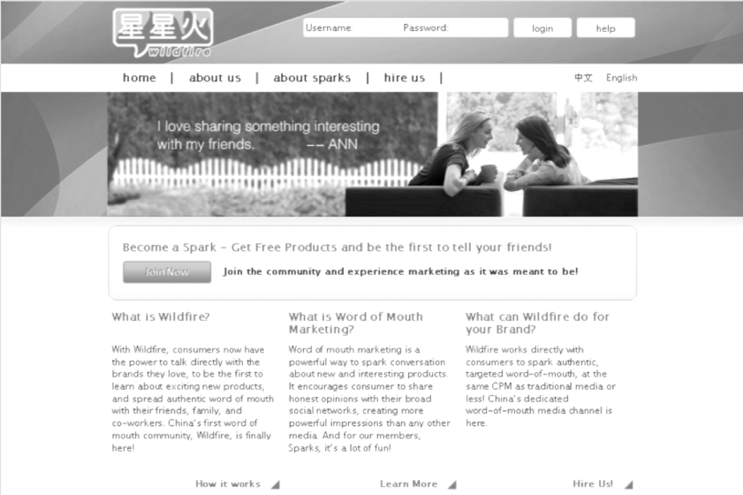

2010: InfluencerMedia

InfluencerMedia was a rebranding of the initial influencer website with a focus on media impact and the modelling of media efficiency using mainstream media metrics such as CPM (cost per thousand impressions) and measuring impact using mainstream research metrics such as aided and unaided recall, purchase intent, and net promoter score.

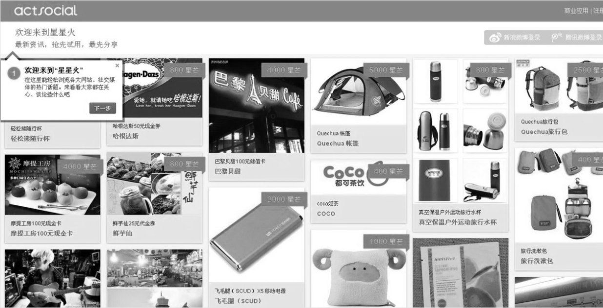

Exhibit 3 (continued)

2010: InfluencerInsight

InfluencerInsight was a research product built on the InfluencerMedia platform. Influencers were given research-oriented missions, such as surveys and interviews (in addition to spreading word-of–mouth marketing messages).The results provided consumer and market research.

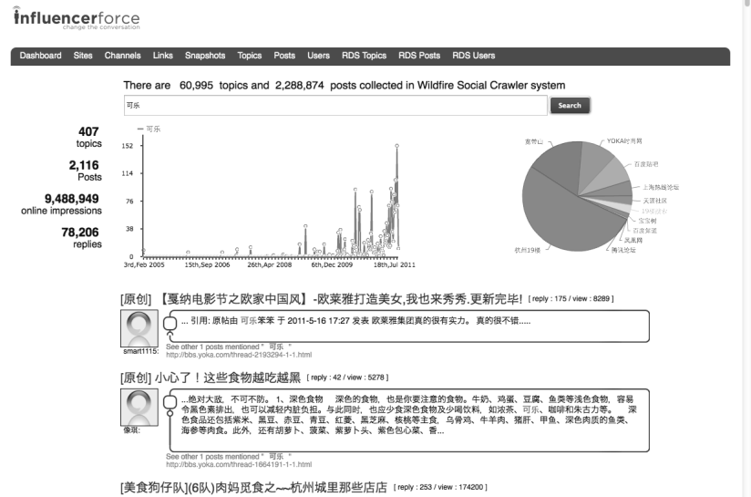

2011: ActSocial Platform

The first release of ActSocial’s social listening platform gathered data from application program interfaces (including Sina Weibo) and web crawler technologies. It used Chinese language algorithms to identify sentiments and topics, and cloud-based visualization software. Using this platform, brands could track key social listening key performance indicators such as volume of mentions, sentiments, topics, and content performance.

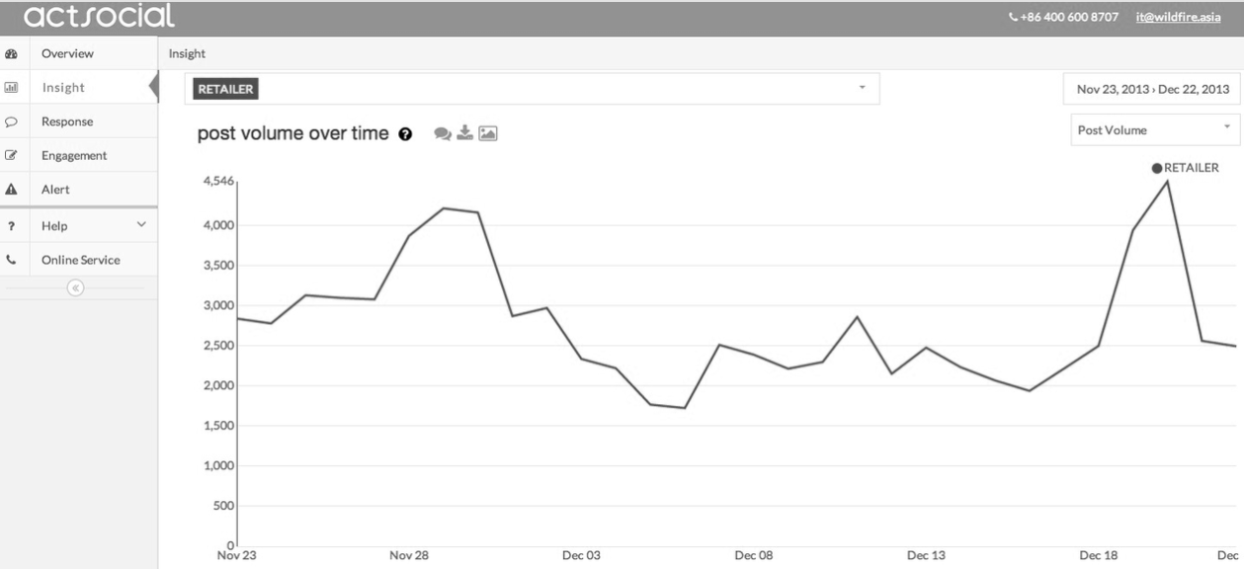

Exhibit 3 (continued)

2014: IAP

IAP was a new version of the InfluencerMedia website, with a mobile app for influencers, a modern user interface, gamification, and a key feature of social pairing, whereby influencers were directed to conversations online where others were seeking advice or feedback related to products the influencers were trying.

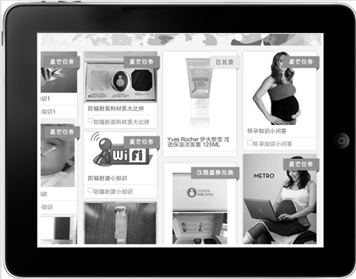

2015: Radarly

In 2015, the ActSocial social listening platform was integrated with Radarly—Linkfluence’s global social listening platform. This integration added significantly improved Chinese data sources and sentiments to the already globally competitive Radarly sources and feature set.

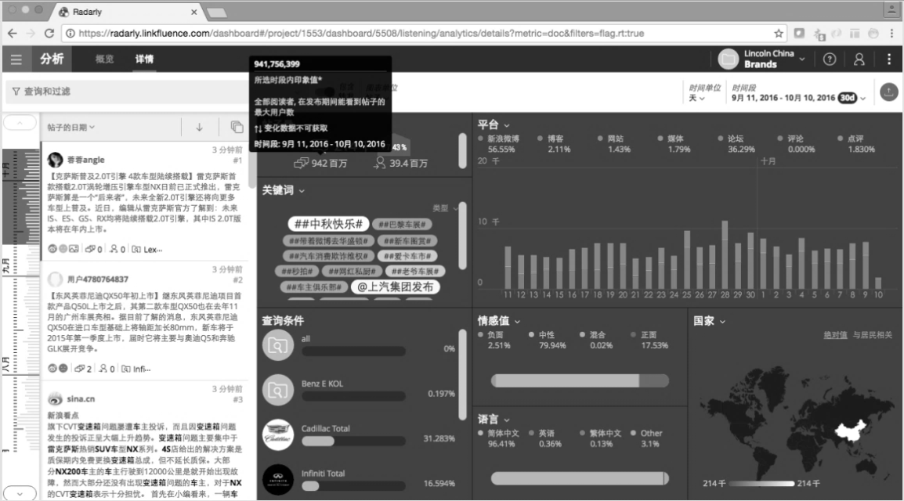

Exhibit 3 (continued)

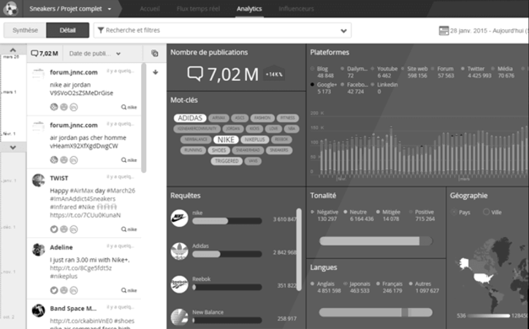

Source: Company files.

Exhibit 4: SAMPLE OF LINKFLUENCE’S PAST AND CURRENT CLIENTS



|  |  |  |  |  |  |  |  |  |  |  |  |  |
| --- | --- | --- | --- | --- | --- | --- | --- | --- | --- | --- | --- | --- |
| edf |  | Vinci |  | SAP |  | | Beck’s | |  | | SanofiI | |
| TOTAL |  | PMU |  | Cetelem |  | | McDonald’s | | | | Roche | |
| Credit Agricole | | GDF SUEZ |  | Crédit Mutuel | | Firmenich | |  | | Havas | |
| Quachua |  | Kellogg’s |  | Volkswagen | | Tesco | |  | | Liquan Beer | |
| Accor |  | Bosch |  | Danone |  | | Bloomberg | | | | MedicAnimal | |
| Cartier |  | oxelo |  | Tupperware | | L’Oreal | |  | | France Télévisions | |
| Boursorama Banque | | DDB |  | Lincoln |  | | Regeneron | | | | BPCE | |
| Club Med |  | Merz |  | Retail IT |  | | Granini | |  | | Richemont | |

Source: Company files.

Exhibit 5: COMPETitIVE POSITIONING OF MAJOR INDUSTRY PLAYERS



Note: The social listening feature is a big data analysis based on the collection from many sources of data on a subject the client wants to monitor (e.g., the client’s brand name). Social media account performance is performance analysis of content that a client posts on its Facebook, Twitter, and other social media accounts. Key performance indicators include, among other indicators, the number of views, likes, followers, forwards, and clicks. Publishing is the functionality of managing the process of content publishing, including workflow management features such as approval and scheduling.

SNS = social networking service; EMEA = Europe, Middle East, and Africa; APAC = Asia Pacific

Source: Company files.

1. All currency amounts are shown in U.S. dollars unless otherwise specified.
2. eMarketer, “eMarketer Co-Founder and CEO Releases Comprehensive Guide for Digital Marketer,” eMarketer: Newsroom, June 28, 2011, accessed July 30, 2017, www.emarketer.com/newsroom/index.php/2011/06/; “China Online Ad Market to Double by 2013,” eMarketer, November 10, 2010, accessed July 30, 2017, www.emarketer.com/Article/China-Online-Ad-Market-Double-by-2013/1008037.
3. M鹿M‘s Weibo post of Adidas commercial, M鹿M, May 31, 2017, accessed July 30, 2017, http://weibo.com/1537790411/F5DVIeXmf?filter=hot&root_comment_id=0&type=comment.
4. Gogoboi’s Weibo blog, M鹿M, May 31, 2017, accessed July 30, 2017, http://weibo.com/1706372681/F5GGZ2o47?filter=hot&root_comment_id=0&type=comment#_rnd1497606137080.
5. SG$ = Singapore dollars; US$1 = SG$1.28 to SG$1.40 in 2010
6. “Barilla IAP EN,” YouTube video, 1:52, posted by “Tessa Song,” May 15, 2017, accessed June 13, 2017, https://youtu.be/rtpqj4eFTvY.
7. Riley Gardner, “China City Tier System: How it Works and Why its [sic] Useful,” Nexus Pacific: Market Intel, July 9, 2013, accessed September 4, 2017, <http://nexus-pacific.com/blog/2013/7/9/china-city-tier-system-how-it-works-and-why-its-useful>.
8. € = euro; US$1 = €0.9044 on Oct 13, 2016.
9. “Linkfluence Announces a Record Investment of 12 Million Euros,” Linkfluence: News Release, October 13, 2016, accessed July 30, 2017, www.multivu.com/players/uk/7949151-linkfluence-announces-record-investment/?c=y.