

9B17M162

note on the cuban cigar industry (revised)

Mila Bojic revised this case (originally written by Akash Kapoor) under the supervision of Professor Paul Beamish solely to provide material for class discussion. The authors do not intend to illustrate either effective or ineffective handling of a managerial situation. The authors may have disguised certain names and other identifying information to protect confidentiality.

*This publication may not be transmitted, photocopied, digitized, or otherwise reproduced in any form or by any means without the permission of the copyright holder. Reproduction of this material is not covered under authorization by any reproduction rights organization. To order copies or request permission to reproduce materials, contact Ivey Publishing, Ivey Business School, Western University, London, Ontario, Canada, N6G 0N1; (t) 519.661.3208; (e)* [*cases@ivey.ca*](mailto:cases@ivey.ca)*;* [*www.iveycases.com*](http://www.iveycases.com)*.*

Copyright © 2017, Richard Ivey School of Business Foundation Version: 2017-11-23

In June 2017, U.S. President Donald Trump had just made a statement regarding his stance on Cuba-U.S. relations. Business leaders in the Northern Hemisphere were very attentive, as his actions would have an impact on the softening U.S.-Cuban relations started by his predecessor in 2016.

John Hernandez, a recent MBA graduate from a prestigious institution in Canada and an avid cigar smoker, viewed this scenario and wondered what effect it would have on the current environment, and if there was potential to invest in the Cuban cigar industry. With an inheritance of US$1 million[1] coming available in the next month, he thought back to his strategy sessions and looked to evaluate this industry.

History

The history of Cuba and tobacco are interwoven. When Columbus arrived in Cuba in 1492, little did he know that the medicinal herb enjoyed by the natives would become the scourge of society to some and a multibillion-dollar industry worldwide. Although the origin of tobacco is still disputed, as is the derivation of the name tobacco, its introduction to Western civilization is well documented and accepted as owing to the expedition to the “New World” of Christopher Columbus. In his quest for the riches of the Orient, he came across a race of native people, called the Taino, who were smoking tobacco leaves roughly rolled into a shape which they called “cohiba.”

Tobacco was brought to the Western world after this expedition, and the Spaniards held a monopoly over the tobacco trade for many years. Cuba was considered to be Spain’s lifeline between the Old and New Worlds. However, in 1762, Britain invaded and briefly dominated the island. During this period, Cuba was opened to worldwide trade and a new found prosperity. When Spain retook control one year later, trade restrictions were imposed. In 1817, Spain removed trade restrictions and began a period of renewed prosperity. World demand for Cuban products was so high that in 1845, tobacco replaced coffee as the second most important agricultural product, and demand for Cuban tobacco continued to increase.[2] In the 1850s, paper bands were introduced in Cuba to distinguish the many prestigious brands of cigars. Members of high society wanted custom-designed bands as symbols of their importance and taste. Hence, the Cuban cigar established a reputation as an “accoutrement of wealth, power and prestige.”[3]

Originally, Cuban tobacco leaves were shipped to Spain for rolling in the factories; however, when the shipments arrived and it was found that the fabricated cigars survived the journey in much better condition than the actual leaf, the cigar factories in Cuba were established. From these humble beginnings the myth of the Havana cigar was born and continues to pervade today.

In 1868, the first of two upheavals in the Cuban cigar industry took place. The Ten Years’ War saw a number of growers flee the country for America, taking with them prized Cuban seed. Key West and Tampa were major beneficiaries of this migration. The second upheaval came at the time of the revolution between 1959 and 1962. When Fidel Castro overthrew then-President Batista and nationalized approximately $1 billion of U.S.-owned property, the U.S. government imposed an economic blockade on Cuba. This action was a shock to the island’s economy, as the United States was one of its largest trading partners.

The first exodus gave the U.S. cigar industry a major boost, the ability to produce a cigar of similar quality sold at a much lower price. The revolution had a far greater impact on the Cuban cigar industry exodus of many key players and workers to other countries. This opened the doors of the cigar industry to competition, as growers, manufacturers, rollers and actual Cuban seed and knowledge found their way to the United States, Dominican Republic and Honduras, to name but a few.

The Cuban revolution also brought with it a command economy. The cigar industry in Cuba was placed under state control, and the celebrated brands of Cuban cigars were disbanded in favor of nameless cigars. However, after the disastrous response to these cigars and their horrendous quality, the state reinstituted the brands and allowed ‘private farming’ for tobacco plantations. It would take until the 1970s before they fully re-established the reputation that Cuban cigars had enjoyed for centuries.

In 1975, the World Court ruled that exiled Cuban cigar makers had the right to use their former brand names. Many great cigar families who had left their homeland, such as the Cifuentes family (Partagas) and the Menendez family (Montecristo), wished to continue production of their brand name cigars, and the ruling gave them the opportunity. This is why, in many cases, there are two versions of many Cuban brands: those produced with Cuban tobacco and those produced with non-Cuban tobacco. The families produced their own tobacco, and developed new packaging and cigar bands for their new versions of cigars. Partagas, Montecristo, Upmann, Hoyo de Monterrey, and Romeo y Julieta are some of the examples of Cuban brands that have dual versions.

The Product

The cigar has remained much the same over hundreds of years. There are three basic types of cigar produced in Cuba: handmade, hand-finished and machine-made. Structurally, the difference among the three is that handmade cigars use long filler and are bunched and rolled entirely by hand, whereas hand-finished cigars are bunched by machine and only the wrapper is put on by hand. Machine-made cigars are fully automated and generally use short filler and a composite binder. Long filler refers to a full tobacco leaf, short filler to cut up or leftover tobacco. The finished product, the cigar itself, comes in many different shapes and sizes. The distinction between brands comes from the blend used in the filler, the type of binder and the wrapper used to finish the product. These “recipes” are closely guarded secrets. In addition to the product itself the bands, the boxes and the traditions were all elements of the Havana cigar.

The Plants

The cigar is constructed from the leaves of two different tobacco plants. One plant yields the filler (tripa) and the binder (capote) of the cigar, and the other yields the wrapper (capa). The Havana cigar contains leaves from the criollo plant and the corojo plant. The criollo plant produces the tobacco to be blended and the binder that holds the tobacco together. The corojo plant produces the wrapper that finishes the cigar and dictates its final appearance. The criollo plant is grown in the sun; the corojo, or other strain for the wrapper, is grown under muslin cloth to protect it and to maintain a uniform leaf color and texture. This tending and careful harvesting of the wrapper leaves adds to the cost of the production.

Growing tobacco is a 9-10-month process, beginning in the summer months with tilling and ground preparation, and ending with the harvesting of the leaves from January through March. Harvesting takes time, patience and much labor. Therefore, the fields are planted a few weeks apart.

The various leaves on each tobacco plant are harvested on different days. A typical tobacco plant has 16 to 18 leaves. Pickers start from the bottom and work to the top, or coronas, because the leaves at the bottom of the plant ripen earlier. As such, harvesting occurs over a staggered period. The leaves at different levels are given different classifications, and their uses differ based on their characteristics. There are only five major categories; capa, capote, and those used for the filler, volado, seco and ligero. The picking of the leaves requires a great deal of judgment and experience on the part of the growers.

When the leaves are picked they are green. They are loaded into carts and taken to curing barns, or casas del tabaco. The drying process usually takes 50 days. Inside the barns, the leaves are strung with needles and threaded onto long poles. During the curing process, the leaves turn to a light brown. Once this occurs, they are removed from the barns and prepared for the first fermentation. This process allows the tobacco to undergo chemical changes, enhancing the flavor and aroma, while reducing the bitterness and the impurities within the tobacco. This first fermentation takes about 30 days. The leaves are then classified and perhaps stripped of their stems. A second fermentation follows and lasts up to 60 days. The tobacco is then aired and packed in large square bales called tercios. These bales weigh about 150 pounds (68 kilograms) and are covered with royal palm leaves and burlap. The bales may be stored in the warehouse for up to two years before being shipped to the factories for cigar production.

Putting the Cigar Together

The long-held legend of the Havana being rolled on the thighs of virgins is a fanciful myth. A journalist in the 1940s observed female workers sorting leaves and placing the piles in their laps, and the legend was born. The actual construction of the cigar requires skill and experience from the torcedores, or rollers. A cigar is put together by taking different leaves from the criollo plant and blending them according to the recipes that the master blender carefully guards and prepares. Generally there will up to three leaves in the blend, placed on top of each other in the correct order and formed carefully to ensure proper tightness and construction. The binder is then used to bunch the blended tobacco. After a process of shaping the bunches in pressed moulds, the wrapper is stretched over the bunched, formed leaves. The torcedores shape the wrapper to the correct size with a chaveta, or semi-circular knife. A piece is then taken from the excess wrapper to make the head of the cigar, which holds the cigar together. This is put on with an odorless, tasteless vegetable gum. The cigar is then inspected for girth and length and is then taken through a rigorous process of fumigation and aging, and then through to quality control for inspection, grading and presentation. The drying and aging is necessary to remove excess moisture from the cigars, and to remove the harshness from the new cigar. A good roller in Cuba can produce 100 to 150 cigars a day. Machine-made cigars can be produced in quantity of 10,000 cigars a day. It is the premium cigars, however, that Cuba has been focused on to this point.

Tobacco Growing Regions

The five main tobacco growing regions in Cuba are: Oriente (eastern provinces), Remedios (central Cuba, near Santa Clara), Partidos (east of the capital, Havana), Semi Vuelta and the famed Vuelta Abajo (western part of the island, in Pinar del Rio Province) (see Exhibit 1). The average temperature is 25°C (75°F) and the average relative humidity is around 80 per cent. The Vuelta and Semi-Vuelta areas are believed to be the cradle of the Havanas, producing the finest tobacco in the world. It is from this region that the tobacco and wrappers for the super premium cigars comes. Approximately 70 per cent of all tobacco grown in Cuba is harvested here.[4] The distinction here is the soil and the microclimate that keeps the humidity ideal for growing and cultivating tobacco. The private (run by families) farm system in Cuba also allows family traditions and secrets to remain and be passed on, in spite of the constant demand and pressure to increase yields. The Cuban government has been the only buyer of the output from these farms since the revolution. The other regions are not as famous as the Vuelta Abajo region. Generally, the tobaccos from the Partido region, are used for wrappers; from the Semi-Vuelta, tobacco is used for filler and cigarettes; from the Oriente and Remedios regions, the tobacco is used for filler, cigarettes and for export to overseas markets. Thus, the very best tobacco of the Vuleta Abajo is in finite supply, and should the industry need to expand, these other regions may become a significant part of the future industry. See Exhibit 2 for more detailed information on the various tobacco growing regions and the characteristics of the tobacco in those regions.

Pests and Disasters

In all regions, farmers and growers are most concerned with the conditions of the plantations and the climate. A major crop can be decimated and yields can be affected within days should the climate become too extreme or disease become introduced into the crop. A major concern for growers is blue mould, a mildew that can destroy entire crops within days. It has affected all the major tobacco growing regions in the Caribbean at one time, and was more of a threat in Cuba when the economic crisis prevented the purchase of sufficient pesticides. New strains of tobacco seed are being engineered and tested that may have a resistance to this scourge; however, this is always a significant concern within the industry.

Cuba’s agricultural land also faced many problems including erosion, poor drainage, low fertility and salinity. Only 28 per cent of the soil was highly productive for agriculture while 50 per cent was considered low productivity according to the Soil Institute data.[5] About 14 per cent of the land was affected by desertification.[6] In 2014, Cuba had 6.3 million hectares of agricultural land, of which only 2.6 million hectares was actually farmed. Most of the land (78 per cent) was held by the state, with the remainder divided by private farmers (15 per cent) and farmer cooperatives (7 per cent). The state land was controlled by three large holding companies.[7]

The Cuban Environment

The United States is one of the largest markets for cigars in the world. Thus a brief recount of the U.S. relationship with the Cuban environment is necessary.

Prior to the revolution, with then-President Batista in power, many perceived that U.S. interests in Cuba shaped the direction of the country. Seventy per cent of the land was controlled by less then 10 per cent of landowners, with U.S.-owners controlling 25 per cent of Cuban property. The sugar trade with the United States was enormous, accounting for one-third of U.S. sugar imports. The deterioration of relations between the two countries began with the revolution and culminated in the early 1960s with the Cuban missile crisis and imposition of the trade and financial embargo in 1962. The loss of U.S. trade and investment, particularly in the sugar industry, was devastating to the Cuban economy. It was at this point that the Russians stepped in and essentially subsidized the economy by picking up the sugar quotas the United States had cut off.Cuba’s economy became heavily dependent on Soviet support, and it also adopted the command type of economy. Cuba’s economy was heavily reliant on sugar, and thus became heavily dependent on the former U.S.S.R. Essentially, the Soviets bartered crude oil and refined products at below-market prices in exchange for Cuban sugar at relatively high price levels ($0.51 per pound in 1986, compared with a world market price of $0.06). The Russians thus counteracted most of the effects of the U.S. blockade and accounted for as much as one-fourth of Cuba’s national income in some years.[8]

However, the effects of the embargo could still be felt. The Russian assistance hid the fact that Cuba was reliant on suppliers and markets as far away as Europe and Asia. Ships that traded with Cuba were unable to enter U.S. ports and thus incurred higher import costs as ships had to go to non-U.S. ports with empty ships. The higher transport were costs paid by the Cubans.

Between 1989 and 1991, the economies in Eastern Europe collapsed and the Soviet Union dissolved. The Cuban economy lost their major source of foreign assistance, as well as their major markets. The loss of Soviet subsidized oil plunged Cuba into an energy crisis.Cuban foreign trade fell 75 per cent, and economic output fell 50 per cent. By 1994, agricultural production had fallen 54 per cent from 1989 levels.[9]

The response from the Cuban government was to implement an austerity program geared to steer through the crisis and begin rebuilding the Cuban economy. This “Special Period in Peacetime” program clamped down on rations, including food, fuel and electricity. Cuban leaders began to reform the economy by looking to the future of their country and studying activities that would develop and bring in hard currency. Industries such as tourism and biotechnology were encouraged, as was domestic food production.

Another major initiative was the encouragement of foreign economic associations in areas such as mining, tourism and telecommunications, among others, as well as tobacco. The initiatives taken, including legalizing the use of American dollars, produced signs of economic recovery. While Cuba’s economic recovery had started, there were still serious problems. For example, the Cuban trade deficit continues, foreign exchange problems persist and energy is still in short supply. Agricultural production has not completely returned to pre-crisis levels. Industry infrastructure remains in poor condition, and investment resources are still in short supply. One estimate stated that Cuba would need $2.3 billion in short-term investments in the transportation infrastructure system and $23.25 billion in long-term investments.[10]

Denied access to the largest trading entity in the Northern Hemisphere makes the needs of the country more expensive. Measures taken in the 1990s added to the pressure on Cuba to maintain its health and viability. The Helm-Burton Act, officially known as theCuban Liberty and Democratic Solidarity Act of 1996, limited the trade that subsidiaries of U.S. companies in other countries could conduct with Cuba. It also allowed the United States to impose sanctions on countries trading with Cuba, and barred officials of corporations doing business in Cuba from entering the United States.

In December 1999, the first commercial transaction took place between the United States and Cuba since the embargo of 1962. Restrictions were eased slightly to allow foodstuffs to be bought, but only on a cash-and-carry basis. No credit could be granted to buy the goods. And despite the vehemence of the rhetoric against the Cuban government, Cuban Americans send home between $600 to $950 million every year. Every year, the United Nations has overwhelmingly condemned the embargo. In October 2016, the vote was 191 in favor of the renunciation of the embargo with two abstentions (United States and Israel). This was the first time the United States had abstained. All this comes at a time when the Cuban-American population holds a great deal of political sway in the elections of Florida and in the United States. Some have even argued that George Bush owed his presidency to the State of Florida and its Hispanic voters.

The Cuban national nightmare, the thing that keeps good revolutionaries awake at night in cold sweats, is the example of Puerto Rico—a Spanish Caribbean island whose independence and culture has been largely swallowed up by the giant to the north. There is an acute Cuban fear that American investment, tourism, cultural influence and an American political system (fueled by American campaign contributions) will someday swamp Cuban society and turn it into a cross between Cancun and Las Vegas.[11]

The Major Companies

The worldwide Cigar industry has two major corporations: Imperial Tobacco Group and Scandinavian Tobacco Group (see Exhibit 3). Through ownership or interest in other companies, they control the distribution of Havana cigars and Cuban brand names worldwide. There are other smaller companies; however, we will focus on the major players that affect the Cuban cigar industry (see Exhibit 4).

Cigar Industry

Since the collapse of the Eastern European economies, Cuba’s need for hard currency has been paramount to supply the country with the basic essentials. As such, the cigar industry in Cuba provided a much needed lift to the economy at a pivotal point.

The cigar industry is a study in Cuban history and in the Cuban people. It is a part of the culture and folklore. The domestic market is not often considered or focused on in analysis, as it is the foreign premium cigar exports that bring in the hard currency. The global cigar market was valued at $21 billion of which the USA represented one third. In 2015, the other five largest premium cigar markets included Germany, France, Spain, Switzerland and China. Premium cigar imports into the United States were in the range of 300,000,000 cigars/year.[12] Approximately 10 per cent of the 100 million people that smoked cigars, smoked luxury hand rolled cigars which represented a $1.5 billion/year market.

The production in the premium cigar factories is under the direct control of Cuba’s TabaCuba and is completely separate from the Altadis-Habanos joint venture. However, the expertise of Altadis in various functions within the factories will surely be felt at some point, particularly in quality control. As the joint venture is responsible for the export and marketing of the products from these factories, Habanos has appointed exclusive dealers throughout the world to distribute the Havana cigars. Only these dealers have access to the cigar supply. Jurisdictions not covered by these dealers have sale and purchase agreements directly with Habanos S.A. From there, the dealers sell to wholesalers and retailers in their jurisdictions.

The production and export of cigars has undergone radical changes. Cigar Aficionado, a magazine devoted to lovers of cigars and celebrity endorsement of cigar smoking, touched off a boom in the cigar market in the mid-1990s. Cuban cigar exports reached 486 tons in 2015,[13] none of which were to the United States. Roughly 500 million cigars are sold worldwide each year and Cuban brands accounted for 20 per cent of those.

Through the 1990s, Habanos S.A. consistently set its target production of cigars at 200 million by the year 2000. Between 2009 and 2014; however, Cuba’s tobacco under cultivation declined 65 per cent. The goal will be to increase production approximately 20 per cent per year for the next five years.

As tobacco firms increased production and worked on improving quality, the perception began to shift towards the thought that too much production would mean a decrease in quality, and cigar buyers worldwide began to question the astronomical production goals set by Habanos. They questioned whether the quality of the Havana cigars could be maintained with new rollers, and ramped up production.

The early 2000s had seen those production goals scaled back since, as by all accounts, the boom of the 1990s has tapered off. The Cuban industry has experienced bouts with blue mould, tobacco theft and drought, all affecting the supply of tobacco necessary for production. In response, Habanos S.A. has changed its focus. Ana Lopez, the head of marketing for Habanos S.A. is clear on the direction of the Havana cigar: “We are not concerned with figures anymore . . . We are only interested in quality. Quality is the key for Cuban cigars at the moment.”[14]

The shift in focus towards an emphasis on quality also affects the production numbers, as there will be more diligence in the entire process to ensure a superior product. In an industry often dominated by perception, the Cubans have recognized the importance of their product and their actions in bringing that product to the export market. The worldwide cigar companies were consolidating through the late 1990s and early 2000, and as other producers in the world become more adept at the art of cigar making, the Cuban cigar will face serious challenges in the future. Yet, in the opinion of many, when the Havana is right, there is absolutely no substitute. The question is, can they continue to get it right?

Branding

COHIBA, Montecristo, Romeo y Julieta. These names evoke reverence among cigar smokers and gives the Havana cigar unparalleled acceptance the world over. The brands themselves differ in the size and the blend of the tobacco.[15] Given the importance of the brand to the Cuban mystique, the most serious threats to the Havana cigars are brand pirating and forgeries. Fake cigars bearing the name of these famous brands damage the prestige of the brand name.

A current example and case of brand infringement, as the Cubans would call it, is with the COHIBA brand. General Cigar registered the brand name COHIBA in 1978 and then put out a limited number of cigars in order to protect the copyright. COHIBA was created post revolution by the Cuban government, and is often considered the pinnacle of cigars. The General Cigar COHIBAs are manufactured in the Dominican Republic with non-Cuban materials. This is a point of great contention with the Cubans, as they contend that the COHIBA name is synonymous with Cuban cigars worldwide, and General Cigar is unrightfully using their brand name. The case has been ongoing for 20 years with appeals and reappeals. In February 2015, the U.S. Supreme Court denied hearing the case, saying it should go before the United States Trademark Trial and Appeal Board (TTAB). As of June 2017, the case had not been decided.

The Future

In 2013, Cuban President Raul Castro announced that he planned to retire in 2018.[16] Two years later, relations between the United States and Cuba had started to change. U.S. President Obama and Cuban President Castro had begun talks between the two nations and restrictions were lifting. Among them were the “wet foot, dry foot” policy for Cubans entering the United States; Americans were permitted to bring in more Cuban cigars (only for personal consumption, not for sale); and each country had opened their respective embassies. President Obama had removed Cuba from its list of state sponsors of terrorism.[17] In 2016, President Obama became the first sitting U.S. president to visit Cuba since President Coolidge in 1928. In June 2017, President Trump commented on the U.S.-Cuba relations stating he was “prohibiting individualized people-to-people travel, but was leaving intact the general licenses for all other travel categories; was prohibiting financial transactions with Cuban enterprises managed by military, but was exempting telecommunications, ports, and airports; diplomatic relations would remain intact; Cuban-American family travel and remittances were untouched; and travelers could still bring back rum and cigars.”[18] The debate on whether the Embargo would be lifted, which could only be lifted by an act of Congress, was wide-ranging. The effect on the Cuban cigar industry was significant and affects the way the business operates. The industry had survived and even prospered without the U.S. market over the past 50 years. If this materially changed, what were the implications?

The Cuban cigar industry was in a state of transformation. The demand for cigars had leveled off, and had even begun to drop somewhat in the worldwide market. The importance of the export business to the Cuban economy was inescapable. In order to move forward, the Cubans had begun to look closely at their industry and at the marketplace, and with the relationships and support they had built with foreign ventures, they were trying to improve. They were investigating new agricultural methods to improve yields and quality, and looking at methods and tobacco strains that would help stave off disease while maintaining the legendary appearance and flavor of the original plants. All these initiatives were geared towards bringing a better, more consistent product to the customer. The joint venture with Altadis had given them the avenue to pursue the US$10 billion machine-made cigar industry, with the introduction of mini versions of their popular brands. The distribution networks and experience that Altadis had in the machine-made market, combined with the branding of the Cuban product, had created considerable potential in this industry. However, it also posed many challenges.

Investing in Cuba

Hernandez noticed that changes were occurring in Cuba since Raul Castro took over the presidency. In 2015, 11 per cent of the labor force were entrepreneurs compared to 3 per cent in 2010.[19] Foreign direct investment (FDI) laws were passed in 2011 and then revised in 2014. Cuban law allowed FDI to take three forms: joint venture, international economic association, and a foreign capital company[20] (see Exhibit 5). In 2014, Cuba approved a new foreign investment law: investors were now exempt from income tax; profit tax would be delayed for eight years upon signing an agreement; minor ventures could be approved at the ministerial level; and 100 per cent foreign ownership was allowed but would not be given the same tax benefits as joint ventures.[21] Since foreign land ownership was not permitted under Cuban law, should he use his ability to speak Spanish to create a connection with tobacco suppliers and invest in farm cooperatives? Should he wait to see if the cigar industry would open up to small investors considering what had happened to numerous industries (wine, distilling, brewing) in the west? Should the embargo be lifted, would it be advantageous for him to already be invested in the industry?

The Task

Armed with all this information, Hernandez needed to analyse the industry and the environment surrounding it in order to decide whether the potential of this industry was significant enough to warrant investment in it and if so, what type of investment? How far could his $1 million inheritance go? He wondered if his studies in the MBA program had given him the tools to provide a clear answer.

Exhibit 1: map of cuba

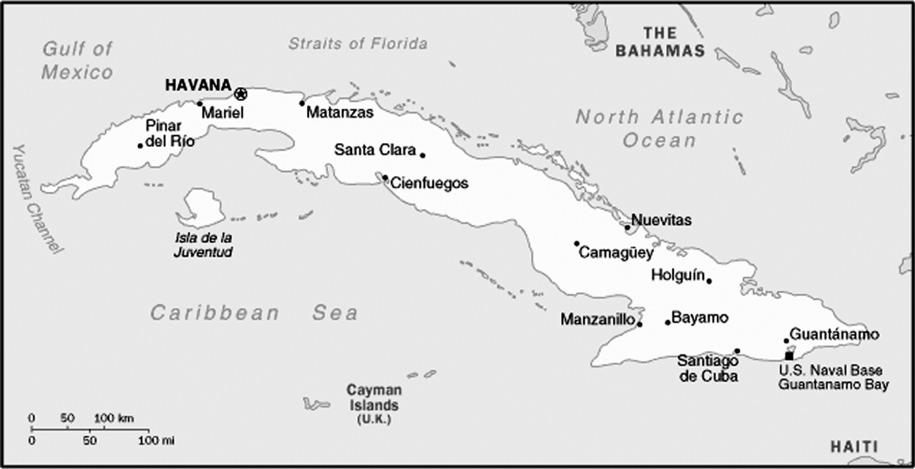

Source: CIA World Factbook 1998.

Exhibit 2: cigar tobacco-growing regions

**Dominican Republic (DR)**: The last 20 years have seen a surge in the quality and variety of cigar tobacco from the DR, and as such, it is now a major producer of top quality tobacco. The primary growing region is the Cibao River Valley, near the city of Santiago in the northern half of the country. Most of the Dominican cigar makers are located close to this city. Although not as strong as the Cuban seed varieties that most Dominican tobacco is derived from, it is quite full-flavored.

**United States**: Two varieties of tobacco are grown in the Connecticut River Valley, north of Hartford—Connecticut Shade and Connecticut Broadleaf. The Connecticut Share is some of the finest wrapper leaf tobacco in the world. It has a high degree of elasticity, is fine brown to brownish-yellow, and creates a mild- to medium-bodied smoke. The Connecticut Broadleaf is a dark, almost black leaf and is used on maduro-style cigars. Compared to shade-grown tobacco it is heavier and veinier.

**Honduras/Nicaragua**: Both countries produce high-quality tobacco including shade-grown from Cuban-seed and Connecticut-seed. In recent years, Honduras has been affected by periodic blue mold infestations. Nicaragua has three main growing areas: Esteli, Jalapa and Condega. The 10-year civil war in Nicaragua affected the Esteli area. Their tobacco is full-bodied with heady aromas and strong, spicy flavors.

**Indonesia**: The series of islands that make up Indonesia produce Sumatra-variety tobacco which can be referred to as Java or Sumatra. Sumatra wrapper leaves are generally dark brown with neutral flavors. The majority of wrapper leaf grown in Indonesia is used for small cigars.

**Ecuador**: Ecuador grows filler and wrapper and shade and sun tobacco. It is high quality tobacco using both Connecticut- and Sumatra-seed varieties. When compared to the originals, the Ecuadorian tobacco usually seems milder and less robust in strength and flavor.

**Mexico**: The Mexico tobacco region is located in the San Andres Valley. This tobacco which is sun-grown is a variety of the Sumatra-seed and is world-famous. These leaves are widely used in cigars for binder and filler. Since it holds up during the cooking and sweating process that creates darker leaf colors, this variety is used as a maduro wrapper. Usually, cigars manufactured in Mexico are produced with 100 per cent local tobacco.

**Cameroon/Central African Republic**: This region is well-known for its high-quality wrapper leaf. Due to management changes and bad weather in recent years, production has suffered. Prized for its neutral characteristics, the Cameroon leaf makes an ideal wrapper for full-flavoured filler tobaccos.

Source: Created by the case authors using data from “Cigar Tobacco Countries & Growing Regions,” The Blending Room, June 22, 2015, accessed October 20, 2017, <https://www.jrcigars.com/blending-room/university/cigar-regions/2015/06/22/>; and “Tobacco Regions,” Altadis USA, accessed October 20, 2017, <http://www.altadisusa.com/cigar-101/history/regions>

Exhibit 3: the structure of two major companies in the cuban cigar industry

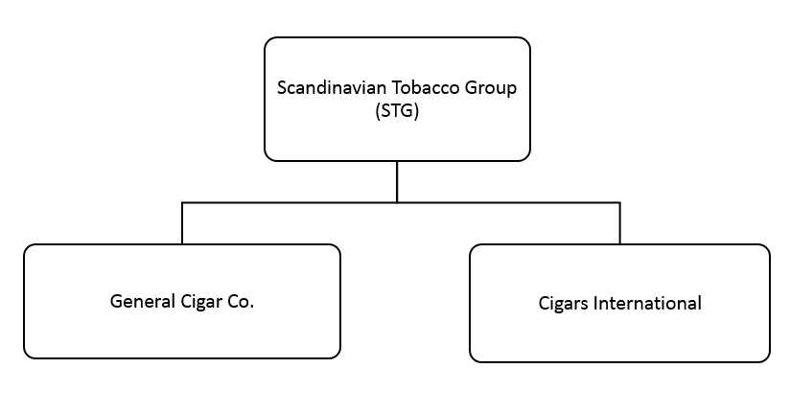

Source: 2016 Annual Report <http://investor.st-group.com/investor-overview>

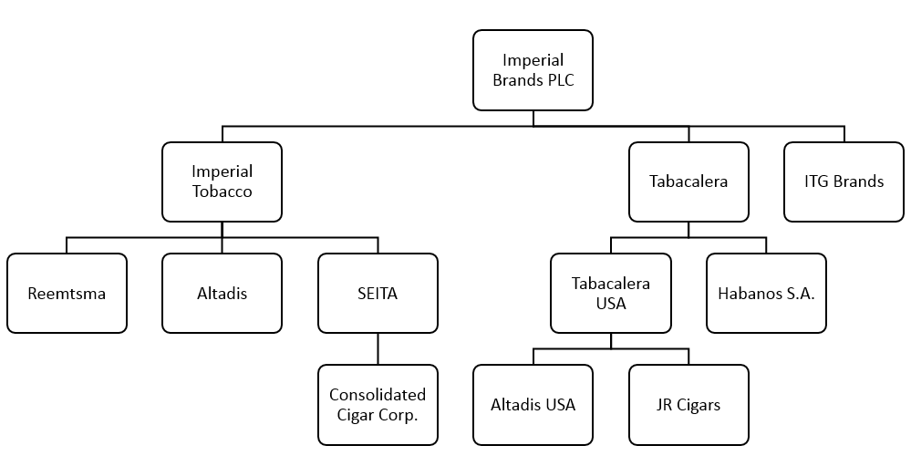

Source: Created by case authors using data from Imperial Brands, accessed October 20, 2017, <http://www.imperialbrandsplc.com/About-us/Our-companies.html>; and Tabacalera De Garcia, accessed October 20, 2017, <http://www.tabacalerausa.com/our-companies/>.

Exhibit 4: OVERVIEW OF THE MAJOR CIGAR COMPANIES

Imperial Brands PLC

In 2007 Imperial Brands PLC acquired Altadis S.A for $22.4 billion, creating the world’s largest cigar company. Altadis was the result of a 1999 merger, valued at US$3.3 billion, between industry giants: Spanish Tabacalera S.A. and the French SEITA S.A. In 2000, Altadis also completed a joint venture agreement with Habanos S.A., the company that holds the monopoly on Cuban cigar exports out of Cuba, and which owns all Cuban brands outside of the United States. Altadis purchased 50 per cent of Habanos for US$477 million, giving it access to most of the major Cuban brands in all markets. In 2015, Imperial Brands PLC formed Tabacalera USA to oversee the premium, handmade cigar business in the USA and is also in charge of Altadis USA and JR Cigars (a premium cigar wholesaler and retailer in the United States).

The history of Tabacalera and Cuba is very strong and is in direct contrast to the relationship that competitors in the United States share with Cuba. Tabacalera, the Spanish catalyst behind the merger to form Altadis, was and is Cuba’s biggest and most revered cigar partner. It is this former government-controlled entity that annually invests upwards of US$25 million into Cuba’s industry, thereby serving the dual purpose of aiding the financially strapped industry and ensuring Tabacalera the largest access to Cuban tobacco and finished cigars.

Habanos S.A.

Habanos S.A. was formed in 1994 as the export, distribution and marketing arm of the state tobacco firm. They are the official owners of all of the Cuban brand names. As mentioned above, Habanos S.A. entered into a joint venture agreement with Altadis that has brought increased investment into the Cuban industry, as well as stability and increased production capacity. Also, the joint venture brought greater exposure for the Cuban cigars worldwide. In 2015, Habanos S.A. revenues were US$428 million. A major initiative of the joint venture is to enter the machine-made cigar industry with Cuban-produced tobacco.

Altadis U.S.A. (formerly Hav-A-Tampa and Consolidated Cigar)

In August 2000, Hav-A-Tampa and Consolidated Cigar merged to form Altadis U.S.A. This new entity now controlled more than a third of the U.S. cigar market, including many of the non-Cuban produced Cuban brands. Altadis sells close to two billion cigars per year, and through their equity position in the company, Cuban Cigar Brands, Altadis U.S.A. has sole ownership of their rights to these non-Cuban produced Cuban brand names, including Montecristo and H.Upmann.

Scandinavian Tobacco Group

Scandinavian Tobacco Group is the second largest producer of cigars in the world. In 2010, Swedish Match merged with Scandinavian Tobacco to create Scandinavian Tobacco Group Company. Earlier, Swedish Match had acquired El Credito Cigars Inc in 2009, General Cigar Holdings Inc. in 2005 and Bogaert Cigars in 2007. General Cigar has the rights to market many of the non-Cuban-produced Cuban brand names in the United States. Scandinavian Tobacco Group is highly diversified in tobacco products and accessories, and through General Cigar has a well-established presence in the huge U.S. cigar market (more than 25% of the US market in 2014).

Sources: Created by authors using data accessed on November 7, 2017 from Imperial Brands, <http://www.imperialbrandsplc.com/index.html>; Cigar Aficionado, <https://www.cigaraficionado.com/>; Habanos, <http://www.habanos.com/en/>; Scandinavian Tobacco Group, <http://www.st-group.com/>.

Exhibit 5: SELECT FORMS OF FDI IN CUBA

International Economic Association

Cuban law states that international economic association agreements for hotel production or service management must have the following purposes and characteristics. Purpose: improve the customers’ services or the quality of production; benefit from the use of an internationally recognized brand and its publicity; and benefit from the international marketing and promotion designed by the foreign investor. Characteristic: foreign investor must act on behalf and in representation of the national investor with regard to the signed management agreement; profits must not be shared; and payments to foreign investors must be conditioned to the results of their performance.

Foreign Capital Company

A foreign investor must govern the company, enjoy all rights and be liable for all the obligations established in the authorisation. If registered with the Business Register then a foreign investor can settle in Cuba as: natural persons, acting on their own behalf; legal persons, by means of a public deed by setting up a Cuban subsidiary office of the foreign entity they own in the form of a corporation with registered shares; or legal persons, establishing a branch of a foreign entity. If incorporated as a subsidiary then the company can set up offices, representations, branches and subsidiaries both within Cuba and abroad and have interests in entities abroad. In the form of a subsidiary then dissolution is determined by the articles of incorporation and is subject to the legislation in force. The provisions contained in the authorisation and the legislation in force will determine the termination of the activities authorised for a natural person and the branch of the company.

Source: Adapted from Marco Mastracci, “Conducting Foreign Business in Cuba,” Thomson Reuters Practical Law, April 1, 2017, accessed October 20, 2017, https://uk.practicallaw.thomsonreuters.com/w-007-5975?transitionType=Default&contextData=(sc.Default)&firstPage=true&bhcp=1

1. All currency in US$ dollars unless specified otherwise.
2. L. Glenn Westfall, “Don Vicente Martinez Ybor, *The Man and His Empire: Development of the Clear Havana Industry in Cuba and Florida in the Nineteenth Century*,” Garland Publishing, Inc., New York and London, c. 1987.
3. Nathanial Lande and Andrew Lande, “The Havanas: Past, Present, and Future,” *Smoke Magazine*, Summer 1998, Volume III, (3).
4. Business Tips on Cuba, July 1998, “The Cigar Market.” Printed in La Habana, Cuba.
5. Ivet Gonzalez, “Sustainable Technologies Safeguard the Soil in Cuba,” Inter Press Service, accessed October 20, 2017, http://www.ipsnews.net/2013/08/sustainable-technologies-safeguard-the-soil-in-cuba/.
6. Mario Reinoso Perez, “Agroforestry: A Viable Alternative for Sustainable Land Management,” UNCCD 2nd Scientific Conference, April 10 2013, accessed October 20, 2017, https://www.slideshare.net/GRFDavos/mario-reinoso-prez-agroforestry-a-viable-alternative-for-sustainable-land-management.
7. Richard E. Feinberg, “Cuba’s Foreign Investment Invitation: Insights into Internal Struggles,” Brookings, November 21, 2014, accessed October 20, 2017,https://www.brookings.edu/blog/up-front/2014/11/21/cubas-foreign-investment-invitation-insights-into-internal-struggles/.
8. ”Cuba’s Agriculture: Collapse & Economic Reform, “Agricultural Outlook 1998, Economic Research Service/USDA, pp. 26-31.
9. Ibid.
10. Sergio Alfonso, Jr., and Carlos A. Penin, “Transportation Infrastructure in a Free Cuba: How to Meet Demands in a Challenging Economic Environment,” accessed October 20, 2017, http://www.ascecuba.org/c/wp-content/uploads/2014/09/v19-alfonsopeninetal.pdf.
11. Walter Russell Mead, “End the Cuba Embargo Now,” *Esquire*, New York, September 2001.
12. Gregory Mottola, “ U.S. Imported 310 Million Premium Cigars in 2014,” Cigar Aficionado, May 7, 2015, accessed October 2017, http://www.cigaraficionado.com/webfeatures/show/id/us-imported-310-million-premium-cigars-in-2014-18157; and Gregory Mottola, “U.S. Imported 315 Million Premium Cigars in 2015,” April 27, 2016, accessed October 20, 2017, http://www.cigaraficionado.com/webfeatures/show/id/us-imported-315-million-premium-cigars-in-2015-up-2-3-percent-18755.
13. Cuban National Statistics Office, Sector Externo 2016, accessed October 20, 2017, http://www.one.cu/aec2016.htm.
14. James Suckling, “The Rebirth of Habanos,” Cigar Aficionado, posted on Web site July 1, 2002, www.cigaraficiando.com.
15. For a list of popular vitolas, or sizes, visit the Web site:http://habanossa.com/galeras.asp.
16. Damien Cave, “Raul Castro Says His New 5-Year Term as Cuba's President Will Be His Last,” *The New York Times*, February 24, 2013, accessed October 20, 2017, http://www.nytimes.com/2013/02/25/world/americas/raul-castro-to-step-down-as-cubas-president-in-2018.html?mcubz=0.
17. Julie Hirschfeld Davis, “U.S. Removes Cuba from State-Sponsored Terrorism List,” The New York Times, May 29, 2015, accessed October 20, 2017,<https://www.nytimes.com/2015/05/30/us/us-removes-cuba-from-state-terrorism-list.html?mcubz=0>.
18. William M. Leogrande, “Trump Has Set U.S.-Cuba Relations Back Decades,” Foreign Policy, June 22, 2017, accessed October 20, 2017, http://foreignpolicy.com/2017/06/22/trump-has-set-u-s-cuba-relations-back-decades/.
19. “ForeignInvestment in Cuba: Will ‘Serious Changes’ Open a Floodgate?,” Wharton, April 7, 2015, accessed October 20, 2017, http://knowledge.wharton.upenn.edu/article/foreign-investment-in-cuba-will-serious-changes-open-a-floodgate/.
20. Richard Feinburg, “The New Cuban Economy: What Roles for Foreign Investment?,” Brooking, December 9, 2012, accessed October 20, 2017, https://www.brookings.edu/research/the-new-cuban-economy-what-roles-for-foreign-investment/.
21. “Factbox: What’s Changed in Cuba’s New Foreign Investment Law,” Reuters, March 29, 2014, accessed October 20, 2017, http://www.reuters.com/article/us-cuba-investment-factbox/factbox-whats-changed-in-cubas-new-foreign-investment-law-idUSBREA2S0KB20140329.