****

9B17M188

Twenty one toys INC.: Sparking growth

Ken Mark wrote this case under the supervision of Professor Dominic Lim solely to provide material for class discussion. The authors do not intend to illustrate either effective or ineffective handling of a managerial situation. The authors may have disguised certain names and other identifying information to protect confidentiality.

*This publication may not be transmitted, photocopied, digitized, or otherwise reproduced in any form or by any means without the permission of the copyright holder. Reproduction of this material is not covered under authorization by any reproduction rights organization. To order copies or request permission to reproduce materials, contact Ivey Publishing, Ivey Business School, Western University, London, Ontario, Canada, N6G 0N1; (t) 519.661.3208; (e)* [*cases@ivey.ca*](mailto:cases@ivey.ca)*;* [*www.iveycases.com*](http://www.iveycases.com)*.*

Copyright © 2017, Richard Ivey School of Business Foundation Version: 2018-04-10

“We’re working on our next product, the Failure Toy, and deciding when to launch it,” said Ilana Ben-Ari, founder and chief executive officer (CEO) of Twenty One Toys Inc. (Twenty One Toys), a Toronto-based designer and manufacturer of wooden toys that taught key skills such as empathy, creative communication, and collaboration.

On July 20, 2017, Ben-Ari was speaking with her team in their open-concept office at the Centre for Social Innovation on Bathurst Street, a space Twenty One Toys shared with more than a dozen other social enterprise start-ups. “We’ve got a great network of customers around the world and facilitators who use our toys. What should our goals look like for the next year?” Ben-Ari asked. She had three full-time and one part-time staff, and the Empathy Toy, Twenty One Toys’ first product, was now sold in 45 countries, and was in over 1,000 schools and over 100 companies around the world. Now, Ben-Ari and the team were thinking of ways to build upon the momentum of the first product. Their key concern was how to operate a growing firm on a shoestring budget. In a recent post on the blogging platform Medium, Ben-Ari, who had been growing her toy start-up for years with limited capital, offered her thoughts on the challenge of managing a start-up’s finances:

There are a lot of secrets when it comes to starting a business. The first secret I discovered when I started my own business, designing toys that teach empathy and failure, was that entrepreneurs barely pay themselves for at least the first few years. That’s because we are merely vessels, dare I say, train stations for money. As sales increase, more money comes through your station, but it’s not stopping. It has places to go, people to see, talks to give. You are merely waving to it on its way through your station. Wishing it luck, and hoping it comes back. Maybe it even brings a few friends with it when it returns. Making the train stop when you’re just beginning means it won’t go towards other things. Things that are far away and hard to get to otherwise. So you keep waving at your money, saying hello and goodbye, and working until, one day, hopefully, the train makes a stop at your station.[[1]](#footnote-1)

In July 2017, with sales from the Empathy Toy growing, Ben-Ari and her team were determined to craft a plan to set Twenty One Toys on a path to take it to the next level. In particular, Ben-Ari wanted to examine her company’s marketing plan for corporate training and the high-school market, and the financial plan that would support that plan.

Twenty One Toys Inc.

Twenty One Toys had come a long way since its early beginnings in 2010, in an old theatre space in Montreal that Ben-Ari had shared with circus performers. She had been inspired by the originator of Kindergarten, Friedrich Froebel, who had designed 20 educational toys for children in the 19th century. “I named my firm Twenty One Toys in recognition of Froebel’s contribution to learning and development, and because we were now living in the 21st century,” she recalled.

Ben-Ari was an industrial designer with a bachelor’s degree in Industrial Design (with distinction) from Carleton University. Her thesis had explored the development of a navigational aid for people who were visually impaired, for the Canadian National Institute for the Blind. In the process of designing her product, she noticed that there was a large social and emotional gap between people who were sighted and the visually impaired community. Her prototype, designed to teach navigational skills, turned into a product with applications for sighted students. She stated:

My product won “Best in Show” at a design competition. But I was a lighting designer, and one of my first thoughts was that while the reaction was great, what could I do with it? I tried to sell the idea to a company but no one was buying toy ideas. I had student loans to pay off so I shelved the idea for a few years.

Then in 2010, she left her lighting design job and moved to Montreal, armed with a CA$1,200[[2]](#footnote-2) artist’s grant.

“I had no idea what I was doing but I was determined,” she continued. “I decided I could make it happen as long as I told every person I met what my plan was: I was going to change education with toys.”[[3]](#footnote-3) She used $400 of the artist’s grant to create a website, another portion to create prototypes at a friend’s jewellery studio, and the remaining funds to purchase tickets to two design conferences: Bitnorth in Northern Quebec, and The Feast, in New York. “Both conferences not only opened my eyes to the incredible work engineers, designers, and entrepreneurs were doing to make the world a better place —  [they were also] the beginning of my acceptance that I wasn’t just a designer, I was a design-entrepreneur,” she noted.[[4]](#footnote-4)

Ben-Ari needed to develop a presentation as part of meeting the requirements of attending Bitnorth. Owing to the presentation she gave at the conference, Ben-Ari was invited to given the opening speech at the TEDx conference in Montreal in 2011. In March 2012, Ben-Ari started an internship at Design Against Crime, a “socially motivated design consultancy” based at Central Saint Martins College of the University of the Arts in London, England. There, she learned more about what it meant to make social concerns a part of the design process. Her next step was to move to a start-up accelerator, Startup Sauna, in Finland, which was offering grants of €15,000–€25,000[[5]](#footnote-5) to entrepreneurs without prior funding. While Ben-Ari was able to win one of the grants, she was unable to take advantage of it, as she had to return to Canada because of an unforeseen family issue. She recounted what happened next, in fall of 2012:

I came back to Canada defeated and broke. I’d spent the last of my savings working to win that grant, and now I had nothing. One of my best friends convinced me to move in with her in Toronto. She said I could sleep on her couch, borrow her clothes and sneak into her workplace at the Centre for Social Innovation until I got back on my feet.

So I slept on her couch for months, sneaking into every education conference I could, bouncing around between Montreal and Toronto. I gatecrashed more events, kept writing in my blog, and started getting requests to use the toys in youth programs in Uganda and Trinidad. I went back to my friend Harvey’s [jewellery] studio in Montreal, made eight more prototypes. Sanded them in another best friend’s lab, and sent them on their way.

Then, just a month after publicly announcing the name Twenty One Toys, I made my first official toy sale to a school board in Toronto. Thanks to a consultant I met at one of those conferences, a school board found my TEDx talk on Twitter and put in a pre-order for 30 toy sets. I nervously asked: “Great! Can you pay in full and wait five months for me to manufacture?” They agreed. The following week we won three awards — The Centre for Social Innovation’s Youth Agents of Change Award (free rent and mentorship!), the Youth Social Innovation Capital Fund (a 2-year 10k [$10,000] loan), and the Spin Master Innovation Award (a 4-year 50k [$50,000] loan with mentorship).[[6]](#footnote-6)

After her first sale, Ben-Ari began thinking about other channels through which she could sell her product. She focused on the corporate training market, noting that it was a large market and that empathy training was becoming more recognized and accepted.[[7]](#footnote-7) The dual focus of selling directly to schools and selling to corporate consultants who offered empathy training meant that she needed to develop two different go-to-market strategies. Yet, the two market segments had commonalities, meaning the majority of the training materials that Ben-Air needed to develop, including facilitator instruction plans, could be shared.

The First Product

“My instinct is that we are creating a new category here, using toys to teach specific skills,” remarked Ben-Ari. “At the beginning, it’ll take more work and time to acquire customers. But by setting ourselves as the thought leaders in the market, we can lead the industry in this niche. We will look to partner with others as we grow.”

The Empathy Toy (see Exhibit 1) sold for $149 for the At-Home Set, $299 for the Teacher’s Kit or the Facilitator’s Kit, and $799 for a bundle of three Teacher’s Kits or three Facilitator’s Kits, including 90 minutes of online training and a professional development workshop. Each Empathy Toy set included combinations of walnut and maple puzzle pieces that participants had to replicate while blindfolded. An Empathy Toy session took between 30 minutes and an hour, and began with a briefing of the task—one partner would be blindfolded and the other would provide instructions. A number of puzzle pieces were to be put together in a complex shape, with each piece attaching to the others at odd angles. The goal of the task was for the instructor to provide clear direction to the blindfolded participant to enable that participant to build a replica of the complex shape. The learning point occurred during the game when it became evident that issuing instructions that can be grasped by someone without the benefit of sight was a lot tougher than it seemed. The real value in the toy was in the conversation it could start; this was why the toy sets came with guidebooks offering over 50 ways to adapt the game for lessons in the classroom or on a staff retreat.

“Our top priority was to get a strong handle [on] manufacturing,” said Ben-Ari. Twenty One Toys reviewed and rejected three manufacturers before finding a firm in China to build its toys. Thanks to its being awarded the Spin Master Innovation Fund, the company was introduced to ethical manufacturers known to Spin Master Toys. Ben-Ari insisted that a toy about empathy needed to be produced and sold ethically. “The Chinese manufacturer we use can mass-produce ethically,” said Ben-Ari. “The owners of Spin Master Toys made the introduction for us and I have since gotten to know the ethical manufacturer’s owner and his family. As quality is of the highest importance to us, I am on site for weeks every time we go into production.”

One of the most important lessons Ben-Ari learned as she placed her first product orders was to conserve the cash she had. “Between trying to coordinate our production runs with pre-orders and developing support materials for our toys, we’re tapped out for cash,” she noted. Production runs were generally scheduled three to six months in advance.

The Market for Educational Toys—Training and Retail

Twenty One Toys’ products appealed to at least three different market segments: educational toys for consumers, training tools in educational settings, and training tools aimed at the corporate training market. Ben-Ari reviewed information from the three markets in an effort to understand the size and dynamics of each segment.

Educational Toys

The global toy market was worth US$87.4 billion[[8]](#footnote-8) in 2015 (the U.S. market was worth US$20.4 billion)[[9]](#footnote-9) and revenues from games and puzzles were US$1.95 billion in 2016, up from US$1.64 billion in 2015.[[10]](#footnote-10) Several categories of toys could be combined under what could be considered educational toys: games and puzzles, construction sets, and technology-enabled toys. Leaders in the toy market included Lego A/S, Mattel, and Hasbro with sales of US$5.38 billion, US$5.46 billion, and US$5.02 billion, respectively. Lego had about a 6 per cent share of the global market in its segment.[[11]](#footnote-11)

An increasingly popular segment of the toy market was educational toys powered by software, such as LeapFrog’s LeapPad devices, which delivered educational content to children. However, the growth in online and smartphone-based applications had started encroaching on the market for technology-powered educational toys, and even industry-leading firms such as LeapFrog were struggling as competitors proliferated.[[12]](#footnote-12)

Educational toys were purchased by consumers through traditional retail channels such as Toys “R” Us and Walmart, and purchased online through websites such as Amazon.com. Manufacturers tended to have dozens, if not hundreds of different products available for sale. Lego, for example, launched, on average, 130 new Lego sets per year.[[13]](#footnote-13) Retail stores tended to stock product that consumers would find appealing, devoting shelf space to product categories such as construction sets, puzzles, and games.

Within each category of toys, a category manager selected what was believed to be the bestsellers for the upcoming year, and placed monthly orders to restock the shelves. For new manufacturers such as Twenty One Toys, it was typical to work through distributors who presented new items to these category managers. Distributors tended to earn a 5–10 per cent margin on sales, and retailers required a margin of between 30 and 50 per cent of the selling price. The key sales period for retailers was the November to December holiday period. Unsold merchandise was generally discounted for sale in January, when the process of selecting the following year’s potential bestsellers began anew.

Corporate Training

In 2016, around 126,000 U.S. firms—each with an employee base of more than 100—spent a total of US$70.7 billion on corporate training expenditures. The bulk of these expenditures was on payroll for training staff at US$37 billion; training expenditures such as travel, facilities, and equipment at US$26.1 billion; and spending on outside products and services at US$7.5 billion. According to Statista, there were 637,690 management consultants in the United States in 2016, up from 614,110 in 2015, and the management consulting industry was estimated to be worth US$251 billion, up from US$240 billion in 2015.[[14]](#footnote-14)

Consultants offering corporate training, including empathy training, tended to cultivate relationships with key players at corporate clients’ firms, including the human resources team and the leadership team. Demand for corporate training could stem from firms asking for specific training programs or from consultants successfully selling new programs to corporate leaders. Consultants for hire could differentiate themselves from their competitors through a combination of innovative programming, strong delivery, and relationships with key decision makers.

About 20 per cent of U.S. employers offered empathy training as part of their corporate training, according to Richard S. Wellins, a senior vice-president with Development Dimensions International. In 2016, Development Dimensions International summarized an analysis of 15,000 leaders in 18 countries over 10 years by stating that empathy was the “number one leadership skill for overall success.”[[15]](#footnote-15) The average U.S. corporate training budget by organization type can be found in Exhibit 2.[[16]](#footnote-16)

Twenty One Toys held professional development workshops, which attracted 20 to 200 people per workshop. Ben-Ari and her team targeted larger corporations that could afford these training sessions. The workshops were intended to generate awareness of the importance of empathy, to develop empathy skills among these corporations’ employees, and to earn consulting revenue for Twenty One Toys.

Twenty One Toys provided two types of training workshops: in-person and online. Individual facilitators and teachers could choose from a full-day training workshop at Twenty One Toys’ head office discounted to $499 to $999 per person, or they could have a customized program delivered on-site, which included consultation with Twenty One Toys pre- and post-training. The customized program’s cost was comparable with typical on-site programs. As an example, an on-site program held by a typical human resources consultancy ranged from $5,000 to $15,000.[[17]](#footnote-17)

Online training was targeted at internal facilitators and external consultants—perhaps a manager of human resources, the CEO of a start-up, or an educational consultant looking to book business with clients. These 90-minute online sessions involved a Twenty One Toys representative providing the leader an overview of the Empathy Toy, a list of the resources available on its site, and feedback and recommendations to help prepare for leading a training session. Online sessions were priced competitively—at less than $1,000—and were designed to generate interest from self-directed workshop leaders. An agenda for a typical in-person training session can be found in Exhibit 3.

After these training workshops, corporate employees who were passionate about using the Empathy Toy could reach out to Twenty One Toys for further help and support in using it within their corporations. Those who wanted to use it more broadly—for example, within a large firm—could seek certification under Twenty One Toys’ Enterprise Partner Certification (EPC) program.

The EPC program provided training and licensing to run large group workshops and provided impact measurement and access to Twenty One Toys’ toy library. This approach supported Twenty One Toys’ larger goal—to support play-based learning to teach skills such as empathy in business, and to track long-term impact. In general, licensing would include multi-day training to certify facilitators, listing the corporation as an approved partner of Twenty One Toys. Ben-Ari said, “If we run a workshop and then train one facilitator, this person has deep impact because he or she can carry out workshops with multiple groups.”

Ben-Ari believed that there was a big opportunity for consultants to add empathy training to their lineup and that the Empathy Toy could facilitate these training sessions. Some educational consultants learned about the Empathy Toy through Ben-Ari’s online presentations and media articles. These warm leads could be easily closed, as the potential customers were already well aware of the benefits the Empathy Toy could bring to their training sessions. Selling sets of Empathy Toys to new consultants meant reaching out to consulting teams and providing information about the Empathy Toy and its reviews, then following-up to ascertain interest and to answer any questions they might have.

Education Segment—Universities, Colleges, High Schools

For the education segment, the selection of customized programs such as empathy training tended to lie with each individual school’s leadership team, including program managers and, at high schools, the principal and vice-principal. Ben-Ari noted that a personal approach was necessary to convince individual schools to adopt innovations such as the Empathy Toy. Twenty One Toys could consider part of this market segment to include approximately 16,000 educational institutions in Canada, from elementary to postgraduate schools (see Exhibit 4).

In total, approximately five million students attended public elementary and secondary schools in Canada, and two million students attended Canadian universities and colleges.[[18]](#footnote-18) Elementary and secondary schools were grouped and managed under school boards. For example, Ontario had 31 English public school boards, 29 English Catholic school boards, four French public school boards, and eight French Catholic school boards. In total, the Ontario government spent $22.6 billion on education funding, employing 123,577 full-time-equivalent (FTE) teachers, of whom 42,338 were secondary school teachers. Ontario had approximately 635,759 high-school students.

Ben-Ari and her team had been able to hold workshops at schools interested in learning more about the Empathy Toy. Twenty One Toys’ website had generated many of these enquiries from guidance counsellors, teachers, professors, and principals who contacted the firm asking for more information on how to arrange for sessions. The decision to host a workshop depended on the commitment of the individual at the school. This leader—the internal champion—would seek approval for the workshop from “management,” or the principal’s office, find a source for funds, and arrange for groups of students to attend.

Many high schools set aside enrichment funds that they could tap into to pay for Twenty One Toys’ workshops, at a 30 per cent discount compared with the typical corporate on-site training price. It was possible to arrange for multiple workshops at different schools in a city. To do this, Ben-Ari and her team would ask a potential customer for contacts in other schools, then follow-up with warm or cold calls.

A typical school-based session would be run the same as would a corporate training session. The key difference was that school audiences were typically larger—perhaps 50 teachers—and required Twenty One Toys to have more than one facilitator on site. The fee included a day-long session at the school facilitated by Ben-Ari and another Twenty One Toys facilitator. The facilitators would arrive with as many toy kits as were necessary in the session. Schools could also purchase kits after the session, if they wished.

While Twenty One Toys could see enormous potential in the education segment, Ben-Ari wanted to think more about how best to tackle this market. For example, as large as the Canadian market seemed, the U.S. market was about 10 times the size, and Twenty One Toys had received inquiries from institutions in such distant countries as Switzerland and Hong Kong. Taking a facilitator team beyond Toronto would involve travelling time, and expenses such as lodging and meals.

There was one big advantage of hosting these workshops. Going directly to both the corporate training and educational market meant that the toys could be sold at full price, thereby earning a typical 50 per cent gross margin.

Marketing and Promotion

Twenty One Toys sold its kits directly to consumers, schools, businesses, and workshop facilitators. Currently, about 20 per cent were sold to consumers, 46 per cent to schools, and 34 per cent to businesses and workshop facilitators. Twenty One Toys had distributors in the United States, Europe, and Australia. “Half of our sales are outside Canada: we’ve got strong support in the U.S. and distributors on the ground in Switzerland, Denmark, and Australia,” Ben-Ari said.

The company’s distributors were sales representatives who had connections with key retailers in each country. These distributors had built up relationships with retailers over decades by bringing to them innovative products that sold well. Many of Ben-Ari’s distributors took the initiative to introduce themselves to Twenty One Toys because they felt that the Empathy Toy was a compelling product. And despite not having a team in either the corporate market or the educational market, sales were still rising rapidly. Ben-Ari had purposefully kept her burn rate as low as possible thus far, as the company had only 2.5 FTE contractors.

Guidebooks and training resources were made available to purchase online, and Ben-Ari’s team continually added new material to Twenty One Toys’ website. “All of our growth has been achieved through just word of mouth, and without spending anything on traditional marketing. We can continue on this path but I’d like to know if we will need a more substantial, online marketing push, and if our in-person training will be enough to enter new markets.”

As more people learned about the Empathy Toy, they would be inclined to visit the site and place orders for more toy sets. Twenty One Toys had considered launching a global online community as an extension of its training and certification programs. Ben-Ari wondered what the commitment to building this community would cost above dedicating an employee to be an online community manager. “Would it be worth our effort to focus on creating online resources first, before travelling to provide onsite support?” she wondered.

On the other hand, Ben-Ari could continue developing the business, one school at a time, spending days at high school and working with school educators to hold workshops on-site. It was Ben-Ari’s experience that the schools could commit to buying 20 sets per school. One of Ben-Ari’s plans was to develop a schedule to visit 10 schools per district per trip. A related strategy was to meet school district educators in charge of developing curriculum for that region, encouraging district educators to buy multiple sets for each of their schools in their area. For example, in May 2016, Ben-Ari travelled to train groups of teachers from different schools: 100 teachers from schools in Winnipeg, and, on another occasion, 40 teachers from schools in Geneva, Switzerland. Pictures from a facilitation session can be found in Exhibit 5.

Looking Forward to the Launch of the Failure Toy

Ben-Ari was aware that she would be in charge of an increasingly more complex operation. “I didn’t go to business school; when I went to design school, I thought I was just learning to become a good employee,” she said. “The idea of calling myself an ‘entrepreneur’ didn’t even cross my mind until about two years into it.”

One of Ben-Ari’s business mentors who had observed the company since its founding estimated that Twenty One Toys could achieve revenues of perhaps $12 million with a broad suite of toys within three years, or $1 million per toy. The revenues would not come from sales of the toys alone: they would include other consulting, training, and certification services that Twenty One Toys could provide. “Is this estimate realistic and, if so, how can we get to that level of revenues?” asked Ben-Ari. She also wondered how they could develop brand ambassadors in the community.

At present, Ben-Ari wanted to make it easier for potential customers to find Twenty One Toys. “People may encounter our toys in a session and come away with a great experience,” she said. “But it takes three to five steps for them to find us: they have to go online and search for us, then navigate to our website and contact us. Instead, we are thinking of offering an app that can be downloaded onto their smartphone during the training session. Is this a good idea?”

The concept of making it easier for customers to connect with Twenty One Toys could also be extended to its distributor partners. Ben-Air met quarterly with her distributors in the United States, Europe and Australia. “We’d like to streamline the way we deal with our distributors,” she stated. “We are making available more online resources and building our Facilitator community so that we can spark demand for them. Currently, we have three internal facilitators including me and we hope to grow this number to up to six by the end of 2017.”

Ben-Ari noted that the number of facilitators that her company could hire depended on the number of schools that signed on for sessions. “How do we streamline this process so that we have schools and organizations coming to us for sessions?” she wondered. Twenty One Toys had recently uploaded an article onto its website—“21 Leaders”—about how a school was transformed by a year-long, empathy-based leadership program that used the Empathy Toy. “There was an 85 per cent reduction in conflict based office referrals following the program,” Ben-Ari said. “What more can we do to get the word out? And should we continue to charge a per-school facilitation fee or should we move to a per-classroom fee?”

She thought about offering multi-day training sessions, and about how best to license Twenty One Toys’ products and facilitation sessions. “Am I missing any opportunities to grow the business?” she asked her colleagues. Customer feedback on the Empathy Toy can be found in Exhibit 6.

In 2016, Twenty One Toys had doubled its revenues each year for the past two years. “And that’s just with one toy,” noted Ben-Ari. “What should our growth strategy look like with our Failure Toy and with our pipeline of new products?”

The Ivey Business School gratefully acknowledges the generous support of the K.W. Lemon Fund in the development of this case.

Exhibit 1: The Empathy Toy

**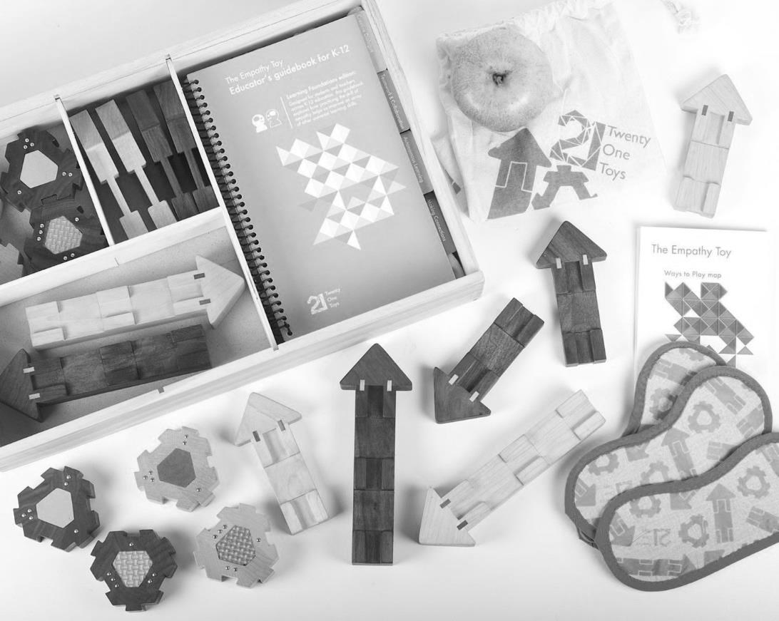**

Source: Company documents.

Exhibit 2: Average U.S. Corporate Training Budget, 2016 (in US$)

**Organization Type**

**Large**

**Midsize**

**Small**

**Average**

Education

2,166,333

520,556

567,385

742,400

Government/Military

16,480,000

950,044

191,500

5,562,409

Manufacturer/Distributor

20,223,176

1,289,636

250,357

5,043,103

Nonprofit

2,682,000

368,000

907,771

1,232,174

Association

–

1,250,000

492,000

871,000

Retail/Wholesale

5,315,625

237,000

208,500

1,991,087

Services

16,460,729

1,831,798

300,257

4,657,747

Average Across Sizes

14,282,589

1,368,788

375,251

4,122,002

Source: “2016 Training Industry Report,” (November/December 2016): 29, *Training*, accessed January 23, 2017, https://trainingmag.com/sites/default/files/images/Training\_Industry\_Report\_2016.pdf.

Exhibit 3: Twenty one toys’ In-Person Training Session Agenda

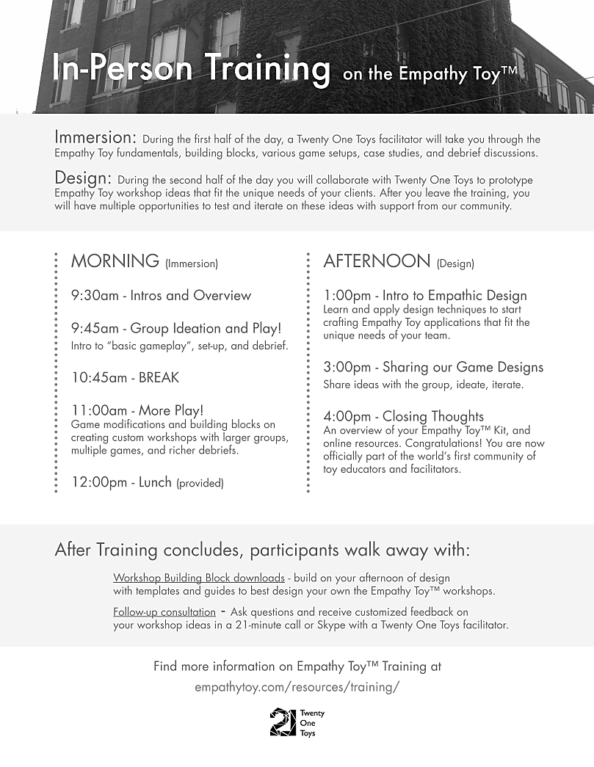

Source: Company documents.

Exhibit 4: educational institutions in Canada

Institutions

Elementary Schools

10,100

Secondary Schools

3,400

Mixed Elementary and Secondary Schools

2,000

Public and Private Universities

163

Public Colleges and Institutions

183

Authorized institutions with selected programming

119

15,965

Source: Council of Ministers of Education Canada, “Some Facts About Canada’s Population,” accessed April 23, 2017, https://www.cmec.ca/299/Education-in-Canada-An-Overview/index.html.

Exhibit 5: Twenty One Toys—Facilitation Sessions

|  |  |
| --- | --- |
| **C:\Users\kmark\Downloads\Chinese University of Hong Kong_Executive MBA Program_Empathy Toy Workshop_August 2016_7.JPG** | **C:\Users\kmark\Downloads\Chinese University of Hong Kong_Executive MBA Program_Empathy Toy Workshop_August 2016_1.JPG** |

Source: Company documents.

Exhibit 6: Twenty One Toys—Customer Feedback

The Empathy Toy for Job Interviews

MaRS Discovery District, Toronto, ON

Julia Scott—Human Resources Managers, MaRS Discovery District:

People in job interviews tend to say things like “I’m a great communicator” or “I really love collaboration,” but it can be difficult to test for that in an interview format.

We spend about 30 minutes of the second interview using the Empathy Toy. We play the game twice. During the first game, the hiring manager provides instruction to the candidate. It’s interesting to see how the candidate receives instruction from their potential manager. For example, do they wait and listen first before they start to move the pieces, or do they just launch right into it and start shoving things together? Are they asking for clarification?

After the first game, the candidate has an opportunity to reflect on what worked and what didn’t. Then, they play one more game. This time the candidate provides the instructions to the hiring manager.

In that second game we are looking to see if the candidate can identify the key lessons that will help them improve. In one case, the first game was very challenging for the candidate as a result of vague descriptions. [The candidate] kept saying that the pieces “fit together” without exploring or attempting to explain more specifically how they fit together. After removing the blindfolds, they saw that the pieces slide together in a groove on the pieces. However, this insight did not get applied in the next game. This was really telling for me—[the candidate] had the opportunity to learn from something that went badly, but didn’t take it.

The game actually led to insights, not just about the candidate, but about the people doing the hiring as well. It was fascinating watching my colleagues deal with the challenges of the game. It revealed that there could be opportunities to try some communication and collaboration exercises with our own staff. In fact, I plan on using it for a team building activity for our HR team in the fall.[[19]](#footnote-19)

Empathy-Based Leadership Program to Reduce Bullying

St John's High School, Winnipeg, MB

Vice Principal Cree Crowchild—“How an Empathy-Based Leadership Program Changed a School:

While we were playing with [The Empathy Toy], one family was speaking in Tagalog [a language native to the Philippines] to start, which was fine with me—whatever you’re comfortable with. Then they started having problems, so they went to English and were still having problems. Then, they went to a combination of English and Tagalog to the point where they finally figured it out. That’s what the game does—you do what you need to do until you figure it out. And to me that was, like, wow! Kids and parents are working together. That’s the purpose of the game, to find a common language—whatever that may look like. Finding a common ground where you can build an understanding. For me, it doesn’t matter where you come from, you can still get along.

[Mayor Bowman] played the game with a student and said, “Wow, this is so great! It’s such a simple idea!” I could tell he was interested in exploring it further. So, when he [hosted the Mayor’s National Summit on Racial Inclusion, in response to the *Maclean’s* article], we were asked to meet with him in his chambers. When we arrived, he had the toy set up to play with. Other politicians were there to see the game. That told me that he believes [The Empathy Toy] isn’t just a one-and-done type of thing. He’s supporting the spread of knowledge and sees the impact and potential [The Empathy Toy] can have. When he spoke, he mentioned multiple times the great things we’re doing at the school in regards to the empathy project. He even posted it on his social media.[[20]](#footnote-20)

Exhibit 6: continued

21st Century Learning Powered by STEAM

Royal Ontario Museum, Toronto, ON

Jamea Zuberi—Classroom Teacher & Club Team Leader, “How a Museum Created an Empathy Zone to Inspire Future Innovators”:

What we’ve created is an Empathy Zone where we use the toy as a tool to inform thinking and actions of young people in the program. We start every session with 15–20 minutes of Empathy Toy game play. When we have a problem we can’t solve or we’re having difficulty figuring out where we’re going to go with the team, we use the whole concept of empathy. We always come back to the toy and playing the game as a frame of reference.

The last session really brought it home for me. We gave the children options of activities, including working with the 3-D printer, working with the computer, building art pieces, putting things together with their hands, and the Empathy Toy. I thought that not many of them would be interested in the Empathy Toy. But there was a large group [that gravitated to] it. We seem to think that our children are just interested in computer games, and that moment was proof that that’s not true. If we give them alternatives, they surprise us.

The Empathy Toy has become such an essential and engaging part of the program. I think that the idea that there [are] no losers helps. It’s a competition where everyone must win.

My moment with the kids was when some conflict was happening and I heard one of the kids say, “Hey! That’s not very empathetic!.” And I thought, woah—they’re actually using the vocabulary.[[21]](#footnote-21)

Source: Company documents.

1. Ilana Ben-Ari, “These Aren’t My Pants—And Other Ways I’m Bootstrapping My Way to the Top,” Medium, December 13, 2016, accessed January 23, 2017, https://medium.com/@IlanaBenAri/these-arent-my-pants-and-other-ways-i-m-bootstrapping-my-way-to-the-top-7bfb0927ddca#.u1d0m9kmt. [↑](#footnote-ref-1)
2. All currency amounts are in Canadian dollars unless specified otherwise. [↑](#footnote-ref-2)
3. Ben-Ari, op. cit. [↑](#footnote-ref-3)
4. Ibid. [↑](#footnote-ref-4)
5. € = EUR = euro; CA$1 = €0.76232 on March 1, 2012. [↑](#footnote-ref-5)
6. Ben-Ari, op. cit. [↑](#footnote-ref-6)
7. Matt Tenney, “Why You Should Train for Empathy, and How to Do It,” *Huffington Post*, June 17, 2015, accessed January 23, 2017, www.huffingtonpost.com/matt-tenney/why-you-should-train-for-\_b\_7485950.html. [↑](#footnote-ref-7)
8. CA$1 = US$0.71937 on December 31, 2015. [↑](#footnote-ref-8)
9. Statista, “Total Revenue of the Global Toy Market from 2007 to 2015 (in billion U.S. dollars),” statista.com, 2015, accessed January 23, 2017, https://www.statista.com/statistics/194395/revenue-of-the-global-toy-market-since-2007/. [↑](#footnote-ref-9)
10. Statista, “Games and Puzzles U.S. Toy Sales from 2003 to 2016 (in billion U.S. dollars),” statista.com, 2016, <https://www.statista.com/statistics/247409/toy-sales-in-the-us--games-and-puzzles/>. [↑](#footnote-ref-10)
11. The Lego Group, “The Lego Group Increases Its Market Share,” Lego, March 3, 2011, accessed January 23, 2017, https://www.lego.com/en-us/aboutus/news-room/2011/march/the-lego-group-increases-its-market-share; Hasbro, “Hasbro Reports First $5 Billion Revenue Year with Growth in Revenue, Operating Profit and Net Earnings for Full-Year 2016,” February 6, 2017, accessed January 23, 2017, <http://investor.hasbro.com/releasedetail.cfm?releaseid=1010468>; “Mattel Inc.,” MarketWatch, accessed January 23, 2017, www.marketwatch.com/investing/stock/mat/financials. [↑](#footnote-ref-11)
12. Rachel Abrams, “Once Unique, LeapFrog Has Rivals in the Educational Toy Market,” *New York Times*, March 12, 2015, accessed January 23, 2017, https://www.nytimes.com/2015/03/13/business/once-unique-leapfrog-faces-competition-in-the-educational-toy-market.html?mcubz=1. [↑](#footnote-ref-12)
13. Jesus Diaz, “Everything You Always Wanted to Know About Lego,” Gizmodo, June 26, 2008, accessed January 23, 2017, http://gizmodo.com/5019797/everything-you-always-wanted-to-know-about-lego. [↑](#footnote-ref-13)
14. Statista, “Size of Global Consulting Market from 2011 to 2016, by Segment (in Billion U.S. Dollars),” statista.com, accessed October 3, 2017, https://www.statista.com/statistics/624426/global-consulting-market-size-by-sector/. [↑](#footnote-ref-14)
15. Development Dimensions International, Ready-Now Leaders: 25 Findings to Meet Tomorrow’s Business Challenges, Global Leadership Forecast 2014–2015, revised (New York: The Conference Board, 2015), accessed January 23, 2017, [www.ddiworld.com/DDI/media/trend-research/global-leadership-forecast-2014-2015\_tr\_ddi.pdf](http://www.ddiworld.com/DDI/media/trend-research/global-leadership-forecast-2014-2015_tr_ddi.pdf); Development Dimensions International, “What’s the Number 1 Leadership Skill for Overall Success?,” press release, February 23, 2016, accessed January 23, 2017, www.ddiworld.com/global-offices/united-states/press-room/what-is-the-1-leadership-skill-for-overall-success. [↑](#footnote-ref-15)
16. Training, “2016 Training Industry Report,” (November/December 2016): 28–41, accessed January 23, 2017, https://trainingmag.com/sites/default/files/images/Training\_Industry\_Report\_2016.pdf. [↑](#footnote-ref-16)
17. Action Learning Associates Inc., “Fee Ranges for Consulting Services,” October 7, 2012, accessed October 3, 2017, www.action-learning.com/fee-ranges-for-consulting-services/. [↑](#footnote-ref-17)
18. Statistics Canada, “Back to School . . . by the Numbers, 2014,” July 30, 2014, accessed October 3, 2017, www.statcan.gc.ca/eng/dai/smr08/2014/smr08\_190\_2014. [↑](#footnote-ref-18)
19. The Empathy Toy, “The Empathy Toy for Job Interviews,” October 12, 2016, accessed October 3, 2017, http://empathytoy.com/community/stories/strategic-hiring-marsdd-innovative-job-interview/. [↑](#footnote-ref-19)
20. The Empathy Toy, “Empathy-Based Leadership Program to Reduce Bully,” August 25, 2016, accessed October 3, 2017, http://empathytoy.com/community/stories/highschool-empathy-leadership-program-reduce-bullying/. [↑](#footnote-ref-20)
21. The Empathy Toy, “21st Century Learning Powered by STEAM,” November 8, 2016, accessed October 3, 2017, http://empathytoy.com/community/stories/museum-stem-learning-club-steam/. [↑](#footnote-ref-21)