

9B17N022

ALTAGAS LTD.: ACQUISITION OF DECKER ENERGY INTERNATIONAL

Ken Mark and Cherise Nielsen wrote this case under the supervision of Professor Craig Dunbar solely to provide material for class discussion. The authors do not intend to illustrate either effective or ineffective handling of a managerial situation. The authors may have disguised certain names and other identifying information to protect confidentiality.

*This publication may not be transmitted, photocopied, digitized, or otherwise reproduced in any form or by any means without the permission of the copyright holder. Reproduction of this material is not covered under authorization by any reproduction rights organization. To order copies or request permission to reproduce materials, contact Ivey Publishing, Ivey Business School, Western University, London, Ontario, Canada, N6G 0N1; (t) 519.661.3208; (e)* [*cases@ivey.ca*](mailto:cases@ivey.ca)*;* [*www.iveycases.com*](http://www.iveycases.com)*.*

Copyright © 2017, Richard Ivey School of Business Foundation Version: 2017-10-25

In January 2012, David W. Cornhill, chairman and chief executive officer (CEO) of AltaGas Ltd., (AltaGas)—an energy infrastructure business focused on natural gas, power, and regulated utilities—was looking to expand the company’s operations into the United States. He was specifically interested in entering the U.S. renewable energy market with the purchase of Decker Energy International, Inc. (DEI). Cornhill stated:

Acquiring DEI will provide AltaGas with an opportunity to enter the U.S. green energy market with fully contracted assets. DEI’s assets and the Busch Ranch Project, which is expected to be operational by the end of 2012, will provide us with operating assets in the U.S. energy market, and ensure sustainable returns for shareholders.

Cornhill was preparing his presentation on DEI to the AltaGas board of directors. Assisting him was the company’s finance team. “Let’s go through the numbers one more time so that we’re sure our argument is tight,” he suggested.

The move into renewables and into the United States would be a departure for AltaGas, which was primarily focused on traditional energy and infrastructure businesses in Canada. “I’d like to see how well the proposed purchase aligns with our strategic objectives,” said Thomas Campbell, the financial lead on the project. “Along with our assumptions, we need to consider the business environment, the competitive environment, and whether DEI is a sound fit for us.”

Campbell added: “I’m wondering if there are any other potential buyers for DEI. To whom can they sell this asset in the market? I believe that there are only a small number of players in the market able and willing to purchase DEI.” Campbell continued to evaluate the acquisition by taking a look at the latest information on the biomass energy market.

**Biomass as a Renewable Energy Source**

Biomass was a relatively new renewable energy source. Biomass power plants produced electricity by combusting wood waste from sources such as urban construction sites that would have otherwise gone to landfills and forest waste. These waste woods could otherwise contribute to forest fires and greenhouse gas emissions. Biomass as a fuel could be classified as carbon neutral because biomass power plants, in producing power, burned off the methane component of carbon. Biomass power plants were slowly beginning to emerge in the renewable energy sector. One drawback was that the investment required to build these plants was large. Also, with low natural gas prices, the most efficient way to harness biomass power production was to locate plants as close to wood waste fuel sources as possible.

**AltaGas History**

Founded in 1994, AltaGas was a diverse energy infrastructure firm with a market capitalization of about CA$4.5 billion[1] in late 2011. There were three distinct business units: gas, power, and utilities. The gas business revolved around field gathering, processing, natural gas liquid extraction, transmission, and storage. Its operations managed over two billion cubic feet in Canada per day. The power business encompassed over 560 megawatts (MW) of generation from a combination of fuel types such as coal, hydro, wind, and natural gas. The utilities business was geographically diverse, with customers in Alberta, British Columbia, Nova Scotia, and the Northwest Territories. A proposed acquisition of SEMCO ENERGY Gas Company (SEMCO) would further diversify the utility business into Michigan and Alaska.

Each AltaGas business unit operated independently, with the company as a whole benefiting from a diversified portfolio of commodities and geographies. There were complementary effects as well, with growth in one business leading to opportunities in adjacent segments. The financial contribution of each business unit was clear (see Exhibit 1).

“Our strategy is to capitalize on the supply and demand for natural gas and power by owning and operating assets in gas, power and utilities in places that provide a strategic competitive advantage,” said Cornhill. “We operate physical assets and provide essential services to customers who produce and consume natural gas and power.” Key to the company’s risk management was signing long-term offtake agreements for its energy products. The agreements allowed it to achieve stable earnings and cash flow, which supported its dividend growth strategy.

In 2012, AltaGas was focusing its growth on the power business. The intent was to explore increasing the portfolio’s capacity with clean power sources such as gas-fired generation, wind, run-of-river, and biomass. One option was to look at power markets and assets in the United States, given the strength of the Canadian dollar. In 2011, all AltaGas assets were in Canada, principally in Alberta.

**Industry Analysis**

AltaGas had focused on growing in the Alberta power market. This market consisted of multiple generation companies that owned physical assets or the rights to generation from assets in the form of power purchase agreements (PPAs). In 2001, Alberta de-regulated power generation and was the first province to operate with a spot market and hourly prices. The market structure was such that generators sold into the hourly wholesale electricity market, known as the Alberta Power Pool, and were paid according to where the market price settled. Alternatively, there was an active financial market where forward swaps were traded among generators, banks, and hedge funds. Consumers were able to purchase power at prices that floated with the hourly market rate or lock in prices at residential load rates.

Active companies in the Alberta Power Pool included a range of companies—from Capital Power Corporation with a market capitalization of $1.5 billion to TransCanada Corporation with a market capitalization of $32.1 billion. Many companies in the power pool were also active in gas markets, distribution, and processing. Others, such as ATCO Power Ltd., were focused primarily on power transmission and distribution. In addition, many Alberta power companies were beginning to expand their presence not only across Canada but also the United States and, in some instances, internationally. As legislation around clean energy progressed, corporations that had expertise in operating renewable projects saw an opportunity to expand across borders (see Exhibit 2).

**Decker Energy International Opportunity**

In the fall of 2011, a U.S.-based energy business broker contacted AltaGas’s vice-president of Business Development—Power regarding an investment opportunity in the U.S. market. McCauley “Mike” Whiting, a Princeton graduate and co-founder, president, and CEO of DEI, was actively looking for a buyer for his company. A recent bid had been approved but the deal did not close due to financing problems on the buyer’s side. Considering the illiquid nature of the market for power generation assets, Whiting was willing to sell DEI at the same price of US$34.8 million, as long as financing could be quickly put in place.

AltaGas learned that DEI had partial ownership in two operating biomass facilities—Craven County Wood Energy (Craven) in North Carolina and Grayling Generating Station (Grayling) in Michigan—as well as a permitted development project in Georgia. As part of the acquisition, AltaGas would receive approximately US$4.8 million[2] in production tax credits (PTCs). PTCs were generated by renewable projects, but for DEI, these PTCs had gone unused due to reduced profits in the past few years. The PTCs could be used to offset project or corporate U.S. income. In the fall of 2011, AltaGas was already moving into the United States with the purchase of SEMCO, its U.S subsidiary. SEMCO, renamed AltaGas Services (U.S.) Inc. (AGUS), focused on regulated gas distribution in Michigan. AGUS would begin paying U.S. corporate taxes shortly, and the opportunity to purchase DEI would allow AGUS to take advantage of the PTCs. “U.S. tax law allows for a consolidated tax return so all of the subsidiaries under AGUS would be treated as a single taxable entity,” stated an AGUS finance manager.

The AltaGas finance team looked at DEI’s Craven and Grayling assets (see Exhibit 3).

**Craven County Wood Energy**

DEI had a 50 per cent flow-through working interest in a 48 MW wood biomass power facility in Craven County, North Carolina. The other 50 per cent was owned by CMS Energy Corporation (CMS Energy), a Michigan-based firm focused on utility operations. There was a PPA in place through 2017 with Progress Energy Inc., an electric power holding company recently purchased by North Carolina-based Duke Energy Corporation. DEI indicated that there was a high likelihood the PPA would be renewed after 2017.

Craven’s chief fuel supply was waste wood. The source for the approximately 550,000 tons of waste wood per year would come from a variety of sources around Craven. The fuel included wood chips, forestry residue, bark, sawdust, and railroad ties. Craven had been operating with availability above 90 per cent, indicating that it was inoperable for less than 10 per cent of the time.

**Grayling Generating Station**

DEI had a 30 per cent flow-through working interest in a 37 MW wood biomass power facility in Grayling Township, Michigan. The other 70 per cent was owned by CMS Energy. Grayling had a PPA in place through June 2027 with Consumers Energy, the principal subsidiary of CMS Energy. As part of this PPA, Consumers Energy had the right to economically dispatch the plant—to adjust or turn off the plant as a result of changing demand. As economically dispatching a plant would lead to lower generation output, there was a contract feature that allowed for a “capacity payment” to Grayling as compensation. AltaGas estimated that the odds of Grayling being economically dispatched were very low.

Grayling’s supply of fuel consisted of approximately 350,000 tons of wood waste per year from a variety of sources, including forestry products firms such as Weyerhaeuser Company and AJD Forest Products LP, and sawmill and forestry residue. The plant also burned approximately 5,000 tons per year of rubber-tire-derived fuel. Waste from the plant in the form of ash was disposed of in a nearby landfill.

Grayling was included as a renewable energy facility under Michigan’s Renewable Portfolio Standard legislation, which was passed in 2008. Under this law, 20 per cent of renewable energy certificates (RECs) generated were kept by Grayling and 80 per cent went to Consumers Energy. The benefits of these RECs were included in the projections created for Grayling. Grayling was named Power Plant of the Year in 1992 by *POWER* magazine and had historical availability of over 96 per cent as well as an exceptional safety record.

**Fitzgerald (Georgia Development Project)**

AltaGas would acquire the rights to a permitted site for a 60 MW forest wood biomass development that was 100 per cent owned by DEI. For the purposes of the acquisition analysis, AltaGas did not attempt to value the option to develop Fitzgerald.

**Reviewing the Issues**

The AltaGas finance team was reviewing the various aspects of the deal. In terms of having a brand-name acquisition, the team believed that DEI met the criteria. DEI was a known and reputable name in biomass in terms of both operating standards and safety. Safety was an AltaGas core value; therefore, ensuring new assets were in line with best operating and safety practices was a key factor in any acquisition and just as important as the financial valuation.

Whiting was a well-known executive in the U.S. power industry and was an acquaintance of AltaGas president David Harris. As part of the sale process, the energy broker requested a finder’s fee of US$900,000 for the exclusive opportunity to evaluate and purchase DEI.

**Proposed Purchase of DEI**

Campbell noted: “We want to take into account financial metrics such as the value of DEI, the payback period, and the impact on AltaGas financials, especially earnings per share, post-acquisition.” As such, there were several issues he had to address with regard to DEI’s forecast performance.

The first was whether AltaGas should assume that plant availability and operating capacity would remain the same as it had been in the past. Craven’s PPA was about to expire in 2017, and the DEI team believed it could be renewed in 2017 with annual price increases, per megawatt hours of 2.5 per cent through 2031. Campbell wondered how conservative he should be with that figure, if at all.

Second, an eight-year major maintenance cycle was anticipated, which would result in availability of about 90 per cent on average per year. The financial forecasts for both Craven and Grayling took this 90 per cent level of availability into consideration (see Exhibits 4 and 5). Campbell assumed that a similar cycle and availability rate would be maintained going forward. He wondered if this assumption would be reasonable.

With regard to both plants, assembling a steady flow of biomass materials was key to ensuring that the plant did not shut down. At Grayling, fuel costs varied slightly more but were within a reasonable amount. Grayling’s PPA was set to expire in 2020, with a major plant overhaul set for 2020. At Craven, which was permitted to burn a range of biomass materials such as waste wood, poultry litter, and railroad ties, annual fuel costs had been consistent, year over year, since 2011.

One of the assumptions in the acquisition price was that Craven would be able to burn railroad ties at US$7.00 per ton compared to approximately US$20.00 per ton for green wood. In addition to costing less, railroad ties generated more British thermal units (BTUs) per ton than green wood, at 6,500 BTUs compared to 4,704 BTUs. However, no railroad tie agreement was in place as of yet. Campbell wondered how to tackle this point of uncertainty. If Craven was unable to secure railroad ties for fuel, the net impact would be lost savings over 19 years, assuming an 8 per cent discount rate, which was AltaGas’s cost of capital.

Craven, according to its management team, was also forecasting productivity savings—separate from the railroad ties opportunity—to yield reductions in overall fuel costs from 2012 through 2014. These reductions could be seen in the financial forecast.

“We’re targeting an after-tax unlevered IRR of greater than 10 per cent,” said Campbell. “Can we achieve this with our proposed acquisition of DEI?” Campbell wanted to compare the DEI opportunity with AltaGas’s current power portfolio, and consider AltaGas balance sheets, income statements, and statement of cash flows (see Exhibits 6, 7, and 8). While the opportunity to move into biomass power production was appealing, Campbell wanted to ensure that AltaGas was making a financially prudent decision.

The Ivey Business School gratefully acknowledges the generous support of the Ivey Energy Policy and Management Centre in the development of this case.

**Exhibit 1: AltaGas—Composition by Segment (IN CA$)**

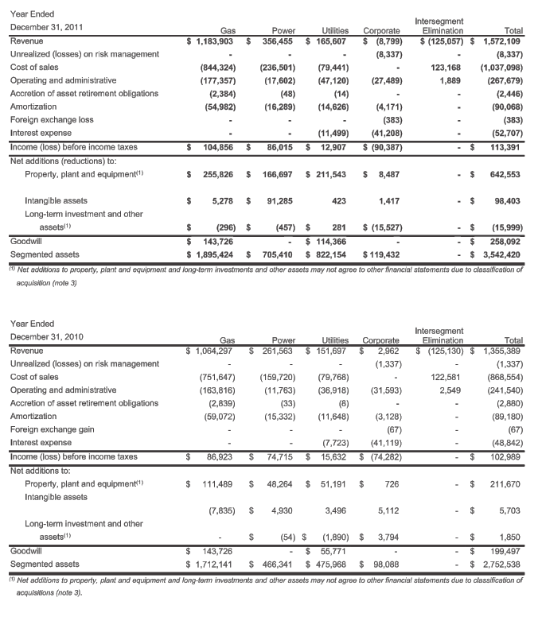

Source: Company documents.

**Exhibit 2: AltaGas Canadian competitors (in Ca$ Billions)**

|  |  |  |  |  |  |  |  |  |  |  |  |  |  |
| --- | --- | --- | --- | --- | --- | --- | --- | --- | --- | --- | --- | --- | --- |
|  | **Geographical Presence** | | | | | | **Market Cap** | | **Core Competencies** | | | | |
|  | **Canada** | **United States** | | **International** | | | **Power** | | **Gas** | | **Utility** |
| ATCO Power Ltd. |  | |  | |  | 4.5 | |  | |  | |  | |
| TransAlta Corporation |  | |  | |  | 3.8 | |  | |  | |  | |
| Capital Power Corporation |  | |  | |  | 1.5 | |  | |  | |  | |
| TransCanada Corporation |  | |  | |  | 32.1 | |  | |  | |  | |
| Enmax Corporation |  | |  | |  |  | |  | |  | |  | |
| AltaGas Ltd. |  | |  | |  | **4.5** | |  | |  | |  | |

Source: Company documents.

**Exhibit 3: Craven county wood energy and Grayling generating station**

|  |  |
| --- | --- |
| Craven County Wood Energy  **Craven County, NC** | **Grayling, MI** |

Source: Company documents.

**Exhibit 4: Craven—Forecast Performance (in thousands of US$)**



Note: MWh = megawatt hour; EBITDA = earnings before interest, tax, depreciation, and amortization; EBT = earnings before tax

Source: Created by the case authors.

**Exhibit 5: Grayling—Forecast Performance (in thousands of US$)**



Note: MWh = megawatt hour; EBITDA = earnings before interest, tax, depreciation, and amortization; EBT = earnings before tax

Source: Created by the case authors.

**Exhibit 6: AltaGas—Balance Sheets (in Ca$)**

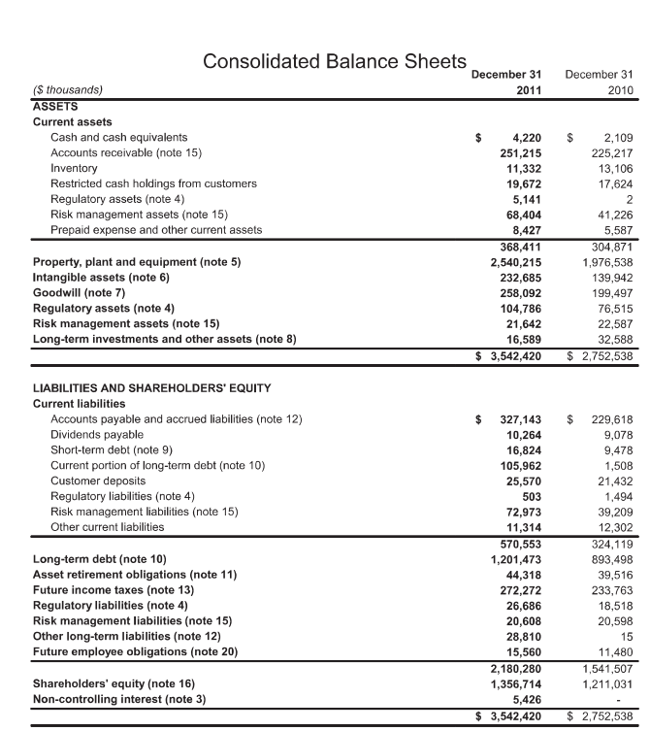

Source: Company documents.

**Exhibit 7: AltaGas—Income Statements (IN CA$)**

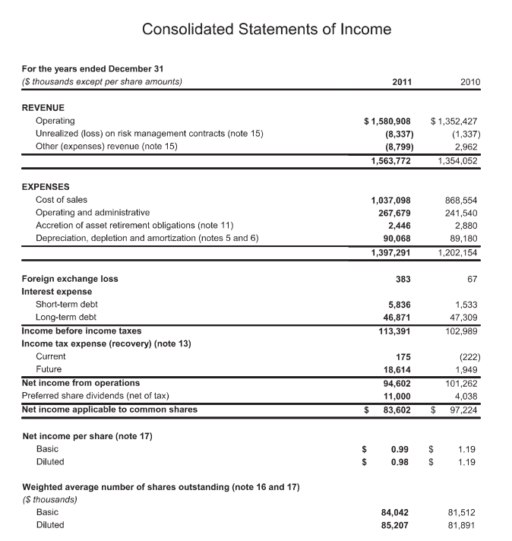

Source: Company documents.

**Exhibit 8: AltaGas—Statements of Cash Flows (in Ca$)**

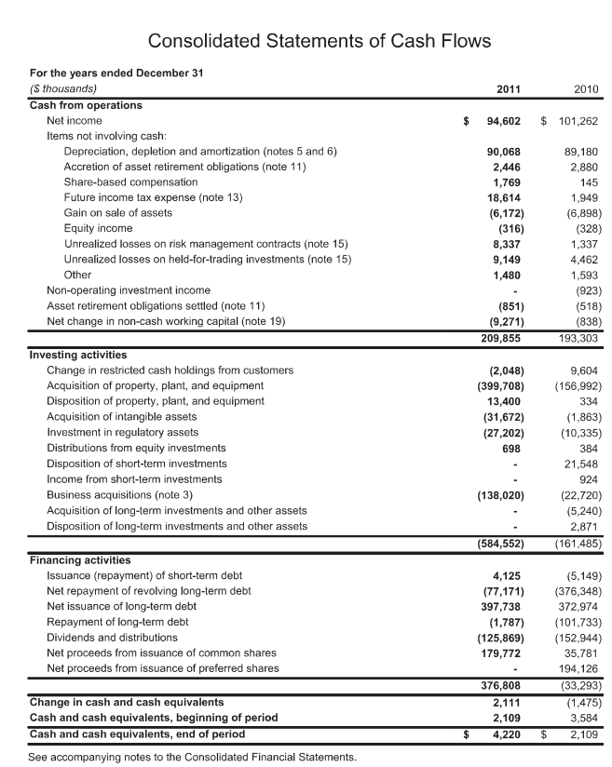

Source: Company documents.

1. All currency amounts are in Canadian dollars unless otherwise specified; CA$1.00 = US$0.9762 on September 1, 2011.
2. At this time, the Canadian dollar was trading at parity to the U.S. dollar.