

9B18A017

UBER ELEVATE: THE CASE FOR FLYING CARS[1]

Ethan Pancer, Kyle Gulliver, and Morris MacLeod wrote this case solely to provide material for class discussion. The authors do not intend to illustrate either effective or ineffective handling of a managerial situation. The authors may have disguised certain names and other identifying information to protect confidentiality.

*This publication may not be transmitted, photocopied, digitized, or otherwise reproduced in any form or by any means without the permission of the copyright holder. Reproduction of this material is not covered under authorization by any reproduction rights organization. To order copies or request permission to reproduce materials, contact Ivey Publishing, Ivey Business School, Western University, London, Ontario, Canada, N6G 0N1; (t) 519.661.3208; (e)* [*cases@ivey.ca*](mailto:cases@ivey.ca)*;* [*www.iveycases.com*](http://www.iveycases.com)*.*

Copyright © 2018, Ivey Business School Foundation Version: 2018-03-08

“Push a button, get a flight,” said Jeff Holden, Uber Technologies Inc. (Uber)’s chief product officer, on April 25, 2017, at the Uber Elevate Summit in Dallas, Texas.[2] “Flying cars have been promised for decades, but are actually arriving now,” said Holden. The self-proclaimed “Chief Not-Satisfied Officer” was excited to announce the launch of Uber Elevate, Uber’s latest venture that aimed to cut two-hour commutes to 15-minute rides in the sky by 2020. “If you’re not planting the seeds for five to ten years out, you’ll have no company in five to ten years,” said Holden. “In that context it’s very natural for Uber to turn its eyes to the air.”

Holden and his team at Uber started Uber Elevate with the intent to revolutionize the transportation industry and position the company as the world’s first “urban air transport” service.[3] Flying cars would fundamentally change the way people were transported and would complement Uber’s staple services on the ground, setting the company up for future success—so long as the company had a future. . . . On the same day, it was estimated that Uber’s private stock price was reduced by 15 per cent and its overall value by US$10 billion,[4] following a string of scandals that included sexual harassment claims, intellectual property theft, upper-management resignations, and illegal software-related activity.[5]

On June 20, 2017, Uber investors demanded that Uber’s co-founder and chief executive officer (CEO), Travis Kalanick, step down from his position, leaving Jeff Holden and 13 other executives in charge of the company until a new CEO could be hired.[6] Headlines read: “Uber Appears to Be in Self Destruct Mode,”[7] “Can Uber Be Saved from Itself?,”[8] and “Uber Has a Leadership Void at a Time of Crisis.”[9] With no CEO, chief operating officer, chief financial officer, or chief marketing officer,[10] launching Uber Elevate became a Herculean task for Holden and his team. On August 28, 2017, Uber had finally found its new CEO in Dara Khosrowshahi, former CEO of the travel-booking behemoth Expedia. In his initial meeting with staff, Khosrowshahi quickly noted that, “This company has to change.” He also emphasized his desire to take “big shots” and possibly conduct an initial public offering (IPO) in the next 18–36 months.[11] Could Uber Elevate be the company’s next “big shot”? If so, Holden would need to highlight the merits of flying cars to the new CEO. More importantly, he and his team would need to articulate a strategy to get what would be named “UberAir” into the marketplace. Otherwise, Uber Elevate risked being shelved indefinitely.

COMPANY BACKGROUND

Founded in March 2009 by Travis Kalanick of Los Angeles, California, and Garrett Camp of Calgary, Alberta,[12] Uber started as a taxi-like ridesharing service that secured patrons using a cellphone application (app) and GPS (Global Positioning System) technology.[13] Less than two years later, the company was valued at $60 million. At Uber’s core, customers were able to book a ride from an everyday driver at the press of a button.[14] If you had a smartphone, a licence, a car, car insurance, and a clean driving record, you qualified as an Uber driver. It was that easy. Kalanick and Camp chose a dynamic pricing model for Uber that charged riders in accordance with supply and demand. If there were few drivers and many customers, Uber prices were high; if there were many drivers and few customers, Uber prices were low. As the company grew, it added to its taxi-like service by offering food delivery services (UberEats), business transportation services (Uber for Business), and freight services (Uber Freight). Ultimately, Uber’s vision was “to make transportation as reliable as running water.”[15]

By 2014, the company’s offering consisted of four ridesharing services: Economy, Premium, Accessibility, and UberPool*.* UberPool was Jeff Holden’s brainchild and the ridesharing equivalent to carpooling.[16] In May 2016, Uber’s Advanced Technologies Group launched a fleet of self-driving cars in Pittsburgh, Pennsylvania, as a pilot project for what the company hoped would be the future of autonomous taxi service and freight delivery.[17] By January 2, 2017, Uber was hailed as the world’s most valuable start-up with a valuation of nearly $70 billion.[18] By this point, the company had serviced more than one billion rides in more than 600 cities. Proposed benefits of Uber included the following: (1) Uber led to fewer cars on the road, which led to less traffic congestion and less pollution; (2) Uber reduced the need for parking spaces, which took up one-fifth of the land mass in major cities; (3) Uber reduced the need for people to buy and service a vehicle of their own; (4) Uber had statistically demonstrated that it reduced driving-under-the-influence offences and alcohol-related deaths; and (5) Uber was a quick, reliable, and safe 24-hour ridesharing service.

RECENT EVENTS AT UBER

After surging from a $60 million valuation to a $70 billion valuation in less than six years, Uber seemed unstoppable—until June 2017, when Travis Kalanick was forced to step down as CEO following a seven-month snowball of scandals that included significant fines, lawsuits, federal investigations, customer boycotts. and more,[19] as detailed below:

*December 2016:* Uber employees admitted to regularly spying on high-profile individuals, including politicians and celebrities. Without permits, Uber tested an autonomous vehicle on the streets of San Francisco. The vehicle failed to stop at multiple red lights and put cyclists in danger.

*January 2017:* Uber was fined $20 million for duping drivers. The company had falsely advertised earnings, leaving drivers with far less money than promised. During a travel ban protest by the New York City Taxi Drivers Association,Uber lifted “surge pricing” at the John F. Kennedy International Airport, in an attempt to capitalize on the demand, leading to a #DeleteUber campaign.

*February 2017:* Travis Kalanick was forced to resign from Donald Trump's advisory council after users threatened to boycott the company. Former Uber engineer, Susan Fowler, went public about Uber’s sexist and discriminatory culture, which led to an investigation. Google filed a lawsuit against Uber, claiming that the company had stolen autonomous transportation technology trade secrets.

*March 2017:* Uber was caught using “Greyball” technology that allowed drivers to evade law enforcement, which led to a federal investigation. Travis Kalanick was caught on camera yelling at an Uber driver after the driver complained about “declining rates” and “how hard it was to make a living off Uber.” Travis Kalanick and other senior employees visited an escort bar in Seoul, Korea, during a business trip, leading to a human resources complaint from other employees on the trip.

*April 2017:* Uber was caught using illegal software hacks and complicit drivers to spy on its major competitor, Lyft.

*May 2017:* Uber agreed to pay tens of millions of dollars to Uber drivers in New York City after the company kept a larger cut of the drivers’ profits than it was entitled to.

*June 2017:* More than 20 Uber employees were fired following an investigation into sexual harassment claims and poor workplace culture. Uber executive Eric Alexander obtained the medical records of a woman raped by an Uber driver because he questioned the validity of her claim. Travis Kalanick took a leave of absence after an internal report was released regarding Uber’s horrendous corporate culture. In an all-staff meeting to combat Uber’s toxic work environment, board member David Bonderman made a sexist joke, forcing him to resign from his position hours later. Uber’s largest investor hand-delivered a letter to Travis Kalanick demanding he step down as CEO.

As a result of these blunders, by June 22, 2017 (two days after Kalanick’s departure), Uber’s valuation plummeted by nearly $20 billion.[20] Since launching in 2009, the company was facing its first real hardship, which had led to 12 upper management departures and voids in critical executive positions.

JEFF HOLDEN

On February 14, 2014, Travis Kalanick was “super-pumped” to announce the hiring of Jeff Holden as Uber’s new chief product officer (CPO).[21] Holden, former vice-president of product development at Groupon, was hired to “solve Uber’s hardest problems and invent [the company’s] future.”[22] Kalanick had been drawn to Holden because of his previous experience at Amazon, where he had been described as “the ‘mercury’ planet orbiting closest to Jeff Bezos’ Sun.”[23] It was an impressive post, given that Bezos was, at the time, the richest man in the world.[24] Holden’s tenure at Amazon prepared him for the turbulence that came with working for a “hyper-growth” firm, giving him the experience and poise needed to scale Uber and take the company to the next level. His experience proved to be of benefit during Holden’s first major project, “UberPool,” which was a smashing success that accounted for 20 per cent of all Uber drives by April 2017.

Given Holden’s achievements, the CPO was given full authority to lead Uber into the future, resulting in Uber Elevate, or what had been named “UberAir.” In a 100-page white paper elaborating on the who, what, when, where, and why of flying cars, Holden and his team believed that the future of commuting lay in Vertical Take-Off and Landing (VTOL) transportation:

On-demand aviation, has the potential to radically improve urban mobility, giving people back time lost in their daily commutes. . . . Just as skyscrapers allowed cities to use limited land more efficiently, urban air transportation will use three-dimensional airspace to alleviate transportation congestion on the ground. A network of small, electric aircraft that take off and land vertically (called Vertical Take-off and Landing, or VTOL, and pronounced *vee-tol*), will enable rapid, reliable transportation between suburbs and cities and, ultimately, within cities.[25]

ELECTRIC VERTICAL TAKEOFF AND LANDING

“The Elevate white paper articulated our thought process; why not urban aviation? Why can’t we do this?,” asked Holden at the Uber Elevate Summit. “I hate the term *flying cars*, but we’re going to have to live with it,” he said. To the audience, it may have seemed that electric Vertical Takeoff and Landing (eVTOL) aircraft served the same purpose as cars (i.e., getting people from point A to point B) but in Holden’s eyes, they were considerably different. However, powering the eVTOL aircraft used an amount of electricity comparable to that of a small grocery store, causing Holden and his team to admit that their energy consumption posed a feasibility barrier in terms of latent battery technology. Other barriers to eVTOL included the certification process, vehicle efficiency, vehicle performance and reliability, air traffic control, cost and affordability, safety, aircraft noise, emissions, city infrastructure, and pilot training. Uber would have much to overcome if the company wanted to see UberAir come to life. After releasing the white paper, critics of Uber Elevate believed that Uber needed a reality check,[26] that the company’s flying car plans were a fantasy,[27] and, as Tesla visionary Elon Musk put it: “it’s difficult to imagine the flying car becoming a scalable solution.”[28]

Holden responded in his closing remarks at the Uber Elevate Summit on April 26, 2017, stating, “There have been hundreds of articles written, very favorable and very excited . . . and very much about the clear transition from skepticism into ‘Hey, I think this is actually going to happen,’ and that’s incredibly exciting.”[29] Holden proclaimed that he and his team had partnered with leading eVTOL manufacturers, high-profile investors, air traffic control executives, influential politicians and policy makers, NASA (National Aeronautics and Space Administration) scientists, elite engineers, and other eVTOL specialists who shared the belief that Uber Elevate could and would be successful. “Everyone has as much passion as the Elevate team to bring this future to fruition,” said Holden. “In order to hit these ambitious goals . . . we’re going to need to put the pedal down.”[30]

Continuing with his speech, Holden stated that Uber’s eVTOL aircraft could be expected to launch in two cities—Dallas, Texas, and Dubai, United Arab Emirates—by 2020. The initial UberAir service in the United States would travel from Frisco Station, Texas, to the Dallas/Fort Worth International Airport (a drive that normally took 70 minutes) in an estimated eight minutes (see Exhibit 1). Similarly, the United Arab Emirates route, travelling from Jumeirah Beach to the Dubai International Airport, would turn a 45-minute automobile commute into an estimated seven-minute eVTOL flight (see Exhibit 2), thereby solidifying Holden’s claim that on-demand aviation would be an incredibly time-saving and efficient mode of transportation (see Exhibits 3 and 4).

VEHICLE PERFORMANCE

By April 2017, Uber had partnered with industry-leading manufacturers such as Bell Helicopter, Aurora Flight Sciences, Pipistrel, Mooney, and Embraer. This ecosystem, along with Uber’s other various partners, had been assembled to design eVTOL aircraft that, most notably, would be able to accomplish the following goals: (1) vertically take off and land in 30 seconds and hover for up to one minute; (2) reach cruising speeds between 150 and 230 miles (240 to 370 kilometres) per hour; (3) carry a minimum of two to a maximum of four people (including a pilot); (4) travel a minimum 50-mile (80-kilometre) round trip at maximum speed; and (5) have fully autonomous capabilities.

RIDER EXPERIENCE

Jeff Holden credited Uber’s previous success to the company’s “magical ride experience,”[31] and ensured customers that UberAir would deliver just that. In the Uber Elevate white paper, Holden noted that UberAir would complement traditional transportation methods. In a best-case scenario, UberAir would take riders directly to their destination. In a worst-case scenario, UberAir, combined with Uber’s ground services and/or public transportation, would transport customers from point to point. Similar to Uber’s traditional ridesharing services, selecting UberAir on the company’s app would provide riders with an itinerary, including sequenced walking or driving directions on either end of a trip, making any commute easy to navigate (see Exhibit 5).

According to Holden and his team, boarding an eVTOL aircraft would require minimal assistance. Most aircraft would have direct access by elevator (if on top of a building) or by an automobile drop-off entrance (if on the ground). The white paper stated that Uber planned on building sheltered waiting portals that also provided customers with washrooms, refreshments, instructional information, and signage on what to expect. Before boarding, riders would be directed to their eVTOL aircraft where they’d be allowed to stow bags or luggage. Once boarded and ready for departure, the eVTOL aircraft would take approximately 30 seconds to propel upward in its vertical takeoff.

Once in the air, Holden noted that passengers could expect the same noise level as a commercial aircraft flight. Unlike a helicopter ride, riders would not need to wear noise-cancelling headphones. Within the cabin, passengers would be able to access real-time trip information, including location and remaining time. Finally, upon arrival, riders would have the option to take Uber ground transportation service to a second destination, if needed.

SAFETY CONCERNS

Safety concerns for Uber Elevate included severe weather, pilot error, loss of situational awareness, engine failure, battery failure, injury due to turbulence, landing errors, birds, and other aerial hazards. Despite these concerns, Uber vowed to make eVTOL aircrafts twice as safe as cars; however, doing so might prove challenging. Historically, per 100,000 driving miles (160,000 kilometres), fatality rates in the United States were two times greater in air taxis than in cars. However, the company understood that a high level of perceived safety was critical for early adoption and that this safety goal needed to be achieved for UberAir to be a success.

URBAN INFRASTRUCTURE

Uber planned on taking advantage of already established infrastructure in major cities such as Los Angeles and San Francisco. For example, downtown Los Angeles had 40 high-rise helipads that the company wished to convert into “vertiports” and “vertistops*.*”Vertiports (see Exhibit 6)were designed to be eVTOL hubs with multiple takeoff and landing sites, along with charging stations and small maintenance spaces. Vertistops(see Exhibit 7) were designed to be single pads for drop-off and pickup. Although new infrastructure would be needed, Uber was primarily focused on repurposing existing assets, which it believed would be the most cost-effective and efficient way forward. For Uber, repurposing a highway cloverleaf was one type of infrastructure thought to offer several advantages as a vertistop site, including less stringent noise standards over highways, clear paths of transport, and less conflict with private property. Other areas that UberAir desired to utilize included roofs of parking garages, office towers, harbour-side barrages, and existing spaces such as parking lots.

ECONOMICS AND FEASIBILITY

Initial costs were estimated to be significant; near-term costs, expensive; and long-term costs, advantageous. In launching UberAir, economy-of-scale forces were significant and represented a material input for the costs associated with the service over time.

It was estimated that the eVTOL aircraft would be utilized 50 per cent of the time (between 6 a.m. and 10 p.m. each weekday) for 260 days per year. Maintaining such rates of utilization was thought to be critical for UberAir’s business model to succeed. It was believed that eVTOL aircraft would have a useful life of 13 years and a salvage value of 30 per cent of production costs, which equated to approximately 400,000 miles (640 kilometres) per year and 5 million miles (8 million kilometres) per aircraft. Meanwhile, battery power costs were pegged at $0.12 per kilowatt hour (kWh), while the successful eVTOL prototype was expected to achieve 2 miles/kWh (3 kilometres/kWh) or better.

During the initial stage and the near-term stage, piloting needs were assumed to be 1.5 pilots per aircraft at $50,000 per salary. Pilots would need a sport aircraft licence to operate an eVTOL aircraft. In the long term, a $60,000 improvement to avionics was assumed, which would drop the cost of piloting. When artificial intelligence (AI) was employed to pilot eVTOL aircrafts in the future, the need for pilots would decrease to one-eighth as a virtual flight deck would be available in case emergency human intervention was needed. The total cost, per eVTOL aircraft, in the initial stage, had been estimated to be approximately $1.2 million, with 100 units manufactured. Near-term costs were estimated at $600,000, with 500 units manufactured. In the long term, costs were estimated at $200,000, with 5,000 units manufactured.

Travel distances needed to be sufficient to gain efficiency over current transportation options. At slow speeds, automobiles provided a more efficient form of transport, but as speeds increased, automobile efficiency decreased. Unlike automobiles, eVTOL efficiency had been proven to increase with speed to a point of maximum efficiency before declining. The eVTOL aircraft’s efficiency would be maximized at approximately 125 miles (200 kilometres) per hour (see Exhibit 8).

COMPETITION

Uber intended to be an intermediary between passengers and eVTOL aircraft. As a result, competition in this space was relatively narrow. Uber’s main competitor in the “push a button, get a flight” sector was the same as its primary competitor on land—Lyft.[32] Although Lyft had yet to take a stance on entering the flying car market, the company had the rider base and technology needed to challenge Uber in this domain.

Several other competitors were looking to make flying cars a reality by 2020.[33] For example, eVolo, the German eVTOL manufacturer, was on the verge of piloting an air-taxi service. The Volocopter 2X could fit two people and fly for up to 17 minutes on a 40-minute charge. Another company, A3, was developing a single-passenger eVTOL aircraft that was expected to pilot by the end of 2017. The company planned on making trips on the aircraft as affordable as a taxi by 2020. Airbus was working on CityAirbus, an UberPool-style flying drone that could be booked by multiple patrons via an app. The Chinese drone company, EHang, launched its flying-taxi prototype in July 2017, in the city of Dubai. It was able to carry 220 pounds (100 kilograms) and cruise at more than 60 miles per hour (100 kilometres per hour). Another company, Terrafugia, was building an eVTOL hybrid that could take off, fly, and land autonomously. Drivers needed a sport pilot licence to operate the vehicle. Yet another company, Kitty Hawk, was working on a Google-associated, single-passenger eVTOL aircraft, which was expected to launch by 2020. It could only be flown over water, however.

More broadly, UberAir was competing against alternative modes of futuristic transportation, such as Hyperloop.[34] The American bullet-through-a-chamber-like transportation company, which had top speeds as high as 700 miles per hour (1,100 kilometres per hour),[35] claimed it would be able to transport people and/or things from Los Angeles, California, to Las Vegas, Nevada, in 30 minutes or less (a drive that normally took 4.5 hours)[36] for as little as $20.[37]

LOOKING FORWARD

In his closing remarks at the Uber Elevate Summit, Holden told the audience and those watching around the world that “his hope and dream is to be at scale with Elevate as part of our daily lives in 10 years.” He believed, however, that “we’ll be seeing it around, everywhere, well before that.” With the hiring of Dara Khosrowshahi, Holden understood the importance to the new CEO of solidifying Uber Elevate’s worth, both strategically and financially. With so many challenges facing Uber’s business model and threatening the company’s future, was it the right time to proceed with Uber Elevate? How could Holden be sure that UberAir could and would be the success that he and his partners believed it would be? What steps were needed to ensure such success? These were only a few of the questions that Holden had to ask himself before pitching Uber Elevate as the company’s next “big shot” to both Dara Khosrowshahi and the board of directors. Not lacking faith in the project, Holden wrapped up his speech at the Uber Elevate Summit by stating, “I can say with great confidence, every rider, everywhere, is going to be excited about this and want to take advantage of the UberAir service. . . . Together, we’re inventing the future of transportation.”

Exhibit 1: UberAIR’s Estimated Travel Time, from Dallas to Frisco Station, Texas

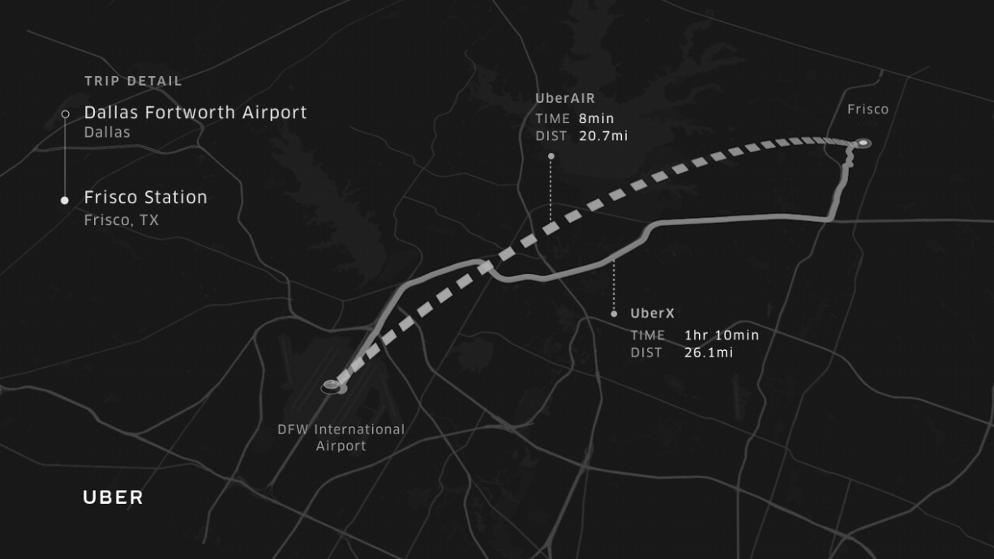

Source: Jeff Holden, “Uber Elevate & The Future of Urban Mobility*,*”April 25,2017, accessed September 1, 2017,

https://uber.app.box.com/s/jv1p4nwt4ijo67f3fss1098d9wog7bmd. Used with permission.

Exhibit 2: UberAIR’s Estimated Travel Time, from Jumeirah to Dubai

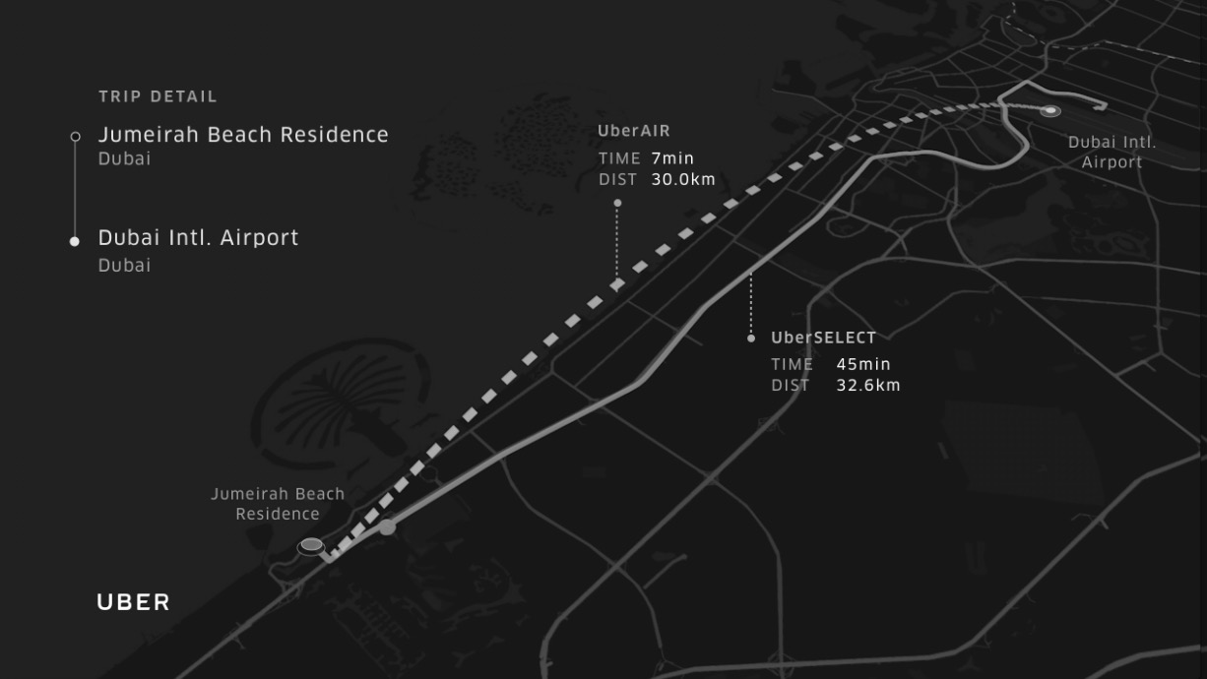

Source: Jeff Holden, “Uber Elevate & The Future of Urban Mobility*,*”April 25,2017, accessed September 1, 2017,

https://uber.app.box.com/s/jv1p4nwt4ijo67f3fss1098d9wog7bmd. Used with permission.

Exhibit 3: Proposed Flight Traffic in Dubai Using Vertiports

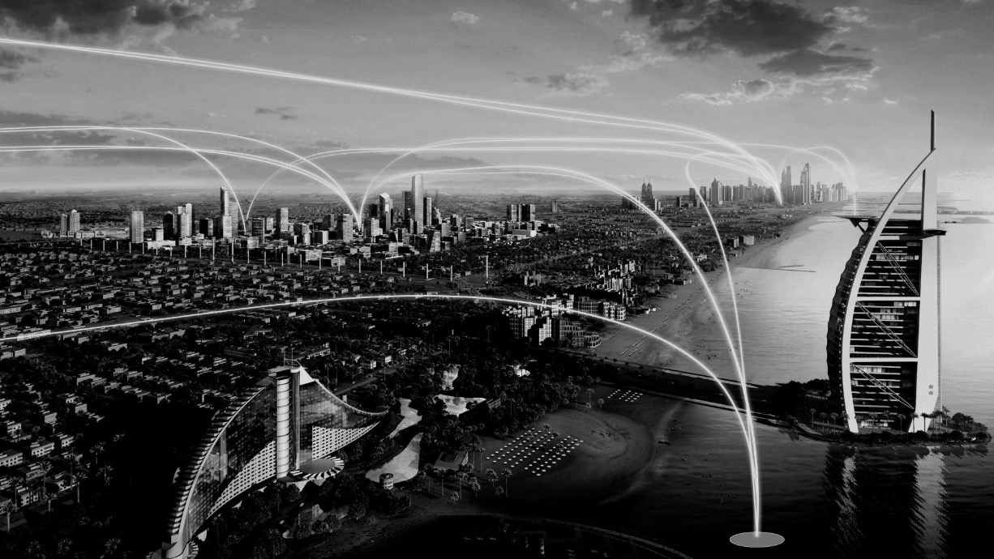

Source: Jeff Holden, “Uber Elevate & The Future of Urban Mobility*,*”April 25,2017, accessed September 1, 2017,

https://uber.app.box.com/s/jv1p4nwt4ijo67f3fss1098d9wog7bmd. Used with permission.

Exhibit 4: Proposed Vertiport Design in Dubai

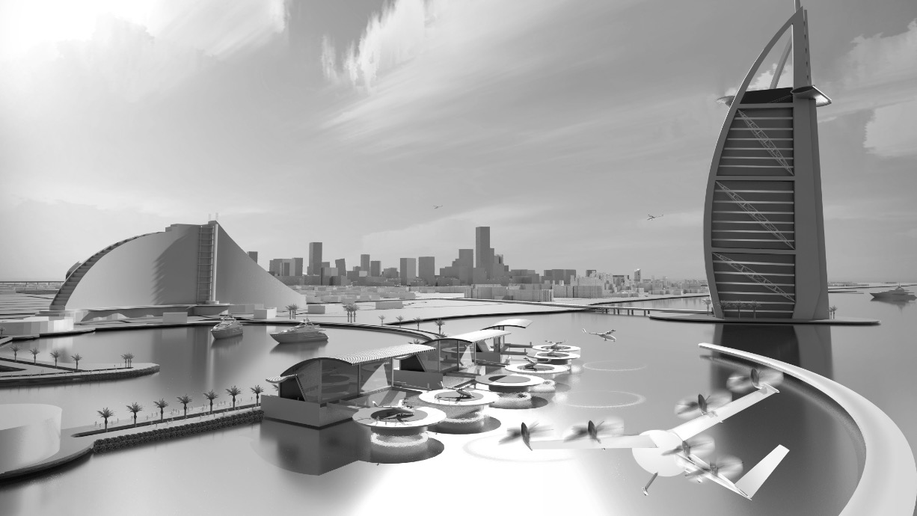

Source: Jeff Holden, “Uber Elevate & The Future of Urban Mobility*,*”April 25,2017, accessed September 1, 2017,

https://uber.app.box.com/s/jv1p4nwt4ijo67f3fss1098d9wog7bmd. Used with permission.

Exhibit 5: UberAIR App’s Interface Prototype

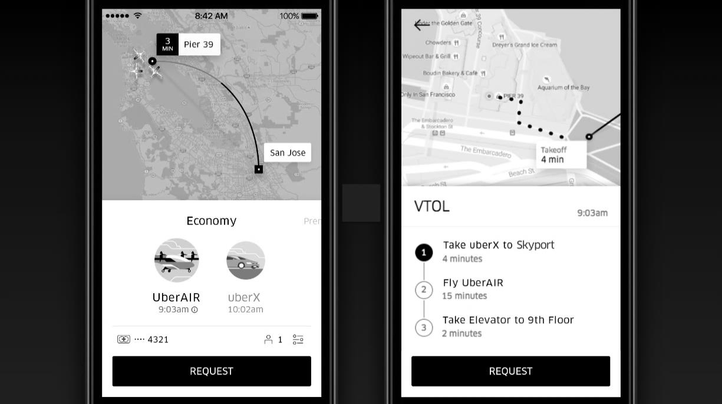

Source: Jeff Holden, “Uber Elevate & The Future of Urban Mobility*,*”April 25,2017, accessed September 1, 2017,

https://uber.app.box.com/s/jv1p4nwt4ijo67f3fss1098d9wog7bmd. Used with permission.

Exhibit 6: uberair’s Proposed Vertiport Design

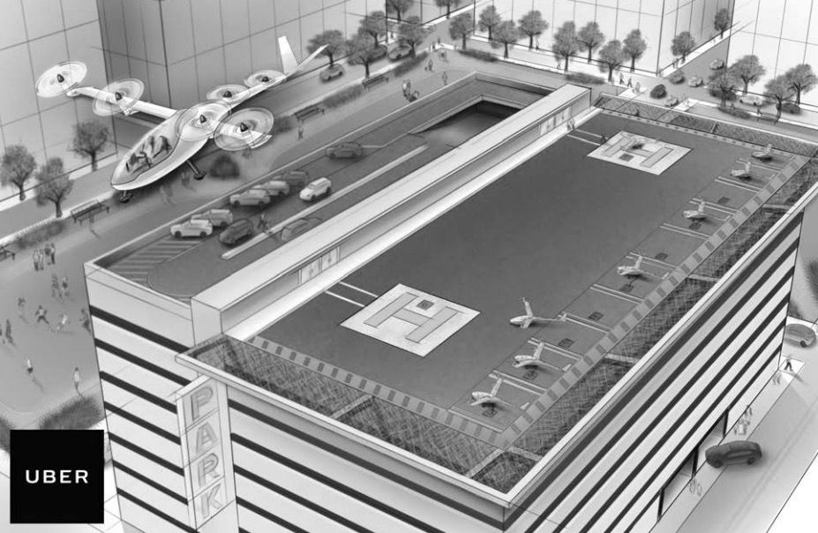

Jeff Holden and Nikhil Goel, *Fast-Forwarding to a Future of On-Demand Urban Air Transportation* (San Francisco: Uber Elevate,October 27, 2016), accessed September 1, 2017, https://www.uber.com/elevate.pdf.

Exhibit 7: Proposed Vertistop Design

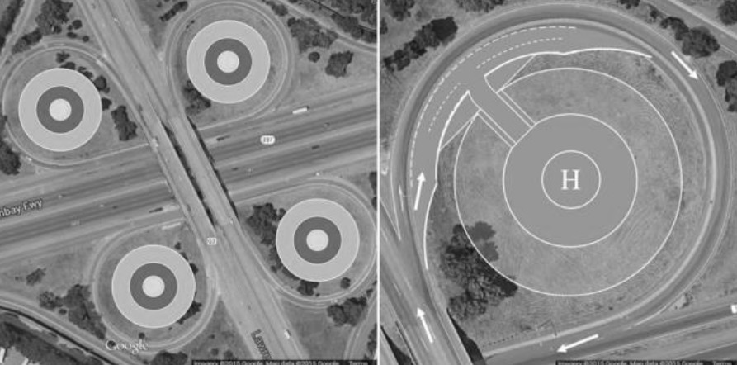

Jeff Holden and Nikhil Goel, *Fast-Forwarding to a Future of On-Demand Urban Air Transportation* (San Francisco: Uber Elevate,October 27, 2016), accessed September 1, 2017, https://www.uber.com/elevate.pdf. Used with permission.

Exhibit 8: Efficiency Analysis – Vertical Take-Off and Landing transortation versus the Automobile

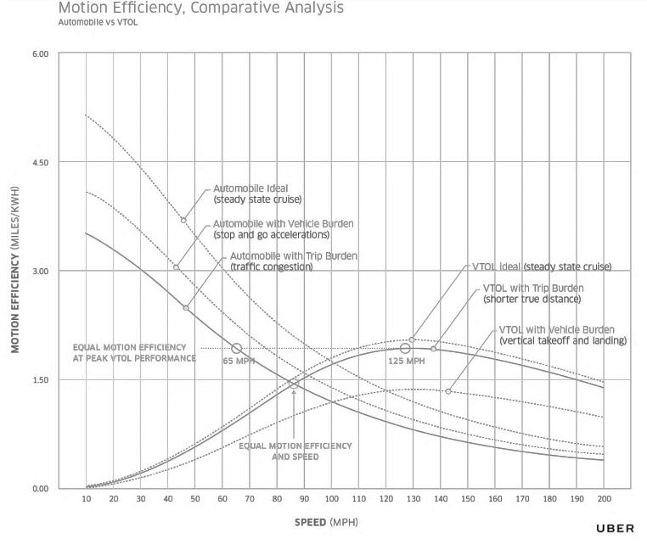

Jeff Holden and Nikhil Goel, *Fast-Forwarding to a Future of On-Demand Urban Air Transportation* (San Francisco: Uber Elevate,October 27, 2016), accessed September 1, 2017, https://www.uber.com/elevate.pdf. Used with permission.

1. This case has been written on the basis of published sources only. Consequently, the interpretation and perspectives presented in this case are not necessarily those of Uber Technologies Inc. or any of its employees.
2. “Uber Elevate and Future of Urban Mobility,” YouTube video, 55:12, posted by Elevate Summit, May 5, 2017, accessed September 1, 2017, https://www.youtube.com/watch?v=HO3eH_c9ZQk.
3. Jeff Holden and Nikhil Goel, *Fast-Forwarding to a Future of On-Demand Urban Air Transportation* (San Francisco: Uber Elevate,October 27, 2016), accessed September 1, 2017, www.uber.com/elevate.pdf.
4. All currency amounts are in U.S. dollars unless otherwise specified.
5. Anita Balakrishnan, “Scandals May Have Knocked $10 Billion off Uber’s Value, a Report Says,” *CNBC*,April 25, 2015, accessed September 1, 2017, www.cnbc.com/2017/04/25/uber-stock-price-drops-amid-sexism-investigation-greyballing-and-apple-run-in--the-information.html.
6. Mike Isaac, “Uber Founder Travis Kalanick Resigns as CEO,” *New York Times*, June 21, 2017, accessed September 1, 2017, www.nytimes.com/2017/06/21/technology/uber-ceo-travis-kalanick.html.
7. Thomson Reuters, “Uber Appears to Be in Self-Destruct Mode with Internal Squabbles,” *Disruptive Views*,August 14, 2017, accessed September 1, 2017, https://disruptiveviews.com/uber-appears-self-destruct-mode.
8. Andrew Hawkins, “Can Uber Be Saved from Itself?,” *Verge*, March 6, 2017, accessed September 1, 2017, www.theverge.com/2017/3/6/14791080/uber-sexism-scandal-strike-waymo-lawsuit-travis-kalanick.
9. Seth Fiegerman, “Uber Has a Leadership Void at a Time of Crisis,” *CNN Money*, June 13, 2017, accessed September 1, 2017, http://money.cnn.com/2017/06/12/technology/business/uber-leadership-void/index.html.
10. Ellen Huet and Mira Rojanasakul, “Uber’s Top Ranks Thin Out as CEO Travis Kalanick Steps Away,” *Bloomberg*, June 14, 2017, accessed September 1, 2017, www.bloomberg.com/graphics/2017-uber-leadership-gap.
11. Heather Somerville and Tom Hals, “New Uber CEO Promises Culture Change, Eyes IPO within 18 to 36 Months,” *Financial Post*, August 31, 2017, accessed September 1, 2017, http://business.financialpost.com/transportation/update-5-new-uber-ceo-promises-change-sees-ipo-in-18-36-months.
12. “Our Trip History,” Uber, 2017, accessed September 2, 2017, www.uber.com/en-CA/our-story.
13. Avery Hartmans and Nathan McAlone, “The Story of How Travis Kalanick Built Uber into the Most Feared and Valuable Startup in the World,” *Business Insider*, August 1, 2016, accessed September 1, 2017, www.businessinsider.com/ubers-history.
14. John Patrick Pullen, “Everything You Need to Know about Uber,” *Time*, November 4, 2014, accessed September 1, 2017, http://time.com/3556741/uber.
15. Chris Sacca, “Why I Wouldn't Want to Compete with Uber’s Travis Kalanick,” *Fortune*, February 4, 2015, accessed September 1, 2017, http://fortune.com/2015/02/04/why-id-never-want-to-compete-with-ubers-travis-kalanick/.
16. Uber, “Ride with Uber,” 2017, accessed September 2, 2017, www.uber.com/en-CA/ride/.
17. Uber, “Steel City’s New Wheels,” *Uber Blog*, May 19, 2016, accessed September 1, 2017, www.uber.com/blog/pittsburgh/new-wheels.
18. Avery Hartmans, “The $10 Billion Club: Meet the 8 Most Valuable Startups in the US,” *Business Insider*, January 2, 2017, accessed September 1, 2017, www.businessinsider.com/most-valuable-us-startups-2016-12/#8-dropbox-1.
19. Sam Levin, “Uber’s Scandals, Blunders and PR Disasters: The Full List,” *Guardian*, June 28, 2017, accessed September 1, 2017, https://www.theguardian.com/technology/2017/jun/18/uber-travis-kalanick-scandal-pr-disaster-timeline.
20. Connie Loizos, “As Uber’s Value Slips on the Secondary Market, Lyft’s Is Rising,” *TechCrunch*, June 22, 2017, accessed September 1, 2017, https://techcrunch.com/2017/06/22/as-ubers-value-slips-on-the-secondary-market-lyfts-is-rising/.
21. Travis Kalanick, “Introducing Our New Chief Product Officer,” *Uber Newsroom*, February 14, 2017, accessed September 1, 2017, https://newsroom.uber.com/introducing-our-new-chief-product-officer/.
22. Ibid.
23. Biz Carson, “Meet the Power Players Who Really Run Uber,” *Business Insider*, January 21, 2017, accessed September 1, 2017, www.businessinsider.com/uber-top-executives-power-players-2017-1.
24. Lisa Marie Segarra, “Jeff Bezos Just Dethroned Bill Gates as the Richest Man in the World,” *Fortune*, July 27, 2017, accessed September 1, 2017, http://fortune.com/2017/07/27/jeff-bezos-net-worth/.
25. Holden and Goel, op. cit., 2.
26. Michael Wade, “It’s Time for a Reality Check on Flying Cars Like Uber’s,” *Fortune*, April 27, 2017, accessed September 1, 2017, http://fortune.com/2017/04/27/flying-car-drone-uber-dubai-kitty-hawk-2020/.
27. James Temperton, “Flight of Fancy: Here Are All the Reasons Why Uber’s Flying Car Plans Are Fantasy,” *Wired*, April 28, 2017, accessed September 1, 2017, /www.wired.co.uk/article/uber-flying-car-engineering-regulation-issue.
28. Danielle Muoio, “Elon Musk Says Flying Cars Aren’t a Good Fix for Traffic—Here’s Why,” *Business Insider*, February 16, 2017, accessed September 1, 2017, www.businessinsider.com/elon-musk-flying-cars-bad-idea-2017-2.
29. “Uber Elevate Day 2 Session 3,” YouTube video, 2:40:58, uploaded by Elevate Summit, May 2, 2017, accessed September 1, 2017, https://www.youtube.com/watch?v=rukutJ_FVu8&feature=youtu.be&t=2h34m7s.
30. Ibid.
31. Holden and Goel, op. cit., 77.
32. Michal Lev-Ram, “How Lyft Could Defeat Uber,” *Fortune*, July 19, 2017, accessed September 1, 2017, http://fortune.com/2017/07/19/uber-vs-lyft-race/.
33. Danielle Muoio, “These 7 Companies Are Looking to Make ‘Flying Cars’ a Reality by 2020,” *Business Insider*, June 5, 2017, accessed September 1, 2017, www.businessinsider.com/flying-cars-companies-2020-2017-6.
34. “Our Story,” Hyperloop, accessed September 1, 2017, https://hyperloop-one.com/our-story.
35. “Hyperloop Explained,” Hyperloop, accessed September 1, 2017, https://hyperloop-one.com/hyperloop-explained.
36. “Facts & Frequently Asked Questions,” Hyperloop, accessed September 1, 2017, https://hyperloop-one.com/facts-frequently-asked-questions.
37. Rob Wile, “Here’s How Much the Hyperloop Will Cost,” *Business Insider*, August 12, 2013, accessed September 1, 2017, www.businessinsider.com/hyperloop-cost-2013-8.