|  |  |  |
| --- | --- | --- |
|  |  | NCCU_LOGO_words_bw |

9B18A020

namchow’s frozen cooked noodles: the sanuki udon

Professors Lien-Ti Bei and Shih-Fen Chen wrote this case solely to provide material for class discussion. The authors do not intend to illustrate either effective or ineffective handling of a managerial situation. The authors may have disguised certain names and other identifying information to protect confidentiality.

*This publication may not be transmitted, photocopied, digitized, or otherwise reproduced in any form or by any means without the permission of the copyright holder. Reproduction of this material is not covered under authorization by any reproduction rights organization. To order copies or request permission to reproduce materials, contact Ivey Publishing, Ivey Business School, Western University, London, Ontario, Canada, N6G 0N1; (t) 519.661.3208; (e)* [*cases@ivey.ca*](mailto:cases@ivey.ca)*;* [*www.iveycases.com*](http://www.iveycases.com)*.*

Copyright © 2018, College of Commerce National Chengchi University and Ivey Business School Foundation Version: 2018-03-20

At a July 17, 2012, ribbon-cutting ceremony in Taoyuan, Taiwan, Alfred F.L. Chen, the chief executive officer (CEO) of Namchow Chemical Industrial Ltd. (Namchow), opened the second production line of frozen cooked noodles. Namchow was a Taiwanese manufacturer of consumer goods (e.g., soap, cookies, and baking oil) sold to business clients and household consumers. It had invested over NT$200 million (about US$6.66 million) to make frozen cooked noodles for thousands of restaurants and cafés in Taiwan.[[1]](#footnote-1) The popularity of this product among business clients had led Namchow to expand its marketing efforts to cover household consumers. Namchow was also at the early stages of exporting its frozen cooked noodles to foreign markets, with a focus on Europe and Australia first, and then China.

COMPANY HISTORY

The origin of Namchow could be traced back to Southern Overseas Chinese Industrial Ltd., a trading and manufacturing company founded in 1944 in Shanghai by a group of overseas Chinese entrepreneurs in the Philippines, Indonesia, Singapore, and Hong Kong. The partners were expert traders but inexperienced manufacturers. Therefore, they decided to sell all of the factories to one of the partners—Kee-Chih Chen (Alfred Chen’s father). At the time, Kee-Chih lived in the Philippines, but he later returned to China to start a trading company and set up factories in Shanghai and Xiamen.

After China was taken over by the communist government, Kee-Chih moved his family to Taiwan in 1947 and set up a subsidiary of Namchow in Taipei. In 1952, Kee-Chih rebuilt Namchow and formally started his business in Taiwan. At that time, the Taiwanese economy was recovering from World War II and facing a severe shortage of consumer goods. Kee-Chih chose soaps as the first product to make in Taiwan. Riding the tide of economic growth, Namchow’s soap business reached annual sales of NT$36 million in 1959, placing the company among the top three in a crowded market of about 160 manufacturers.

After the initial success of the soap business, Kee-Chih bought a vast area of land in Taoyuan County, Taiwan, to start his second business—manufacturing baking oil. The decision to manufacture baking oil was intuitively derived from the fact that soap was largely based on oil. However, Taiwan’s booming soap industry came to an end shortly after Namchow started the baking oil business. The price of soap followed a sharp decline despite an increase in per capita income from US$154 in 1951 to US$189 in 1963. Namchow’s diminishing profit margins were also affected by an oversupply of soaps in the market.

Further Expansions of Namchow

To revitalize the soap business, Alfred Chen (Kee-Chih Chen’s oldest son) took the major challenge of purchasing a set of auto-production machines from the Italian supplier Mazzoni, at a cost that was triple the price that Japanese makers charged for similar machines. With the help of the most advanced technology, Namchow pushed its soap quality to a new level by creating a semi-crystal look for the product. Chen labelled the new product Namchow Crystal Soap.

In 1974, at the age of 36, Chen became the CEO of Namchow, after his father, the company’s founder, suddenly passed away. Chen was born in Hong Kong but was educated in China (Shanghai), Taiwan, and the United States. Applying the marketing skills that he learned from his U.S. experience, Chen made heavy investments in newspaper advertising and television commercials. He also distributed 4,000 boxes of free samples to promote the Namchow Crystal Soap. He was the first advertiser in Taiwan to introduce the concept of soap opera into the Taiwanese market as a major sponsor of television programs. At one time, Namchow enjoyed a 50 per cent share of the Taiwanese soap market.

While visiting the Philippines and Indonesia in his 20s, Chen found that the consumer goods industry in Southeast Asia, after the opening of the market to foreign investors, was soon dominated by a few global giants, such as Procter & Gamble and Unilever. He noted that these global brands had effective marketing and advertising strategies to attract end-users into retail stores, but were relatively ineffective at reaching out to business clients. In addition, global brands preferred to deal with retail chains instead of free-standing stores. Chen sensed that winning competition over global giants depended on the provision of customized products to small retail clients in Taiwan.

Along with the growth of its soap business, Namchow gained more experience and knowledge in the oil industry. Chen decided to target a new market segment of the baking oil business—small bakeries and restaurants. In 1970, Namchow signed a licensing agreement with Miyoshi, one of the four major edible oil companies in Japan that possessed the necessary production techniques. With help from Miyoshi, Namchow sold baking oil directly to business customers, without needing to reach household consumers. Chen referred to the business-to-business (B2B) operation as a way of “selling invisible oil” to end-users because the consumption of oil by end-users was “invisible” in the market.

Based on the success in selling baking oil to bakeries and restaurants, Namchow further expanded its B2B line to cover even more customers, including instant noodle manufacturers, ice cream makers, fast-food chains, and other food processing factories. “This is a bold decision that takes a long time to recoup the investment,” thought Chen. “But big global brands can hardly provide customized services to small business owners in Taiwan. Besides, the profit margin that I get from small businesses is often higher than the margin from major accounts.”

Unlike the business-to-consumer (B2C) segment, which relied heavily on marketing and advertising, the B2B segment featured sales teams that visited clients regularly. The primary target customers of Namchow’s baking oil were bakeries, where the oil-based ingredients were critical to the taste of baking goods such as bread and cake. So, Namchow started to build up sales teams that visited owners and chefs of small bakeries and cafés one by one. Namchow’s sales teams needed to become familiar with bakers, understand their needs, and recommend suitable oil products for their needs.

Chen wanted Namchow to become not only an oil supplier but also a business consultant to small cafés and bakeries. For instance, Namchow developed new pastry recipes for trendy products, and its salespeople would teach the recipes to the bakers. The company even provided accounting and store decoration advice for small bakeries. “This is exactly the B2B operation that global companies are reluctant to engage in,” noted Chen.

Diversification of B2C Operations in 1980s

In 1981, Chen became chairman of the company and consolidated all operations into the Namchow Group. Chen was chairman for seven years. Under his guidance, Namchow started its diversification into personal care and beauty products through a wide range of alliances with foreign brands. Namchow’s joint venture partners included such companies as Unicharm Corporation from Japan, and Chesebrough-Pond’s and Procter & Gamble from the United States. In these alliances, Namchow served as a distributor for its foreign partners in Taiwan. Namchow also made products for its foreign partners through licensing agreements, and ran sales and marketing operations for these foreign brands in the Taiwanese markets. However, once Namchow’s foreign partners set up their own subsidiaries in Taiwan, the joint ventures came to an end (see Exhibit 1).

The collapse of these alliance relationships pushed Namchow to launch more consumer brands of its own and move upward to the high-end market segment. For example, to take advantage of its channel relations, Namchow launched its own packaged food products by introducing two new cookie business lines: O’smile was created from scratch, and Lucky was acquired from Uni-President (a food conglomerate in Taiwan). In 1996, Namchow sold these two cookie lines to Nabisco Taiwan, a member of Kraft Foods Group Inc.

Refocus on B2B Operations in the 1990s

The winding down of personal care and packaged food products in the B2C segment led Namchow to refocus on its B2B operations. As the supplier of cooking oil to bakeries, Namchow saw first-hand the difficulties of small business owners in Taiwan, including the escalation of store rents that forced many bakeries to shut down. To preserve its customer basis, Namchow decided to set up a research and development kitchen to develop more varieties of breads, and supplied ready-to-bake frozen dough to small bakeries that could not afford to run their own kitchen.

The use of ready-to-bake frozen dough provided small bakeries with more benefits than just space savings. It took only 15 to 165 minutes to ferment and bake frozen dough, much less than the 385 minutes required to hand-make fresh dough. Smaller bakeries did not need a fully equipped kitchen. In addition, frozen dough could be more easily stored and preserved than fresh dough, making it easier for small bakeries to handle demand fluctuations. Labour costs were also lower due to the simplification of store operations. Bakers who liked to keep the uniqueness of final pastry could still add signature toppings on the dough. Namchow’s adaptation of frozen dough significantly increased profit margins for small bakeries.

The business model of oil and frozen dough was extended to China in the late 1990s. Namchow started its oil business in China in 1996. Besides selling oil to major food companies such as McDonald’s and Ting Hsin, Namchow also built up a consulting sales team and ran seminars and conventions for small bakeries in China. In 2004, Namchow established its first bakery store—**The Deli & Bakery Café—in Shanghai.** Demonstrations were held at the store for both current and aspiring bakers to learn how to run their own bakery. Chen considered opening a chain of bakeries in China but gave up on that idea when he realized it would be unwise to directly compete against Namchow’s own customers.

B2C and B2B Interaction: The Häagen-Dazs Example

While expanding its B2B operations from baking oil to frozen dough, Namchow did not forget its B2C operations. Thanks to the strong market position of its Crystal Soap line, Namchow was able to introduce other household items, such as detergents, rice crackers, and ice cream. The capacity to cover both B2B and B2C segments provided Namchow with a unique opportunity to grow and expand. The complementarity of Namchow’s B2B and B2C operations could be best illustrated through the introduction of ice cream.

Namchow started its ice cream business incidentally in 1988, through the acquisition of a factory in a small city in southern Taiwan. The factory had an ice cream line that was insignificant, but Chen chose to keep it anyway. The ice cream market in Taiwan was young but crowded, with many companies competing on price. Overall, ice cream consumption was low and seasonal. Chen figured that only a high-end brand could survive the winter season and make a profit.

In 1988, Namchow introduced its own ice cream line—Duroyal—which was positioned as a prestige ice cream with a 50 per cent premium over competitors. Namchow offered a wide range of flavours to occupy store shelves at supermarkets, but the B2C segment was only part of Chen’s plan for the Duroyal brand. For its ice cream business to reach maximum cost-efficiency, Namchow needed to expand it to also include the B2B segment.

Following the business model established to sell baking oil to restaurants, Namchow’s sales teams visited cafés and restaurants to promote ice cream desserts, which were a relatively new concept for the Taiwan consumer in the 1980s. It took six years, twice the time that Chen had estimated, for Duroyal to occupy the leading position in the B2B segment of the ice cream market in Taiwan. The success of Duroyal ice cream in the B2B segment further strengthened its position in the B2C segment. Many consumers who had tried the product at cafés and restaurants started to purchase it from supermarkets.

To further expand its ice cream line, Namchow entered a 50:50 joint venture with Häagen-Dazs and introduced the high-end brand to Taiwan. To replicate the luxury image of Häagen-Dazs, Chen set up a flagship store in Taipei, selling decorated ice cream desserts with afternoon tea. The store became a hub of social gatherings for affluent consumers in metropolitan Taipei. The attention received by the flagship store helped Namchow distribute the Häagen-Dazs line through stores and supermarkets. Unlike the Duroyal brand that shared freezers at retail stores with other brands, the Häagen-Dazs line was displayed through exclusive freezers bearing its logo.

Namchow also enlisted its B2B capacity to promote the Häagen-Dazs brand in the B2C market. Chen persuaded the Regent Taipei, a luxury hotel, to provide Häagen-Dazs as a dessert in its upscale buffet restaurant. The expensive Häagen-Dazs ice cream was a great value for patrons of the all-you-can-eat restaurant. At the same time, the upscale image of a five-star hotel reinforced the high-end image of the Häagen-Dazs brand. The capacity to serve the B2C and B2B segments allowed Namchow to push the price of ice cream from the NT$20–NT$30 range to NT$60–NT$90 per scoop.

Similar to previous joint ventures with foreign brands that Namchow had formed and then sold, the Häagen-Dazs joint venture was also sold, in this case to Pillsbury Taiwan Ltd., a subsidiary of General Mills. Shortly after the sale in 2003, Namchow launched its own high-end ice cream brand called Хлеб-соль, a Russian word meaning salt and bread, which are symbols of welcome and blessing. Like Duroyal and Häagen-Dazs, Хлеб-соль was made available to consumers through the dual channels of B2B and B2C.

By the end of 2013, Namchow covered a wide range of products sold at the B2B and B2C levels, such as soap, detergent, packaged food, baking oil, frozen dough, and others (see Exhibit 2). The most notable record was that it served over 35,000 business customers for its baking oil and frozen dough, enjoying a market share of about 40 per cent and 60 per cent respectively. Namchow Crystal Soap was still the major brand in the detergent market in Taiwan, and the Duroyal line was the number-one ice cream brand with a 38 per cent market share. With its expertise in serving cafés and restaurants, Namchow was able to diversify into the catering industry and operated several high-end restaurants in Taiwan. Overall, the company had almost 5,000 employees, with annual revenues of NT$13.426 billion in 2013 (see Exhibits 3 and 4).

Introduction of Namchow’s Frozen Cooked Noodles

After accumulating years of experience in producing frozen dough, Namchow moved to introduce frozen cooked noodles that could be served almost instantly. The noodles were made of fresh dough, cooked, flash-frozen, and then packaged in a portion suitable for one serving, all at a production plant. It could be stored in a freezer for a long period and was ready to serve after less than one minute of boiling in hot water.

The product concept was similar to packaged instant noodles that originated from Japan and were popular in Taiwan. One major advantage of frozen cooked noodles over instant noodles was that they tasted just like freshly cooked noodles. Because the noodles were frozen, they did not need preservatives to keep them fresh, and thus were safer and healthier to consume.

The technology of frozen cooked noodles was mature in Japan. In 1997, Chen had flown to Japan to visit Katokichi Co. Ltd., a pioneering company of flash-frozen noodles, to taste the product. He realized then that the technology of frozen cooked noodles had greatly improved the taste and shelf life of noodles.

In 1998, Namchow had signed a contract to license the technology of flash-frozen noodles from Katokichi Co. Ltd. Namchow then invested NT$300 million to purchase the most advanced machinery. This production line was the first in Taiwan and the world’s seventh set of fully automated machinery of flash-frozen noodles. The technology handled the cooking, freezing, and cleaning, all through electronic control panels. Namchow sent a crew of technicians to Katokichi Co. Ltd. for training on setting up and operating the new production line.

HISTORY OF PACKAGED NOODLE PRODUCTS

Noodles were one type of staple food that had appeared in various cultures for thousand years. To extend their shelf life, freshly cooked noodles were often dried for future consumption. However, compared with flash-frozen noodles, dried noodles took a longer time to cook, and resulted in a less tasty product. In recent years, commercial innovations were made to balance the benefits and weaknesses of freshly made noodles. The two major inventions were instant noodles and frozen noodles.

Instant Noodles

Instant noodles were a precooked and dried [noodle](http://en.wikipedia.org/wiki/Noodle) block, usually sold with flavouring powder, seasoning oil, and other toppings in a separate package. The dried noodle block was ready to be served after one to three minutes of soaking in boiling water. It was an invention to overcome the weaknesses of both freshly made and dried noodles, pioneered by a Taiwanese Japanese entrepreneur named Momofuku Ando in the 1950s. The convenience, long shelf life, and friendly price all contributed to the spread of instant noodles from Japan to all over the world.

Instant noodles were first marketed in Japan in August 1958 under the name Chikin Ramen by a company called Nissin Food Products Co. Ltd. (Nissin). After its initial success in Japan, Nissin promoted this new noodle product to other Asian markets aggressively. Although instant noodles were quickly accepted by consumers all over Asia, the product failed in its first attempt to conquer the U.S. market. To overcome the lifestyle difference, Nissin invented cup noodles to suit the U.S. market.

Up to the 2010s, Nissin was still the biggest manufacturer of instant noodles in Japan with 30 per cent of the market.[[2]](#footnote-2) According to an estimate by the World Instant Noodles Association (WINA), the global demand for instant noodles stood at approximately 105.695 billion servings as of 2013. China led with 43.8 per cent of world consumption, followed by Indonesia at 14.1 per cent and Japan at 5.2 per cent.

Frozen Cooked Noodles

Together with the popularity of instant noodles among consumers, the health effect of this convenient product became apparent. Rich with fat and carbohydrate ingredients, instant noodles lacked fibre, proteins, vitamins, and minerals. Preservatives were also added to extend their shelf life. Food scientists kept working on new noodle types that were nutritional and convenient.

Frozen cooked noodles were identified as one substitute. Unlike instant noodles sold in the dehydrated form, frozen noodles were precooked and stored in a frozen form with moisture. Similar to instant noodles, they could be instantly prepared for consumption.

The production of frozen noodles started with boiling noodles to an optimal state of doneness. Generally, the surface of the noodles had the moisture absorption of about 80 per cent, and the core about 50 per cent. After boiling, the cooked noodles were immediately flash-frozen at a temperature of –35° to –40° Celsius for 30 minutes. The flash-freezing process made noodles less sticky, firmer, and thicker than their dried counterparts. The noodles were then stored at a temperature of –18° Celsius at all times. At this storage temperature, frozen cooked noodles had a shelf life of up to one year (chilled noodles could last for only about one week).

The benefits of frozen cooked noodles included convenience and taste. The frozen form needed only 20–60 seconds of immersion in boiling water to reach the ready-to-eat state. After having been reheated, frozen cooked noodles tasted much better than dried noodles and just like freshly cooked noodles. The technology of flash-frozen noodles became well developed after 2000, which made for a promising frozen cooked noodles market.

COMMERCIAL NOODLE PRODUCTS IN TAIWAN

In Taiwan, rice had been the major agriculture product and staple food until the 20th century. Noodle consumption was introduced with Japanese colonization and became more popular after the influx of north-eastern Chinese consumers into Taiwan after World War II. Before the 1960s, only uncooked noodles (dried and freshly made) were available to consumers at traditional food markets. However, cooked noodles were available in bowls for consumption by patrons of food stands and restaurants in Taiwan.

In 1967, a local company, called National Food, co-operated with Nissin to launch instant noodles into the Taiwanese market. From then on, instant noodles became a popular food choice among Taiwan consumers, and the instant noodles market was quickly captured by a new company called Uni-President Enterprise Corporation (Uni-President). The food conglomerate first sold instant noodles with seasoning oil in a separate package. Uni-President also invested heavily in television commercials to promote its food products.

From 1967 to the 1990s, Taiwan’s per capita gross domestic product grew from US$281 to over US$10,000. During that time, instant noodles retained their popularity among Taiwanese consumers, both as a staple food and as a snack food. The total market of instant noodle was estimated at over NT$10.6 billion in 2012.[[3]](#footnote-3)

During that same period, noodle consumption at Taiwan restaurants also saw a rapid increase with young families choosing to eat out for more than half of their meals. With a population of 23 million, Taiwan boasted more than 110,000 food stands and restaurants, with revenues of NT$313.8 billion in 2013. Entry barriers in the catering industry were relatively low. More than 90 per cent of food stands and restaurants were owned and operated by families, while franchises accounted for the remaining amount, less than 10 per cent.[[4]](#footnote-4) In the catering industry, noodles were always a popular option for restaurant patrons because of their simplicity, quick service, and taste variety.

The noodle market in Taiwan was therefore divided between home consumption and eating out. Instant noodles were distributed mostly through retail stores to convenience-seeking buyers for home consumption. Dried and freshly made noodles were sold to both households and business clients in the catering industry (using the dual channels of B2C and B2B). Most noodle stands or restaurants made their noodles from wheat flour. Some also outsourced chilled noodles from specialized suppliers. The problem with chilled noodles was their short shelf life. Until the early 1990s, frozen cooked noodles were still unavailable in the Taiwan market.

NAMCHOW’S SANUKI UDON

Seven months after signing the licensing contract with Katokichi, Namchow opened its production line of flash-frozen noodles. It was Taiwan’s first and only production line for frozen cooked noodles. A fully automated machine, imported from Australia, imitated human labour in the pounding of moistened wheat flour. The production line could produce 4,500 packages of frozen cooked noodles per hour, continuously for 22 hours per day.

The first frozen cooked noodle product that Namchow launched was the Japanese udon, a type of thick noodle based on wheat flour with a diameter of 2–3 millimetres. Chen named the noodle Sanuki, a historical place in Japan that was made famous as the origin of the udon noodle.

The product package displayed the Namchow company name along with the Sanuki brand. This branding strategy was used to serve both B2C and B2B segments of the market, which differed from the company’s previous routine, as noted by Chen:

In B2C marketing (e.g., soaps, detergents, cookies, or ice cream), we use only the product brand to highlight its positioning and promote its brand image. In B2B marketing (e.g., oil and dough), we use the Namchow name to establish the corporate identity, because our business customers usually recognize only the Namchow brand.

For convenience, the Sanuki udon was sold to end-users in a small package of one serving that also carried the Namchow name and the corporate logo. The noodle product was still individually packaged and sold to business customers under the Sanuki brand, although the Namchow name and its corporate logo were more prominently displayed on the package, which was less sophisticated in design (see Exhibit 5).

B2B Operations

Initially, Namchow supplied its Sanuki udon to business customers only, including restaurants, cafés, and food stands. From many years of selling baking oil and ice cream to restaurants, Chen knew how to alleviate the difficulties faced by small business owners in the catering industry. He saw the introduction of frozen cooked noodles in a small pack of one serving as a business opportunity because this new product could help to mitigate many of the difficulties faced by Namchow’s customers in the B2B segment.

Reduction in Preparation Time

Only 50 seconds of boiling was needed to reheat the Sanuki udon to the ready-to-eat state, shorter than all other types of noodles—dried, chilled, or freshly made. Reduction in preparation time could improve the operational efficiency of the catering industry that followed a three-meals-per-day cycle. During the peak meal hours, the use of precooked udon could help to cut customer wait time and increase table turnover. Packing one serving of udon in a small bag made it even easier for restaurant chefs to allocate a portion for each customer.

Space Savings

The adoption of precooked udon could reduce the preparation area in the kitchen of a restaurant, which needed only a freezer to keep the product. Thanks to a smaller preparation area, the restaurant could afford to reduce its overall space or allocate more space to serve customers. The saving on space could translate into profits, an advantage much appreciated by restaurant operators in a crowded country such as Taiwan.

Labour Savings

A shorter time to reheat precooked udon and the elimination of noodle-making allowed the restaurant owner to hire fewer employees without reducing its capacity to host customers. Labour savings improved store profitability, a critical advantage in a country where wages had been rising steadily over the years.

Ease in Inventory Planning

Inventory planning was a challenge in the catering industry, particularly for those restaurants and food stands located in tourist areas. Mainly, it was difficult to estimate the number of customers and therefore the quantity of noodles needed for a given date. Restaurants that used freshly made or chilled noodles tended to be conservative in their inventory planning due to noodles’ short shelf life. As a result, they could run out of inventory in the middle of a highly busy day. Planning conservatively did not fully resolve the issue of food waste. The number of visitors to a tourist spot depended in part on weather conditions. Sometimes, a food stand was forced to throw away all freshly made noodles because bad weather had kept most customers at home.

Namchow’s frozen cooked udon also made inventory planning easy for its business clients. For example, a food stand could keep its inventory at a larger-than-necessary level. If the date turned out to be busier than expected, the owner could extract more precooked udon from the freezer. If it turned out to be a slow business day, all precooked udon had a long shelf life so it could be stored in the freezer and used for future sales.

The Sanuki udon addressed the above problems in the catering industry without sacrificing the food’s flavour. After reheating, Namchow’s frozen cooked noodles tasted as good as freshly made noodles. Unlike instant noodles sold in the market with a separate pack of seasoning oil, Namchow supplied its frozen cooked noodles to its business clients without adding any flavour. The restaurant chefs could still create their own signature taste from the same Sanuki udon.

To promote its frozen noodles in the B2B market, Namchow opened seven noodle shops to exemplify how a small shop could use the Sanuki udon to serve a large number of customers during peak meal hours. The Sanuki logo was visibly displayed at the noodle stands (see Exhibit 6). The company invited its business customers to visit the shops, taste the udon, and even cook it themselves as a trial. One noodle stand located at a highway service area recorded selling 2,688 bowls of udon in 10 hours, with only five employees running the stand. After the initial acceptance of Sanuki udon by its business clients, Namchow shut down all but one of the noodle shops, keeping open only the stand inside the factory in Taoyuan for the research department to run executive commercialization tests.

Even though the Sanuki udon tasted as good as freshly made noodles, Namchow emphasized the short preparation time and convenience as its selling points to promote frozen udon in the B2B market, without mention of the product’s great taste. Restaurants that used the Sanuki udon were reluctant to reveal that precooked udon was being served to their customers. Consumers still had the misconception that freshly made noodles tasted better than the factory-made versions, so restaurants kept the source of the noodles secret.

Gradually, as more restaurant customers expressed an appreciation for the taste of the Sanuki udon, perceptions changed. One popular noodle shop even offered two types of udon: the regular no-name brand udon and the Sanuki brand udon, with a surcharge of NT$10. Most customers eventually chose the Sanuki udon because of its flavour and texture and the restaurant dropped the no-name udon.

In 2012, the Sanuki udon had penetrated more than 10,000 restaurants in Taiwan, many of them clearly displaying the Sanuki logo, which helped small noodle shops attract consumers who trusted the corporate reputation of Namchow. The popularity of the Sanuki udon in the B2B segment gave Namchow the confidence to eventually launch a line of frozen cooked noodles in the B2C segment.

B2C Introduction

Although the Sanuki udon was first supplied to business clients only, Chen had in mind the idea of selling the product directly to end-users. The B2C business consisted mainly of restaurant patrons who loved the flavour and texture of the Sanuki udon. Unable to find the product in retail outlets, they looked for it on the Internet or at high-end supermarkets that imported frozen cooked udon from Japan.

In responding to the demand from household buyers, Namchow started to sell the Sanuki udon online to consumers at NT$100 per bag, which contained five small packs of one serving. Namchow also made the Sanuki udon available at high-end supermarkets, displaying it next to imported udon from Japan, but did not heavily promote the Sanuki brand in the consumer market.

Instead, a wide range of tools promoted Namchow’s frozen cooked noodles in the B2C market. First, it collaborated with celebrity chefs on television cooking shows to illustrate how easy it was to prepare a bowl of frozen cooked udon. Second, Namchow held in-store food samplings in supermarkets for shoppers to taste the product. Third, gourmet food bloggers were creating udon recipes and sharing them with their followers, sometimes without any involvement from Namchow. Fourth, the Namchow noodle shops that were used to promote frozen cooked udon to B2B clients helped spread awareness of the product to the B2C segment. The patrons of these noodle shops would purchase the product online or from supermarkets.

Unlike the Japanese competitor Katokichi, which focused on udon only, Namchow used the technology to develop other noodle products (e.g., soba, ramen, spaghetti, and a variety of Chinese-style noodles). Namchow added a second production line to its factory and redesigned the original one for the Sanuki udon. The new production line was reserved for other types of noodle products in small production batches. At the end of 2012, Namchow introduced more than 20 different types of frozen cooked noodles. Namchow’s B2C business accounted for 16 per cent of the company’s total sales.

OVERSEAS EXPLORATION

Thanks to its long shelf life, frozen cooked noodles could endure overseas transportation without losing flavour or texture. Equipped with B2B and B2C experience from Taiwan, Namchow started exporting its Sanuki udon to foreign markets in early 2010. Namchow sold the noodles in Asia, North America, and Europe. Chen envisioned that the Sanuki udon could become a popular food in the European market.

Chen used a wide range of B2B techniques that he had learned in Taiwan to promote the Sanuki udon in Europe. First, he entered the product in food and beverage fairs around the continent, including the Allgemeine Nahrungs- und Genussmittel-Ausstellung (in English, General Food and Drink Trade Fair) held in Cologne, Germany, and the Salon international de l’alimentation (in English, International Food Fair) held in Paris, France. The two tradeshows attracted clients from the hotel and restaurant industries around Europe. Following the standard process of food exhibitions, Namchow’s employees cooked the Sanuki udon on the spot to show its short preparation time. The reheated udon noodles were served to tradeshow attendees to certify its flavour and texture.

In 2003, Chen decided to build a model noodle shop in Zurich, Switzerland, that was similar to the stands Namchow used to promote the Sanuki udon in Taiwan. Prospective business buyers were invited to visit this model shop and witness how frozen cooked noodles could help restaurant operators save on preparation time, labour, and space.

Namchow also used special events to promote its Sanuki udon, sometimes in creative ways. For example, the company built a portable three-metre long noodle bar equipped with a stove and shipped it to the ski park on the top of the Alps (see Exhibit 7). Namchow also set up a noodle stand at a Zurich film festival and at a Salzburg fashion show. At a conference hosted by the luxury company Rolex to announce a new watch, the Sanuki udon was designed as a *petit-four* appetizer and served with biscuit, cookie, and cake.

Namchow’s efforts to promote its Sanuki udon seemed to pay off. The first container of frozen cooked noodles was shipped to a client in Zurich in 2004. Since that first shipment, Namchow went on to acquire other notable business customers in Europe, including the Mövenpick Group, which adopted the Sanuki udon for the Asian Noodle Bar in its hotel chain.

China was another foreign market that Namchow considered to be an opportunity for its frozen cooked noodles. However, Chen had reservations about the high-priced positioning of the Sanuki udon in the Chinese market, where noodle shops often appealed to customers who were more price-sensitive. The lack of restaurant chains in China also made it difficult for Namchow to penetrate the market.

Chen decided to take a different approach to cultivate the Chinese market. In 2004, Namchow opened the Deli & Bakery Café in Shanghai to sell breads and quick meals. The Sanuki udon became the most popular customer request during the lunch hour, even though the café charged higher prices than competing restaurants in the surrounding area.

The success of the Sanuki udon in Shanghai led Namchow to consider the possibility of opening its own noodle chain in China. After the completion of the second production line, Namchow expanded its frozen cooked noodles to also cover Chinese ramen, which could be prepared in many styles, all with a Chinese flavour. Therefore, a noodle chain in China based solely on the frozen cooked noodles made in Namchow’s own factories seemed feasible. However, Chen had various options to consider.

Namchow could choose to deploy a combined B2B and B2C model to expand into the Chinese market, as it had done in Taiwan. The catering industry in China also featured many smaller family-owned restaurants. Namchow could instead promote frozen cooked noodles in the B2B segment first in China. After frozen cooked noodles gained acceptance by its business clients, Namchow could then appeal to household buyers in the B2C sector. Chen needed to decide on the best course to pursue.

**Exhibit 1: Namchow History Timeline**

|  |  |
| --- | --- |
| 1952 | Namchow Chemical Industrial Co., Ltd. founded in Taiwan by Kee-Chih Chen |
| 1963 | Crystal Soap launched |
| 1970 | An agreement with Miyoshi signed to transfer production techniques of baking oil |
| 1971 | First oil factory established in Taoyuan, Taiwan |
| 1973 | Namchow Chemical Industrial Co., Ltd. listed in Taiwan Stock Market |
| 1974 | Alfred Chen named chief executive officer of Namchow, after the death of his father, Kee-Chih Chen |
| 1979 | Joint venture with Lam Soon Ltd. from Singapore |
| 1980 | Joint venture with Unicharm Corporation from Japan to launch Sofy sanitary napkin; ended in 1985 |
| 1981 | O’smile cookies launched; Alfred Chen named chairman of Namchow Group |
| 1982 | Joint venture with Chesebrough-Pond’s from United States to produce and operate Pond’s lotions; ended in 1987 |
| 1984 | Joint venture with U.S. company Procter & Gamble to produce and operate sanitary napkin, shampoo, and diaper; ended in 1990 |
| 1985 | Local agent of Kellogg’s |
| 1987 | Little Cook instant noodle launched |
| 1988 | Duroyal ice cream launched |
| 1990 | Namchow (Thailand) Ltd. founded in Thailand |
| 1992 | Frozen dough factory established in Taoyuan, Taiwan; Joint venture with Häagen-Dazs Company, Inc. to produce and operate Häagen-Dazs ice cream; ended in 2003 |
| 1996 | Joint venture with Ting Hsin Group to produce baking oil in Tianjin, China; Paulaner Restaurant launched in Shanghai, China, licensed Paulaner Group from Germany; O’smile cookies sold to Kraft Foods |
| 1998 | Flash-frozen noodles factory established in Taoyuan, Taiwan, with technical supports by Katokichi, Japan |
| 1999 | Ben Chang Liu noodle shops launched in Taiwan |
| 2002 | Ambrosia Teppanyaki launched in Shanghai, China; ended in 2016 |
| 2003 | Tianjin Yoshi Yoshi Food Co., Ltd. founded in Tianjin, China, with technical supports by Miyoshi, Japan, to produce fresh cream |
| 2004 | Aseptic cooked rice launched; Хлеб-соль ice cream launched; Deli & Bakery Café launched in Shanghai, China; ended in 2016 |
| 2005 | Dian Shui Lou Restaurant launched in Taipei, Taiwan |
| 2006 | KÄFER by Binjiang One launched in Shanghai, China |
| 2010 | Seven restaurants invited in Shanghai World Expo to provide services; Chao Jiang Yan Restaurant launched in Taipei, Taiwan |
| 2011 | Frozen dough factory established in Tianjin, China |
| 2012 | Second production line of frozen dough factory established in Taoyuan, Taiwan |
| 2014 | Namchow (Japan) Ltd. founded to prepare Dian Shui Lou Hotel and Restaurant in Japan |

Source: Company documents.

**Exhibit 2: Major Business of Namchow Group**

Source: Company documents.

**Exhibit 3: Namchow Financial Statements, 2006–2015 (in NT$ Thousand)**

**Income Statement**

|  |  |  |  |  |  |  |  |  |  |  |
| --- | --- | --- | --- | --- | --- | --- | --- | --- | --- | --- |
|  | **2015** | **2014** | **2013** | **2012** | **2011** | **2010** | **2009** | **2008** | **2007** | **2006** |
| Operating revenues | 15,479,543 | 14,831,846 | 13,426,115 | 12,041,049 | 11,020,127 | 9,577,202 | 7,995,269 | 7,805,545 | 6,501,019 | 5,539,637 |
| Cost of sales | –9,871,293 | –9,913,530 | –9,100,697 | –8,521,808 | –7,981,494 | –6,477,637 | –5,315,042 | –5,733,188 | –4,639,003 | –3,797,704 |
| Gross profit | 5,608,250 | 4,918,316 | 4,325,418 | 3,519,241 | 3,038,633 | 3,099,565 | 2,680,227 | 2,072,357 | 1,862,016 | 1,741,933 |
| Operating expenses | –3,652,831 | –3,340,375 | –2,938,409 | –2,721,712 | –2,438,282 | –2,258,591 | –2,008,697 | –1,809,718 | –1,759,849 | –1,661,696 |
| Net Operating income | 1,955,419 | 1,577,941 | 1,387,009 | 797,529 | 600,351 | 840,974 | 671,530 | 262,639 | 102,167 | 80,237 |
| Non-operating income | 184,129 | 157,000 | 77,818 | 80,209 | 205,872 | 125,458 | 65,302 | 91,854 | 421,039 | 97,038 |
| Non-operating expenses | –398,507 | –156,338 | –136,730 | –166,731 | –196,236 | –116,321 | –151,973 | –256,293 | –266,031 | –224,430 |
| Income before income tax | 1,741,041 | 1,578,603 | 1,328,097 | 711,007 | 609,987 | 850,111 | 584,859 | 98,200 | 257,175 | –47,155 |
| Income tax expense | –577,080 | –569,866 | –428,551 | –250,626 | –215,906 | –243,293 | –87,962 | –34,604 | –168,441 | –29,115 |
| Net income | 1,163,961 | 1,008,737 | 899,546 | 460,381 | 394,081 | 606,818 | 496,897 | 63,596 | 88,734 | –76,270 |

**Balance Sheet**

|  |  |  |  |  |  |  |  |  |  |  |
| --- | --- | --- | --- | --- | --- | --- | --- | --- | --- | --- |
|  | **2015** | **2014** | **2013** | **2012** | **2011** | **2010** | **2009** | **2008** | **2007** | **2006** |
| ASSETS |  |  |  |  |  |  |  |  |  |  |
| Current assets | 9,391,406 | 8,498,553 | 6,313,685 | 4,921,157 | 4,968,521 | 4,123,762 | 3,411,604 | 3,678,116 | 3,571,635 | 3,177,554 |
| Noncurrent assets | 9,007,929 | 8,415,761 | 6,944,866 | 6,599,688 | 6,705,280 | 5,371,767 | 5,256,650 | 5,391,879 | 5,498,615 | 6,016,544 |
| Total | 18,399,335 | 16,914,314 | 13,258,551 | 11,520,845 | 11,673,801 | 9,495,529 | 8,668,254 | 9,069,995 | 9,070,250 | 9,194,098 |
| LIABILITIES AND STOCKHOLDERS' EQUITY | | | | | | | | | | |
| Current liabilities | 6,871,475 | 6,178,713 | 5,122,599 | 3,467,121 | 4,945,566 | 2,975,332 | 2,631,988 | 3,571,009 | 3,200,426 | 2,772,722 |
| Noncurrent liabilities | 5,883,783 | 5,483,023 | 3,508,300 | 4,135,087 | 2,729,374 | 2,785,927 | 2,780,602 | 2,717,993 | 3,261,030 | 2,900,626 |
| Total liabilities | 12,755,258 | 11,661,736 | 8,630,899 | 7,602,208 | 7,674,940 | 5,761,259 | 5,412,590 | 6,289,002 | 6,461,456 | 5,673,348 |
| Stockholders’ equity | 5,644,077 | 5,252,578 | 4,627,652 | 3,918,637 | 3,998,861 | 3,734,270 | 3,255,664 | 2,780,993 | 2,608,794 | 3,520,750 |
| Total | 18,399,335 | 16,914,314 | 13,258,551 | 11,520,845 | 11,673,801 | 9,495,529 | 8,668,254 | 9,069,995 | 9,070,250 | 9,194,098 |

Note: NT$32 = US$1 on December 31, 2015.

Source: Company documents.

**EXHIBIT 4: SUMMARY OF NAMCHOW PRODUCTS in 2016—BUSINESS-TO-BUSINESS AND BUSINESS-TO-CONSUMER CATEGORIES**

|  |  |  |  |  |
| --- | --- | --- | --- | --- |
| **Category** | **Products and Services** | **Brand Name** | **Business-to-Business** | **Business-to-Consumer** |
| Household Cleaning Products | Soap and Detergent | Chrystal |  | Since 1963 in Taiwan |
| Baking Materials | Baking Oil and Cream | Namchow | Since 1971 in Taiwan |  |
| Frozen Dough | Namchow | Since 1992 in Taiwan |  |
| Frozen and Cooked Food | Ice Cream | Duroyal | Since 1990 in Taiwan | Since 1988 in Taiwan |
| Ice Cream | Хлеб-соль |  | Since 2004 in Taiwan |
| Snack | Rice Crackers |  | Since 1993 in Thailand |
| Instant Noodle | Little Cook |  | 1987~1989,  2015 return in Taiwan |
| Frozen Noodle | Sanuki | Since 1998 in Taiwan | Since 1999 in Taiwan |
| Aseptic Cooked Rice | Namchow Omefun |  | Since 2004 in Taiwan |
| Restaurants and Catering | Restaurant | Paulaner |  | Since 1997 in Shanghai |
| Teppanyaki Restaurant | Ambrosia |  | Since 2002 in Shanghai |
| Bakery Store | **Deli & Bakery Café** |  | Since 2004 in Shanghai |
| Restaurant | Binjiang One |  | Since 2006 in Shanghai |
| Restaurant | Dian Shui Lou |  | Since 2005 in Taiwan |
| Restaurant | Chao Jiang Yan |  | Since 2010 in Taiwan |
| Noodle Shops | Ben Chang Liu |  | Since 1999 in Taiwan |

Source: Company documents.

**Exhibit 5: SANUKI UDON PACKAGing**

Packaging for the End-Consumer

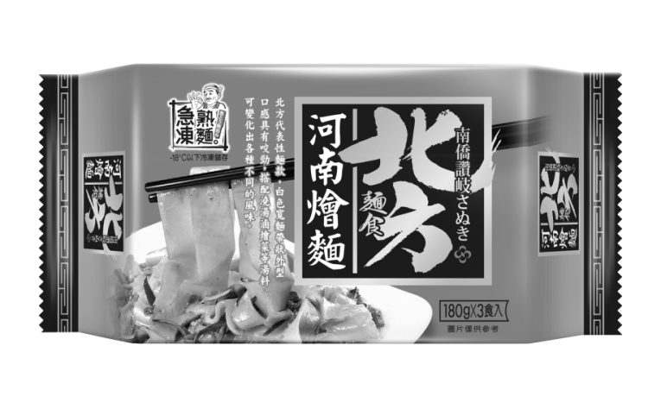

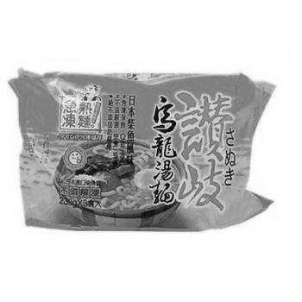

**Packaging for the Commercial Customer**

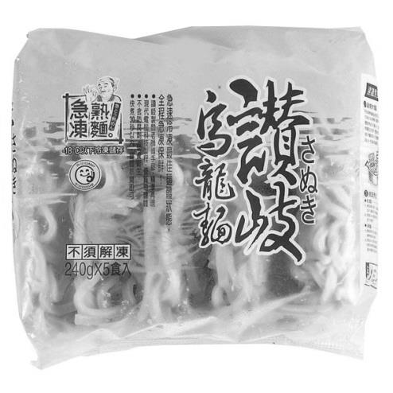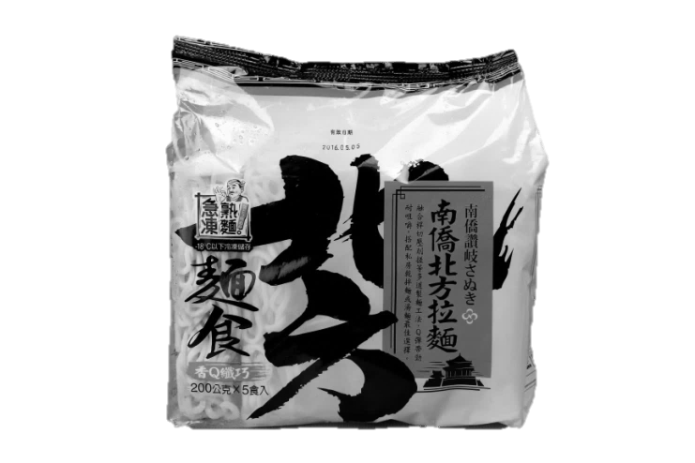

Source: Company documents.

**Exhibit 6: Namchow NOODLE STANDS Featuring THE SANUKI UDON**

**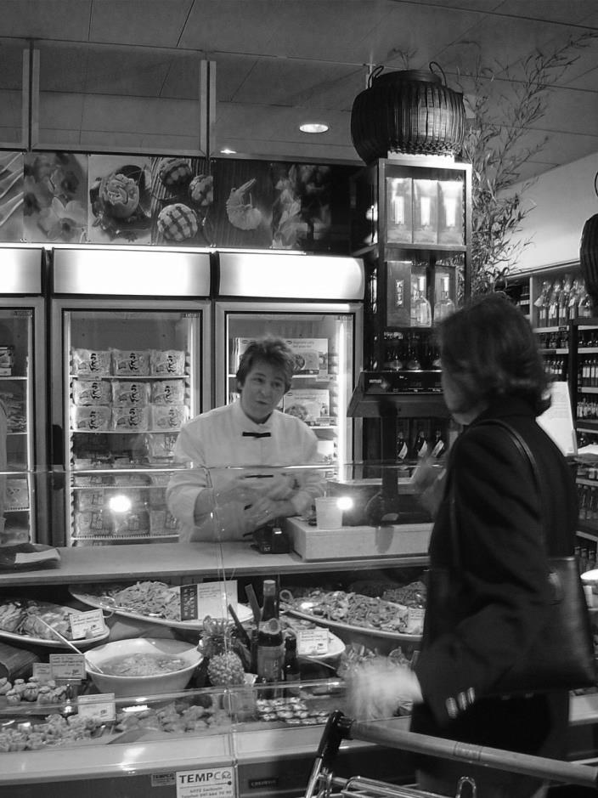**

**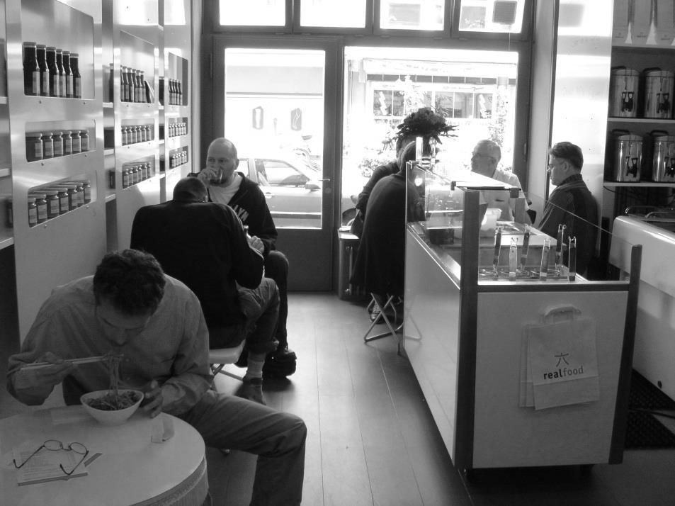**

Source: Company documents.

**EXHIBIT 7: NAMCHOW NOODLE STAND USED IN EUROPE**

**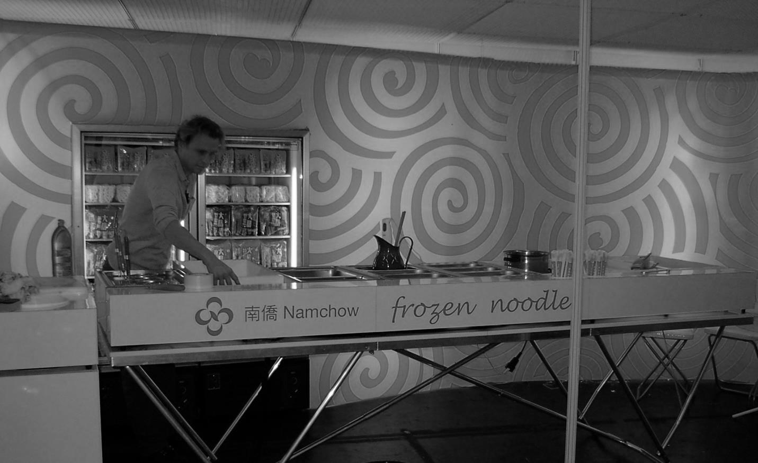**

Source: Company documents.

1. NT$ = new Taiwanese dollar; all currency amounts are in NT$ unless otherwise specified; NT$30 = US$1 on July 17, 2012. [↑](#footnote-ref-1)
2. Agriculture and Agri-Food Canada, International Markets Bureau, *Packaged Food Sales in Japan*, Market Indicator Report, May 2012, accessed November 21, 2017, https://docs.google.com/viewer?url=http%3A%2F%2Fpublications.gc.ca%2Fcolle

   ctions%2Fcollection\_2012%2Fagr%2FA74-1-68-2012-eng.pdf. [↑](#footnote-ref-2)
3. Industrial Technology Information Service, *2013 Taiwan Food Industry Report*, May 25, 2014, accessed November 21, 2017, www.firdi.org.tw/Bulletins\_DownloadDoc.aspx?BulletinDOCID=50000124. [↑](#footnote-ref-3)
4. Chi-Nain Chou and I-Lin Ho, *Industrial Analysis: The Development and Trend of Catering Industry*, Taiwan Trend Research, 2011. [↑](#footnote-ref-4)