

9B18A026

la protectora: Engaging in social media for

a social cause

Daiane Scaraboto wrote this case solely to provide material for class discussion. The author does not intend to illustrate either effective or ineffective handling of a managerial situation. The author may have disguised certain names and other identifying information to protect confidentiality.

*This publication may not be transmitted, photocopied, digitized, or otherwise reproduced in any form or by any means without the permission of the copyright holder. Reproduction of this material is not covered under authorization by any reproduction rights organization. To order copies or request permission to reproduce materials, contact Ivey Publishing, Ivey Business School, Western University, London, Ontario, Canada, N6G 0N1; (t) 519.661.3208; (e)* [*cases@ivey.ca*](mailto:cases@ivey.ca)*;* [*www.iveycases.com*](http://www.iveycases.com)*.*

Copyright © 2018, Ivey Business School Foundation Version: 2018-05-03

Reflecting on his past six months as a marketing manager at La Protectora de la Infancia (La Protectora), Thomas Valéry glanced through the report on the results of the latest fundraising campaign conducted by the non-profit. It was late March 2016, and Valéry was walking toward the main building of La Protectora in Santiago de Chile to meet with general manager, Sergio Olivera.

A non-profit organization, La Protectora had been operating in Chile for 120 years, providing care and education to more than 10,000 vulnerable children. For the past decade, the institution had been professionalizing its management. Valéry’s marketing challenges were to raise funds, increase loyalty among donors, and extend the number of people committed to protecting the country’s most disadvantaged children. The annual fundraising campaign was one of La Protectora’s most visible projects, taking thousands of volunteers to the streets asking for donations. Valéry believed he could use the fundraising campaign as an opportunity to engage volunteers and donors on social media, generating a stronger and more positive image for the institution.

As he walked toward Olivera’s office, Valéry recalled September 2015, when La Protectora partnered with Chilean celebrities who used social media to advertise its annual fundraising campaign. Until that time, 1,500 volunteers collected money donations at stop signs across the country. This was the first time the non-profit had used social media, and even though money donations went up, the overall results had been less than impressive.

Before entering Olivera’s office, Valéry quickly went through his arguments for continuing to make social media a key tool in this year’s fundraising campaign. Valéry felt good about numbers indicating that the latest campaign resulted in more donations than the one prior, but he knew more opportunities lay ahead. Since that campaign also represented La Protectora’s first efforts on social media, Valéry was hoping to convince the general manager and other senior members of the organization that further effort and investment on social media could result in increased donations and awareness for La Protectora.

But even with additional investments, Valéry and his marketing coordinator, Sofía Montero, had a limited amount of knowledge on how to create, plan, and coordinate a social media marketing. Valéry’s first meetings with TV producers to discuss the campaign were in a week, and he had not yet decided whether to keep last year’s hashtag or create a new one for this year’s campaign. He was also not sure about how to establish a connection between the fundraising campaign that happened on the streets and the institution’s social media presence.

Valéry was eager to get La Protectora’s general manager on board with his intention to embrace social media fully, so he could more confidently pursue this path and start making these important decisions.

Organization Background

La Protectora was launched in 1894 with the goal of helping vulnerable children by giving them shelter, food, and basic care. It was founded by eight Chilean women, guided by their Catholicism and motivation to improve the lives of less fortunate Chilean children. Led by Emiliana Subercaseaux and Josefina Gana, the foundation evolved through the following decades to provide children with high- quality education, in addition to food and shelter. When the founders passed away, their daughters and granddaughters continued to run the institution, while occasionally collaborating with some Catholic organizations, so La Protectora was similar to a family business in several aspects.

La Protectora operated across the country, employing around 1,200 people and engaging more than 250 regular volunteers. The organization was divided into three main branches: an educational foundation, kindergartens, and a social area. Under the educational foundation, La Protectora operated one preschool, three elementary schools, and two technical institutes, which comprised almost 4,000 students, in addition to eight kindergartens established in a neighbourhood called La Protectora, which reached more than 1,200 children. Under the social branch of the organization, more than 30 different social programs assisted more than 4,500 children and their families. In these three branches, the institution had been working to improve child and youth care, constantly looking for the best practices that could be implemented in the institution to extend the social impact of its organizational activities.

The Chilean government funded most of La Protectora’s budget. Additional funds came from private donations made by companies and individuals, in a distribution similar to that of most Chilean non-profit and charity organizations’ budgets. The total budget for the organization in 2014 was approximately US$15 million.[1] Conversely, the number of children in need—and the extent of their needs—was increasingly growing, constantly requiring more resources to address them. From the total expenditures of 2014, 89 per cent went directly to education and social programs, and the remaining covered administration and fundraising costs.

La Protectora’s president, Alicia Amunátegui, was a renowned personality in Chile, having run the organization for more than 40 years. In 2016, Amunátegui was elected “Woman of the Year” in an annual award promoted by a Chilean chain of shopping malls in partnership with the non-profit initiative Comunidad Mujer. The non-profit promoted women’s rights and actively contributed to the generation of public policies for greater equality and equity in education, labour, and politics.

Non-Profit Organizations in Chile

Chile’s economy had experienced consistent growth, as was reflected in the supportive behaviour of Chilean people toward social causes and non-profit organizations. The country had been frequently assailed by natural disasters such as earthquakes and tsunamis; hence, the general themes of community building and infrastructure development were important among Chile’s charities. Nevertheless, a large part of Chile’s charitable sector aimed to provide educational opportunities to marginalized communities and vulnerable children. Research indicated that more than 106,000 non-profit organizations were registered in Chile, generating more than 160,000 jobs.[2]

Most of the Chilean population was only aware of those organizations that were actively present in media.[3] One such organization was Fundación Teletón, launched in 1978 by television personality Mario Kreutzberger, commonly known by his stage name, Don Francisco. The annual television event for that organization (in the telethon format) was held in November or December and had been raising money for people living with disabilities for over three decades. All of the country’s major television networks lent their support to the event, which was also supported by an enthusiastic team of local volunteers. In 2015, Fundación Teletón raised more than $52 million for its causes.

Every non-profit or charitable organization formally registered in Chile had the right to conduct one yearly national fundraising campaign. Most organizations took volunteers to the streets of all cities in which it operated. Volunteers were identified with a vest and positioned themselves at stop signs or street corners holding a bag or jar, asking drivers and passersby to contribute with a small donation or pocket change.

Another common practice during fundraising campaigns was to hand out a sticker to each person who made a donation. Stickers were frequently placed on a person’s clothing and served as a social signal that the person had contributed to a charitable cause. La Protectora did just that for the several years preceding Valéry’s arrival at the organization. Yet, as noted by Valéry, “No one sees these stickers, no one cares. They aggregate cost but add no value.”

Consistently, the amount of donations for La Protectora during the fundraising campaign had been steadily falling, and volunteers were lacking in motivation to participate in the yearly event. Reflecting on the potential consequences of lack of motivation among volunteers, Olivera affirmed, “On fundraising days I usually worry, because I see our volunteers on the street corners with their vests and bags, and it is not easy for them; they are clearly doing something they don’t find that attractive. To me, this signals a challenge. These volunteers are ambassadors of La Protectora, and it should not be like this.”

When Valéry analyzed La Protectora’s social media presence, he found that it was very incipient. The organization had a website, a Facebook page counting approximately 3,000 likes, and a Twitter account with around 1,200 followers. Since their inception, these accounts had been casually managed by one of the organization’s employees, without a clear strategy or policy and with no focus on content development. There was little interaction between the organization and its followers or among followers. Moreover, aside from occasional interviews on the radio or TV and free ads offered by newspapers, La Protectora did not consistently appear on traditional media either. The organization had a partnership with Metro de Santiago, the city transit system, for displaying billboards and collecting Christmas gifts for children inside subway stations. However, after bomb attacks were perpetrated inside subway stations in 2014, the collection of gifts had to be cancelled. Hence, the fundraising campaign was the best opportunity La Protectora had to reach a large audience.

Inquiring about this lack of a strategic approach to marketing communications, Valéry found that his predecessor had left the organization two years ago. Since then, the organization had been operating without a marketing manager. The board of directors had concerns about adopting marketing as a tool, as reflected in concerns manifested by Olivera during one his first meetings with Valéry:

We have always had a more serious image, of an institution with a traditional identity. If we go to the media with this identity, won’t we lose control? What if someone starts saying things about La Protectora like “we’ve got to help poor children because they are so unhappy”? We have never thought of our goal as paternalistic; we want to get to know these children and support the development of their potential. So I am a bit afraid that the media will use these appellative headlines to capture attention that doesn’t necessarily represent the meaningful job we do here.

Considering that scenario, Valéry knew that change was in order if La Protectora wanted to create a positive image for itself in Chilean society and connect to potential donors in meaningful and value-creating ways. Valéry thought that trying something different for the fundraising campaign could be a good lever for change, given that concerns with the lack of donations and decrease in employees’ and volunteers’ motivation for fundraising were shared among board members. Montero, the marketing coordinator at La Protectora, noted, “There are other institutions in which their employees are their best volunteers in fundraising. Here, we have not developed this culture, so people are reluctant to go out and ask for money. It takes a lot of effort to cross these internal barriers.”

Those concerns generated disquietude among members of the board of directors and highlighted the need for change. Olivera said, “We know that the annual fundraising campaign is not our main source of funds. It is important, but the money raised represents less than 1 per cent of La Protectora’s income. So it has to support us in other ways.”

Social Media Use in Chile

Analyses of social media use in Chile noted that the country was “one of the most engaged social media markets worldwide, averaging 9.5 hours per day per visitor to social media sites.”[4] Chile was the third most highly penetrated market for Facebook in the world and had the highest rate of broadband connection in Latin America. Chileans loved to take selfies, especially in groups, and while travelling, and they shared those photos on social media, particularly on Facebook, WhatsApp, and Instagram. Their key motivations were to remember a certain moment and share with others something they were doing.[5]

On the business side, a survey of 800 Chilean executives found that 90 per cent of the respondents’ companies had a strategy for digital and social media marketing, and attributed high importance to social media.[6] Moreover, 65 per cent of the surveyed executives planned on increasing investment in social media marketing the following year. Additionally, research conducted at a Chilean university found that 61 per cent of Chilean people considered social media very influential in shaping their opinion about politicians; 58 per cent considered social media influential in determining newsworthy topics; and 48 per cent agreed that social media was important to determine the image of companies and organizations.[7] Clearly, social media had become ubiquitous in Chile, and most organizations considered it a fundamental tool in communicating with its stakeholders.

One of the key challenges for non-profit organizations in employing social media was the trend known as “slacktivism,” whereby people engaged in social media actions that required little involvement with social causes (such as clicking “like” on Facebook or sharing a post), and felt as if they had contributed and made a difference to the cause. This behaviour was related to narcissism, a personality trait that led individuals to crave the admiration of others, and which researchers had found increased with the practice of taking selfies.[8] Critics said that slacktivism only truly benefitted the egos of people participating in it, while offline activities or actions that really mattered were neglected. Conversely, academic research showed that slacktivism could make a difference, and that its power lay in “the network effect created by this engagement,” which made the actions of just a few activists or protesters visible to millions of people, all around the world.[9]

#LetsSmileTogether—The 2015 fundraising campaign

After brainstorming with his team and conducting extensive research on other initiatives by non-profit organizations around the world, Valéry proposed replacing the stickers given to people who contributed to the fundraising campaign with a red plastic clown-like nose. The plan was to take to the streets during the fundraising campaign with volunteers wearing the red plastic noses and distributing 230,000 of these to people, asking donors to photograph themselves wearing the red noses and upload the photos on social media pages using the hashtag #LetsSmileTogether.

With the support of La Protectora’s president, who agreed to take a photo with a red plastic nose and share it with employees and volunteers, Valéry and his team started to motivate employees to participate in the campaign. They had only a month before the fundraiser began and needed everyone’s support. The marketing team distributed the campaign materials internally, and the hesitancy with which many received the news of a change in the fundraising practice soon gave way to excitement.

Simultaneously, to create buzz and encourage participation, the marketing team at La Protectora wrote personal messages to about 30 Chilean television personalities and social media influencers, inviting them to participate in the campaign. The organization did not follow a particular method for selecting these potential partners. It started from the personal networks of members of the organization to reach television personalities, but it did not aim at top Chilean celebrities. Tomás Silva, the account manager who worked closely with Valéry at the development of the campaign, recounted:

They are not uber celebrities, I mean, not the anchor of the morning show, but the commenter. We did have one actor and one actress that are frequently the lead in Chilean soap operas and movies, but they are not the ones that have the most followers on social media. We also picked some influencers from social media that are simply known for their opinion on a topic such as fashion, or sports. These are more micro-celebrities, I guess. They have a more modest number of followers but an audience that really listens to what they say.

Most of the celebrities contacted by La Protectora also responded positively, and a box with several red plastic noses and a thank you letter was sent to them. Several of these personalities uploaded photos of themselves wearing the red nose on the days preceding the fundraising campaign (see Exhibit 1). At the same time, La Protectora’s own social media accounts were publicizing the campaign with the same hashtag.

The attitude among volunteers, employees, and donors during the fundraising campaign in 2015 was markedly different from that of prior years. An employee who collaborated as a fundraiser noted:

The red nose thing . . . it was a really interesting dynamic. People would ask us, why the red nose? And we told them to take a photo with the nose on and share it on social media. . . . A lot of people would indeed take a photo and share it online. Others would give me their phone number so I could send them the photos I took with my phone via WhatsApp.

Soon after the campaign, Valéry and his team prepared a presentation of the results for the board of directors. Positive results included an increase of more than 100 per cent in the amount of funds raised, and more than 21,000 impressions on Twitter during the campaign. The numbers of followers for La Protectora’s Facebook page, Twitter, and (newly created) Instagram accounts also increased (see Exhibit 2).

Upcoming campaign—Opportunities and Challenges

Olivera opened the door to his office and warmly greeted Valéry, introducing him to Gabriela Lima, a pro-bono consultant who volunteered to share her expertise in social media marketing with La Protectora. The three of them sat next to each other facing a table where several documents were displayed: a Gantt chart starting from March 2016 and ending with the planned date for the upcoming fundraising campaign in September 2016; prototypes of visual communication materials for the campaign (see Exhibit 3); a social media plan for the event; and a research report on the campaigns and fundraising activities of other institutions.

Montero had been working on preparing these materials and supporting the marketing team in dealing with one of their main pending challenges: how to strengthen the association between the red clown nose, social media engagement, and La Protectora. In the first fundraising campaign, when the red plastic noses were distributed, many people uploaded photos of themselves wearing the playful object without establishing a connection between that token and the image of the institution. Valéry recalled a comment Montero made earlier that day:

Last year’s campaign was super powerful because the red clown nose was entertaining and fun. But we made a mistake: we did not associate the red nose to La Protectora. We explained it to donors in conversations on the street, as we were fundraising, but that was not enough. There was no clear connection between that element and our brand. We’ve been trying hard to figure it out; we have searched for alternatives but we don’t have anything concrete yet.

The marketing team had considered printing the hashtag for the campaign or the La Protectora logo on the red plastic noses. They also thought of inserting the red plastic noses on a plastic bag that contained more information about the campaign, and even considered switching from a red nose to a multi-coloured version that related to the visual identity of the organization. Yet, pursuing any of those options implied additional costs and the need to work with large manufacturing companies outside Chile.

As Olivera started the conversation, he expressed concerns about the challenge ahead: “So the goal for this year is to strengthen the connection between the fundraising campaign and our brand. Have you got any other ideas on how to do this?” Valéry hesitated for a few seconds before admitting,

All we’ve got is here on this table. We identified that we need to support our fundraising campaign with other forms of communication on traditional and social media throughout the year to develop a long-term relationship with our volunteers, celebrity supporters, and audiences. In this way, we aim to establish a connection that can be easily activated during the fundraising campaign. We have been doing that already, and our numbers of followers have been slowly increasing. In other words, we think that the association between the red nose and La Protectora has to be developed on a long-term, ongoing basis.

Flipping through the pages of the social media plan and glancing at the visual materials that lay on the table, Lima eagerly jumped in:

That is a good idea, but these materials and action plans are not going to make that happen. You don’t need traditional media. Social media offers all the channels you need to engage with your audience. And the materials you have here are too conservative, too uptight, and too cautious. The red plastic nose is ludic, humorous. If you want people to associate La Protectora with that element, *everything* you do on social and traditional media has to be ludic and humorous. If the goal is to use a hashtag such as #LetsSmileTogether, you’ve got to give people content that will make them smile every day, so when time comes to ask them to put on a red nose and be a clown to make children smile, they will know exactly what you are talking about and they will do that for you because you’ve given them so much already. Better than that, you have to let people create content for you—the hashtag has to be theirs to play with.

Olivera shifted uncomfortably in his chair, and Valéry knew that what the consultant was proposing challenged the organizational culture at La Protectora. Moreover, he had seen many social media campaigns go awry worldwide and knew that a hashtag that became too popular could be appropriated for uses other than the ones intended by its creator.

Upon leaving the meeting, Valéry called Silva and Montero, recounted the conversation to them and asked, “I am at a loss here. What do you think? Should we follow our initial plan and use the materials we have or take the plunge and engage in social media full force with a bolder approach as Lima is suggesting?”

The author would like to thank Maria Catalina Torres Giglio, Hans Rosenkranz, and Domingo Errazuriz, all of whom assisted her in the research conducted for this case.

Exhibit 1: CAMPAIGN TWEETS

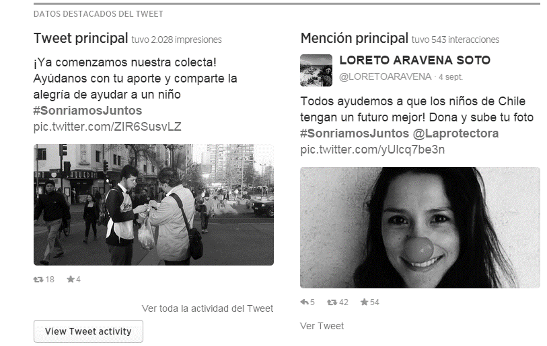

Source: Company documents.

Exhibit 2: social Media Results

|  |  |  |  |
| --- | --- | --- | --- |
|  | **Twitter** | **Facebook** | **Instagram** |
| Prior to fundraising campaign | 1,355 followers | 3,142 likes | (no account) |
| After fundraising campaign | 1,480 followers | 3,652 likes | 94 followers |

Source: Company documents.

Exhibit 3: visual communication materials for fundraising in 2016

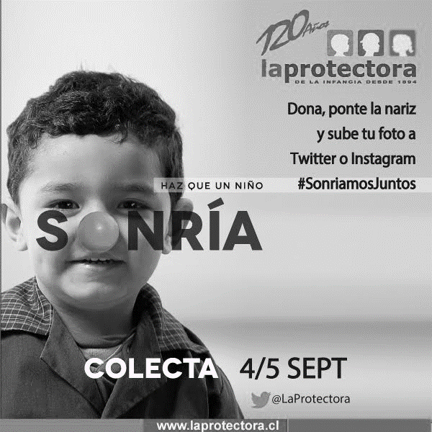

Source: Company documents.

1. All currency is in US dollars unless otherwise stated.
2. I. Irarrázaval, E. Hairel, S. Wojciech Sokolowski, and L. Salamon, *Estudio Comparativo del Sector Sin Fines de Lucro—CHILE* (Baltimore, MD: John Hopkins University—United Nations Development Program, 2006).
3. Patricio C. Cruz and Graciela Z. Zapata, “Diagnóstico del uso de redes sociales a través de un análisis mixto, basado en las recomendaciones de expertos y las experiencias de organizaciones sin fines de lucro” (undergraduate thesis, Pontificia Universidad Católica de Valparaíso, 2015), accessed July 5, 2017, www.ingcomercial.ucv.cl/sitio/assets/tesis/tesis-2015/memoria2015calderonzuiga.pdf.
4. Nell Haynes, *Social Media in Northern Chile* (London, UK: UCL Press, 2016).
5. Daniel Halpern, Sebastián Valenzuela, and James E. Katz, “’Selfie-ists’ or ‘Narci-selfiers’?: A Cross-Lagged Panel Analysis of Selfie Taking and Narcissism,” *Personality and Individual Differences* 97 (2016): 98–101.
6. Jelly-Cadem, *#Inmersión: Diagnóstico de Redes Sociales y Empresas* (2016), accessed July 5, 2017, http://jelly.cl/inmersion.
7. Sebastián Valenzuela, “Unpacking the Use of Social Media for Protest Behavior: The Roles of Information, Opinion Expression, and Activism,” *American Behavioral Scientist* 57, no 7 (2013): 920–942.
8. Halpern, Valenzuela, and Katz, op. cit.
9. Kate Groetzinger, “Slacktivism Is Having a Powerful Real-World Impact, New Research Shows,” Quartz, December 10, 2015, accessed July 5, 2017, https://qz.com/570009/slacktivism-is-having-a-powerful-real-world-impact-new-research-shows.