

9B18A054

CQ Max: Crafting a Product Launch

Servjaeta Verma wrote this case solely to provide material for class discussion. The author does not intend to illustrate either effective or ineffective handling of a managerial situation. The author may have disguised certain names and other identifying information to protect confidentiality.

This publication may not be transmitted, photocopied, digitized or otherwise reproduced in any form or by any means without the permission of the copyright holder. Reproduction of this material is not covered under authorization by any reproduction rights organization. To order copies or request permission to reproduce materials, contact Ivey Publishing, Ivey Business School, Western University, London, Ontario, Canada, N6G 0N1; (t) 519.661.3208; (e) cases@ivey.ca; www.iveycases.com.

Copyright © 2018, Ivey Business School Foundation Version: 2018-08-13

It was the afternoon of March 1, 2017, and a flurry of thoughts ran through the mind of Inderjit Baboota, head of Sales and Marketing at Genspec Lifesciences (Genspec), as he prepared to meet his team to craft the brand launch strategy of CQ Max. Genspec was a health care start-up mainly operating in the oncology (cancer-related) segment, and CQ Max was the first product to be introduced by the organization. Roughly a year ago, when he first thought of foraying into the health care segment, Baboota wanted to introduce innovative products mainly derived from natural sources backed by scientific evidence. After thorough market research, he chose turmeric, which had become very popular in recent years for the treatment and prevention of a variety of clinical conditions, particularly cancer, due to its active ingredient curcumin. The product had a high market potential, but there was no curcumin-based formulation that was readily available in the Indian market, primarily due to its poor solubility and low absorption. CQ Max, a nanocurcumin supplement available in syrup form, was thus conceptualized and pilot tested in the market. Nanocurcumin was a modified form of curcumin, prepared using nanotechnology to increase its solubility and therapeutic efficacy.

During the pilot launch, Baboota was successful in incorporating desired changes into the formulation to enhance its acceptability; now he was strategizing the brand launch of CQ Max. Though there were many challenges ahead, the key decision for Baboota was whether to position CQ Max as a prescription-based product or an over-the-counter product. The health benefits of turmeric for the treatment of cancer were widely known and accepted in India, but the absence of a branded formulation limited its use by doctors. Further, the market for cancer wellness products was relatively underdeveloped in India. Though positioning it as a prescription-based product would establish the credibility of the brand, it would require rigorous efforts for category creation and market education. On the other hand, the recognition of alternative therapies in India for the treatment and prevention of cancer would merit its positioning as an over-the-counter product but would dilute the brand value. Baboota kept this all in mind as he prepared to craft the brand launch strategy of CQ Max.

INDERJIT BABOOTA

Baboota was a pharmacy graduate from the prestigious university Jamia Hamdard in New Delhi. He went on to further his education, obtaining a postgraduate diploma in marketing management. Baboota began his professional career working in various areas including sales and marketing, training, market research, and key accounts management. After 12 years, having gained expertise in different therapeutic domains, he transitioned to the position of marketing and training consultant with various pharmaceutical organizations, where he was instrumental in successfully launching new products and suggesting various strategic initiatives. He also conducted training sessions for pharmaceutical personnel across India and Southeast Asia. Apart from this, Baboota also published various scientific papers and was on the editorial panel of various reputed pharmaceutical magazines. After more than 25 years in the pharmaceutical industry, Baboota became an entrepreneur and launched Genspec.

DEMAND FOR SUPPLEMENTAL THERAPIES

During his association with key stakeholders, Baboota had observed that ever-changing disease patterns had become an ongoing challenge for health care professionals, and it had thus become necessary to introduce supplemental therapies for facilitating better clinical outcomes. Some of the innovative products he had launched as part of his consultancy assignments for different pharmaceutical organizations had been highly successful in the market. Sensing an opportunity in the aforementioned domain, Baboota thought of introducing a portfolio of innovative and scientifically proven products into the Indian market. Baboota said, “I had gradually seen a paradigm shift towards alternative and natural therapies even in the treatment of chronic diseases. I wanted to integrate the traditional knowledge with [the] requirements of contemporary treatment procedures of the modern day.” This led to the conceptualization of Genspec.

the COMPANY

Headquartered in Delhi, Genspec was registered in December 2016 by Baboota. It was India’s first highly specialized health care start-up in the cancer wellness segment. The company began its operation with a robust team of 12 people. There were 10 key account managers responsible for sales, supported by one logistics executive and one administrative professional. Every professional at Genspec was an expert in his or her own field, contributing to the fulfillment of the Genspec vision, which revolved around three Ps: patient, prescriber, and product. The team of professionals at Genspec possessed rich working experience in the health care sector; these individuals had been associated with leading pharmaceutical companies in various capacities during their previous assignments.

By the time the company was officially registered, the first batch of CQ Max had already been pilot tested in the market. The company began its operation in select cities—Delhi, Mumbai, Ludhiana, and Guwahati. With the motto of adding a “Quality number of years to life,” the product portfolio aimed to augment treatment outcomes and improve the quality of life of patients.

CANCER STATISTICS and EMERGING SUPPORTIVE CARE MARKET

Cancer was prevalent in India, and cases of it were increasing at an alarming rate. As per recent statistics, an estimated 2.5 million people were living with the disease, and over 700,000 new patients were diagnosed every year. Cancer was the second most common cause of death in India after cardiovascular diseases, causing approximately 570,000 deaths every year. It was estimated that one woman died of cervical cancer every eight minutes in India, the primary reasons being low awareness and late detection. Products related to cancer treatment and wellness represented a sizeable market opportunity in India. Though there were many substances used for the treatment of various types of cancer, there were a negligible amount of products available for cancer wellness.[1]

Various advancements in the treatment of cancer had resulted in increased life expectancy, yet there were many challenges associated with these. Whereas toxicity and morbidity were major hurdles a patient encountered during chemotherapy or radiotherapy, other associated side effects often led to relapse. Further, there had been no significant decrease in the mortality rate of patients, and the number of years that a person suffered from cancer still remained high. Because of this, the oncology drug market had witnessed a shift from chemotherapy treatment to alternative therapies, with rising demand for supportive care products.[2]

The cancer supportive care product market consisted of products that were intended to prevent or treat the symptoms of cancer along with reducing the overall side effects of cancer treatment. The emphasis of such products was on improving the overall quality of a patient’s life. By the end of 2015, the global market for cancer supportive care products was estimated at US$24.6 billion.[3] Over the last two years, 21 new molecules had been introduced by different manufacturers. Since the cancer supportive care product market was relatively new, manufacturers were continuously researching better molecules that could be effective in that segment for the treatment of clinical conditions. With a rise in the number of cancer cases, demand for safe and effective cancer supportive care drugs was also expected to rise.[4]

In India, natural therapy was recognized and advocated by many doctors as supplemental therapy to improve treatment outcomes. Though the market for such cancer wellness products was not fully established, it offered immense potential.

HEALTH BENEFITS OF TURMERIC

Of the many naturally derived products with an established role in the treatment of cancer or of associated side effects, turmeric was considered the most potent. With a plethora of health benefits to offer, turmeric had been used in India for more than 4,000 years. It was a widely used and well-established natural product with various scientifically proven efficacies and a high safety profile. It was a natural antidepressant and painkiller and had a proven role in boosting digestion and treating various skin conditions. It was indicated in the treatment of conditions such as Alzheimer’s disease, Parkinson’s disease, stroke, major depression, oxidative stress, and bone and joint diseases. Various scientific studies, mostly originating in the United States, India, Europe, and Australia, backed its role in the management of cancer and in protecting against the progression of the disease. Moreover, due to its health benefits, turmeric had lately been gaining popularity in the West.[5]

The benefits of turmeric were due to its active ingredient, curcumin, which constituted only 2–5 per cent of the total compound. The characteristic colour and odour of turmeric, its anti-inflammatory properties, and its therapeutic benefits were due to curcumin. However, curcumin had poor solubility, minimal absorption, and was expelled from the body quickly, thus reducing its treatment efficacy. Moreover, high concentrations of curcumin were required in the treatment of various chronic disorders.[6]

CURCUMIN FORMULATION

Although a curcumin formulation could improve treatment outcomes, it was difficult to prepare it commercially due to its poor solubility. Various methods were tested by a variety of players to increase its solubility, absorption, and, consequently its therapeutic benefits. Nanotechnology was found to be the most effective one. Nanotechnology was the science of manipulating materials on an atomic or molecular scale in order to create materials with remarkably enhanced properties.

Along the same lines, Baboota conceptualized the launch of CQ Max, a nanocurcumin formulation that had the potential to revolutionize the health care industry. It was India’s first commercially available nanocurcumin formulation. The pilot launch of the product was done by targeting key opinion leaders; the product proved to have high therapeutic usage in cancer treatment.

CQ MAX PRODUCT INFORMATION

CQ Max was a nanocurcumin formulation that was prepared using nanotechnology. The maximum retail price of CQ Max was ₹2,500[7] for a 100-millilitre (ml) bottle. Available in syrup form, it had 125 milligrams of active curcumin per 5 ml. The recommended dosage was 5 ml, which was to be taken with 100 ml of water 30 minutes after a meal. Depending on the severity of symptoms, its usage was recommended once or twice a day.

The use of nanotechnology in the preparation of CQ Max was the key to enhancing the health benefits associated with the core ingredient. Nanotechnology not only made curcumin 100 per cent water soluble and bioavailable (the proportion of a drug available in the body after absorption for active effect) but also improved curcumin’s therapeutic efficacy. Nanotechnology ensured high serum levels of curcumin along with improved anticancer effects compared to conventionally prepared curcumin.

CQ Max was suggested in the improved management of cancer as an adjunct to chemotherapy and radiotherapy. Several studies suggested curcumin had potential in preventing the growth of cancer, protecting the body from various adverse effects of cancer, and offsetting the side effects associated with chemotherapy or radiotherapy.[8] CQ Max also played a role in overcoming fatigue, boosting immunity, treating depression, and improving digestion (see Exhibit 1).

PILOT LAUNCH OF CQ MAX

Baboota was confident about the efficacy of the product and was aware of the psychology of Indian patients, who had great trust in natural therapies for curing chronic diseases. His aim was to integrate the benefits of a natural product into modern medicine by targeting specialty doctors. Having worked in the pharmaceutical industry for more than 25 years, Baboota was familiar with industry dynamics, which gave him an edge in convincing oncologists to pilot test CQ Max on cancer patients who were in different stages of the disease. The first batch of the formulation was pilot tested in the market in September 2016.

Strategizing the Pilot Launch—The Blue Ocean Strategy

Baboota had an innovative product at hand, but his first task was to position the product in the saturated cancer treatment segment during the pilot launch. He was aware that cancer treatment options were varied and targeted different stages of cancer. Moreover, various new molecules had been discovered, each vying to establish their relevance over the other. Most of the leading brands were from multinational companies that spent heavily on promoting their products. With Genspec being a health care start-up with a relatively low promotional budget, Baboota knew it would be difficult to compete in this space. Moreover, convincing treatment providers to use a product for chronic therapy that was derived from a plant-based extract was a challenge.

On the other hand, the segment had witnessed a paradigm shift in recent years towards alternative therapies that focused on improving the quality of life of patients. The cancer wellness segment was in an emerging phase in India, and there were no established players in the segment. Baboota decided to position CQ Max in the wellness segment as an adjunct to primary cancer treatment options. This was an important strategic move for Baboota, as operating in this way made the existing competition redundant for him.

Challenges during the Pilot Launch

The first challenge was the manufacturing of the raw material and subsequent syrup formulation, as the product had poor solubility. This was overcome using nanotechnology, which required significant investment in technology and the manufacturing process.

The first batch of the formulation did not receive the desired positive feedback, owing to the bitter taste of the active ingredient. The second challenge was therefore to enhance the palatability of the product so it could be well received by patients. After four months of experimentation with various flavours, CQ Max was reintroduced in January 2017 in a nano-mango flavour that made it highly palatable.

Another challenge was to arrive at the right price, since no similar formulation existed in the Indian market. After thorough market research, a competitive price of $37.25 for a 100 ml bottle was set.

CRAFTING THE BRAND LAUNCH

After overcoming the hurdles faced during the pilot launch, Baboota wanted to launch the brand officially on April 1, 2017. He called for his core team to meet on March 1, 2017, to strategize the launch. Before doing so, the following points were taken into consideration.

Selecting the Target Segment

If CQ Max was targeted at oncologists, Baboota could make the product available in leading corporate hospitals, which had full-fledged departments for the treatment of cancer. With an innovative product, Baboota could easily leverage the first-mover advantage. Moreover, being prescribed by oncologists would allow the brand to gain the required credibility for its therapeutic benefits and to become established in the emerging cancer wellness market in India.

As alternative therapy was trusted and recognized by the masses in India, the second option was to target it directly at cancer patients. This would broaden the scope of brand penetration but would also require significant investment in product advertising to the target consumers. Moreover, targeting the product directly at the consumers in the early stage would dilute the brand value of the product.

Other Factors to Consider

*Category creation*: The cancer supportive care market was in an emerging phase in India and not well-established. Category creation was therefore one of the biggest challenges foreseen in the establishment of the product.

*Challenges of a new product*: Since CQ Max was new to India, the major challenge was to create awareness about the product and educate the target markets about the benefits and usage of the product. Furthermore, since no similar product was available, there was uncertainty about potential sales volume.

*Challenge of meeting break-even*: Since Genspec was an emerging health care start-up with a significant investment in technology, meeting break-even for the brand was the company’s utmost priority. Limited resources had made it difficult for Genspec to spend heavily on the initial promotion of the brand.

*Highly trained and skilled employees*: Owing to the scientific nature of the product, a high degree of technical competence was required in the sales team. Moreover, thorough product training for the sales team would be necessary to ensure flawless communication and significant query resolution about the brand to the target customers.

*Field-force expansion*: To make the brand accessible to target customers within the selected segment, field-force expansion would have to be carried out.

*Product positioning*: It was necessary to arrive at a product positioning carefully in order to establish a benchmark.

the WAY forward

The core team at Genspec brainstormed about aspects of the brand launch during their meeting on March 1, 2017. Though the market was witnessing a paradigm shift in cancer treatment options and there was a huge marketing opportunity in emerging supportive care treatment, many challenges lay ahead. Being new to the Indian market, Baboota could leverage the first-mover advantage with CQ Max, but the upcoming challenges would be to educate the market, create an engaging brand, and position it in a way that would resonate well with the target customers. The team needed to finalize elements of the launch strategy.

Exhibit 1: Promotional input used during pilot launch

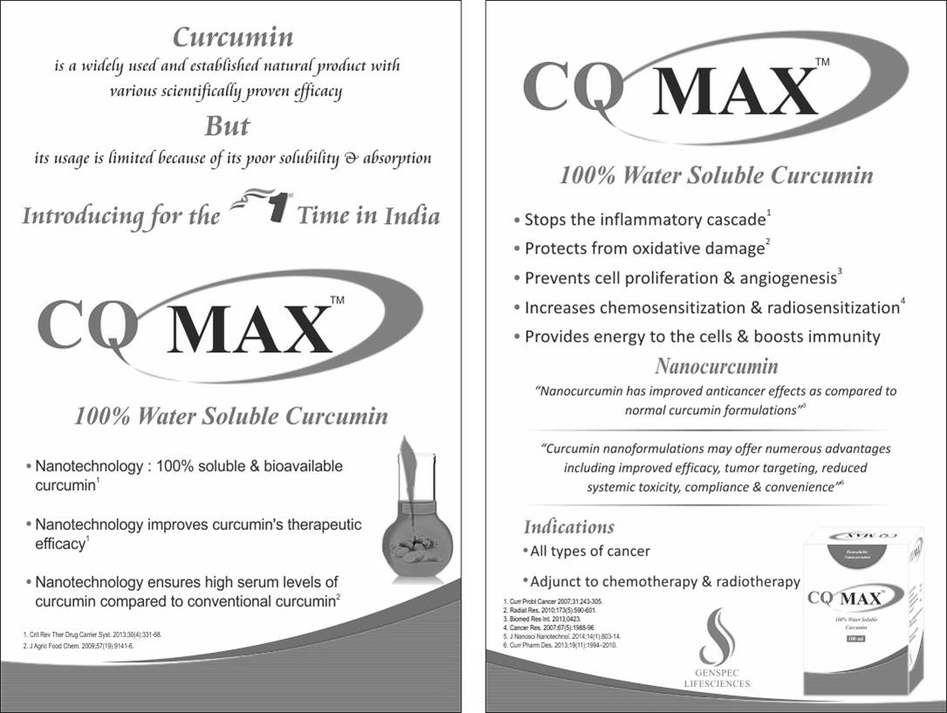

Source: Company documents.

1. National Institute of Cancer Prevention and Research, “Statistics,” Cancer India, accessed April 9, 2018, http://cancerindia.org.in/statistics/; Sushmi Dey, “India Now Has 3rd Highest Number of Cancer Cases among Women,” *The Times of India*, September 24, 2017, accessed April 9, 2018, https://timesofindia.indiatimes.com/india/india-now-has-3rd-highest-number-of-cancer-cases-among-women/articleshow/60812041.cms.
2. Persistence Market Research, *Global Market Study on Cancer Supportive Care Products: Lung Cancer to Become Second Largest Disease Indication by 2021*, March 2018, accessed April 9, 2018, <https://www.persistencemarketresearch.com/market-research/cancer-supportive-care-products-market.asp>.
3. All amounts are in U.S. dollars unless otherwise specified.
4. Persistence Market Research, op. cit.
5. Natalia G. Vallianou, Angelos Evangelopoulos, Nikos Schizas, and Christos Kazazis, “Potential Anticancer Properties and Mechanisms of Action of Curcumin,” *Anticancer Research* 35, no. 2 (2015): 645–651.
6. Ty Bollinger, “The Amazing Cancer-Fighting Benefits of Curcumin,” The Truth About Cancer, March 27, 2018, accessed April 10, 2018, https://thetruthaboutcancer.com/cancer-fighting-benefits-of-curcumin/.
7. ₹ = INR = Indian rupee; US$1 = ₹64.82 on March 31, 2017.
8. Muthu K. Shanmugam, Grishma Rane, Madhu Mathi Kanchi, Frank Arfuso, Arunachalam Chinnathambi, M. E. Zayed, Sulaiman Ali Alharbi, Benny K. H. Tan, Alan Prem Kumar, and Gautam Sethi, “The Multifaceted Role of Curcumin in Cancer Prevention and Treatment,” *Molecules* 20, no. 2 (2015): 2728–2769; Matthew C. Fadus, Cecilia Lau, Jai Bikhchandani, and Henry T. Lynch, “Curcumin: An Age-Old Anti-inflammatory and Anti-neoplastic Agent,” *Journal of Traditional and Complementary Medicine* 7, no. 3 (2017): 339–346; Jayaraj Ravindran, Sahdeo Prasad, and Bharat B. Aggarwal, “Curcumin and Cancer Cells: How Many Ways Can Curry Kill Tumor Cells Selectively?,” *The AAPS Journal* 11, no. 3 (2009): 495–510; Gagan Flora, Deepesh Gupta, and Archana Tiwari, “Nanocurcumin: A Promising Therapeutic Advancement over Native Curcumin,” *Critical Reviews™ in Therapeutic Drug Carrier Systems* 30, no. 4 (2013).