 

9B18A060

FARM HARVEST: A DISTRIBUTION DILEMMA

Semila Fernandes, Pooja Gupta, and Vidyasagar A. wrote this case solely to provide material for class discussion. The authors do not intend to illustrate either effective or ineffective handling of a managerial situation. The authors may have disguised certain names and other identifying information to protect confidentiality.

*This publication may not be transmitted, photocopied, digitized, or otherwise reproduced in any form or by any means without the permission of the copyright holder. Reproduction of this material is not covered under authorization by any reproduction rights organization. To order copies or request permission to reproduce materials, contact Ivey Publishing, Ivey Business School, Western University, London, Ontario, Canada, N6G 0N1; (t) 519.661.3208; (e) cases@ivey.ca; www.iveycases.com.*

Copyright © 2018, Ivey Business School Foundation Version: 2018-11-13

The morning of April 24, 2017, was bright and sunny, but the mood of Rajesh Kumar, managing director of Farm Harvest Pvt. Ltd. (Farm Harvest), was far from sunny as he entered his office that day. Rajesh needed to hold an emergency meeting with his core team concerning distribution problems within Farm Harvest, which produced and marketed fresh corn and ready-to-eat (RTE) corn products. Sathish Kalaimani, head of sales for the company, was the first person to walk into the boardroom.

“Good morning, chief,” he said to Rajesh. “What happened? I thought we were meeting at 12:00 p.m.”

“I wanted to meet the core team right now. Let’s wait for others to join us and then I will explain,” Rajesh said. It was then that the other two members of the core team—Selva Kumar, the marketing manager, and Raghavendra Rao, the finance manager—walked into the board room.

“Gentlemen, I wanted to meet all of you right now to discuss an urgent matter,” Rajesh said. He went on:

Yesterday, I went with my family to a mall to watch a movie. During the intermission, we went to the refreshment stall to get sweet corn and realized that Farm Harvest RTE packs were not available, whereas the RTE packs of other competing brands were prominently displayed. The stall owner complained that there was no stock of Farm Harvest products and that the distributor had not contacted them for two weeks. On further enquiry, I learned that this stock-out situation happens on a regular basis, at least three to four times a month. I then checked up on the kiosk and it was the same story all over again. What is happening?

Rajesh passed folders around the table to all three team members. “Look at our sales figures. I compiled the sales, category-wise, for the last six years.” He pointed out the three tables in the report marked Fresh Corn Sales, Ready-to-Eat Sales, and Kiosk Sales (see Exhibit 1-3). “The tables tell us, in black and white, the truth—that our sales are falling.” Rajesh continued, “Going by my experience yesterday, a large part of our sales dip seems to be coming from non-availability of our product in the market. I want to get to the bottom of this,” he said. “I want you all to find out where the gap is in our distribution model and what the alternatives available to us are. Let’s meet again in the evening.”

SWEET CORN PRODUCTION IN INDIA[1]

Sweet corn, a variation of the maize crop, was a specialty crop in which the sweetness of the corn was enhanced due to a particular gene. Maize was an important cereal of India and was grown on over 4 per cent of the country’s total cultivable area. The country produced 1.7 million tons in 1950–51, rising to 19.6 million tons in 2014–15. There had been large variations in the production of maize in India since the country’s independence in 1947. Over the last 10 years, sweet corn had been the fastest-growing maize crop in India, showing an output growth of 56 per cent in that period.[2]

BEGINNING OF FARM HARVEST

Rajesh had recognized the potential in cultivating and marketing fresh corn in India while talking to the farmers in his town. Those conversations had prompted Rajesh to consider getting into the corn business. He was from a strong farming background, had earned a degree in management, and had big entrepreneurial dreams.

Rajesh decided to find the best places in the world for growing sweet corn. He focused on Iowa, in the United States, because it had been designated as the king of corn for the last two decades. In an average year, the state of Iowa produced more corn than most countries did.[3] Rajesh set out for Iowa to find the best sweet corn farmers in the world and learn their trade. As soon as he returned from Iowa, he bought five acres of land and embarked on his new venture, setting up a sweet corn cultivation and distribution business.

Farm Harvest was established in 2010. It started producing and processing top-quality sweet corn through a close-knit community of farmers. The company tapped the existing distribution network for fast moving consumer goods and, in a phased manner, launched the product in 10 cities in South India over a period of five years.

Over the years, the company had been selling fresh sweet corn to consumers across the southern part of India. By 2016, the company was cultivating sweet corn on over 120 acres through co-operative farming. It had also forayed into export markets after 2014.

The company’s cutting-edge manufacturing facility ensured fresh produce was processed in a clean and hygienic environment. By using the latest Japanese retort technology with temperature control, the packaged sweet corn stayed fresh for a period of six months without any added preservatives.

FARM HARVEST DISTRIBUTION STRATEGY

Right from the beginning, Rajesh had realized that in order to be successful, Farm Harvest had to cater to various kinds of customers. There were customers who liked to purchase from a retail outlet and would take the sweet corn home for further processing. Some customers liked to eat at the place of purchase. Apart from these, many small retailers from neighbouring areas liked to buy multiple packs and resell the packs in their local neighbourhood. Farm Harvest classified this line of business as RTE sales. The other line of business was supplying sweet corn at shopping malls and movie halls through staffed kiosks. Farm Harvest had a clearly defined table that showed the breakdown of the price and commission at various points in the distribution channel (see Exhibit 4).

The biggest challenge faced by the company in its initial years was establishing a distribution network for its products. The company categorized trade sales under three different heads: fresh corn sales, RTE packaged products, and vending kiosk supplies. It grouped the distribution of bulk sales to small vendors, RTE packaged stock keeping units, and vending kiosks requirements into trade, and appointed distributors who would cater to these.

The company operated with two to three distributors in each of the cities where it had a presence. The distributors were responsible for supplying the requirements of the small vendors (fresh corn) to the neighbouring traders, and the network of retailers in the city of operation.

The dilemma

Later the same day, at 4:00 p.m., Rajesh and his core team assembled again in the boardroom. Rajesh started the meeting:

Gentlemen, I hope you all have come up with some answers. Total sales have dipped again this year. This is on top of a drop of 12 per cent from the previous year. We seem to have dropped across all the categories in all cities, for the second year in a row. So, last year was not an aberration as some of you have mentioned. There seems to be a problem here.

“We had stressed the importance of RTE products with the distributors, which is why that segment has a drop of just 4 per cent compared to 13 per cent the previous period,” Selva responded.

“But consider the drop of 9 per cent in the fresh corn category and the whopping 13 per cent drop in the vending kiosk category,” retorted Rajesh.

“I think the distributor is trading off the effort on one category against the other. If we stress one category, the distributor focuses on that, since there are incentives, and ignores the others,” Raghavendra remarked.

“Have you looked into the retail distribution figures for 2016?” Rajesh asked the sales manager, Sathish. “There seems to be a huge skew toward the large retailers, and that could be a cause for concern. We did realize in the beginning that RTE sales had to follow extensive distribution while vending machines would be selective in nature. However, looking at the sales in various outlet types, this is not borne out!”

“The distributors are not keen on visiting smaller outlets because the returns from RTE sales do not work out for them, in terms of costs. They are very reluctant to deploy additional personnel. Consequently, several outlets face a stock-out situation at times,” replied Sathish [see Exhibits 5-8].

“In fact,” Sathish added, “most distributors say that the markup of 9 per cent is inadequate to cover the costs of the distribution of RTE products. Instead they are quite happy with the bulk sales of the fresh corn even though the margins are at 5 per cent. The customers in the fresh corn category actually come to the distributors’ premises to pick up stock and thus the distributor incurs no costs whatsoever.”

“Looking back, the primary reason we gave RTE and kiosk business [see Exhibit 9] to the fresh corn wholesalers was because of the low expected sales in RTE and kiosks. This was mainly to give us a foothold in the retail market,” Rajesh pointed out.

“Agreed,” chorused Selva and Raghavendra.

“Some of the distributors have reduced the number of sales representatives for our products in order to cut costs, and that has led to a drop in our kiosk sales, which now don’t get replenished on time—this despite the fact that kiosk sales give a markup of almost 35 per cent on the distributor landed price,” said Selva. To emphasize his point, he distributed to everyone copies of monthly outstanding, monthly stock, and monthly credit reports (see Exhibits 10, 11, and 12).

“Have you considered other alternatives for distribution?” asked Rajesh.

Raghavendra replied, “We did work on several combinations, and there seems to be another alternative. One such alternative is to consider separating the RTE and vending business from the distributors and leaving the distributors to only focus on the fresh corn business.”

“Are you saying that we should appoint a new set of distributors for the RTE and vending business? Is that viable?” enquired Rajesh.

“Actually, we were looking at whether we should manage this new channel directly, at least in some of the key towns,” said Selva.

“What do you think will be the reaction of the current set of distributors, if we do that?” asked Rajesh.

“I have a feeling that they will not have a major problem—not in the major cities. They have been complaining about low margins on the RTE line for quite some time now. After all, they were originally wholesalers of commodities, and we were the ones who asked them to take up the distribution of the RTE line of products,” replied Sathish.

Rajesh asked, “Have you looked at all the logistics issues?”

Raghavendra replied, “Yes, we have prepared a list of the costs that we will incur once we make this change for the three major cities—Chennai, Coimbatore, and Salem.[4] After all, in the other cities, we haven’t established ourselves.”

Sathish interjected:

Today, we offer a credit period of 15 days to the distributors and insist that they carry a month’s stock at all times. We also expect them to extend a 30-day credit period to the retailers. The distributors claim that they are using their overdraft option with the bank, which then charges them an interest of 12 per cent per year. If we were to manage the channel ourselves, we save on the distributor-related costs, which would offset some of the additional costs. Also, we should expect an increase in sales by at least 35 per cent in each of these cities, with proper coverage and no stock-outs.

Raghavendra added:

We will have to employ our own sales representatives in these cities. Today, we are subsidizing 50 per cent of two sales representatives’ salaries. This would mean additional expenses at each of the cities. The salary would be roughly ₹14,000[5] per person per month including local travel. The fuel costs incurred would be ₹9,000 per month, the rent around ₹3,000 per month, and miscellaneous expenses would be ₹2,000 per month. Apart from all these, there will be the kiosk costs. I have taken these cost estimates from the average costs incurred by our distributors.

“This sounds like a good plan. For now, let us go ahead with this line of thinking. Instead of renting warehouse space in the city, we will continue with carrying and forwarding agents, and have a contract with a transporter for delivery,” posed Rajesh.

He continued, “Gentlemen, I want you all to look at the feasibility of this alternative. Let us meet at the end of the week to discuss the viability of this option.”

Exhibit 1: farm harvest Annual Sales, Fresh corn (in ₹ Thousands)

|  |  |  |  |  |  |  |
| --- | --- | --- | --- | --- | --- | --- |
| **City** | **2011** | **2012** | **2013** | **2014** | **2015** | **2016** |
| Chennai | 102.48 | 94.12 | 86.44 | 91.95 | 71.45 | 58.85 |
| Coimbatore | 97.18 | 92.89 | 82.80 | 88.47 | 65.68 | 52.11 |
| Salem | 96.23 | 89.97 | 78.15 | 85.23 | 63.66 | 51.31 |
| Tiruchy | 10.50 | 11.36 | 12.07 | 13.63 | 13.64 | 13.98 |
| Madurai | 10.28 | 12.97 | 13.80 | 13.98 | 13.48 | 12.08 |
| Kochi | 7.33 | 8.00 | 9.48 | 11.21 | 12.12 | 14.35 |
| Trivandrum | 0.00 | 2.67 | 3.56 | 9.65 | 11.77 | 14.27 |
| Pallakad | 0.00 | 0.00 | 1.70 | 7.10 | 8.01 | 9.81 |
| Trichur | 0.00 | 0.00 | 0.00 | 6.80 | 7.43 | 9.44 |
| Bengaluru | 0.00 | 0.00 | 0.00 | 7.98 | 8.76 | 15.81 |
| **Total** | **324.00** | **312.00** | **288.00** | **336.00** | **276.00** | **252.00** |

Source: Company documents.

Exhibit 2: farm harvest Annual Sales, Ready-To-Eat (in ₹ Thousands)

|  |  |  |  |  |  |  |
| --- | --- | --- | --- | --- | --- | --- |
| **City** | **2011** | **2012** | **2013** | **2014** | **2015** | **2016** |
| Chennai | 33.02 | 32.43 | 34.77 | 32.26 | 25.90 | 23.79 |
| Coimbatore | 31.31 | 33.99 | 33.37 | 30.70 | 23.30 | 21.07 |
| Salem | 30.52 | 32.97 | 31.57 | 30.20 | 24.14 | 20.74 |
| Tiruchy | 3.71 | 5.52 | 5.96 | 6.10 | 5.63 | 5.65 |
| Madurai | 3.31 | 4.72 | 5.75 | 5.60 | 4.95 | 4.88 |
| Kochi | 2.52 | 2.92 | 5.20 | 5.21 | 5.26 | 5.80 |
| Trivandrum | 0.00 | 0.97 | 2.25 | 4.51 | 5.29 | 5.77 |
| Pallakad | 0.00 | 0.00 | 1.13 | 3.09 | 3.42 | 3.97 |
| Trichur | 0.00 | 0.00 | 0.00 | 2.70 | 3.62 | 3.82 |
| Bengaluru | 0.00 | 0.00 | 0.00 | 2.87 | 4.47 | 6.39 |
| **Total** | **104.40** | **113.52** | **120.00** | **123.24** | **105.96** | **101.88** |

Source: Company documents

Exhibit 3: farm harvest Annual Sales, KioskS (in ₹ Thousands)

|  |  |  |  |  |  |  |
| --- | --- | --- | --- | --- | --- | --- |
| **City** | **2011** | **2012** | **2013** | **2014** | **2015** | **2016** |
| Chennai | 15.22 | 11.33 | 15.95 | 14.75 | 12.57 | 13.84 |
| Coimbatore | 14.43 | 14.96 | 15.47 | 13.07 | 9.90 | 12.26 |
| Salem | 12.57 | 14.94 | 14.84 | 14.65 | 14.68 | 12.07 |
| Tiruchy | 2.71 | 5.80 | 5.49 | 6.55 | 4.61 | 3.29 |
| Madurai | 1.53 | 2.11 | 3.13 | 4.54 | 2.57 | 2.84 |
| Kochi | 1.67 | 1.31 | 5.84 | 6.02 | 4.94 | 3.37 |
| Trivandrum | 0.00 | 0.44 | 3.07 | 5.28 | 5.38 | 3.36 |
| Pallakad | 0.00 | 0.00 | 1.61 | 3.13 | 3.09 | 2.31 |
| Trichur | 0.00 | 0.00 | 0.00 | 2.14 | 4.31 | 2.22 |
| Bengaluru | 0.00 | 0.00 | 0.00 | 1.51 | 5.73 | 3.72 |
| **Total** | **48.12** | **50.88** | **65.40** | **71.64** | **67.80** | **59.28** |

Source: Company documents.

Exhibit 4: farm harvest Stock keeping units and Price List

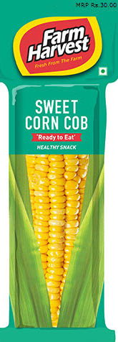 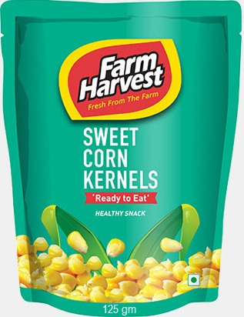

Ready-to-Eat (RTE) Single Cob RTE Sweet Corn Kernel, 125 g

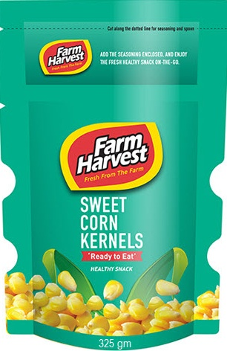 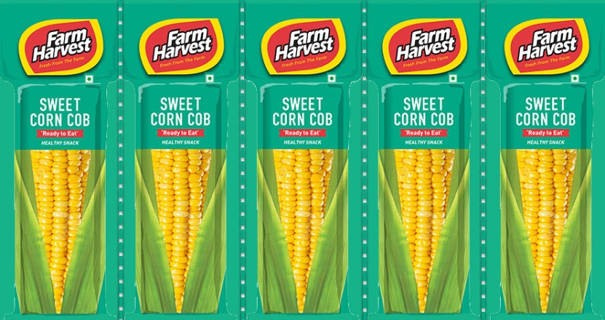

RTE Sweet Corn Kernel, 325 g RTE Bulk-Pack Cobs (5 per pack)

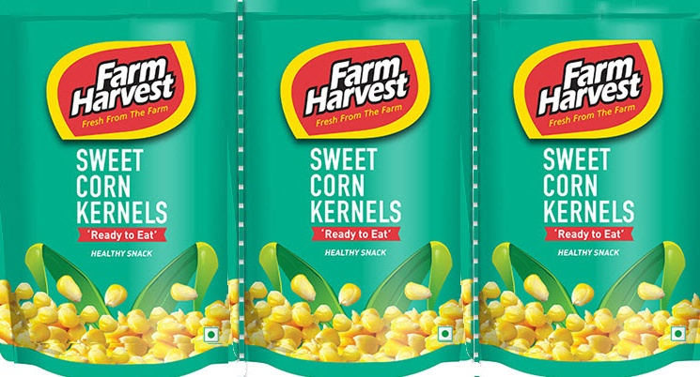

RTE Bulk-Pack Kernels (3 per pack)

EXHIBIT 4 (CONTINUED)

 

Kiosk Pack Fresh Corn

|  |  |  |  |  |  |
| --- | --- | --- | --- | --- | --- |
| **Price List (in ₹)** | **RTE Single Cob** | **RTE Kernel** | **RTE Kernel** | **RTE Bulk Pack Cobs** | **RTE Bulk Pack Kernels** |
| **1 per pack** | **1 per 125 g pack** | **1 per 325 g pack** | **5 per pack** | **3 per pack** |
| Ex-factory Price | 20.94 | 41.89 | 76.80 | 97.74 | 118.68 |
| CFA Commission @ 2.5% | 0.52 | 1.05 | 1.92 | 2.44 | 2.97 |
| Distributor Landed Price | 21.47 | 42.94 | 78.72 | 100.18 | 121.65 |
| Distributor Markup @ 7% | 1.93 | 3.86 | 7.08 | 9.02 | 10.95 |
| Retailer Landed Price | 23.40 | 46.80 | 85.80 | 109.20 | 132.60 |
| Retailer Margin | 6.60 | 13.20 | 24.20 | 30.80 | 37.40 |
| Final Maximum Selling Price | 30.00 | 60.00 | 110.00 | 140.00 | 170.00 |

|  |  |  |
| --- | --- | --- |
| **Bulk Sales Price List (in ₹)** | **Kiosk Pack** | **Fresh Corn** |
| 540 g | 200 cobs |
| Ex-factory Price | 149.22 | 1,756.51 |
| CFA Commission @1.5% | 2.24 | 26.35 |
| Distributor Landed Price | 151.46 | 1,782.86 |
| Distributor Markup | 35% | 5% |
| Distributor Markup Amount | 53.01 | 89.14 |
| Retailer Landed Price | 0.00 | 1,872.00 |
| Retailer Margin | 0.00 | 528.00 |
| Final Maximum Selling Price | 204.82 | 2,400.00 |

Note: g = grams; CFA = carrying and forwarding agent.

Source: Company documents.

Exhibit 5: farm harvest Distributors (number)

|  |  |  |  |  |  |  |
| --- | --- | --- | --- | --- | --- | --- |
| **City** | **2011** | **2012** | **2013** | **2014** | **2015** | **2016** |
| Chennai | 4 | 4 | 5 | 5 | 3 | 3 |
| Coimbatore | 3 | 3 | 3 | 4 | 4 | 2 |
| Salem | 3 | 2 | 3 | 4 | 3 | 2 |
| Tiruchy | 1 | 2 | 3 | 2 | 3 | 3 |
| Madurai | 1 | 1 | 3 | 3 | 2 | 2 |
| Kochi | 2 | 1 | 2 | 2 | 2 | 2 |
| Trivandrum | 0 | 0 | 0 | 1 | 1 | 1 |
| Pallakad | 0 | 0 | 1 | 2 | 2 | 2 |
| Trichur | 0 | 0 | 0 | 1 | 2 | 2 |
| Bengaluru | 0 | 0 | 0 | 2 | 3 | 3 |
| **Total** | **14** | **13** | **20** | **26** | **25** | **22** |

Source: Company documents.

Exhibit 6: Throughput per DIstributor (in ₹ Thousands per month)

|  |  |  |  |  |  |  |  |  |
| --- | --- | --- | --- | --- | --- | --- | --- | --- |
| **City** | **2009** | **2010** | **2011** | **2012** | **2013** | **2014** | **2015** | **2016** |
| Chennai | 4.04 | 4.04 | 3.08 | 3.42 | 3.05 | 2.32 | 3.05 | 2.68 |
| Coimbatore | 4.39 | 4.39 | 4.41 | 4.67 | 4.15 | 2.76 | 2.06 | 3.56 |
| Salem | 3.45 | 3.45 | 3.67 | 3.69 | 5.84 | 2.71 | 2.85 | 3.51 |
| Tiruchy | — | — | — | 1.12 | 1.45 | 1.10 | 0.66 | 0.64 |
| Madurai | — | — | 1.22 | 2.87 | 2.91 | 0.67 | 0.88 | 0.83 |
| Kochi | — | — | 0.71 | 1.28 | 3.02 | 0.94 | 0.93 | 0.98 |
| Trivandrum | — | — | — | — | — | 1.62 | 1.87 | 1.95 |
| Pallakad | — | — | — | — | — | 0.56 | 0.61 | 0.67 |
| Trichur | — | — | — | — | — | 0.97 | 0.64 | 0.65 |
| Bengaluru | — | — | — | — | — | 0.52 | 0.53 | 0.72 |

Source: Company documents.

Exhibit 7: Coverage of outlets in 2016 (Number)

|  |  |  |  |  |  |
| --- | --- | --- | --- | --- | --- |
| **City** | **# Outlets** | **Super A** | **A** | **B** | **C** |
| Chennai | 115 | 6 | 15 | 31 | 63 |
| Coimbatore | 117 | 5 | 17 | 36 | 59 |
| Salem | 85 | 4 | 12 | 25 | 44 |
| Tiruchy | 75 | 4 | 12 | 21 | 38 |
| Madurai | 68 | 2 | 10 | 21 | 35 |
| Kochi | 56 | 3 | 9 | 16 | 28 |
| Trivandrum | 47 | 3 | 7 | 14 | 23 |
| Pallakad | 29 | 1 | 6 | 7 | 15 |
| Trichur | 39 | 2 | 8 | 8 | 21 |
| Bengaluru | 70 | 6 | 9 | 19 | 36 |
| **Total** | **701** | **36** | **105** | **198** | **362** |

Note: Retail outlets defined by the company as Super A (chain department stores that have centralized purchases), A (large department stores with individual purchases), B (grocery outlets with a sales turnover between ₹150,000 and ₹300,000), and C (small grocery outlets with a sales turnover less than ₹150,000).

Source: Company documents.

Exhibit 8: farm harvest Sales by outlet category, 2016 (%)

|  |  |  |  |  |  |
| --- | --- | --- | --- | --- | --- |
| **City** | **# Outlets** | **Super A** | **A** | **B** | **C** |
| Chennai | 115 | 2.97 | 2.25 | 2.17 | 0.64 |
| Coimbatore | 117 | 2.92 | 1.57 | 1.78 | 0.85 |
| Salem | 85 | 2.38 | 1.96 | 2.24 | 0.42 |
| Tiruchy | 75 | 0.69 | 0.59 | 0.46 | 0.17 |
| Madurai | 68 | 0.46 | 0.50 | 0.56 | 0.13 |
| Kochi | 56 | 0.65 | 0.67 | 0.53 | 0.12 |
| Trivandrum | 47 | 0.51 | 0.64 | 0.60 | 0.20 |
| Pallakad | 29 | 0.32 | 0.38 | 0.46 | 0.19 |
| Trichur | 39 | 0.35 | 0.35 | 0.41 | 0.18 |
| Bengaluru | 70 | 0.93 | 0.41 | 0.69 | 0.13 |
| **Total** | **701** | **12.20** | **9.30** | **9.90** | **3.00** |

Note: Retail outlets defined by the company as Super A (chain department stores that have centralized purchases), A (large department stores with individual purchases), B (grocery outlets with a sales turnover between ₹150,000 and ₹300,000), and C (small grocery outlets with a sales turnover less than ₹150,000).

Source: Company documents.

Exhibit 9: Monthly Cost, KioskS (in ₹ Thousands)

|  |  |  |
| --- | --- | --- |
| **City** | **Number of Kiosks** | **Monthly Cost/Kiosk** |
| Chennai | 4 | 0.06 |
| Coimbatore | 4 | 0.05 |
| Salem | 4 | 0.04 |
| Tiruchy | 4 | 0.05 |
| Madurai | 3 | 0.05 |
| Kochi | 3 | 0.05 |
| Trivandrum | 3 | 0.05 |
| Pallakad | 2 | 0.04 |
| Trichur | 2 | 0.04 |
| Bengaluru | 4 | 0.06 |

Source: Company documents.

Exhibit 10: farm harvest Average Monthly Outstanding (in ₹ Thousands)

|  |  |  |  |  |
| --- | --- | --- | --- | --- |
| **City** | **RTE** | **Vending Sales** | **Fresh Corn** | **Total** |
| Chennai | 1.16 | 0.65 | 2.82 | 4.63 |
| Coimbatore | 0.97 | 0.54 | 2.37 | 3.87 |
| Salem | 0.91 | 0.53 | 2.14 | 3.58 |
| Tiruchy | 0.29 | 0.16 | 0.68 | 1.13 |
| Madurai | 0.25 | 0.14 | 0.58 | 0.96 |
| Kochi | 0.32 | 0.17 | 0.71 | 1.19 |
| Trivandrum | 0.36 | 0.17 | 0.72 | 1.25 |
| Pallakad | 0.18 | 0.11 | 0.45 | 0.74 |
| Trichur | 0.18 | 0.11 | 0.44 | 1.72 |
| Bengaluru | 0.32 | 0.19 | 0.79 | 1.29 |

Note: RTE = ready-to-eat.

Source: Company documents.

Exhibit 11: Average Monthly Stocks with all distributors (in ₹ Thousands)

|  |  |  |  |  |
| --- | --- | --- | --- | --- |
| **City** | **RTE** | **Vending Sales** | **Fresh Corn** | **Total** |
| Chennai | 1.41 | 0.65 | 6.01 | 8.07 |
| Coimbatore | 1.06 | 0.63 | 4.86 | 6.55 |
| Salem | 1.02 | 0.35 | 4.49 | 5.86 |
| Tiruchy | 0.54 | 0.29 | 1.56 | 2.39 |
| Madurai | 0.47 | 0.24 | 1.28 | 1.99 |
| Kochi | 0.60 | 0.30 | 1.49 | 2.39 |
| Trivandrum | 0.68 | 0.30 | 1.51 | 2.49 |
| Pallakad | 0.34 | 0.20 | 0.95 | 1.49 |
| Trichur | 0.33 | 0.20 | 0.91 | 1.44 |
| Bengaluru | 0.78 | 0.66 | 2.01 | 3.45 |

Note: RTE = ready-to-eat.

Source: Company documents.

Exhibit 12: Average Monthly Credit offered to retailers by all distributors

(in ₹ ThousandS)

|  |  |  |  |  |
| --- | --- | --- | --- | --- |
| **City** | **RTE** | **Vending Sales** | **Fresh Corn** | **Total** |
| Chennai | 1.41 | 0.00 | 4.81 | 6.22 |
| Coimbatore | 0.99 | 0.00 | 3.40 | 4.40 |
| Salem | 1.09 | 0.00 | 2.92 | 4.01 |
| Tiruchy | 0.46 | 0.00 | 1.33 | 1.79 |
| Madurai | 0.41 | 0.00 | 1.14 | 1.55 |
| Kochi | 0.54 | 0.00 | 1.36 | 1.90 |
| Trivandrum | 0.66 | 0.00 | 1.47 | 2.13 |
| Pallakad | 0.34 | 0.00 | 0.94 | 1.27 |
| Trichur | 0.28 | 0.00 | 0.76 | 1.03 |
| Bengaluru | 0.68 | 0.00 | 1.75 | 2.43 |

Note: RTE = ready-to-eat.

Source: Company documents.

1. Puja Mondal, “Maize Cultivation in India: Conditions, Production and Distribution,” Your Article Library, accessed May 24, 2017, www.yourarticlelibrary.com/cultivation/maize-cultivation-in-india-conditions-production-and-distribution/20918/.
2. Ajay Modi, “Amazing,” *Business Today*, May 25, 2014, accessed May 24, 2017, www.businesstoday.in/magazine/features/cargill-india-ceo-siraz-chaudhury-maize/story/205721.html.
3. “Corn FAQs: Iowa’s Corn Production,” Iowa Corn, accessed May 25, 2014, https://www.iowacorn.org/resources/faqs.
4. Major cosmopolitan cities in South India.
5. ₹ = INR = Indian rupee; ₹1 = US$0.02 on April 30, 2017.