|  |  |
| --- | --- |
|  | VLERICK LOGO |

9B18A065

**toon: eneco’s smart platform for selling less energy to the home**

Professors Steve Muylle and Niraj Dawar wrote this case solely to provide material for class discussion. The authors do not intend to illustrate either effective or ineffective handling of a managerial situation. The authors may have disguised certain names and other identifying information to protect confidentiality.

*This publication may not be transmitted, photocopied, digitized or otherwise reproduced in any form or by any means without the permission of the copyright holder. Reproduction of this material is not covered under authorization by any reproduction rights organization. To order copies or request permission to reproduce materials, contact Ivey Publishing, Ivey Business School, Western University, London, Ontario, Canada, N6G 0N1; (t) 519.661.3208; (e)* [*cases@ivey.ca*](mailto:cases@ivey.ca)*;* [*www.iveycases.com*](http://www.iveycases.com)*.*

Copyright © 2018, Vlerick Business School Version: 2019-03-22

On Monday January 9, 2017, Erik van Engelen, director of the consumer business unit of the Dutch utility Eneco Group (Eneco), visited the Amsterdam offices of wholly owned subsidiary Quby B.V. (Quby) to meet with Marcel Timmer, chief product officer and chief operating officer. Van Engelen and Timmer sat down to outline the strategic priorities for Toon (pronounced *tone*), the smart thermostat manufactured by Quby and distributed by Eneco as their platform for energy services. Toon was their star product and the gold standard in the smart home market in the Netherlands.

Toon, which originated as a smart thermostat, had demonstrated strong consumer adoption since its launch in 2012, with close to 350,000 units sold in the Netherlands by the end of 2016. As it developed into a smart platform, Toon became the centrepiece of many consumer homes for its digital services for energy management. Thanks to Toon, consumers obtained insight into their energy consumption, their energy production with solar panels and heat pumps, and their at-home battery storage systems, which helped consumers manage their energy needs, cut greenhouse gas emissions, and save money on their energy bills. These important customer benefits significantly enhanced customer loyalty and net promoter scores (NPS), and substantially reduced customer churn for Eneco in a highly competitive market. The platform had already opened itself up to partners such as smart lighting system, Philips Hue, manufactured by Koninklijke Philips N.V, and Tesla Inc. for charging electronic car batteries in a smart way. What is more, Toon had succeeded in keeping the Dutch market leader, Essent N.V. (Essent), at bay, despite Essent’s partnership with Google’s Nest Labs (Nest). Finally, Eneco was also starting to export Toon’s innovative product and platform to other countries in Western Europe.

The two senior executives focused on the following key questions for the meeting: How could the strategic roadmap for Toon be evolved to bring more value to its consumers, platform partners, and Eneco? How could Toon’s lead be maintained and the competition held off? How could Quby be transformed to accelerate its competitive lead and growth trajectory? These key questions involved tough decisions: Should the prices for digital services be increased? Should the core of the platform, namely the supply of electricity and gas, be opened so that consumers could readily switch to the cheapest utility provider through Toon? Should Toon be made into a global brand?

Eneco

Eneco was the second-largest utility company in the Netherlands, headquartered in Rotterdam. In 2016, there were about 7.7 million households in the Netherlands, and Eneco had a share of almost one-quarter of that market. The average Dutch household consumed about 3,500 kilowatt hours (kWh) of electricity and 11,000 kWh of gas annually, with an average yearly bill of €595[1] and €801 respectively. The charges, which included transmission and distribution network costs as well as taxes and charges, were paid through 12 monthly instalments. Eneco’s share of the bill was approximately 40 per cent for electricity and 35 per cent for gas.[2]

Eneco also had operations in Belgium, France, Germany, and the United Kingdom. In 2016, it had 2,882 full-time equivalent employees and had revenues from continued operations of €2.75 billion. Net income from continuing operations was €103 million.

Eneco’s origin could be traced through joint ventures and mergers back to the nineteenth century. Gasworks were set up in the Netherlands at the beginning of the nineteenth century, and electricity emerged a little later in the 1880s. Rotterdam was the first city in the Netherlands to experiment with electric power in a private initiative. Because the prices for gas and electricity were high, the local municipalities took over, first, the gas companies and then, when they emerged, the electricity companies, creating utility companies that made gas and electricity more affordable and thus available to the whole population.

Gradually, the production and distribution of gas and electricity were integrated into single energy companies. Eneco was the result of various joint ventures and mergers of such companies; its shares were owned by 55 Dutch municipalities. In accordance with the *Independent Network Management Act* of 2006, also known as the “Unbundling Act,” the company ceased to be an integrated energy company by January 31, 2017. It was, instead, unbundled into an energy company and a network company. The energy company focused on the production, trading, and supply activities, which were continued, while the network company focused on the transmission and distribution activities, which were discontinued.

Jeroen de Haas, chief executive officer (CEO) at Eneco, articulated the company’s mission—“sustainable energy for everyone”—soon after his appointment in 2007. This was in keeping with his strong belief that sustainability was the only way to keep energy available and affordable for all. Through its investments in renewable energy installations including wind turbines, solar panels, biomass, and hydropower, Eneco took a lead role in innovating the market and accelerating the supply of sustainable energy.

While the CEO recognized early the potential of transitioning to green energy, he also understood that Eneco had to prepare itself for the changing energy marketplace:

In a locally organized energy system, people decide where and how they generate green energy, and how they use, store and share it. The traditional boundaries between the supplier, the producer and the customer are disappearing. One moment a resident or a company can play the role of customer, and the next moment the role of producer and supplier. Because of these changing roles, our responsibility now goes much further than producing and supplying green energy. We offer added value by providing people with services and resources that allows them to organise their energy themselves.

To allow people to take control of their own energy supply, Eneco set out to develop energy solutions centred around the customer through an open innovation approach—an ecosystem of supplier and partner companies engaged in creating new ways of buying, consuming, and trading energy.

toon: the product

In 2010, Eneco initiated a pilot project with Home Automation Europe (HAE), a Dutch start-up company that had been experimenting with home automation systems since 2004. Eneco embarked on an innovation project to explore how HAE’s “Home Control Box,” a box that connected electrical equipment and automated its functionality (e.g., turned lights or appliances on and off), could be used by consumers to obtain insight into their energy consumption and save money on their utility bills. According to van Engelen, “We were looking for something that would represent our purpose—our mission of sustainable energy for everyone—and what Home Automation Europe put forward got us interested. It could provide us with a completely new touch point into the home and open the black box that is your energy bill.”

Eneco quickly set its sights on developing a smart thermostat for the home. Toward that end, HAE signed a contract with Eneco to pilot 100 units. According to Tako in ‘t Veld, then responsible for product development at Eneco, “Upon delivery, the product, named Display 2.0, did not work well, and the project was not considered a success.” Anneke van Kollenburg, then senior marketer, confirmed:

They installed the first thermostat in my house, on a chilly Friday afternoon. It got very cold in the evening and the thermostat did not work, which was not pleasant with two young children. HAE were tech geeks and instead of adding functionality, which is what they wanted to do, they had to create a reliable, quality product. Now, instead of us getting mad at them, we said, “How can we do this better?”

While HAE had expertise in software, it lacked expertise in hardware. Also, a strategy and business plan would be needed to develop a marketable product. Van Engelen commented:

We started building a rocket from scratch. We were not thermostat makers. They [HAE] weren’t either. We had a board meeting and invited an expert from KPN, a leading supplier of telecom and ICT [information and communication technologies] services, to discuss the idea of smart thermostats. He told us what could go wrong, 25 what-ifs. What if the thermostat gets hacked? What if customers complain about privacy? We had no answers to any of them. We plunged into the great wide ocean. Our mission was the only thing we had to hang onto. The rest was risk, issues, and problems.

Eneco selected a hardware partner, Prodrive Technologies from Eindhoven, Netherlands, and together with HAE, they developed a new product, which was backed by customer research. A business plan was developed by in ‘t Veld and Hans Valk, then commercial director of Eneco’s consumer business. The product’s display served as the central home energy control unit, replacing the traditional thermostat. It connected with both the smart meter[3] and the boiler in the home, as well as with Eneco’s back-end systems, through which databases could be accessed and applications could be run. The latter included applications for energy use, boiler management, graphical user interface, alerts, and advice, as well as external applications for weather and traffic information.

The business ambition was to acquire and retain customers and increase the revenue per subscriber, while facilitating energy reduction by households. Eneco would market its energy solutions and attract subscribers while also providing installation, billing and support, graphical user interface and applications, and back-end integration. The hardware supplier would be paid a one-off fee for the development of the display; the sensor, which was an optical eye placed on gas and electricity meters that registered and transferred usage data wirelessly to the display; and the OpenTherm[4] module, which provided power to the display through the boiler wires. The supplier would then also be paid for the production of the units. HAE, which had changed its name to Quby—based on the name of a product HAE had piloted with Dutch electricity and gas network operators Alliander N.V. and Enexis Netbeheer B.V.—would dedicate software development talent to the project in return for a fee, and they would be paid for support. A design agency, Spark design & innovation, from Rotterdam, was also involved.

Throughout 2011, proofs of concept were tested as part of a program in the innovation department, which reported to Valk. In January of 2012, the new product was introduced to the market under a new brand that had been developed by Eneco—Toon—and a pre-sales campaign was launched. Toon was available for sale in July 2012, and by the end of the year, about 7,000 units had been sold. van Engelen commented, “We did not sell more because our volume was limited, as there was a lot of anxiety about the first winter! You don’t want a lot of negative publicity because of thousands of customers having no heating.”

Toon was introduced as an easy-to-use, Wi-Fi-enabled thermostat featuring a wall-mounted tablet with a touch screen colour display with dimmer and sleep mode (see Exhibit 1). It showed the time, date, weather information, inside temperature, and program selection, and had touch controls for the temperature and programs. On the display’s home tab, Toon also showed the actual energy and gas consumed; additional tabs provided detailed information on electricity and gas consumption. These tabs showed standby power consumption, consumption in euros per day, peaks in the last few hours, and the percentage difference between Eneco’s annual estimate based on the consumption in the previous year and the household’s actual consumption. The latter could also be detailed over time on a daily, weekly, monthly, and yearly basis, in volume and euros. A thumbs-up emoticon was used to show that the user was on track, whereas an exclamation mark warned of actual consumption exceeding the estimated consumption. If actual consumption was higher, the display advised the user to either lower consumption or adjust the monthly instalment amount. Toon also alerted the user of boiler failure. Finally, the user could also check detailed weather and traffic reports on the tablet. According to in ‘t Veld, “Toon also learns how long it takes for the heating system to reach a desired temperature and controls the boiler accordingly. Furthermore, Toon collects data on 200 variables from which it can learn a lot.”

The product’s features were translated to a customer value proposition focused on insight into energy use and lowering energy costs by up to 10 per cent through smarter energy consumption.[5] Also, aesthetics was viewed as a potentially strong differentiator. Toon was priced at €199 per unit and had an installation cost of €75.[6] A subscription-based revenue model was introduced, similar to the telecom industry, in which Eneco customers paid a monthly fee of €3.50, including a 21-per-cent value-added tax, for the digital services. Non-Eneco customers could also become Toon customers and were charged a €4.95 monthly subscription fee.

Installers were the dominant go-to-market channel for thermostat vendors in the Netherlands, as in other European countries. Given that installers would not readily switch to a brand-new product from an unusual vendor, Eneco decided to install the thermostats at customers’ houses through its own installation services department to accelerate customer adoption.

In 2013, the Toon innovation program was moved to a new department, Product House, which had its own profit and loss responsibility, reporting to Valk. At the same time, Eneco handed over product ownership to Quby and acquired a stake in its BeNeLux division by buying out its business angels. Eneco appointed in ‘t Veld as the management team member responsible for the product at Quby, who would interact with Eneco on product and roadmap. According to in ‘t Veld, “For a utility, product development is a new profession, and working with small companies is not obvious. When I was at Quby, I brought a crate of beer and potato chips and we played computer games to connect. When I went back to Eneco, we discussed strategic plans.” At Eneco, workshops were organized to address potential growing pains and to keep costs under control. Fonger Ypma, then senior consultant in Eneco’s supply department, commented: “Cost-to-serve is a key metric at an energy company and we don’t want the number of phone calls to go up. How do we grow the Toon user base without costs going berserk?”

As Because the smart thermostat device was considered strategic, Eneco ended its partnership with the hardware provider Prodrive Technologies and moved development of the hardware in-house. Eneco also developed a proprietary mobile application for users to control their thermostat remotely, and it launched an awareness campaign. Toon was bundled with four-year Eneco energy contracts, and sales took off—closing in on 37,000 units by the end of 2013 (see Exhibit 2). According to van Engelen, “Sales gave Toon pretty much away—free product, free installation. With an energy contract, you get Toon as a perk. If you don’t want an energy contract, you can get Toon for €199 and pay €75 installation, approximately equivalent to the free vacuum cleaners or iPads they were receiving before.” Ypma added, “It was basically a telco model, giving away hardware with a contract.”

toon: the platform

Given the strong uptake of Toon, a task force was established in 2014 and a much bolder vision was articulated for 2020. Toon would leverage its central position in the house and the valuable data it collected to become the heart of the smart home (see Exhibit 3). In addition to user control over temperature, boilers, solar panels, heat pumps, storage batteries, and appliances, as well as user real-time and historical energy consumption insights, Toon would become a gateway for lighting, safety (e.g., smoke detectors, air quality), security (e.g., surveillance), health (e.g., assisted living), mobility (e.g., electric vehicle battery charging), and other local third parties with custom connections. Through open application programming interfaces (APIs),[7] Toon would expand its ecosystem and accommodate new partners that could connect their applications, products, or services to Toon and its user base.

In September 2014, Toon introduced its first platform partner, Philips Hue, making it possible for users to control their Philips Hue personalized lighting system through the Toon display and mobile applications.

With 117,000 units sold at the end of 2014, Eneco launched its innovation and ventures department in 2015, headed by Valk, while van Engelen took over as the director of the consumer business unit. Eneco fully acquired Quby, including its “International/Rest of World” division, and accelerated the transition of Toon into a platform through which Eneco could deliver services to its customers.

In 2015, Jorg van Heesbeen, a trainee at Eneco Energy Trade and Quby, devised a mobile application to time the charging of electric cars when there was an ample sustainable energy supply and the price was low. According to van Heesbeen, “Eneco put their faith in us and wanted to invest in our idea. We got to work with a team of experts, using Tesla software. And when Microsoft came on board as a partner, we were able to present our first demo to the world. That was the kickoff for the market’s first smart charging app that actually works.”[8] The venture was spun off from Eneco as Jedlix and was partnered with automakers BMW Group and Groupe Renault.

Eneco introduced a smart smoke detector in 2015 and grew the installed base of Toon to 237,000 by the end of the year.

In June 2016, Quby changed its management team and appointed Valk as its CEO and Erwin Tiemens as its chief financial officer. In November, Timmer, previously innovation director at Microsoft Netherlands and executive sponsor for the Eneco–Quby account, joined Quby as chief product officer and chief operating officer. According to Timmer, “I quickly noticed that the start-up ways of working no longer matched the scale of the organization. It was the typical case of a start-up organization needing more clarity on strategy and structure to cope with its fast growth.”

While Quby had organized itself around the principles of agile software development,[9] which had served the company well, there now was a need to properly assess business opportunities through market and technology scans rather than jumping straight into product solutions. Investment decisions would need to be tied to business cases in support of strategic priorities, which would need to be made explicit. Also, people would need to be made responsible. Timmer explained, “We did too many things at the same time. We lacked a clear vision, mission, and strategy, and needed to organize the company around business domains with clear responsibilities, including profit and loss. This was not an easy job. There were few role models for a company like Quby.”

Over the years, Quby had evolved from a handful of entrepreneurs to 150 people representing 25 nationalities. Being located in Amsterdam, a hot spot for digital talent in Europe, Quby was able to attract and retain many individuals with sought-after profiles. Timmer, who was a strong advocate for teaching Dutch children to write software code,[10] commented, “It is close to impossible to find a security engineer in the Netherlands. However, we can attract talent from abroad as we offer a challenging job, a multicultural place to live like Amsterdam, and job security by putting them on the payroll.” Conversely, local talent wanted more flexibility and provided services for a fee, instead of being on the payroll. According to Timmer, “Eighty out to the 150 people were not on our payroll, and their cost was about 2.5 times higher. Our biggest cost driver is the number of hours that people work, and we need to get salary cost under control.”

The new management team also took a hard look at Toon’s business model. Timmer explained:

Every company is now becoming a software company. We no longer want to make money with the device on the wall. That is how we started. We want a better business model with recurring revenues from value added services that we bring to our three target groups: consumers, companies/utilities, and third parties.

As part of that discussion, Timmer asked in ‘t Veld to accelerate the development of digital services that would give consumers insight into the efficiency of their electrical appliances and facilitate proactive maintenance, allowing Eneco to charge more for these value-added services. Valk summarized, “You are going to pay for flexibility, not for the ‘neutrons.’”[11]

Furthermore, two key decisions needed to be made. On the one hand, Eneco had to decide how far the platform functionality would be extended. According to Timmer, “We view ourselves in the smart home space, with an extension being the smart thermostat. In the smart home, it all starts with smart energy and we can add various service layers around that.” On the other hand, the debate was still open as to whether Eneco should open the core of its smart platform to third-party players. Timmer elaborated, “Should we enable Eneco customers to automatically switch to one of our competitors through Toon when competitors’ prices are lower? Should we guarantee the lowest prices to our Toon customers?”

competition

The Dutch energy market was fiercely competitive. Eneco’s main rivals were Essent and N.V. Nuon Energy (Nuon). Essent, which was part of Innogy SE, a large German energy concern that operated in 16 countries with 40,000 employees, was generally considered the market leader in the Netherlands. It employed 2,870 full-time equivalent employees at the end of 2016,[12] and it had a share of about one-quarter of the Dutch consumer energy market. Nuon, which was part of Vattenfall, a Swedish-based European energy company with approximately 20,000 employees, was considered to be the third largest player in the Dutch market, with a share slightly below Eneco’s, employing 4,200 people and posting net revenues of €2.6 billion in 2016.[13]

It was common industry practice to give away products such as Philips vacuum cleaners or Apple Inc. (Apple) iPads when customers signed up for an energy contract. However, over 40 per cent of newly-acquired customers typically churned within a year.[14] At the time of Toon’s launch, Essent and Nuon were also about to offer thermostats to attract customers. Van Kollenburg commented, “When creating our campaign, we heard through the advertising agency that Nuon was having the same punch line on energy cost savings, so we had to speed up, be the first! At the time of the launch of Toon, Nuon indeed offered an energy savings product they had bought into.” Likewise, Essent started to offer externally sourced thermostats with its energy contracts.

Van Kollenburg commented:

We were successful while the others were not. I personally believe that you need a use case. Anyone can make or buy the technology, but we co-created it and integrated it with the company’s billing and other back-end systems, which the others did not do, and which enabled consumers to link Toon to their energy bills and get deep insight.

While HAE had reached out to all energy players, it had only found Eneco truly interested. According to van Engelen, “HAE reached out to everyone, not just Eneco, but the others were too afraid to take up the challenge. While they offered thermostats to their customers for free, they did not get into the market, develop connectors, and invest in cybersecurity, as part of a long-term strategy. The real strategic insight was that people will get into smart thermostats if they see the cost reduction.”

Essent then turned to Nest, a home automation producer of smart thermostats, co-founded in 2010 by former Apple engineers Tony Fadell and Matt Rogers in Palo Alto, California. Nest introduced the Nest Learning Thermostat in 2011 as its first product and then added Nest Protect, a smoke and carbon monoxide detector, in October 2013. In February 2014, Google acquired Nest for US$3.2 billion as it set out to make its mark in the smart home sector, continuing the Nest brand identity.[15] In June 2014, Nest bought security camera start-up Dropcam for US$555 million and integrated its technology into Nest Protect (to automatically start recording when there was an alert) and into the Learning Thermostat (to sense motion).[16] In June 2015, an upgraded indoor security camera was launched, branded the Nest Cam, and in July 2016, the Nest Cam Outdoor was announced.[17]

The Nest Learning Thermostat was an electronic, Wi-Fi-enabled thermostat that learned people’s schedules through monitoring regulation of the thermostat and sensing household presence. The thermostat personalized temperature control and shifted to energy saving mode when nobody was at home.[18]

In September 2014, Essent announced a partnership with Nest, introducing the Nest Learning Thermostat in the Netherlands.[19] Through the partnership, Essent offered new and existing customers a Nest Learning Thermostat for €49 with a three-year, fixed-price electricity and gas contract. Installation costs amounted to €79. With a five-year contract, the thermostat was complimentary.[20] In December 2014, Essent also announced the introduction of the Nest Learning Thermostat in Belgium for €1 with a three-year, fixed-price green electricity and gas contract. It also provided its customers with a list of certified partner installers, who charged €99.[21] According to Timmer, “Essent basically sponsored Nest’s market entry.”

While the Essent–Nest partnership seemed initially to pose a major threat, it hardly impacted Eneco. According to Timmer, “Nest was a product developed for the U.S. market, not for Europe. In essence, Google was bringing an unadapted product to our market.” Ypma elaborated:

It is not a plug-and-play world. The technical set-up is not straightforward, and this is where we have a competitive advantage over Nest. The combination Eneco–Quby, with our own installation department expertise in all local systems beats an imported product developed for a different set of standards. This also has a disadvantage. While Nest struggled here, it makes going international harder for us. We do not have a presence as a utility in all these other countries.

In ‘t Veld added, “Nest doesn’t have insight in the consumption of electricity and gas. We do and that opens up opportunities for far more data-driven functionalities such as benchmarking your energy consumption with similar households, one of our well-liked services.” Van Engelen underlined the customer perspective: “Nest eats away the brand and the customer relationship for utilities. With our brand Toon, we own the customer interface.”

In addition to the big three players in the Dutch energy market, the Nederlandse Energie Maatschappij, an independent energy company founded in 2005 and number four in the market, announced the introduction of “Anna,” a smart thermostat it had co-created with Plugwise B.V., a Dutch energy management system start-up, in September 2014. The thermostat was priced at €249, excluding an installation charge of €70. The monthly subscription fee was €3.99. According to van Engelen, “History was repeating itself. Same thing, big buzz, but no strategy and not willing to invest!”

Outside of the energy business, big tech players were introducing smart products that could be connected to the home. Amazon.com (Amazon) had made Echo, its brand of portable smart speakers that were voice-controlled through the intelligent personal assistant service Alexa, widely available in the United States in June 2015 and prominently featured it in its first-ever Super Bowl advertisement in 2016.[22] Through voice control, Echo could offer news and weather reports; play music; maintain alarms, timers, shopping and to do lists; and access Wikipedia articles. Through Alexa Skills Kit, a collection of self-service APIs, outside developers could add capabilities so that it could be used, for instance, to get an Uber. Also, through its Smart Home Skill API, developers could easily teach Alexa how to control lighting and thermostat devices, as Amazon had done when it integrated Echo with Philips Hue and Nest thermostats.[23] As of November 2018, Amazon had not made any announcement about when Echo would be introduced in the Netherlands.

Google announced the launch of Google Home, a competitor to Echo, at its developer conference in May 2016; Google released the product for sale in the United States in November 2016. Google Home was a brand of smart speaker, voice-controlled through Google Assistant, its intelligent personal assistant. Google Home also integrated various in-house and third-party services, including home automation features such as Philips Hue and Nest.[24]

It was rumoured that Apple, which had been “blindsided” when Amazon launched Echo, would soon offer voice-activated smart speakers, building on its earlier development projects for a speaker with premium sound quality.[25] In China, Alibaba Group, Baidu, Inc., and Tencent Holdings Ltd. had their own smart speaker platforms and were integrating them with other devices and smart homes.

internationalization

Given the success of Toon in its home market, Eneco looked to expand Toon abroad.

A market study indicated that there were few smart thermostat initiatives outside the United States. A notable exception was Centrica plc (Centrica), an energy and services company active in the United Kingdom, Ireland, and North America. As part of its Connected Home unit, Centrica introduced the Hive Active Heating™ smart thermostat through British Gas in the United Kingdom in 2013. This smart thermostat led the U.K. market with 360,000 customers in August 2016.[26] It had strong capabilities in operating platform design and operation, hardware and software development, data analytics, and installation and maintenance of its particular heating systems, which was done by British Gas engineers and technicians.[27] In September 2016, when Amazon confirmed the entry of Amazon Echo to the U.K. market, it also announced a partnership with the Hive brand, enabling customers to use Alexa to control temperature with Hive Active Heating, lighting with Hive Lights, and devices with Hive Active Plugs.[28] According to Ypma, “We see very few energy players that have a workable solution. British Gas in the U.K. has a successful model with Hive, but others don’t.”

Eneco first turned to Belgium, a neighbouring country in which it was already active in the energy market as a smaller player. Rather than offering Toon to its existing customer base in Belgium, Eneco sold Toon as a private label solution to ENGIE Electrabel, the local market leader and part of the ENGIE Group, previously GDF Suez, a global energy concern with revenues of €66.6 billion and activities in 70 countries.[29] In April 2016, ENGIE Electrabel introduced “boxx” as a smart platform and part of a package deal with new prices for electricity and gas, with a monthly subscription fee of €3.50. According to van Engelen, “We did not sell a product. We sold a strategy to utilities to become an energy service provider rather than a supplier of a commodity, and Toon was the platform that enabled that.” Ypma added:

ENGIE Electrabel was a good proof-of-concept. Could we pull it off in another country? Not just technically, as every country brought its own specific challenges, but also could we help a utility to scale up through an energy-as-a-service strategy? The idea is that we manage the platform and that the utility chooses the partners that build services on top. This allows us to spread our development costs over a larger base and balance partnerships across countries by making the platform scalable with some modifications per utility.

Eneco had to decide which countries to enter next, and how. Timmer asked, “Should we branch out to other countries through a private label offering like we are doing in Belgium, or should we simplify our product and launch Toon as an international brand targeted at end consumers and reach a huge audience?”

results

The two executives, van Engelen and Timmer, also reviewed Toon’s success. According to van Engelen:

What has been the success so far? We have a strong strategy and have invested tens of millions to make a very good product and platform for the smart home, with a subscription model. We have a very high NPS and substantial churn reduction. While customer churn was rampant and NPS negative, like it is for all big utilities, through Toon, we were able to reduce churn by over 60 per cent, while increasing our NPS by 30 points, bringing us into positive territory (see Exhibit 4).

Timmer added, “There was this positive vibe around Toon. It gave us a strong image as an innovator in the market and helped us attract new talent.”

Commenting on the return on investment (ROI), van Engelen noted, “ROI is hard in the Netherlands alone. One of the big challenges is to get the cost-to-serve down, and we succeeded in getting that down. What if we had not introduced Toon? Our board doesn’t look at it this way. This is the new world. We see this as a strategic move.”

With an installed base of 350,000 Toons at the end of 2016, Eneco was looking to further engage its customers and add digital services. What should be its next steps and how should it organize for this? Which extra services should it offer, and at what price? Should it open its platform core? Which countries should it enter? Should it expand with its own brand or as a private label through utilities? How could it make energy available and affordable for all?

EXHIBIT 1: TOON DISPLAY

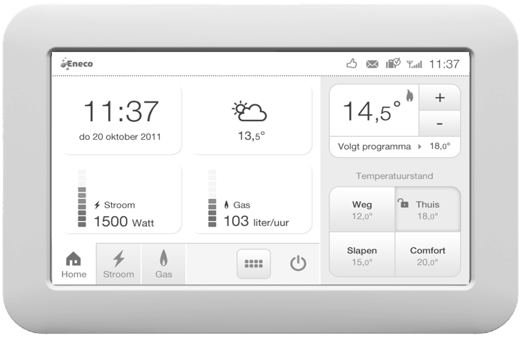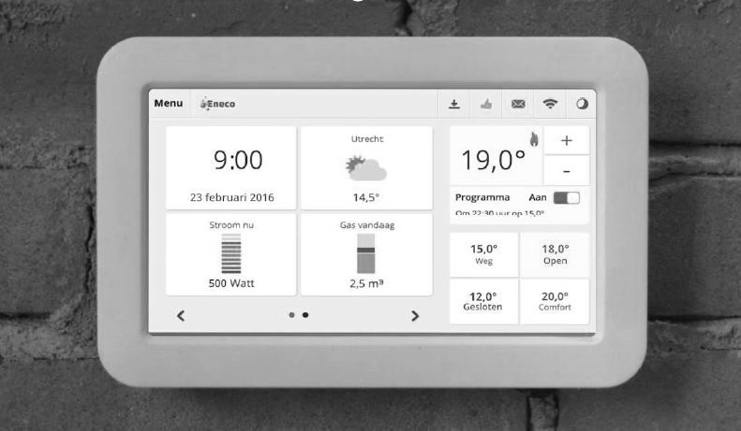

Source: Company documents (2011 and 2016).

EXHIBIT 2: TOON UNIT SALES IN THE NETHERLANDS

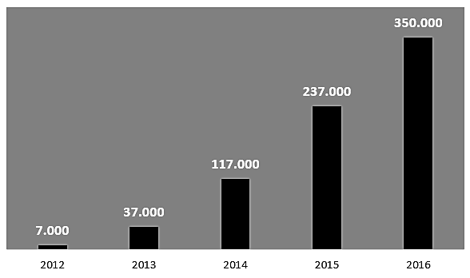

Source: Company documents.

EXHIBIT 3: VISION 2020

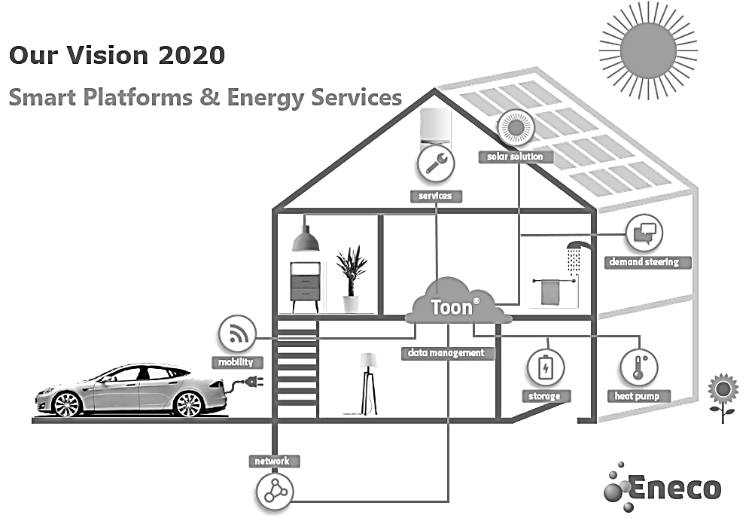

Source: Company documents.

**EXHIBIT 4: TOON CHURN REDUCTION AND NPS IMPROVEMENT**

|  |  |
| --- | --- |
|  |  |

Note: NPS = net promoter score.

Source: Company documents.

Endnotes

1. € = EUR = euro; US$1 = €0.9264 on January 31, 2017; all currency amounts are in euros unless specified otherwise.
2. Agency for the Cooperation of Energy Regulators and the Council of European Energy Regulators, ACER/CEER Annual Report on the Results of Monitoring the Internal Electricity and Gas Markets in 2016: Electricity and Gas Retail Markets Volume (October 2017).
3. A smart meter was an electronic device that recorded and communicated electricity consumption to the utility for monitoring and billing. Smart meters were being rolled out in the Netherlands as of 2005. Rik de Lange, Marktbarometer Aanbieding Slimme Meters: Voortgangsrapportage 2017 [in Dutch] (Rijksdienst Voor Ondernemend Nederland: 2018).
4. OpenTherm was a non-manufacturer dependent system used in central heating systems for communication between a thermostatic controller and a boiler. “Why OpenTherm?,” OpenTherm Assocation, accessed February 16, 2018, www.opentherm.eu/why-opentherm.
5. “The Smart Thermostat that Pays for Itself [in Dutch],” Toon, accessed May 23, 2018, www.toon.nl/thermostaat/ontdek-toon/energie-besparen.
6. All prices, fees, and costs included a value-added tax (VAT) of 21 per cent.
7. An API was “a tool used to share content and data between software applications.” “APIS for Scholarly Resources, MIT Libraries, accessed February 16, 2018, https://libraries.mit.edu/scholarly/publishing/apis-for-scholarly-resources.
8. “Smart Charging in Gear,” Eneco Group, accessed February 27, 2018, www.enecogroup.com/what-we-do/in-practice/how-we-realize-our-mission/smart-charging-in-gear.
9. “Principles behind the Agile Manifesto,” Agile Manifesto, accessed March 5, 2018, http://agilemanifesto.org/principles.html.
10. Marcel Timmer, “Dutch Children are in Danger of Missing Out on the Labour Market” [in Dutch], Financieele Dagblad (FD), December 10, 2015, accessed March 5, 2018, https://fd.nl/opinie/1131060/nederlandse-kinderen-dreigen-de-aansluiting-op-de-arbeidsmarkt-te-missen.
11. Stanley Reed, “Dutch Utility Bets Its Future on an Unusual Strategy: Selling Less Power,” *New York Times*, August 18, 2017, accessed March 7, 2018, www.nytimes.com/2017/08/18/business/energy-environment/eneco-netherlands-electricity-utility.html.
12. “Facts and Figures” [in Dutch], Essent, accessed February 16, 2018, www.essent.nl/content/overessent/dit-is-essent/feiten-en-cijfers/index.html
13. “Organization” [in Dutch], Nuon, accessed February 16, 2018, www.nuon.com/het-bedrijf/organisatie.
14. Paul Groothengel, “Toon Has Become a Platform,” Management Scope, November 30, 2017, accessed February 26, 2018, https://managementscope.nl/magazine/artikel/1101-hans-valk-quby.
15. Lance Whitney, “Google Closes $3.2 Billion Purchase of Nest,” C Net, February 12, 2014, accessed February 26, 2018, www.cnet.com/news/google-closes-3-2-billion-purchase-of-nest.
16. Sam Frizell, “Google’s Nest Is Buying a Home-Monitoring Carmera Company,” *Time*, June 21, 2014, accessed November 28, 2018.
17. “Google-owned Nest Launches HD Security Camera,” BBC, June 17, 2015, accessed November 28, 2018, www.bbc.com/news/technology-33168384; Lisa Eadicicco, “Nest’s New Product Is an Outdoor Security Camera,” *Time*, July 14, 2016, accessed November 28, 2018, http://time.com/4403751/nest-cam-outdoor-launch/.
18. “Nest Learning Thermostat: Overview,” Nest, accessed February 26, 2018, https://nest.com/thermostats/nest-learning-thermostat/overview.
19. Essent, “Essent Energy Partner of Nest Labs in the Netherlands” [in Dutch], press release, September 6, 2014, accessed February 26, 2018, www.essent.nl/content/overessent/actueel/index.html/essent-energiepartner-van-nest-labs-in-nederland.
20. Essent, “Essent Starts Sales Nest Learning Thermostat” [in Dutch], press release, September 25, 2014, accessed February 26, 2018, www.essent.nl/content/overessent/actueel/index.html/essent-start-verkoop-nest-learning-thermostat.
21. Ibid.
22. “Amazon Echo: The Best Super Bowl 2016 Commercial Ad Alec Baldwin Cheese,” YouTube video, 0:30, posted by “Ad Bowl 2016,” February 8, 2016, accessed February 26, 2018, https://youtu.be/OhqOvm8Gjks.
23. Matt Hanson, Jon Porter, “The Best Alexa Skills and Commands: The Ultimate Amazon Echo Tips and Tricks,” Tech Radar, accessed February 28, 2018, www.techradar.com/how-to/the-best-amazon-echo-alexa-skills-and-how-to-install-them/4.
24. Christian de Looper, “The Best Smart Home Devices for Your Google Home,” Business Insider, January 23, 2018, accessed February 28, 2018, http://uk.businessinsider.com/best-google-home-devices.
25. Joe Rossignol, “Apple’s Early Version of HomePod Stood Three Feet Tall and Packed Dozens of Speakers,” MacRumors, November 21, 2017, accessed February 28, 2018, www.macrumors.com/2017/11/21/apple-developed-several-homepod-prototypes.
26. Gaurav Sharma, “Centrica Unit Chief Says Smart Thermostat Adoption Has Doubled within a Year,” International Business Times, August 31, 2016, accessed February 27, 2018, www.ibtimes.co.uk/centrica-unit-chief-says-smart-thermostat-adoption-has-doubled-within-year-1577876.
27. “What We Do: Centrica Hive Limited,” Centrica, accessed February 27, 2018, www.centrica.com/about-us/what-we-do/connected-home.
28. Chris Hall, “Hive Confirms Compatibility with Amazon Echo for Voice Controlled Heating and Lighting,” Pocket Lint, September 14, 2016, accessed February 26, 2018, www.pocket-lint.com/smart-home/news/amazon/138828-hive-confirms-compatibility-with-amazon-echo-for-voice-controlled-heating-and-lighting.
29. “2016,” Engie, accessed February 26, 2018, www.engie.com/en/investors/results/2016-results.