

9B18B003

AgriSmart: Funding New Corporate Ventures

Marc Wouters and Antonio Dávila wrote this case solely to provide material for class discussion. The authors do not intend to illustrate either effective or ineffective handling of a managerial situation. The authors may have disguised certain names and other identifying information to protect confidentiality.

*This publication may not be transmitted, photocopied, digitized, or otherwise reproduced in any form or by any means without the permission of the copyright holder. Reproduction of this material is not covered under authorization by any reproduction rights organization. To order copies or request permission to reproduce materials, contact Ivey Publishing, Ivey Business School, Western University, London, Ontario, Canada, N6G 0N1; (t) 519.661.3208; (e)* [*cases@ivey.ca*](mailto:cases@ivey.ca)*;* [*www.iveycases.com*](http://www.iveycases.com)*.*

Copyright © 2018, Ivey Business School Foundation Version: 2018-03-23

Kathrin Müller, chief executive officer (CEO) of AgriSmart, was preparing for the approaching board meeting at the end of January 2017 in Stuttgart, Germany. It was no ordinary meeting; the main item on the agenda was to set new milestones for the company and get more funding. To that end, the directors had received an overview of the company’s performance since the last milestone (see Exhibits 1 and 2). AgriSmart was part of the Bosch start-up platform, which was the incubator program of Robert Bosch GmbH (Bosch). Müller was preparing AgriSmart’s forecasts to share with the board. She wanted to be ready for all possible questions from the directors regarding the company’s past performance and the assumptions going forward.

AgriSmart and the Bosch Start-up Platform

AgriSmart was a start-up focused on the development and application of robots, sensors, and data management to improve agriculture.[1] For instance, AgriSmart technology helped to optimize water consumption, the use of pesticides and herbicides, as well as harvesting dates, based on an analysis of data gathered in fields through its sensors. The AgriSmart team brought together mechanical engineers, software developers, robotics specialists, and agricultural engineers. The company’s vision was to support sustainable green farming and conserve nature through technology. AgriSmart’s products included hardware (robots and sensors in the field or mounted to tractors) and software (for data management and analysis). The start-up was still in the product development phase, although it had already carried out several pilots at customers’ premises and launched sales of two of its innovative products (see Exhibit 3).

AgriSmart was part of the Bosch start-up platform, through which Bosch invested in start-ups that used Bosch technology in new markets, and business models that were innovative for Bosch. Formally called the Robert Bosch Start-up GmbH, the Bosch start-up platform was established in 2013 as a 100 per cent subsidiary of Robert Bosch GmbH, and had its own premises in Ludwigsburg, Germany (see Exhibit 4). By the end of 2016, it comprised five start-ups in Germany employing approximately 65 people, and two start-ups in the United States.

The typical path for entering the Bosch start-up platform was the following: first, a small team of people from different areas of expertise devised a new business idea for developing a particular technology for a new product or service, and proposed the idea to the platform. If the idea was deemed interesting and a fit with the Bosch strategy, the team attended a two-day workshop called “the grow Expedition.” This structured process offered participants experience in developing a first business model, creating a product draft, and conducting initial trials. The workshop ended with the delivery of a pitch to a jury that decided whether the team made it to the third and last step of becoming a start-up. This last step was a 10-week preparation and selection program called “the grow Discovery,” which provided more in-depth knowledge. Led through a six-step process, the teams developed their ideas into a business model, a market, and a product. The grow Discovery program also helped to prepare the teams to make a pitch to the Bosch start-up platform board. Selected projects needed to fit Bosch’s strategic vision—summarized by its slogan “invented for life” (or *Technik fürs Leben* in German). They also needed both to be based on technology that Bosch owned and to address a new, scalable, and sustainable business for Bosch.

Arriving at the Bosch start-up platform, entrepreneurs found a distinctive building with open spaces. The platform offered few rules and flexible working conditions, as well as ready access to talent and resources within and outside of Bosch that were highly suitable for radical innovation. Start-up founders became employed by the Bosch start-up platform and basically received the same salary and benefits they had at Bosch; however, they received no stock in their start-up. Instead, they received an annual bonus based on the venture’s success. Unlike with an independent start-up, this arrangement did not offer the opportunity to get rich—nor did it pose the risk of losing it all. Bosch wanted to tap into other forms of motivation: the opportunity to get an innovative technology to work, the freedom to be entrepreneurial, and the chance to create something exciting. Corporate entrepreneurship in the Bosch start-up platform meant performing like a start-up entrepreneur while benefiting from corporate networks and resources (such as technology, legal services, human resource development systems, the Bosch brand, contacts with potential customers and other partners, and contract conditions with Bosch suppliers).

Like any other start-up in the program, AgriSmart had its own board that reviewed its performance, providing advice and deciding on further funding. The timing for board meetings was based on the achievement of milestones rather than on calendar time. During each meeting, board members looked at whether the start-up had achieved the milestones, as well as the money spent. At the meeting, the start-up team presented detailed research and development (R&D) and market development plans for reaching the subsequent milestones and the expected cash flows. During the meetings, management and board members discussed these plans and set new milestones. At funding decision meetings, the board could decide to fund the next round of the start-up with the aim of giving it enough cash to achieve several milestones, or to stop funding and wind down the start-up.

AgriSmart Products—Market and Business Model

To reach its current milestone, AgriSmart had launched its first two products: SmartSense and SmartData. SmartSense was a set of high-precision sensors that measured various soil characteristics, such as ground temperature, nutrient density, and moisture at various depth levels. Sensors sent the data to a server that the user accessed through a smartphone and tablet application. The production of the sensors was outsourced, and they were sold to customers directly through AgriSmart’s online shop.

SmartData was “big data” software that collected, processed, and analyzed data from sensors and other agricultural equipment, as well as from weather stations, image-capturing satellites, and drone mapping. The software provided warnings (such as of pest infestation or drought conditions) and advice (for example, when and how to irrigate a field; which and how much fertilizer, pesticides, or herbicides to apply and when to apply them; and at what moment to harvest). Customers bought a 12-month subscription. AgriSmart used a service partner to sell and manage the subscriptions, and paid a fee per sales unit (the fee was a stated amount, not a percentage of sales revenues). Another service partner provided the extensive data storage and computing capabilities. The contract with that service provider had a complex structure, whereby the costs varied with the amount of storage guaranteed, the amount of storage actually used, the bandwidth, and server time. As an approximation, the company used the total number of SmartData units as the cost driver.

SmartSense sales had been disappointing. The first customers had identified some issues that required further design modifications. For the inconvenience, the company decided to offer discounts to these early customers. The newly redesigned sensors moved quickly through the contract manufacturer to decrease the delay in reintroducing the product; further delay would led to significant additional costs. In contrast, sales of SmartData had been better than expected. The software had received rave reviews from early customers, and AgriSmart did not need to offer as much of a discount, as was originally planned.

R&D was still the major activity at AgriSmart. Müller was disappointed when two engineers decided to quit and work for another start-up. To replace them, Müller hired an engineering consulting firm that was paid per hour. She also hired an external engineering firm to test the SmartSense devices in an attempt to reduce the time to market after the early feedback from the market had put the project behind schedule. The external firm charged for results rather than by the hour. AgriSmart also worked on an R&D project with a partner who paid for that project’s development. The R&D activities and results had moved almost completely according to plan, and nearly all of the payment from the project had been collected. Because of the heavy penalties associated with missing the deadlines for the project, AgriSmart had given it high priority.

As part of the package that would be presented to the board, Müller included a document comparing AgriSmart’s financial performance since the previous milestone (milestone 6) with the original budget. The document included an overview of revenues and expenses for the period between the previous milestone and the one the company had just reached (milestone 7) (see Exhibit 1). When the company had reached milestone 6 three months earlier, the board had approved AgriSmart’s budget for reaching the current milestone.

Müller wondered whether the directors would want more details explaining the differences, and she considered how she could provide such information in terms of volumes, prices, and the shift in the sales mix and in the R&D activities.

Operational Budget Toward the Next Milestone

The second critical topic on the board meeting agenda was the budget for reaching milestone 8. The board would use this budget as the basis for an in-depth discussion with Müller and her team about their expectations, challenging various assumptions and providing advice.

In her presentation, Müller highlighted the following priorities for reaching the next milestone:

* She would put more effort on marketing and sales to support the delayed sales of SmartSense. The start-up would offer more free trials to potential customers; it would continue giving discounts to customers who were willing to share their success stories; and it would increase its presence in the industry through participation in trade shows and websites. Müller was projecting a 30 per cent increase in marketing expenses, but if she could convince the board to increase this budget by 70 per cent, sales toward the next milestone would grow an additional 10 per cent. More importantly, the brand would be stronger going forward.
* R&D would use the results from tests with pilot customers to finalize the third product, StrawberrySmart—a sensor that measured air temperature and humidity surrounding strawberry plants to warn of overheating, of soil being too dry or too wet, and of any risk of fungus infection. R&D would also accelerate the development of other products. To do this, AgriSmart planned to hire additional R&D staff (internal hours would grow by 20 per cent) and to use more external hours (an additional 15 per cent). It would spend about the same on external development services. Müller was also considering being more aggressive in her R&D strategy to get more products to market faster. If she could double her internal staff, she believed she would be able to have an additional product in the market before reaching milestone 8: WineSmart for wineries.
* AgriSmart would discontinue the joint development agreement, since early results were not promising and it was not a priority for the partner.

Müller also wondered about the remaining inputs to the budget. She believed she could deliver on the following:

* Grow unit sales by 150 per cent for SmartSense and 150 per cent for SmartData at the current actual sales prices.
* Grow other R&D expenses by 10 per cent.
* Keep non-R&D labour expenses constant.
* Keep the cost per unit for the contract manufacturer at the originally planned level, as there should be no more rush orders.
* Keep the cost per unit with the SmartData reseller at the same level.
* Keep the contract for computing services the same.
* Ensure a lead time of three months for reaching milestone 8.

Yet, she wondered whether she should be more conservative to easily hit the budget and reduce the projected loss. Alternatively, she could be more aggressive to impress the board and ensure that it funded the company.

Funding AgriSmart

The board meeting would also include a funding decision. In taking this decision, the board needed to have an idea of the company’s longer-term prospects, and the budget considered only the next milestone. Müller was aware that the board considered two options. One option was to fund the next milestone and keep its funding commitment for the next two years and then exit; it would then either transfer the start-up to a Bosch division or sell it to an outside party. The other option was to stop the funding and dismantle AgriSmart.

Müller was unsure how fast the company could grow after milestone 8. She knew that the technology gave the company a significant lead time over competitors. The market was large and covered the world. Yet, it was difficult to predict how quickly customers would buy into the new technology. One option she contemplated was establishing partnerships with large companies, but doing so would put pressure on prices.

Müller envisioned four scenarios: she considered two different market sizes and two strategies—go-alone versus partnership, which would affect AgriSmart’s market share. Given AgriSmart’s technology lead, in two years the company could capture 10 per cent of the expected €150 million[2] market for smart agriculture, which was the most relevant market segment for AgriSmart (see Exhibit 5). Variable costs would remain at the same percentage of revenues. Total R&D expenses would continue to increase by 15 per cent every quarter, and non-R&D labour costs and marketing expenses by 10 per cent. However, AgriSmart’s current target market segment within the smart agriculture market was a tiny percentage of the potential market. Müller also considered the possibility of the market growing faster than forecasted and, in two years, being twice the size than was expected. Furthermore, she considered the option of pursuing a partnership rather than going alone. If AgriSmart partnered with large agricultural companies, the price pressure would reduce contribution margins by at least 60 per cent, yet smart agriculture would gain the support of these companies and grow even faster. Müller considered capturing 20 per cent of the market as a feasible alternative. It was difficult to say how the future would unfold, so she considered each of these four scenarios as equally likely.

Milestone 8 would reveal important information regarding the feasibility of the go-alone versus the partnership strategies as well as the size of the market. If the current go-alone strategy received further support, those alternatives would become much more likely and each of the partnership alternatives would drop to about 10 per cent. Of the two go-alone scenarios, the likelihood of having a large market would be 50 per cent and having a smaller market would be 30 per cent. If the go-alone strategy lost support, then going forward with partners would become more likely, with having a small market with partners at 50 per cent and going ahead with partners but having a large market at 20 per cent. The other two alternatives would remain equally likely.

The valuation of AgriSmart was based on estimates of the financial results (earnings before interest, taxes, depreciation, and amortization, or EBITDA) for the next eight quarters after milestone 8. The discount rate used internally at the Bosch start-up platform was 5 per cent per quarter. The terminal value was the last quarterly forecasted EBITDA multiplied by 20.

Müller realized she needed to present a convincing outlook. After all, her business was still losing money every quarter, and results toward milestone 8 did not look any better. The Bosch start-up platform had already invested €3.2 million; would it continue to fund the business? Müller wondered how she could also convince the board that important information would be revealed over the next three months.

Exhibit 1: Financial data for AGRISMART’S Milestone 7

|  |  |  |  |  |
| --- | --- | --- | --- | --- |
|  | **Milestone 7** | | | |
|  | Planned | | Actual | |
| **Revenues** | **€170,900** | | **€161,016** | |
| SmartSense |  | 31,500 |  | 22,562 |
| SmartData | 29,400 | 38,454 |
| Development Agreement | 110,000 | 100,000 |
| **Development Expenses** | **€709,000** | | **€783,800** | |
| **Variable Costs** | **€14,896** | | **€17,122** | |
| Cost of SmartSense Sold |  | 10,800 |  | 11,670 |
| Sales Costs for SmartData |  | 1,200 |  | 1,508 |
| Computing Costs |  | 2,896 |  | 3,944 |
| Internal Labour Costs |  | 360,000 |  | 333,500 |
| External Labour Costs | 104,000 | 163,800 |
| External R&D Services | 175,000 | 210,000 |
| Other R&D Costs | 70,000 | 76,500 |
| **Non-R&D Labour Costs** | **€69,000** | | **€70,500** | |
| **Marketing Costs** | **€66,000** | | **€69,960** | |
| **EBITDA** | **−€687,996** | | **−€780,366** | |

Note: R&D = research and development; EBITDA = earnings before interest, taxes, depreciation, and amortization

Source: Created by the authors.

Exhibit 2: Additional information for AGRISMART’S Milestone 7

|  |  |  |
| --- | --- | --- |
|  | **Planned** | **Actual** |
| Units Sold—SmartSense | 900 | 778 |
| Units Sold—SmartData | 600 | 754 |
| Internal Research & Development Hours | 8,000 | 7,250 |
| External Research & Development Hours | 1,600 | 2,600 |

Source: Created by the authors.

Exhibit 3: Examples of AgriSmart products and prototypes

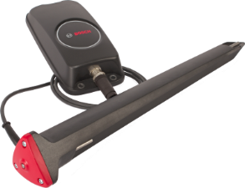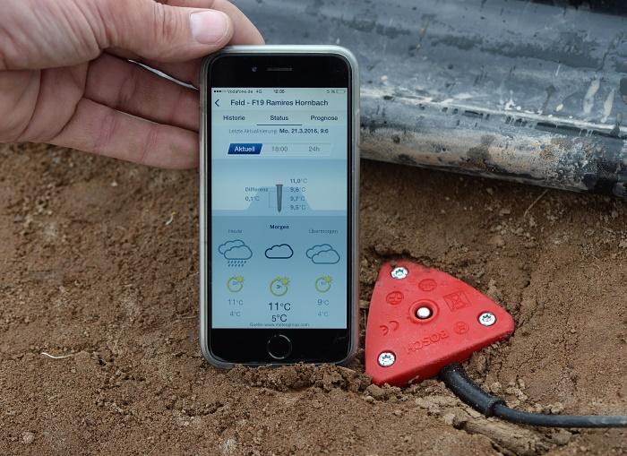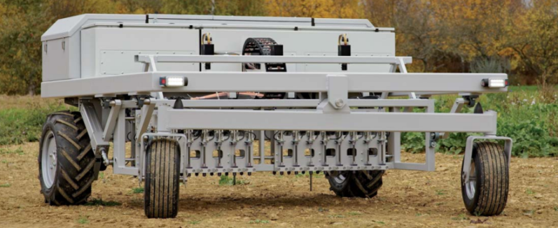

Source: Company documents.

Exhibit 4: exterior and Interior of the Bosch Start-up Platform

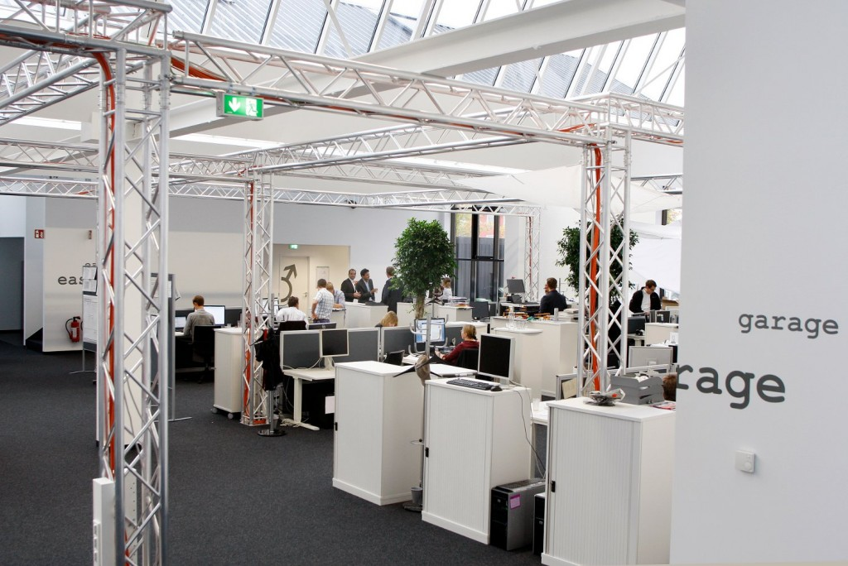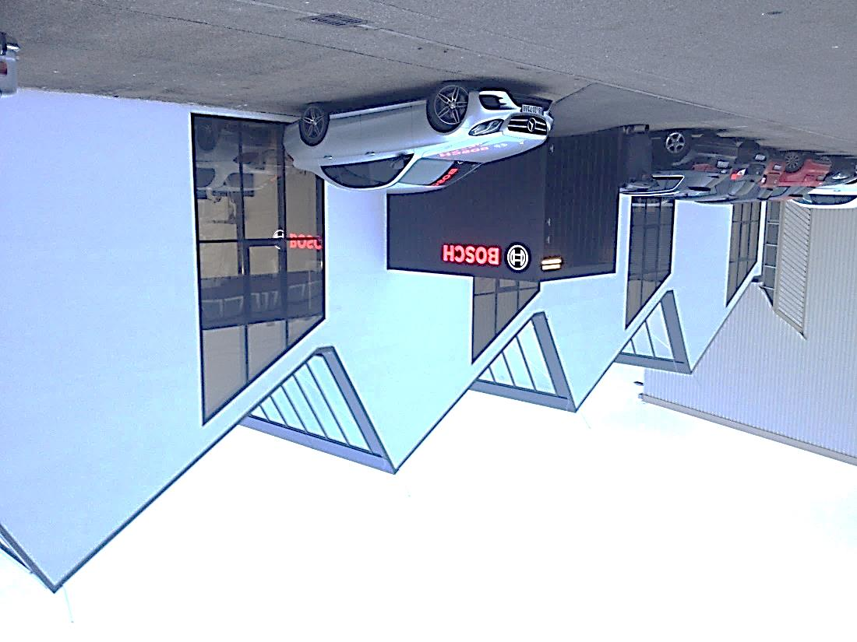

Source: Company documents.

Exhibit 5: Agricultural Market Information

|  |
| --- |
| The market for smart agriculture is often segmented according to type of agriculture, solution, and geography.  Type of agriculture includes precision agriculture, livestock monitoring, fish farming, smart greenhouse, and other. *Precision agriculture* is based on crop and soil observation, and allows farmers to optimize decisions relative to quality and quantity of crops with the help of accurate data collected from the field.  Solution includes network management, agriculture asset management, supervisory control and data acquisition, logistic and supply chain management, and smart water management. *Network management* involves operations related to remote monitoring systems based on data generated from the field.  Relevant for AgriSmart is the cross-section of network management in precision agriculture in Europe. Two years from now, this market is estimated to be around €150 million per year and to grow 40 per cent per year. |

Note: The data presented in this exhibit have been disguised.

Source: Transparency Market Research, *Smart Agriculture Market*, March 2017.

1. Also called “smart farming” or “smart agriculture;” it was also referred to as “IoT farming” or “IoT agriculture” (IoT was the acronym for “Internet of Things”).
2. € = EUR = euro; €1 = US$1.0516 on January 1, 2017; all currency amounts are in €.