

9B18B005

sink or float: an oliver wyman and duke royalty investment opportunity

Amy Horrocks wrote this case under the supervision of Mary Gillett solely to provide material for class discussion. The authors do not intend to illustrate either effective or ineffective handling of a managerial situation. The authors may have disguised certain names and other identifying information to protect confidentiality.

*This publication may not be transmitted, photocopied, digitized, or otherwise reproduced in any form or by any means without the permission of the copyright holder. Reproduction of this material is not covered under authorization by any reproduction rights organization. To order copies or request permission to reproduce materials, contact Ivey Publishing, Ivey Business School, Western University, London, Ontario, Canada, N6G 0N1; (t) 519.661.3208; (e)* [*cases@ivey.ca*](mailto:cases@ivey.ca)*;* [*www.iveycases.com*](http://www.iveycases.com)*.*

Copyright © 2018, Ivey Business School Foundation Version: 2018-09-28

In late 2016, Amy Horrocks, an analyst at Oliver Wyman (OW), was contemplating the high stakes of her new project. A few days earlier she had sat in the boardroom with Neil Johnson, chief executive officer (CEO) of Duke Royalty (Duke), and J. David Campbell, a founding partner of OW’s Life Sciences practice. Prominently displayed on the boardroom table at that time was the pitch book for Temarca Group (Temarca)—the first potential investment of the newly-formed partnership. The previous week, the European riverboat company had approached Duke seeking €9.0 million[1] to expand its riverboat fleet.

If a financing decision was made, Temarca would be one of the first investments in Duke’s portfolio. Ensuring that this investment was aligned with Duke’s investment mandate, met the financial criteria, and delivered the targeted returns would be essential to please keystone investors. Similarly, Horrocks knew this deal would be highly scrutinized by the OW partners because Temarca would be OW’s first fully-financed deal with Duke. With all this in mind, Horrocks’ task was to make a preliminary recommendation to Johnson and Campbell about the soundness of this opportunity.

ROYALTY FINANCING

Royalty financing was a sizeable, well-established, and successful segment of the financial markets in North America, and had delivered excellent returns for investors. Under the terms of this type of financing, capital was provided to an investee company in return for a royalty stream (i.e., percentage of revenues) over a long-term period (i.e., 15 to 30 years). The investee company received the capital immediately, while the investor earned a pre-tax return (typically 12–15 per cent per year) from the royalty stream paid out of the company’s free cash flow.[2]. For growth-oriented private companies with predictable cash flows, royalty financing represented an excellent alternative, non-dilutive financing solution in comparison to either bank debt or private equity.

Royalty investing was considered a passive investment where investors would have little to no management control and no equity stake. In addition to preserving the equity ownership for existing investors and company founders, this structure also allowed well-performing companies and their management teams to continue to make autonomous decisions given their experience and expertise. As a result, an investor such as Duke was exposed to the risk that, over the 15- to 30-year investment period, management teams would be replaced and new teams might make decisions that were not in the best interests of the investor.

Royalty capital represented an intermediate risk–reward structure as compared to traditional debt and equity financing. Unlike fixed debt payments, which required principal and interest payments, royalty payments were structured to fluctuate proportionally with revenues.[3] As a result, variable royalty payments were typically higher risk than fixed debt payments with no guarantees of payback. Private equity and venture capital investors typically invested in a company’s future potential by taking an equity stake in an organization in return for capital. Royalty investors, on the other hand, recouped their investment over time and did not need to rely on exit opportunities (such as a sale of shares) to generate returns. Royalty investors usually held long-term assets as security against their debt.

OLIVER WYMAN & DUKE ROYALTY

Duke and OW had recently entered into an exclusive collaboration agreement to source, provide due diligence,[4] and finance royalty investments. This unique partnership between a consulting firm and fund was the first of its kind, and both parties were eager to make an initial investment.

Duke was the first listed diversified royalty company in the U.K. market with the objective of building a diversified portfolio of royalty partners across various economic sectors. Duke’s CEO, Johnson, had spent a decade on Bay Street and in London and had seen the potential in the U.K. royalties market. Using his industry experience, he created a tax-advantaged investment structure, providing his fund with a lower cost of capital and a competitive advantage.[5] Further, the U.K. domicile gave Europeans their first chance to participate in this lower risk, higher yield financing model. Johnson had set Duke’s target pre-tax internal rate of return (IRR) benchmark at 15 per cent.

OW was a leading global management consulting firm with offices in over 50 cities across 26 countries and 35 years of consulting experience. The firm’s management committee had begun to seek new, high- value business models in an attempt to diversify its revenue stream. With OW’s growing global footprint and deep industry knowledge, the potential business of deal sourcing and diligence offered the firm the opportunity to diversify its revenues as well as earn higher returns. Partnering with Duke had the added benefit to OW of benefiting from Duke’s expertise in raising capital and negotiations.

Within the framework of the collaboration, OW assisted Duke in identifying and performing due diligence on potential investments. The blended investment committee then played the integral role of advising Duke in making the final investment decision using specific investment criteria developed jointly by Duke and OW (see Exhibit 1). Horrocks understood that each of these criteria would be critical to consider in making her recommendation to Johnson and Campbell.

INDUSTRY OUTLOOK

Economic Overview

Following the meeting, Horrocks researched and accumulated information on the European economy, the travel and tourism sector, and the cruise industry. The European economy had entered its fifth year of financial recovery and was expected to continue growing at a steady pace for the next couple of years. The European Commission expected European Union (EU) gross domestic product (GDP) growth of 1.7 per cent in 2017 and 1.8 per cent in 2018;[6] however, these figures lagged behind global growth rates of 3.7 per cent and 3.9 per cent in 2017 and 2018, respectively.

Over the past six decades, tourism had grown and diversified to become one of the largest and fastest growing economic sectors in the world. This trend was expected to continue as the sector’s direct contribution to the European GDP was expected to grow at an average of 3.9 per cent annually over the next 10 years.[7] By 2027, travel and tourism was expected to account for 11.4 per cent of global GDP and to outperform the global economy over the next 10 years. Within the EU, the direct contribution of travel and tourism to GDP in 2015 was €629.8 billion (3.5 per cent of GDP). This was forecasted to rise by 2.9 per cent to €647.8 billion in 2016.

A rise in terrorist attacks across Europe over the past few years had had an impact on well-known travel destinations including cities in France, the United Kingdom, Germany, and Turkey. The impacts of terrorist attacks were predominantly regional, but were significantly damaging to local businesses (e.g., occupancy rates at Paris hotels fell by 25 per cent immediately following the Paris attacks in 2016).[8] The economic impact of terrorism on this sector was shown to sometimes be significant and immediate, but it was typically not permanent. It took on average about 13 months for tourism to recover from a terrorist attack.[9] Nevertheless, Horrocks was concerned that a potential attack would have a severe impact on a family business like Temarca and on its ability to pay royalties to Duke.

Global Cruise Industry

The cruise industry was currently one of the fastest-growing categories in the leisure travel market. Since 1980, the industry had experienced an average annual passenger growth rate of approximately 7 per cent.[10] The global cruise industry had grown significantly over the past 10 years, and consisted of approximately 300 ships. Worldwide, the international cruise industry had an annual passenger compound growth rate of 4.8 per cent from 2005−2015.[11] To meet demand, between 2015 and 2020, 55new ships (22 river cruisers) would join the global fleet—an investment in new vessels of more than US$25 billion.

River cruises offered an experience completely unlike ocean cruises. Ocean cruises promoted glitz, glam, and onboard amenities, whereas river cruises were focused on helping passengers slow down, enjoy the scenery, and learn about the local history, culture, and cuisine (see Exhibit 2). Unsurprisingly, Europe was the most popular destination for river cruises given the location of the Rhine, the Danube, and the Seine. Those waterways, which bustled with commercial and leisure traffic, were the arteries that connected clusters of countries, offering a variety of experiences to river cruisers. Cruise passengers were typically about 50 years old, with river-cruise passengers being more than 10 years older than ocean cruise passengers. The river-cruise passenger demographics looked promising considering the aging of the baby boom cohort, as 42 per cent of the U.S. population and 51 per cent of the EU population were expected to be over 4+ by 2030.[12]

Over the past decade, river cruising had transformed itself from a mass of small, family-run businesses with ageing vessels into a collection of professionally operated enterprises, whose managers often had years of experience in the ocean-cruise industry. From 2009–2013, river cruising in Europe had grown at an annual rate of 11–14 per cent versus 4–5 per cent for ocean cruising.[13] This growth was attributed to a greater awareness of river cruises’ unique experiences, a growing retired demographic with higher disposable incomes, and an increased quality of service and onboard amenities that could compete with those of traditional ocean cruises. These companies had invested in new ships and modernized existing fleets. Luxury riverboats, although much smaller than ocean cruisers, were now fitted with some of the same amenities—luxurious accommodations, a choice of several dining rooms, swimming pools, exercise areas, cinemas, and balconies.

TEMARCA, SIJFA CRUISES

Milan Visser and Lotte Visser established Temarca in 1997 with the purchase of their first vessel, Calypso, offering river cruises along the Rhine and Danube rivers under the brand name SijFa Cruises. The company remained a small family-owned organization, operating in the Netherlands, and the couple maintained full control of their business. In recent years, the Vissers had relinquished their on-boat responsibilities to other managers in the organization and spent most of their time in the head office in Nijmegen, Netherlands.

Operating under its trade name, SijFa Cruises, Temarca offered multi-day riverboat cruises on Europe’s most popular rivers including the Rhine and the Danube (see Exhibit 3). The company employed a unique business strategy, purchasing second-hand boats and refurbishing them at a fraction of the cost of a new boat (approximately an 80- to 90-per-cent saving). Late in 2016, Temarca contracted to sell one vessel and purchase two second-hand vessels—the MS Neptune and the MS Bellefleur. These vessels required substantial renovations to be ready for the sailing season. Both of these ships were 114 metres long with a capacity of 115 passengers each. Including the Rigoletto,[14] the purchase brought Temarca’s total fleet up to three ships, which were valued together at €14 million, once the two new vessels were fully refurbished.

Temarca also had a unique selling process. Instead of focusing on a direct-to-consumer model, Temarca sold its cruises through 27 international travel agencies with the three largest agencies representing almost 60 per cent of 2016’s capacity. The responsibility for finding end consumers was outsourced to the tour operators through which Temarca also outsourced sales and marketing. As was typical in the industry, travel agencies tended to buy capacity one year in advance, so sales of the year ahead were known on January 1 of that year.[15] Travel agencies paid Temarca 20 per cent of the revenue within one month of booking and the balance one month prior to sailing. Temarca’s 2016 season was fully booked, and the company was actively selling out 2017 and 2018 capacity. Horrocks noticed that Temarca relied heavily on these tour operators and knew that losing a key client could severely impact its ability to sail its vessels at full capacity.

Temarca’s travel operators and agency partners sold SijFa Cruises to European couples aged 50 and over, and most of the passengers and crew were Dutch or German. SijFa Cruises operated in a niche space of the cruise industry; the 4-out-of-5 star service offering, at an average cost of €250 per night, was still a crowded space (see Exhibit 4). As she studied Temarca’s business model, Horrocks wondered if the company had a differentiated enough service offering to continue to thrive in a seemingly competitive market.

Each boat was operated by four key employees: a hotel manager, a captain, a head chef, and a maître-d’ who were all responsible for ensuring the guests had a great on-boat experience. At head office, the Vissers were supported by a team of seven part-time employees who were all responsible for key aspects of the business. The Vissers were childless but had a niece, Anna, whom they had appointed the sole beneficiary of the business. Anna was in her late 20s and completing a masters in Renaissance literature. She had started to become more involved in the business and envisioned eventually taking over the business.

Temarca had shown strong, consistent financials over the past five years (see Exhibit 5). It had grown revenues with new ship acquisitions but had kept selling, general, and administrative costs low, at about 1 per cent of revenue. Both Campbell and Johnson, however, had indicated their concern to Horrocks regarding the high levels of debt on Temarca’s balance sheet. Though they knew the cruise industry was a high fixed-asset business, they wondered if the levels of debt were justified or if this company was too highly leveraged for Duke. Horrocks knew she would need to consider the financial health of the business both pre- and post-capital investment given Temarca’s expected use of proceeds.

PROJECTING NEEDS

The Vissers had a three-pronged plan for the €9-million investment from Duke. First, they planned to use €3.6 million to repay part of the company’s long- and short-term debt including all of the secured loans as well as the bank overdraft and accounts payable. Temarca still planned to maintain €1 million of unsecured debt from one of its largest customers.

The company also planned to use the capital to finance the purchase agreement for the new Neptune boat for a total of €3.7 million. In addition to the Neptune purchase, Temarca needed to significantly refurbish the boat, which was quoted at €880,000. The company had also entered into a rent-to-own purchase agreement for the Bellefleur, with the Bellefleur requiring the same amount of refurbishment. Temarca planned to pay for the Bellefleur’s renovation from its cash flow from operations.

Finally, the remaining €820,000 in cash from Duke’s investment would be maintained for working capital needs.

Expansion Plans

Temarca’s sole revenue stream was the income generated from each passenger per sailing day. Given the seasonality of the waterways, Temarca estimated that it would have 165 sailing days per year. The company assumed its capacity would be sold through travel agents or operators and that the agents would take a 30-per-cent commission. The Neptune was estimated to sail at 75-per-cent capacity in 2017; 85 per cent in 2018; and maximum capacity, at 90 per cent, in 2019. The Bellefleur was estimated to generate 80 per cent of revenue generated by the Neptune. Rigoletto, already at maximum capacity, was estimated to generate sales of €2.2 million, net of commission in 2017. The revenue generated by the three ships was forecasted to grow at 3 per cent per year from 2020 until maximum capacity was reached in 2025, and then grow at 2 per cent per year until the end of the investment period.

Unlike a hotel, where labour was the largest variable expense and entire floors could be taken out of service when demand was low, a cruise ship had little ability to reduce variable costs. Before a ship sailed, almost all ship-related costs were fixed (fuel, staffing, and docking fees). Passenger-related costs (food and excursion fees) could potentially vary with the number of passengers sailing; however, the cruise industry was known for last-minute sailors, and thus the Vissers’ strategy was to plan for the cost of full occupancy on each of the company’s vessels. Temarca classified these two types of costs as their cost of sales. Shipping costs were estimated to be €120 per sailing day per ship. Passenger costs were estimated on a per passenger per-sailing-day basis and varied by ship. By 2017, these costs were expected to be €60 for the Neptune, €55 for the Bellefleur, and €50 for the Rigoletto. Both passenger and shipping costs were projected to increase by 1.3 per cent per year. All other operating costs were estimated to be €1.2 million in 2017 and to grow at 1.5 per cent per year.

To forecast the difference between earnings before interest, taxes, depreciation, and amortization, and free cash flow, Horrocks estimated that the expected increase in working capital requirements as well as the maintenance capital expenditures required for each vessel annually would be proportionate to the year-over-year revenue growth. Each vessel’s annual maintenance costs to replace items such as damaged furniture, or purchase new engine parts were typically 3 per cent of sales growth, net of travel agency commission. General working capital requirements had also historically been proportional to sales, typically representing 5 per cent of total revenue growth, net of travel agency commission.

Duke’s proposed financing conditions required Temarca to pay an initial royalty of €110,000 monthly in 2017. Future royalty payments in 2018 and beyond would then increase or decrease in proportion to the percentage change in total revenue compared to the prior year. That is, if total revenues increased by 5 per cent, the royalty payment would also increase by 5 per cent of the previous year’s amount. However, Duke also agreed it would not increase the total royalty payment by more than 6 per cent a year.

Horrocks knew that Duke liked to assess management’s capabilities by reviewing past decisions. She realized that she had the revenues and cost estimates related to the purchase of the Neptune, so she could double-check the logic behind this investment. Her tax colleague told her that the new vessel qualified for a capital cost allowance rate of 15 per cent. Her own review of the income statement indicated a 25 per cent tax rate for the company. She assumed a modest 14 per cent rate of return would be used by Temarca for assessing long term investments. She also assumed that the purchase of one additional vessel would not significantly impact other operating costs.

DECISION

Horrocks knew that Duke was considering a €9-million investment on January 1, 2017 with an expected investment term of 15 years and a targeted IRR of 15 per cent. She also knew that Duke would hold Temarca’s three vessels as security, but it was well documented within the ocean-liner cruise segment that it was extremely difficult to sell ships second-hand—especially within a consolidated market. Ships often sat for more than two years in a weak market with no interest before being sold. On the other hand, she also knew that there was a growing river-cruise market in Asia and Africa; however, shipping vessels to different locations was extremely costly.

The investment committee was looking not only to hit financial targets but also to ensure it would be a strong qualitative fit with the committee’s mandate and criteria. Therefore, Horrocks knew it was critical to consider the mechanics of the industry and the important levers of Temarca’s business. Given the strong growth in this sector, the number of river-cruise vessels on the riverways was also growing. Securing docking ports was becoming increasingly competitive. In addition, certain European countries were petitioning to regulate the number of boats allowed on the waterways at one time. Given that Temarca was one of the smaller players in the industry, it was not unforeseeable to imagine that these new regulations could result in losing 30 days of sailing per year. Horrocks was also somewhat concerned about the 15-year investment horizon. Because Duke had little control over the daily business, circumstances could result in Duke having only a 10-year horizon.

Horrocks knew that the management committee would make a decision based on its strict investment criteria and in particular focus on ensuring that the investee’s free cash flow was at least two times greater than the royalty payment. In addition, the committee wanted to evaluate the risks of the business and how Duke could structure the deal to mitigate any of the aforementioned risks. Horrocks needed to lay out these risks and mitigations in her recommendation and be able to defend her answers. She had to decide, at least in the first round of discussions, whether Duke should invest in Temarca, or let this opportunity sink.

Exhibit 1: Duke Royalty’s Investment Criteria

|  |  |
| --- | --- |
| Criteria | Description |
| **Stable or growing revenues** | * Organization demonstrates low volatility of revenues and potential for growth in the business model |
| **Positive cash flow** | * Has a history of positive cash flows to ensure the ability to meet terms or royalty financing from its cash flows * Free cash flow at least 2.0x greater than expected royalty payments* |
| **Operational history** | * 5+ years of management experience; longevity of customers, products, employees, and management |
| **Management capability** | * Management is stable, qualified, and has a demonstrated ability to overcome challenges |
| **Low debt levels** | * No or low pre-existing debt obligations * Sufficient level of assets for security |
| **Defined use of proceeds** | * Organization has a defined use of proceeds so that Duke or Oliver Wyman can assess the effects on future performance |
| **Positive market dynamics** | * Large, growing, and accessible market * No glaring risks or drivers of instability in the industry |
| **Competitive position** | * Product, service, or organization must have a strong and defensible source of competitive advantage |

Note: *Duke based the company’s ability to meet its royalty obligations on this ratio; that ratio was a critical element in evaluating an investment opportunity.

Source: Company files.

Exhibit 2: Comparison between Ocean Liners and River Cruises

|  |  |  |
| --- | --- | --- |
|  | **Ocean liner “amenities focused”** | **River cruise “destination focused”** |
| **Size** | * Length: 200 metres * Breadth: 26 metres * Capacity: 1,000–5,000 passengers | * Length: 108 metres * Breadth: 11 metres * Capacity: 100–500 passengers |
| **Primary geographies** | * Caribbean, Trans-Atlantic, Northern Europe, Alaska, Mediterranean | * Primarily within Europe * New markets appearing in Russia, Vietnam, China, and Africa |
| **Amenities** | * Size allows for a wider range of facilities including rock climbing walls, spas, pools, mini golf courses, multiple restaurants | * Newer ships have more amenities, but are typically limited to gyms, spas, and a small pool |
| **Key attractions** | * Main attractions are inside the ship—speakers, shows, instructional classes * Sails during the night * Multiple sea days with no chance to disembark | * Primary attractions are outside the ship * No sea days with a port heavy itinerary—sometimes two cities in a day * Sails during the day |
| **Cultural experience** | * Ocean cruise lines tend to promote glamour and frenetic activity * The ships dock a fair distance from a city centre and passengers have to be transported to local attractions | * River cruises promote itineraries focusing on scenery, local history, culture, and cuisine * Ports are typically located in the heart of the city |
| **Consumer choice and flexibility** | * Larger market allows for more price, ship, and location choice for consumers * Typically loads the bill once passengers are on board, charging for extras (i.e., excursions, alcohol) | * Has a more limited range of options due to the size of market and operators * Typically structured as all-inclusive packages including excursions |

Source: Company files.

Exhibit 3: Rhine and Danube Destinations

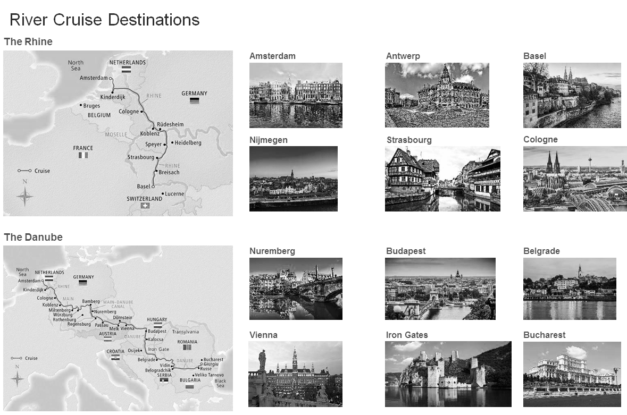

Source: Company files.

Exhibit 4: Competitive Landscape, Price versus Star Ranking

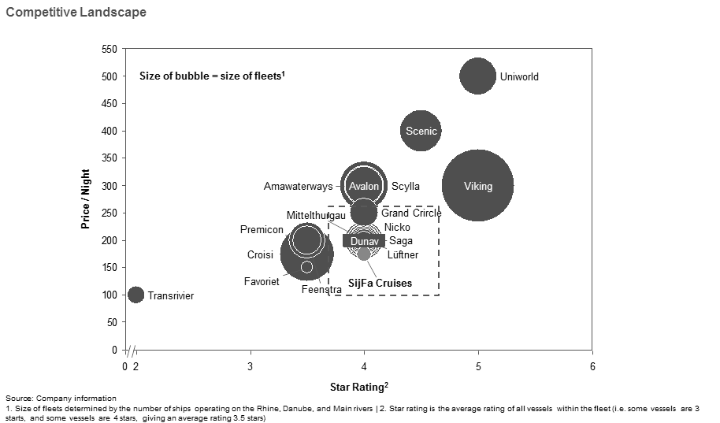

Note: (1) The size of fleets was determined by the number of ships operating on the Rhine, Danube, and main rivers; (2) star rating was the average rating of all vessels within the fleet (i.e., some vessels were 3 stars and some vessels were 4 stars, giving an average rating of 3.5 stars).

Source: Company documents.

Exhibit 5: temarca Financial Statements (Year ended December 31)

Income Statement



Note: € = EUR = euro; € .906 = US$1 on November 1, 2016

Source: Company files.

Exhibit 5 (Continued)

Balance Sheet



Note: € = EUR = euro; € .906 = US$1 on November 1, 2016

Source: Company files.

1. € = EUR = euro; € .906 = US$1.00 on November 1, 2016; all currency amounts are in € unless otherwise specified.
2. Free cash flow was calculated as operating cash flow minus capital expenditures and change in net working capital, with operating cash flow typically measured by earnings before interest, taxes, depreciation, and amortization.
3. Although royalty payments were typically structured as a percentage of revenue, upper and lower payment limits were typically in place to protect both the investor and the investee (i.e., monthly royalty payments would never be below $1,000,000 or over $10,000,000).
4. Due diligence referred to the process of investigating a potential investment to confirm all presented facts such as review of financial records and key business transactions.
5. Duke Royalty was incorporated in Guernsey, where the corporate tax rate was 0 per cent.
6. “Spring 2017 Economic Forecast,” European Commission, accessed September 1, 2017, https://ec.europa.eu/info/business-economy-euro/economic-performance-and-forecasts/economic-forecasts/spring-2017-economic-forecast_en.
7. “Travel & Tourism: Global Economic Impact and Issues 2017,” World Travel and Tourism Council, accessed September 1, 2017, https://www.wttc.org/-/media/files/reports/economic-impact-research/2017-documents/global-economic-impact-and-issues-2017.pdf.
8. Will Codwell, “The Slow Return to Paris: How Tourism is Taking Time to Recover,” *The Guardian,* February 20, 2016, accessed September 1, 2017, https://www.theguardian.com/travel/2016/feb/20/return-to-paris-tourism-after-november-terror-attacks.
9. Katherine, LaGrave, “How Terrorism Affects Tourism,” Condé Nast Traveler, March 31, 2016, accessed September 1, 2017, https://www.cntraveler.com/stories/2016-03-31/how-terrorism-affects-tourism.
10. “2017 Cruise Industry Outlook,” CLIA: Cruise Lines International Association, December 2016, accessed September 1, 2017, https://www.cruising.org/docs/default-source/research/clia-2017-state-of-the-industry.pdf?sfvrsn=4.
11. Ibid.
12. “Population Projections: Population Projections Datasets,” United States Census Bureau, 2014 (last updated April 6, 2017), accessed September 1, 2017, https://www.census.gov/programs-surveys/popproj/data/datasets.html;” Population and Population Change Statistics, “Eurostat Statistics Explained,” July 2017 (last updated October 31, 2017), accessed September 1, 2017, http://ec.europa.eu/eurostat/statistics-explained/index.php/Population_and_population_change_statistics.
13. Helga Loverseed, “Cruise Industry—2015,” *Mintel Reports*, accessed September 1, 2017, http://reports.mintel.com/homepages/guest/what_is_oxygen/?__cc=1.
14. The Rigoletto also had a capacity of 115 passengers.
15. Contacts with the travel agencies stated that, in principle, the travel agencies bore the non-sold room risk.