

9B18B009

Fleetway: where the fun never stops

Jeremiah De Sousa wrote this case under the supervision of Professor Ian Dunn solely to provide material for class discussion. The authors do not intend to illustrate either effective or ineffective handling of a managerial situation. The authors may have disguised certain names and other identifying information to protect confidentiality.

*This publication may not be transmitted, photocopied, digitized or otherwise reproduced in any form or by any means without the permission of the copyright holder. Reproduction of this material is not covered under authorization by any reproduction rights organization. To order copies or request permission to reproduce materials, contact Ivey Publishing, Ivey Business School, Western University, London, Ontario, Canada, N6G 0N1; (t) 519.661.3208; (e)* [*cases@ivey.ca*](mailto:cases@ivey.ca)*;* [*www.iveycases.com*](http://www.iveycases.com)*.*

Copyright © 2018, Ivey Business School Foundation Version: 2018-07-12

In March 2018, Harvey Katz, vice-president of Fleetway, was sitting in a newly renovated office located at the back of his 65,000-square-foot (6,000-square-metre) family entertainment centre (FEC) in London, Ontario, wondering how to improve Fleetway’s competitive position. The company had made sound investment decisions in a growing industry, but the industry was nearing saturation, and a billion-dollar company had recently opened its doors in the city. Katz was feeling pressure. Fleetway had a great deal of land and building assets, and the question was how to put these to better use. The board preferred to have an expansion plan operational by the summer when the company could capitalize on the surplus leisure time of students and families. Katz needed to have his proposal ready for the next board meeting in just a few days.

FAMILY ENTERTAINMENT CENTRES

An FEC was a small-scale amusement facility, usually marketed toward families with children or teenagers. Having multiple anchor attractions differentiated FECs from single-anchored leisure attractions such as bowling, skating, laser tag, miniature golf, or arcades. Demographic studies had revealed a direct relationship between the number of amenities offered and the happiness of consumers. Multiple attractions created an FEC’s identity and reputation, leading to its appeal and popularity. FECs were known to have long wait-times during peak season, but consumers did not mind because they could enjoy other activities or food and beverages while they waited. Offering food and beverages did not yield high margins but helped bring consumers through the door to play the higher-margined recreational games.

The FEC businesses in Canada were small and under-developed compared to the international FEC industry. Canadian businesses would often look to the American industry for resources and direction. Not-for-profit organizations like the International Association of Amusement Parks and Attractions, as well as the Bowling Proprietors’ Association of America, hosted trade shows that offered consulting sessions, half-day symposiums, and networking receptions. These events helped attendees improve their efficiency, marketing, safety, and profitability while providing them with an opportunity to stay ahead of their competitors. Active management was an important quality for any FEC, especially in regions with a higher concentration of competition.

The Canadian industry was highly fragmented, composed of many small establishments that operated a single location and catered to a market niche of local consumers. In 2017, the largest industry operators accounted for less than 5 per cent of industry revenue. Of the more than 20,000 establishments in Canada, an estimated 99.2 per cent had fewer than 100 employees. However, with the expanding presence of U.S.-based companies in Canada, market share was expected to become more concentrated over the next five years. The number of new enterprises had increased 4.5 per cent annually, due to growing demand and relatively low barriers to entry. The Canadian FEC **industry saw revenues of CA$1.5 billion**[1] **in 2017 and,** at an average rate of 4.5 per cent between 2012 and 2017, **was growing faster than the gross domestic product**.[2] Continued growth of 2.3 per cent annually was projected (see Exhibit 1).

Per-capita expenditure was between $10 and $17 for a typical visit, where the average length of stay was two to two-and-a-half hours. Most FECs were subject to seasonality, and fluctuation in revenue was dependent on weather, location, and product mix. Competing factors differentiating FECs were the type of facility, level of technology, location, customer service, and price offerings. Investing in innovative equipment and hiring technical expertise were key advantages to ensure customer safety and to extend the life-span of equipment. In turn, this helped reduce operating costs, increase profits, and improve customer service and loyalty.

The industry was expected to cope with many consumers being time-strapped over the next few years as per capita leisure time remained at 5.4 hours per day. Nevertheless, health-conscious consumers and households who valued spending their limited leisure time with family preferred to fill their spare time with physical activities rather than watching television or participating in other sedentary activities. Furthermore, the number of children under 19 and the amount of disposable household income were both expected to increase.

REGULATION AND POLICY

Industry operators had difficulty developing brand awareness beyond their local community. Securing a large amount of space required to build an FEC was challenging because many Canadian municipalities allocated urban land for industrial and office use, rather than for retail areas or establishments like FECs. This limited the opportunity for an FEC to expand its operations or to relocate close to large retailers, such as shopping malls, which would drive customer traffic. Furthermore, FECs were required to comply with regulations related to the *Amusement Devices Act*. For example, offering high-adrenaline activities such as a trampoline park or go-karts required taking steps to obtain a licence and complete a government mandated inspection.

Small businesses in Ontario were facing increased rates for a few of their main expenses due to recent government legislation. Most notably in January 2018, the minimum wage increased by 22 per cent to $14 per hour and was set to rise again in 2019. Most FECs hired at minimum wage. The prices for hydro and utilities, another substantial cost for FECs, were also expected to increase. The government planned to institute a 2 per cent annual increase until the year 2022. Between 2022 and 2027, hydro and utilities were projected to grow 6.5 per cent annually, followed by a significant 10.5 per cent increase in 2028. In 2017, rent and utilities, and wages accounted for 8.9 per cent and 32.9 per cent of industry revenue, respectively.

To combat obesity among the general population, particularly in younger individuals, many provinces and territories had planned to invest in campaigns that raise awareness of health ailments related to obesity. FECs were increasingly incorporating physical activity into their offerings to attract health-conscious individuals.

CUSTOMERS

The majority of FECs targeted families as their primary customers. London was the 11th-largest city in Canada and had over 100,000 families, up 3.5 per cent over the previous decade. However, London was experiencing an increased number of households without children. The average after-tax income was $70,000 for families without children and $90,000 for those with children. The north and west regions of London were host to the majority of high-income earners.

Families were not willing to travel more than 15 to 20 minutes per visit. In addition to proximity, families valued price, safety, and a multitude of amenities for the whole family to enjoy. During the summer months, they preferred to engage in outdoor activities and summer programs—something to keep the kids busy during their time out of school. Families were also known to choose an FEC to host their children’s birthday parties. They preferred an FEC that had party rooms and catered food and beverages. In addition, where bowling was offered, families with young children preferred five-pin bowling over the standard 10-pin bowling.

Besides families, FECs attracted young individuals, recreational groups, and local businesses. University and college students often visited because it was a fun date location or because it was a good way to decompress from their studies. They would grab drinks and go for a few rounds of bowling, billiards, or miniature golf. Typically, they visited later in the evening when families had gone home. Students valued price and promotions as well as location—close to where they lived. Another type of consumer was the regular who thoroughly enjoyed a particular activity and visited weekly for recreational purposes. The most common recreational programs were bowling leagues that mainly engaged an older, retired consumer who had a great deal of free time. Lastly, FECs located at an upscale location hosted corporate events, which made consumers out of a wide array of local businesses. Businesses looking to conduct team-building exercises or host holiday events would choose an FEC for their private rooms and amenities. They were not price-conscious, but they did place a high value on service and reputation. Location was not a top priority; they valued the atmosphere as well as the food and beverage options.

COMPETITORS

Palasad: Thrilling Food and Fun

Palasad was a leading entertainment venue operator with two locations in London (see Exhibit 2), priding itself on a thrilling experience for both its guests and its employees. The founder, Rob Szabo, started Palasad with the conviction that bowling and billiards should be comfortable, cool, and accompanied by great food and drink. Szabo managed his family’s fitness club after getting a degree in economics and an MBA from Ivey at Western University (Western). Palasad opened its doors in the mid-1990s after Szabo capitalized on the closure of a rundown bowling alley in the same building as the fitness club. After a few years of success, Palasad expanded to another location in south London.

Palasad North was at the corner of a busy intersection, a few blocks away from London’s downtown core. This location attracted many private events, especially over the three-month span leading up to the holiday season. Revenues from this consumer segment represented roughly 35 per cent of the company’s total revenues. However, this location was too far away from downtown to benefit from the high traffic during the summer months. In addition to competing with the nearby patios and festivals that graced London’s Richmond Row, Palasad North was negatively affected by the departure of university and college students. Seasonality was not as prominent at the south location where the focus was more on families.

Palasad’s upscale lounge and dining experience was the main attraction. Food and beverage accounted for over 50 per cent of revenues, with the big draw coming from its wood oven cuisine. The strategy was to attract parents with the dining experience and have them bring their kids for the games. Palasad North occupied a 20,000-square-foot (1,800-square-metre) facility, which offered 10-pin bowling (10 lanes), billiards, and an arcade. Their long-standing liquor licence set them apart in the industry and their policy of no minors after 9 p.m. was attractive for millennials.[3]

The south location was a beautiful 40,000-square-foot (3,700-square-metre) facility that saw recent renovations worth over $1 million. In addition to the premier dining experience, the location offered 10-pin bowling (20 lanes), billiards, arcade games, laser tag, karaoke, and ping pong.

Palasad had maintained a high customer service standard over the years. However, questions arose on how this standard would be maintained in the face of rising wages. Palasad’s emphasis on food and beverages meant it employed more workers than the industry average.

The Rec Room: Canada’s Premier Eats and Entertainment

The Rec Room (RR) would be the newest entrant in London’s family entertainment scene, opening its north London location in April 30, 2018. In 2016, Cineplex Entertainment Company (Cineplex), known for its movie theatres, opened the first RR location in Edmonton, followed by a second location in Toronto in 2017. Developing and scaling gaming-related amusement and leisure concepts, including RR, was one of Cineplex’s key strategic points of focus for future growth. Cineplex welcomed 75 million guests annually through its network of 164 theatres across Canada. Additionally, Cineplex was a joint venture partner in SCENE, which was Canada’s largest entertainment loyalty program. Membership in the program had surpassed eight million Canadians in 2017.

RR was a premium FEC, offering a wide range of entertainment options including simulation, arcade, recreational gaming, and an auditorium-style live entertainment venue for watching a wide range of entertainment programming. The typical FEC activities such as bowling and billiards were complemented by exclusive experiences like virtual reality gaming, axe throwing, and next-generation racing simulators.

The entertainment options were paired with an upscale casual dining environment, featuring one of the largest wood-fired grills in Canada. The open kitchen design, centre bar with a wide range of digital monitors, and a large screen above the bar allowed customers to watch sporting and other major events. RR also offered exclusive use of the building and designated space for private meetings, large groups, luncheons, team building, and seminars. The premium products and services targeted families, high- income earning adults, or anyone looking for an alternative entertainment experience. The effect of RR’s opening on the industry and the other players in London has yet to be seen.

East Park: London’s Place to Play

Established in 1963, East Park (EP) had grown to be one of the most popular summer destinations in London. EP was an entrenched institution and facility in the city. It was founded by a group of 10 prominent London families who had given much to the community, providing jobs and contributing millions to various local not-for-profit initiatives. It was rare to have grown up in London and not to have had memories of going to EP as a child. EP’s general manager was well known within London. He was passionate about people and about his job. He received an honours bachelor degree in urban development from Western.

EP was located on over 100 acres of parkland near the eastern boundaries of the city. Its combination of indoor and outdoor activities served all ages and attracted over 75,000 annual visitors (in summers only). At its inception, the park employed 20 people and offered just a few golfing related activities. It had since grown to employ 250 people and offered an 18-hole golf course, driving range, two miniature golf courses, batting cages, a go-kart track, seven water slides, a splash pad with a waterclimber, a rock climbing wall, bumper cars, jungle gym, a video arcade, and two on-site indoor café and bar areas. Many recreational programs were offered over the years, including Summer Junior Day Camp, which ranged from golf and rock climbing to fun camps with over 700 campers each season. Other innovative programs included the East Park Corporate Challenge, various team building events, and most recently the East Park Amazing Race.

The Factory

The Factory was set to open its doors in London’s old east core in spring 2018. Located in the old Kellogg cereal plant that opened in 1913, the future FEC was projected to be the largest in London at 160,000 square feet (15,000 square metres). Dan Cassidy, part-owner and prospective general manager, had no previous experience in the FEC industry. He graduated from Mohawk College and had experience in supply chain management in the home improvement industry. The Factory had been under development since January 2017. Cassidy’s vision was to fill every last inch of space with endless fun catered to all ages. The FEC was expected to offer high ropes, zip-lines, a trampoline park, an ultimate warrior course, an arcade, a kid’s jungle gym, laser tag, virtual reality, escape rooms, and a restaurant and lounge area with Wi-Fi. Cassidy and his financial partners believed that the London market was ready for a big recreational attraction.

FLEETWAY

Fleetway was owned and managed by its parent company, Esam Group, which had its head office at the back of Fleetway’s facility. Sam Katz, the co-founder, was known as “the mayor of Cherryhill,” having built what is known as the Cherryhill region of London on Oxford Street West (see Exhibit 2). After surviving six years in a Nazi concentration camp, Katz came to Canada in 1949 and met German immigrant Ewald Bierbaum while standing in an unemployment line. In 1955, the new business partners combined their first names to form Esam Construction Ltd. Katz would eventually buy out his partner and take full control of the company. Katz was prominent and beloved among Londoners; he was named to the mayor’s first seniors’ honour list. Katz died in 2001—the father of high-rise living in London. The business had since been passed on to his two sons, Howard and Harvey, who earned degrees at Western in engineering and commerce, respectively. Perhaps out of necessity, running Fleetway had become a team effort where extended family filled up Esam’s offices to support the Katz sons, who were also pastors at a local congregation of around 500 people. Esam had recently completed one of the biggest real estate deals in Canada, selling off a portion of its apartment assets for over $200 million.

Fleetway began in the 1960s as a bowling centre called Fleetway 40 (having 40 lanes) and, since its inception, had gone through many changes, offering everything from rock climbing to a high ropes course. However, Fleetway’s current operations included six business segments: 10-pin bowling (24 lanes) and five-pin bowling (20 lanes), billiards (14 tables), glow miniature-golf (18 holes), Fleetplay (a children’s jungle gym), arcade games, and revenues from leased space to Dairy Queen and Pizza Projekt (see Exhibit 3).[4] Fleetway also offered event rooms, primarily used for children’s birthday parties (revenues from this segment were negligible).

Dairy Queen had been in a lease agreement with Fleetway for 20 years and just recently teamed up with a local restaurant owner to open a new restaurant in the complex. This was Fleetway’s first venture into offering food beyond what was served at Dairy Queen. Pizza Projekt was a full-service restaurant that offered gourmet pizza using high quality ingredients. Additionally, Pizza Projekt offered alcoholic beverages, appetizers, and fresh salads. Because of Pizza Projekt’s alcoholic beverage offerings, Fleetway had licensed the whole complex for alcohol to be served at the bowling lanes and the pool tables. “Food on the floor” was a new service of which customers had yet to take full advantage.

Fleetway appealed mostly to the family market (parents with children), because it was a clean, safe, and spacious entertainment facility. Its secondary market was students from Western and Fanshawe College, and seniors who resided in the nearby apartment buildings. League bowling was popular among seniors, which accounted for approximately 35 per cent of bowling revenues. The bowling industry had experienced negative growth forcing many bowling centres out of business. Fleetway had become the only bowling alley in London that offered five-pin league bowling and standard lane sizes.

FLEETWAY FINANCIALS

Katz wanted to make sure he had a strong understanding of Fleetway’s financial position before preparing his proposal for the board of directors (see Exhibits 4 and 5). He considered investigating the company's cash position as well as reviewing some relevant financial ratios (see Exhibit 6). Katz also wanted to evaluate the performance of Fleetway’s individual business segments (see Exhibit 7). The total revenue for all six segments was $2,833,274 in fiscal year (FY) 2018 (see Exhibit 8). To allocate FY 2018 expenses across the individual segments, Katz needed to make a few assumptions. He thought expenses that were not easily traceable to individual business streams should be divided evenly between segments. He determined that staff wages should be allocated based on the percentage of sales each segment earned, excluding the leased space. Moreover, Katz thought it would be best to divide utilities and property taxes based on the measured area of each segment (see Exhibit 9). The depreciation for building, computer, and furnishings could also be allocated using measured area; however, the remaining depreciation was attributable to each segment based on its respective assets. Finally, 70 per cent of the advertising and promotion expenses would be split evenly between Fleetplay and bowling, where the remaining 30 per cent was divided evenly between the arcade, billiards, and miniature golf.

FLEETWAY’S FUTURE FOCUS

As London’s FEC industry grew crowded, Fleetway’s management wanted to re-establish its identity in the market. Fleetway had three strategic options: position itself as a premium experience, focus on providing the best experience for families, or become all things to all people. As Katz weighed the long-term implications of such a positioning decision, he wanted to evaluate the feasibility of a few different expansion options. Fleetway’s management agreed to consider the possibility of expanding the company’s service mix to offer an adventurous go-kart track, state-of-the-art escape rooms, or both.

Go-Kart: Driving the Fun Forward

Behind Fleetway’s facility was an empty 13,000-square-foot (1,200 square-metre) warehouse that belonged to Esam and was available to Fleetway if Katz could convince Esam’s management that an expansion would be profitable. The closure of a few go-karting tracks left a single competitor in the market, EP, who was open for only half the year. Fleetway considered filling a need in the market by offering go-karting year-round, rain or shine, by building a go-karting arena in the warehouse. Such a transformation would require a significant investment. Katz wondered if this decision was worth all the effort and if there was room for another go-karting business in London. Fleetway considered choosing electric go-karts over gas-powered models to set itself apart. [Electric go-karts were faster](https://www.youtube.com/watch?v=8_o9T7jGMw0&list=UU4E_HFzJYAu7Q4xU21XJ5Eg), cleaner, safer, and easier to maintain.

Fleetway would save $100,000 by not having to build a structure for go-karting; however, other significant investments were needed before business could begin. The major start-up costs included all new go-karting equipment, the cost to build a track, getting the warehouse up to code, and building a corridor that connected the warehouse to Fleetway’s existing facility (see Exhibit 10). Furthermore, $10,000 was needed to cover an initial grand opening event; the cost was expected to be covered by re-allocating Fleetway’s existing advertising and promotion budget. Katz expected operating costs to include utilities, insurance, maintenance on the go-karts, and supplies. Utilities would be a minimum of $4,000 per month, plus 1 per cent of the overall sales, taking into account the electrical charging of the go-karts. Insurance and maintenance costs would be $2,000 per month and 5 per cent of sales, respectively. Supplies related to go-karting were projected to be 3 per cent of sales.[5] Fleetway would hire a track manager at $17 per hour and a technician at $15 per hour; both would work 40 hours per week for 50 weeks per year. Three additional part-time employees would also be required and would work 20 hours per week. Part-time employees would be paid minimum wage and would require five hours of paid training before they began their job.

The indoor facility would allow Fleetway to operate go-karting year-round. Daily hours of operation for go-karting would be between 12 p.m. and 10 p.m. daily. Fleetway’s pricing strategy was to charge the same amount as East Park—$8 per ride. At full capacity, Fleetway expected to utilize all go-karts for each cycle.[6] Interest in go-karting in London was relatively small and appealed mainly to thrill seekers. On average, Fleetway expected to run at 13 per cent capacity for half the year and at 10 per cent capacity the other half of the year when EP was open.

Katz expected the construction of the facility to be completed after two months, with the licensing and government approval taking an additional one to three months. Because go-karting was different from the rest of Fleetway’s offerings, Katz did not expect any cannibalization. However, he wanted to be conservative in his estimates and analyze the feasibility of the venture with only half of the projected revenues being earned.

Escape Rooms: A Suspenseful Opportunity

An escape room was a challenging group activity that took place inside a themed game-room. The objective was to discover clues, solve puzzles, and open locks that eventually led to escaping the room.[7] Escape rooms were considered a premium form of entertainment due to their significantly higher price point, which was between $25 and $30 on average. Escape rooms attracted an older and wealthier demographic, while family groups accounted for just 14 per cent of total client groups (see Exhibit 11).

The North American escape room industry had grown 300 per cent annually since its inception. However, Katz wondered if the London market had reached saturation. The city already had five escape rooms—the majority concentrated in London’s downtown core. Still, Fleetway’s management was intrigued by the idea of opening its own escape room to capitalize on a growing industry while diversifying its consumer base. Furthermore, the decision would be independent from the go-karting opportunity.

If Fleetway went forward with an escape room, it would have to build a 7,000-square-foot (650-square-metre) extension to the facility.[8] The construction costs would average $125 per square foot ($1,300 per square metre) and an additional $20,000 would be needed to finish and furnish the welcome desk and lobby area. A brand new, state-of-the-art facility was thought to be a potential competitive advantage; most escape rooms were not aesthetically welcoming. The design and layout of the rooms would be decided one of two ways: Fleetway would outsource it to an escape room in Toronto or they would hire a “puzzle master” to work in-house. Either option would cost about $70,000 per year, which covered the cost of the props and either the licensing fees or the manager’s salary. Both scenarios had their merits. Outsourcing would bring an instantaneous reputation for premium puzzles and would allow operations to commence almost immediately. The in-house option allowed for more control and the opportunity to earn money in the future from outsourcing the puzzle designs created by the puzzle master.

Fleetway would need to hire a manager and four part-time employees to run the escape rooms. They would be paid the same rates as those listed in the go-karting opportunity. Annual maintenance, utilities, and insurance would cost $15,000, $14,000, and $12,000, respectively. The escape rooms would be open between 4 p.m. and 10 p.m. on weekdays and between 12 p.m. and 11 p.m. on weekends. The weekend rate would be $28 per person, up from the $25 weekday price. Like any other Fleetway activity, customers would pay with cash or credit, except for corporate clients who were all expected to exercise extended credit terms of net 30 days.[9] Katz predicted that the escape rooms would operate at a capacity of between 5 and 10 per cent during the week and between 20 and 30 per cent on the weekend. Lastly, 20 per cent of Fleetway’s existing advertising and promotional budget would be re-allocated to promote the escape rooms.

CONCLUSION

As Katz watched his grandson climb to the top of Fleetplay’s jungle gym, he wondered what it would take to become the leading FEC in the city. Which option would help Fleetway better establish itself: offering escape rooms, creating a go-kart complex, or both? Fleetway had an internal target of between 20 and 25 per cent return on investment or an approximate five-year payback period. Katz did not believe it was necessary to project financial statements, because Fleetway’s financials were seldom analyzed apart from the financials of the parent company, Esam Group.

The upcoming opening of RR and the future opening of The Factory had forced many industry incumbents to re-consider their strategy; Fleetway was no different. Katz wondered which would be better—continuing to position Fleetway as a fun-first location or operating more as a premium FEC? While Katz had a lot to consider, he also wanted to maintain a faithful commitment to his congregation and grow the family legacy that his father had passed on to the next generation. He waved to his grandson as he pondered the company’s future strategy.

**EXHIBIT 1: INDUSTRY REVENUE GROWTH**



Source: “Solutions: Industry Research Reports,” IBIS World: Where Knowledge Is Power, accessed February 18, 2018, https://www.ibisworld.ca/.

EXHIBIT 2: MAP OF LONDON AND FEC LOCATIONS

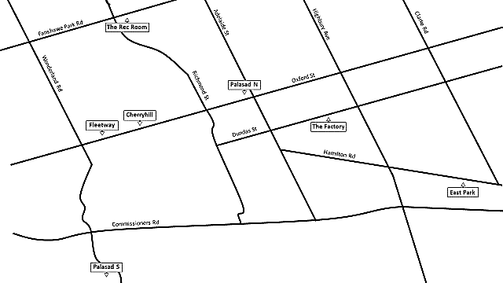

Source: Created by the authors.

EXHIBIT 3: SERVICES OFFERED BY FLEETWAY

BOWLING

KIDS PLAY ZONE

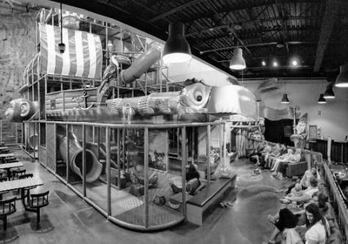

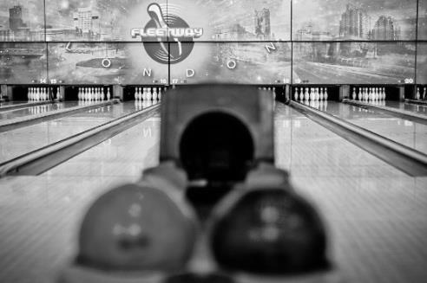

GLOW MINIATURE GOLF

BILLIARDS

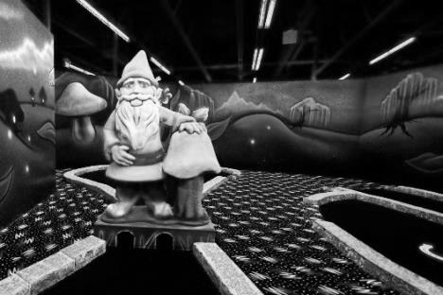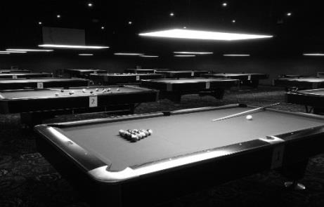

ARCADE

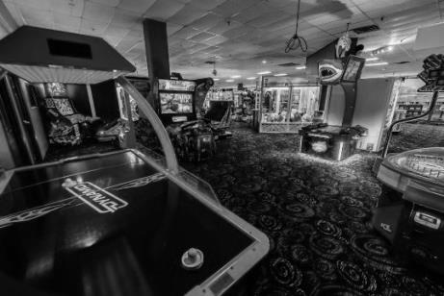

DAIRY QUEEN

PIZZA PROJEKT

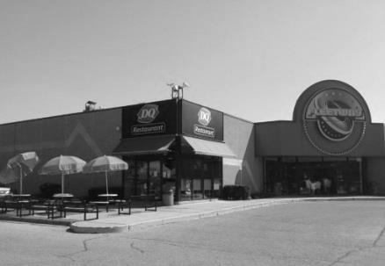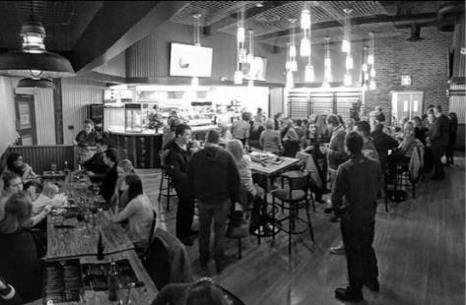

Source: Company files.

EXHIBIT 4: STATEMENT OF EARNINGS For the Years Ending February 28 (in CA$)

|  |  |  |  |  |  |  |  |  |
| --- | --- | --- | --- | --- | --- | --- | --- | --- |
|  |  |  | **2018** |  |  |  | **2017** |  |
| **REVENUES** | 100% |  |  | $2,833,274 | 100% |  |  | $2,672,900 |
|  |  |  |  |  |  |  |  |  |
| **OPERATING EXPENSES** |  |  |  |  |  |  |  |  |
| Management salary | 6.9% |  | $195,496 |  | 6.5% |  | $173,739 |  |
| Employee benefits | 3.5% |  | 99,165 |  | 3.2% |  | 85,533 |  |
| Staff wages | 27.0% |  | 764,984 |  | 25.2% |  | 673,571 |  |
| Ad. and promo. | 5.0% |  | 141,664 |  | 5.0% |  | 133,645 |  |
| Depreciation | 11.2% |  | 316,000 |  | 9.0% |  | 240,561 |  |
| Bowling supplies | 0.5% |  | 14,166 |  | 0.5% |  | 13,365 |  |
| Arcade supplies/prizes | 1.1% |  | 31,166 |  | 1.1% |  | 29,402 |  |
| Insurance | 2.2% |  | 62,332 |  | 1.8% |  | 48,112 |  |
| Licensing and fees | 0.1% |  | 2,833 |  | 0.1% |  | 2,673 |  |
| Office supplies | 1.9% |  | 53,832 |  | 1.9% |  | 50,785 |  |
| Property taxes | 2.2% |  | 62,332 |  | 2.0% |  | 53,458 |  |
| Utilities | 3.5% |  | 99,165 |  | 3.1% |  | 82,860 |  |
| Loss on disposal | 0.9% |  | 25,000 |  | 0.0% |  | 0 |  |
| Total | 65.9% |  |  | 1,868,135 | 59.4% |  |  | 1,587,704 |
| Income before tax |  |  |  | 965,139 |  |  |  | 1,085,196 |
|  |  |  |  |  |  |  |  |  |
| Income Tax |  |  |  | 241,285 |  |  |  | 271,299 |
|  |  |  |  |  |  |  |  |  |
| **Net Income** |  |  |  | $723,854 |  |  |  | $813,897 |

Source: Company files.

EXHIBIT 5: STATEMENT OF FINANCIAL POSITION, AS OF FEBRUARY 28 (in CA$)

|  |  |  |  |  |  |  |  |  |  |  |  |  |
| --- | --- | --- | --- | --- | --- | --- | --- | --- | --- | --- | --- | --- |
| **ASSETS** | **2018** | | | |  | | **2017** | | | | | |
| CURRENT ASSETS |  | |  | |  | |  | | |  |
| Accounts receivable* | $15,250 |  | |  | | $10,000 | |  | | | |
| Inventory | 7,000 |  | |  | | 8,000 | |  | | | |
| Total current assets |  | $22,250 | |  | |  | |  | $18,000 | | | |
|  |  |  | |  | |  | |  |  | | | |
| LONG-TERM ASSETS |  |  | |  | |  | |  |  | | | |
| Building, computers, and furnishings | 317,000 |  | |  | | 317,000 | |  |  | | | |
| A/D—Building, computers, and furnishings | (280,500) | 36,500 | |  | | (254,500) | |  | 62,500 | | | |
| Bowling equipment | 2,500,000 |  | |  | | 2,500,000 | |  |  | | | |
| A/D—Bowling equipment | (2,350,000) | 150,000 | |  | | (2,325,000) | |  | 175,000 | | | |
| Computer scoring system (bowling) | 400,000 |  | |  | | 400,000 | |  |  | | | |
| A/D—Computer scoring system (bowling) | (160,000) | 240,000 | |  | | (80,000) | |  | 320,000 | | | |
| Miniature golf | 550,000 |  | |  | | 550,000 | |  |  | | | |
| A/D—Miniature golf | (310,000) | 240,000 | |  | | (220,000) | |  | 330,000 | | | |
| Billiards | 200,000 |  | |  | | 200,000 | |  |  | | | |
| A/D—Billiards | (200,000) | – | |  | | (180,000) | |  | 20,000 | | | |
| Fleetplay | 450,000 |  | |  | | – | |  |  | | | |
| A/D—Fleetplay** | (75,000) | 375,000 | |  | | – | |  | – | | | |
| Rock climbing wall | – |  | |  | | 250,000 | |  |  | | | |
| A/D—Rock climbing wall | – | – | |  | | (250,000) | |  | – | | | |
| Total long-term assets |  | 1,041,500 | |  | |  | |  | 907,500 | | | |
| **TOTAL ASSETS** |  | $1,063,750 | |  | |  | |  | $925,500 | | | |
|  |  |  | |  | |  | |  |  | | | |
| **LIABILITIES AND EQUITY** |  |  | |  | |  | |  |  | | | |
| CURRENT LIABILITIES |  |  | |  | |  | |  |  | | | |
| Accounts payable† | $10,000 |  | |  | | $11,500.00 | |  |  | | | |
| Accrued wages payable | 21,400 |  | |  | | 24,000 | |  |  | | | |
| Total current liabilities |  | $31,400 | |  | |  | |  | $35,500 | | | |
|  |  |  | |  | |  | |  |  | | | |
| SHAREHOLDERS’ EQUITY |  |  | |  | |  | |  |  | | | |
| Common shares | 10,000 |  | |  | | 10,000 | |  |  | | | |
| Retained earnings | 1,022,350 |  | |  | | 880,000 | |  |  | | | |
| Total shareholders’ equity |  | 1,032,350 | |  | |  | |  | 890,000 | | | |
| **TOTAL LIABILITIES AND EQUITY** |  | $1,063,750 | |  | |  | |  | $925,500 | | | |

Note: A/D = accumulated depreciation; *Accounts receivable are from bowling leagues; **Fleetplay was purchased March 1, 2017 to replace the rock climbing wall; †Fleetway used accounts payable to make all purchases of supplies inventory

Source: Company files.

EXHIBIT 6: SELECTed Family Entertainment Centre RATIOS FOR 2018

|  |  |  |  |  |  |  |
| --- | --- | --- | --- | --- | --- | --- |
|  |  | **PALASAD** | **CINEPLEX** | **INDUSTRY** | **FLEETWAY** | |
|  |  |  |  |  | **2018** | **2017** |
| Current ratio | | 1.75 | 0.50 | 1.10 | 0.70 | 0.50 |
| Quick ratio | | 1.50 | 0.40 | 0.80 | 0.50 | 0.30 |
| Days of A/R | | 2.00 | 18.00 | 0.60 | 11.10 | 7.70 |
| Days of A/P | | 2.00 | - | 19.70 | 36.30 | 44.30 |
| Days of inventory | | 18.00 | 13.00 | 15.80 | 25.40 | 30.10 |
| ROA |  | 0.27 | 0.05 | 0.07 | 0.68 | 0.88 |
| ROE |  | 0.40 | 0.11 | 0.25 | 0.70 | 0.91 |
| Interest coverage | | 16.00 | 6.80 | 5.80 | – | – |
| Debt to equity | | 0.65 | 0.65 | 3.80 | 0.03 | 0.04 |
| Debt to assets | | 0.50 | 0.56 | 2.20 | 0.03 | 0.04 |

Note: A/R = accounts receivable; A/P = accounts payable; ROA = return on assets; ROE = return on equity

Source: Company files.

EXHIBIT 7: SEGMENT UTILIZATION

|  |  |  |  |  |  |  |  |
| --- | --- | --- | --- | --- | --- | --- | --- |
| **PEAK SEASON** | |  | **Arcade** | **Billiards** | **Bowling** | **Miniature Golf** | **Fleetplay** |
|  |  |  |  |  |  |  |  |
| **Monday** | Afternoon | | 5% | 40% | 60% | 10% | 50% |
| Evening |  | 15% | 40% | 100% | 25% | 5% |
| **Tuesday** | Afternoon | | 5% | 40% | 60% | 10% | 50% |
| Evening |  | 15% | 40% | 100% | 25% | 5% |
| **Wednesday** | Afternoon | | 5% | 40% | 60% | 10% | 50% |
| Evening |  | 15% | 40% | 100% | 25% | 5% |
| **Thursday** | Afternoon | | 5% | 40% | 80% | 10% | 50% |
| Evening |  | 15% | 40% | 100% | 25% | 5% |
| **Friday** | Afternoon | | 5% | 40% | 20% | 10% | 50% |
| Evening |  | 15% | 80% | 75% | 60% | 10% |
| **Saturday** | Afternoon | | 80% | 40% | 80% | 75% | 90% |
| Evening |  | 80% | 80% | 90% | 75% | 20% |
| **Sunday** | Afternoon | | 80% | 40% | 90% | 75% | 90% |
| Evening |  | 40% | 50% | 40% | 60% | 20% |

Source: Company files.

EXHIBIT 8: DISTRIBUTION OF REVENUES BY BUSINESS SEGMENT in 2018

Source: Company files

EXHIBIT 9: FLEETWAY FLOOR PLAN

Arcade

1,500

sq.

ft.

Bowling

48,000

sq.

ft.

Dairy Queen

3,500

sq.

ft.

Mini Golf

3,500

sq.

ft.

FleetPlay

3,500

sq.

ft.

Billiards

2,000

sq. ft.

Pizza Projekt

3,000

sq.

ft.

Note: sq. ft. = square feet; 1 square foot = 0.09 square metres

Source: Company files.

EXHIBIT 10: GO-KART INVESTMENTS (in CA$)

|  |  |
| --- | --- |
| **Start-up Costs—Go-Karting Costs\*** |  |
| Go-karts (x18) | 45,000 |
| Helmets (x25) | 2,500 |
| Spare equipment on hand (tires, gas tanks, batteries, parts) | 10,000 |
| Track design (outsource) | 1,200 |
| Track construction (tire barriers, railing, labour) | 40,000 |
| Additional props (race lights, themed items, paint) | 10,000 |
| Technology (speed clocks, screens, racing software) | 10,000 |
| **Total Go-karting Outflows** | **118,700** |
| **Start-up Costs—Renovation\*\*** |  |
| Concrete floor paving ($8 per square foot) | 52,000 |
| Sound proofing walls ($6 per square foot) | 78,000 |
| Heating, ventilation, and cooling | 10,000 |
| Electrical, fire safety, and security | 50,000 |
| Welcome desk, bathrooms, seating | 20,000 |
| Corridor leading to facility | 50,000 |
| **Total Renovation Costs** | **260,000** |
|  |  |
| **Total Start-up Costs** | **378,700†** |

Notes: *Go-karting costs would be depreciated using the straight-line method with no residual value; useful life was expected to be six years; **Renovation costs would be depreciated using the straight-line method with no residual value; useful life was expected to be 10 years; †Fleetway’s internal borrowing rate was 3 per cent.

Source: Company files.

EXHIBIT 11: ESCAPE ROOM AGE DISTRIBUTION

Source: Scott Nicholson, “The State of Escape: Escape Room Design and Facilities,” paper presented in Lansing Michigan, 2016, accessed February 18, 2018, http://scottnicholson.com/pubs/stateofescape.pdf.

1. All currency amounts are in CA$ unless otherwise specified.
2. The gross domestic product (GDP) was the total value of goods produced and services provided in a country for one-year; GDP was often used as an indicator to gauge the economic health of a country.
3. Millennials are defined as those aged between 18 and 34.
4. Fleetway formed a partnership with Cineplex, offering space in its building for Cineplex-owned arcade machines.
5. Initial start-up costs would include a 15-day inventory of supplies.
6. A cycle was the time it took for a person to complete one ride, plus any time to prepare the rider for the race. On average, each cycle took 7.5 minutes to complete.
7. Groups had 60 minutes to complete the challenge; the average group size was eight people.
8. The building was expected to have a useful life of 15 years and would have a total of six escape rooms.
9. Corporate customers were expected to make up 25 per cent of all clientele.