

9B18B010

master decker: Expansion Opportunities

Eleni Petrou wrote this case under the supervision of Professor Ian Dunn solely to provide material for class discussion. The authors do not intend to illustrate either effective or ineffective handling of a managerial situation. The authors may have disguised certain names and other identifying information to protect confidentiality.

*This publication may not be transmitted, photocopied, digitized or otherwise reproduced in any form or by any means without the permission of the copyright holder. Reproduction of this material is not covered under authorization by any reproduction rights organization. To order copies or request permission to reproduce materials, contact Ivey Publishing, Ivey Business School, Western University, London, Ontario, Canada, N6G 0N1; (t) 519.661.3208; (e)* [*cases@ivey.ca*](mailto:cases@ivey.ca)*;* [*www.iveycases.com*](http://www.iveycases.com)*.*

Copyright © 2018, Ivey Business School Foundation Version: 2018-07-11

In May 2017, Matthew Druzcz was contemplating expanding his deck restoration business. Master Decker was entering its fourth year of operations, and Druzcz thought it was the right time to focus on growth. He was considering three expansion alternatives: offering deck building, marketing an exclusive line of stains, and manufacturing deck cleaning chemicals. Druzcz wondered which option would provide the best return on investment.

COMPANY BACKGROUND

Druzcz had started restoring decks in London, Ontario to generate income in the summer of his second year of studies at Western University. He quickly realized that the demand for a company that would seal, stain, and repair decks and other wood structures was significant. Druzcz incorporated Master Decker in 2014 and developed a specialist restoration system by researching the methodology used by Australian and American deck-servicing companies and modifying it for the Canadian climate. Druzcz continued to operate and manage Master Decker while completing his bachelor’s degree at the Ivey Business School at Western University. After graduation, Druzcz, an entrepreneurial individual, balanced operating Master Decker and a couple of other business ventures with his work in data analytics.

Druzcz was born and raised in London, Ontario, and he had a history of involvement in community and social initiatives. As a result, he was well connected, and Master Decker drew a lot of business purely because of Druzcz’s relationships. Many clients were also referred to Master Decker through word of mouth from past customers who had been satisfied with the service they received. Druzcz secured an office location in Zorra, Ontario, which enabled Master Decker to better serve the company’s main markets of London, Kitchener, and Hamilton. The company also had a number of clients in Guelph. Master Decker sometimes serviced smaller cities and townships in the surrounding area such as Sarnia, St. Thomas, and Windsor.

As the company grew over the years, Master Decker started to rely more on marketing tactics such as the company website (see Exhibit 1) and Google AdWords. Google reviews, where Master Decker had a five-star rating, also contributed to Master Decker’s positive brand image.

Druzcz believed that a job well done was the best advertisement; therefore, he focused on quality work and good service. He advertised a four-step process (see Exhibit 2), which included a free estimate, an on-site evaluation prior to beginning the project, and project completion to full satisfaction. Restoration services included stripping, cleaning, brightening, sanding, staining, and board replacement. The extensive process employed by Master Decker, as well as the use of high quality supplies and stains meant that restoration projects would remain in good condition far longer than the one season that was typical of the industry. On top of the promised quality, results, service, and expertise offered by the company, Master Decker also provided warranties guaranteeing customer satisfaction with each job.

THE DECK-BUILDING INDUSTRY

With residential real estate at an all-time high and with a shortage of new builds, the housing market in Southwestern Ontario was booming. The deck industry was tied closely to the housing market. For every new house that had been designed with a deck, developers had to hire deck builders. In addition, the high volume of transactions in the housing market generally resulted in more homeowners looking to restore existing decks.

The deck building industry was fragmented, and many small businesses with varying levels of expertise operated in the region. Individuals who were considered “jacks-of-all-trades,” with no particular expertise in building decks, would offer the service. The larger and better-known names included franchises and family-owned companies such as Hickory Dickory Decks, Forans Fence Deck & Spa, and Creative Custom Decks. No one player was dominant.

Many companies offered deck-building services in London, Kitchener, Hamilton, and the surrounding area. However, none of these companies specialized in deck restoration services. In fact, Druzcz had developed good working relationships with the owners of many of these companies, who would refer their customers to Master Decker for maintenance and refurbishing.

Do-it-Yourself (DIY) consumers were individual homeowners who liked to do outdoor projects on their own. Building a deck was a labour-intensive process, and the DIYers had access only to stains and products available at big-box retail stores. Most products carried in these chain stores were not high quality, and they would typically result in the need to re-sand and re-seal the deck every season.

POTENTIAL EXPANSION OPPORTUNITIES

As Druzcz was working and operating other businesses in addition to Master Decker, he started to realize the limits of his personal capacity. If he were to continue operating Master Decker, Druzcz wanted to expand operations such that he could justify his time investment in the company. He was attached to the business that he had started as a student and wanted to grow it to its full potential. In addition, he wanted Master Decker to continue to provide excellent service and quality workmanship, considering that his name would be tied to the company as it grew.

Druzcz was considering three options for the expansion of company operations: providing deck-building services, selling exclusive stains, and manufacturing cleaning chemicals. Though he was curious as to which option would provide the greatest return on investment, Druzcz was open to pursuing one, two, or all three of the options. He did not have a set timeline in mind but wanted to move forward with at least one of the options immediately.

Service Expansion: Deck-building

Druzcz had started thinking about expanding Master Decker’s offerings to include building decks, as this would be in line with the company’s current service offerings. Many of Master Decker’s customers would inquire as to whether the company built decks, and Druzcz had noticed a sharp increase in client requests for the company to expand its existing service offerings. Though Master Decker’s perceived expert status in deck restoration could possibly be compromised, Druzcz was not convinced this risk was real. Based on Druzcz’s conservative projections, Master Decker could build at least 10 decks over the course of the fiscal year. Considering the market demand and the willingness to pay for quality builds, Druzcz figured that he would have no trouble charging CA$10,000[1] per deck. Decks were to be sold on credit with the same terms as his existing service offering of net 9 days.

The deck-building season in Southwestern Ontario lasted around eight months, and Druzcz knew that he would have to hire an additional experienced carpenter. He planned to pay a competitive rate of $40 per hour, and expected that he would need the carpenter for 20 hours per week for the first half of the season, and 40 hours per week for the second half of the season. This carpenter would be accompanied by one of Druzcz’s existing and previously trained employees, who was currently paid a salary of $600 per week. Druzcz estimated that lost referrals resulting from moving into the deck-building business would cost him about $2,500 in foregone restoration sales. He also calculated that he would need $15,000 worth of building materials to construct 10 decks. Master Decker kept 80 days’ worth of inventory on hand at all times.[2] Druzcz knew that if this option were pursued, he would have to purchase insurance costing $2,000 annually. He was also considering opening a line of credit for $20,000 at an annual interest rate of 4 per cent to help finance his expansion plans.

Exclusive Master Decker Stains

Master Decker used top-of-the-line deck stains manufactured by a supplier called DFM. These stains were not widely available to DIYers through the big-box retailers, and Druzcz saw an opportunity to market and sell his stains to these consumers. He thought that having exclusive stains would add to the company’s value proposition and selling them would diversify Master Decker’s revenue stream. Druzcz estimated that Master Decker would be able to sell 500 gallons of stain each year at $71 per gallon, and planned to keep 60 days of inventory on hand at all times. The stain wholesale business was one of thin margins; Master Decker would have to purchase the stains from the supplier at $41 per gallon. Master Decker would purchase the stains on credit, with terms of net 30 days. The credit terms also applied to the packaging, which cost an additional $3 for each gallon of stain.

Druzcz thought that the most convenient sales channel, at least at the beginning, would be online sales through Amazon. This would allow Master Decker to send inventory to one destination at Amazon, and then Amazon would take care of shipping the stains to individual buyers. The average deck-owner would need between one and two gallons of stain for one deck. Shipping fees on Amazon were based on weight, so an order of one gallon would cost Master Decker $6.75 to ship, and an order of two gallons would cost $9.90. Druzcz estimated that 100 people would purchase one gallon of stain in a single order, and 200 people would purchase two gallons. To deal with the supplier purchasing and shipping to Amazon, Druzcz figured that it would take 10 per cent of his time. He did not plan to hire any additional workers for this option.

To ensure a viable stream of revenue, Druzcz would require an exclusivity agreement with DFM, ensuring that Master Decker would be the only company able to purchase these particular stains at wholesale prices. Druzcz had nurtured a good working relationship with DFM and did not expect any difficulty in coming to an agreement. However, the initial agreement, drawn up by a lawyer, would cost an estimated $1,800.

Manufactured Cleaning Chemicals

Over the course of a couple months, working out to about $4,000 worth of his salary, Druzcz had figured out how to mix chemicals to create his own deck cleaning formulas. This formula ensured Master Decker had the highest quality cleaning chemicals for the lowest possible cost. Druzcz estimated that he could easily sell this chemical formula to consumers through the existing website for $30 per chemical package. He anticipated selling 400 packages per year and calculated that, at current rates, the raw material cost would be $7.50 per package. Master Decker would not incur any additional labour costs for this option. Company employees already mixed the chemicals for Master Decker’s own use, and additional time dedicated to packaging and shipping would be negligible.

Since Druzcz would be buying the chemicals in much greater quantities, Master Decker would benefit from a 10 per cent purchasing discount from the supplier, applicable to these additional quantities only. Master Decker would incur a $6 packing cost, a $2 labelling cost, and a $5 shipping cost per cleaning package. The company had to keep 60 days of inventory on hand at all times.[3]

This option would be easy for Druzcz to execute and would cause little disruption to Master Decker’s current operations. However, he did not think this option would provide significant revenue for the business.

CONCLUSION

Druzcz was pleased with Master Decker’s success so far, and he was looking forward to expanding the business. With no concerns about demand for services, Druzcz was curious as to which direction to move his company. He wanted to determine the profitability of expanding services to include deck building, selling exclusive stains, and selling cleaning chemicals, to decide whether the benefits of expanding operations would be worth the additional costs of implementation. Depending on his analysis, Druzcz was open to implementing more than one option.

Exhibit 1: MASTER DECKER WEBSITE

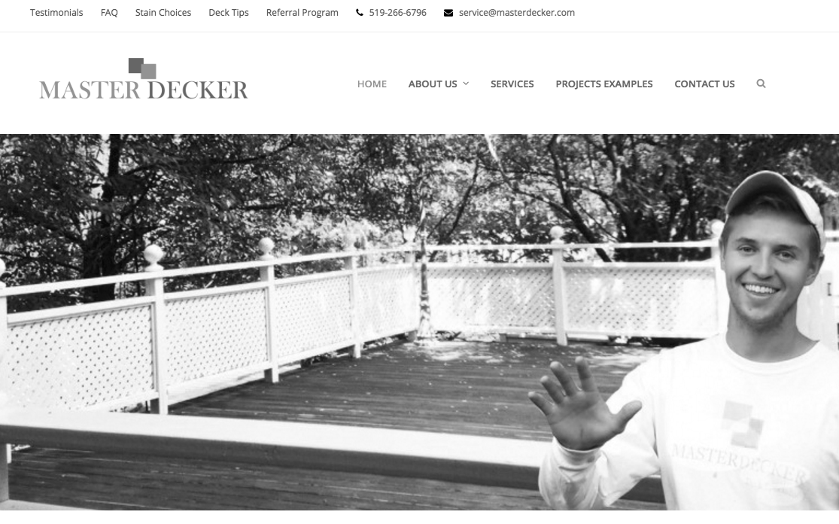

Source: Company files.

Exhibit 2: THE MASTER DECKER FOUR-STEP PROCESS

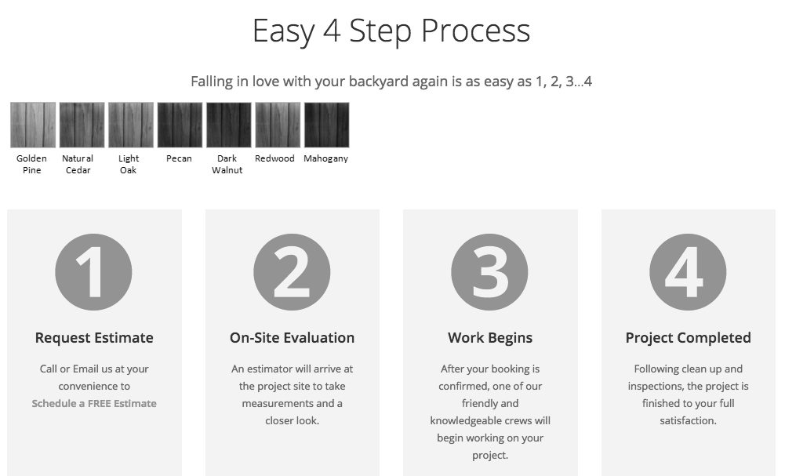

Source: Company files.

1. All currency amounts are in CA$ unless specified otherwise.
2. Inventory consisted of deck-building materials.
3. Inventory was calculated using differential costs of goods sold.