

9B18B011

DECISIONS BREWING AT FIRE ROASTED coffee company

[Jeremiah De Sousa](https://iveypubs.my.salesforce.com/003A000001lEzZw) and [Ian Dunn](https://iveypubs.my.salesforce.com/003A000001CqbMX) wrote this case solely to provide material for class discussion. The authors do not intend to illustrate either effective or ineffective handling of a managerial situation. The authors may have disguised certain names and other identifying information to protect confidentiality.

*This publication may not be transmitted, photocopied, digitized, or otherwise reproduced in any form or by any means without the permission of the copyright holder. Reproduction of this material is not covered under authorization by any reproduction rights organization. To order copies or request permission to reproduce materials, contact Ivey Publishing, Ivey Business School, Western University, London, Ontario, Canada, N6G 0N1; (t) 519.661.3208; (e)* [*cases@ivey.ca*](mailto:cases@ivey.ca)*;* [*www.iveycases.com*](http://www.iveycases.com)*.*

Copyright © 2018, Ivey Business School Foundation Version: 2018-07-11

The Fire Roasted Coffee Company (Fire Roasted), based in London, Ontario, had decided it was time to update its point-of-sale (POS) system in the summer of 2017. A POS system was a combination of software and hardware that allowed a business to process customer transactions; it typically included a computer, a cash register, and a debit/credit machine. David Cook, the founder and president of Fire Roasted, recognized this was an opportunity to implement a new set of prices within the updated POS system.

Cook was proud of Fire Roasted’s coffee beverages and the agreeable menu the company offered to coffee connoisseurs. He had a short list of coffee beverages that he was considering for a price change, including the Americano, cappuccino, latte, macchiato, mocha, and drip coffee. Cook thought that costing methods might be the most appropriate way to determine prices, but he was also considering ways to account for industry and competitive dynamics in the pricing decision.

**BACKGROUND**

Fire Roasted began in 2002, when Cook used a frying pan to roast his first blend. Cook had worked in the food industry for over 30 years, and his experience and entrepreneurial drive contributed to rapid growth and multiple location openings for Fire Roasted (see Exhibit 1). In 2017, his company’s roastery consisted of state-of-the-art small batch roasters operating in a 3,000-square-foot (278-square-metre) open-concept space. The roastery was located in a 100-year-old building in London’s historic Old East Village.

Fire Roasted roasted all of its coffee by hand in small batches, extracting the best qualities from each green bean, which it sourced from 35 different growers around the world. Fire Roasted controlled the whole supply chain, from sourcing and roasting to grinding and brewing.[1] The company’s goals were to promote Fairtrade coffee while maximizing profits. In 2009, Cook travelled to Guatemala and El Salvador to understand the struggles faced by coffee growers. The close relationship Fire Roasted built with its suppliers ensured consistency and continuity in the company’s product. Fairtrade coffee was designated by organizations that collaborated with coffee bean farmers to establish better working conditions, sustainable practices, and greater equity in international trade, empowering farmers and workers in developing countries. Fire Roasted was one of the city’s only Fairtrade-certified companies.

**COFFEE IN CANADA**

Coffee was the beverage most consumed among adults in Canada, surpassing tap water for the top spot. The coffee industry made CA$6.2 billion[2] in revenue, and coffee provided more than 160,000 jobs in cafés and coffee shops.[3]

Sixty-seven per cent of Canadians over the age of 18 enjoyed at least one cup of coffee a day; the average adult consumed three cups per day. In 2016, 76 per cent of Canadians consumed drip coffee, while 62 per cent consumed specialty coffee beverages. The most popular specialty beverages included cappuccino, latte, and espresso. Consumption of specialty coffee beverages and frozen blended coffee was highest among those 18–49 years of age. Drip coffee was most likely to be consumed by those over the age of 50. Millennials were also more interested in coffees that were ethically sourced and certified as Fairtrade, organic, or both.3

Canada was home to over 5,000 independent coffee shop owners and several thousand franchise operators.[4] The traditional importing markets for coffee included North America, Europe, and Japan. Canada, however, had showed the fastest sustained growth since 2007 by a large margin, importing coffee from over 30 developing countries worldwide.[5]

COMPETITORS in LONDON

There were many businesses in London, Ontario, that sold coffee, including restaurants, cafés, and fast food chains. There was a distinction in the industry between those that predominantly served standard drip coffee and those that offered specialty coffee beverages that were made using an espresso machine. Espresso machines were specially designed to force water through finely ground coffee and were equipped with a frothing wand that allowed the creation of specialty espresso-based beverages such as lattes, cappuccinos, and macchiatos. Drip coffee required an automatic drip coffee maker, which was normally much cheaper than an espresso machine.

Tim Hortons Inc. and Starbucks Corp. were the largest sellers of coffee in London, possessing 84 per cent of the market. The two fast food chains covered nearly every major intersection in the city, which had 55 Tim Hortons locations and 20 Starbucks locations. While Tim Hortons offered an array of specialty coffee drinks, it primarily sold drip coffee; many perceived its product to be low quality and low price, since a small coffee was just $1.59. In contrast, Starbucks was perceived to be a premium product, offering both drip coffee and specialty coffee beverages at higher prices.

Because Fire Roasted used espresso machines and sourced its beans from high-quality Fairtrade suppliers, it offered a premium coffee experience. In addition to Starbucks, other direct local competitors included the Black Walnut Bakery Café (Black Walnut), Coffee Culture, The Ground Up Organic Café (Ground Up), Locomotive Espresso (Locomotive), Williams Fresh Café (Williams), and 10Eighteen (see Exhibits 1 and 2).

**PRICING A CUP OF COFFEE**

Fire Roasted primarily used a specialty blend, Saint Drogo, for its classic drip coffee. Saint Drogo was made with 40 per cent Brazilian beans, 30 per cent Peruvian beans, and 30 per cent Costa Rican beans. Fire Roasted also had an espresso blend called Expression, which was made up equally from five different beans: Brazilian, Ethiopian, Mexican, Nicaraguan, and Peruvian. The Expression blend was used to make all espresso-based beverages (see Exhibit 3).[6]

The green, pre-roasted beans were purchased at different rates, in bags weighing 55 pounds (see Exhibit 4).[7] However, the beans lost moisture when they were roasted, so each of these bags produced 15 per cent less roasted coffee by weight. Fire Roasted used one ounce of roasted coffee beans for a small cup of brewed coffee and one-half ounce of beans for a single ounce of espresso.[8] The dairy-based coffee beverages used milk, which cost $0.035 per ounce. The chocolate syrup included in the mocha had a cost of $0.50 per cup.

Fire Roasted used two coffee bean roasters for all its roasting needs. Each roaster had an original cost of $15,000 with no residual value. The roasters were depreciated using the units of production method, where each machine had an expected useful life of 12,000 hours. Cook hired workers to oversee the roasting process; they were each paid $15 per hour and could process two bags of green beans per hour (one bag per machine).

Once the beans were roasted, they were ground and served to customers in their drinks of choice. All coffee beverages were served in paper cups printed with the Fire Roasted logo, sleeves to keep customers from burning their hands, and plastic lids, for a total cost of $0.15 per drink.

The remainder of Fire Roasted’s costs were estimated based on the expenses and the amount of coffee sold in the previous fiscal year.

After purchasing a cup of coffee, customers were free to add dairy and sugar to their beverages. Regardless of the beverage, customers chose to add $0.005 worth of sugar to their cups on average. Dairy was typically added to purchases of drip coffee only and cost about $0.055 per cup. Cook considered the milk and sugar costs to be a part of the factory overhead costs.

Cook estimated that utilities and rent costs could be broken down to $0.30 per cup of coffee.[9] Miscellaneous costs such as coffee disposal fees, cleaning supplies, and barista wages totalled $0.35 per cup, regardless of the beverage purchased. The depreciation cost of the espresso machine, on a per-cup basis, was $0.01; the depreciation for the drip coffee machine was determined to be negligible. Administration overhead costs, including Cook’s salary, added $0.17 to the cost of a cup of coffee, regardless of the beverage purchased.

With all the numbers in front of him, Cook began organizing his company’s costs. He questioned which type of cost might be most useful for making his pricing decision: direct cost, absorption cost, or full cost. Cook planned to calculate each of these costs for the six products he was considering for price changes (see Exhibit 5). He sat down with an Americano and prepared to analyze his costs and decide on the most appropriate prices for these products.

**EXHIBIT 1: MAP OF LOCAL COMPETITORS IN LONDON, ONTARIO**

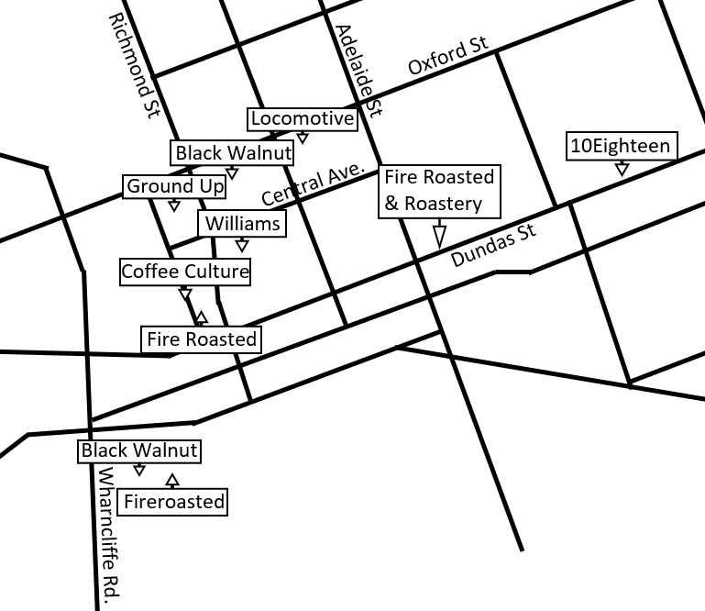

Source: Created by the case authors.

**EXHIBIT 2: COMPETITOR PRICING FOR SELECT COFFEE BEVERAGES (IN CA$)**

|  |  |  |  |  |  |  |
| --- | --- | --- | --- | --- | --- | --- |
|  | **Drip Coffee** | **Americano** | **Latte** | **Cappuccino** | **Mocha** | **Macchiato** |
| **Starbucks** | $2.21 | $3.10 | $4.80 | $4.80 | $5.59 | $2.57 |
| **10Eighteen** | 2.63 | 3.41 | 5.09 | 4.06 | 5.65 | 2.63 |
| **Locomotive** | 2.00 | 4.50 | 5.09 | 4.15 | 6.30 | 2.75 |
| **Black Walnut** | 2.00 | 3.10 | 4.20 | 4.04 | 4.73 | 2.63 |
| **Ground Up** | 2.36 | 2.89 | 4.15 | - | 5.59 | 2.89 |
| **Coffee Culture** | 2.09 | 2.79 | 3.99 | 3.99 | 4.29 | 2.79 |
| **Williams** | 1.89 | 2.63 | 5.09 | 5.09 | 5.65 | 2.63 |
| **Average** | **$2.17** | **$3.20** | **$4.63** | **$3.73** | **$5.40** | **$2.70** |

Source: Company files.

**EXHIBIT 3: BREAKDOWN OF INGREDIENTS FOR SELECT BEVERAGES**

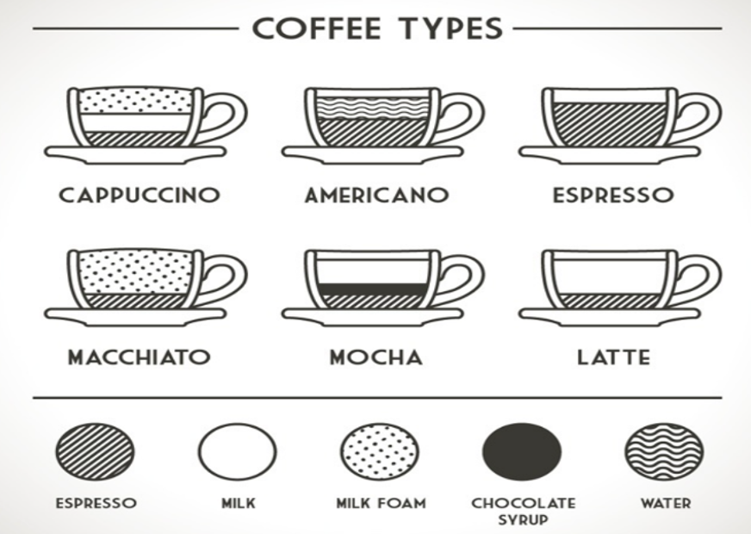

|  |  |
| --- | --- |
| Latte | ten ounces of steamed milk; two ounces of espresso |
| Cappuccino | two ounces of foamed milk; two ounces of steamed milk; two ounces of espresso |
| Macchiato | dot of foamed milk; two ounces of espresso* |
| Americano | three ounces of hot water; two ounces of espresso |
| Mocha | one ounce of steamed milk; two ounces of chocolate syrup; two ounces of espresso |

Note: *Cook considered the dairy costs for the “dot of foamed milk” in the macchiato to be a negligible cost.

Source: With permission, “12 Different Types of Coffee Explained,” Latte Art Guide, accessed August 10, 2017, www.latteartguide.com/2016/01/different-types-of-coffee.html.

**EXHIBIT 4: GREEN BEAN COFFEE PRICES (IN CA$)**

|  |  |
| --- | --- |
| **Origin** | **Price per Pound** |
| Costa Rica | $3.32 |
| Brazil | $2.97 |
| Peru | $3.57 |
| Mexico | $3.27 |
| Nicaragua | $3.52 |
| Ethiopia | $3.17 |

Source: Created by the case authors.

**EXHIBIT 5: COSTING CHART**

|  |  |  |  |  |  |  |
| --- | --- | --- | --- | --- | --- | --- |
|  | **Drip Coffee** | **Macchiato** | **Cappuccino** | **Mocha** | **Americano** | **Latte** |
| **Direct Cost** |  |  |  |  |  |  |
| Coffee |  |  |  |  |  |  |
| Moisture Loss |  |  |  |  |  |  |
| Paper |  |  |  |  |  |  |
| Labour |  |  |  |  |  |  |
| Milk/Syrup |  |  |  |  |  |  |
| Shipping |  |  |  |  |  |  |
| Total Direct Cost |  |  |  |  |  |  |
| **Absorption Cost** |  |  |  |  |  |  |
| Depreciation, Roaster |  |  |  |  |  |  |
| Depreciation, Espresso Machines |  |  |  |  |  |  |
| Rent/Utilities |  |  |  |  |  |  |
| Miscellaneous |  |  |  |  |  |  |
| Total Factory Overhead |  |  |  |  |  |  |
| Total Absorption Cost |  |  |  |  |  |  |
| **Full Cost** |  |  |  |  |  |  |
| Rent/Utilities |  |  |  |  |  |  |
| Admin |  |  |  |  |  |  |
| Total Admin Overhead |  |  |  |  |  |  |
| Total Full Cost |  |  |  |  |  |  |

Note: All costs should be rounded to three decimal places.

Source: Created by the case authors.

1. The roasting process was typically the bottleneck in the supply chain, and the roastery was operating at 70 per cent capacity in 2016.
2. All currency amounts are in Canadian dollars unless otherwise specified.
3. “Coffee Facts,” Coffee Association of Canada, accessed August 10, 2017, www.coffeeassoc.com/coffee-facts/.
4. On average, coffee shops in North America earned a profit margin of 16 per cent.
5. *Coffee & Snack Shops: US Market Research Report,* IBIS World, accessed August 10, 2017, [www.ibisworld.com/industry-trends/market-research-reports/accommodation-food-services/coffee-snack-shops.html](https://www.ibisworld.com/industry-trends/market-research-reports/accommodation-food-services/coffee-snack-shops.html).
6. “12 Different Types of Coffee Explained,” Latte Art Guide, accessed August 10, 2017, www.latteartguide.com/2016/01/different-types-of-coffee.html.
7. On average, it cost Fire Roasted $40 to ship each bag.
8. One pound = 16 ounces.
9. Cook attributed 10 per cent of the rent and utility costs to the office and administration areas of the building.