

9B18B012

Metta Rest Spa: Should the Stricklands Lend?

Lindsay Clayton wrote this case solely to provide material for class discussion. The author does not intend to illustrate either effective or ineffective handling of a managerial situation. The author may have disguised certain names and other identifying information to protect confidentiality.

*This publication may not be transmitted, photocopied, digitized, or otherwise reproduced in any form or by any means without the permission of the copyright holder. Reproduction of this material is not covered under authorization by any reproduction rights organization. To order copies or request permission to reproduce materials, contact Ivey Publishing, Ivey Business School, Western University, London, Ontario, Canada, N6G 0N1; (t) 519.661.3208; (e)* [*cases@ivey.ca*](mailto:cases@ivey.ca)*;* [*www.iveycases.com*](http://www.iveycases.com)*.*

*Copyright © 2018, Richard Ivey School of Business Foundation* *Version: 2018-07-18*

Dan and Deanna Strickland were vacationing in Brazil when they received a call from their daughter, Natasha Strickland, one of the owners of Metta Rest Spa (Metta), a flotation spa in Vancouver, British Columbia, Canada. The Stricklands had already invested almost CA$1.2 million[1] in Natasha’s business when it opened in September 2014, and Natasha was in need of another $60,000 to keep the business afloat. The Stricklands sat down to review Metta’s 2015 financial statements, but they also wondered what other information they should be asking Natasha for (see Exhibit 1). They needed to decide whether to invest more money in the business or not by early 2016.

Industry

Flotation therapy (“floating”) was invented by U.S. neuroscientist John Lilly in the 1950s.[2] Floating was based on a scientific approach to relaxation called restrictive environmental stimulation technique (REST), a sensory-deprivation practice that allowed someone to float weightlessly in a tank or pod with no sound or light (see Exhibit 2). Floating had been proven to relieve countless aches and pains, increase concentration, improve memory, and eliminate fears and phobias.[3] Customers usually floated for 60 to 90 minutes, showering both before and after entering the float pod or tank. To allow customers to float, 800 pounds of Epsom salt was added to each tank of body temperature water. Between customers, water was filtered three times and more salt was added if the concentration dropped.

Floating was popular with the general public in the 1970s; however, growth was halted in the 1980s due to uneducated fears about how the AIDS virus was transmitted.[4] Floating became popular once again in the early 2000s, and in 2012, Float On (a six-tank facility located in Portland, Oregon) began to host an annual float industry conference for float centre owners, researchers, prospective owners, and equipment manufacturers. A state of the float industry survey conducted at the annual industry conference in 2016 collected information from 170 current float centre owners and 247 prospective float centre owner/operators (see Exhibit 3).

Customers

Almost anyone was able to float. There were four main reasons that customers floated: to relieve stress and anxiety; to manage pain; to generate creativity and ideas; and to improve athletic performance.

Stress and Anxiety Relief

Anyone who felt burned out or overwhelmed could benefit from 60- to 90-minute flotation therapy sessions, where light and noise were eliminated. Many avid floaters described entering a deep state of relaxation or actual sleep. Flotation therapy left customers feeling relaxed and rejuvenated.

Pain Management

Knee pain, back pain, neck pain, and pregnancy-related pain could all be managed effectively with flotation therapy. The weightlessness took stress off muscles, joints, and bones, providing relief from even serious chronic pain conditions such as arthritis and fibromyalgia.

Creativity and Idea Generation

When other senses were limited, those that remained could be sharpened. With no sensory information to process, the brain was free to focus on one specific problem or to wander and explore new ideas that may otherwise not have been accessible. Some corporations send employees to flotation therapy sessions followed by creative brainstorming sessions. Students have experienced improved memory and improved test scores by floating.

Athletic Performance

Professional athletes Stephen Curry, a National Basketball Association (NBA) all-star, and J. J. Watt, a National Football League (NFL) linebacker, had advocated for flotation therapy as a way to improve athletic performance.[5] The physical benefits included pain relief, better sleep, and healing induced by the Epsom salt. The mental benefits were focus, positive visualization, and stress relief.

Company Background

Metta was founded by three partners—Natasha Strickland, Kimberly Paulson, and Charlie Paulson—all of whom had been “utterly transformed” by the practice of floating, and who had a common interest in owning and operating a float centre. Metta claimed to be Vancouver’s most luxurious float spa, offering state-of-the-art relaxation treatments (see Exhibit 4).

Metta had flotation tanks in seven private rooms, each with its own shower facilities. Each room had a towel, face cloth, bath mat, neck support, earplugs, barrier cream (for any cuts), shower gel, shampoo, and conditioner. Metta’s pods were filtered after each guest float, and sanitized between guests. Women’s and men’s change rooms were available, where clients could change into robes and slippers (provided by Metta) and lock up valuables. The change rooms were stocked with toiletry items such as lotions, cotton swabs, and hair dryers. Metta also had an infrared sauna, a reading lounge, and a yoga and meditation studio. It provided a large selection of books and tea for post-flotation relaxation; guests were not hurried out of the spa. Metta bordered two established neighbourhoods in Vancouver: Kitsilano and West Point Grey (see Exhibit 5), and attracted both men and women aged 18 to 65.

Neither of the Paulsons, a married couple, were Canadian citizens, but both had work visas that allowed them to work in Canada for six months. At the time that Natasha asked for a new round of financing from the Stricklands, the Paulsons were living in the United States, and neither was contributing to Metta’s daily operations. The intention of the partnership had been for Charlie to work the front counter and handle staffing, and for Kimberly to be in charge of marketing and of developing relationships with groups of interested customers, such as students, new mothers, and corporations. Since they had contributed neither the work that was promised nor any financial contribution to the start-up, Natasha intended to take over everything and handle the operations and financing on her own. Natasha was a yoga teacher, and she continued to teach at studios in Vancouver while managing Metta.

Competition

Between 2013 and 2014, 13 float spas had opened in the Vancouver–Lower Mainland area. Metta’s strongest competition came from Float House, a franchise float studio located only a few kilometres from Metta on a road with very busy car and foot traffic. Float House had access to considerable marketing resources through its franchise arrangement. Float House had five locations in British Columbia and one in Edmonton, Alberta.[6] Float House had a different pricing structure and a different tank supplier than Metta, and it had only three tanks at its Fourth Avenue location (see Exhibits 6 and 7). Float House’s pods were not drained and sanitized between guests; water underwent a triple-sanitization and filtering process instead.

Decision

Should Dan and Deanna Strickland invest another $60,000 in Metta Rest Spa? The Stricklands were less concerned about investing their funds at a high return than they were with supporting their daughter’s dream to own and operate a flotation therapy business; however, they also wanted to protect the money they had already invested. Was it time to give up? What additional information should the Stricklands ask for to help them make this decision?

Exhibit 1: Metta Rest Spa Financial Statements (in ca$)

**Income Statement (For the Year Ended December 31, 2015)**

Revenue $159,177

Less: Operating Expenses

Wages and Salaries (Including Benefits) 72,659

Accounting and Legal 6,918

Advertising and Promotion 42,772

Business Fees and Licences 699

Cleaning Services 3,900

Courier and Postage 434

Equipment Rental 5,809

Insurance 7,138

Interest and Bank Charges 719

Office Supplies 4,178

Meals and Entertainment 178

Research 1,143

Rent 160,272

Repair and Maintenance 771

Supplies 17,425

Telephone 2,082

Utilities 13,268

Total Operating Expenses 340,366

Net Income (Loss) −$181,189

**Balance Sheet (as of December 31, 2015)**

**ASSETS**

Current Assets:

Cash $49,264

Accounts Receivable 14,192

Supplies 2,579

Note Receivable 31,475

Deposits 14,928

Total Current Assets $112,438

Capital Assets:

Tanks and Leasehold Improvements (Net) 656,683

Office Furniture and Equipment 16,164

Computers (Net) 2,997

Yoga Equipment (Net) 296

Total Capital Assets $676,140

**TOTAL ASSETS** $788,578

exhibit 1 continued

**Liabilities and Shareholders’ Equity**

Current Liabilities:

Accounts Payable $15,065

Long-Term Liabilities:

Note Payable 529802 1,157,690

Note Payable—Leanne Strickland 33,798

Total Liabilities $1,206,553

Shareholders’ Equity:

Common Shares 0

Retained Earnings −417,975

Total Shareholders’ Equity −$417,975

**TOTAL LIABILITIES AND**

**SHAREHOLDERS’ EQUITY** $788,578

Source: Company files.

**Exhibit 2: Metta rest spa’s Float Pod**

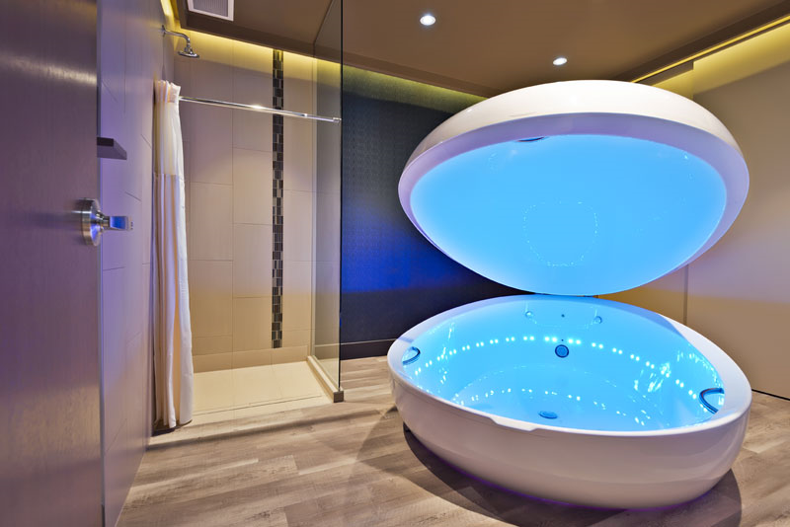

Source: “Flotation Rest Tanks,” Metta Rest Spa, accessed February 28, 2017, http://restspa.ca/spa-menu/flotation-rest-tanks.

**Exhibit 3: State of the Industry Select Survey Results**

|  |  |
| --- | --- |
| |  | | --- | |  | |

|  |
| --- |
| EXHIBIT 3 (CONtinued) |
|  |
|  |
|  |

Note: Average income per float tank = CA$68,704; average number of floats per tank (per month) = 91

Source: Created by the case author based on data from Float Tank Solutions, *2016 State of the Float Industry Report*, accessed February 28, 2017, www.floattanksolutions.com/product/2016-state-float-industry-report/.

**Exhibit 4: Metta rest spa's Product Selection and Prices (in CA$)**

|  |  |
| --- | --- |
| Single Session | $75 |
| 3-pack | $165 |
| 7-pack | $315 |
| Membership | $50 |
| Unlimited 1-month membership | $299 |
| Unlimited 1-year membership | $2,000 |

Source: Adapted from “Flotation Rest Tanks,” Metta Rest Spa, accessed February 28, 2017, http://restspa.ca/spa-menu/flotation-rest-tanks.

**Exhibit 5: Census Data for Kitsilano and West Point Grey, 2006**

|  |  |  |
| --- | --- | --- |
|  | **Kitsilano** | **West Point Grey** |
| Total population | 41,375 | 12,795 |
| Total population between 18 and 65 years old | 32,280 | 8,305 |
| Median household income | CA$53,000 | CA$77,079 |

Note: Vancouver’s median household income was CA$47,299

Source: Created by case author based on data from “Kitsilano Demographics,” accessed February 28, 2017, http://vancouver.ca/commsvcs/planning/census/2006/localareas/kitsilano.pdf; “West Point Grey: Neighbourhood Numbers,” *Vancouver Courier*, April 24, 2013, accessed February 28, 2017, www.vancourier.com/community/vancouver-special/west-point-grey/west-point-grey-neighbourhood-numbers-1.376572#sthash.IEOGrzdo.dpuf.

**Exhibit 6: Float House Prices (in ca$)**

|  |  |
| --- | --- |
| Single Float | $75.00 |
| 3-pack | $180.00 |
| 10-pack | $390.00 |

Source: “Pricing and Memberships,” Float House, accessed February 28, 2017, www.floathouse.ca/pricing-and-memberships.

**Exhibit 7: Float House Float Tanks**

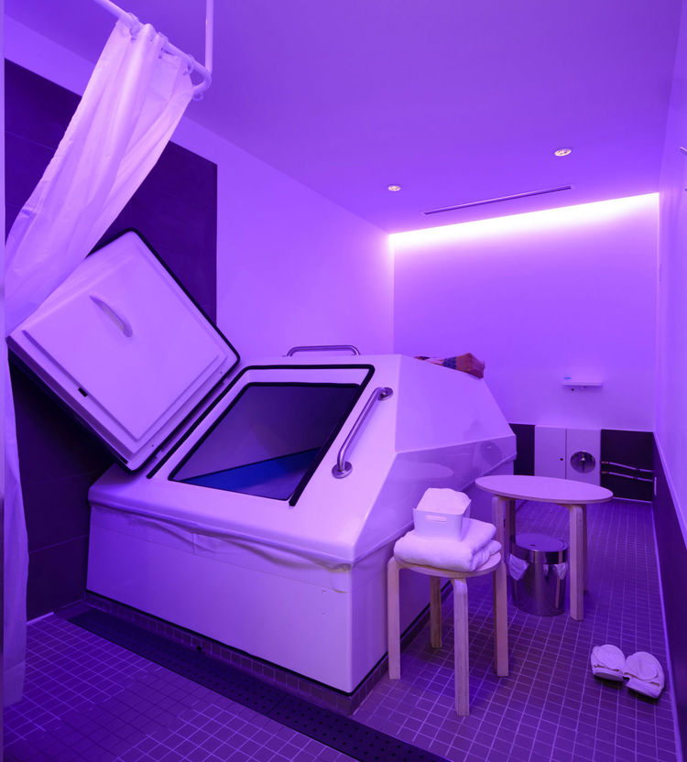

Source: “Kitsilano,” Float House, accessed February 28, 2017, www.floathouse.ca/locations/vancouver-kitsilano/.

1. All currency amounts are in Canadian dollars.
2. “The History of Floating,” Float Floatation Center and Art Gallery, accessed February 28, 2017, www.thefloatcenter.com /history.html#.
3. “The Benefits of Floating,” Floataway, accessed February 28, 2017, https://floataway.com/index.php/floating/the-benefits-of-floating.
4. Jane C. Hu, “Is There Any Real Science Behind The Urban Float Craze?” Crosscut, February 13, 2015, accessed May 5, 2017, http://crosscut.com/2015/02/real-science-behind-urban-float-craze/.
5. “Floating for Athletic Performance,” Serene Dreams, accessed February 28, 2017, http://serenedreams.com/floating-athletic-performance/.
6. “Our Story,” Float House, accessed February 28, 2017, www.floathouse.ca/our-story/.