

9B18B017

DANONE: ADOPTING INTEGRATED REPORTING OR NOT? (A)

Ken Mark wrote this case under the supervision of Professors Diane-Laure Arjaliès, Delphine Gibassier, and Michelle Rodrigue solely to provide material for class discussion. The authors do not intend to illustrate either effective or ineffective handling of a managerial situation. The authors may have disguised certain names and other identifying information to protect confidentiality.

*This publication may not be transmitted, photocopied, digitized or otherwise reproduced in any form or by any means without the permission of the copyright holder. Reproduction of this material is not covered under authorization by any reproduction rights organization. To order copies or request permission to reproduce materials, contact Ivey Publishing, Ivey Business School, Western University, London, Ontario, Canada, N6G 0N1; (t) 519.661.3208; (e)* [*cases@ivey.ca*](mailto:cases@ivey.ca)*;* [*www.iveycases.com*](http://www.iveycases.com)*.*

Copyright © 2018, Ivey Business School Foundation Version: 2020-08-06

By June 2013, almost two years had passed since the Nature team at Danone SA (Danone) had agreed to pilot a new reporting standard, the integrated report (<IR>),[1] for the International Integrated Reporting Council (IIRC). The IIRC promoted <IR> as the next generation of corporate reporting and had an ambitious goal: to champion integrative thinking as the new norm for business reasoning in public and private firms. The IIRC’s aim was for organizations to adopt <IR>, making better information available to capital providers—their main stakeholders.

As envisioned by the IIRC, an <IR> would combine a range of data highlighting the factors that affected an organization’s ability to create value, using a streamlined approach. The report would improve stakeholders’ awareness of an organization’s various capitals (e.g., financial, manufactured, intellectual, human, social/relational, and natural) and explain how these capitals were interrelated. The report was also envisioned as a potential catalyst for higher-quality thinking and decision making, with the objective of creating more value over time.[2]

Adopting a third-party standard would be a significant change for Danone, which had pioneered in advocating a dual social and economic goal for over 40 years. Throughout the years, it had developed and relied upon socially responsible standards and practices. For example, Danone had elaborated and implemented a comprehensive carbon accounting program. However, while its carbon accounting program was robust and comprehensive, it did not adhere to the carbon accounting standards that other companies relied on at the time. This meant that even though Danone’s internal carbon accounting program was thought to be more comprehensive, the firm was not given external credit for its initiative.

Danone joined the IIRC’s pilot project in September 2011. Danone’s initial intention was to develop a model integrated report,[3] under the form of a “mock report,” or a shadow report from currently available data while continuing with its internally developed sustainability report. The integrated reporting project had experienced setbacks at Danone: there had been unwanted external pressure to commit to the standard, dissent over who was the report’s primary audience, and questions about the suggested metrics. A corporate cost reduction plan, announced in December 2012, seemed to have tipped the scales in favour of business-oriented choices. Consequently, the integrated reporting project was put on hold.

In early June 2013, Laura Palmeiro, vice-president of Finance for Danone’s Nature division, felt that she had come to a crossroads. She needed to decide whether Danone should (1) commit to adopting <IR>; (2) decline to continue and revert to producing the traditional report about corporate social responsibility (CSR) that the company had been committed to for the past 20 years; or (3) refine its own version of integrated reporting, which it had been working with since 2012. At this point, the IIRC had already consulted stakeholders twice about draft versions of the <IR> framework, and it was close to publishing the final framework, which was due in December 2013. Many questions were raised about integrated reporting and whether it fit with Danone’s strategic goals. If Palmeiro wanted to stop the integrated report project at Danone, she had to act very soon.

Danone: A Historical Focus on both Economic and Social Impact

In 1919, Isaac Carasso launched a yogurt brand in Barcelona, Spain, and named it after his son Daniel, whose nickname was “Danon.” The company’s first factory in France was built in 1929. In 2012, Danone’s sales were €21 billion,[4] and 60 per cent of its total sales were outside of Europe. The company had four key business lines. Fresh dairy products accounted for 56 per cent of sales, and water accounted for 18 per cent of sales; the two remaining business lines—baby nutrition and medical nutrition—accounted for 20 per cent and 6 per cent of sales, respectively. Danone’s key brands included Danone and Activia yogourt, Milupa and Cow & Gate baby food, and Evian and Volvic bottled water.

Starting in the 1970s, Danone’s management team had outlined business values that combined economic impact with social impact. The company’s founder had spoken about the organization’s purpose being both social and economic—it was a dual project that would provide benefits for all stakeholders involved—and this foundation was the source of values that Danone had adhered to for the past 40 years. These values were based on the intuition that human development and economic performance were complementary goals. Danone summed up its key values with the acronym HOPE, which stood for humanism (sharing, responsibility, respect for others); openness (curiosity, agility, simplicity); proximity (accessibility, authenticity, empathy); and enthusiasm (boldness, passion, appetite for change).[5]

The Danone Way (2001)

Danone’s sustainable development strategy, called the “Danone Way,” was launched in 2001 after three decades of continuous social and environmental commitment. The goal was for all of Danone’s country business units (CBUs) to reach sustainable development targets. A comprehensive list of CSR criteria was created to track Danone’s progress towards its sustainability goals, which related to the environmental effects of product lifecycles; human rights and human relations within Danone and with its suppliers and others; and product nutritional standards and consumer health.

Each CBU administered an annual self-assessment program that covered 16 areas under five broad themes: human rights, human relations, environment, consumers, and governance. The prerequisite was that the company would use no child labour or forced labour. Human rights themes included equal opportunities and diversity, safety at work, and health at work. Human relations themes included social dialogue, working hours, wage policy, and development and training. Environmental themes included management of environmental footprint, control of environmental risks, raw materials management, and reduction in packaging. Consumer themes included quality management, and standards on nutrition and health. Finally, governance themes included a policy for conducting business, CSR applied to suppliers, and a relationship with local communities.[6]

CBUs established their own policies, which corresponded to established formalized and documented management practices, and their own assessment criteria—figures that could be used to measure social performance. The annual self-assessment allowed CBUs to evaluate their progress towards their 16 goals based on a 1,000-point scale. CBUs with a score of 900 points and above were awarded five stars, the best rank available. A score of 500 or fewer points meant that the CBU would be awarded zero stars, the lowest possible rank. These self-assessments were reviewed and validated by the executive committee of each CBU. Executive committees also set the objectives for the following year and devised appropriate plans to reach the targets. Each CBU received a scorecard or dashboard containing the results of the assessment (see Exhibit 1).

When the final self-assessed scores for a CBU were less than three stars (less than 700 points), the Danone Way results were integrated into the bonus calculation process for the CBU’s general manager. When the score was three stars or higher, inclusion of the Danone Way results was at the discretion of the CBU’s executive committee.

Reporting Using the Global Reporting Initiative (2004)

Starting in 2004, Danone had been reporting externally based on guidelines from the Global Reporting Initiative (GRI). GRI, based in Boston, was an international, independent standards organization “founded in 1997 by the Coalition for Environmentally Responsible Economies (CERES) and the Tellus Institute with the support of the United Nations Environment Programme.”[7] It focused on key performance indicators on themes encompassing economics; environmental, social, and human rights; society; and product responsibility. The goal of GRI was to allow firms to standardize their reporting on key areas so that results could be compared from period to period and between firms. By the start of 2013, over 11,000 companies were using the GRI framework for their sustainability reporting.[8] Danone had been consistently updating its reporting based on newer versions of GRI.

The Carbon Accounting Initiative (2006)

In 2006, Danone’s management decided to further emphasize economic and social considerations in its strategy. Franck Riboud, chairperson and chief executive officer of Danone, explained:

The mission set by Danone, to “bring health through food to as many people as possible,” has structured our whole approach and driven the decision to integrate, even more deeply, economic and social considerations into our company’s strategy. Four issues closely related to the mission have been defined.

The four issues and objectives were (1) health—to contribute to public health through nutrition; (2) nature—to drastically reduce the environmental impact of the company’s activities throughout the lifecycle of products; (3) people—to give all employees the opportunity to develop and anticipate changes, and to give meaning to their work; and (4) overall—to create products and economic models accessible to population groups with low purchasing power (see Exhibit 2).[9]

In 2006, the overarching question related to the environment was how to find a single indicator—one that anyone could understand and relate to—to represent the company’s performance with regard to nature. With a single indicator, the company would be able to inform and motivate internal and external stakeholders by showing them how their collective efforts would have an impact. The indicator had to be certifiable, auditable, measurable, and generally accepted by environmentalists and other stakeholders. In 2007, the company narrowed its search down to the measurement and reduction of carbon emissions as the key indicator. Danone believed that the non-financial priority of the company should be to decrease its carbon footprint.

Given the social and environmental ramifications of climate change, the focus on carbon as a single indicator was thought to be the best way to show Danone’s progress on its social responsibility goals. The company aimed to build a best-in-class carbon-reduction program that was integrated throughout the value chain. It also altered its compensation structure to provide an incentive across the organization to see the program succeed.

Danone built its carbon accounting methodology in 2007, based on the life cycle assessment approach used by the International Organization for Standardization’s ISO 14040 and the British Standards Institution’s publicly available specification (PAS) 2050. The objective of carbon reduction was integrated into the compensation plans of 1,400 top executives—general managers of CBUs and group directors. The company announced an ambitious target of a 30-per-cent reduction in carbon over four years. It also created a new “Nature” team to replace a small corporate environmental team. The Nature team’s objective was to oversee the environmental management strategy at Danone. Data related to the strategy were tracked by product and centralized in a Microsoft Excel database that Danone called Danprint. There were more than 800 total carbon footprints calculated for individual products that either accounted for 80 per cent of the volume of products sold in a category or were the top 10 products in a category, based on sales.

The key challenge Danone faced was that external stakeholders had no way to compare Danone’s carbon results to those of other firms. Danone was therefore considered by most non-governmental organizations and third parties to be a poor performer from a carbon footprint perspective. This refusal by external stakeholders to acknowledge the legitimacy of Danone’s internally developed carbon accounting process prompted concern inside the company. Although the Nature team believed Danone was doing a great job of reducing the company’s carbon footprint, it eventually chose in 2010 to reconcile its carbon accounting process with that of the greenhouse gas (GHG) Protocol Corporate Accounting and Reporting Standard (GHG Protocol), which had earned external recognition. Palmeiro believed that Danone needed to comply with existing standards to provide proof of the organization’s performance to its stakeholders. Danone had kept its own internal carbon accounting system, integrated within its enterprise resource planning system co-created with SAP SE; it also reported using the internationally recognized GHG Protocol framework.

International Integrated Reporting Council’s Integrated Report (<IR>)

Danone discovered <IR> in 2010 through a survey of the market. Following the challenges linked to the external reception of Danone’s carbon accounting initiative, Palmeiro asked her controllers to undertake a review of available sustainability accounting initiatives. She wanted to make sure that Danone was well aware of all the initiatives in which it could participate. One controller brought IIRC’s <IR> to her attention. At the same time, Danone’s chief financial officer (CFO) was invited to participate in meetings hosted by Accounting for Sustainability, an organization dedicated to encouraging corporations and the public sector to consider environmental and societal goals as part of their planning processes. During one of these meetings, the CFO discovered <IR>. Palmeiro and the CFO wondered if <IR> would be the next sustainability framework. In July 2011, an academic in a key opinion leaders’ meeting at Danone reinforced their position by stating that, considering the company’s past achievements related to its dual project, it should consider becoming part of the <IR> pilot. Palmeiro and the CFO saw an exceptional opportunity and agreed that Danone should be part of the <IR> pilot project starting as soon as September 2011. Integrated reporting, after all, seemed well aligned with the dual social and economic project of the company.

The IIRC developed <IR> in August 2010 to “create a globally accepted framework for a process that results in communications by an organization about value creation over time.”[10] <IR> was to be the latest of several attempts to integrate social, economic, and environmental performance in reporting. Calls for such integration had already been issued in publications such as *The Corporate Report* (1975), *Corporate Social Accounting* (1976), and *The Greening of Accountancy* (1990),[11] and through the GRI’s *Sustainability Reporting Guidelines* (2000)[12] and the A4S *Connected Reporting Framework* (2007).[13] The common theme throughout all of these reporting standards, including <IR>, was the need to include details on economic, social, and environmental performance in one report. The objectives for <IR> were as follows:

* Improve the quality of information available to providers of financial capital to enable a more efficient and productive allocation of capital.
* Promote a more cohesive and efficient approach to corporate reporting that draws on different reporting strands and communicates the full range of factors that materially affect the ability of an organization to create value over time.
* Enhance accountability and stewardship for the broad base of capitals (financial, manufactured, intellectual, human, social and relational, and natural) and promote an understanding of their interdependencies.
* Support integrated thinking, decision making, and actions that focus on the creation of value over the short, medium, and long term.[14]

The <IR> framework focused on these areas:

* *Organizational overview and external environment*: What does the organization do and what are the circumstances under which it operates?
* *Governance*: How does the organization’s governance structure support its ability to create value in the short, medium, and long term?
* *Business model*: What is the organization’s business model?
* *Risks and opportunities*: What are the specific risks and opportunities that affect the organization’s ability to create value over the short, medium, and long term, and how is the organization dealing with them?
* *Strategy and resource allocation*: Where does the organization want to go and how does it intend to get there?
* *Performance*: To what extent has the organization achieved its strategic objectives for the period and what are its outcomes in terms of effects on the capitals?
* *Outlook*: What challenges and uncertainties is the organization likely to encounter in pursuing its strategy, and what are the potential implications for its business model and future performance?
* *Basis of presentation*: How does the organization determine what matters to include in the integrated report and how are such matters quantified or evaluated?[15]

The <IR> strategy was aimed at showing how the various capitals and interdependencies were integrated and how they would drive long-term gains in shareholder value if they were properly aligned. The inspiration for <IR> came from an initiative led by three firms. Novozymes, a Danish biotechnology firm, published an “Integrated Annual Report: Environmental and Social Report” in 2002;[16] Natura, a Brazilian cosmetics firm, included analysis of “economic-financial, environmental and social results” in its annual report in 2003;[17] and Novo Nordisk, a Danish pharmaceutical firm, had been publishing a triple-bottom-line integrated report since 2004.[18]

With the objective of presenting <IR> as the preferred reporting option for organizations, the IIRC aimed to provide information that stakeholders could use to evaluate firms’ long-range prospects. As <IR> was being developed, the IIRC was looking for companies interested in conducting pilot projects, helping to shape the new standard, and promoting it. Following the official announcement that Danone would join the IIRC pilot program in September 2011, the first IIRC pilot meeting was held in October 2011 (see Exhibits 3 and 4).

Contrasting Perspectives: Danone’s Integrated Reporting and IIRC’s Integrated Reporting

In January 2012, Palmeiro and her Nature finance team (see Exhibit 5) were working on an integrated report presentation to be shared with the top managers of the company. Many concepts in <IR> were yet to be defined, and it was clear to the team that Danone would be part of the process of defining these concepts for others. The team believed that Danone had all the data necessary to create an integrated report and could be a leader in this form of reporting. Given that there were unanswered questions about what an integrated report should look like, the Nature team agreed that Danone would carry out its reporting in the spirit of integrated reporting but without any firm commitment to the <IR> framework. The team wanted to retain the ability to do integrated reporting its own way. An external consulting firm was hired to facilitate the development of the shadow report, and the process launched internally in May 2012.

The IIRC, eager to advance the process, insisted on following up with Danone with regular online progress updates. However, as soon as the Nature team began working with the IIRC, team members realized that there was a disconnect between the project of <IR> put forward by the IIRC and their own vision of integrated reporting. They felt that the culture of Danone was not translated into the framework envisioned by the IIRC.

The Nature team could not decide alone what an integrated report should look like for Danone but had to involve the rest of the company in the process. To facilitate discussions about what integrated reporting could mean for Danone, the Nature finance team decided to organize five workshops with internal stakeholders. The goal of the workshops was to design the company’s first shadow report, which would be populated with existing data and would demonstrate to internal stakeholders what an integrated report could look like, and garner the stakeholders’ support for the development of an authentic integrated report in future. Internal stakeholders who were consulted included top managers from the departments of strategy, finance, CSR, investor relations, and communications, and from the health and risk management teams (see Exhibit 6). It was clear to all participants that defining the integrated report would be an emergent process, as Palmeiro explained: “The idea of an integrated report is new and there is no known example of an <IR> out there. Our participation in the pilot is novel because we are watching the development, in real time, of a new standard.”

During these workshops, top managers from all departments kept raising the same questions: How can an integrated report be more “aspirational” for the company? How can a broader set of stakeholders be included? What does an integrated report tell about us? People at Danone wondered whether the IIRC’s focus actually was a triple-bottom-line standard (i.e., environmental, social, and economic performance) since it seemed to focus on investors only. This approach was not aligned with Danone’s dual project.

In addition, the IIRC <IR> project appeared to suggest that non-financial outcomes could only be considered positive if they somehow contributed to increasing the firm’s financial bottom line. Instead, Danone’s managers questioned the usefulness of attempts to value the different types of capital in monetary terms. A manager explained:

Putting a monetary value on an indicator may not be ideal when dealing with issues of employee health and the environment. First, it is very difficult to put a value on something that is inherently subjective. We can still include data points to allow for the data to be integrated. But we do not need to put a dollar figure on everything.

The team delved further, wondering how managers should put a figure on the non-financial capitals—intellectual, human, social and relational, and natural—being tracked. Danone dedicated a workshop to quantifying these key performance indicators. While it was simple to report on the financial capitals, which involved figures, putting a monetary value on human or intellectual capital seemed more problematic. For example, the quest to build integrated key performance indicators included indicators that were, by nature, “unmeasurable” and “soft,” such as improving the engagement of employees and improving the firm’s reputation.

Members of the Danone team also felt that complying with the IIRC’s framework would impair their ability to describe the entire range of issues as they saw them at Danone. For example, the <IR> framework seemed to de-emphasize some key reporting points. For example, Danone team members believed that “well-being and health” was an important capital for demonstrating Danone’s business model, but this was absent from the IIRC framework. They suggested that the capitals should be adapted to each company’s own strategy and value creation process.

As workshops unfolded, the Nature team realized they needed to decide which stakeholders were most important for Danone and which topics to favour. The team started listing the stakeholders potentially concerned by <IR>—that is, employees; suppliers; local, regional, and national political representatives; consumers; communities; non-governmental organizations; and shareholders. The team believed that Danone’s version of an integrated report could be a useful tool for explaining the distinctiveness of Danone’s dual social and economic objectives to these stakeholders.

The Nature team noted that Danone and the IIRC had differing definitions of what was deemed material. The IIRC seemed to suggest that monetary values should be assigned to each indicator and that every footprint reduction or social program should be viewed through the lens of shareholder value. The premise, from the IIRC’s perspective, was that information contained in the integrated report was included because it was relevant to understanding the firm’s financials and had an impact on the firm’s long-term financial success. Including information to satisfy stakeholders other than shareholders was important as long as the information was linked in some way to shareholder value.

In contrast, Palmeiro and her team concluded that they wanted Danone’s integrated report to focus on both social and economic aspects and not to favour one stakeholder over another.

Moving Forward

While the Nature team was working on the shadow report, the IIRC began reshaping its objectives for <IR>. In 2011, IIRC had initially wanted <IR> to replace the other reports companies were producing, leading to one report,[19] but it changed this objective in early 2013, stating that the integrated report could be one among other reports. Danone, instead, insisted on adhering to the initial concept of one report that could integrate all of its existing internal work on reporting. The emerging differences between Danone’s views of integrated reporting and its understanding of the conceptualization proposed by the IIRC led the company to step back from active participation in the IIRC pilot by mid-2012. Danone officially refused the IIRC’s request to showcase it as a pilot project. In the meantime, the Sustainability Accounting Standards Board (SASB) had appeared with a new reporting standard. Although this reporting standard was not directly linked with the IIRC, it intended to encourage U.S. companies to report on their non-financial capital using a financial risk approach in their annual Form 10-K reports to the U.S. Securities and Exchange Commission. Meanwhile, companies such as Kering SA (Kering) were starting to experience triple-bottom-line accounting. In 2011, Kering published its first environmental profit and loss statement for its brand Puma, marking a first attempt at monetizing externalities and demonstrating how the environment could be financialized as the “natural capital” of companies.[20] Members of the IIRC showcased this as an example for other companies to follow.

Danone had been experiencing growth in social and environmental accounting and reporting standards in organizations such as GRI, IIRC, and SASB since the year 2000 (see Exhibit 7). Keeping up with these standards and making sure Danone was adhering to their underlying concepts was becoming difficult. Danone was often critical of emerging or evolving standards that seemed to take the company away from its view of how calculations should be made or how reports to external stakeholders should be drafted.

In December 2012, Danone had undertaken a reorganization to reduce costs by €200 million, and this had resulted in the layoffs of 900 managers. At the same time, the company announced that its sales growth would slow and profits would decline. Palmeiro wondered what effect the recent announcement would have on her team and on the integrated report project.

Despite the uncertainty regarding the economic future of the company, efforts to produce a shadow integrated report continued in 2013. However, Palmeiro wondered: Should Danone publish an integrated report according to its own beliefs or according to the future <IR> framework? Should the Nature team stop the integrated report project altogether? If Danone decided to publish an integrated report, which metrics should it use?

The Ivey Business School gratefully acknowledges the generous support of the CPA-Ivey Centre for Accounting & the Public Interest in the development of this case.

**Exhibit 1: The Danone Way Scorecard**

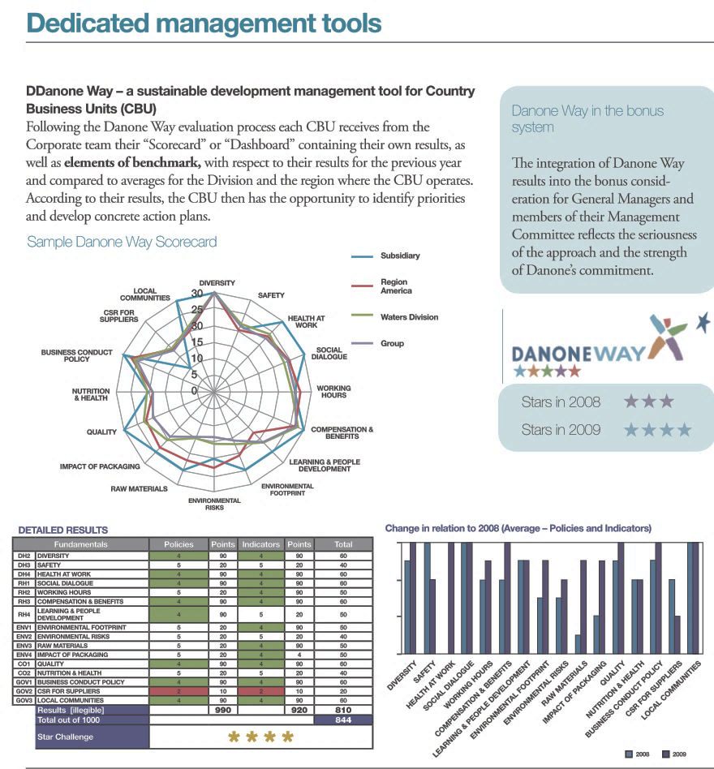

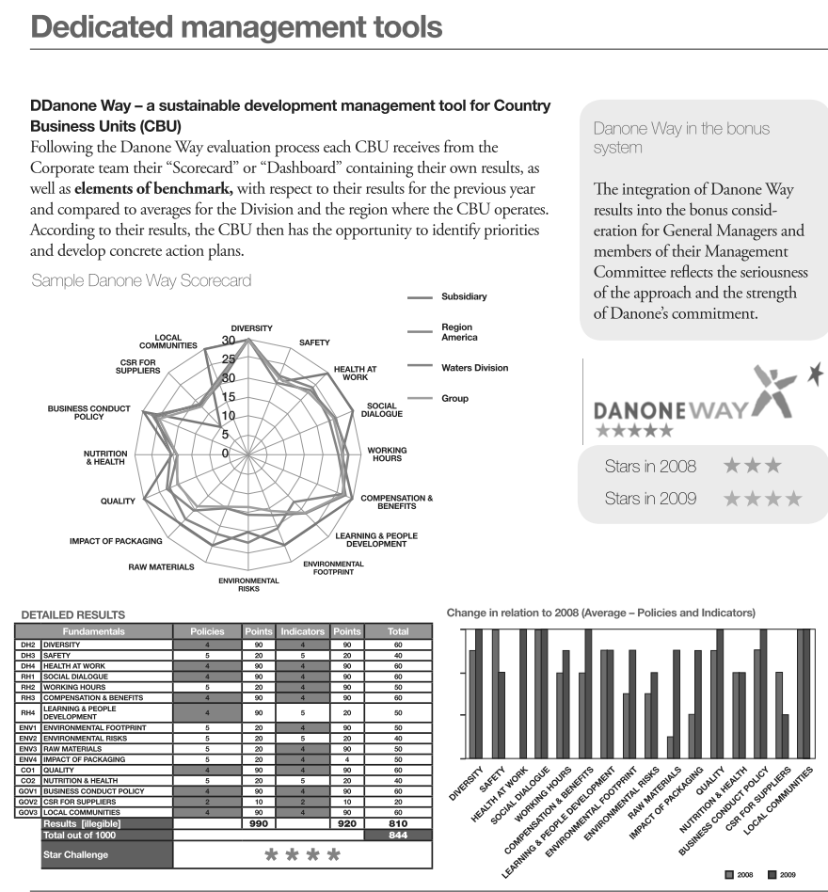

Source: Company files.

**Exhibit 2: Danone—Four Themes to be Prioritized by danone**

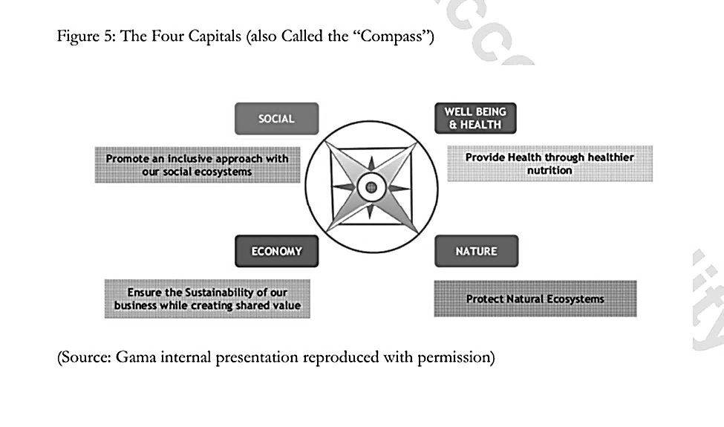

Source: Company files.

**Exhibit 3: Danone—Timeline of Events**



Note: IIRC = International Integrated Reporting Council; <IR> = the IIRC’s integrated report; KPIs = key performance indicators

Source: Created by the case writers.

**Exhibit 4: IIRC—Timeline of Events**



Note: IIRC = International Integrated Reporting Council; <IR> = IIRC’s integrated report

Source: Created by the case writers.

**Exhibit 5: Danone—The Nature Team**

Note: CFO = chief financial officer

Source: Created by the case writers.

**Exhibit 6: Danone—Internal Stakeholders**

|  |  |
| --- | --- |
| **Stakeholder** | **Main Difficulties/Attempts Regarding Integrated Reporting** |
| **Nature Team** | <IR> was too focused on investors; monetization of non-financial indicators would not help. The team disagreed with the six capitals approach. |
| **Investor Relations Manager** | The integrated report should provide information for investors to get a comprehensive view of the company, a view of its value creation process. |
| **Strategy Manager** | The integrated report should allow for a better view of the firm’s activities (such as manufacturing products or delivering them). |
| **Communications Manager** | The integrated report should offer information and data for all stakeholders, not just financial stakeholders. |
| **Finance Manager** | The integrated report should be aligned with the economic concerns of the company. |
| **Health Manager** | <IR> did not seem to be aligned with Health’s interest in a more holistic framework. |
| **Nature Manager** | <IR> did not seem to be aligned with Nature’s goal of developing a more aspirational framework. |
| **Environmental Reporting Manager** | The integrated report should allow for some reporting of environmental cost savings, but it might not necessarily capture the full impact of environmental benefits, some of which were intangible and unquantifiable. |
| **Sustainability Reporting Manager** | <IR> did not seem to allow reporting on intangible benefits. |
| **Risk Manager** | <IR> could potentially be beneficial for risk assessment, but it was unclear how. |

Note: <IR> = the International Integrated Reporting Council’s integrated report

Source: Created by the case writers.

**Exhibit 7: An Overview of Selected Reporting Standards**

|  | **Key Focus** | **Corporate Citizenship** | **Corporate Footprint** | **Audience** |
| --- | --- | --- | --- | --- |
| **Global Reporting Initiative (GRI)–1997** | Objective: Corporate interest and incentives aligned with the communities in which the company operated  Outcome: Transparency on environmental, social, and governance (ESG) issues and comparative ESG information between firms, prompting laggards to improve | * Information on corporate workforce, including labour/management relations, health/safety training, and gender and diversity statistics * Disclosure on corporate record on human rights in society, including child labour monitoring, support of collective bargaining rights, social effect on communities, and adherence to laws and regulations | * Tracking of physical inputs and outputs such as materials, energy, biodiversity, emissions, effluents, and waste * Disclosure on environmental initiatives and recycling rate of products; information on environmental fines and corporate investment in the environment | * Multi-stakeholder focus * Information from reports to be relevant to both corporations and their peers and non-corporate stakeholders |
| **International Integrated Reporting Council (IIRC) 2011** | Objective: Placing a value on intangible assets, or “capitals,” to complement a firm’s financial assets; advocating integrative thinking  Outcome: Creating an efficient way to disseminate comprehensive and quantitative information to shareholders and other stakeholders so they can evaluate a firm’s long-term prospects; within a firm, access to information on other “capitals” should lead to better corporate decision making | * High-level guidance to corporations with companies determining how best to answer the questions; asking firms to apply judgment in determining what information to include * Use of intellectual capital, human capital, and social and relationship capitals are to report on corporate citizenship | * High-level guidance to corporations with companies determining how best to answer the questions; asking firms to apply judgment in determining what information to include * Use of natural capital to report on a corporation’s footprint | * Information designed to be relevant primarily to providers of financial capital (investors or shareholders) and to other stakeholders |

**Exhibit 7 (continued)**

|  |  |  |  |  |
| --- | --- | --- | --- | --- |
| **Sustainability Accounting Standards Board (SASB) 2012** | Objective: Assisting firms and shareholders to manage and reduce “material” risks as defined by the U.S. Securities and Exchange Commission (SEC)  Outcome: Enabling firms to disclose industry-specific “material” factors so as to be in compliance with SEC standards | * Industry-specific reporting requirements * Tracking legal compliance with social issues such as human rights, community relations, data and customer privacy issues, fair disclosure and labelling, and adherence to marketing and advertising standards * Employee relations data including labour relations, diversity, compensation and benefits, and labour practices * Governance data including accident and safety metrics and information on ethics, transparency of payments, and competitive behaviour | * Industry-specific reporting requirements * Reporting on legal limits for GHG emissions, energy and fuel use, volume and management of waste, water and hazardous materials, and effects on the environment, such as air quality | * Designed for corporations and shareholders |

Source: Created by the case writers using data from “Getting Started with the GRI Standards,” Global Reporting Initiative, accessed May 16, 2018, www.globalreporting.org/standards/getting-started-with-the-gri-standards; International Integrated Reporting Council, *The International <IR> Framework*, accessed May 16, 2018, http://integratedreporting.org/wp-content/uploads/2015/03/13-12-08-THE-INTERNATIONAL-IR-FRAMEWORK-2-1.pdf; and the Sustainability Accounting Standards Board website, accessed May 16, 2018, www.sasb.org/standards/download/.

1. The International Integrated Reporting Council (IIRC) identified its integrated reporting framework using the abbreviation “<IR>.”
2. International Integrated Reporting Council, *The International <IR> Framework: Integrated Reporting <IR>*, accessed April 17, 2018, https://integratedreporting.org/wp-content/uploads/2013/12/13-12-08-THE-INTERNATIONAL-IR-FRAMEWORK-2-1.pdf.
3. “Integrated report” indicates Danone’s view of an integrated report, whereas <IR> designates the integrated approach put forward by the IIRC.
4. € = EUR = euro; €0.7628 = US$1.00 in June 2013.
5. “Our Company Culture / Distinctive Values,” Danone, accessed July 27, 2018, www.danone.com/impact/people-communities/our-values.html.
6. Danone: Sustainability Report 2009, p 53, accessed April 17, 2018, <http://csringreece.gr/files/reports/en/2009/danone_2009.pdf?user=>.
7. Martin Petrushevski, “Sustainability Reporting According to the GRI Guidelines,” IIIEE Master Thesis, 2014, accessed April 17, 2018, www.etd.ceu.hu/2014/petrushevski_martin.pdf.
8. Ben Tuxworth, “Global Reporting Initiative: A New Framework?,” *The Guardian*, February 22, 2013, accessed April 17, 2018, www.theguardian.com/sustainable-business/global-reporting-initiative-updates.
9. Danone Sustainability Report 2009, p 5, accessed April 17, 2018 http://csringreece.gr/files/reports/en/2009/danone_2009.pdf?user=.
10. Deloitte, “International Integrated Reporting Council (IIRC), IASPlus, accessed October 19, 2018, www.iasplus.com/en/resources/sustainability/iirc.
11. ICAEW, *The Corporate Report: A Discussion Paper* (London, Accounting Standards Steering Committee, 1975); Ralph W. Estes, *Corporate Social Accounting* (Hoboken, NJ: Wiley, 1976); R.H. Gray, *The Greening of Accountancy: The Profession After Pearce* (n.p.: Certified Accountants Publications, 1990).
12. Global Reporting Initiative, *Sustainability Reporting Guidelines*, 2000, accessed May 16, 2018, www.globalreporting.org/resourcelibrary/G3.1-Guidelines-Incl-Technical-Protocol.pdf.
13. Accounting for Sustainability, “The Connected Reporting Framework,” 2007.
14. International Integrated Reporting Council, *The International <IR> Framework: Integrated Reporting <IR>,* op. cit., 3.
15. International Integrated Reporting Council, *The International <IR> Framework: Integrated Reporting <IR>*, op. cit., 5.
16. “Novozymes,” Ebrary.net, accessed April 17, 2018, https://academlib.com/8524/marketing/novozymes.
17. Natura, *Annual Report 2003*, 26, accessed April 17, 2018, http://natu.infoinvest.com.br/enu/63/Eng_Annual_Report_2003.pdf.
18. Novo Nordisk, *Annual Report 2017*, accessed April 17, 2018, www.novonordisk.com/sustainability/performance/Integrated-reporting.html.
19. Robert G. Eccles and Michael P. Krzus, *One Report: Integrated Reporting for a Sustainable Strategy* (Hoboken, NJ: John Wiley & Sons, 2010).
20. “Kering Sustainability Technical Advisory Group Appointments Announced,” Kering, July 2013, accessed April 17, 2018, www.kering.com/en/press-releases/kering_sustainability_technical_advisory_group_appointments_announced.