

9B18B021

Character House entertainment: the Moana Character ExpansioN

Jayson Killoran wrote this case under the supervision of Ian Dunn solely to provide material for class discussion. The authors do not intend to illustrate either effective or ineffective handling of a managerial situation. The authors may have disguised certain names and other identifying information to protect confidentiality.

*This publication may not be transmitted, photocopied, digitized or otherwise reproduced in any form or by any means without the permission of the copyright holder. Reproduction of this material is not covered under authorization by any reproduction rights organization. To order copies or request permission to reproduce materials, contact Ivey Publishing, Ivey Business School, Western University, London, Ontario, Canada, N6G 0N1; (t) 519.661.3208; (e)* [*cases@ivey.ca*](mailto:cases@ivey.ca)*;* [*www.iveycases.com*](http://www.iveycases.com)*.*

Copyright © 2018, Ivey Business School Foundation Version: 2018-12-20

It was April 2017, and Daisy Stargell, founder of Character House Entertainment (Character House), a small entertainment company in the Greater Toronto Area that provided Disney and cartoon-character performance for children’s birthday parties and corporate events, sat down with a delicious blue slushy as she began to prepare for the company’s third fiscal year. She had recently finished the second year of a bachelor of arts and science degree at McMaster University in Hamilton, Ontario, and expected to have an influx of demand for *Moana*-themed events this upcoming fiscal year.[1] She was excited by the idea of offering new characters but wondered if the initial investment would be worth the cost. She wanted to examine whether she should expand her character options or maintain the status quo. To ensure the expansion was not too complex, she wanted to offer *Moana* performances only for either residential birthday parties or corporate events.

**Company Overview**

Character House was started in April 2015 by Daisy Stargell in Markham, Ontario, when she was in grade 12. Throughout high school, Stargell had spent her summers working at Canada’s Wonderland and Casa Loma as a character performer and host for children’s shows and meet-and-greets. She quickly ascended from part-time performer to a host and event coordinator, and she even gave individual tours for celebrities such as Mike Tyson and Zac Efron. When Stargell learned that parents were beginning to find the ticket prices unreasonably expensive, she decided to launch her own business—one that would offer lower-priced but high-quality birthday party performances for young children in the comfort of their own homes.

Stargell started the business as a sole proprietorship and received a CA$3,000[2] grant from the Ontario Summer Company program.[3] She found a low-cost supplier in China who provided costumes at one-third the price of suppliers in Ontario. She also purchased materials for children to create their own stuffed animals and invested in a “stuffing station,” calling it the “Fluff Factory” (see Exhibit 1). With new equipment, start-up inventory, and a website that Stargell had designed herself, Character House was launched.

Stargell launched Character House in Markham and Stouffville, and it became an instant success. Parents were drawn to Character House because it provided a custom birthday party performance that was tailored towards children’s favourite Disney and cartoon characters for a reasonable price. Parents would book an event one month prior to the party for an average cost of $150. Each one-hour event included two Disney and/or cartoon characters, a musical performance, pictures with the children, games, dances, and cotton candy. Birthday parties were organized year-round and took place inside the customer’s home. During the summer months, Character House would host events outdoors, and games and dances were replaced with a bouncing castle and the Fluff Factory for children to make their own stuffed animals.

After the first fiscal year, Character House grew rapidly from one or two shows per weekend to an average of 10 shows every weekend. Stargell and her sister went from performing every show themselves to hiring high school and university actors to portray the characters. This allowed Stargell to manage the business and ensure customers were satisfied while she continued her studies at university. Stargell believed it was important for Character House to give back to the community, so she provided free performances for sick children at hospitals every month. Stargell was also adamant about ensuring that Character House was both run and performed by students, which meant that all actors hired were high school or university students. Since many Disney and cartoon characters were meant to be in their late teens and early twenties, hiring young actors that were about the same age gave Character House’s performances a more authentic feel, and parents enjoyed supporting an organization that was committed to helping students save money for their education.

Character House required little marketing, as the business expanded successfully through positive word-of-mouth referrals throughout the Greater Toronto Area (GTA). In its second fiscal year, Character House expanded into corporate events, which included musical performances and meet-and-greets at daycares, camps, and business events. With this increased demand came requests for specific characters that Character House sometimes did not have the costumes or skilled actors to portray. The business often hired and trained new actors to cater to this demand; otherwise, it turned customers away.

**Customers**

Character House’s customers were divided into two segments: residential birthday parties and corporate events. Residential parties included middle-upper-class families in the GTA that wanted to provide a fun and memorable birthday party for their children, who were usually between two and eight years old. These customers were happy to organize a fun-filled day for their kids, but they did not want to pay an exorbitant amount of money for a one-hour event. They were also looking for an option that allowed their children and friends to have fun in a nearby location.

The second customer group was corporate events, which included daycare companies, summer camps, city festivals at the Canadian National Exhibit,[4] and private business events for employees and their children. These events were planned several months in advance. Organizers requested grandiose performances that averaged two hours in duration. Because the corporate events were more intricate and complex, Character House charged $500 per hour. Businesses were willing to pay this higher rate, as they were looking for professional and magical performances that would amaze the children, and they often later used pictures and videos from these events as marketing materials to enhance their brand and recruit new customers. Character House garnered positive customer reviews and received requests for longer-duration performances. Stargell expected the average duration of all corporate events for the coming fiscal year would increase to three hours.

In Character House’s second fiscal year, sales for the residential customers and corporate events amounted to $60,000 and $20,000, respectively. The cost of sales for the residential customers was $48,000, and for the corporate customers it was $11,000.

**Competition**

Customers had a plethora of options available when considering birthday parties and corporate events. There were several direct and indirect competitors; however, the market was quite fragmented for character performances. Stargell identified three of Character House’s direct competitors:

**Little Jingle Beans Inc.[5]**

Founded in 2013 and offering its services in Toronto, Milton, and Oshawa, Little Jingle Beans Inc. (LJB) specialized in mascot costumes and birthday parties, and in meet-and-greets with actors depicting superheroes and Disney princesses. LJB offered three times as many character options as Character House and used professional actors who were often in their thirties and forties. In addition to the meet-and-greets, LJB offered musical performances, face painting, art classes, and live interactive shows. Prices ranged between $200 and $300 for a 60-minute event. It also had corporate clients, including Labatt Brewing Company Limited, TJX Canada, and North York General Hospital.

**The Superhero Company Inc.[6]**

The Superhero Company Inc. (TSC) had been in business for 10 years and also used professional actors who were in their thirties and forties. The company had garnered positive media recognition and was deemed the number-one superhero party company in Canada by *City Parent* magazine for five straight years. TSC offered superhero meet-and-greets for children and adults, interactive games, and temporary tattoos. TSC also helped plan personalized events. The average price for a one-hour event was $170 for a one-character appearance in Toronto. Requests for more characters and events in the GTA were subjected to higher fees.

**Tricks with Bricks[7]**

Located in Newmarket, Tricks with Bricks (TWB) was founded in 2013 and provided Lego-themed birthday parties for preschool to preteen children. In addition to hosting birthday parties, TWB also used Lego for educational purposes, including teaching programming essentials, creating animated Lego videos, and incorporating Lego into introductory robotic designs. Birthday party prices ranged between $220 and $350 for a 60-minute event.

**Indirect Competitors**

Parents had countless other options for their children’s birthday parties, including bowling, laser tag, miniature golf, rock climbing, escape rooms, and arcade games. Prices for these events in the Markham and Stouffville area varied between $50 and $200 per hour. Stargell felt that these competitors were not a direct threat to her business because the companies did not offer character appearances.

**The *Moana* Opportunity**

*Moana* starred Dwayne “The Rock” Johnson and Auli’i Cravalho as the primary characters Maui and Moana. The film had been one of the highest-earning movies from the end of 2016 to April 2017, grossing over US$643 million worldwide.[8] Stargell anticipated that the movie’s popularity would result in a high demand for *Moana*-themed birthday parties and corporate events, and she decided to examine if it would make sense for Character House to add Moana and Maui to its selection of characters.

Stargell wanted to assess the opportunity of offering *Moana* events solely for either residential customers or corporate events. She did not want to offer *Moana* events for both residential parties and corporate events for two reasons. First, the type of advertising required to attract corporate customers was costlier than residential customers, and it required more time to meet with corporate event organizers. Stargell felt it would be difficult to effectively advertise to both customers simultaneously. Second, there were often requests from both groups of customers for the same dates throughout the year. In order to maximize her advertising efforts and continue offering great service to customers, Stargell decided to target only one customer group in the upcoming fiscal year; she would consider offering *Moana* events to both customer groups in future years.

With residential customers, Stargell would charge the same price of $150 for a one-hour birthday party, and she believed the additional sales from *Moana*-themed events would be equal to 40 per cent of the total residential events revenue from the last fiscal year. Customers typically paid for half of the event cost upfront, and the other half would be paid within 60 days of booking each event. Character House would need to audition high school and university actors to ensure they looked the part, had an ability to sing well, and displayed professional conduct. Based on her past experiences in hiring actors, the auditioning process would take two weeks and cost $1,500 in scripts, props, and filming. Once the two actors were selected to play Maui and Moana, each actor would need to undergo three hours of training to rehearse and choreograph the songs and dances and learn professional etiquette for engaging with children. Due to the nature of the performances, Character House offered competitive wages of $40 per hour to attract skilled young actors.

Makeup costs for Character House averaged $9.50 per event, and the cotton candy expense was 5 per cent of sales.[9] The stuffed animal shell and cotton fluff used to create a stuffed animal cost $0.25 and $0.05, respectively, and Stargell expected that each party would request 10 stuffed animals. Fuel costs for Stargell and the actors was projected to be $2,500. Character House would need to order professionally designed Maui and Moana outfits. Each outfit was $200, and Stargell wanted to have two of each character. She believed each outfit could be used for five events before needing to be washed and dry cleaned, which cost $10 per outfit. Insurance expenses for Character House would be $450, the same amount as the previous year. Stargell wanted to attract new customers in the GTA, so she decided to increase her marketing expenditures by $1,500 for the upcoming year only. She would use this money for newspaper, Facebook, Inc., and Google LLC advertising. The days of inventory was expected to remain the same at 30 days.[10]

Corporate events took place infrequently; however, with the box office success of *Moana*, Stargell believed Character House would increase its number of corporate events by 50 per cent. Hourly prices charged to corporate customers would remain the same as the previous year. Corporate clients would also pay half of the cost upfront, with the remaining amount paid within 90 days of booking. Actors would be paid the same $40 hourly rate for training, but they would each be compensated $150 per corporate event. Stargell would order a third set of costumes to have as spares for corporate events. Cotton candy would increase to 15 per cent of sales, and an average of 40 stuffed animals would be created at each event. Stargell would double the advertising budget to attract corporate clients, fuel expenses were projected to be $1,750, and the days of inventory would increase to 60 days. All other recurring costs and investments were expected to remain the same as the residential opportunity.

**Conclusion**

Stargell was excited for Character House’s third fiscal year after two consecutive years of strong sales growth and a high level of customer satisfaction. If she decided not to offer *Moana*-themed events, Character House would need to turn away business, and competitors would take advantage of this. Customers liked that Character House was run by students and enjoyed supporting students’ ambitions of working hard to pay for their university and college tuition. Whether or not Character House decided to expand, Stargell wanted to ensure that she could continue putting smiles on children’s faces, gain leadership experience, and increase profitability. After a mild brain freeze, she began analyzing her options.

**Exhibit 1: Fluff Factory**

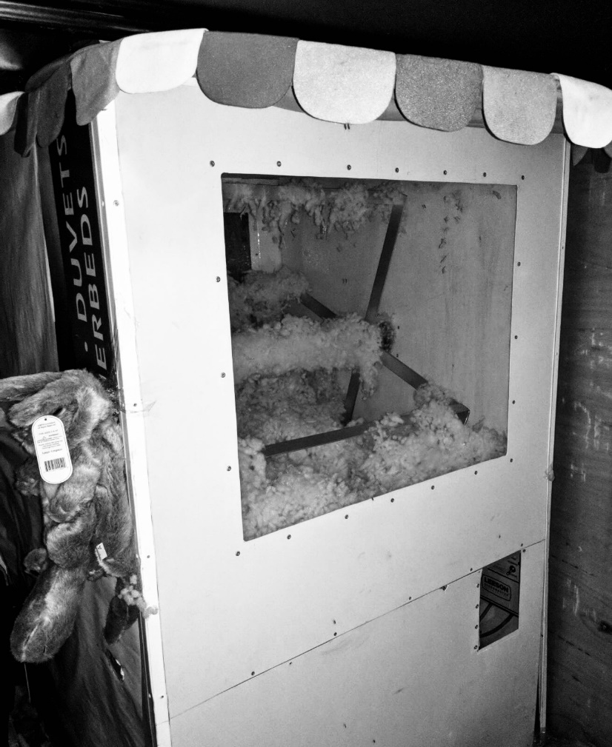

Source: Company files.

1. *Moana* was a popular animated Disney movie that was released in theatres on November 23, 2016.
2. All dollar amounts are in Canadian dollars unless otherwise specified.
3. Summer Company was a Government of Ontario program that provided funding, advice, and services for young people between the ages of 15 and 29 looking to start and run their own summer business.
4. The Canadian National Exhibit was an annual event that took place in Toronto at the end of August during the 18 days leading up to, and including, Canadian Labour Day.
5. “About Us: A Living Fairytale,” Little Jingle Beans, accessed June 17, 2018, https://www.littlejinglebeans.com/.
6. The Superhero Company (website), accessed June 17, 2018, http://thesuperherocompany.com/.
7. Tricks with Bricks (website), accessed June 17, 2018, https://www.trickswithbricks.ca/.
8. “*Moana*,” Box Office Mojo, June 15, 2018, accessed June 18, 2018, www.boxofficemojo.com/movies/?id=disney1116.htm
9. Character House used a local cotton candy supplier, who extended credit terms of net 15.
10. Inventory consisted of makeup, cotton candy, stuffed animal shells, and cotton fluff.