

9B18B022

GRAND RIVER UNIVERSITY WATER BUFFALOS: ACTIVITY-BASED COSTING OF UNIVERSITY SPORTS

Kun Huo and Ian Burt wrote this case solely to provide material for class discussion. The authors do not intend to illustrate either effective or ineffective handling of a managerial situation. The authors may have disguised certain names and other identifying information to protect confidentiality.

*This publication may not be transmitted, photocopied, digitized, or otherwise reproduced in any form or by any means without the permission of the copyright holder. Reproduction of this material is not covered under authorization by any reproduction rights organization. To order copies or request permission to reproduce materials, contact Ivey Publishing, Ivey Business School, Western University, London, Ontario, Canada, N6G 0N1; (t) 519.661.3208; (e)* [*cases@ivey.ca*](mailto:cases@ivey.ca)*;* [*www.iveycases.com*](http://www.iveycases.com)*.*

Copyright © 2019, Ivey Business School Foundation Version: 2019-03-22

On April 30, 2018, Liam McKenzie, the athletic director of Grand River University, sat in his office to contemplate the past year and the future of the athletic teams under his supervision. The men’s basketball team, the university’s most popular team, had had a winning season but lost in the first round of the conference championship, missing the chance to advance to the National Collegiate Athletic Association (NCAA), Division 1, Men’s Basketball Championships (commonly known as “March Madness”). The men’s hockey team, the university’s second most popular team, had barely managed to win a third of its games and finished the season on a losing streak. The women’s basketball team had improved from the last two years but still ended the season on a losing record. The past season had more low points than highlights, but McKenzie was optimistic about the future. He had already been brainstorming on new ideas to help his varsity teams. However, his new ideas would have to wait because a meeting with the school’s board of trustees was fast approaching, and they needed information from him.

McKenzie had only a few days to prepare a financial report for the board. The report was intended to advise the board on whether to add new sports teams, drop any of the current sports teams from the university’s lineup, or continue as usual. These were major decisions with wide-ranging implications. In fact, the school’s decision to cancel the women’s hockey program in 2012 was seen as a controversial move by the university. Costs were cited as a major reason for that change, but McKenzie often wondered how much money was saved by cutting the sports program, and whether the school had fully accounted for the non-financial impact.[1] More recently, another local university, Grand Island University, had cut its swimming, baseball, and men’s soccer programs. McKenzie was asked by the board to provide the cost associated with each student athlete, which the board would use to make a decision. McKenzie was unsure about the adequacy of the current method for reporting costs (see Exhibits 1 and 2) because it did not allocate the shared costs to each team.

A related issue was growing pressure on schools to be transparent and accountable for their athletic spending decisions. Some advocates and researchers had accused schools of hiding the true cost of college sports programs, which was then passed on to student fees. A group of researchers had used activity-based costing (ABC) to show that the actual cost of having a team was much higher than the schools reported. McKenzie wondered what his school’s costs would look like after applying the ABC method to his calculations.

McKenzie was also asked to report on Grand River University’s performance regarding gender-equal treatment to all athletes. The U.S. Department of Education had a mandate to achieve gender equity in all levels of education. The department had set up a database called Equity in Athletics Data Analysis (EADA) where athletic spending data, separated by gender, from individual universities was published for scrutiny by the public. Grand River University had submitted data to EADA in the past, but McKenzie wondered if the numbers the school had provided had reflected the full cost. He also wondered if the per-athlete spending would look different when calculated using the ABC method, and how it would compare to a peer school, such as Grand Island University (see Exhibit 3).

As athletic director, McKenzie spent much of his time meeting with people in different locations. He rarely had the chance to spend a full day in his office, as he would that day, so he took a moment to glance over all the championship trophies from past Water Buffalo teams. He yearned to bring more trophies to the school, but first he had to make sense of the numerous financial reports his staff had generated for him.

THE WATER BUFFALOS

Grand River University was located on the banks of the Grand River, one of the mightiest rivers in the United States and the world, commonly known as “The Grand.” It was a small, independent, and faith-based institution that prided itself on providing high quality education while maintaining a very safe and inclusive community environment on campus. Grand River University’s enrolment was consistently between 2,500 and 3,000 students. Despite its relatively small size, more than one in 10 students played competitive sports for the school and received various levels of scholarship aid. The Water Buffalos had a proud sporting history. In the previous 20 years, the university’s basketball, soccer, volleyball, tennis, and swimming teams had captured multiple conference championships and secured entry positions into the prestigious NCAA national tournaments. Currently, Grand River University was labelled by the NCAA as a “Division I institution without football” and had 18 NCAA Division I sports teams. Many current and prospective students cited the vibrant sports culture as a strength of the school.

The school’s athletic teams were also popular within the local community, with many teams offering young athlete clinics and lessons. The hockey team had a particularly strong presence in the community due to its affiliation with the Grand River Junior Water Buffalos minor hockey association. In fact, McKenzie’s 12-year-old son, Ian, was a big fan of the Water Buffalos and played in the minor hockey association. The close ties between the athletes, the student body, and the local community had made the loss of the women’s hockey team in 2012 especially hard. The Junior Water Buffalos girls program had been continually growing, but since the removal of the program, the numbers of girls in the organization had dropped to half. Many players and team alumni felt shunned by the school, which was expected to have an impact on alumni relations for years to come.

NATIONAL COLLEGIATE ATHLETIC ASSOCIATION

The NCAA was a non-profit organization that regulated athletes of 1,123 colleges and universities.[2] It was organized into three divisions. Division I schools generally had large student bodies, managed the large athletic budgets, and provided many athletic scholarships.[3] The NCAA determined who would be eligible to participate in NCAA-sanctioned sports and events. Generally, student athletes had to meet certain academic standards and only moderate scholarship funding to qualify as amateur athletes. The NCAA also served as a source of income re-distribution. Most of the NCAA’s revenue came from ticket sales, television rights, and marketing rights to its Division I Men’s Basketball Championship, or March Madness.[4] A portion of the funds were given to schools that participated in March Madness. The remainder was distributed as student aid to all schools who funded programs in NCAA Division I sports.[5]

FUNDING AND SPENDING IN ATHLETICS

Although the Grand River University men’s basketball team had not competed in March Madness in the previous 10 years, the university received US$335,476[6] from NCAA and $77,000 from its regional conference in 2016. These amounts were partially based on the number of Division I sports at the school and on the amount of grants and aid the school provided to its students. Despite the help these sources of income provided, most of the athletic department’s funding came from the school itself, in the form of operating budget funds. In fact, a recent internal document showed that revenue from college sports covered only approximately 15 per cent of the school’s $10 million overall cost of maintaining these teams (see Exhibit 1). Of that overall budget, more than $4 million consisted of scholarships to subsidize tuition for selected students, rather than providing cash directly to the students. McKenzie was unsure how this cost should be factored into the calculation.

Grand River University’s sports funding model was neither unique nor extreme. McKenzie had read a report from the Knight Commission[7] showing that in 2017, among institutions that did not have football programs, about 78–89 per cent of all athletic funding had come from government and institution grants and from extra student fees.[8] Sources of spending and funding of athletic budgets came from both private institutions (see Exhibit 4, panels A and B) and public institutions (see Exhibit 4, panels C and D).

Grand River University did not have a football program. Costs for participating in sports included travel, coaching, and facilities. These costs were increasing at a faster rate than school revenues, which caused many university administrators to question the viability of college sports. It seemed that the success of a few universities was built on continuous losses from others.[9]

McKenzie was also alarmed by critics who claimed that the athletic departments of universities were intentionally obfuscating actual costs to avoid public backlash, as was stated in one report:

A significant hurdle to the implementation of ABC is that institutions will be averse to applying ABC if other institutions do not. A possible fear is that ABC will result in a greater understanding of the high cost associated with some sport programs. The programs that are already known to be expensive such as football will become more expensive if ABC is implemented. Thus, it would be unlikely that a single athletic department would choose to make public financial information, which may result in a more negative public perception for a single sport program or the entire athletics department.[10]

McKenzie was not familiar with ABC accounting methods, but he thought it might be prudent to learn about ABC in preparation for tough questions about athletic spending. He was also confident that if ABC helped to generated more accurate costs, the board of trustees would be better informed for their decisions, during their evaluation of the optimal number of teams for the school to support.

COST OF ATHLETICS AT GRAND RIVER

Looking at the total costs incurred by the athletic department, McKenzie had several concerns. He was unsure how the shared expenses of administration, marketing, broadcast, sports information, facilities, and athletic training should be allocated. In particular, facilities expenses were costs associated with the use of facilities by the athletic department and were allocated from the university’s overall facilities budget. These expenses consisted of costs related to several buildings used by the athletes and other students, staff, and faculty. A simple method would be to evenly distribute the costs to each team, but McKenzie was intent on being more precise, so he had his staff generate several different reports including a description of each facility, its uses, and other expenses.

Facilities

The three sport facilities at Grand River University included the Boschetto Center, the Mason Arena, and the Nicholson Center.

The Boschetto Center was a workout facility that housed a weight training room, three gymnasiums, a cardiovascular exercise room, and a swimming pool. The weight training room was open to all athletes throughout the day, as well as to any student or staff member that had a membership. The gymnasiums were used according to a schedule where athletic teams were allotted specific times. However, the gymnasiums could also be booked for intramural sports or for drop-in recreation by students. The swimming pool was booked for much of the day by the university’s swimming and diving team, but was open to all students during the evening. The Boschetto Center also housed the main athletic training facility for injured and rehabilitating athletes.

The Mason Arena’s ice surface was used mainly by the university’s hockey team, but it was also available for rent to a private hockey club, the Grand River Junior Water Buffalos organization, and to the general public. The arena also housed the ice hockey team locker room and the coaches’ offices, the women’s lacrosse team locker room and coaches’ office, athletic laundry facilities, a weight training room reserved for athletes, and offices for sports administrative staff. The weight training room in this facility was run by the strength and conditioning coach, who typically scheduled team workouts throughout the day.

The Nicholson Center was a two-level building. The lower level was a food court and relaxation area for students. The facility’s upper level held a 2,400-seat basketball court, where both the men’s and women’s basketball teams played and practised. Several more offices for coaches and sports administrative staff were also in this building.

Uses of the Facilities

Different teams had different needs for the facilities. For example, the hockey team was the only team that used the ice surface in Mason Arena. Similarly, only the basketball teams used the Nicholson Center for practice. In comparison, the gymnasiums at the Boschetto Center hosted multiple teams because the equipment could be arranged to suit a variety of needs. Unlike the specialized facilities, the weight training room in the Boschetto Center was used by all teams (see Exhibit 5).

Other Expenses

More information on shared expenses and non-team-specific costs was available (see Exhibit 2). The main component of expenses was wages and benefits for the athletic department staff, including McKenzie. Unlike the coaches, who worked mainly with one particular team, department staff members were responsible for a variety of tasks including coordination with NCAA and conference administrative staff, selling tickets, promoting the teams on radio and television stations, and supporting the teams that travelled for away games.

CONCLUSION

As McKenzie refilled his cup of coffee, he began to consider how the report to the board should be structured. He was aware that although he was the athletic director, the school’s board of trustees had ultimate authority on the decision to cut funding for any particular programs. Beyond providing information for the board to make a decision on the future of university teams, the report could also help administrators understand the efficiency of the athletic department’s operations and its progress on gender equity.

Finally, McKenzie considered the specific characteristics of the report’s readers. Although the board trustees were highly competent individuals, they lacked professional accounting and financial expertise. Therefore, it was important that McKenzie presented his analysis in an easy-to-understand format, and that the report outlined the various alternatives in a concise manner.

**Exhibit 1: Summary of Expenses and Revenues for the Athletics Department, 2017 (in US$)**

**Panel A: Sources of Expenses**

|  |  |  |  |  |  |
| --- | --- | --- | --- | --- | --- |
| **Department** | **Operating Budget** | **Salaries** | **Salaries and Benefits** | **Scholarships** | **Expense by Department** |
| Administration | 250,000 | 287,600 | 406,100 | - | 656,100 |
| Marketing and Sponsorships | 53,000 | 97,500 | 129,400 | - | 182,400 |
| Broadcast Radio and TV | - | - | - | - | - |
| Sports Information | 41,100 | 143,300 | 173,300 | - | 214,400 |
| Facilities | 600,700 |  |  | - | 600,700 |
| Athletic Training | 39,500 | 304,000 | 420,700 | - | 460,200 |
| W Basketball | 309,900 | 293,500 | 424,700 | 555,600 | 1,290,200 |
| W Volleyball | 99,700 | 53,400 | 72,100 | 235,800 | 407,600 |
| M Hockey | 348,800 | 458,600 | 648,400 | 437,600 | 1,434,800 |
| M Basketball | 551,100 | 394,400 | 566,100 | 620,000 | 1,737,200 |
| W Soccer | 89,800 | 88,700 | 121,700 | 341,700 | 553,200 |
| W Softball | 90,700 | 48,500 | 64,000 | 248,500 | 403,200 |
| W Golf | 23,300 | 8,100 | 8,900 | 68,000 | 100,200 |
| W Lacrosse | 99,200 | 71,600 | 86,100 | 397,000 | 582,300 |
| M Baseball | 145,900 | 53,100 | 70,700 | 338,100 | 554,700 |
| M Soccer | 109,600 | 73,000 | 101,500 | 297,000 | 508,100 |
| Tennis (M and W) | 60,600 | 21,200 | 23,000 | 129,900 | 213,500 |
| Cross Country (M and W) | 37,900 | 14,300 | 18,200 | 78,700 | 134,800 |
| Swimming and Diving (M and W) | 45,900 | 61,300 | 79,900 | 325,600 | 451,400 |
| M Golf | 20,600 | 10,300 | 11,300 | 26,000 | 57,900 |
| W Track and Field | 28,400 | 70,600 | 98,800 | 133,700 | 260,900 |
|  | **3,045,700** | **2,553,000** | **3,524,900** | **4,233,200** | **10,803,800** |

**Exhibit 1 (continued)**

**Panel B: Sources of Income**

|  |  |
| --- | --- |
| NCAA | 335,400 |
| Conference | 77,000 |
| Game Guarantees | 308,000 |
| Sales (Tickets, Sponsorships, Licensing) | 210,600 |
| Gift Account Contribution | 235,600 |
| Student Fees | 471,700 |
| **Total Income** | **1,638,300** |

Note: TV = television; M = men’s; W = women’s; NCAA = National Collegiate Athletic Association

Source: Company documents.

**Exhibit 2: Explanations of Non-Team-specific Costs**

**Administration**: Administrative costs included expendable equipment, postage, seminars, courier services, travel, office supplies, telephone, dues and memberships, books and subscriptions, and salaries and benefits. Liam McKenzie and his administrative staff spent little time with the athletes; most of their time was spent with the National Collegiate Athletic Association, the conferences in which the university’s teams played, university administration staff, and alumni.

**Marketing and Sponsorships**: These costs included postage, expendable equipment, seminars, travel, office supplies, printing, telephone, advertising, salaries and benefits, and sponsorship fulfillment.

**Sports Information**: These costs included postage, equipment, seminars, travel, office supplies, telephones, subscriptions, software, photography, press box fees, publications, programs, salaries and benefits.

**Facilities**: Inquiries with university administration revealed that the cost of operating and maintaining the facilities were split as follows: Mason Arena (60%), Boschetto Center (30%), and Nicholson Center (10%).

**Athletic Training**: These costs included weight room supplies, expendable equipment, postage, seminars, travel, office supplies, telephone, ice, clothing, tape, protective equipment, medical supplies, equipment maintenance, medical consultants, medical expenses, nutritionist fees, and salaries and benefits. Besides supplies, a significant amount of costs was incurred by hiring consultants and strength and conditioning coaches on an hourly basis.

Source: Company documents.

**Exhibit 3: Operating Expenses as Reported by Equity in Athletics Data Analysis, 2017 (in US$)**

**Panel A: Grand River University**

|  |  |  |  |  |  |  |  |  |
| --- | --- | --- | --- | --- | --- | --- | --- | --- |
| **Varsity Team** | *Men’s Teams* | | | *Women’s Teams* | | | **Total  Operating Expenses** | |
| **Participants** | **Operating Expenses per Participant** | **By Team** | **Participants** | **Operating Expenses per Participant** | **By Team** |
| Basketball | 14 | $27,151 | $380,114 | 15 | $15,057 | $225,855 | $605,969 |
| Baseball | 31 | $4,348 | $134,788 | - | - | - | $134,788 |
| Golf | 10 | $1,484 | $14,840 | 8 | $2,054 | $16,432 | $31,272 |
| Hockey | 30 | $7,895 | $236,850 | - | - | - | $236,850 |
| Lacrosse | - | - | - | 25 | $3,715 | $92,875 | $92,875 |
| Soccer | 25 | $3,169 | $79,225 | 31 | $2,220 | $68,820 | $148,045 |
| Softball | - | - | - | 21 | $3,899 | $81,879 | $81,879 |
| Swimming and Diving | 24 | $1,664 | $39,936 | 20 | $756 | $15,120 | $55,056 |
| Tennis | 8 | $3,490 | $27,920 | 6 | $3,511 | $21,066 | $48,986 |
| Track and Field | - | - | - | 28 | $867 | $24,276 | $24,276 |
| Cross Country | 8 | $1,420 | $11,360 | 11 | $1,630 | $17,930 | $29,290 |
| Volleyball | - | - | - | 14 | $6,307 | $88,298 | $88,298 |
| **Total Operating Expenses Men’s and Women’s Teams** | **150** | **-** | **$925,033** | **179** | **-** | **$652,551** | **$1,577,584** |

**Exhibit 3 (continued)**

**Panel B: Grand Island University (for Comparison)**

|  |  |  |  |  |  |  |  |  |  |  |
| --- | --- | --- | --- | --- | --- | --- | --- | --- | --- | --- |
|  | *Men’s Teams* | | | | *Women’s Teams* | | | |  | |
|  | **Participants** | **Operating Expenses per Participant** | **By Team** | **Participants** | | **Operating Expenses per Participant** | **By Team** | **Total Operating Expenses** | |
| Basketball | 14 | $18,641 | $260,980 | 14 | | $13,656 | $191,180 | $452,160 | |
| Baseball | 37 | $5,013 | $185,471 | - | | - | - | $185,471 | |
| All Track Combined | 72 | $731 | $52,650 | 66 | | $736 | $48,599 | $101,249 | |
| Golf | 7 | $5,411 | $37,879 |  | |  |  | $37,879 | |
| Ice Hockey | 29 | $8,706 | $252,469 |  | |  |  | $252,469 | |
| Lacrosse | 35 | $4,170 | $145,940 | 26 | | $5,296 | $137,685 | $283,625 | |
| Rowing |  |  |  | 29 | | $2,196 | $63,688 | $63,688 | |
| Soccer | 24 | $3,505 | $84,127 | 25 | | $2,604 | $65,096 | $149,223 | |
| Softball | - | - | - | 19 | | $5,509 | $104,666 | $104,666 | |
| Swimming and Diving | 28 | $1,228 | $34,395 | 23 | | $1,175 | $27,025 | $61,420 | |
| Volleyball |  |  |  | 14 | | $5,114 | $71,590 | $71,590 | |
| **Total Operating Expenses Men’s and Women’s Teams** | **246** | **-** | **$1,053,911** | **216** | | **-** | **$709,529** | **$1,763,440** | |

Source: “The Tools You Need for Equity in Athletics Analysis,” U.S. Department of Education, Equity in Athletics Data Analysis, accessed November 28, 2018, https://ope.ed.gov/athletics/#/.

**Exhibit 4: Report by the Knight Commission on Intercollegiate Athletics**

**Panel A: Private Institutions Spending**

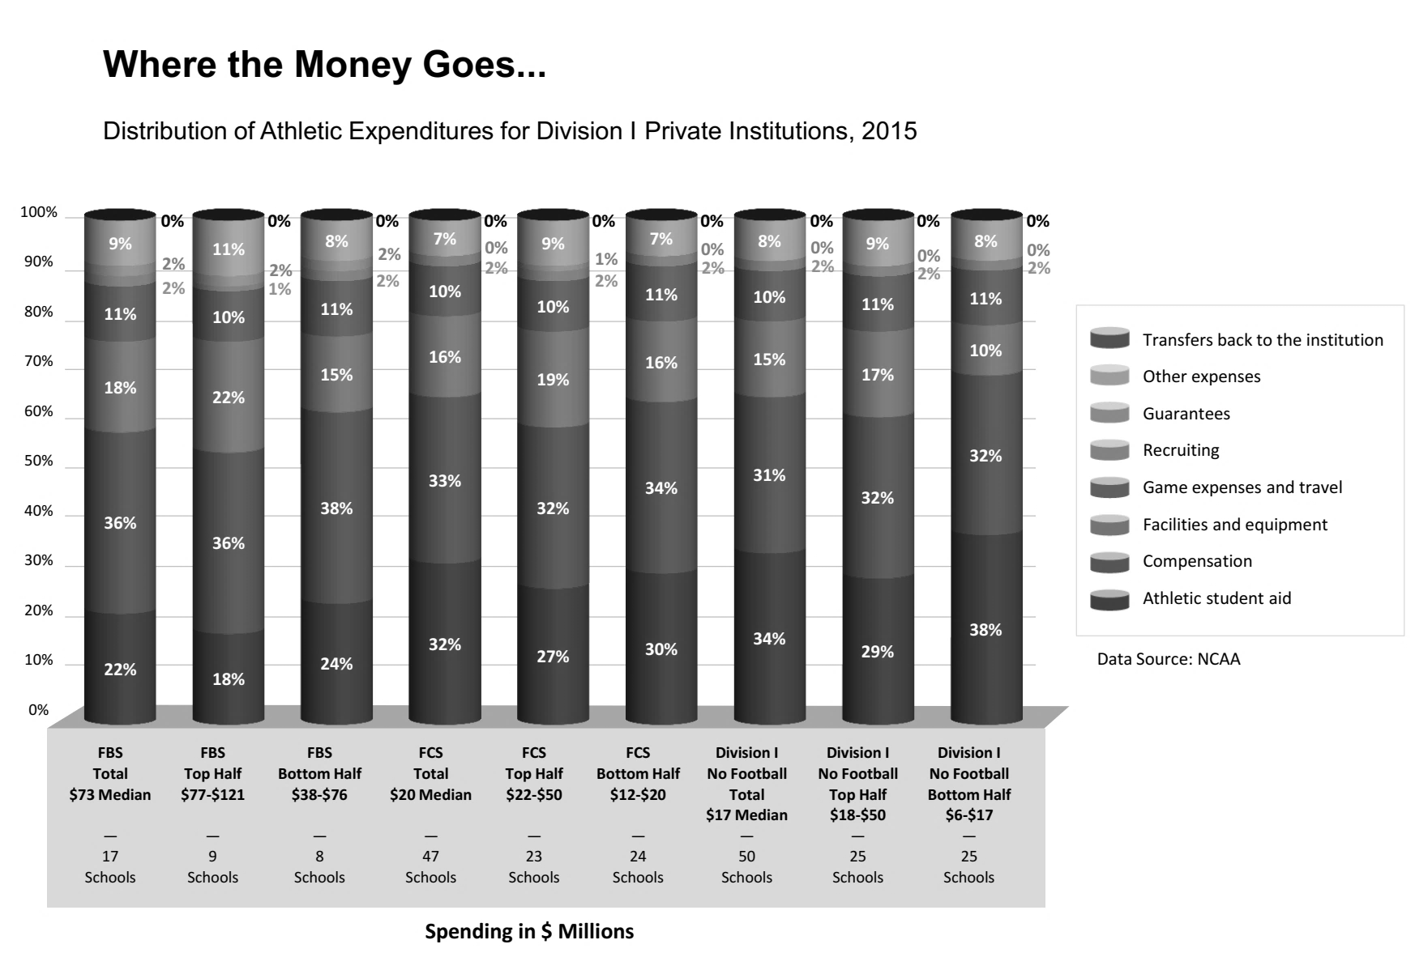

**Exhibit 4 (continued)**

**Panel B: Private Institutions Funding**

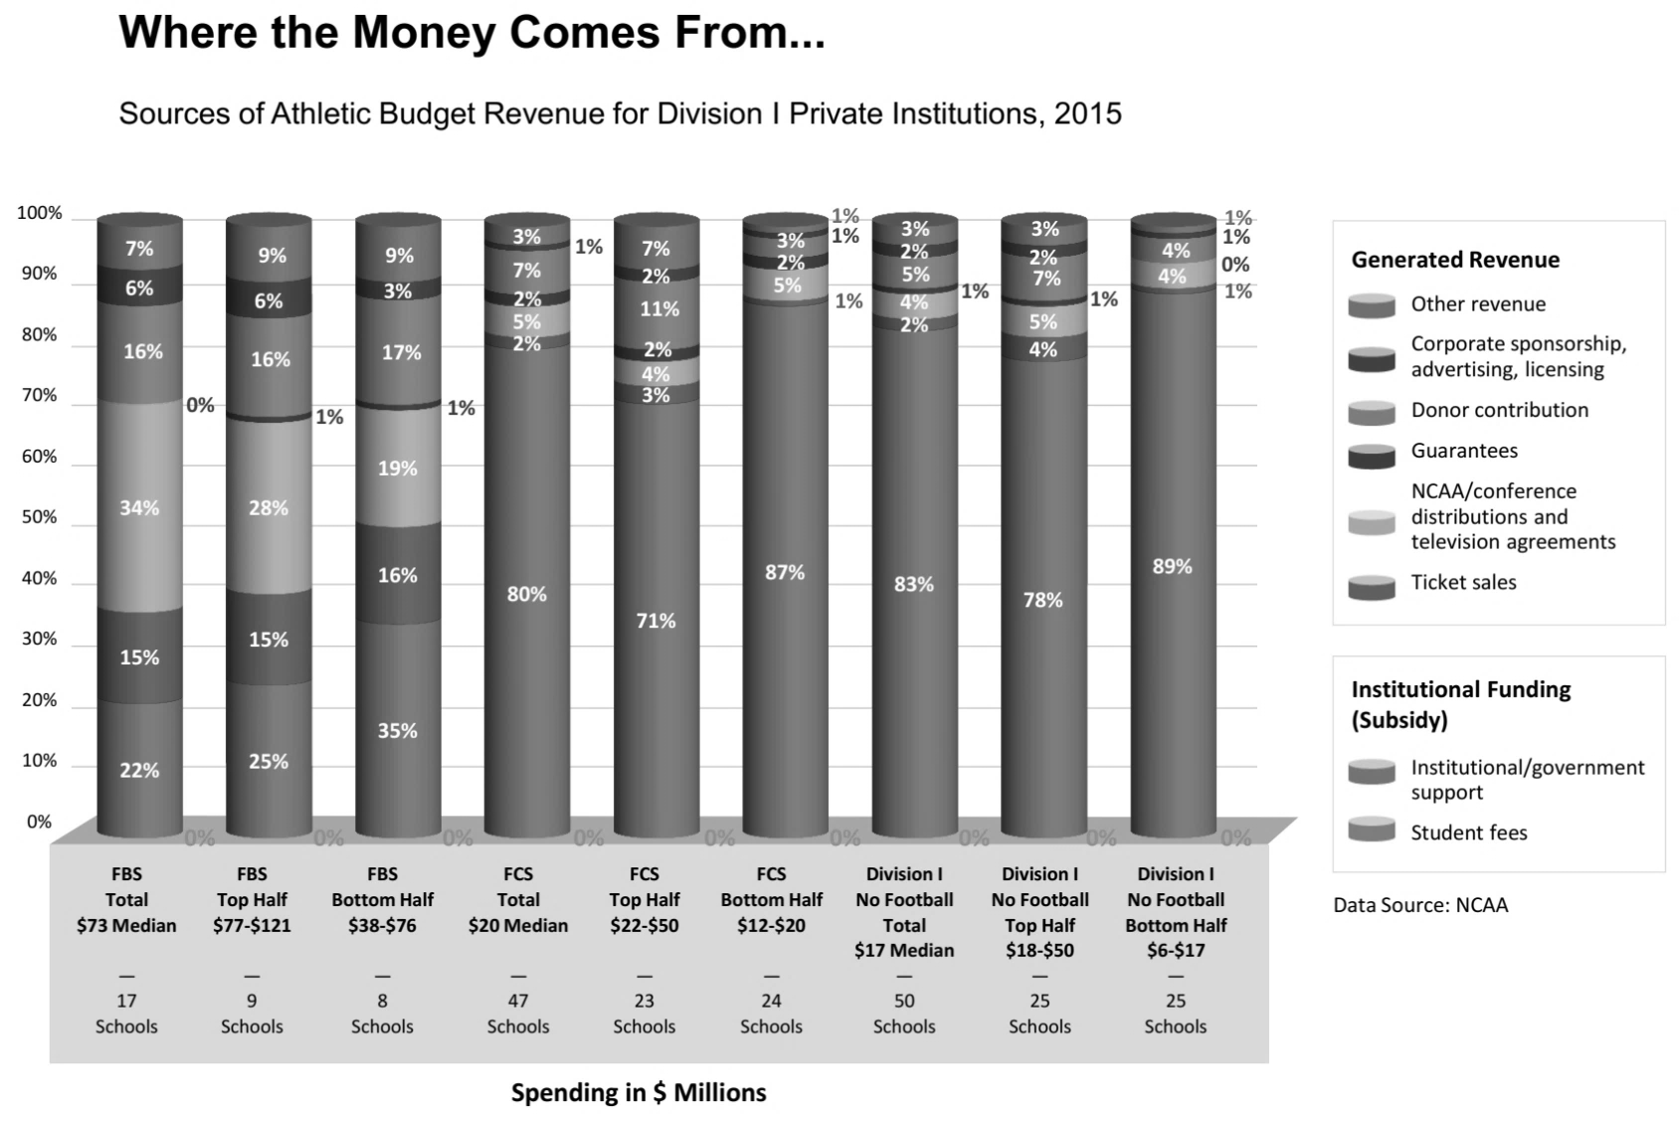

**Exhibit 4 (continued)**

**Panel C: Public Institutions Spending**

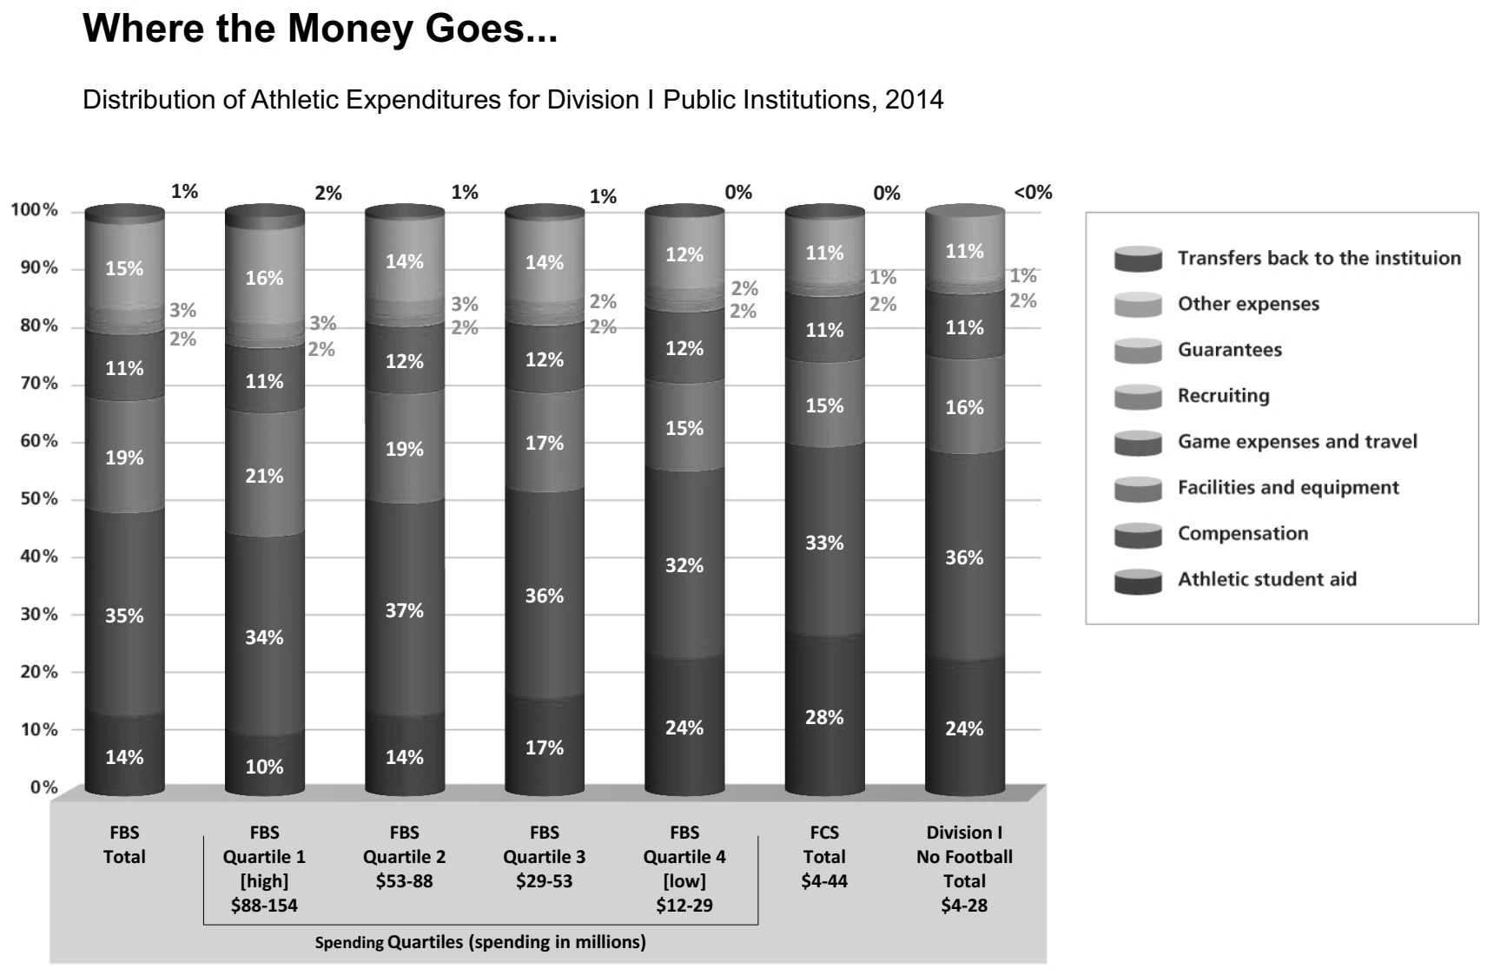

**Exhibit 4 (continued)**

**Panel D: Public Institutions Funding**

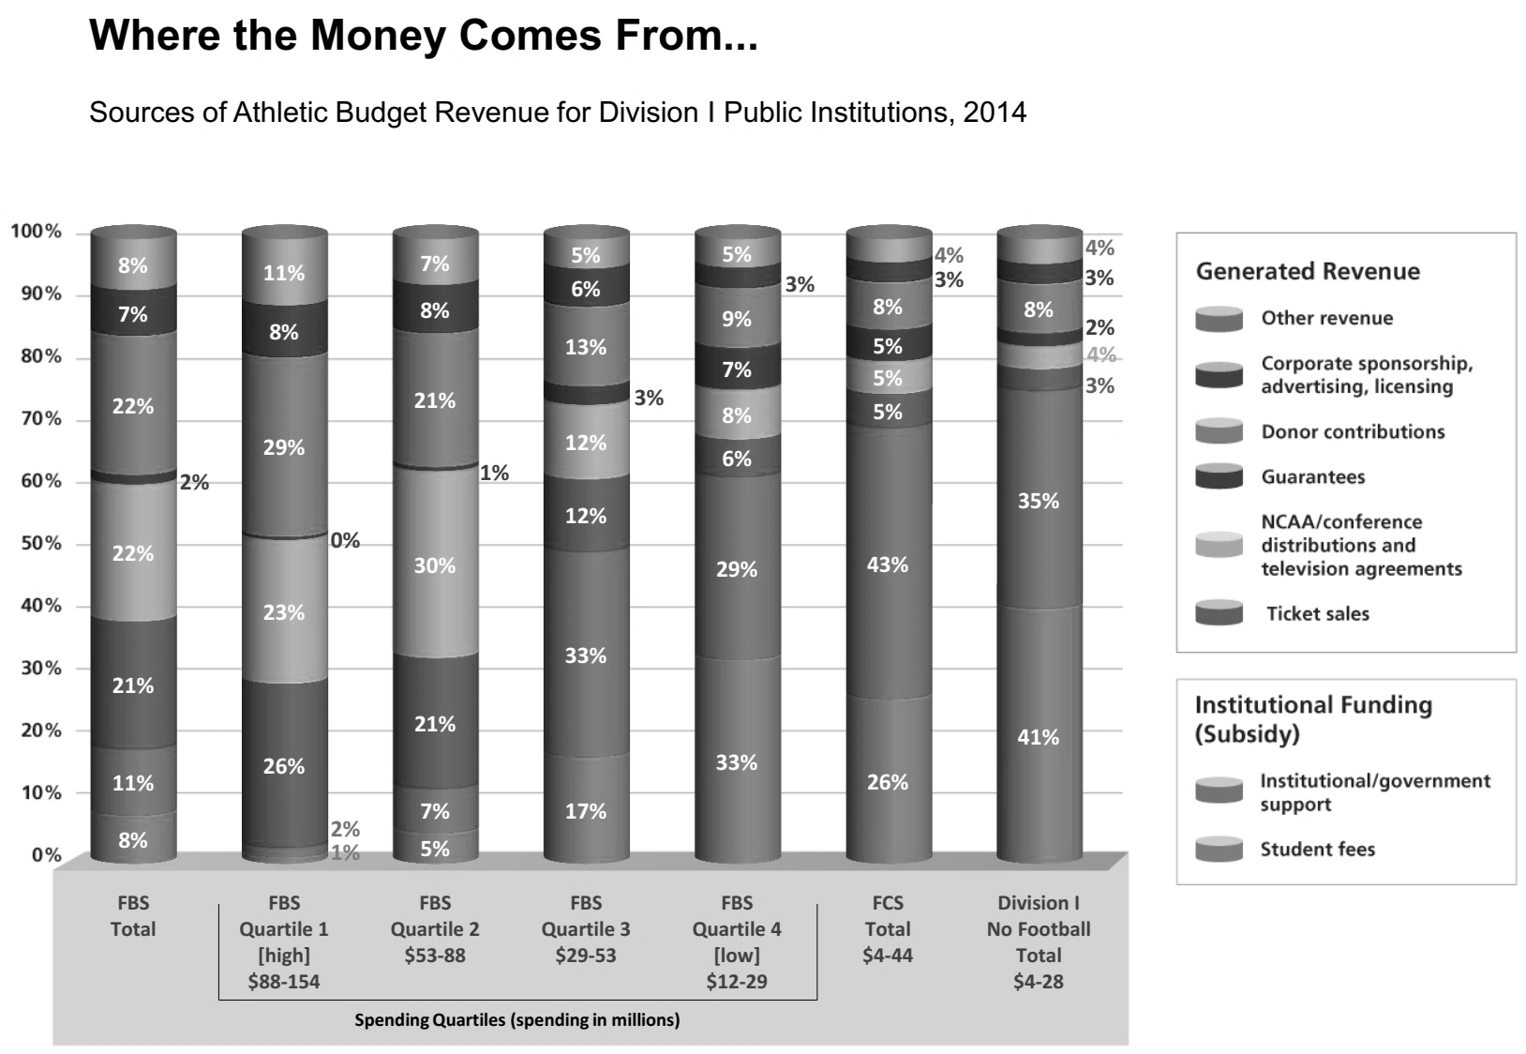

Note: All currency amounts are in US$; NCAA = National Collegiate Athletic Association; FBS = Football Bowl Subdivision; FCS = Football Championship Subdivision

Source: “Finances of College Sports,” Knight Commission on Intercollegiate Athletics, accessed November 28, 2018, www.knightcommission.org/finances-college-sports. Used with permission.

**Exhibit 5: Team Usage of Facilities by Hours per Week**

|  |  |  |  |  |  |  |  |  |
| --- | --- | --- | --- | --- | --- | --- | --- | --- |
| Team | Mason Arena | | | Boschetto Center | | | Nicholson Center | |
|  | Weight Room | Ice Surface | Gymnasiums | | Pool | Cardio Room | Basketball Court |
| W Basketball | 4 |  |  | |  | 2 | 20 |
| W Volleyball | 4 |  | 18 | |  | 2 |  |
| M Hockey | 6 | 28 |  | |  | 4 |  |
| M Basketball | 4 |  |  | |  | 2 | 25 |
| W Soccer | 4 |  | 4 | |  | 2 |  |
| W Softball | 4 |  | 4 | |  |  |  |
| W Golf | 4 |  | 3 | |  |  |  |
| W Lacrosse | 4 |  | 5 | |  | 2 |  |
| M Baseball | 4 |  | 4 | |  |  |  |
| M Soccer | 4 |  | 4 | |  | 2 |  |
| M and W Tennis | 4 |  | 4 | |  |  |  |
| M and W Cross Country | 4 |  |  | |  |  |  |
| M and W Swimming and Diving | 4 |  |  | | 30 |  |  |
| M Golf | 4 |  | 3 | |  |  |  |
| W Track and Field | 4 |  |  | |  |  |  |
| **Total** | **62** |  | **49** | | **30** | **16** | **45** |

Note: University facilities staff estimated that 90 per cent of costs at Mason Arena were attributable to maintenance of the ice surface, 80 per cent of costs at Boschetto Center were attributable to the swimming pool, and 10 per cent of costs at each facility were attributed to the gymnasium and the cardiovascular exercise room. W = women’s; M = men’s

Source: Company documents.

1. The decision to remove the hockey team from the university’s sports program had preceded McKenzie’s hiring by one year.
2. “Where Does the Money Go?,” National Collegiate Athletic Association, accessed November 28, www.ncaa.org/about/resources/finances?division=dl.
3. Ibid.
4. Unlike revenue from basketball, revenue from Division I Men’s Football was not controlled by the NCAA. The football championships (known as “bowls”) were independently operated.
5. “Where Does the Money Go?,” op. cit.
6. All currency amounts are in U.S. dollars.
7. “Impact,” Knight Commission on Intercollegiate Athletics, accessed November 28, 2018, www.knightcommission.org/impact.
8. The Knight Commission on Intercollegiate Athletics was an independent advisory group formed by current and former university presidents, chancellors, trustees, and former athletes with the goal to maintain adequate health and safety standards as well as to promote educational achievements among schools that maintained athletic programs; “About the Knight Commission,” Knight Commission on Intercollegiate Athletics, accessed November 28, 2018, www.knightcommission.org/about-knight-commission.
9. Brad Wolverton, Ben Hallman, Shane Shifflett, and Sandhya Kambhampati, “The $10-Billion Sports Tab,” The Chronicle of Higher Education, November 15, 2015, accessed November 28, 2018, www.chronicle.com/interactives/ncaa-subsidies-main.
10. Heather J. Lawrence, E. Ann Gabriel, and Lauren E. Tuttle, “Using Activity-Based Costing to Create Transparency and Consistency in Accounting for Division I Intercollegiate Athletics,” Journal of Intercollegiate Sport 3, no. 2 (2010): 366–381.