|  |  |  |
| --- | --- | --- |
| Publishing-Logo |  |  |

9B18C013

Bidcorp Baltics: Contextually intelligent leadership of entrepreneurial food services

Caren Scheepers and Chantal Ramsingh wrote this case solely to provide material for class discussion. The authors do not intend to illustrate either effective or ineffective handling of a managerial situation. The authors may have disguised certain names and other identifying information to protect confidentiality.

*This publication may not be transmitted, photocopied, digitized, or otherwise reproduced in any form or by any means without the permission of the copyright holder. Reproduction of this material is not covered under authorization by any reproduction rights organization. To order copies or request permission to reproduce materials, contact Ivey Publishing, Ivey Business School, Western University, London, Ontario, Canada, N6G 0N1; (t) 519.661.3208; (e)* [*cases@ivey.ca*](mailto:cases@ivey.ca)*;* [*www.iveycases.com*](http://www.iveycases.com)*.*

Copyright © 2018, Ivey Business School Foundation Version: 2018-05-04

On October 14, 2016, Ramūnas Makutėnas, chief executive officer (CEO) of Bidcorp Baltics, was making his way from his home in Kaunas, Lithuania, to his company’s depot in Tallinn, Estonia. Bidcorp Baltics was part of the Bid Corporation Limited (Bidcorp) group, the third-largest food services company globally. It included businesses from catering to food processing, and operated in more than 20 countries across Europe, Australasia, the Middle East, and Southern Africa. Makutėnas was considering whether to expand his company’s warehouse depot in Lithuania and what arguments to present in a business case during a teleconference the following week with Bidcorp group’s head office executives, including Ashley Biggs, Bidcorp’s group company secretary. Biggs and the rest of the executive team members were located in Sandton, South Africa. The geographical distance made it difficult to persuade these executives on capital investments.

Makutėnas planned to offer the Bidcorp’s group executive team some background information on operations in the Baltics (see Exhibit 1). He hoped the information would enable the executives to appreciate the growth of the company’s operations in the resource-poor environment. Makutėnas asked his financial manager, Sigitas Ramanauskas, to gather information on the three countries along the Baltic Sea—Estonia, Latvia, and Lithuania. Makutėnas was confident that the current growth in the Baltics could be sustained. The company’s vision was to be the best service supplier for its food service customers, and to be the leading retail fish and seafoods brand. Total sales since 2011 had increased by 9,34 per cent and food service sales by 11,76 per cent (see Exhibit 2). Locally, they called their company Bidfood Baltics, which was part of the global Bidcorp group of companies and represented the Baltics. The international company Bidcorp had commenced a global rebranding exercise in 2016, and would thereafter be operating under the name Bidfood. This strategy was aimed at reinforcing the company’s image as “value-add food people” rather than logistics providers.[1]

Expanding the warehouse depot in Lithuania fit this strategic direction. However, Makutėnas’s dilemma was that there were other options that would also enable his company’s growth, such as diversifying into beverages. The timing of the expansion was also a potentially contentious issue. Ramanauskas and the other members of his management team had debated many of these options and their consequences, and Makutėnas now needed to present those alternatives during the teleconference.

Bidfood Baltics business model

Bidfood sales of food services to 3,000 individual client restaurants—consisting of 86 per cent independent food service outlets, and 14 per cent local food service chains and institutional clients—grew from 63 per cent of individual client restaurants to 69 per cent from 2015 to 2016. In contrast, sales for retail and other types of customers remained flat and were even decreasing, from 37 per cent of all available customers in 2015 to 31 per cent in 2016.

One of Bidfood’s main clients was Nowaco, a family-owned Danish company and one of the most well-known retail seafood brands. Nowaco had been winning yearly awards as the most popular food services company in the fish category.[2] Bidfood was also represented in retail in the largest supermarket chains—namely, Maxima Group, IKI Company, NORFA Limited, Prisma Corporation, and Rimi, as well as in most independent retail shops. Its mission was to help customers grow their businesses and achieve better results. Its business model was thus based on providing personal service and building relationships with a large number of individual customers. Bidfood’s salespeople made friends with the chefs and would regularly socialize with customers. Sales representatives focused on assisting clients with finding solutions to improve the cost-effectiveness of their businesses, for example, by improving the yield from their fish. This individualized service was thus focused on selling solutions and not only products. Product management experts who knew the trends recommended prices, and the salespeople were responsible for margins. They were mostly—up to 80 per cent—paid by commission, and had to take into account local prices, as well as competitors’ prices and costs.

In 2016, Bidfood sales per product group of its 2,000 food service products comprised 68 per cent frozen products, 18 per cent chilled products, and 14 per cent ambient products. However, from 2011 to 2015, the category sales increased for all products: 69 per cent for frozen products, 247 per cent for chilled products, and 388 per cent for ambient products. Well-known brands that Bidfood transported included Nestlé, Nescafé, Unilever Food Solutions, Heinz, Nowaco, Hӓagen-Dazs, Bayernland, Ardo, and Fudo. The new upgraded Bidcorp Baltics vehicles had an interior flexible wall that enabled the simultaneous delivery of products in all three temperature regimes (i.e., frozen, chilled, and ambient), according to client requirements. This upgrade enabled the company to optimize its logistic service for clients by delivering all products at the same time. Depot workers picked up goods for clients in chambers ranging from 20 degrees Celsius to –18 degrees Celsius, 24 hours a day, to satisfy their clients.

On May 30, 2016, the Bidvest Group Ltd. (Bidvest) from South Africa unbundled and separately listed the international food services business as Bidcorp on the Johannesburg Stock Exchange (JSE).[3] Bidcorp rose to more than double its parent’s market value on the first day of trading, showing investors’ preference for South African stocks that had greater international exposure. Bidcorp shares started trading on the JSE at R270[4] per share and rose to R281 per share by 2:00 p.m., valuing the company at R94.2 billion. The stock gained 10.15 per cent by 5:15 p.m. to close at R304 per share. It was the largest primary listing on the JSE since Vodacom in 2009.[5] Bidcorp’s global businesses comprised leading food service distributors of prestigious brands, which supplied premium goods across a wide range of product lines, and had a significant presence of its own brand manufacturing and distribution in 36 countries across Australasia, Europe, the United Kingdom, the Middle East, Africa, South America, and Asia. The separation positioned the food business for a new phase of both internal and acquisitive growth, according to Bidcorp chief executive Bernard Berson, who opened trading in Johannesburg by blowing a ceremonial kudu horn.[6]

Multicultural context

The former Soviet Union countries along the Baltic Sea—Latvia, Estonia, and Lithuania—were members of the United Nations and the North Atlantic Treaty Organization. Each of the three countries had its own language. From 1990 and 1991, these countries struggled for independence, and they ultimately won their independence from the Soviet Union. They were the only countries in the Bidcorp group from the former Soviet Union. Historically, the Soviet Union had assigned each country with a particular focus area. For example, Estonia was to focus on the telecommunication sector, whereas Latvia and Lithuania were to focus on the agricultural sector. The rich history of these countries played a role in their current economic strengths and development areas.

The population in the Baltic region was 6 million in 2016.[7] Lithuania had the largest population at 2.9 million people. Over the past 15 years, 600,000 people had immigrated from Lithuania. This trend of an outflux of skilled people to Western European countries was turning, as salaries in the Baltics increased. In the Baltics, 31.94 per cent of the total population lived in cities (1,978,887), with 50 per cent of the people living in the 20 largest cities. For example, Riga, the capital of Latvia, had 696,593 people, with 542,664 living in Vilnius, the capital of Lithuania. Tallinn, the capital of Estonia, had 441,961 people. Kaunas, the second biggest city in Lithuania, had a population of 297,669 (see Exhibit 3).

Makutėnas knew that he was leading a multicultural organization, with diverse ethnic and religious groups spread over the three countries. He needed to obtain an intimate knowledge of their histories, preferences, and habits to be able to adapt to the unique identities of the three operations. For example, in Lithuania, 86.7 per cent of the people spoke Lithuanian, 5.6 per cent Polish, and 4.8 per cent Russian, with 77 per cent being Roman Catholic. In contrast, in Latvia, 61.6 per cent of the people spoke Latvian and 25.8 per cent, Russian. In terms of religious groups, Latvia’s population was 32 per cent Lutheran Christian, 24 per cent Roman Catholic, and 18 per cent Russian Orthodox. In Estonia, 68 per cent of the people spoke Estonian and 25.1 per cent spoke Russian; in terms of religion, 16 per cent of the people were Orthodox Christian, 10 per cent Lutheran Christian, and 54 per cent had no religion. In Latvia, most Bidcorp Baltics employees were Russian-speaking. In Estonia, several were English-speaking, and the rest Russian-speaking. Some of Bidfood’s clients were Russian-speaking; Chinese restaurant chefs spoke Russian.

Lithuania had historically been home to a significant Jewish community, and was an important centre of Jewish scholarship and culture from the 18th century until the eve of World War II. Of the approximately 220,000 Jews who lived in the Republic of Lithuania in June 1941, almost all were annihilated during the Holocaust. The community numbered about 4,000 at the end of 2009. Makutėnas knew that the South African students who would soon be visiting Bidcorp Baltics might be interested to learn that around 70 per cent of the South African Jews’ descendants had originally been from Lithuania.

Bidfood Baltics operations

Arriving at the depot in Tallinn, Makutėnas noticed that parked outside were the cars of his two executive team members: Birgit Nilisk, Estonia country manager since 2013, and Sigitas Ramanauskas, his financial manager who had been with the company since 2001. Their cars were next to Bidfood trucks containing fresh fish. The trucks had come from the harbour that morning after fetching fresh salmon, a delicacy, from Norwegian ocean liners. As Makutėnas passed the enormous freezers, the chill raised the hair on his arms as always, and brought a smile to his face, taking him back to his humble beginnings.

During the teleconference, Makutėnas planned to share with the executives his story about starting out (on a small scale) as an entrepreneur buying and selling fish from Argentina. In 1994 he joined Bidcorp Baltics, which had been founded two years earlier in Lithuania with only four employees. Makutėnas still remembered the heady days between 1996 and 1999 when the company had experienced fast growth in the trading and distribution businesses. Food service sales had then represented only 0.2 per cent of the company’s total sales. In 1999, the company was acquired by Nowaco, which had been one of its suppliers. The acquisition enabled the company to grow to 10 employees, as it needed capital investment at the time and the banks were not allocating loans for small businesses.

Bidcorp Baltics expanded in 2009 to Latvia and in 2010 to Estonia. In 2011, Bidvest acquired the whole Baltic business. In 2012–13, the companies’ names were changed to Bidvest Lithuania, Bidvest Latvia, and Bidvest Estonia. The period 2013–2015 saw investments and growth in food service. Food service sales increased to 70 per cent of total sales. Even though the Baltics were surrounded by the ocean, the fish was of poor quality. As a result, customers preferred imported fish from Norway, Argentina, and South Africa. Bidfood therefore invested in the fish-processing plant in Latvia where the labour costs were lower. Of Bidfood’s total sales, Lithuania constituted 74 per cent, Latvia 17 per cent, and Estonia 9 per cent.

Investing in technology to support food services in the Baltics

Food services in the new multi-temperature vehicles opened up opportunities to transport frozen and chilled ambient food in the same truck (see Exhibit 4). Bidcorp needed to invest in a state-of-the-art warehouse management system, as the amount, assortment, and volume of products had increased. The hand‑held scanning system, Equinox, and mobile ordering e-commerce systems had been implemented throughout the Baltics. Sales representatives submitted 86 per cent of their orders through the Merisoft system directly to the enterprise resource planning (ERP) system. The remaining 14 per cent of orders were sent through e‑commerce—using Edisoft—directly from the client to Bidcorp’s ERP system. Bidcorp also invested in QlikView, a business intelligence tool offering current information about profits and losses at the client’s fingertips. This ERP system had different views for the purchasing application, stock application, sales application, and sales representatives’ KPI (key performance indicator) application. The truck tracking system, Ruptela, and the truck tachograph analysis, called Tachomat, assisted with monitoring and ensuring vehicle safety.

Bidcorp had 134 employees in the Baltics and owned 20 vehicles. It had 4,400 pallet places—chilled, ambient, and frozen—of which 3,000 were in Kaunas, Lithuania, where workers handled an assortment of 2,000 products. The operations in Estonia were much smaller; for example, there were 400 pallets with 800 products in Tallinn. In Latvia, there were 1,000 pallets with 1,000 product assortments (see Exhibit 5). Bidcorp bought salmon in Norway and conducted manual food processing and packaging in Latvia, where the labour costs were lower and the manual process offered higher yields. The depot in Lithuania had three levels of pallets, and the company was looking to expand it.

Bidcorp was promoting from within; for example Andrius Shulmeister, who was the food service sales representative, was promoted to food service manager with 20 employees on his team. Elvis Tartilas, the first employee, had stayed with the company and was promoted to the role of logistic director. Of the three Baltic states, two of the country managers were women—Katrina Korotkiha in Latvia and Birgit Nilisk in Estonia. Bidcorp’s performance management system was focused on measuring quality by noting mistakes.

While most of Bidfood’s clients were restaurants and entrepreneurial businesses, such as small food outlets, the company also had large retail clients to whom it supplied frozen fish and also fresh fish, as of one-and-a-half years ago. Bidfood also supplied vegetables, french fries, and meat products—in total, more than 100 stock-keeping units. The fish plant in Latvia of 300 square metres and the total depot of 1,300 square metres were important features of Bidcorp’s operations in the Baltics. Bidcorp imported and distributed 5,000 tons[8] of a variety of products from the Czech Republic, Norway, Poland, Belgium, the Netherlands, Argentina, China, Vietnam, Spain, France, Germany, Denmark, and Italy. It collaborated with local producers as well as manufacturers in Lithuania, Latvia, and Estonia.

Moving forward

While Bidfood was capitalizing on being part of a group that was one of the largest food service companies worldwide, it intended to gain more from synergies with other companies in the group, such as the Bidcorp Procurement Company in Asia. Makutėnas believed there was a high demand to create a Baltics-wide food service solution and to be unique. Bidfood was constantly expanding its rented depot, but it was reaching its limits. It had enhanced the ambient, chilled stores in Lithuania, as most sales were still from Lithuania; had moved to a new depot and opened a fish‑processing plant in Latvia; had increased the number of sales representatives in all three countries; and had changed most of its vehicles. In addition to these improvements, Makutėnas and his team had considered various options in expanding the business.

For example, one option was to diversify the business to include the transportation of beverages; however, the issue they foresaw was that drivers would then need to interact with hotel personnel at the bars, whereas the current business had been built on meaningful relationships with the chefs, and engaging with the kitchen staff who received the deliveries. The trucks’ cooling and freezing facilities meant they could transport medicines and other commodities, but Makutėnas was adamant that the company’s identity was that “they were food people.” The company preferred to grow by offering more end-to-end supply to its clients. In Lithuania, the company was thus working on a business case to build a new depot with space for five levels of pallets. Makutėnas was on the brink of purchasing the stand for this depot, but he needed sign-off from the head office executives. He had already drawn up architectural plans for the intended expansions.

Biggs, one of the executives that Makutėnas needed to influence, regularly made the point that contextual factors, such as location, mattered when making expansion decisions. Makutėnas intended to share the benefits of locating the expanded warehouse in Lithuania rather than in either of the other two Baltic countries. Biggs had recently completed her Masters degree in Business Administration (MBA) at the Gordon Institute of Business Science, University of Pretoria, and had organized a company visit of 20 MBA students from the university to the Bidfood operation in Estonia for that morning. These visitors were all business people with extensive managerial experience. Makutėnas used the visit as an opportunity to build his relationship with Biggs and to discuss his intended proposal for expansion. He knew that the visitors would learn valuable decision-making lessons around establishing and expanding entrepreneurial businesses in the unique context of the Baltics, with their multicultural workforce and multi-faceted supply-chain operations.

As the luxury bus turned into the parking lot, Makutėnas could see the visitors’ excited, curious faces in the windows, and he was filled with anticipation. He looked forward to sharing his learning experiences over the years of building entrepreneurial businesses in the Baltics. He wanted to use the opportunity to also learn from them, as they matched the profile of the South African executives he needed to convince during the next week’s teleconference. These executives would probably have many arguments for and against his specific business expansion plans. Makutėnas wanted to think through all options and counter-arguments to prepare for the teleconference.

EXHIBIT 1: THREE INDEPENDENT Baltic STATES ALONG THE BALTIC SEA

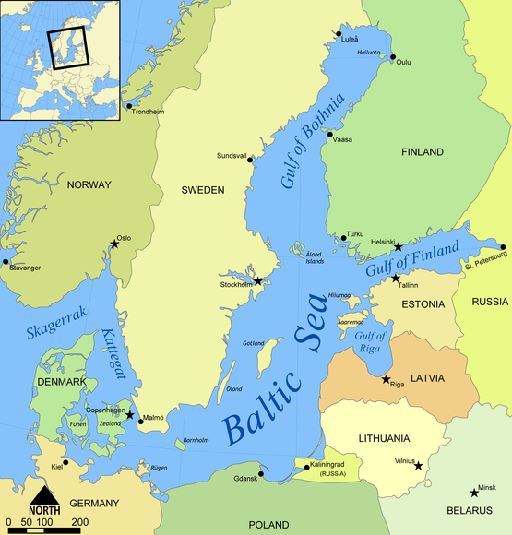

**Estonia**

**Latvia**

**Lithuania**

Source: Adapted from Norman Einstein, Baltic Sea Map, Creative Commons Attribution-Share Alike licence, accessed March 6, 2018, <https://commons.wikimedia.org/wiki/File:Baltic_Sea_map.png>.

EXHIBIT 2: BidFood baltics TOTAL SALES and food service sales, 2011–2017

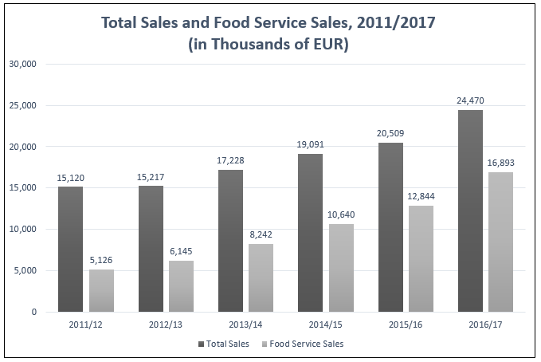

Source: Company documents.

EXHIBIT 3: COMPARISON OF BALTIC countries

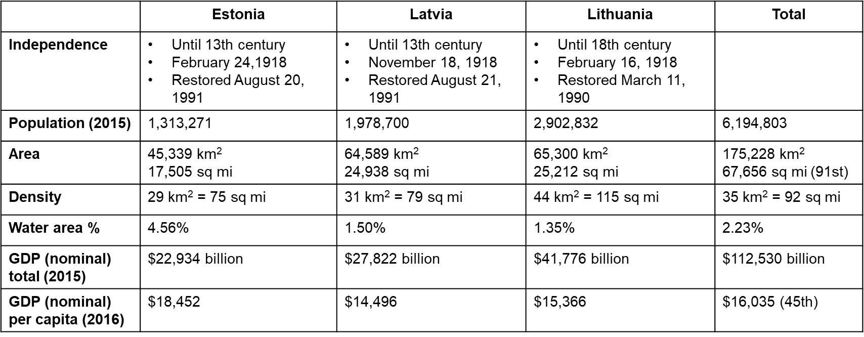

Note: All dollar amounts are in US$; km2 = square kilometres; sq mi = square miles; GDP = gross domestic product

Source: Company documents.

EXHIBIT 4: TRANSPORTING FOOD IN a MULTI-TEMPERATURE VEHICLE ACROSS THE BALTICS

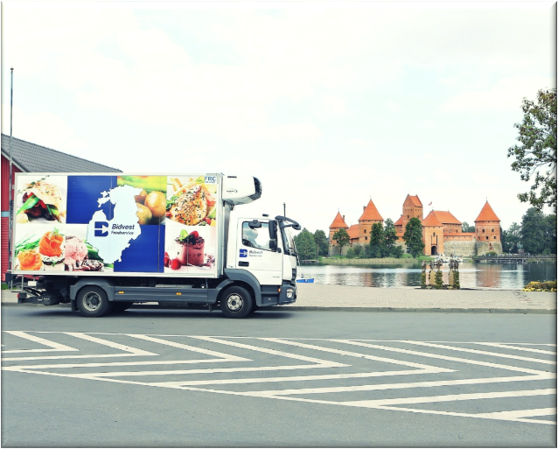

Source: Company documents.

EXHIBIT 5: RELATIVE SIZE OF BIDFOOD BUSINESSES IN THE THREE baltic COUNTRIES

|  |  |  |  |
| --- | --- | --- | --- |
| **Country** | Estonia (Tallinn) | Latvia (Riga) | Lithuania (Kaunas) |
| **Number of Employees** | 12 | 37 | 85 |
| **Depot** | 400 pallets, chilled, ambient, frozen | 1,000 pallets, chilled, ambient, frozen | 3,000 pallets, chilled, ambient, frozen |
| **Assortment** | 800 products | 1,000 products | 2,000 products |
| **Operations** | Outsourced logistic service | 5 own vehicles,  fish-processing plant | 15 own vehicles, outsourced fish packing |
| **Established** | 2009 | 2010 | 1994 |

Source: Company documents.

**EXHIBIT 6: BIDFOOD BALTICS STRUCTURE IN 2016**

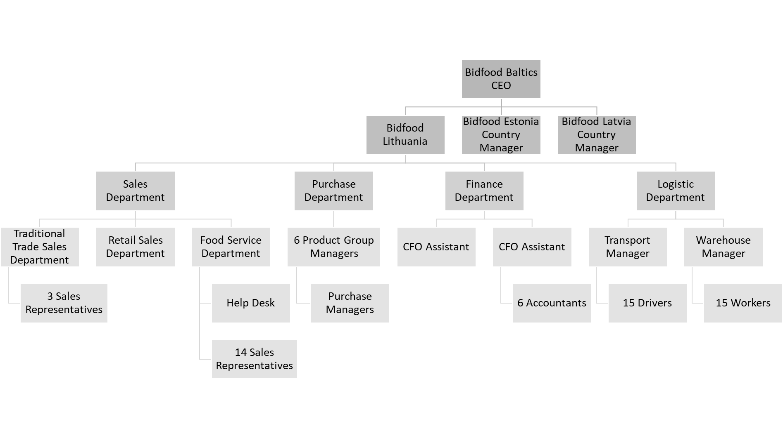

Note: CEO = chief executive officer; CFO = chief financial officer

Source: Company documents.

EXHIBIT 7: CURRENT long-term storage DEPOT IN LIThUANIA

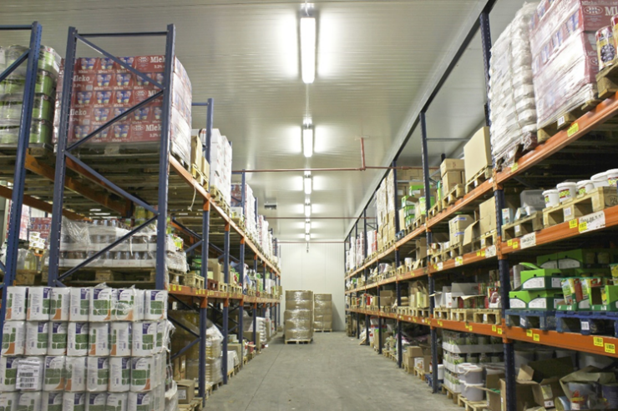

Source: Company documents.

EXHIBIT 8: EXPANSION PLANS FOR NEW DEPOT IN LIThUANIA

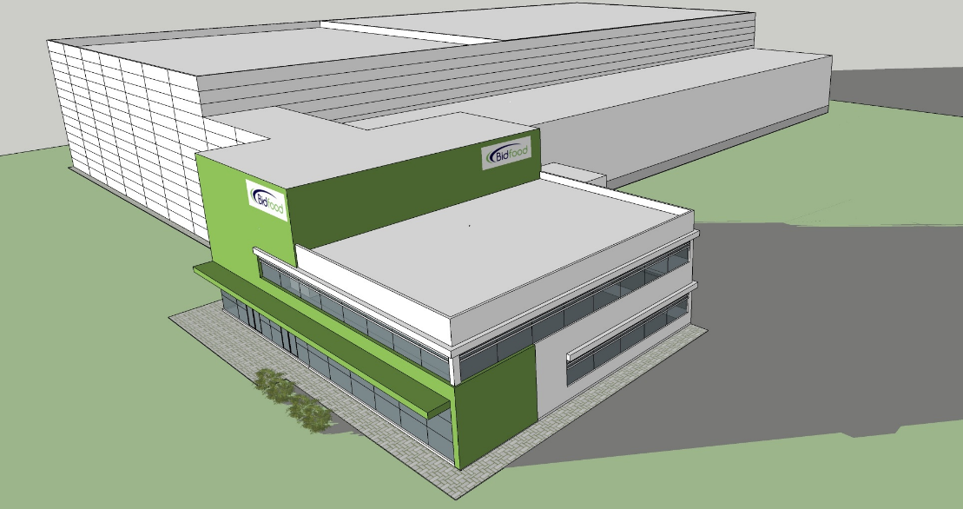

Source: Company documents.

1. Bid Corporation Limited, “Comment,” Bidcorp, accessed August 17, 2017, www.bidcorp-reports.com/results/interim-results-2017/comment.php; This webpage provides information on the strategy to be called Bidfood.
2. See the Nowaco website, accessed August 17, 2017, www.nowaco.com/history.aspx.
3. Reuters, “Bidvest Foods Spin­Off Bidcorp Valued at $Bln in Market Debut,” May 30, 2016, accessed October 30, 2016, http://af.reuters.com/articlePrint?articleId=AFKCN0YL0MA.
4. R = ZAR = South African rand; R1 = US$0.07 in December 2016; all currency amounts are in R unless otherwise specified.
5. “Bidcorp a Hit with Investors on Debut,” Business Report, May 31, 2016, accessed August 16, 2017, https://www.iol.co.za/business-report/companies/bidcorp-a-hit-with-investors-on-debut-2028289.
6. Ibid.
7. James H. Bater and Romuald J. Misiunas, “Baltic States,” *Encyclopaedia* *Britannica*, accessed March 29, 2018, https://www.britannica.com/place/Baltic-states.
8. 1 ton = 0.907 tonnes