|  |  |
| --- | --- |
|  | ISB_Logo_BW2 |

**9B18C018**

ImplementING FORTIS OPERATING SYSTEM (A)[[1]](#footnote-1)

Subramaniam Ramnarayan and Sunita Mehta wrote this case solely to provide material for class discussion. The authors do not intend to illustrate either effective or ineffective handling of a managerial situation. The authors may have disguised certain names and other identifying information to protect confidentiality.

*This publication may not be transmitted, photocopied, digitized, or otherwise reproduced in any form or by any means without the permission of the copyright holder. Reproduction of this material is not covered under authorization by any reproduction rights organization. To order copies or request permission to reproduce materials, contact Ivey Publishing, Ivey Business School, Western University, London, Ontario, Canada, N6G 0N1; (t) 519.661.3208; (e)* [*cases@ivey.ca*](mailto:cases@ivey.ca)*;* [*www.iveycases.com*](http://www.iveycases.com)*.*

Copyright © 2018, Ivey School of Business Foundation Version: 2018-06-29

It was quite late in the evening on November 16, 2007 when the last visitor left the office of Daljit Singh, president of Strategy and Organizational Development at Fortis Healthcare Limited (Fortis). Daljit sat back and reflected on the day’s events. The day had been hectic, yet deeply satisfying. During the organization-wide review of a major change initiative called Fortis Operating System (FOS), the mood had remained consistently upbeat. Clearly, the change initiative had succeeded beyond most people’s expectations, having generated great enthusiasm all around. When Ashish Bhatia, facility director (FD) at Fortis Hospital Mohali and a key member of the core change team, had said that he and his colleagues on the change team would regard the experience of FOS implementation as the high point of their careers thus far, his words seemed to resonate with others present at the meeting.

The top leaders of the organization, including promoter and chief executive officer Shivinder Mohan Singh, had been present at the meeting. They were pleased that an important and strategic change intervention, which had been initiated six months earlier at Mohali, a small city in the northern part of India, had worked out so well. Shivinder had smiled and said to Daljit, “As you well know, the reward for good work is more work. We should roll out FOS in two more hospitals in the next two months, and then plan to quickly take it to all the hospitals in our group.”

Daljit knew that the successful implementation of FOS at the Mohali facility was only the first in a series of steps that the top team had worked out. Given the ambitious plan of growing to 35 hospitals in the following five years, it would be important to rapidly implement FOS in all of the Fortis facilities to streamline non-clinical processes that affected patient satisfaction, predictability of outcomes, and efficiency. Some of the hospitals in the Fortis group had been acquired, and some were located in smaller towns with limited management bandwidth and depth. Despite such differences, FOS had to be rolled out quickly and effectively in all of those hospitals, mainly through in-house efforts. Given the strategic importance of the change, the board would certainly want a detailed presentation of how the change would be quickly and effectively scaled up.

HEALTH CARE INDUSTRY IN INDIA

The health care industry in India was categorized into public and private health care providers. Inadequate public investments provided an opportunity for the private players to contribute significantly to the development of the health care industry. The private sector accounted for 73.8 per cent of the country’s total health care expenditure.[[2]](#footnote-2) Rising income levels, an aging population, and growing health awareness was driving the growth of the health care industry, which was estimated at US$38 billion in 2007 and was expected to grow at a compound annual growth rate of 15 per cent for the next 15 years.[[3]](#footnote-3)

Corporate hospitals accounted for less than 10 per cent of total private ownership; the remainder was made up of unorganized and fragmented clinics and nursing homes.[[4]](#footnote-4) Apollo Hospitals Enterprise Limited, founded in 1983, was the first organized private player in the health care industry. After a long gap, Fortis was set up in 1996. Other players followed, including CARE Hospitals, Max Hospitals, Aravind Eye Hospitals, Manipal Group of Hospitals, and Narayana Health. Though there were myriad growth opportunities for the health care sector in India, there were challenges in health care delivery even for private players—there were hardly any standards of quality of service delivery, and little focus on patient engagement activities. Most of the hospitals, including the corporate hospitals, followed traditional methods of paper-based record keeping, which resulted in delays both in access to records and in diagnosis, and ultimately affected the quality of health care services.

FORTIS HEALTHCARE LIMITED

Fortis, a leading provider of integrated health care, was founded by the late visionary business leader Dr. Parvinder Singh, whose contributions to the Indian pharmaceutical industry were legendary. His vision for Fortis was “to create a world-class integrated health care delivery system in India, entailing the finest medical skills combined with compassionate patient care.” After Parvinder’s death, his sons Malvinder and Shivinder pursued their father’s vision by bringing in talented personnel, instilling strong values, building efficient systems, and inculcating responsibility toward stakeholders on a strong foundation of trust.

Fortis commenced its commercial hospital operation by setting up the Fortis Hospital at Mohali, a multi-specialty hospital in 2001. Fortis pursued an ambitious growth path through a combination of acquisitions, greenfield projects, brownfield projects, and management contracts. By 2007, Fortis had a network of 11 hospitals in India, with 1,580 inpatient beds in use across its network of hospitals.

Each hospital under Fortis was headed by an FD. Heads of departments such as Human Resources, Finance, Patient Care Services, Quality, and Marketing reported directly to an FD, who was supported by a medical director—in charge of the medical administration—and a unit head administrator, who was in charge of the non-medical administration and other support services.

WHY AN OPERATING SYSTEM AT FORTIS?

Until 2006, hospital operations across Fortis locations were disparate and based on local infrastructure and local needs. Computerization at Fortis hospitals, which began in 2006, was limited to stand-alone systems to take care of routine, local area needs, with the emphasis mainly on bookkeeping activities.

Shivinder had always felt the need to improve hospital processes, to ease the pain experienced by the patients and their attenders. He had gained a first-hand experience of hospital processes when he accompanied his father Parvinder, who was undergoing treatment for cancer, to a hospital in 1997. During his visits to one of the world’s best hospitals, Shivinder saw hospital functioning from the patient’s and the attendant’s perspectives. He realized how crucial it was to ensure that the patients and attendants did not have to fret over delayed appointments, misplaced reports, shuttling from one department to another, billing issues, delayed discharges, poor emergency responses, or a lack of information on what would happen next or the line of treatment. In the words of Shivinder, “We [Fortis hospitals] are able to attract patients from across the country, but the processes are not standardized and efficient. When a patient enters any Fortis hospital, he or she should expect the same service everywhere. It is like becoming the McDonald’s of health care; you know exactly what to expect, irrespective of where you are. There has to be one Fortis—one Experience.”

Fortis had articulated its “Mission 2011” as follows: providing excellence in service delivery; showing domestic leadership in cardiology, orthology, neurology, nephrology, and gastroenterology; being globally recognized in cardiology and orthology; having a pan-India presence with 35 to 40 hospitals with about 6,000 beds; having talented staff comprising about 3,500 doctors and 15,000 nurses; and having an international presence. There was a specific plan in place to reach 35 hospitals by 2011 (see Exhibit 1).

Daljit outlined why the top team considered standardization such a key issue for a new player with growth aspirations in a new industry:

In 2006, we were a young organization with six hospitals, each with its own way of functioning. We had a strategy mandate that there will be standardization in the way we run our organization. The aspiration was to grow to 40 hospitals. We realized early on that it is tough enough to run one hospital, let alone 35! We . . . [made the] call that it would be prudent to standardize now, so that we [could] build a meaningful network with high quality and SOPs [standardized operating procedures]/ways of working and not 40 disparate, individual hospitals. This platform would not only be a major enabler for us to replicate and scale up our operations as we grew, but it would also drive the improvement and standardization of the various patient-facing, non-clinical processes that impact patient satisfaction, predictability of outcomes, and efficiency.

McKinsey & Company (McKinsey) was appointed as consultant to help with the development of FOS. From the McKinsey side, Dr. Mandar Vaidya was made the project manager for the assignment. As Vaidya explained,

The assignment was unique in the sense that it involved creating standard operating procedures for an organization on a high-growth path. The top management believed very strongly that this was a key priority for building an institution of scale. Clearly the burning platform was that without FOS, we cannot achieve our aspiration of rapid growth in a new industry. The mandate was to make the operating system Reliable, Repeatable, and Replicable. “Reliable” meant that the process would work to produce intended results again and again without intervention. “Repeatable” meant that it would happen every single time, and 365 days per year. And “Replicable” meant that by the time the system was set up in one hospital, the codification would have been completed and the process would be ready to be rolled out in 10 other hospitals.

Fortis defined the objectives and specific deliverables of FOS (see Exhibit 2).

PREPARING THE GROUND

In February 2007, Fortis Hospital at Mohali was made the test bench for implementing FOS. This would establish the concept, and McKinsey would play a key role in facilitating change. In Wave 2, it was expected that FOS would be taken to two more hospitals, and this change would be driven by Fortis leadership with some limited back-end support from McKinsey. In Wave 3, FOS would be taken to a much larger number of Fortis hospitals, completely on its own. On the choice of Mohali, Ashish stated, “Mohali was chosen basically for the reason that it was the first child of Fortis and it had reached a certain maturity level to handle a large change initiative of this kind. There was [a] comfort level in terms of getting the basics right. Other hospitals were relatively new and were in the process of settling down.”

A steering committee was formed that included Shivinder, Daljit, the chief operating officer of hospitals under Fortis, head of the Medical Operations group, head of Finance, head of Human Resources, and Vaidya from McKinsey. The committee conducted several meetings over a week, and discussed the need for and benefits of change. Daljit was designated as the corporate champion to steer the change; he also coordinated with McKinsey. The entire engagement from the conceptualization stage to implementation to institutionalizing the change was led by Daljit, as he understood Shivinder’s vision. Daljit stated,

The objective of FOS was essentially to have a framework to ensure uniformly delivered, high quality, efficient, and predictable services to our patients; to make the patient journey, within the hospital, informed and pain free, recognizing their state of vulnerability. This would necessitate the creation of a one “look and feel” Fortis across locations. A major benefit of this would be to optimize utilization of resources; i.e., inpatient beds, OPDs [outpatient departments], OTs [operation theatres], ICUs [intensive care units], radiology/pathology/emergency services, admissions/discharge processes, etc. Last but not least, we also wanted to leverage this major initiative to build leaders of tomorrow—for a growing organization this was an important deliverable.

Daljit knew that the most important task was to get the clinicians on board the project. The clinicians’ domain was a specialist domain, and it was important to clearly convey that the exercise dealt with non-clinical areas and would ease and support their work in the hospital. Vaidya conducted one-on-one interviews with senior clinicians to understand their pain points. As all activities revolved around the clinicians, this helped in figuring out what had to be tackled and what could be left alone. The interviews clearly brought out that most of the pain points were outside the clinical domain; for example, delayed reports, patient crowding, poor OT scheduling, and disparate and un-smooth step-downs from the ICU to regular wards.

The McKinsey team realized that, given the scope of the change, it would be necessary to have a strong, full-time internal team. At their request, the steering committee approved the move of six high-performing and high-potential individuals to this initiative full-time for the duration of the assignment. A core team was formed that included Ashish and Vaidya as well as six staff members selected from different functional areas. The selection process of the core team was rigorous and involved the screening across the organization of 30 high-potential staff members who were in the 25–35 age group and who had been with Fortis for the past five years. At the next level, interviews were conducted by a mixed panel of consultants, and only those who were best in their areas of work and showed the potential to become future facility heads were selected. The selection process conveyed that the six individuals selected were the best among the lot, and positioned FOS firmly at the top of management’s agenda.

The various departments in the hospitals were called assets, and 12 assets were identified for FOS implementation. To keep staff excited and motivated about FOS, initially only six assets were picked up for FOS implementation in the first three months. As Vaidya pointed out, “We felt that we had to function like a ‘haretoise’—be rapid, flexible, and fast-moving like a hare and at the same time, steady, consistent, and no pauses and rests like a tortoise. Let us concentrate on just six assets in the first three months, and even among the six, let us pick up one or two areas where we can have [the] most rapid improvements to quickly establish proof of concept. This will galvanize the entire organization.”

Daljit realized that obtaining buy-in for FOS from all stakeholders (clinicians, nurses, medical staff, and administrators) would be a challenging task, as they were themselves busy dealing with their routine activities. He strongly believed that powerful communication was the only way forward in catalyzing the change. He ensured extensive communication with staff at all levels to make them understand the benefits of the change. Banners on FOS implementation were put up at various locations across the hospital to provide the initiative with high visibility.

The first meeting involving the core team and all department heads was conducted every day for a week, and the need for and benefits of change were discussed. A boot camp was organized at an offsite location for the core team and the heads of various departments, including Pathology, Radiology, Outpatient, Emergency, and OT. All members of the steering committee addressed the team at the boot camp, sending a clear signal about top management’s involvement in and commitment to the change program. Ashish said, “The leaders made us feel as the ‘chosen ones.’ Their expectations and approaches strengthened our ownership and commitment to the change agenda.”

The core team was divided into two teams, and these visited all the departments to talk to staff and explain to them the benefits of the change. Town hall meetings were conducted every week, which everyone attended and where department heads/process owners made presentations about the ongoing progress made during the previous week. The FOS presentation was recorded on compact disc and made available to every employee. McKinsey remained in the background and instead put employees at the front, recognizing their expertise in their areas of work. As a result, ownership was steadily built and shop-floor problems dictated the solutions.

FOS METHODOLOGY

The FOS team viewed the various processes in the hospital from three dimensions: processes within the department, patient flow processes, and performance management system–scorecard and review process (see Exhibit 3). For processes within the department/asset, the core team identified process owners or process champions who were energetic, keen, and analytical. They posed questions to the process owners on what they were doing and the rationale behind it, and challenged them to find ways to improve the process.

The process owners took the lead in defining the process and collected data to measure, analyze, and identify bottlenecks and suggest solutions. Each process was broken down and analyzed from the beginning of the process, for example, from the time of patient accession in the Outpatient/Inpatient departments or of blood sample collection in the Pathology department. It was found that several tasks in most of the processes were being held up because something else had to be taken care of before they could be addressed. The staff had to record the delays that were occurring in the various processes, along with the reasons for them. The data included information on the time taken for admission, discharge, waiting for appointments, and getting test results; workloads; staffing; hygiene; and meals. The core team then had discussions with various stakeholders, process owners, and department heads in an effort to frame the FOS agenda.

For instance, Vaidya had initial discussions with the departmental heads of Laboratory (Lab), OT, Wards, and Emergency. Dr. Anita Sharma, the head of Lab said,

Dr. Vaidya asked me, “How do you measure your performance and the departmental performance? The head of the hospital may have P&L [profit and loss] as a possible performance measure; but how does a department like Lab assess itself?” The question made me reflective. Let us say that the Lab performance measures are: turnaround time by which you give reports to patients; accuracy of the reports; and equipment utilization. The next question was what behaviours or processes are needed to achieve these performance measures. Again, these could be identified through reflection. For Lab, the processes may include: calibrating the equipment every day; receiving samples; running the samples; doing the reports; vetting the reports; delivering them; and patients collecting the report. For each one of these processes, there is a separate one for inpatients and a separate one for outpatients. In short, there were ten-odd processes. [The] next question was, “How do these processes happen today?” After all, we were functioning reasonably well. Thus, we define the processes; then we think about how to improve the processes. Once we improve the processes, then we’ll have to convince others as to why the improved process is better. Actually, we would already have involved the others in [the] idea generation stage itself, and so the buy-in would have been partly achieved by that stage. In a nutshell, that’s how we went about creating SOPs.

As Vaidya put it,

McKinsey had access to processes followed in the best of the hospitals across the globe. But if we had sat and written processes for them, the exercise would have totally failed. We would have written 100 SOPs. They would have just sat on the shelf and collected dust. If the process comes externally and people are told “do this,” it will fail. What created huge enthusiasm and success was the strong feeling of ownership.

The approach was based on a few fundamentals. First, everything has to be focused on performance management measurement and analysis. Second, ten-odd processes had to be the backbone for each department, and the starting point would be “what you do today.” Then we borrowed from “lean” and “six sigma” thinking—we applied [the] DMAIC [define, measure, analyze, improve, and control] framework: “Define” involves laying down what you do today. Then you “measure” and “analyze.” This will help you understand the process and come up with “improvement” ideas. While McKinsey played a facilitative role, the primary role was that of people directly involved with the tasks. Finally, in terms of “control,” the idea was to measure and monitor on a regular basis, and report to your boss. The boss will report to the unit head; and the unit head reports to [the] CEO [chief executive officer].

Staff members were trained in the DMAIC methodology, and they used it to implement FOS (see Exhibit 4). In the spirit of the “haretoise,” certain departments such as Lab ran far ahead of the rest. Within six weeks of the initiation of the exercise, there were dramatic improvements in certain areas. For instance, the waiting time for patients for sample collection decreased from 35 minutes to 5 minutes. The reporting time decreased from 210 minutes to 45 minutes. Without adding more machines or increasing staff, how did such changes happen so soon? As Ashish pointed out,

Earlier, the equipment calibration used to happen every morning. As the day shift starts at 8:00 a.m., calibration was done between 8:00 and 8:45 a.m. The sample processing could start only at 8:45 a.m. But the peak time for sample collection for inpatients was 6:30 a.m., and the peak time for [the] OPD was 9:00 a.m. The OPD samples could not be started before 10:30 a.m. When the concerned people measured, analyzed, and thought of improvement ideas, they quickly realized that the equipment calibration should be the last job of the night shift, rather than the first job of the day shift. This single change put an end to the mad morning rush and frayed tempers. Earlier, when the doctors took ward rounds at 9:30 a.m., they had no reports. Now the reports were there, so [the] discharge of patients got streamlined, and the length of stay started to come down. Even the OPD patients left the hospital earlier and happier with their reports.

When a team looked at the discharge process, it realized that the improvement ideas were constrained by the fact that the shift nurse was just too busy to focus on this process. Then, as a small digression, the team looked at what kept the shift nurse so busy. When the shift nurse’s routines were mapped, it was found that the nurse spent 40 per cent of the time filling in registers—and there were 23 registers to be filled in. Three nurses were co-opted to apply DMAIC to the registers to examine the data entered in them. The exercise brought down the number of registers from 23 to three, and freed up significant spare time for the nurses.

Since the teams were measuring and documenting everything, news of the rapid performance improvements spread across the organization. People started turning up at meetings, participating enthusiastically, and volunteering to take up process improvements. The process documentation exercise was no longer a mundane chore to be performed—DMAIC had become part of the vocabulary.

Several processes were re-engineered, such as cutting out a process/doing some things in a different order; and resources and tasks were re-allocated and re-prioritized to remove wastage from the system. Frequent reviews of various processes took place within the departments. Process owners were designated the change agents to convince their colleagues to follow the new process to improve scores.

After many interactions, the FOS scorecard was framed. The scorecard was a comprehensive document that captured 12 assets. Each asset had seven to eight parameters to be monitored, so the scorecard initially had 130 items across various functions. As it was difficult to measure and review 130 items every week, an extract of the scorecard, called the report card, was framed. The report card, which had 30 items from the scorecard, became the metric. The scorecard and report card were continuously reviewed, and both underwent many changes before being finalized (see Exhibit 5). The score reflected the ability to anticipate bottlenecks in various processes and helped in making the processes more efficient; thus, it had a major impact on patient satisfaction. Every department created process manuals for their department.

Benchmarks were set for each parameter. For example, the admission process should take “X” minutes and the discharge process should take “Y” minutes, the waiting time before meeting the doctor should not be more than “Z” minutes, and the final bill and the estimate bill should not vary by more than “X” per cent. The benchmarks were based on whatever was actually happening. The aim was to keep improving the values by removing the bottlenecks. McKinsey remained in the background and facilitated the finding of solutions.

Since the core team members had been moved to this assignment full-time, they initially wondered if the move would derail their careers. As young internal change agents, they were required to influence without much authority. Of course, they were strongly backed by the top leaders; still, influencing senior physicians who were experts in their own areas was a big challenge. The core team members received special and intensive training from McKinsey. They worked at the Mohali hospital from Monday to Thursday, and every Friday they moved to Delhi for reviewing and debriefing the change experience. They received training and coaching on influence tactics and on developing communication, personality, and Excel skills. These off-site interactions were also used to help the core team members understand the dilemmas and challenges they faced, and to hone their leadership skills.

MEASUREMENT AND REVIEW

The workflows in the hospital health care system were highly complex and involved many people, so any short-sightedness could result in inefficiencies and scope for error. The workflows had to be consistently measured and reviewed. The steering committee set the overall direction, was accountable for the overall program results, and monitored progress against milestones (see Exhibit 6).

The measurement and review process was a cascade of three levels. There were 12 assets, and each process owner measured five to six parameters in their asset and reviewed these daily with their team. Out of these parameters, only three were reported weekly to the FD. Therefore, 36 parameters (12 assets × 3 parameters) were amalgamated as a scorecard, which was presented by the FD at the steering committee meeting every month. Reviewing the scorecard made it easy for top management to deep dive and identify any pain points in the hospital processes. So, every asset was reviewed by the FD at least once a week, and Daljit—being the corporate champion—reviewed progress every Friday with the core team, and the whole process once a month.

After implementation of FOS in September 2007, an FOS audit was done to check the authenticity of the data. Carrying out an audit was institutionalized quarterly, and through it, patient satisfaction scores were analyzed; this ensured that all of the effort that had been put into the change was reflected in the patient satisfaction score and that, ultimately, the patient felt the difference.

COMMUNICATION

The steering committee meeting was conducted once a month at Mohali and was different from any conventional board meeting. The members spent only 30 minutes in the boardroom and three hours walking around the hospital. The meeting in the boardroom included a three-minute video in which different people talked about their experience with the change initiative and a PowerPoint presentation, which displayed the scorecard metrics. A printout of the metrics was provided to all members, who were then divided into two teams for a tour of the hospital so they could see for themselves the improvements and pain points. This also gave top management an opportunity to interact with the staff in the spirit of “seeing is believing.” Ashish said that the impact of this design had positive outcomes all around. He stated, “When the top leaders walked around and talked to people, it gave them far greater confidence than any number on any chart displayed in the boardroom. For the employees, it was an opportunity to show and tell directly to top leaders.”

Quick wins were celebrated, and people were appreciated for any small progress. A pat on the back, appreciation letters, movie tickets, or cake sent to a specific department generated excitement among staff. Appreciation letters from patients were also forwarded to staff. In addition, an FOS newsletter was introduced that recognized the contribution of different people. This publication was circulated across all Fortis hospitals.

By August 2007, FOS had made a significant impact in making various processes more efficient. To understand and recognize the impact, a video was made in which key doctors talked about how they felt about the change experience. These videos were shown across the organization. During this time, tours to Mohali were conducted for clinicians and staff from other hospitals to see for themselves the impact of FOS and to interact with the people involved. These interactions created a huge buy-in for the initiative, resulting in other Fortis hospitals clamouring for FOS implementation.

MAINTAINING EXCITEMENT

The FOS outcomes were evident and generated much excitement. The process at Fortis Mohali became very efficient and standardized. Ashish said,

With the high patient footfall at Mohali, we had been struggling with the existing infrastructure and had put up the requirement of two more OTs to the management. When FOS was initiated, McKinsey told me to wait for the FOS outcomes. Sure enough, processes became so efficient that we did not need those additional OTs. Another example was cutting throughput time. For an operation at 2:00 p.m., normally the patient was admitted one day prior and various pre-operative tests were done. Now, we are admitting the patient on the day of operation and tests are conducted in the OPD, leading to [an] increase in the availability of beds.

Remarkable results were seen within a period of three to four months. The average length of stay in the hospital in Mohali decreased from four and a half days to less than three and a half days, which meant that FOS had enabled the creation of 25 per cent excess capacity by simply improving the various processes. The percentage of discharges before 11:00 a.m. improved from 14 per cent to 71 per cent (see Exhibit 7). Ambulances left in seven to 10 minutes, whereas earlier they had taken 20 minutes to leave the hospital (see Exhibit 8). The percentage of patients waiting beyond 15 minutes for an appointment reduced from 32 per cent to 15 per cent (see Exhibit 9). The average billing time reduced from 13 minutes to seven minutes (see Exhibit 10).

NEXT CHALLENGE: SCALING UP FOS

With FOS successfully implemented at Mohali, the agenda for Daljit was to ensure its effective rollout in two more hospitals in Wave 2, and thereafter in the remaining hospitals in the Wave 3. The plan was for two core team members to continue to institutionalize the change at Mohali, and for the remaining members of the core team to move to other hospitals to initiate change. New members would be recruited from the respective hospitals to join the core team; this was also expected to help groom them for future leadership positions.

As Daljit reflected on the presentation he had to make to the board the following week on the FOS rollout plan, certain specific issues crossed his mind. The first challenge would be to ensure the consolidation of changes and the sustenance of gains already achieved; there would be a sharp drop in the energizing presence of top management and external consultants at Mohali, but there should be no slippage in the commitment of the hospital team to strengthen FOS. Second, with the Mohali staff creating all the SOPs pertaining to hospital operations, it had taken six months to complete the entire change process. But now with a blueprint available, it was expected that FOS would be implemented within the following two months in two more hospitals. Would a ready-made plan be able to generate the same level of excitement and enthusiasm in the subsequent hospitals?

Another nagging question was whether FOS would receive the same level of open acceptance in the acquired hospitals. How should interventions be modified to implement FOS in small-town hospitals that did not have the same quality of talent to kick-start the process?

Finally, McKinsey had played a significant role as a change partner at Mohali; going forward, it would have a far diminished role in the Wave 2 and none at all in Wave 3. It would therefore be necessary to negate or minimize the impact of this major gap. The internal team would need to be fully prepared to step up to this challenge. Daljit opened his notepad to a fresh page to start drawing up plans for scaling up FOS.

EXHIBIT 1: FUTURE GROWTH PLANS AS Of MARCH 2007

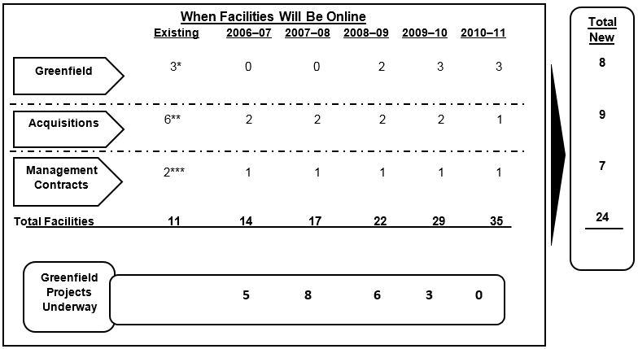

Note: \*Fortis Mohali, Noida, Amritsar; \*\*La femme, Escorts Heart, Escorts Faridabad, Escorts Raipur, Escorts Amritsar, Escorts Jaipur; \*\*\*Jeevan Mala, Jessa Ram.

Source: Company files.

EXHIBIT 2: FOrtis operating system OBJECTIVES AND SPECIFIC DELIVERABLES

**Objectives:**

* To ensure uniform high quality of customer-facing processes across Fortis hospitals
* To embed best practices in operational efficiency to yield bottom-line impact
* To facilitate performance management across all sites through use of a standardized cascade (scorecards at different levels) of metrics, tools, and templates
* To build the next generation of leaders in the Fortis system

**Specific Deliverables:**

* A methodology for the management of hospital capacity (operation theatres, emergency rooms, intensive care units, etc.)
* Well-defined standard operating procedures for key patient-related processes, including driving service excellence
* Efficient management of facility services like pharmacy, food and beverage, housekeeping, etc.
* Criteria for staffing levels across departments
* A performance management system with a cascading scorecard
* Managers trained in the “continuous improvement methodology”

Source: Company files.

EXHIBIT 3: PROCESSES AT FORTIS FROM FOS PERSPECTIVE

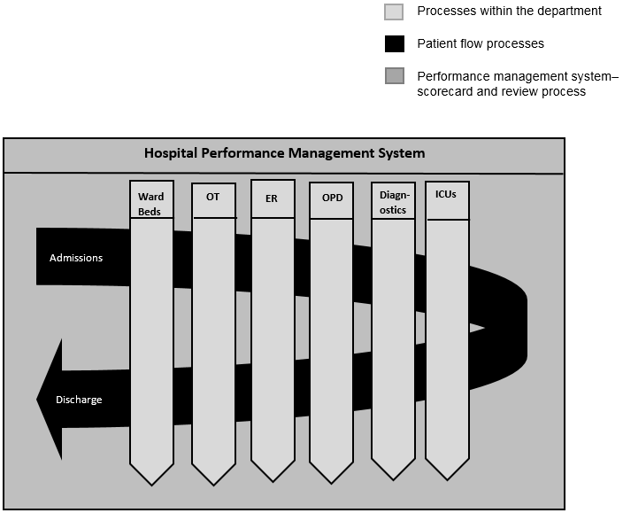

Note: OT =operation theatre; ER = emergency room; OPD = outpatient department; ICUs = intensive care units.

Source: Company files.

EXHIBIT 4: DMAIC FOR IMPLEMENTING FOS

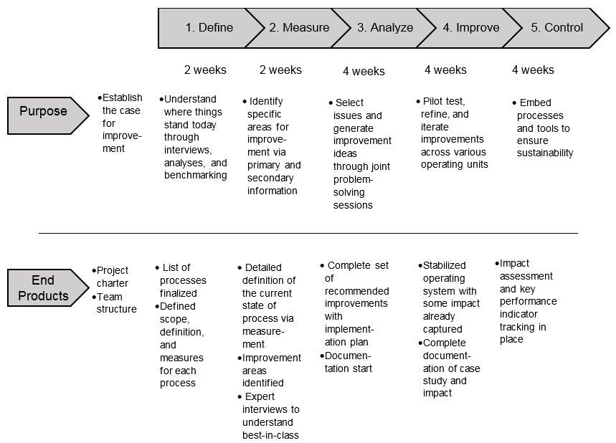

Source: Company files.

**EXHIBIT 5: OVERALL PERFORMANCE REPORT CARD, 2009**

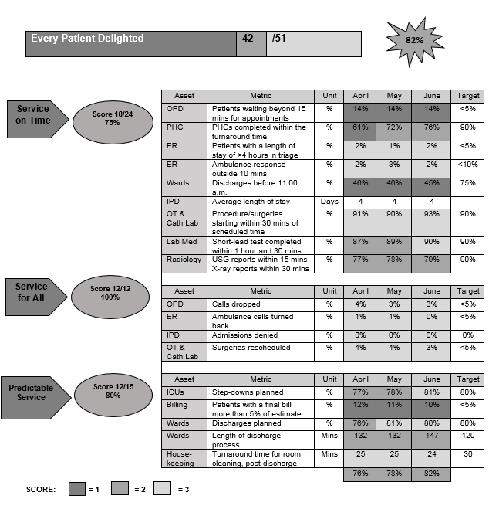

Note: OPD = outpatient department; PHC = primary health care; ER = emergency room; IPD = inpatient department; OT = operation theatre; Lab Med = laboratory medicine; Cath Lab = catheterization laboratory; ICUs = intensive care units; mins = minutes; USG = urine specific gravity.

Source: Company files.

EXHIBIT 6: OVERALL PROGRAM PLAN

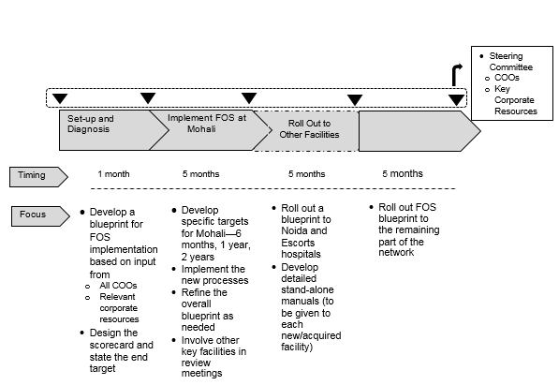

Source: Company files.

EXHIBIT 7: DISCHARGES BEFORE 11 A.M., FOLLOWING FOS IMPLEMENTATION (%)

Source: Company files.

EXHIBIT 8: EMERGENCY RESPONSE METRICS, FOLLOWING FOS IMPLEMENTATION **(Average Ambulance Response Time for Local Calls, in Minutes)**

Note: w/e = week ending

Source: Company files.

EXHIBIT 9: OUTPATIENT DEPARTMENT METRICS, FOLLOWING FOS IMPLEMENTATION (% of patients waiting beyond 15 minutes of appointment)

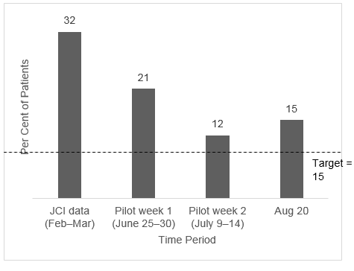

Source: Company files.

EXHIBIT 10: AVERAGE BILLING TIME IN MINUTES, FOLLOWING FOS IMPLEMENTATION

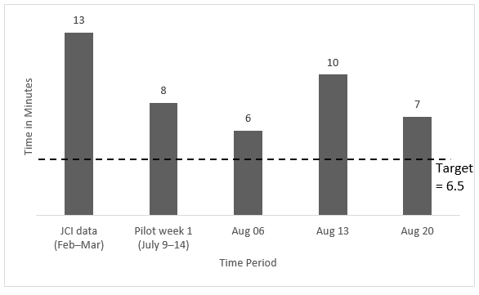

Note: JCI = Joint Commission International; JCI is a not-for-profit accreditation agency to survey hospitals outside of the United States and currently accredits facilities in Asia, Europe, the Middle East, and South America.

Source: Company files.

1. The authors gratefully acknowledge the support provided by the Max Institute of Healthcare Management at the Indian School of Business in the writing of this case. [↑](#footnote-ref-1)
2. KPMG, *Healthcare: Reaching Out to the Masses*, PanIIT Conclave, 2010, accessed December 16, 2017, www.kpmg.de/docs/Healthcare\_in\_India.pdf. [↑](#footnote-ref-2)
3. “Health Care,” India Brand Equity Foundation, September 2009, accessed December 16, 2017, www.ibef.org. [↑](#footnote-ref-3)
4. “National Health Profile 2009,” cited in KPMG, op. cit. [↑](#footnote-ref-4)