 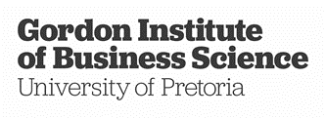

9B18C024

T-Systems South Africa: Contextual leadership of shared value

Caren Scheepers, Abdullah Verachia, and Sheila Motsepe wrote this case solely to provide material for class discussion. The authors do not intend to illustrate either effective or ineffective handling of a managerial situation. The authors may have disguised certain names and other identifying information to protect confidentiality.

This publication may not be transmitted, photocopied, digitized, or otherwise reproduced in any form or by any means without the permission of the copyright holder. Reproduction of this material is not covered under authorization by any reproduction rights organization. To order copies or request permission to reproduce materials, contact Ivey Publishing, Ivey Business School, Western University, London, Ontario, Canada, N6G 0N1; (t) 519.661.3208; (e) cases@ivey.ca; www.iveycases.com.

Copyright © 2018, Ivey Business School Foundation Version: 2022-07-06

On the morning of June 19, 2017, Gert Schoonbee, managing director of T-Systems South Africa (TSSA), was making his way from his farm in Mpumalanga province to the TSSA head office in Midrand, South Africa. TSSA operated information and communication technology (ICT) systems for South African multinational corporations and public sector institutions. The morning drive signalled the beginning of another week of opportunities toward fulfilling the company’s ethos of creating jobs in an industry that was often responsible for job losses as a result of automation.

TSSA was committed to contributing positively to nation building in South Africa.[1] To this end, Schoonbee was considering the dilemma of how to practically involve the larger business ecosystem, especially the company’s customer base, in TSSA’s quest toward creating shared value. Schoonbee believed it was no longer adequate to minimize an organization’s impact on only the physical environment—the challenge to sustain businesses and society was often a far greater challenge. In looking to create a broader impact, Schoonbee had wondered how TSSA might receive a positive sustainable return on its investments in environmental and social impacts.

Schoonbee understood that digitization was a reality and that his organization was an enabler of Industry 4.0, which Professor Klaus Schwab, the founder and executive chairman of the World Economic Forum, referred to as the Fourth Industrial Revolution (4IR), when describing the disruption caused by the fusion of digital and physical technologies.[2]

Schoonbee was contemplating how TSSA could, in spite of these changes, shape technology in a way that did not thoughtlessly destroy jobs in a country with an exceptionally high unemployment rate. The company wanted a positive net effect, which it called “net positive.” TSSA used this term to illustrate its focus on sustainability and shared value. For Schoonbee, underlying the term “net positive” was the realization that the business needed not only to minimize its impact on society but also to ensure a positive outcome with respect to how it engaged with the economy, the environment, and society at large. The impact of this commitment went deeper than offering handouts and charity to people and communities in need; critically, Net positive also aimed to empower people in such a way that they retained their dignity. As such, TSSA’s approach would focus on more than short-term financial results—it would, as proposed by academic Michael Porter, pay attention to the social, or human, and environmental impacts of doing business. Schoonbee’s team grappled with how to use digital disruption in a positive way.

Schoonbee was aware of how the embodiment of his vision would influence the actualization of these values across his own organization. He was, however, also considering how to extend this influence. Which organization should TSSA partner with, and how could he personally influence more stakeholders, including the company’s customers, to come on board? During times of cost-cutting, how could he sustain his organization’s focus on doing good for the nation?

tssa Background

The international company T-Systems launched in South Africa in 1997 under the TSSA brand. T-Systems itself was a global multinational organization. The major shareholder in T-Systems was Deutsche Telekom AG (DT), a German telecommunications company established in 1996, following the privatization of the previously state-owned monopoly Deutsche Bundespost. As TSSA’s parent company, DT’s main focus was providing fixed-line and mobile Internet broadband to its 14 million registered Internet customers. DT expanded its LTE (long-term evolution) mobile network coverage to 85 per cent of Germany’s territory, and provided 24 million households with optical fibre broadband, increasing the availability of high bandwidth. DT had planned to increase its revenues from enterprises in Germany to €600 by 2018.[3] DT also had enterprises that offered ICT security systems, intelligent networks, and cloud-based platforms through the group’s subsidiary, T-Systems. T-Systems was founded in October 2000, and in 2017 it was the number-one ICT service provider in Germany and a leading ICT company in Europe, according to Adel Al-Saleh, chief executive officer of T-Systems.

T-Systems operated in 20 countries with 46,000 employees worldwide. It had 90 technology partner companies, including industry leaders such as Avaya Inc.; Cisco Systems, Inc. (Cisco); Huawei Culture Co. Ltd.; Informatica Corporation; Microsoft Corporation; Salesforce.com, Inc.; and VMware, Inc. Several corporations relied on T-Systems’ expertise and storage capacities via the Internet, including Royal Dutch Shell plc, Daimler AG, steel giant ThyssenKrupp AG, and Spain’s national postal service Correos Spain, as well as financial services providers such as Union Investment. The T-Systems telecommunications portfolio was divided into several different areas: connectivity and network access; corporate networks; end-user communications; access services for high-performance mobile and fixed networks; and secure corporate networks, including operations, maintenance, and updates.

Schoonbee took the lead

Schoonbee was an industrial engineer with a master’s degree in business administration. He had worked on TSSA’s purchase of Arivia.Kom (pty) Limited,[4] a South African ICT company, for three years before becoming managing director of TSSA in 2010. His predecessor was Mardia Niehaus, who had started “ICT with Soul,” a culture change within the organization. TSSA defined its purpose as “making the country work,” which spoke to the fact that TSSA’s solutions involved numerous consumer purchases through the likes of South African retailers Woolworths, Truworths, and Foshini, and even Sub-Saharan Africa’s leading glass packaging company, Consol Glass Pty Ltd. Niehaus was a clinical psychologist who focused on the people side of the business, and her leadership style had influenced the organization to pay attention to the human aspect of business.

Because the ICT industry was known for often being a lonely place, TSSA endeavoured to bring in the human side, by focusing on people in addition to job-related aspects. Schoonbee himself realized that although he was often winning arguments, he was sometimes losing the other person in the process. Understanding that he was very rational and effective in debate, Schoonbee realized that he needed to develop his compassionate side. He and Niehaus made a great team, as he brought a strategic approach to decision making and she had a significant influence on his development as a leader. When he became managing director, he rose to tackle the challenges facing the company and in the process had ample opportunity to utilize his newly acquired people skills.

The initial period of Schoonbee’s role as managing director (2011–2012) represented a challenging time for TSSA, as 60 per cent of the business’s revenue was being generated from only two companies, Eskom Holdings SOC Limited, South Africa’s state-owned power generator and distribution company, and Transnet SOC Limited (Transnet), South Africa’s state-owned transport company. These state-owned entities were under pressure to support local suppliers, which made it difficult to also be a multinational service provider. In addition, TSSA was not a niche player; being number four in the market made it impossible for the company to fly under the radar.

An additional challenge was the resistance from public service companies to the appointment of Schoonbee, a white male, at a time in the country’s young democratic history when transformation through employment equity was critical. It was also a challenging period for Schoonbee, who needed to internalize these circumstances and make sense of them. One option he had considered was to move out of his role, but that did not feel right; ultimately, TSSA decided to focus instead on the empowerment of black people through adhering to South Africa’s legislation on affirmative action, known as Broad-Based Black Economic Empowerment (B-BBEE) transformation. This focus entailed TSSA giving preference to black-owned organizations as suppliers, and developing policies based on the percentage representation of black people in management and across all staff levels within the organization. In this context, the term *black* referred to all people of colour who had previously been disadvantaged under South Africa’s system of apartheid.

Celebrating diversity though nation building

Schoonbee and his team acknowledged that the B-BBEE charter in South Africa’s legislation could become a useful formula, but that its policies risked being executed in a mechanistic manner. Nonetheless, he made a personal decision. As he spent so much of his time and energy at TSSA, he felt that he might as well make it count.

Schoonbee was also driven to merge the value systems of his private life with those in his professional life. In his private life, Schoonbee had three sons and wanted to create a bright future for them in South Africa—this desire motivated his quest for nation building. He convinced his executive team and then the rest of the organization that they needed to not only create the country in which they wanted to live but also ensure its sustainability for future generations. This commitment started with each one of them as individuals and the way they treated one another. They were also encouraged to celebrate diversity within the organization, which would have a ripple effect on their customers and communities.

As an organization, TSSA deliberately chose to focus on dimensions that promoted diversity, in terms of the country’s *Employment Equity Act*. For example, because Schoonbee was male, the company promoted females; because he was white, it actively promoted employees who were black, Indian, and coloured (the official South African designation for mixed-race individuals). It endeavoured to create capacity and capability within a diverse employee base.

In 2011, TSSA initiated the process of removing barriers and providing a fair opportunity for women, and those who were black, Indian, and coloured. As the process evolved, the company realized that creating equal opportunities was not a simple task: the ravages of apartheid were tangible both within the company and across broader South African society.

In terms of gender equality, TSSA ensured 50 per cent representation of women in all of its programs, and even the TSSA board had 66 per cent female representation. As a result of its female representation, TSSA achieved a gender mainstreaming award from “The 30% Club,” a campaign launched in the United Kingdom in 2010 with the goal of achieving a minimum of 30 per cent women on The Financial Times Stock Exchange 100 Index boards.[5] TSSA was a founding member of this organization’s Southern Africa chapter.[6]

During her tenure, from 2005 to the end of 2010, Niehaus was the only woman on the TSSA board. By 2017, the executive team’s female representation stood at 50 per cent. Martly Rademeyer, manager of International Diversity at T-Systems, reported, “The emerging markets actually presented opportunities for gender equality, due to a higher flexibility and less established norms in the emerging markets.”

Schoonbee believed it was important for the company to also make its support for diversity visible, and to ensure that everyone could enjoy the opportunities offered by greater diversity. Getting the numbers in place was critical, and TSSA’s nation-building theme gave meaning to the company’s actions. It was not merely about driving change, but also about *how* change was being driven. Schoonbee believed that greater diversity would make TSSA’s “ICT with Soul” philosophy far more sustainable.

Taking Nation Building One Step Further

TSSA endeavoured to take its pursuit of nation building to the next level, which led to the idea of Net positive—TSSA’s term for shared value. Schoonbee acknowledged 4IR, a term that encompassed digitization, the Internet of Things and Services, cloud computing, and cyber-physical systems. 4IR, or Industry 4.0,[7] followed on from mechanization (Industry 1.0), mass production (Industry 2.0), and automation (Industry 3.0). TSSA, as an enabler of 4IR, was working in health care and retail, and with Transnet, where the digitization of core processes within South Africa’s ports had significantly improved throughput (the daily quantity of cargo and passengers passing through a port). Transnet was also using cutting-edge underwater drone technology to improve port security.

However, Schoonbee advocated for being cognizant of the shadow side of digitization. One implication of 4IR was the concept of singularity, which implied that by adding artificial intelligence to technology, lower-skilled jobs would ultimately be automated. An Oxford University study revealed that 40 per cent of job classes would disappear by 2050.[8] Lower-skilled jobs would almost all disappear.

However, in a country such as South Africa, which had the world’s second-highest Gini coefficient (an index provided by the World Bank to measure the level of inequality between a nation’s wealthy and poor citizens),[9] digitization needed to be shaped in such a way that technology was not prioritized at all costs. Organizations should be careful not to mindlessly destroy employment in the country under the umbrella of innovation. Adre du Plessis, TSSA’s director of Corporate Social Responsibility, described the organization’s approach: “For each job that is replaced by technology, there should be two jobs being created, then the net effect remains positive.”

ICT Academy and internships

The idea for an ICT Academy arose when Niehaus was TSSA’s human resources director. In 2004, she began to ask where the company could source ICT skills for a South African context. She considered where the company could find young women, specifically young black women, in a highly male-dominated environment. Because ICT skills were in such high demand, TSSA would be forced to recruit entry-level university students, which would have resulted in TSSA covering the students’ extremely high education costs, which the company was unable to do at that stage.

Niehaus then discussed the issue with a German development organization that was supporting aid efforts in South Africa. This organization partnered with TSSA to invest in an ICT academy, and matched its contribution to the investment made by TSSA. The organization was instrumental in the creation and management of the academy. Niehaus was also proactive in involving TSSA’s competitors, including IBM, SAP SE, Cisco, and Sun Micro Systems Inc. This collaboration saw the creation of an ICT Academy specifically aimed at developing ICT skills for South Africa.

Skills shortages were a significant problem in South Africa, extending across all industries and organizations. Involving competitors meant that resources could be pooled to create a skills pipeline. While TSSA could not get all industry players on board, those that were involved assisted in finding financing.

The decision was made to collaborate with the Community & Individual Development Association (CIDA) City Campus in downtown Johannesburg. CIDA was South Africa’s first low-cost, fully accredited university. It was the first institution of its kind to offer free education in South Africa. It was launched with valuable input from renowned South African entrepreneur Taddy Blecher. Further funding for the Academy came from American media personality and philanthropist Oprah Winfrey. Students from CIDA were also sponsored by South African businesses.

TSSA chose to work with CIDA because the university had already conducted a screening of students. Its class intake comprised bright, high-performing students who were the products of difficult rural and economic environments. These students often came from families headed by only one parent who was either unemployed or working in an unskilled job.

After students completed their first year at CIDA, they could then apply to the ICT Academy (the Academy), which was housed in the same building. TSSA and its partners sponsored the computers and designed the curriculum. The offering was a blend of a German concept with a South African twist. The Academy’s work was highlighted by the example of a young woman who had grown up in a village with access to only one telephone. Through the opportunities offered at the Academy, she went on to become a consultant specializing in SAP, a globally utilized enterprise resource planning product.

The Academy offered a three-year curriculum, and the course was linked to an internationally accredited qualification. Students of the Academy needed to successfully complete the first year of their bachelor of business administration (BBA) degree through CIDA.[10] Then, in their second year, they became parallel students of both CIDA and the ICT Academy.

Students of the Academy needed to work incredibly hard. They needed to fit in lectures for the ICT accreditation courses in the afternoon, on Saturday mornings, or in the evenings when they did not have CIDA lectures. Students had the choice to study at the Academy to obtain a one-year, two-year, or three-year qualification.

The first year at the Academy gave students a basic qualification, so if they chose not to continue they already had a basic understanding of and background in computers. In the second year, they completed the Sun Micro System qualification; and in the third year, they completed the courses for Cisco-certified engineers. By the time they were ready to enter the job market, the students had a four-year BBA degree, as well as ICT certificates and qualifications. As a result, as job seekers they were well rounded, and possessed far more skills than graduates from other universities.

When the first group graduated, TSSA started an internship program, selecting the top students and offering them formal work experience, along with additional training (encompassing soft skills) and development. To fully utilize these interns’ skill sets, the one-year program underwent many iterations to improve the internship. From then, TSSA took on between 90 and 120 students each year. Once students had completed their internship, they could either apply for a permanent position at TSSA or seek employment at other organizations in the South African ICT space. The program model was designed in such a way that the Academy could claim back funds from the country’s ITC Sector Education and Training Authority (SETA), one of 23 government-established SETAs established to develop sector-specific skills in South Africa.

By 2018, the program had been running for 14 years, during which time the ICT Academy had separated from CIDA (the university had run into problems and no longer complemented the Academy’s approach). The Academy was opened up to students from all universities but continued to use the same study model.

Contrasting a traditional ICT story with a shared-value success story

TSSA had been a brand sponsor of South African athlete Wayde van Niekerk[11] since his spectacular 400-metre run at the Rio 2016 Olympic Games in Rio de Janeiro, Brazil. Van Niekerk had been born prematurely, weighing only 900 grams. From the time of his birth, his mother remained involved with the neonatal unitat Groote Schuur Hospital, a renowned public hospital in Cape Town that had treated van Niekerk when he was born. [12]

At a TSSA event in Cape Town in 2016, van Niekerk announced that he would donate ZAR500,000[13] of his own money to the hospital’s neonatal unit. Schoonbee had been caught unaware, as van Niekerk had not mentioned that he had planned to donate the money, or even that he would be making an announcement. Thinking on his feet, Schoonbee supported van Niekerk’s goodwill and committed to delivering ICT services to the hospital’s neonatal unit. Schoonbee, having decided that delivering the ICT service was core to TSSA’s business, had chosen to offer the neonatal unit its services rather than money.

The first step in delivering this service was to go through a design-thinking process[14] to understand the unit’s “pain points” and determine how TSSA could assist the unit through the application of new technology. Interestingly, this corporate social investment opportunity gave TSSA a traditional ICT contribution story and provided a clear illustration of shared value in action.

The traditional ICT story was illustrated by TSSA’s contribution to the Groote Schuur Hospital, whereby the company supplied it with a Microsoft customer relationship management (CRM) solution. This solution improved the neonatal unit’s patient administration system. Because the time spent in hospital was a highly emotional and intense period for a premature baby’s parents, when the baby was discharged, the parents often did not return for checkups. However, premature babies were prone to retina dysfunctions, and if the retina was torn, the baby could be left completely blind, as evidenced by numerous people who had been born prematurely and had subsequently experienced a torn retina that had led to total blindness. Luckily, the condition was 100 per cent curable, provided it was diagnosed and treated within three months.

Improving the checkup rate could thus have a positive influence on the treatment of the condition. The hospital treated 40 per cent of all premature babies in the Western Cape province of South Africa; many of the parents in these cases were impoverished individuals who lacked access to technology such as smartphones. Therefore, the technology that TSSA introduced in 2016 needed to work on feature phones (i.e., mobile phones that could access the Internet but lacked the full functionalities of smartphones). The company’s solution served as a calendar entry to remind parents about checkups and to set up appointments at specific times. TSSA also offered to conduct the system’s service maintenance at no cost. This support of the business process enabled an increase in the checkup attendance rate by 30 per cent, to 40 per cent.

This shared-value success story highlighted the necessity of the checkups by showing their impact on society as a whole. An astonishing 20 per cent of children in the Western Cape’s Worcester, a school for the blind, had become blind due to a retina condition caused by premature birth. A significant percentage of the children who attended the school had been born at Groote Schuur Hospital’s neonatal unit. Schoonbee realized that if the checkups could have prevented these children from going blind, the impact on society would have been even more significant, in terms of the cost savings, for both the families and the greater society, which would be looking after these children for the rest of their lives. See Exhibit 1 for an illustration of shared value as a balance between a focus on financial growth and social impact.

The cost of this cause of blindness was evident in another South African province, KwaZulu-Natal, where the parents of five children took legal action against their provincial government, claiming that public hospitals in the province should have detected the torn retina condition. They were suing the government for ZAR50 million per child. This high amount was determined according to the prolonged influence of the condition on the individual children, their families, and society. Taking this information into account, Schoonbee determined that if TSSA were able to deploy a solution for less than ZAR50 million, it would create a highly successful shared-value story.

Seeing that TSSA’s solution cost only approximately ZAR500,000, it certainly was an example of the company’s positive shared-value contribution. Schoonbee realized that if the company could save one child through the solution, it could save society up to ZAR50 million. The value to society and to the individuals involved would indeed be positive. He realized, too, that TSSA required more of these measures to advocate for greater shared value.

A value-chain approach to creating sustainable shared-value solutions

TSSA wanted to benefit society as a whole, while profiting in the ICT space. A win–win example of this approach was TSSA’s social corporate investment project in Hazyview, a town in the province of Mpumalanga, which was well known for being home to one of Africa’s largest game reserves, Kruger National Park.[15] The area was beset with a 46 per cent unemployment rate.

The project started with TSSA simply training people from the area in ICT skills at Hazyview Digital Learning Centre (Hazyview). The company then saw an opportunity to create a service desk that operated at a cost 20–30 per cent less than in the province of Gauteng, since people in the country’s rural areas were prepared to work for lower salaries than in highly urbanized regions such as in Gauteng. Additionally, in a province such as Gauteng, where many more job opportunities existed, TSSA’s service desks experienced a very high attrition rate. At Hazyview, however, people were proud to have these jobs, which took them out of poverty and gave them status and dignity. In this way, TSSA could add value to a community while also generating shareholder value.

This project, therefore, was not an example of charity work; rather, TSSA was leveraging the situation for itself and for the other stakeholders involved in the project. It was achieving its stated goal of nation building by contributing to society, while offering world-class service from Hazyview and generating revenue.

Hazyview was an excellent example of how organizations could execute their business imperatives with a view to creating shared value. Another learning point from the Hazyview story was that the investments were sustainable only when they were linked to the organization’s value chain. Although moving in a different direction, the approach of Hazyview Centre was similar to the ICT Academy’s beginnings 14 years earlier in collaboration with CIDA. (See Exhibit 2 for an illustration of the circular process of investing in the community and the company. TSSA was benefiting in the long run, thereby making it a shared-value initiative.)

However, Schoonbee was concerned about not only mechanization in the ICT industry. While spending time on his farm, Schoonbee had also contemplated the degree of mechanization of this privately owned agricultural business. Mechanization would put 2,500 people’s jobs at risk. In the past, the Schoonbee family had endeavoured to apply more technology to grow the business, but ensured it did so without reducing the number of jobs the farm had created.

Schoonbee firmly believed that it was unsustainable to run a business without considering the bigger picture. Negatively impacting society in terms of job creation would ultimately result in his business running out of steam. Schoonbee acknowledged that it was not a simple task to work toward the creation of shared value, but he realized from both a business case perspective and a societal perspective that it was the right way to go.

Moving forward

When Schoonbee adopted his shared-value vision, he never imagined how many like-minded people would come together to champion that approach. He was delighted when a mining group partnered with TSSA in this quest. The mining group was investigating how to make old mining villages, located in deeply rural areas, self-sustainable. TSSA became the group’s technology partner and assisted by enabling the optimization of energy usage in these rural areas. It created technology solutions geared toward developing smart homes, smart energy, and even smart food as it collaborated with other partners.

On that Monday morning as Schoonbee turned into the Midrand office park, the magenta-coloured banners of TSSA came into view. He felt a sense of expectation, and knew the magenta brand meant a great deal to his employees. It symbolized TSSA’s unique value proposition. Schoonbee saw that even that early in the morning many cars already filled in the parking lot, an indication of his employees’ dedication to their work. He realized that the employees were making shared value a part of their own personal ethos.

Schoonbee’s authenticity and vocal support for shared value inspired many people to change the way they executed their day-to-day jobs. Sometimes the shared-value story sounded very simplistic, as if Schoonbee was playing with words, but it was about looking at TSSA and what the company’s employees did every day through a different lens, but without necessarily changing the service they offered. It was a mindset against which all decisions could be evaluated. For instance, how could a decision lead to nation building and ultimately a shared-value result?

Schoonbee realized that like-minded people would need to support one another in this quest. If the aim was simply to achieve shared value, then all companies would already have adopted shared value as their business model. South Africa represented many challenges that inhibited companies from making a positive impact, from historical considerations to a political situation that was dehumanizing and failed to support diversity. Therefore, he and the company’s leadership needed to ensure that TSSA was not isolated in its thinking. The company needed to share ideas with like-minded people to ensure the plans it was creating would remain sustainable. TSSA also needed to realize that its ideals around shared value were not mainstream and required rigorous and continuous debate.

Schoonbee also reflected on the global digital economy, which would not be contained. He believed, however, that organizations had a choice of how to shape their identities within that unpredictable space. He realized that digitization brought beautiful enablement as well as shadows, but felt that TSSA could turn the inevitable digital disruption into a good outcome for the country and for future generations. Nonetheless, he grappled with the question of how to involve more partners and customers in this quest. Schoonbee wondered how he could influence more people and draw them toward supporting the ethos of shared value.

**EXHIBIT 1: SHARED VALUE AS A BALANCE BETWEEN A FINANCIAL GROWTH FOCUS**

**AND A SOCIAL IMPACT FOCUS**

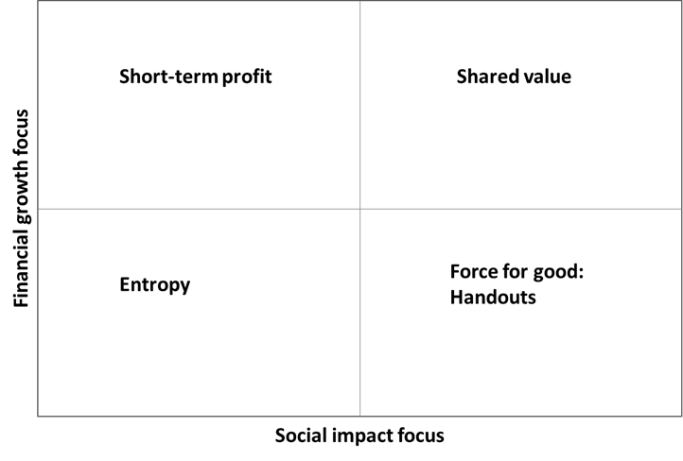

Source: Authors’ own synthesis based on Michael E. Porter and Mark. R. Kramer, “Creating Shared Value: How to Reinvent Capitalism and Unleash a Wave of Innovation and Growth,” *Harvard Business Review* (January/February, 2011): 62–77. Available from Ivey Publishing, product no. R1101C.

EXHIBIT 2: POSITIVE SPIRAL OF INVESTING IN THE COMMUNITY

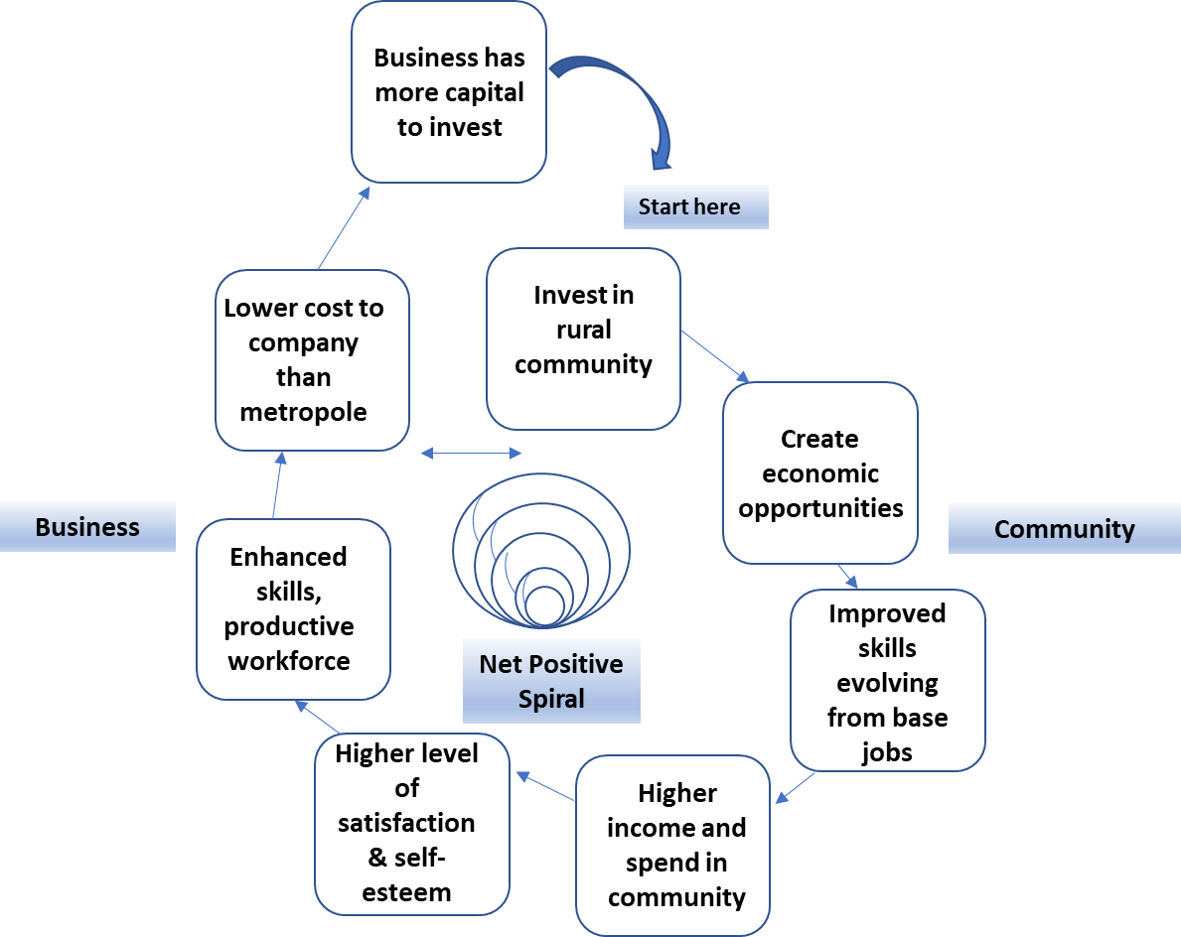

Source: Created by the authors based on information from the case study interview transcripts.

1. T-Systems, a subsidiary of Deutsche Telekom AG in Germany, was a leading telecommunications company in Europe. See the company profile of T-Systems and the explanation by its chief executive officer, Adel Al-Saleh, of the group’s functions at: Adel Al-Saleh, “Editorial: Speaking for Myself,” T-Systems, accessed May 12, 2018, www.t-systems.com/en/best-practice/01-2018/editorial/ceo/adel-al-saleh-782546; TSSA was part of T-Systems. It had established the local project “Nation Building,” which Gert Schoonbee had initiated as a way to contribute to South African society by creating jobs.
2. “The Fourth Industrial Revolution, by Klaus Schwab,” World Economic Forum, 2018, accessed May 12, 2018, <https://www.weforum.org/about/the-fourth-industrial-revolution-by-klaus-schwab>.
3. € = EUR = euro; US$1 = €0.87530 on June 30, 2017.
4. Arivia.Kom (pty) Limited was a provider of information technology (IT) services and solutions in South Africa. It developed, supplied, and implemented business solutions, and offered managed services, regional services, and integrated program office service. For more information on the company, see “Company Overview of Arivia.Kom (pty) Limited,” Bloomberg, accessed May 12, 2018, www.bloomberg.com/research/stocks/private/snapshot.asp?privcapId=10364936.
5. Interview with Gert Schoonbee in June 2016 as part of the research for Shireen Chengadu and Caren Scheepers, for *Women Leadership in Emerging Markets* (New York, NY: Routledge, 2017).
6. “Who We Are,” The 30% Club, 2015, accessed May 12, 2018, <https://30percentclub.org/about/who-we-are>.
7. Dr. Reinhard Geissbauer, Jesper Vedso, and Stefan Schrauf, *Industry 4.0: Building the Digital Enterprise*, PwC, 2016 Global Industry 4.0 Survey, 2016, accessed June 24, 2017, www.pwc.com/gx/en/industries/industries-4.0/landing-page/industry-4.0-building-your-digital-enterprise-april-2016.pdf.
8. Erik Brynjolfsson and Andrew McAfee, *The Second Machine Age: Work, Progress, and Prosperity in a Time of Brilliant Technologies* (New York, NY: W. W. Norton & Company, 2014).
9. Haroon Bhorat, “Is South Africa the Most Unequal Society in the World?,” *Mail & Guardian*, September 30, 2015, accessed March 29, 2018, <https://mg.co.za/article/2015-09-30-is-south-africa-the-most-unequal-society-in-the-world>.
10. The BBA degree was a four-year undergraduate degree in business studies awarded by University of South Africa; University of South Africa, “Undergraduate & Honours Qualifications: Bachelor of Business Administration,” accessed May 12, 2018, [www.unisa.ac.za/sites/corporate/default/Apply-for-admission/Undergraduate-qualifications/Qualifications/All-qualifications/Bachelor-of-Business-Administration-Business-Administration-(98316-per centE2per cent80per cent93-BBA)](http://www.unisa.ac.za/sites/corporate/default/Apply-for-admission/Undergraduate-qualifications/Qualifications/All-qualifications/Bachelor-of-Business-Administration-Business-Administration-(98316-%E2%80%93-BBA)).
11. Wayde van Niekerk was a South African track and field sprinter who competed in 200- and 400-metre races. He was the first athlete to run 100 metres in under 10 seconds, 200 metres in under 20 seconds, and 400 metres in under 44 seconds.
12. Groote Schuur Hospital was well known as the site of the first human-to-human heart transplant performed by Dr. Chris Barnard.
13. ZAR = South African rand; ZAR1 = USD0.0677 on June 30, 2016.
14. Design thinking was a methodology that designers used to solve complex problems and find desirable solutions for clients in a way that was not problem-focused but rather solution-focused and action-oriented toward creating a preferred future; Linda Naiman, “Design Thinking as a Strategy for Innovation,” Creativity at Work, accessed May 12, 2018, www.creativityatwork.com/design-thinking-strategy-for-innovation/.
15. Siyabona Africa, “Places in Hazyview,” Kruger National Park, accessed May 5, 2018, www.krugerpark.co.za/place/Hazyview.html.