

9B18C048

Hart Schaffner Marx: Neurodiversity at a Classic American Suit Maker

Professor Robert D. Austin wrote this case solely to provide material for class discussion. The author does not intend to illustrate either effective or ineffective handling of a managerial situation. The author may have disguised certain names and other identifying information to protect confidentiality.

*This publication may not be transmitted, photocopied, digitized or otherwise reproduced in any form or by any means without the permission of the copyright holder. Reproduction of this material is not covered under authorization by any reproduction rights organization. To order copies or request permission to reproduce materials, contact Ivey Publishing, Ivey Business School, Western University, London, Ontario, Canada, N6G 0N1; (t) 519.661.3208; (e)* [*cases@ivey.ca*](mailto:cases@ivey.ca)*;* [*www.iveycases.com*](http://www.iveycases.com)*.*

Copyright © 2018, Ivey Business School Foundation Version: 2018-11-30

In 2017, Doug Williams, chief executive officer (CEO) and owner of the W. Diamond Group Corporation/Hart Schaffner Marx (HSM), listened with interest as David Geslak, president and founder of Autism Workforce (AW), reported on new developments in the rollout of HSM’s autism employment program. They were meeting in Williams’s office, in the Des Plaines, Illinois, building that housed the HSM factory. The 130-year-old classic American suit maker—the only company still making suits and sports coats in America—had sought out AW’s expertise in autism-ready work design. Working together, HSM and AW had been able to activate the talents of seven autistic[1] people in different positions across four departments at HSM. Williams was pleased with the progress and wondered how far they could reasonably take this work.

In recent years, other companies, such as SAP SE and Microsoft Corporation (Microsoft), had also developed autism employment programs, but their programs differed from HSM’s. Candidates for technology company programs were often academically successful university graduates who possessed advanced abilities to manage autism-related difficulties by themselves. Some observers, while earnestly congratulating these companies on what they had accomplished, expressed concern that their programs focused on only a small subset of autistic people. There was a much larger population of autistic people who might be employed.[2]

The HSM program “dipped more deeply” into the autism spectrum, developing and deploying methods to make employment accessible to a much wider group of autistic people. Some candidates for the HSM program were more affected by autism’s difficulties. The people HSM hired would need more support to be able to do their jobs well and independently. Also, the factory environment at HSM was noisy and complex compared with white-collar settings. In effect, HSM and AW had taken on a tougher challenge. To create a successful program, they would need to break new ground.

“The spectrum is broad,” said Williams. “There are employable individuals, really, for any role in the company. . . . The goal is to hire the best person for the job, and if that person turns out to be autistic, they’re the person who is going to do it. This is not a charity program; this is an opportunity program.”

A Brief History of Hart Schaffner Marx

In 1887, two immigrant brothers, Harry and Max Hart, opened a men’s clothing store, Harry Hart and Brother, in Chicago. The Harts’ brother-in-law, Marcus Marx, and a cousin, Joseph Schaffner, soon joined the business, which was renamed Hart Schaffner & Marx. Thinking there was more potential in the suit-making side of the business than retail, they shifted focus. A contract to make clothing for the U.S. military moved them toward off-the-rack, ready-to-wear clothing.

By 1897, the company was selling off-the-rack suits through many retailers. They advertised nationally, using well-known illustrators to create brand-related materials, establishing themselves as a premium brand. Tailoring suits of all sizes and shapes, they offered them at cheaper prices than custom-made suits, and achieved mass-market volumes. Their innovations included zippered trousers and tropical-weight wool suits. The company incorporated in 1911. When World War I broke out, the company made uniforms for the military.

Beginning in 1926, the company expanded by acquiring Wallachs, a New York-based clothing chain, then Chicago-based Al Baskin Co. The company produced military uniforms for World War II, and after the war, HSM acquired more manufacturers, retailers, and brands, including Society Brand, Hickey Freeman, Jaymar-Ruby, Kleinhans, and M. Wile & Co. The industry concentration HSM achieved eventually drew attention from antitrust regulators, resulting in a consent decree, in 1973, which effectively barred HSM from further acquisitions (without court approval) for 10 years.

After 10 years, HSM resumed its acquisitions: the U.S. licensee of Pierre Cardin, retailer Bishop, and discount suit retailer Kuppenheimer. The company also expanded into women’s clothing by acquiring Country Miss. It then restructured; Hartmarx Corporation (Hartmarx) was established as a holding company, parent to the subsidiaries. Acquisitions continued through the 1980s, with Briar Neckwear Inc.; manufacturers H. Oritsky Inc. and the Bitwell Company; and retailers Anton’s (Detroit), Boyd’s (St. Louis), and Raleigh’s (Washington D.C.).

As the company entered the 1990s, however, it began to lose money. To regain focus, Hartmarx sold off retail operations, as well as two tailored clothing factories, while acquiring manufacturing capacity and a few additional brands. Competitors moved manufacturing offshore, creating new cost pressures in the industry. To adjust its costs, Hartmarx closed domestic factories and moved some production to China, Mexico, and Costa Rica, eventually stabilizing its financial situation.

During the campaign for the 2008 presidential election, then-senator and president-to-be Barak Obama, who was from Chicago, made a point of wearing HSM suits, which generated favourable publicity for the company. Despite this promotion, growing international competition combined with the financial crisis of 2008 forced the U.S. company and its subsidiaries into bankruptcy. In August 2009, Hartmarx assets were acquired by S. Kumars Nationwide Limited (SKNL), a publicly traded company based in India. HMX Group, a new holding company was established, with Hart Schaffner & Marx as its flagship brand and more focused operations. Williams was hired to run the new company. Plans called for an additional influx of capital from SKNL in 2012.

When 2012 arrived, however, SKNL was not in a position to inject capital into HMX, and this precipitated another bankruptcy. Nevertheless, Williams, who had, by this time, been in the CEO for about three years, saw value in the company and believed that a turnaround could still be executed. He brought to bear the resources of his family, and his relationships with sources of financing. By year-end, the company had been reborn as the W. Diamond Corporation, owned by Williams and his family.

HSM’s Competitive Challenges

A key skill in the HSM business was the ability to operate a sewing machine, but the Chicago area had an ongoing shortage of people skilled in sewing. It was not a job that could be done by just anyone. When the company trained people from scratch, at a cost approximately $5,000[3] per person, only one in three ultimately possessed the dexterity necessary to meet the quality requirements.

As the last men’s suit maker committed to manufacturing in the United States, HSM operated under constant price pressure, which constrained how much it could raise salaries. Because the suburbs near the HSM factory were affluent, most of the factory workers commuted long distances to work from the southern suburbs; in addition to the commute time, the expense of commuting cut into workers’ wages. Also, a successful movement to raise the required minimum wage in Chicago made jobs in Chicago relatively more attractive. Some HSM workers had subsequently given up their skilled sewing jobs in favour of unskilled service jobs in Chicago. In 2015, when Hugo Boss shut down a plant in Cleveland, HSM jumped at the chance to buy it, mainly to access a large workforce skilled in sewing.

Cost pressures also generated a constant need to improve efficiencies and redesign processes. Both were challenging for HSM. Processes were not very explicit because the average employee had a long tenure with the company and knew how things were done. People who had been doing things the same way for a long time sometimes had trouble envisioning new and better ways.

HSM also had competitive advantages. The brand remained strong, and was the only suit manufacturer with a “made in America” story. “We produce a better garment than you can buy from an offshore factory, and can charge a higher price for it,” said Ellen Shaw, HSM’s vice-president of sales and customer service. “There is no 45-day delay for transportation due to crossing the ocean, as is true with our competitors, so we can respond more quickly to new orders and requests.” However, maintaining the HSM brand required investment; the company used higher-quality materials than its competitors, was selective about retail distribution, and spent regularly for print and social media coverage.

Autism Workforce

While majoring in health promotion at the University of Iowa, David Geslak had served as a student assistant strength and conditioning coach for the university’s football team and earned certifications as an exercise physiologist and a strength and conditioning specialist. His first job as a personal trainer was with a nine-year-old autistic boy. With help from Geslak, the boy acquired abilities that he had not been able to achieve with other therapists and teachers; word-of-mouth referrals won Geslak other jobs with autistic children.

As he achieved physical and emotional breakthroughs with these clients, Geslak realized that exercise provided them with improved self-confidence and social skills and also helped them gain more control over their behaviour. When he took a job as a fitness coordinator at Giant Steps, a school for autistic children, he was able to accumulate more experience working with autistic children and young adults. Out of this experience, he developed a systematic exercise program for autistic children that provided them with a broad range of behavioural benefits.

This new exercise program garnered attention and accolades. Geslak presented the program and its results internationally. He hosted his own TV show, *Coach Dave*, on the Autism Channel. In 2009, he started a company, Exercise Connection, to use as a platform for diffusing his innovations for improving the lives of people with autism. Geslak’s work eventually came to the attention of Jay Goltz, a Chicago-area business owner who wrote a column called “You’re the Boss: The Art of Running a Small Business,” for the *New York Times*. Goltz wrote about Exercise Connection in his column.

Meanwhile, Williams, CEO and new owner of HSM, was attending an event in New York to recognize a company that had started a program to hire autistic people. His interest in the well-being of autistic people was personal: he had a son on the spectrum. “As you raise your child,” said Williams, “you begin to realize that kids ‘age out.’ Once they do, what is going to be their role in society? As many as 85 per cent never have gainful employment.” He read Goltz’s article in the *Times*, and reached out to Geslak.

“I would like to start a program around my factory,” he told Geslak. “I want to build something that will have a true business case in our company, but that will also be a laboratory to develop approaches for other companies who want to set up their own programs.” Excited, Geslak accepted the challenge, and founded Autism Workforce, a division of Exercise Connection that would apply to employment situations what he had learned about helping autistic people.

Some Facts About NEURODIVERSITY, Autism, and Autism Employment

John Elder Robison, a scholar in residence at William & Mary’s Neurodiversity Initiative who self-identified as an autistic person, defined neurodiversity as:

The idea that neurological differences like [autism](https://www.psychologytoday.com/us/basics/autism) and [ADHD](https://www.psychologytoday.com/us/basics/adhd) [attention deficit hyperactivity disorder] are the result of normal, natural variation in the human genome. This represents a new and fundamentally different way of looking at conditions that were traditionally pathologized . . . Atism, ADHD, and other conditions emerge through a combination of genetic predisposition and environmental interaction; they are not the result of disease or injury . . . People with differences do not need to be cured; they need help and accommodation. . . . When 99 neurologically identical people fail to solve a problem it’s often the 1% fellow who’s different who holds the key. Yet that person may be disabled or disadvantaged most or all of the time. To neurodiversity proponents, people are disabled because they are at the edges of the bell curve; not because they are sick or broken.[4]

Autism spectrum disorder (ASD) impaired an individual’s ability to interact socially. The people affected by ASD often had difficulty understanding the nuances of communication, both verbal (e.g., tone of voice) and non-verbal (e.g., facial expressions). During conversation, autistic people might not send reflexive signals of attentiveness, such as eye contact. Thus, they could seem aloof, indifferent, or odd. The situation became more difficult when autistic people lost confidence in their social abilities or experienced anxiety in social situations.[5] Some were sensitive to sensory stimuli produced by workplace noise or lighting; some engaged in repetitive behaviour, felt a compulsion to order things (e.g., lining up toys in a row), or resisted changes in routine (e.g., always wanting to take the same path to a destination).

In 2018, ASD affected one in 59 people, which made it one of the most common developmental disorders in the general population.[6] But manifestations varied widely. Autistic people were individuals, differently affected by autism symptoms. Resulting difficulties could range from mild to severe. Some autistic people were non-verbal and/or seriously affected by mental health issues; some invented compensating strategies that helped them to establish workable, mostly independent life arrangements.

ASD could also convey advantages. Autistic people could exhibit an uncommon ability to focus and impressive thoroughness. Some were capable of exceptional feats, such as quickly memorizing vast quantities of information or detecting subtle mistakes or patterns in large data sets. The enhanced ability to focus could extend to monotonous tasks on which “neurotypical” people could not maintain attention. Difficulties with social nuance could lead autistic people to be exceptionally honest. And yet unemployment rates among autistic adults were often 85 per cent or higher. Those who did find employment were often underemployed, in the kinds of jobs that many people left behind in high school.

This situation began to change in 2004, when Danish social entrepreneur Thorkil Sonne started a for-profit consulting firm, *Specialisterne* (“the specialists” in Danish), staffed by autistic people. His firm focused on software testing, a repetitive activity boring to most people but requiring exacting attention to detail.[7] Specialisterne’s analysts excelled in this work, and the company was able to charge premium prices for its high-quality services. Sonne and his team developed innovative processes for selection, training, and support that became the basis of other programs—especially for technology companies.

SAP, the world’s fourth-largest software company, announced its Autism at Work program in May 2013, with a goal of having autistic people comprise 1 per cent of its employee base by 2020. Other large companies followed: Hewlett Packard Enterprise/DXC Technology, Microsoft, EY, Ford Motor Company, and JPMorgan Chase & Co. In 2015, the United Nations called on companies the world over to make their hiring practices more inclusive of autistic people. The result was major progress in expanding opportunities for autistic people; however, at the Autism at Work Summit in 2018 at Microsoft headquarters in Redmond, Washington, representatives from each of the above companies acknowledged the need for additional know-how to help them “dip more deeply” into the autism spectrum, to employ larger numbers from what was a huge population.

The Hart Schaffner Marx Autism Employment Program

At HSM, Williams questioned the factors that kept many autistic people out of the workforce:

Due to autism’s high prevalence, there is a large part of the population that has trouble joining the workforce. As an employer having difficulty finding employees, this doesn’t make any sense to me. How do you structure the internals of a company to make this work better?

AW began working with HSM in the fall of 2014. Together, they built a small facility within the factory to allow exercise to be integrated into the new employment program. HSM adjusted the work environment, painting walls in less harsh colours, adding plants to some areas, and changing lights to address the sensory issues that autistic job candidates might experience. At the same time, the company also worked on “staff enlightenment,” which meant developing a custom “autism awareness” guidebook and a training program for the HSM employees, to prepare them for what to expect from autistic co‑workers. Then HSM settled into the hard work of examining jobs throughout the factory to identify positions that might prove suitable for people in the autism employment program.

Job Tasks and Job Design

Because autistic people often struggled when it was not apparent what they should do, jobs needed to be clearly defined and divided into clearly documented steps and processes. To provide this detail, AW experts Ashley Palomino and Amy Willer[8] carefully studied jobs and developed check lists, signage, and navigational aids (e.g., paths on the factory floor); created detailed visual process descriptions; and wrote instructions to handle various contingencies that program participants might experience. For example, they documented part of the job for a “swatch specialist” in “Making the Seasonal Swatch Book” (see Exhibit 1). Instructions for some contingencies covered processes that some companies might have assumed people understood without explicit instructions, such as what to do during a fire drill (see Exhibit 2). Some job tasks (e.g., folding cardboard into boxes) could not easily be divided into steps in the manner illustrated in Exhibit 1; they were far easier to show than to explain. Such tasks were documented using “video modelling”—in videotapes of people doing the tasks so that candidates (or anyone, for that matter) could watch them repeatedly. AW also designed colour-coded overlays to make confusing company and government forms easier to complete. For each job that AW divided into steps and documented, Palomino or Willer validated the models by using the documentation to actually *do* the job.

Recruiting

Recruiting candidates began with the development of a detailed description of a job that AW had divided into steps and documented, and that HSM had agreed was appropriate for the program. These descriptions featured an original format developed by AW that included elements not usually present in job descriptions, such as information about the job’s physical requirements (e.g., endurance and movement) and environment sensory levels (e.g., sound, light, and smell—each ranked from low to high). Because everyone, from parents to job coaches, was eager to see candidates be successful in the job, the company needed to base decisions about “the right fit” on an objective comparison of the abilities of a particular candidate with realistic position requirements. The uniquely formatted job descriptions facilitated such comparisons (see Exhibit 3).

To identify candidates for a position, AW worked with other organizations (e.g., non-profits and government employment agencies) that knew of autistic people seeking employment. Employee networks could also be resources (e.g., someone within HSM might know someone who fit the profile). A few possible candidates would be identified and scheduled for a tour of the HSM facility.

The tour was designed as a gentle introduction to the work setting. Usually, it involved three or four candidates visiting HSM for about half an hour. The tour gave AW and HSM representatives an opportunity to notice major challenges that might prevent candidates from performing a job (e.g., extreme distress due to factory noise); it also provided candidates an opportunity to see what the workplace would be like and an opportunity to say, “This is not for me” (if that was what they were feeling). In preparing candidates for the HSM tour, AW took the same approach to detailed documentation that it did to everything else: step-by-step instructions were provided for candidates (see Exhibit 4).

A few days after a tour, a subset of the candidates would be invited to HSM for interviews and skills assessment. The skills assessment involved watching candidates do a part of the job they were being considered for—not the whole job, but a few steps usually including the critical parts. The manager who would supervise the job was also present to observe the candidate doing some of the work that would be expected. Based on the interview and skills assessment, a candidate might be offered the job.

On-boarding of new program hires was also designed to be careful and gentle. It began with an orientation process of a duration that depended on the position—for example, two weeks. The first meeting might be a couple of hours (some candidates had never before worked a full eight-hour day), filling out employment forms and briefing candidates on company policies. The second day might be a little longer. Because these new hires often had no previous employment experience, these briefings included more than the usual detail on subjects such as the dress code and the use of electronics while at work, all rewritten in graphic form (see Exhibit 5). Participants were introduced to the exercise regime that would be part of the program (all began their days with a session in the exercise centre, for which they were paid).

After orientation, they began a two- to four-week enhanced job training process led by AW representatives, managers, and a co-worker. Training was intentionally structured in phases, with responsibilities added one at a time. After the enhanced training period, program participants earned a Certificate of Completion. Their responsibilities continued to grow, based on systematic reviews aimed at determining when each participant was ready for more.

One important innovation in the program came with the development of mock interviews. Early in the program, human resources (HR) staff noticed simple problems in job interviews (e.g., candidates not brushing their hair or not being appropriately dressed). The candidates would have benefited from hearing about their missteps in the form of feedback; however, in a formal employment context, providing such feedback could lead to legal problems. The solution: simulated interviews that served as job training, outside the formal hiring process. As a community service, HSM and AW reached out to local agencies and high schools to invite young people—not only autistic people but anyone who had a disability—to take part in practice interviews, after which they would receive feedback. This service accomplished three purposes: (1) it helped those who participated to become better at interviewing; (2) it educated the HR staff about the full range of the autism spectrum (and also other disabilities) and increased their comfort level in interviewing autistic candidates; and (3) it helped the company identify a pool of talent from which it might recruit for new program positions. The information that was gathered and some of the feedback for candidates who participated in the mock interviews was documented (see Exhibit 4).

Filling Positions

In September 2015, Jordan,[9] the first person hired into the program, was hired as a swatch specialist in the customer service department. A swatch specialist provided retailers with samples of materials that their customers could closely examine; the job involved entering retailer requests into a database, packaging the swatch order for shipment, and shipping the order, as well as maintaining and updating the library of HSM swatches. Jordan started with just one responsibility, and then more were added, one at a time, as he proved proficiency in each and demonstrated that he could do each independently; as of mid-2018, he had mastered six different responsibilities.[10]

About a month later, in October, HSM hired Marice into an expeditor position in the special orders department. As an expeditor, Marice was the final person in a team of seven involved in the process to fill a custom suit order. The job involved entering data and transferring an order to production so a suit could be made. It also required the program participant to navigate the complexities of the factory floor.[11]

Having experienced good results with Jordan and Marice, HSM on-boarded Max in spring 2016 in a videographer position. Max was in college, majoring in film and video production, and wanted to gain more experience; HSM engaged him as a contractor. In addition to making videos that were of use to HSM in a variety of capacities, one of Max’s most important jobs was the video-modelling process that became part of the visual documentation of some program-related jobs.[12]

One of his video models of the process for making suit boxes was critical in bringing Andy on board in June 2016. Andy was a stock associate working in the distribution centre. Part of a team of seven, he built boxes and—eventually, as he learned more—packed made-to-measure suits, in preparation for shipment. Designing his job involved colour-coded signage and racks to keep the process organized and flowing well. He learned box folding by watching the video, which validated the effectiveness of video modelling; being able to watch the video was clearly related to improvements in his ability to do the job.

Information technology support analyst, Erron, started in the distribution centre in September 2017, as an inventory cycle counter. “Michael” came on board in March 2018, also in the distribution centre, as an inventory matcher.

Program participants settled successfully into their new jobs. Their managers, co-workers and AW staff helped them with difficulties and taught them new things about the work. AW staff monitored and attended to the participants’ mental and emotional well-being and provided advice and visual guidance in practices such as “leaving your worries at the door” (see Exhibit 6).

Experience with the Program

Williams and his team were pleased with the work being done by program participants. Andy, as an example, had quickly established himself as a high-productivity box maker. Also, Erron’s attention to detail and organizational strengths led him to spotlight opportunities to improve processes that helped HSM decrease its inventory holdings. “He asks very good questions,” observed Davis Chand, vice-president of operations, “like ‘Why are we doing things this way?’ And then it turns out that there’s no good reason, and it would be better to do it a different way.”

Because autistic people often found inconsistency and disorder to be disturbing, program employees often pointed HSM to better or more efficient ways of doing things. “It’s like testing the way things have always been done here,” said Chand. “It helps us rehabilitate the old ways, so that they can work better, which we must do in such a competitive industry.” It was also necessary to monitor the frustration and stress levels of employees in the program, and to coach them about it. “We go back to them and say, ‘You gave us feedback that resulted in real improvements; so even if it caused you stress, you should be pleased and proud of identifying an opportunity for improvement.’”

HSM also found that having a program employee in a group changed managers’ behaviour—in positive ways. It created a need for managers to spot-check, to check in with people working on the floor, which most people thought was a valuable way to operate. A theme emerged: changes instigated by the program led to ways of managing that were better for all employees.

Benefits from the Program

In general, the benefits that HSM was experiencing from the program were surprisingly broad. Beyond the focus and productivity that the program participants brought to their jobs, there was a “feel-good” factor that affected the entire organization. “We can fill roles that are needed—the individuals are very productive,” said Williams. “But it also creates in the company a sense of community, and positive sense of our company in the community. There is this socialization of the company and how it relates to the community, how we give back to the community.”

And there were more practical benefits: signage and colour-coding developed for autistic people were also, useful to people not on the spectrum. The detailed process descriptions created in support of the program helped a great deal with process improvement efforts. As Williams explained,

An autistic person doesn’t learn by osmosis. So, we have to be explicit. By being more explicit, we avoid the “telephone tag” problem: people interpreting at each level. And explicit processes are easier-to-improve processes; they provide a way for people to question processes that did not exist when everything was assumed.

The overlay templates created for program participants to make confusing government forms more accessible made them more accessible to others, too, “especially,” an HR representative explained, “to those for whom English is not their native language.” As Palomino pointed out, when they designed job aids for a specific population and doing so led to creating better designs for everyone, they, in effect, were practising “universal design”—a well-developed subfield of industrial design. Palomino and Willer applied principles of universal design in the work that they did at HSM and even refined and extended the principles to better apply in their specific applications.

Looking Forward: Issues and Challenges

The program’s success made Williams and his HSM managers want to explore further possibilities. “I’d like to staff as many people from this program as I can,” said Chand, “to show there are no boundaries here, and that we’re committed to doing whatever is necessary to go for top notch efficiency.” But several issues needed to be addressed.

One issue was the union status of program employees. So far, it had been simpler to place program participants in non-union positions. But there were only so many of those positions. It was conceivable that program participants could join the union, but that possibility ran into another issue: part-time versus full-time status.

So far, all program participants had been part-time employees—and for good reasons. Working in sensory-challenging environments could be stressful for autistic people; therefore, part-time work was better for many. In addition, most program participants received Supplemental Security Income (SSI) from the U.S. government; SSI was a program for people who needed assistance due to their disabilities. It was difficult to qualify for, so the families of participants did not want to endanger their SSI status. One thing that could cause problems for that status was taking a full-time job and making too much money. As a result, some parents had inquired whether their children could work for free, to avoid endangering their SSI. In the end, the benefits to the program participants of making a salary of their own (e.g., self-esteem) won out over this sentiment; however, worried families would still say, “You can’t pay them too much.”

The company had no precedent for part-time union positions. Understandably, the union was wary of the idea of replacing full-time jobs with part-time jobs. Even if part-time union positions were available, the policy called for charging part-timers full union dues, the same as full-timers, which could cut deeply into part-time wages. All of these issues could potentially be worked out, but they were complicated and involved multiple parties (e.g., management, union, and government).

Other issues also emerged: the assistance provided by local social service organizations varied widely, both in format and in quality. People from agencies who focused on disability employment more generally sometimes lacked experience with autistic people. HSM and AW talked about trying to influence the service partner ecosystem to better serve programs such as theirs. These agencies were the source of most job candidates for the program and often provided important support, so the effectiveness of their participation mattered. AW had already put together an “expectations agreement” document to ensure that everyone involved in this important partnership was on the same page about what would be needed to ensure the success of a program participant and when an engagement could be considered complete.

As Williams and Geslak reviewed the status of the program and considered the possibilities for expansion, these and other related issues preoccupied them. With each new and exciting success, new challenges emerged. Challenges often had no precedent and needed to be worked out one by one. This approach was, it seemed, the inevitable way with important innovation.

**Exhibit 1: A Visually Documented Work Process at Hart Schaffner Marx**

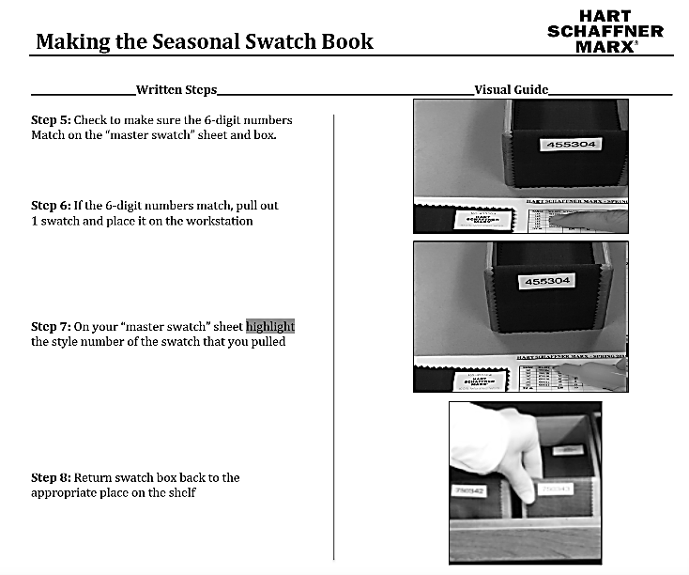

Source: Company files.

**Exhibit 2: Fire Drill Instructions**



Source: Company files.

**Exhibit 3: Cycle Counter Job Description**



Source: Company files.

**Exhibit 4: Instructions and Mock Interview Feedback Form for Candidates for Hart Schaffner Marx Positions**

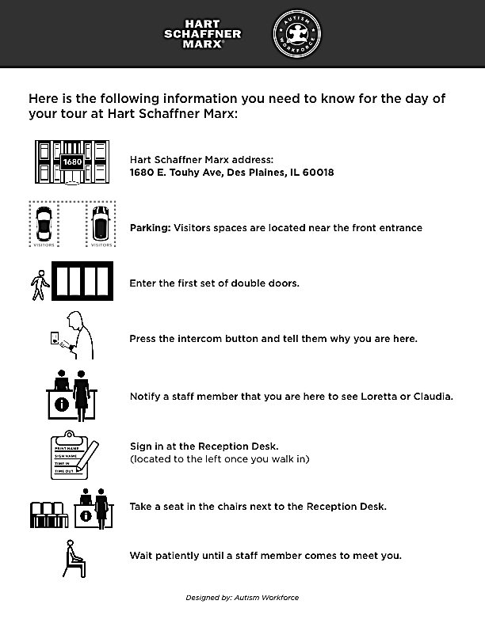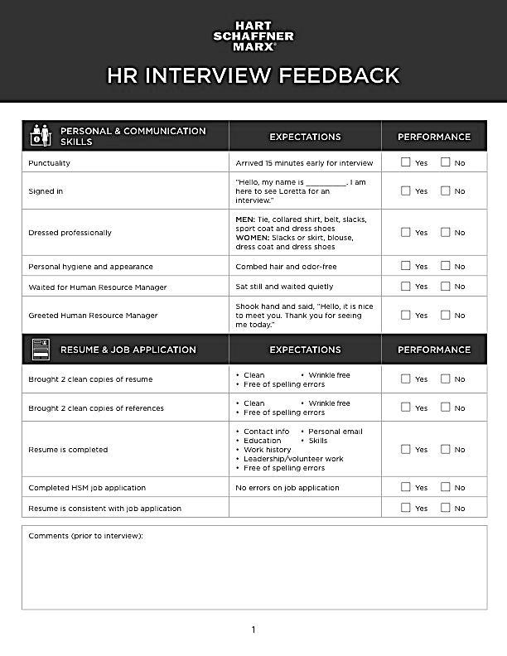

Note: HR = human resources

Source: Company files.

**Exhibit 5: Documents Describing hart schaffner marx’s Policies for New Hires**



Source: Company files.

**Exhibit 6: hart schaffner marx’s Leaving Your Worries at the Door Visual aid**

Designed as a wallet insert, to be folded over so that there is a front and a back.

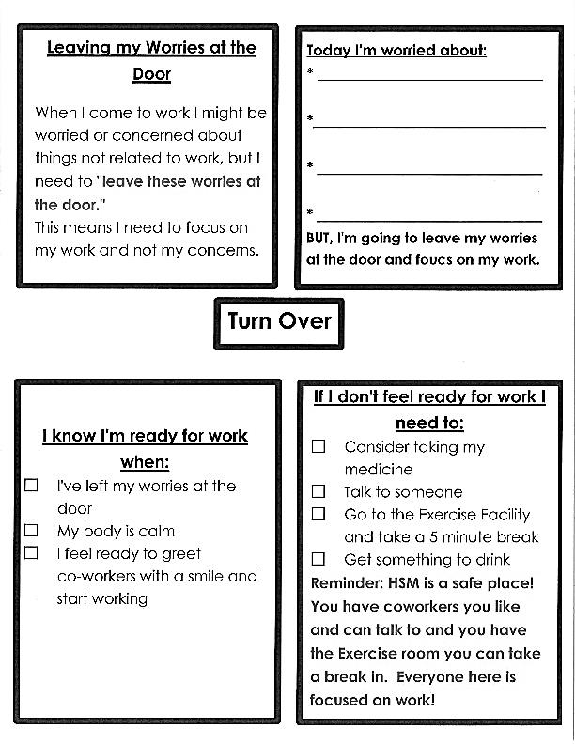

Note: HSM = Hart Schaffner Marx

Source: Company files.

1. Some people who have been diagnosed with autism prefer to be called “autistic people” while others prefer be called “people with autism.” Both labels can be justified by reasonable arguments. As a result of extensive consultation with others, including many people on the autism spectrum, this case consistently uses the term autistic people. No offence is intended to anyone who might use a different term. In discussing a case such as this one, we should strive to be sensitive, but we should also assume that discussion participants are well-intentioned; thus, we should not take offence to accidentally, awkwardly phrased expressions. The United Nations and others remind us also that our efforts to be protective of a presumed vulnerable population should not evolve into a condescending or, worse, disenfranchising stance. The autistic people described in this case are adults with ability and right to make their own decisions (e.g., to consent to participate and be identified in this case). Although we may be well-intentioned in doing so, it would be a violation of human rights to presume to make decisions for such adults, or to act as if they were incapable of making decisions on their own behalf.
2. As of April 26, 2018, the U.S. Centers for Disease Control and Prevention estimated the incidence of autism in the general population to be 1 in 59. According to many estimates, as many as 70 per cent of this population was unemployed or underemployed, and a roughly similar number lived below the poverty line. “Autism Spectrum Disorder (ASD),” Centers for Disease Control and Prevention, accessed October 8, 2018, www.cdc.gov/ncbddd/autism/data.html.
3. All currency amounts are shown in U.S. dollars.
4. J.E. Robison, “What is Neurodiversity?” *Psychology Today*, October 7, 2013, accessed October 8, 2018, www.psychologytoday.com/us/blog/my-life-aspergers/201310/what-is-neurodiversity.
5. A sometimes-repeated fallacy suggested that autistic people were not interested in social interaction, which was not correct. See, for example, Vikram K. Jaswal and Nameera Akhtar, “How to Meet Autistic People Halfway,” *New York Times*, July 13, 2018, accessed October 8, 2018, www.nytimes.com/2018/07/13/opinion/autism-social-life-new-research.html.
6. Autism was roughly four times more prevalent in boys. “Autism Spectrum Disorder (ASD),” op. cit.
7. Some information in this section is drawn from Robert D. Austin, Jonathan Wareham, and Javier Busquets, *Specialisterne: Sense and Details* (Boston, MA: Harvard Business Publishing, 2008). Available from Ivey Publishing, product no. 608109; Gary P. Pisano and Robert D. Austin, *SAP SE: Autism at Work* (Boston, MA: Harvard Business Publishing, 2016). Available from Ivey Publishing, product no.616042; Gary P. Pisano and Robert D. Austin, *Hewlett Packard Enterprise: The Dandelion Program* (Boston, MA: Harvard Business Publishing, 2016).
8. Both Palomino and Willer had master’s degrees, in special education and curriculum design, respectively, and both had worked as special education teachers with autistic students.
9. First names of participants in the HSM program have been used after the release of their names in the public domain—on the AW website, for example. If program participants’ names were not already public, aliases were employed, which are indicated with quotation marks around the name, see “Michael.” AW has confirmed that all participants whose true names are used have consented to being identified.
10. See “Jordan—A New Hire with the Autism Workforce Program,” Vimeo video, 3:25, posted by “Stephen Serio,” n.d., accessed October 8, 2018, https://vimeo.com/160533614.
11. See “Marice—A New Hire with the Autism Workforce Program,” Vimeo video, 2:40, posted by “Stephen Serio,” n.d., accessed October 8, 2018, https://vimeo.com/162197949.
12. See “Max—A New Hire with the Autism Workforce Program,” Vimeo video, 2:19, posted by “Stephen Serio,” n.d., accessed October 8, 2018, https://vimeo.com/162216545.