

9B18D001

Yangtzekiang Garment Group Company: Challenges and Opportunities in Transformation[1]

Professors Jianping Liang, Hubert Pun, and Jing Chen wrote this case solely to provide material for class discussion. The authors do not intend to illustrate either effective or ineffective handling of a managerial situation. The authors may have disguised certain names and other identifying information to protect confidentiality.

*This publication may not be transmitted, photocopied, digitized, or otherwise reproduced in any form or by any means without the permission of the copyright holder. Reproduction of this material is not covered under authorization by any reproduction rights organization. To order copies or request permission to reproduce materials, contact Ivey Publishing, Ivey Business School, Western University, London, Ontario, Canada, N6G 0N1; (t) 519.661.3208; (e)* [*cases@ivey.ca*](mailto:cases@ivey.ca)*;* [*www.iveycases.com*](http://www.iveycases.com)*.*

Copyright © 2018, Ivey Business School Foundation Version: 2018-01-17

In March 2015, shortly after the Spring Festival, Dr. Sui-Kau Chan, the founder and executive chairman of Yangtzekiang Garment Limited (YGM)—also known as the YGM Group—and YGM Trading Limited, drove from Hong Kong to make his early morning rounds of the factory in Panyu, Guangzhou. It was a job Chan still insisted on doing even though he was 89 years old. As usual, Ming Li, the factory director, and several department managers reported on what was going on in the factory. At the meeting, Li mentioned that, “it was very difficult to recruit employees although they had been actively working on recruiting after the Spring Festival. Apparently, it was insufficient to recruit a skilled worker with a ¥4,000–¥5,000[2] [US$640–$800] monthly salary.[3]”

China’s economy had been flourishing since the 1990s, but labour costs had also increased. Due to the global financial crisis in 2008 and the appreciation of the Chinese currency, the yuan renminbi, the quantity of orders was dropping. Since 2013, a nationwide shortage of workers had caused shoe factories, toy factories, and garment factories to gradually shrink. Because of improvements in hometown environments and higher living costs in large cities, more and more migrant workers were unwilling to leave their hometowns for work in the cities. Fewer workers and greater management challenges resulted in the closure of many factories in mainland China and made it difficult to maintain and operate the businesses that surrounded and supported them. In the context of this restructuring of labour-intensive economic activities in mainland China, Chan took time to consider how YGM could respond. The recent emergence of fast-fashion brands had made it necessary to consider how YGM Trading Limited could better implement its original brand manufacturer strategy by acquiring well-known brands and developing independent brands.

YGM, which Chan founded in 1949 with a mere 20 sewing machines, had grown into a prestigious original equipment manufacturer/original design manufacturer (OEM/ODM) garment manufacturer and global organization (see Exhibit 1). Production headquarters were in Hong Kong, and the business extended into mainland China and other countries in Asia. Its sales network extended globally. Chan had realized decades ago that it was unwise for the company to rely solely on factory production, and he had therefore founded YGM, which manufactured and marketed shirts with well-known brands (both licensed and self-owned) for Asian, European, and U.S. markets.

YGM Trading Limited was spun off from YGM in 1987, and it became a separately listed public company based in Hong Kong.[4] The company’s core businesses were garment wholesaling and retailing; its other businesses included garment manufacturing, property investment, and printing. While it had developed its apparel retail and wholesale businesses, YGM Trading Limited also actively grew a franchise business. At this point, YGM had a rich experience in brand management and had been very successful. However, Chan was facing both challenges and opportunities and was considering how to keep YGM and YGM Trading successful in the future.

The chinese Textile industry

The textile industry in China was labour-intensive and highly dependent on international sales. China was the largest producer and exporter of textiles and garments around the world. Compared with Europe, the United States, and other developed countries, its labour costs were low. In addition, the large scale of the textile industry helped companies take full advantage of economies of scale. The government of China had enacted special policies that encouraged garment companies to develop their own brands, and it had also encouraged upgrading rural market consumption and utilized policies to safeguard corporations’ lawful rights and interests. The government provided preferential tax policies and, in recent years, a public research and development design platform was utilized to provide talent, issue new financing, and encourage companies to use brands for mortgages or issuing bonds. The government also encouraged spinning industries from eastern China to develop in western China.[5]

According to data from the National Bureau of Statistics of China, the total market volume for clothing increased from ¥102 billion in 2004 to ¥702.2 billion in 2012, representing a 26.58 per cent average growth rate over this period, which was about 16 per cent higher than the gross domestic product (GDP) growth rate.[6] China’s garment industry went through a relatively long-term development process (see Exhibit 2). The third transformation of the global textile service industry in the 1980s resulted in China becoming a manufacturing centre, and the OEM model became the major business model for Chinese textile and garment companies. After the 1990s, with the maturation of the manufacturing technology used in the textile and garment industry, the business model had changed from OEM to a more advanced processing model: ODM.[7]

However, the industry was facing increasing costs. As a high-polluting industry, the textile industry in China was under increasing social pressure concerning pollution control and abatement. The public was beginning to demand that companies protect the environment, and the government intended to impose environmental pollution taxes. Hong Kong was also facing new operating challenges due to environmental concerns: developed countries were implementing environmental protection measures that formed a “green” barrier—a protective network for the global market. Green symbols provided permission for textile products to enter global markets, and textile printing and dyeing companies invested more in environmental protection.

The development of China’s economy and increasing household incomes also resulted in increasing labour costs. Migrant workers became more reluctant to leave their homes to work in big cities. At the same time, the implementation of labour laws in mainland China led to higher production costs in the textile industry.

As the textile industry was a traditional industry in Hong Kong, most companies paid little attention to research and development, which resulted in large gaps in relation to the global textile market in areas such as new fabric innovations. While the textile and garment industry was a relatively low-cost industry, policy incentives such as the government’s encouraging eastern spinning industries to develop in western China led to the establishment of many emerging garment companies attracted by high gross profits. Garment companies were suffering from potential threats, as the garment industry was a chaotic intellectual property-based industry with too many imitation and counterfeit products.[8] In addition, Britain’s intention to exit from the European Union (i.e., Brexit) and international turmoil were highly likely to affect companies’ profits.

**Recent Industry Statistics**

In terms of market size, China was the world’s largest producer, exporter, and consumer of textiles and garments. According to data from the National Bureau of Statistics of China, with the increase in income levels and an increase in the proportion of the Chinese population living in urban areas, China’s consumer market for apparel was expected to grow sustainably in the future.[9] In 2014, China’s large garment companies had produced clothing worth US$29.921 billion, with a year-on-year growth of 10 per cent.[10] Over the same period, China exported clothing and accessories worth about US$186.31 billion, representing an annual growth rate of 5.2 per cent (i.e., a 6 per cent decline from the previous year’s annual growth rate), and an average price of US$2.7 per piece (i.e., a 0.7 per cent annual price increase).[11] In terms of consumption, garment retail sales of the above-normal wholesale and retail trade totalled ¥8,935.8 billion, with a year-on-year growth of 9.24 per cent.[12] In terms of development prospects, the annual growth rates for per capita expenditures on clothing by urban and rural residents in China were 4.73 per cent and 12.47 per cent, respectively.[13] However, China’s per capita consumption on clothing was still at a low level, much lower than that of some developed countries (see Exhibit 3).

Middle- and High-end Consumption Trends

In 2014, domestic middle- and high-end consumption suffered from a recession in the industry and the macro economy. A decrease in shoppers in malls and increased costs contributed to a temperate decline of middle- and high-end consumption. At the same time, with the popularization of the Internet and WeChat, the traditional business model was replaced gradually by the online to offline business model.

Garment Industry Trends

The garment industry was trending toward two ends. The first trend was toward international fast-fashion brands (e.g., the big four fast-fashion brands—Zara, Uniqlo, GAP, and H&M). Compared with fashion leisure brands such as Baleno, which were in decline, the big four and other international fast-fashion brands were experiencing frenzied expansion in mainland China. Data showed that the top six fast-fashion brands (i.e., Zara, Uniqlo, GAP, H&M, C&A, and MUJI) opened one new retail store every two and a half days.[14] In 2014, fast-fashion brands opened 274 new stores in total, including 13 Uniqlo stores and nine H&M stores in Guangzhou.[15]

The other trend emphasized luxury goods. In recent years, the popular term “entry lux” was created to describe brands that had become the choice of white-collar consumers. These brands were affordable and fashionable. Moreover, with improved purchasing power, the top luxury brands had gradually become the main choice of a new wealthy class.

China’s textile industry was currently entering a decelerated growth stage. On March 4, 2015, the China National Textile and Apparel Council pointed to three main development characteristics that were present in the textile industry: decelerated growth, more pressure for development, and an urgent need for transformation.[16] First, the growth rate of China’s textile industry had slowed down. Second, China’s textile industry was under pressure, and differentiation was accelerating. The traditional production model was difficult to sustain, while the new production model was still in the process of formation. Therefore, for textile companies facing new challenges, a competitive scenario emphasizing survival of the fittest would intensify. Innovation would become the key to transforming production power. Under the terms of this new normal, the key to China’s textile industry was to promote transformation and upgrades. To promote the development of the whole industry, instead of investment-driven and materials-driven development, it was now more important to innovate and to develop new technologies and brands, as well as more efficient management, regulation, governance, and business models. Industry experts pointed out that, as garments were necessities, there was at least a fixed demand for textiles in the Chinese market. In 2015, it was predicted that the growth of Chinese textile sales would be at the level of the previous year (see Exhibit 4).[17]

Yangtzekiang Garment Limited

YGM was the largest multinational textile and garment corporation in Hong Kong. It operated under the names Yangtzekiang Garment Limited and Hong Kong Knitters, and was listed on Hong Kong’s public stock exchange in 1970. YGM Group’s business covered a wide array of activities, from spinning, weaving, dyeing, and finishing, to garment manufacturing and sales. While YGM also had an investment in electrolytic aluminum ingots, the principal activities of the group were manufacturing and sales of garments and textiles, provision of processing services, and rental of properties.[18] YGM’s textiles business included a wide line of products, including yarn, woven and knitted fabrics, and woven and knitted garments (e.g., men’s and women’s shirts, trousers, shorts, polo shirts, T-shirts, jackets, and knitted outerwear). YGM handled both ODM and OEM garment businesses as well as garment procurement, wholesaling, and retailing (see Exhibit 5).

YGM’s operations covered Southeast Asia, the United States, Italy, France, and the United Kingdom. With Hong Kong as its base, YGM branched out to China and other parts of the world. YGM set up sales offices and representatives in the United States, the United Kingdom, France, Singapore, Bangladesh, and China. Branch offices in China were set up in Guangzhou, Shanghai, and Beijing. The export business mainly targeted European, Japanese, and Southeast Asian markets. Production plants were in China and Southeast Asia. YGM grew into a global organization and had over 20,000 employees (see Exhibit 6) and more than 1,200 retail stores worldwide.

Besides Hong Kong and places where YGM had factories, YGM also had offices in Panyu (Guangzhou) and Shanghai, China, which took care of manufacturing needs and oversaw domestic sales in those regions.[19] The company had factories in Hong Kong, mainland China (in Wuxi, Panyu, and Guigang), Bangladesh, Cambodia, Malaysia, Macao, and other regions. Its headquarters in Hong Kong oversaw sales and the overall management of the group, including its manufacturing facilities in China, Bangladesh, India, Cambodia, Myanmar, and Vietnam. It also monitored and supported YGM’s subcontractors in China and abroad.

YGM had wholly owned production plants in Panyu (Guangzhou), China. These production plants included Exquisite Knitters (Guangzhou) Ltd. (EQK); Whampoa Garment Mfg. (Guangzhou) Co. Ltd. (WGM); and Guangzhou Top Yield Garment Ltd. EQK and WGM were compliance plants that focused on the production of high-end clothing. YGM also had a 49 per cent share in Wuxi Talak Investment Co. Ltd., (Wuxi Talak Group), a jointly controlled entity that owned several textile-related companies in Wuxi, China, including Wuxi Changxin Textile Co. Ltd., Wuxi YGM Textile Co. Ltd., and Wuxi Yangtzekiang Textile Co. Ltd. (collectively the Wuxi Talak Group). The core business of the Wuxi Talak Group was the production of medium- to high-end yarns.[20]

Current Performance

According to Tonghuashun Finance, YGM Group’s revenue and pre-tax profits dropped considerably from 2012 to 2016 (see Exhibit 7). YGM Group’s five-year gross profit rate remained relatively steady, but the net profit rates fell between 2012 and 2016 (see Exhibit 8). Data for the textile and garment industry overall in China in the first half of 2016 (see Exhibit 9) indicated that sales incomes had been continuously reduced over the past five years (from 2012–2016). Even though YGM Group’s gross profit for fiscal year (FY) 2015–16 had increased, it was far less than that of the domestic garment industry (i.e., 28.55 per cent less), which implied that YGM Group’s costs were far higher than average costs in the industry. YGM Group’s net profit rate had continued to decline over the past five years, especially in FY 2014–15, which had a negative profit. Although the company was profitable in FY 2015–16, its net profit rate was only 0.5 per cent, compared with an industry net profit rate of 9.72 per cent—a huge gap.

In terms of costs, YGM Group’s sales costs rate was lower than the overall industry rate of 10.29 per cent in FY 2015–16 (see Exhibit 10), which indicated that, as a well-established garment manufacturing company, YGM Group had competitive advantages in its sales channels. However, compared with previous years, its overhead costs rate (see Exhibit 11) was higher than both its rate for previous years and the overall industry rate of 6.20 per cent.

Domestic Environment[21]

YGM’s aggressive innovation always caught the industry’s attention. Chan noted that he was the first to produce ready-to-wear suits that met international standards:

According to the traditional concept of suits production, each suit is customized by the tailor and then [sewn] as the whole suit. While I separated parts of suit to produce, Hong Kong men could follow the pattern of Europe and the United States, buying right away after trying [it on for the] first time. My masterpiece is the three-piece suit, which was most popular in Hong Kong. Hong Kong’s suits and Italian suits were well-known as the international style and the most exquisite clothing in the world because there were several exquisite Shanghai tailor masters in workmanship, and several excellent Guangdong masters with consummate tailoring skills who [were] updating [their] styles constantly. What’s more, with the decades of accumulated experience, the art of Hong Kong suits were [at] the world-class level.[22]

In the 21st century, facing opportunities and challenges from the rapid development of science and technology and intensifying competition from economic globalization, Hong Kong had evolved into a high-value-added economy, and the Hong Kong textile industry could no longer be rigid.

The company evolved from a family-owned textile business by establishing YGM’s own Doctor brand, exporting its products to the Middle East, the Caribbean, and other developing regions, and setting up factories in Macao to take advantage of the Portuguese colony’s duty-free market. After 1959, American markets began to purchase Asian goods, and YGM captured the European and U.S. markets in 1969.

The improvement of the economic environment in mainland China in recent years resulted in increased labour and insurance costs. In addition, the appreciation of the Chinese yuan renminbi led to a decline in the number of orders. As a consequence, Chan considered expanding into new businesses. At that time, a friend who had won an agricultural award indicated that he could supply large quantities of duck down to YGM Group each year. Chan thus decided to open a new duck down business—a field that had recently seen high market demands. His old friend Li Feng helped in sales channels. Chan said, “The business of producing a duck down jacket is equivalent to producing three pants, and the quality is an important factor. I have confidence to produce duck down jackets and expand business for the new products.”[23]

YGM had a long history of delivering excellent product quality; its traditional approach, Cantonese-style products, and its value connotations matched current Chinese consumers’ new consumption concepts. In mainland China, the medium- and high-end clothing markets were mostly captured by Uniqlo, Zara, H&M, and other fast-fashion brands, and domestic brands were in a weak position. This situation provided good opportunities for the emergence of high-end domestic clothing brands.

International Environment

Globalization helped multinational companies to manufacture and sell globally, reduce costs, and increase sales. However, economic globalization also had disadvantages that led to new issues, including fluctuating currency exchange rates and unfair competition caused by international tax treaties. The impacts of diverse economic and political backgrounds in various countries also led to losses for some companies.

Regarding currency fluctuations, since YGM Group’s main business operated in Europe and the United States, and accounts were settled mainly in Hong Kong dollars, U.S. dollars, euros, pounds sterling, and Chinese yuan renminbi, the devaluation of the euro and the pound had a serious impact on YGM’s export business. In 2016, the exchange rates for euros and pounds fell sharply because of Britain’s plan to exit from the European Union. In addition, the fluctuation of exchange rates may have put YGM Group under greater economic risk, business risk, and accounting risk.

Due to international tax treaties and taxation exemptions regarding China’s imports of yarn from Southeast Asia and South Asia, during 2014–15, YGM Group’s yarn manufacturing business had to pay taxes when importing cotton, which weakened the competitiveness of YGM’s manufacturing group. It was inevitable that YGM would be placed in a poor financial situation. In terms of economic and political impacts, if other countries had high inflation, YGM’s net income would decline; and if industries were nationalized in other countries, this nationalization might pose a risk to YGM.

After the financial crisis, from 2009, a labour shortage emerged in the developed areas on the coast of China. In recent years, this issue had been highly damaging to labour-intensive industries that manufactured toys, footwear, and textiles, including YGM Group. The company’s factory in Bangladesh was in good condition, and the benefit of the demographic dividend had not been demonstrated in its factory in Myanmar, which was in the early stages of construction. However, the main production plants were located in Panyu and Guigang in the Pearl River Delta, which suffered from the labour shortage. The Panyu factory was most affected. Because it was too difficult to recruit skilled workers, the Panyu factory had to reluctantly decline some orders, and could rely only on high-end, urgent, and small orders. Therefore, YGM Group’s garment business was in insufficient production.[24]

Manufacturing in China had always taken advantage of lower prices as a competitive advantage; however, with the appreciation of the Chinese yuan renminbi, foreign currencies were in a weak position. Compared with the national corporations in Southeast Asian and South Asian countries, Chinese textile enterprises, including YGM Group, had lost the advantage of low prices for their OEM and ODM businesses.

Due to the financial crisis in 2008, European and U.S. markets had weakened, and market demand had declined. (The demand for high-end garments had decreased significantly.) Garment orders from abroad had been reduced sharply and the profit margin of companies had been further squeezed. Furthermore, major developed countries had again recognized the strategic significance of the manufacturing industry and had implemented re-industrialization strategies: The United States had proposed a U.S. manufacturing industry action plan,[25] and Europe had launched a “Factories of the Future” plan.[26] These countries were looking for new technology and innovation strategies to support the development of their manufacturing industries, which also forced China’s textile industry to transform and upgrade. Moreover, higher production costs had resulted from rapid economic development in China; the appreciation of the Chinese yuan renminbi; and increasing costs for labour, raw materials, energy, and other production inputs. According to *Made in China 2025*,[27] because China had lost its advantage of lower labour costs, global manufacturing industries were moving to Southeast Asia, South Asia, and Africa, where production costs were lower. Since the improvement of labour productivity and the energy advantages in the United States and other developed countries, the manufacturing business of multinational companies presented a trend of accelerated back-flow toward developed countries.[28]

YGM Trading Limited

YGM originally manufactured shirts for local markets and exported products to Europe and the United States. At the beginning of the 1960s, it expanded to also produce trousers and suits. In 1970, YGM was listed on the Hong Kong Stock Exchange (now Hong Kong Exchanges and Clearing Limited). In the 1970s, it established retail outlets in Hong Kong, Macau, Taiwan, Singapore, and Malaysia. In 1987, YGM Trading Limited was established as a separately listed public company based in Hong Kong. YGM Trading developed an apparel retail and wholesale business and distributed a wide range of men’s and women’s wear for many world-renowned brands. It also licensed and acquired internationally recognized brands. The Chan family held controlling shares in YGM Trading Ltd., which had a close relationship with YGM Group.[29]

Business Development

YGM Trading had a network of more than 800 retail outlets throughout Hong Kong, Macau, China, Taiwan, Southeast Asia, and Europe. YGM had been actively developing the Greater China market for the past 10 years and had established retail outlets in major cities such as Beijing, Shanghai, and Guangzhou and expanding this network to many smaller cities. YGM now had more than 200 outlets operating in China, and the company expected to grow further in core and developing cities.[30]

YGM Trading also actively developed a franchise business and distributed many world-renowned brands (e.g., Michel René Ltd., Aquascutum Limited of London, Guy Laroche and Charles Jourdan of Paris, Ashworth and Hang Ten of the United States, J. Lindeberg from Stockholm, and Harmont & Blaine from Italy). YGM Trading opened more than 200 stores in Hong Kong, Macau, Taiwan, and mainland China for the Michel René brand.[31]

During 1950–1952, Chan developed the Doctor brand, which became fashionable in South Asia. In the 1970s, he introduced the American jeans brand Wrangler to China. Meanwhile, Michel René was developed as a store brand and was positioned in the market as a “fast suit” brand. Recently, YGM had launched a casual-wear series to offer tasteful, high-end workwear separates for urban office workers, professionals, and executives. Clients were attracted by the brand’s exquisite tailoring and careful choice in materials. The company also invited well-known personalities to endorse its brands to increase awareness of the brands.[32]

In 2008, the first time that Beijing hosted the Olympic Games, the Michel René, Aquascutum, and Ashworth brands launched limited-edition premium lines for three sporting events, aimed at celebrating the Olympic Games with gorgeous, practical, and cheerful characteristics.[33]

YGM Trading focused on middle- and high-end brands (see Exhibit 12). YGM Group had three acquired brands: Aquascutum, Michel René, and Guy Laroche, while Ashworth was an agent brand and J. Lindeberg was a dealer brand.[34] Based on the sales from March 31, 2015 to March 31, 2016, Aquascutum and Ashworth were the main beneficiaries of the company, and both brands’ sales together accounted for 95 per cent of the total sales.[35]

Dr. Sui-Kau Chan[36]

Personal Influences

Chan served as a member of the eighth and ninth terms of the Chinese People’s Political Consultative Conference, until he reached retirement age. Chan was an honorary citizen of Dongguan, Foshan, Guangzhou, and Wuxi (Jiangsu). He was also the former chairman of the Clothing Industry Training Authority (1986–1997), the founding chairman (1988–1994) and then honorary chairman of the Textile Council of Hong Kong, the former president (1977–1988) and then life honorary president of the Federation of Hong Kong Garment Manufacturers, the honorary president of the Hong Kong Woollen & Synthetic Knitting Manufacturers’ Association (since 1980), and a former member of the Textile Advisory Board of Hong Kong (1971–1987) and the Hong Kong Labour Advisory Board (1985–1995). In 2013, Chan was awarded Industrialist of the Year from the Federation of Hong Kong Industries.

Charity Involvement

Chan was renowned for his charity at home and abroad. He was committed to participating in charity work and strongly supported and promoted education in Hong Kong and mainland China. Chan and the Chan family set up several charitable funds, including the Chan Yuqing Family Charity Fund and the Chan Yin Chuen Charitable Donation Funds.

Decisions

Facing the worker shortage in China, the appreciation of the Chinese currency, increasing labour costs and other costs, and the transformation of the industry, Chan brainstormed about how he could lead YGM forward and how innovation and transformation of traditional industries could help YGM to create a brilliant future in adversity.

Jianping Liang is a professor at Sun Yat-sen Business School, Sun Yat-sen University. Jing Chen is a professor at Dalhousie University.

This case was funded by the National Natural Science Foundation of China (grant no. 71102099, 71672201, 71331004, and 71671081), and the Chan Sui-Kau Asian-Pacific Case Development and Research Center at Sun Yat-sen Business School, Sun Yat-sen University.

**Exhibit 1: YGM Group’s Organizational Structure**

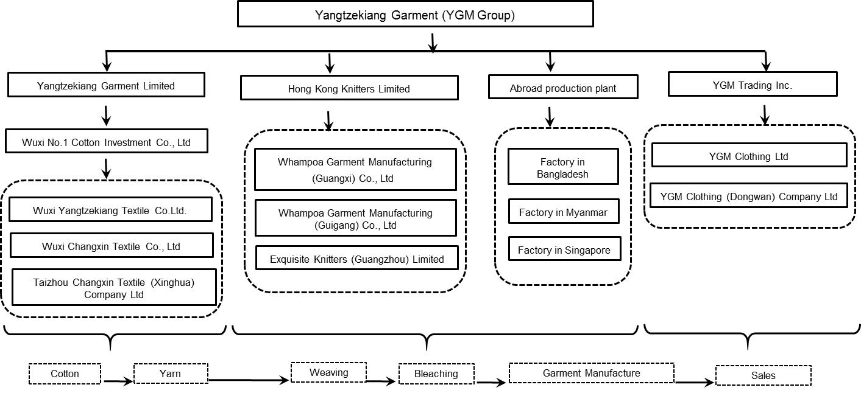

Source: “Whampoa Garment (Guangzhou) Co., Ltd,” accessed November 25, 2017, https://www.tianyancha.com/company/2345218905; “Hong Kong Knitters Limited,” accessed November 25, 2017, https://www.tianyancha.com/company/1212969758.

**Exhibit 2: The Development Process of China’s Garment Industry since the 1980s**

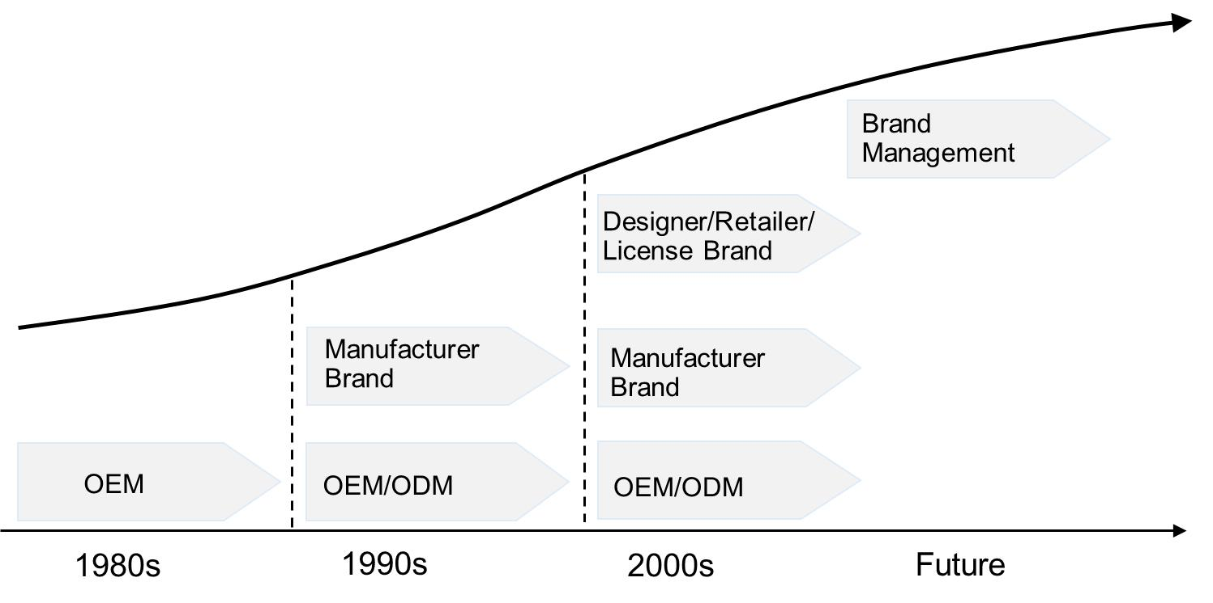

Note: OEM = original equipment manufacturer; ODM = original design manufacturer

Source: Business Information Network, “Development of China’s Garment Industry [in Chinese],” June 10, 2014, accessed November 2, 2017, www.askci.com/news/201406/10/1014405640105.shtml.

**Exhibit 3: Per capita expenditures on Clothing globally and for selected countries, 2010–2014 (in US$)**

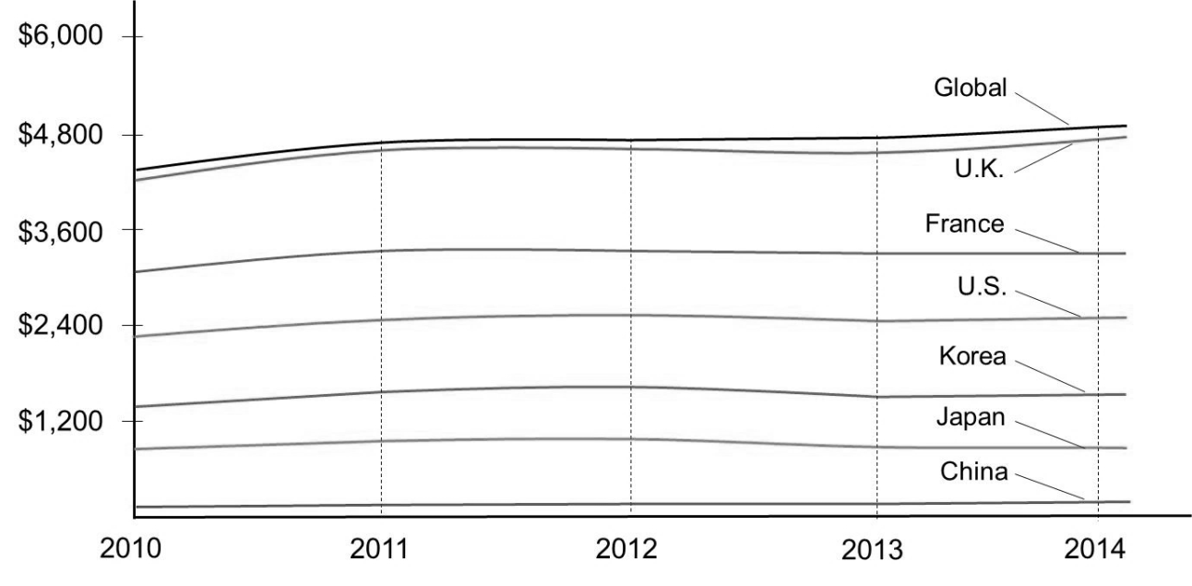

Source: “2016 China Garment Industry Status and Development Trend Prediction [in Chinese],” May 13, 2016, accessed November 20, 2017, www.chinaidr.com/tradenews/2016-05/95655.html.

**Exhibit 4: Growth Rates of Chinese National Textile and Garment Exports,**

**June 2015–February 2016**

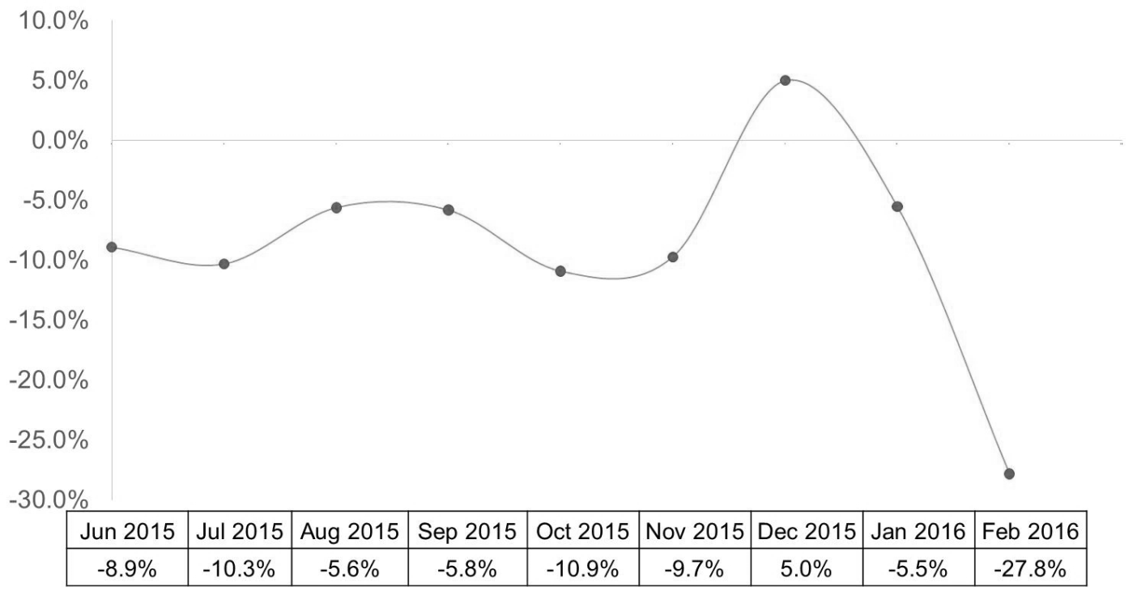

Source: “2015 China Textile Garment B2B Industry Development Report [in Chinese],” May 30, 2016, accessed November 20, 2017, www.ailab.cn/view/20160530189.html.

**Exhibit 5: history of YGM, 1926–2015**

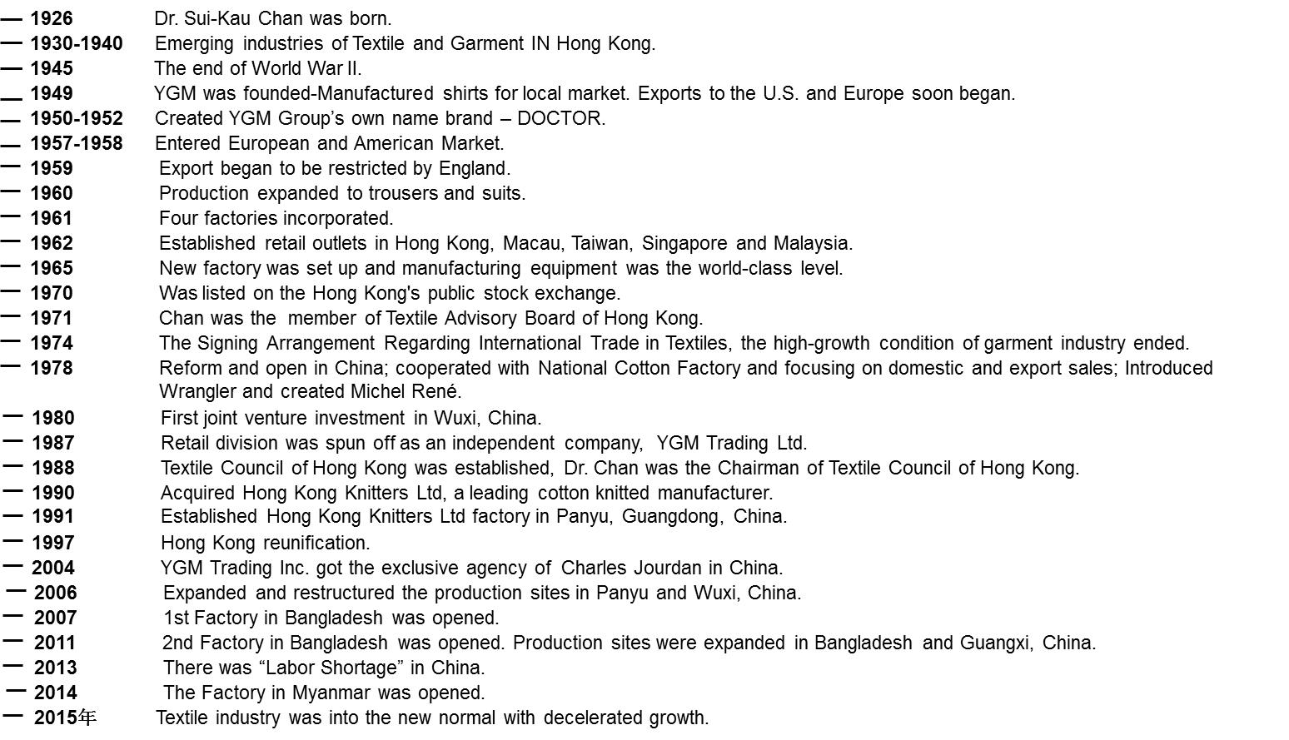

Source: Yangtzekiang Garment Limited, “About YGM,” accessed November 25, 2017, [www.ygm.com.hk/index.php/en/about-ygm](http://www.ygm.com.hk/index.php/en/about-ygm); “Yangtzekiang Garment Group Company,” accessed November 25, 2017, https://baike.baidu.com/item/%E9%95%BF%E6%B1%9F%E5%88%B6%E8%A1%A3%E9%9B%86%E5%9B%A2.

**Exhibit 6: number of employees and changes in business income of YGM Group, 2012–2016**



*Source:* Yangtzekiang Garment Limited, 2012–2016 Annual Reports: Yangtzekiang Garment Limited, accessed November 25, 2017, www.ygm.com.hk/index.php/en/investor-relations/financial-report-2.

**Exhibit 7: YGM Group’s revenue and pre-tax profits, 2012–2016**



Source: Yangtzekiang Garment Limited, 2012–2016 Annual Reports: Yangtzekiang Garment Limited, accessed November 25, 2017, www.ygm.com.hk/index.php/en/investor-relations/financial-report-2.

**exhibit 8: YGM Group’s Five-year gross and net profit rates, 2012–2016**



Source: Yangtzekiang Garment Limited, 2012–2016 Annual Reports: Yangtzekiang Garment Limited, accessed November 25, 2017, www.ygm.com.hk/index.php/en/investor-relations/financial-report-2.

**Exhibit 9: Data for textile and garment industry in China in first half of 2016**

|  |  |  |  |  |  |
| --- | --- | --- | --- | --- | --- |
|  | **Year-on-Year Growth of Sales Income (%)** | **Gross Profit Rate (%)** | **Net Profit Rate (%)** | **Sales Costs Rate (%)** | **Overhead Cost Rate (%)** |
| Textile and Garment Industry | 8.73 | 28.55 | 9.72 | 10.29 | 6.20 |

Source: OUZI Industry Data Report on Garment Industry, accessed November 25, 2017, www.olxoz.com/index.php/rsr/list?catalog=442.

**Exhibit 10: YGM Group’s Sales Costs Rate, 2012–2016**



Source: Yangtzekiang Garment Limited, 2012-2016 Annual Reports: Yangtzekiang Garment Limited, accessed November 25, 2017, www.ygm.com.hk/index.php/en/investor-relations/financial-report-2; OUZI Industry Data Report on Garment Industry, accessed November 25, 2017, www.olxoz.com/index.php/rsr/list?catalog=442.

**Exhibit 11: YGM Group’s Overhead Costs Rate, 2012–2016**



Source: Yangtzekiang Garment Limited, 2012–2016 Annual Reports: Yangtzekiang Garment Limited, accessed November 25, 2017, www.ygm.com.hk/index.php/en/investor-relations/financial-report-2; OUZI Industry Data Report on Garment Industry, accessed November 25, 2017, www.olxoz.com/index.php/rsr/list?catalog=442.

**Exhibit 12: YGM Group’s sales for different brands, 2015–2016**

|  |  |  |  |  |  |  |  |  |  |  |  |  |
| --- | --- | --- | --- | --- | --- | --- | --- | --- | --- | --- | --- | --- |
|  | **Number of POSs by Geographical Locations as at March 31** | | | | | | | | | | | |
|  | **Mainland China** | | **Hong Kong** | | **Macau** | | **Taiwan** | | **Europe** | | **Total** | |
|  | **2016** | **2015** | **2016** | **2015** | **2016** | **2015** | **2016** | **2015** | **2016** | **2015** | **2016** | **2015** |
| Aquascutum | 110 | 135 | 10 | 12 | 4 | 4 | 26 | 26 | 12 | 14 | 162 | 191 |
| Ashworth | 40 | 42 | 11 | 12 | 6 | 5 | 7 | 8 | – | – | 64 | 67 |
| J.Lindeberg | – | – | 7 | 6 | 3 | 3 | – | – | – | – | 10 | 9 |
| Michel Rene | – | – | 1 | 3 | – | – | – | – | – | – | 1 | 3 |
| Guy Laroche | – | – | – | – | – | – | – | – | 1 | 1 | 1 | 1 |
| Total | 150 | 177 | 29 | 33 | 13 | 12 | 33 | 34 | 13 | 15 | 238 | 271 |

Note: POSs = point of sales stores

Source: YGM Trading Ltd., *2016 Annual Report*, accessed November 25, 2017, www.ygmtrading.com/tc/images/pdf/c-Annual%20Report%202015-16.pdf.

**ENDNOTES**

1. This case has been written on the basis of published sources only. Consequently, the interpretation and perspectives presented in this case are not necessarily those of Yangtzekiang Garment Group or any of its employees.
2. ¥ = CNY = Chinese yuan renminbi; ¥1.00= US$0.16 as of March 31, 2015; all currency amounts are in ¥ unless otherwise specified.
3. Zhimin Huang, “2015 First Half Year South China Garment Industry Data Analysis [in Chinese],” North East News website, July 20, 2015, accessed November 20, 2017, www.askci.com/news/chanye/2015/07/20/162827dp0c.shtml.
4. Yangtzekiang Garment Limited, “About YGM,” accessed November 2, 2017, www.ygm.com.hk/index.php/en/about-ygm.
5. Baidu Encyclopedia, “Textile Industry [in Chinese],” accessed November 2, 2017, https://baike.baidu.com/item/%E7%BA%BA%E7%BB%87%E4%B8%9A.
6. Business Information Network, “Development of China’s Garment Industry [in Chinese],” June 10, 2014, accessed November 2, 2017, [www.askci.com/news/201406/10/1014405640105.shtml](http://www.askci.com/news/201406/10/1014405640105.shtml).
7. Ibid.
8. “Garment Industry: More Pain than Pleasure. Where Is the Pain in the Industry Transformation [in Chinese],” October 8, 2016, accessed November 20, 2017, http://news.winshang.com/html/059/4219.html.
9. “2015 Garment Industry Market Size Prediction [in Chinese],” December 23, 2015, accessed November 20, 2017, www.chyxx.com/industry/201512/372177.html.
10. Yuanpan, “2014 China Garment Industry Statistic Analysis [in Chinese],” February 4, 2015, accessed November 20, 2017, www.askci.com/news/chanye/2015/02/04/171341gs6x.shtml.
11. China Textile Import and Export Chamber of Commerce, “2014 China Garment Export Outline [in Chinese],” February 12, 2015, accessed November 20, 2017, www.texindex.com.cn/Articles/2015-2-12/327711.html.
12. “2017 China Garment Industry Development Status, Market Competition, Market Supply and Demand Analysis [in Chinese],” December 13, 2016, accessed November 20, 2017, www.chyxx.com/research/201612/476889.html.
13. “China Garment Retail Industry Market Development Trend and Investment Prediction Report [in Chinese],” [www.proresearch.org](http://www.proresearch.org), September 5, 2016, accessed November 20, 2017, www.cntrades.com/b2b/guanyan123/sell/itemid-98189010.html.
14. Jiayan, Ou, “Two and a Half Day for One New Store—Fast Fashion Brands Enter 2nd- and 3rd-Tier Markets against the Trend [in Chinese],” *Daily Economic News*, October 25, 2013, accessed November 20, 2017, http://business.sohu.com/20131025/n388875262.shtml.
15. “Fast Fashion Brands Opened 274 Stores in China Last Year While Baleno and Many Brands Closed Stores [in Chinese],” May 14, 2015, accessed November 20, 2017, http://news.winshang.com/html/047/8548.html.
16. *China News*, “Three Main Development Characteristics for China’s Textile Industry,” March 4, 2015, accessed November 20, 2017, http://finance.chinanews.com/cj/2015/03-04/7100681.shtml.
17. Ibid.
18. Yangtzekiang Garment Limited, “About YGM,” accessed November 3, 2017, [www.ygm.com.hk/index.php/en/about-ygm](http://www.ygm.com.hk/index.php/en/about-ygm); Yangtzekiang Garment Limited, *10/11 Annual Report: Yangtzekiang Garment Limited*, 2011, accessed November 3, 2017, [www.ygm.com.hk/images/upload/English/E%201011%20ANNUAL%20REPORT.pdf](http://www.ygm.com.hk/images/upload/English/E%201011%20ANNUAL%20REPORT.pdf).
19. Yangtzekiang Garment Limited, About YGM,” op. cit.
20. Yangtzekiang Garment Limited, *08/09 Annual Report: Yangtzekiang Garment Limited*, 2009, accessed November 3, 2017, www.ygm.com.hk/images/upload/English/E%20Annual%20Report.pdf.
21. Tianyi Zheng, *Family Affection*, ed. Qiuquan Wu and Jixuan Hu (Hong Kong: Chan Sui-Kau Family Foundation, 2015).
22. Ibid.
23. Ibid.
24. Yangtzekiang Garment Limited, *14/15 Annual Report: Yangtzekiang Garment Limited*, 2015, accessed November 3, 2017, www.ygm.com.hk/images/upload/English/E%201415%20Annual%20Report.pdf.
25. Xinhua Website “Obama Calls for Returning to US—The Second Spring for American Manufacturing Industry? [in Chinese],” April 3, 2013, accessed November 20, 2017, http://finance.qq.com/a/20130403/002906.htm.
26. Sky Sea Internet Research Institute, “European Union’s Factories of the Future Plan,” May 19, 2016, accessed November 20, 2017, http://blog.sina.com.cn/s/blog_16031ae190102wldi.html.
27. State Council of China, “Made in China 2025,” 2015, accessed November 20, 2017, www.gov.cn/zhengce/content/2015-05/19/content_9784.htm.
28. Ibid.
29. YGM Trading Ltd., “Company Overview,” accessed November 6, 2017, www.ygmtrading.com/eng/about.htm.
30. Ibid.
31. “MICHEL RENE,” accessed November 20, 2017, https://baike.baidu.com/item/%E9%A9%AC%E7%8B%AE%E9

    %BE%99.
32. Zheng, op. cit.; YGM Trading Ltd., *2016-06-29 Annual Report*, accessed November 20, 2017, www.ygmtrading.com/tc/

    images/pdf/c-Annual%20Report%202015-16.pdf
33. “YGM Trading Company,” accessed November 20, 2017, https://baike.baidu.com/item/YGM%E8%B4%B8%E6%98%93%

    E6%9C%89%E9%99%90%E5%85%AC%E5%8F%B8.
34. YGM Trading Ltd., “2016-06-29 Annual Report,” op. cit.
35. Ibid.
36. Zheng, op. cit.