|  |  |
| --- | --- |
|  | **logo_greyscale** |

9B18D002

Jiuzhai Valley National Park: Data-Driven Economic Growth and Ecological Preservation

H. Brian Hwarng and Jianhua Ran wrote this case solely to provide material for class discussion. The authors do not intend to illustrate either effective or ineffective handling of a managerial situation. The authors may have disguised certain names and other identifying information to protect confidentiality.

*This publication may not be transmitted, photocopied, digitized, or otherwise reproduced in any form or by any means without the permission of the copyright holder. Reproduction of this material is not covered under authorization by any reproduction rights organization. To order copies or request permission to reproduce materials, contact Ivey Publishing, Ivey Business School, Western University, London, Ontario, Canada, N6G 0N1; (t) 519.661.3208; (e)* [*cases@ivey.ca*](mailto:cases@ivey.ca)*; www.iveypublishing.ca. Our goal is to publish materials of the highest quality; submit any errata to publishcases@ivey.ca. i1v2e5y5pubs*

Copyright © 2018, National University of Singapore and Ivey Business School Foundation Version: 2022-09-15

In January 2014, while speaking at an international event, the director general of the Jiuzhai Valley Scenic Area Management Bureau (the Bureau), Charles Goh, discussed a “good” problem that he was facing. Since 2000, Jiuzhai Valley National Park (Jiuzhai Valley), located in China’s Sichuan province, had seen its tourist arrivals grow 24 per cent on average every year.[[1]](#footnote-2) This success was driven largely by the valley’s excellent reputation and comprehensive facilities in the vicinity. As transport became more advanced and convenient, the valley had seen an even larger increase in visitor numbers since 2008 (see Exhibit 1). However, due to the park’s remote location and cold temperatures in winter, tourism showed distinct peak and lull seasons; for example, the number of daily visitors could range from a mere 400 in January 2014 to over 40,000 in October 2014. In 2015, over 5 million tourists had visited. In light of this rapid growth, the Bureau needed to examine several areas of development, and Goh needed to devise an effective mechanism to regulate the tourist flow.

After the peak season in 2016, Goh reflected on the situation. As the top tourist destination in its vicinity, Jiuzhai Valley had a direct bearing on the economy of the whole area (see Exhibit 2). While this economic growth was important, developing a sustainable management model that would help preserve the valley’s ecological environment was essential. How could the Bureau balance conservation and development?

THE SOUL OF JIUZHAI VALLEY

Jiuzhai Valley was located in Jiuzhaigou County, Aba Tibetan and Qiang Autonomous Prefecture (Aba), Sichuan Province. Jiuzhai Valley Nature Reserve covered an area of 643 square kilometres. The valley had spectacular landscapes, and its high-altitude lakes, multi-layered waterfalls, colourful forests, snow-capped mountains, and blue ice, along with its visible examples of Tibetan culture, were esteemed as the six unique treasures of Jiuzhai. The valley also enjoyed rich biodiversity, and was home to some rare and precious species, such as the giant panda and Sichuan golden monkey.

In 1992, a team of UNESCO[[2]](#footnote-3) officials visited Jiuzhai Valley, declaring it a UNESCO World Heritage Site. For further protection, Jiuzhai Valley was designated as a state-level nature reserve in 1994. In 2004, it was named a national geological park in an effort to preserve its geological features. One of Jiuzhai Valley’s most beautiful features was its natural water flow system, which consisted of lakes and beaches with travertine deposits, pools, waterfalls, karst water systems, and streams both above and beneath the ground, running from an altitude of 3,070 metres to 2,200 metres. In this way, water was the soul of Jiuzhai Valley.

MAINTENANCE AND STANDARDIZATION

Every morning, before Jiuzhai Valley opened its gates to visitors, over 300 cleaners had already begun their work at different locations in the park, cleaning footpaths and other tourist facilities.[[3]](#footnote-4) Cleaning jobs were classified into different “standards,” each with corresponding quantitative indicators, requirements on quality, working time, aesthetics, and standard operating procedures (SOPs). For example, the SOP for lawn cleaning required that no damage be done to the flowers, trees, or grass, while the cleaning of litter containers followed a meticulous process of dust removal, cleaning with water, wiping, and changing of litter bags. Because of these processes, even the park’s litter containers were almost spotlessly clean. Keeping the park in pristine condition was one of the Bureau’s top priorities.

Cleaning practices in the park followed a high standard and were evaluated with a key indicator: the density of visible litter and stains (see Exhibit 3). For instance, in areas with a Class 1 cleaning standard, no more than one piece of litter was to be visible within a radius of three metres, and any piece must be cleaned away within one minute. Cleaning in the park was managed at three levels: cleaning staff, “protection stations,” and sub-valleys. There were seven protection stations in the park, covering the three sub-valleys (i.e., Shuzheng Valley, Rize Valley, and Zechawa Valley). Each station was led by a senior cleaning manager, and the maintenance of each sub-valley was led by a deputy director of the Protection Department. Visiting international research collaborators often commented that Jiuzhai Valley was the cleanest and the best-maintained park they had visited in China.

Besides cleaning, ecological preservation and forest fire prevention were important tasks for Jiuzhai Valley staff. The Bureau required organization-wide participation in environmental protection and adaptive cleaning operations, and encouraged every staff member to help protect the environment, safeguard security, and improve services in the park.

Cleaners were usually the first park employees that tourists met upon entering the park, which meant these workers were crucial in shaping tourist satisfaction. Most of Jiuzhai Valley’s cleaners were contracted and did not hold officially budgeted posts, but they were entitled to the rights and benefits provided in the Labour Law of the People’s Republic of China. Moreover, the cleaners were carefully selected and recruited. In fact, only 10 per cent of applicants for these positions made it to employment. After being recruited, cleaners received one week of pre-job training, which included knowledge of Mandarin and basic conversational English. Requirements were even stricter for those workers responsible for cleaning the park’s water-free toilets (see Exhibit 4).

During a day’s work, Jiuzhai Valley’s cleaners might encounter a wide variety of challenging situations. For example, some tourists may have left the footpath and entered a protected vegetation zone, or come too close to the streams or lakes; some might even have put their hands or feet in the water, or tried to feed the fish or wild animals. In such cases, the cleaners were responsible for reminding tourists of the rules in the park and dissuading them from these harmful behaviours.

After 4:00 p.m., when tourists started to leave the park, the cleaners would prepare for their final cleaning tasks of the day. They would collect and neatly stack all bagged litter at predetermined locations for pickup (according to SOPs), and toilet cleaners would do the same with the waste buckets from the park’s water-free toilets. For toilets located in more remote places in the park, the workers needed to carry these waste buckets one to two kilometres to reach the predetermined drop-off locations. All litter and human waste materials were transported to and treated at the Jiuzhaigou County Waste Treatment Plant.

Maintaining Jiuzhai Valley required many hours of arduous work, and often involved working in severe weather conditions, including intense sunlight, heavy rain, and freezing temperatures. As tourist arrivals grew and the demand for tourist services rose, the park’s management realized that it was imperative to nurture diligent entry-level managers and technical staff.

Because Jiuzhai Valley recruited a large number of contracted workers, the Bureau introduced ISO9001 and ISO14001 in 2001 and ISO18001 in 2005 to assure the quality of its environmental maintenance and tourist services. Based on such international standards, as well as national and industrial standards, the Bureau adopted a tourism standard system for Jiuzhai Valley in 2009. The China National Tourism Administration designated Jiuzhai Valley as one of the places to pilot standardization of tourism management in 2010, and as a model park in 2011. In the same year, the Bureau set up a Standardization Office to manage the standards for all jobs in the park. Standards for each job were normally drafted by that job’s respective department, and then reviewed by the Standardization Office. The formulation of standards represented a big step forward for management, but much remained to be done in terms of implementing these standards.

“SMART JIUZHAI”

In 2001, the Bureau initiated the “Digital Jiuzhai” project to raise its standard of park management with the aid of more advanced technology. In 2005, the Bureau established Jiuzhai Valley’s Digital Information Centre to better facilitate information technology applications and intelligent management. In 2006, the second phase of Digital Jiuzhai was launched with a focus on expanding the applications of technology—in particular, by collecting visitor movement data with radio frequency identification (RFID) and using that data to coordinate visitor flows, restaurant operations, and bus schedules. Management hoped to apply this information to distribute visitor traffic more evenly and use resources more efficiently.

Development of Smart Jiuzhai

With advances in technology, the Digital Information Centre also began to devise ways to use these advances to achieve sustainability. Digital Jiuzhai soon gave rise to the vision of “Smart Jiuzhai”—a program that aimed to develop Jiuzhai Valley into a park with state-of-the-art smart technology and international standards. More specifically, the status of the park, at any given time, would be visualizable (with real-time views of crowd flow/distribution), quantifiable (management could measure and compare the actual tourist load with the maximum capacity), controllable (relevant information would be available and control measures taken when needed), and interactive (with point-to-point interactive services). In these ways, Smart Jiuzhai would enable better management of tourists, tour buses, indigenous communities, and the environment in the park to reach the ultimate goal of low-carbon ecotourism and sustainable development.

Smart Jiuzhai was an unprecedented program, so the Digital Information Centre joined with research institutes and high-tech companies to research the concept as it developed. With the help of these experts and scholars, the Centre introduced new technologies and better identified the needs to be met in the park.

In 2009, the Bureau collaborated with universities and Jiuzhou Group to research the application of RFID in park management under the National High-Tech R&D [Research and Development] Program. These research partnerships were not limited to domestic tie-ups. In 2010, the Bureau, together with local universities, worked with a top U.S. university on a major international project that focused on models for managing scenic parks while reducing carbon emissions. In 2011, the Bureau participated in a national technology innovation alliance on navigation, applying the BeiDou Navigation and Positioning System (BeiDou)[[4]](#footnote-5) in Jiuzhai Valley to, for example, carry out tourist search and rescue missions and to provide precise location information for environmental monitoring. In 2013, the Bureau undertook another project to further improve intelligent management and service provision with real-time views of the park. That could be used, for example, to provide personalized tourist information for visitors whenever and wherever they needed it, improving information sharing between park management and tourists. The Bureau’s top management had a clear vision for and strong commitment to these projects, but there were concerns that such vision and commitment might not translate well to the lower levels of management, undermining the overall effectiveness of the projects.

Visitor Flows and Restaurant Operations

Because Jiuzhai Valley was situated amid Sichuan’s remote mountains, tourists had to arrive in Jiuzhaigou County one day before they visited the park. Most tourists chose to enter the park before 10:00 a.m. because an admission ticket was only valid on the day it was bought. During peak hours (i.e., 8:00–9:30 a.m.) on a typical day in the high season, there would be seven or more queues of hundreds of ticketed visitors waiting to file into the park entrance. Waiting to join these queues were hundreds to thousands of additional visitors who needed to purchase their tickets first. The Smart Jiuzhai ticketing system (including online booking and offline services) was intended to enable tourists to book tickets online in advance, alleviating overcrowding and reducing waiting times at the entrance. The Bureau required all tour agencies to book tickets online for their group tours, although this rule was not applied to independent tourists. Thus, the main cause of long lineups for entry was not technology or management, but tourist behaviours (i.e., a lack of familiarity or comfort with the time-saving technologies).

Nuorilang Tourist Information Centre, located where the three sub-valleys converged, had the only dining facility in the park. This dining complex was run by Jiuzhai Valley Joint Venture, a company jointly owned by the Bureau and the indigenous communities in the park; it consisted of a number of restaurants that offered everything from fast food to café fare to local cuisine. The complex had a capacity of over 3,000. It was open from 10:30 a.m. to 3:30 p.m. daily, and its busiest period was 12:30–1:30 p.m., with about over 45 per cent of all diners visiting during this time. The second-busiest period was 11:30 a.m.–12:30 p.m., which saw about 20 per cent of each day’s diners.[[5]](#footnote-6) It was estimated that less than 40 per cent of tourists chose to eat at the dining complex, and this figure had been declining in recent years—arguably due to the limited serving capacity of the dining complex and changes in tourist consumption behaviours. With smart technology, the Bureau hoped to exploit the huge amount of visitor movement data to manage the flow of visitors to maximize the use of the dining complex.

Bus Scheduling

Since the park had adopted its “Daytime Visit Only” (DVO) policy in July 2001, private or tourism vehicles were not allowed in the park. Tourists had to take a designated tour bus or travel on foot in Jiuzhai Valley. Tourists mostly entered and exited the park within concentrated time periods in the morning and afternoon, respectively (see Exhibit 5). In the peak season, the Bureau and the tour bus company had to dispatch administrative personnel to help the front-line staff maintain order at key bus stops (e.g., the park entrance, Shuzheng, and Nuorilang Tourist Information Centre). During the peak periods of exiting, Jiuzhai Valley’s major bus stops were just as congested as they were in the morning, providing a stark contrast to the tranquil and exquisite beauty of the surrounding scenery.

The DVO policy changed the flows of tourist traffic in the park (see Exhibit 6). The prefectural government ran a tour bus company to manage tourist transport in the park with regular buses and minibuses,[[6]](#footnote-7) which they ran either as public shuttle buses or charter buses. All buses met Euro III emissions standards,[[7]](#footnote-8) and were eventually equipped with positioning and intelligent dispatching systems based on BeiDou and GPS, enabling real-time monitoring of all technical indicators and improving driving safety.

Nevertheless, bus scheduling proved to be more challenging than expected. When the number of tourists topped 25,000, scheduling had to be highly flexible and effective. If too many buses were chartered or the drivers’ midday breaks were not scheduled properly, transport capacity would be reduced. Moreover, bus scheduling was under the control of the tour bus company, which was part of Aba Dajiuzhai Tourism Group, while the Bureau only maintained the roads within Jiuzhai Valley. From a business perspective, the charter service could generate more revenue for the company; it could even help alleviate tourist overcrowding (e.g., by taking visitors away from overcrowded attractions to less crowded ones). However, from the perspective of most tourists and the Bureau, the charter service could lead to a monopoly on resources like buses, roads, parking spaces, and drivers. Goh wondered if it would be better to provide the charter services mainly for people in need (e.g., the elderly, children, pregnant women, and people with disabilities). Balancing overall service quality and profitability was an ongoing challenge for the Bureau.

Overcrowding of tourists and traffic congestion were even more pronounced during holidays such as the Chinese Spring Festival and “Golden Week”[[8]](#footnote-9) (see Exhibit 7). According to the Bureau’s marketing department, the ratio of group and independent tourists also changed between holidays and regular days, affecting tourist flow dynamics in the park; for example, during Golden Week 2014, independent tourists made up more than 70 per cent of the mix.

BIG DATA

In 2014, the Bureau recognized the potential in “big data” and started incorporating the concept in the Smart Jiuzhai project. The marketing department used data regarding air and road traffic, accommodation, and ticket bookings (see Exhibit 8) to forecast the number of visitors for the following day. Based on this forecast, the Bureau and the tour bus company would respond with appropriate measures, helping them to cope with increased demand during peak seasons (see Exhibit 9).

Starting in July 2014, the Digital Information Centre installed 24-hour automatic ticket dispensers at key hotels and banks near the park,[[9]](#footnote-10) (somewhat) alleviating pressure on Jiuzhai Valley’s ticket office and saving time for visitors. Further, in November 2016, the Centre introduced a new e-ticketing system: after booking online, tourists with second-generation identification (ID) cards could have their ticket information checked at the entrance with these cards, rather than waiting to collect their tickets from the ticket office. Tourists that bought tickets with cash at the ticket office could also enter the park with their ID cards. This method not only saved tourists from waiting in long queues to buy tickets—improving tourist satisfaction, but also lowered operating costs. However, the long-term success of the e-ticketing system would depend largely on its acceptance among tour agencies and tourists.

As Internet penetration increased in China, tourist information was made more accessible, and tourism consumption patterns changed. Information or comments about Jiuzhai Valley travelled quickly through the Internet through social media platforms (e.g., WeChat and Weibo), blogs, online communities, and online video platforms. With the development of new technologies—in particular, mobile devices and the Internet of Things—the Bureau explored ways to apply big data analytics in the operations and management of the park. It also explored how to use big data analytics to provide more personalized and caring service for a holistic visitor experience. The Bureau hoped that the pioneering efforts in Jiuzhai Valley could drive innovation and service improvement across the area’s tourism and leisure industry, and promote region-wide tourism in Aba.

ECOLOGICAL PROTECTION

With the sharp rise in tourists, protecting the ecological environment of Jiuzhai Valley became a serious issue; for instance, the density of tourists at particularly popular attractions and footpaths could reach four to six persons per square metre. Accordingly, in 1996, the Bureau set up a scientific research department and staffed it with researchers in biology, ecology, meteorology, hydrology, and environmental monitoring. The Bureau also built four meteorological stations, two hydrometric stations, and seven ecological protection stations in the valley.

In 2002, the Bureau expanded reforestation and revegetation efforts to encompass the whole valley, and designated a team of cleaners and forest rangers to protect the environment and preserve Jiuzhai Valley’s ecology. Management collaborated with domestic and overseas colleges, research institutes, and national parks (including Yosemite National Park in the United States) to pursue its ultimate mission of creating a national park with low-carbon-generating facilities and services.

Although the scientific research department monitored the temperature, air quality, and water quality in Jiuzhai Valley (see Exhibits 10–12), the distribution of the stations and sampling frequencies left room for improvement. For example, the locations of the air quality monitoring stations did not allow for effective monitoring of places with high tourist and traffic densities, and the water quality monitoring stations were understaffed, making it difficult to reach ideal sampling frequencies. Such deficiencies seemed to be exacerbated by the ever-increasing numbers of visitors.

To protect Jiuzhai Valley’s water quality, management had to control all sources of pollution. The key was to properly dispose of the litter and human waste generated by tourists; in this regard, the park’s water-free toilets (introduced in 2001) were an extremely helpful innovation. The toilets collected human waste in biodegradable plastic bags, and they were equipped with a sensor system which would automatically seal and change the bags after each use, ensuring maximum hygiene and removing the need to flush. However, because Jiuzhai Valley was the first place in China with toilets of this kind, not all first-time visitors knew how to use them properly. The toilets also required maintenance by specially trained technicians. Therefore, the use and maintenance costs of these water-free toilets were much higher than those of conventional toilets.

The DVO policy had been developed due to environmental considerations, because the number of tourist arrivals determined the tourist flows, traffic flows, energy consumption, and amount of litter and human waste generated in Jiuzhai Valley each day. If the arrivals were concentrated over a short period of time (e.g., morning hours, when most visitors entered the park) or at certain places (e.g., popular attractions in the park), the air, water, soil, and vegetation would suffer severe impacts. Fences were erected to prevent visitors from stepping beyond designated pathways, but quiet moments were hard to find in these footpaths because tour buses traversed the only road across the lake at intervals of approximately 5–20 seconds during peak hours. In addition, the footpaths were mostly built on slopes and usually had a width of only two metres, making it difficult to ensure tourist safety when there were too many people on these paths.

According to a master plan of the park compiled and reviewed in 2005, Jiuzhai Valley’s daily tourist capacity was 12,000 visitors, and its annual capacity was 3 million. The plan had predicted that annual tourist arrivals would total 2.45 million by 2020. In fact, by 2014, that number was already approaching 4.56 million, increasing the need for greater environmental protection.

THE TIBETAN INDIGENOUS COMMUNITIES

Jiuzhai Valley was home to nine Tibetan villages. To a certain extent, these indigenous communities and their cultures were what defined the valley. After several reforms, three main communities (Heye, Shuzheng and Zharu) remained in the park, with 356 households or around 1,200 people.

The indigenous communities living in the national park posed a challenge for Jiuzhai Valley management; the communities’ needs for food, clothing, housing, transportation, education, employment, and health care had to be addressed. Among these needs, housing, employment, and children’s education were the most pressing. To address these issues and improve residents’ wellbeing, the Bureau established the Resident Management Office. With respect to housing, the Office strictly managed and protected all buildings in the park and did not allow any arbitrary expansion. In terms of education, most residents sent their children to schools in the county centre, or even to other cities (e.g., Mianyang and Chengdu).

The Bureau provided some jobs for residents, but competition was intense and job opportunities were generally limited in the county. As of 2014, indigenous Jiuzhai Valley residents made up 20 per cent of the mid-level management posts at the Bureau, and they played an important role in the engagement and management of indigenous communities. When the park hired contracted cleaners, forest rangers, and general workers, applicants who were residents were given preference, but few residents applied for these jobs. The retention of talent was a challenge for the Bureau.

The park’s indigenous residents were entitled to a state subsidy, a share of the profits distributed by Jiuzhai Valley Joint Venture (i.e., from the Nuorilang Restaurant),[[10]](#footnote-11) and a share of ticket sales.[[11]](#footnote-12) Residents could also earn money by providing costume leasing and photoshoot services, or renting a stall at Nuorilang Tourist Information Centre to sell handicrafts. However, the earnings were far less than what residents living outside the park could make from running a shop or a hotel, which seemed unfair in the eyes of the residents living inside the park.

With the DVO policy in effect, illegal lodging services inside the park became attractive to visitors and the park’s indigenous residents. Due to the other benefits of residency, the population in the park continued to grow rather than decline. How could the Bureau develop a more sustainable benefit-sharing model in light of this increasing population?

REGION-WIDE TOURISM AND SUSTAINABLE DEVELOPMENT

Not only did tourist arrivals in Jiuzhai Valley show distinct peak and lull seasons (e.g., in July and August of both 2014 and 2015, the park saw over 25,000 tourists each day), the composition of this tourism (e.g., group versus independent visitors) fluctuated as well, directly influencing tourist dynamics in the park. For instance, during the peak season, the composition of tourists might have a strong correlation with the probability of accidents; thus, when the number of visitors to a certain attraction was reaching the upper limit, the Bureau might choose to release information that would channel approaching tourists to other attractions instead.

A new region-wide tourism model aimed to coordinate tourism development in the region at the prefecture and county levels. According to the prefecture’s Tourism Development Committee, this model would focus on using the Internet in tourism marketing, information displays, emergency response processes, and scenic area management.

Jiuzhai Valley had long been one of the top nature destinations in China. According to data from 2015, admission revenues from the park accounted for over 65 per cent of total admission revenues received from the four major scenic destinations in Aba. As the prefecture’s flagship destination, Jiuzhai Valley possessed the influence to drive tourism development—and economic growth—for the entire area. Tourism management was shifting from basic models to more sophisticated ones, and top management believed Aba should also shift its tourist strategy from developing sole-scene attractions to region-wide tourism.

THE END-OF-SEASON MEETING

In November 2016, after another year of record-breaking visitor numbers, Goh raised the issue of seasonal fluctuations again at the end-of-season meeting. Jiuzhai Valley would officially go into its off-peak season after November 15.

Like the peaks and lulls in tourism, demand for services and facilities (e.g., tour buses, attractions, footpaths, toilets, and the restaurant) showed proportional or even greater variations—not only in Jiuzhai Valley but in the county in general. Each shift in demand meant massive reshuffles of personnel and resources. Furthermore, there was significant variety in terms of service quality and attitudes within and beyond the park; for example, there was a contrast between the service standards of the well-trained cleaners in the park and the salespeople of the private (profit-making) shops outside the park. With sustained influxes of tourists becoming the standard, how could the park develop a sustainable personnel dispatch model? How could the Bureau tackle its talent shortage?

Moreover, the changing tourist demographics were imposing tremendous pressure on the park’s environmental resources. Would the park be able to tackle its increasing challenges on its own? While increasing tourist numbers meant a general increase in region-wide tourism and prosperity, Jiuzhai Valley did have a limited tourist capacity—and determining that capacity was not straightforward.

Could Jiuzhai Valley achieve the best of both worlds—preserve its natural beauty and achieve economic prosperity—at the same time? Goh was encouraged by the park’s data-driven efforts but he wondered, “Are we measuring the right things to improve our service to all stakeholders, or are we focusing too much on visitor numbers? What should our priorities be, and what steps should we take before the next peak season?”

EXHIBIT 1: JIUZHAI VALLEY NATIONAL PARK: TRENDS in TOURIST NUMBERS

|  |  |  |  |  |  |  |  |  |  |  |
| --- | --- | --- | --- | --- | --- | --- | --- | --- | --- | --- |
| **Jiuzhai Valley National Park Monthly Tourist Numbers (2007–2015)** | | | | | | | | | | |
| **Month** | **2007** | **2008** | **2009** | **2010** | **2011** | **2012** | **2013** | **2014** | **2015** | **Average** |
| **1** | 12,304 | 15,083 | 12,771 | 19,325 | 16,818 | 38,832 | 31,445 | 30,321 | 75,947 | 28,094 |
| **2** | 24,747 | 15,661 | 12,744 | 23,574 | 30,580 | 37,996 | 70,825 | 104,181 | 151,385 | 52,410 |
| **3** | 75,851 | 77,515 | 43,489 | 58,881 | 108,539 | 146,575 | 213,993 | 280,392 | 347,249 | 150,276 |
| **4** | 136,487 | 131,558 | 84,597 | 108,883 | 178,040 | 237,264 | 214,280 | 240,433 | 334,203 | 185,083 |
| **5** | 228,817 | 68,171 | 162,115 | 168,698 | 266,077 | 288,221 | 172,565 | 300,955 | 372,943 | 225,396 |
| **6** | 223,135 | 1,199 | 145,324 | 187,519 | 304,052 | 353,339 | 330,112 | 376,633 | 378,959 | 255,586 |
| **7** | 428,737 | 23,683 | 208,200 | 330,114 | 375,133 | 592,750 | 261,395 | 791,352 | 836,892 | 427,584 |
| **8** | 469,188 | 62,629 | 196,101 | 245,026 | 460,902 | 627,030 | 390,970 | 797,549 | 957,231 | 467,403 |
| **9** | 381,782 | 71,038 | 167,765 | 137,575 | 391,498 | 415,432 | 411,466 | 513,994 | 576,418 | 340,774 |
| **10** | 391,304 | 118,075 | 278,293 | 291,681 | 531,713 | 673,654 | 625,193 | 743,846 | 728,895 | 486,962 |
| **11** | 109,417 | 43,482 | 87,832 | 94,471 | 151,292 | 171,352 | 157,845 | 291,006 | 235,054 | 149,083 |
| **12** | 40,060 | 18,643 | 26,171 | 34,550 | 46,626 | 56,173 | 46,968 | 87,331 | 92,041 | 49,840 |
| **Total** | 2,521,829 | 646,737 | 1,425,402 | 1,700,297 | 2,861,270 | 3,638,618 | 2,927,057 | 4,557,993 | 5,087,217 | 2,818,491 |
| **Average** | 210,152 | 53,895 | 118,784 | 141,691 | 238,439 | 303,218 | 243,921 | 379,833 | 423,935 | 234,874 |

Source: H. Brian Hwarng and Jianhua Ran*, Jiuzhai Valley National Park: Data-Driven Economic Growth and Ecological Preservation—Student Spreadsheet* (London, ON: Ivey Publishing, 2017), 1–2, based on company documents.

Exhibit 2: location OF JIUZHAI VALLEY NATIONAL PARK in china

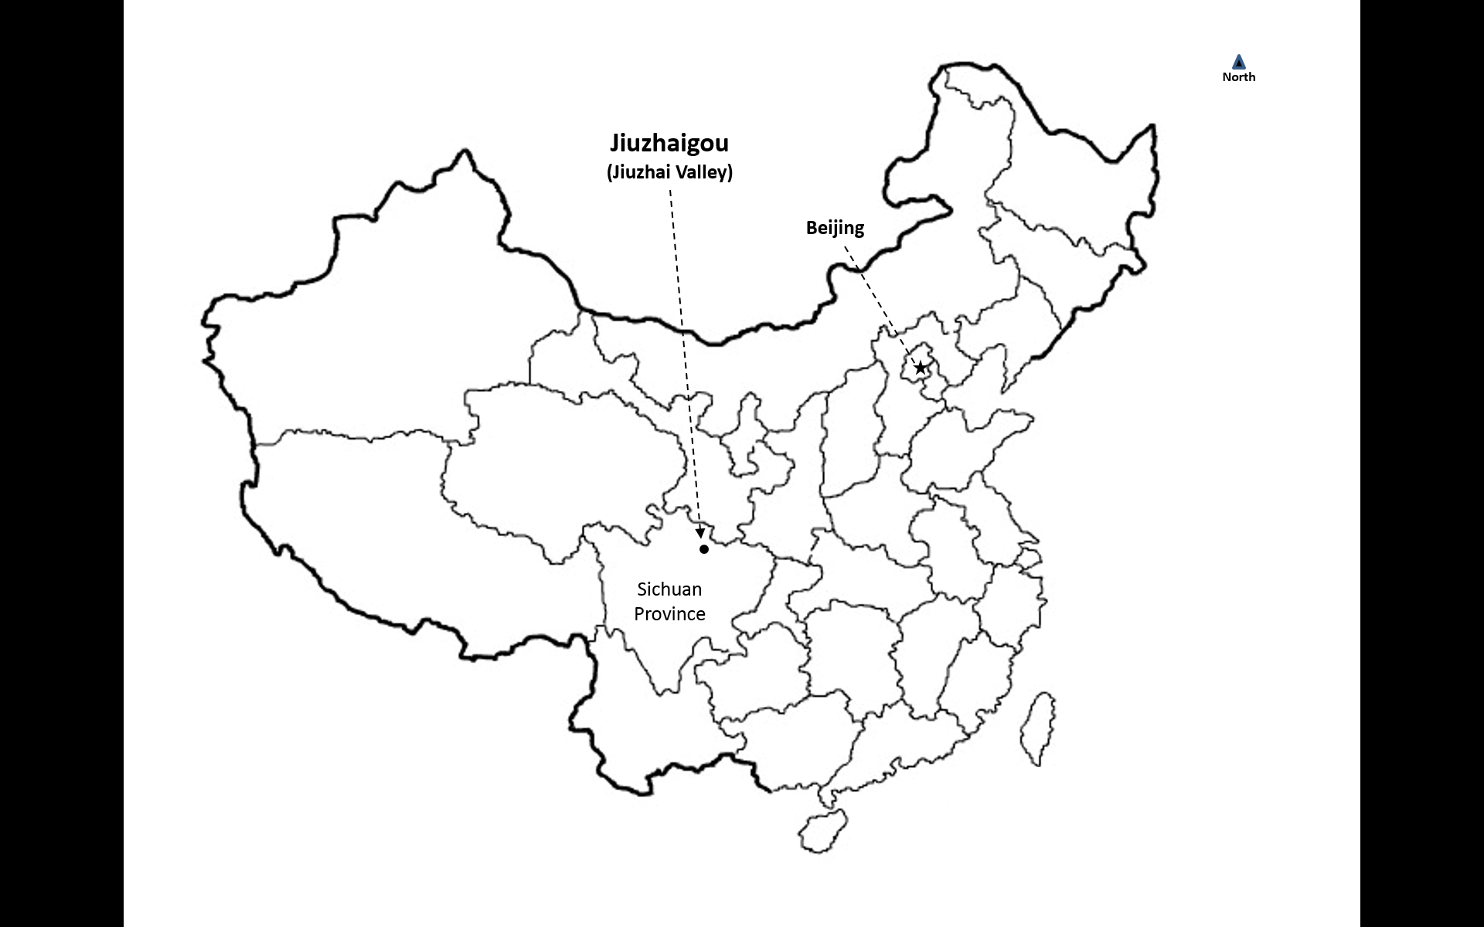

Source: Created by the case authors.

Exhibit 3: JIUZHAI VALLEY NATIONAL PARK CLEANING AND VISIBLE LITTER DENSITY CONTROL INDICATORS

|  |  |  |  |
| --- | --- | --- | --- |
| **CLEANING LEVEL** | **VISIBLE LITTER** | | **ODOUR** |
| **Litter Counts (units)** | **Retention Time (minutes)** |
| I | Within 3-metre radius visible ≤ 1 | ﹤1 | No |
| Without 3-metre radius visible ≤ 3 | ﹤5 | No |
| II | Within 3-metre radius visible ≤ 1 | ﹤1 | No |
| Without 3-metre radius visible ≤ 5 | ﹤15 | No |
| III | Within 3-metre radius visible ≤ 2 | ﹤3 | No |
| Without 3-metre radius visible ≤ 5 | ﹤15 | No |
| IV | Within 3-metre radius visible ≤ 2 | ﹤3 | No |
| Without 3-metre radius visible ≤ 5 | ﹤20 | No |

Source: Created by the case authors based on company materials.

EXHIBIT 4: WATER-FREE TOILETS: A KEY INNOVATION OF JIUZHAI VALLEY NATIONAL PARK

1. A cleaner replenishing biodegradable bags for the toilet.
2. Changing the waste bucket.
3. Before getting off duty: cleaning the walls of the toilet booth, cleaning the toilet, and replenishing the biodegradable bags.

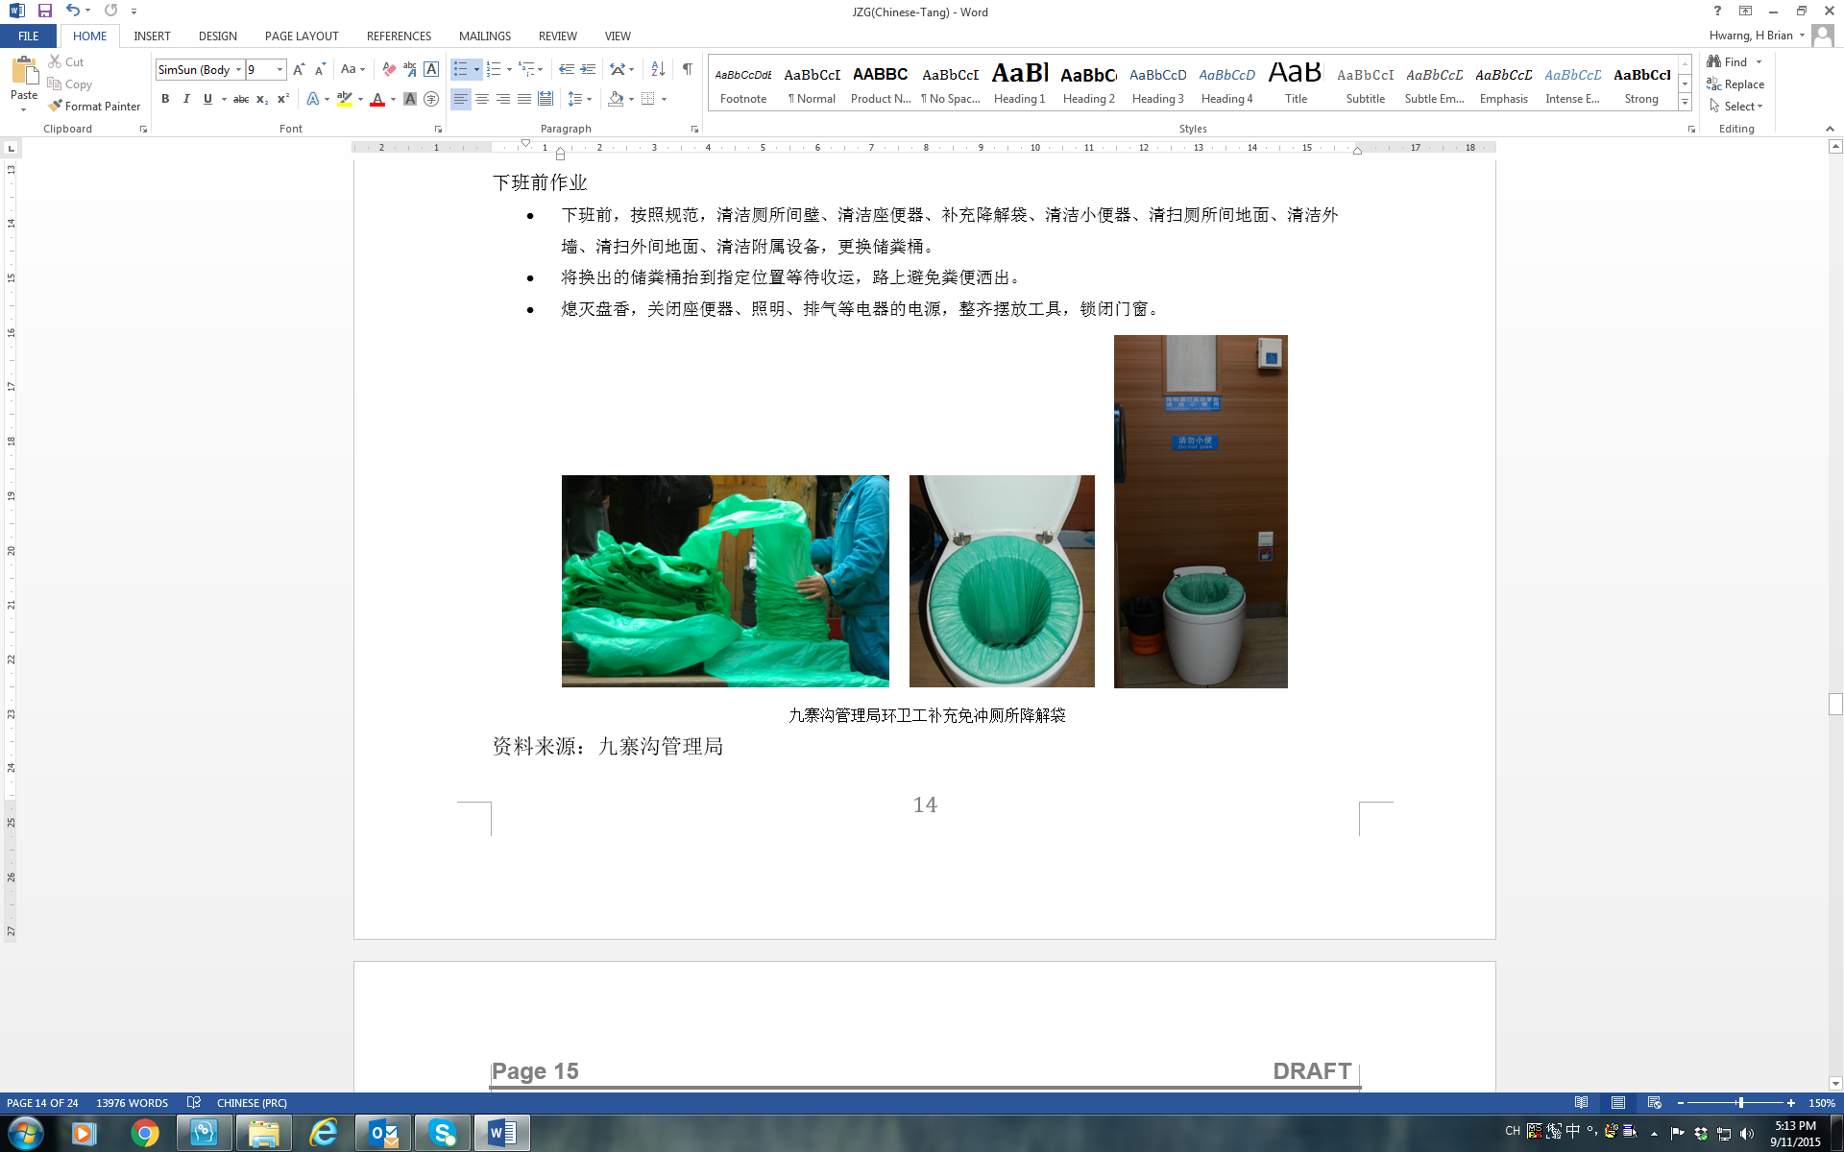

Source: Photographs taken on site by the case authors.

EXHIBIT 5: NUMBERS OF TOURISTS ENTERING AND LEAVING JIUZHAI VALLEY NATIONAL PARK (BY TIME) AND NUMBERS OF TOUR BUSES DISPATCHED DURING GOLDEN WEEK (2016)

|  |  |  |  |  |  |  |  |  |  |  |  |  |  |  |  |  |  |
| --- | --- | --- | --- | --- | --- | --- | --- | --- | --- | --- | --- | --- | --- | --- | --- | --- | --- |
|  | **Entering** | | | | | | | | | **Leaving** | | | | **Tourists** | **Independent Tourists (%)** | **Buses Dispatched** | **Buses Chartered** |
| **Date** | **07:30** | **08:00** | **08:30** | **09:00** | **09:30** | **10:00** | **10:30** | **11:00** | **11:30** | **14:00** | **15:00** | **16:00** | **17:00** | **Regular/**  **Mini** | **Regular/**  **Mini** |
| **10.1** | - | - | - | - | - | - | - | - | - | - | - | - | - | 16,301 | 55.05 | 169/59 | 1/47 |
| **10.2** | - | 11,576 | 16,756 | 22,573 | 27,999 | 32,865 | 35,580 | 37,460 | 39,137 | - | 8,500 | 19,000 | - | **40,813** | 70.01 | 326/81 | 0/78 |
| **10.3** | - | 12,557 | 17,650 | 22,706 | 27,416 | 32,367 | 36,988 | 39,307 | - | 8,500 | 13,400 | 19,600 | 33,700 | **40,995** | 67.73 | 330/79 | 0/79 |
| **10.4** | 10,145 | 16,206 | 21,772 | 27,260 | 32,417 | 36,438 | 39,284 | 40,113 | 40,830 | 7,500 | 18,800 | 31,200 | 39,800 | **40,998** | 67.13 | 330/80 | 0/80 |
| **10.5** | 7,013 | 10,309 | 14,186 | 18,496 | 23,129 | 25,872 | 27,146 | 28,290 | - | 5,500 | 15,400 | 24,800 | 30,700 | **33,014** | 67.66 | 327/81 | 0/81 |
| **10.6** | - | - | - | - | - | - | - | - | - | - | - | - | - | 20,762 | 61.62 | 201/66 | 0/57 |
| **10.7** | - | - | - | - | - | - | - | - | - | - | - | - | - | 16,413 | 43.65 | 176/51 | 0/36 |

Note: The numbers of tourists entering and leaving the park would only be released when the daily visitors exceeded 25,000.

Source: Created by the case authors based on company materials.

EXHIBIT 6: TOUR BUS ROUTES, JIUZHAI VALLEY NATIONAL PARK

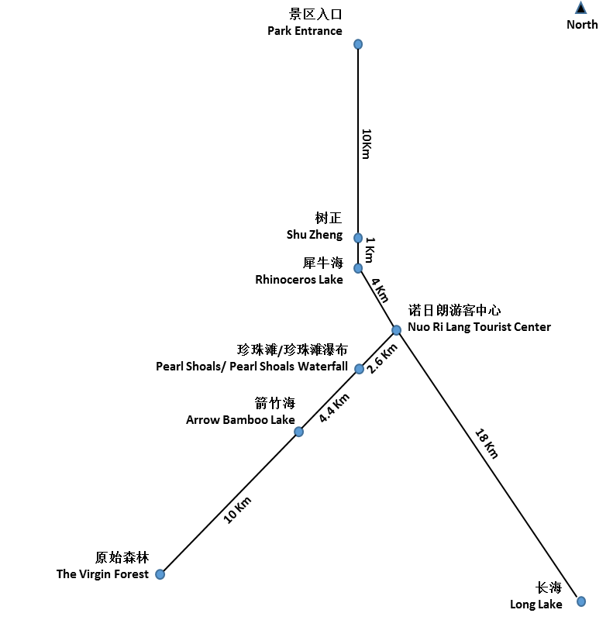

Source: Created by the case authors based on company materials.

EXHIBIT 7: TOURIST NUMBERS: GROUP-TO-INDEPENDENT TOURIST RATIO IN JIUZHAI VALLEY NATIONAL PARK DURING THE CHINESE SPRING FESTIVAL AND GOLDEN WEEK (2012−2015)

|  |  |  |  |  |  |  |  |  |  |  |
| --- | --- | --- | --- | --- | --- | --- | --- | --- | --- | --- |
| **The Spring Festival** | **2012** | | **2013** | | **2014** | | **2015** | | **Average** | |
| **Day** | **Tourist Numbers** | **Independent (%)** | **Tourist Numbers** | **Independent (%)** | **Tourist Numbers** | **Independent (%)** | **Tourist Numbers** | **Independent (%)** | **Tourist Numbers** | **Independent (%)** |
| **First** | 882 | 49.43 | 614 | 56.35 | 1,117 | 68.85 | 1,856 | 66.49 | 1,117 | 60.28 |
| **Second** | 2,205 | 66.62 | 2,801 | 100.00 | 5,147 | 83.10 | 3,542 | 78.01 | 3,424 | 81.93 |
| **Third** | 3,955 | 72.39 | 5,212 | 79.36 | 10,982 | 77.23 | 12,428 | 83.22 | 8,144 | 78.05 |
| **Fourth** | 4,150 | 71.66 | 9,200 | 77.38 | 12,257 | 82.41 | 20,151 | 27.60 | 11,440 | 64.76 |
| **Fifth** | 3,414 | 70.91 | 7,926 | 76.32 | 10,985 | 80.34 | 18,219 | 77.09 | 10,136 | 76.17 |
| **Sixth** | 2,539 | 74.52 | 6,183 | 74.14 | 7,949 | 69.79 | 14,921 | 76.95 | 7,898 | 73.85 |
| **Seventh** | 2,052 | 70.86 | 3,838 | 76.39 | 5,262 | 68.09 | 9,670 | 71.04 | 5,206 | 71.60 |
| **Total** | 17,145 |  | 31,936 |  | 48,437 |  | 71,117 |  | 42,159 |  |
| **Average** | 2,742 | 68.06 | 5,111 | 77.13 | 7,671 | 75.69 | 11,541 | 68.63 | 6,766 | 72.38 |

|  |  |  |  |  |  |  |  |  |  |  |
| --- | --- | --- | --- | --- | --- | --- | --- | --- | --- | --- |
| **Golden Week Holidays** | **2012** | | **2013** | | **2014** | | **2015** | | **Average** | |
| **Date** | **Tourist Numbers** | **Independent (%)** | **Tourist Numbers** | **Independent (%)** | **Tourist Numbers** | **Independent (%)** | **Tourist Numbers** | **Independent (%)** | **Tourist Numbers** | **Independent (%)** |
| **01-Oct** | 32,409 | 63.16 | 16,750 | 62.60 | 8,401 | 62.17 | 15,867 | 58.20 | 18,357 | 61.53 |
| **02-Oct** | 47,353 | 65.16 | 47,786 | 75.20 | 21,639 | 70.79 | 33,333 | 70.33 | 37,528 | 70.37 |
| **03-Oct** | 52,935 | 67.92 | 40,881 | 66.90 | 30,484 | 73.55 | 41,030 | 66.28 | 41,333 | 68.66 |
| **04-Oct** | 46,752 | 69.46 | 40,851 | 70.00 | 40,987 | 80.61 | 37,188 | 67.69 | 41,445 | 71.94 |
| **05-Oct** | 31,036 | 67.72 | 39,008 | 69.10 | 39,753 | 80.81 | 28,283 | 69.51 | 34,520 | 71.78 |
| **06-Oct** | 16,368 | 60.26 | 14,910 | 58.58 | 21,994 | 72.10 | 18,161 | 62.46 | 17,858 | 63.35 |
| **07-Oct** | 10,600 | 53.86 | 8,409 | 52.61 | 14,197 | 55.65 | 16,095 | 55.28 | 12,325 | 54.35 |
| **Total** | 237,453 |  | 208,595 |  | 177,455 |  | 189,957 |  | 191,040 |  |
| **Average** | 33,922 | 63.93 | 29,799 | 65.00 | 25,351 | 70.81 | 27,137 | 64.25 | 29,052 | 66.00 |

Source: Created by the case authors based on company materials.

EXHIBIT 8: TICKET BOOKINGS (BY TIME) FOR JIUZHAI VALLEY NATIONAL PARK DURING GOLDEN WEEK (2015 AND 2016)





Note: Data for September 30, 2016 not available; “Advance Booking %” refers to the ratio of the total tickets booked before 10:00 p.m. on the preceding day to the total tourist numbers on the day (e.g., Advance Booking % for October 1, 2015 was 10,886/15,867=68.61%).

Source: Created by the case authors based on company materials.

EXHIBIT 9: TOUR BUS DISPATCHING RESPONSES

Four levels of tour bus dispatching responses were implemented based on the number of tourists in the park: If the number of tourists was between 25,000 to 30,000, Level IV (Blue); 30,000 to 35,000, Level III (Yellow); 35,000 to 40,000, Level II (Orange); and above 40,000, Level I (Red). At Level IV and above, buses would only run on express lines and tourists would need to walk from the main bus stops to other attractions nearby. Buses would be allocated to each line based on its tourist flow and distance.

At Level IV (Blue) or Level III (Yellow):

* Line 1: Entrance–Shuzheng (Sparkling Lake), 20 kilometres (km) (round-trip distance)
* Line 2: Rhinoceros Lake–Virgin Forest, 42 km (round-trip distance)
* Line 3: Rhinoceros Lake–Long Lake, 44 km (round-trip distance)

At Level II (Orange) or Level I (Red):

* Line 1: Entrance–Shuzheng (Sparkling Lake), 20 km (round-trip distance)
* Line 2: Rhinoceros Lake–Arrow Bamboo Lake, 22 km (round-trip distance)
* Line 3: Rhinoceros Lake–Long Lake, 44 km (round-trip distance)
* Line 4: Arrow Bamboo Lake–Virgin Forest, 20 km (round-trip distance)

Level IV (Blue):

* 230–260 buses (210–230 regular buses and 20–30 minibuses)
* The park would open at 7:00 a.m. and the tour bus company would send 20 per cent of its administrative staff to the front-line operations.
* Response would be upgraded to the next level in severe weather (rain or snow).

Level III (Yellow):

* 260–290 buses (230–250 regular buses and 30–40 minibuses)
* The park would open at 7:00 a.m. and the tour bus company would send 20% of its administrative staff to the front-line operations.
* Response would be upgraded to the next level in severe weather (rain or snow).

At Level II and above, a certain number of buses (normally no less than 50) would be kept in the park during the evening based on the actual needs and traffic conditions outside the park.

Level II (Orange):

* 290–320 buses (250–270 regular buses and 40–50 minibuses)
* The park and ticket office would open at 6:00 a.m. and the tour bus company would send 40 per cent of its administrative staff to the front-line operations.
* Response would be upgraded to the next level in severe weather (rain or snow).

Level I (Red):

* 320–340 buses (270–280 regular buses and 50–60 minibuses)
* In the afternoon, the buses could not be off the duty before 5:00 p.m.
* The park and ticket office would open at 6:00 a.m. and the tour bus company would send all administrative staff to the front-line operations.
* Charter service would be suspended.

When the number of tourists was below 25,000, buses would be dispatched based on the actual conditions on site.

Source: Created by the case authors based on company materials.

EXHIBIT 10: TEMPERATURES: HIGHS, LOWS, AND AVERAGES (2000–2015)





Source: Created by the case authors based on company materials.

EXHIBIT 11: MONTHLY RAINFALL (2000–2015)



Source: Created by the case authors based on company materials.

EXHIBIT 12: SAMPLED AVERAGE WATER LEVELS OF THE LAKES IN JIUZHAI VALLEY NATIONAL PARK (2007–2015)





Source: Created by the case authors based on company materials.

1. This average was affected by a sharp, temporary decrease in 2008, when tourist arrivals dropped 74.35 per cent due to the Wenchuan earthquake. [↑](#footnote-ref-2)
2. The United Nations Educational, Scientific, and Cultural Organization, formed in 1945, was a specialized agency of the United Nations based in Paris. UNESCO aimed to coordinate international co-operation in education, science, culture, and communication. (https://en.unesco.org/) [↑](#footnote-ref-3)
3. In the high season (April 1–November 15), cleaners would start work at 7:00 a.m. and finish cleaning before 8:00 a.m.; in the low season (November 16–March 31), cleaners would start at 8:00 a.m. and finish before 9:00 a.m. [↑](#footnote-ref-4)
4. The Chinese satellite navigation system. [↑](#footnote-ref-5)
5. Feng Gang, Ren Peiyu, Xiao Weiyang, Deng Guiping, and Jian Daijun, “Eco-Protection of Scenic Areas Based on RFID: A Case Study of the Nuorilang Restaurant at Jiuzhai Valley” in *Intelligent Scenic Area Management and Jiuzhaigou Case Studies*, ed. Zhang Xiaoping and Wu Bihu (Beijing: Tsinghua University Press, 2013). [↑](#footnote-ref-6)
6. In October 2014, the tour bus company had 300 regular buses (45 seats each) and 120 minibuses (19 seats each). Ten of the minibuses were reserved for important visitors. [↑](#footnote-ref-7)
7. In 1999, the European Union introduced Euro III standards (2000) setting voluntary, stricter emission limits for extra low emission vehicles, known as “enhanced environmentally friendly vehicles” or EEVs; “EU: Heavy-Duty Truck and Bus Engines,” Diesel Net, accessed December 14, 2017, www.dieselnet.com/standards/eu/hd.php. [↑](#footnote-ref-8)
8. The Chinese Spring Festival referred to the extended holidays during the Chinese Lunar New Year; it usually lasted for seven days in January or February. Golden Week referred to the seven-day holiday commemorating Chinese National Day (October 1). [↑](#footnote-ref-9)
9. A total of 32 ticket dispensers were installed, and the number of tickets available through the dispensers depended on the total number of tickets sold on the same day. [↑](#footnote-ref-10)
10. The ownership structure of Jiuzhai Valley Joint Venture was divided between residents (49 per cent) and the Bureau (51 per cent). Profit distribution was 77 per cent to residents and 23 per cent to the Bureau. [↑](#footnote-ref-11)
11. For the revenue from every ticket sold (¥220 in the high season, ¥80 in the low season), residents could receive ¥7; ¥ = CNY = Chinese yuan; the average monthly exchange rate in 2016 was US$1 = ¥6.6417. [↑](#footnote-ref-12)