

9B18D008

john deere reman: creating value through reverse logistics

R. Chandrasekhar wrote this case under the supervision of Professor P. Fraser Johnson solely to provide material for class discussion. The authors do not intend to illustrate either effective or ineffective handling of a managerial situation. The authors may have disguised certain names and other identifying information to protect confidentiality.

*This publication may not be transmitted, photocopied, digitized or otherwise reproduced in any form or by any means without the permission of the copyright holder. Reproduction of this material is not covered under authorization by any reproduction rights organization. To order copies or request permission to reproduce materials, contact Ivey Publishing, Ivey Business School, Western University, London, Ontario, Canada, N6G 0N1; (t) 519.661.3208; (e)* [*cases@ivey.ca*](mailto:cases@ivey.ca)*;* [*www.iveycases.com*](http://www.iveycases.com)*.*

Copyright © 2018, Ivey Business School Foundation Version: 2018-05-04

Chris Garrison, factory manager at John Deere Reman (Reman) in Edmonton, Alberta, was reviewing the latest plant performance report. The Edmonton plant was one of two John Deere (Deere) operations that remanufactured parts and components (referred to as “cores”) that were used by company dealers to repair and maintain customer equipment. The performance of Deere’s remanufacturing division required careful coordination of a closed-loop supply chain that balanced supply of cores with customer demand. The latest report indicated that core return rates had declined steadily during the past year, creating the potential for parts shortages. Furthermore, a constant and steady flow of cores was essential to ensure proper utilization of the Edmonton operation.

It was September 27, 2017, and Chris was preparing for his quarterly meeting the following week with Jena Steele, general manager of Global Reman Operations and Marketing. This meeting, however, had particular importance. In Jena’s email the previous week, she had told Chris:

Our remanufacturing operations have showed steady improvements during the last decade. However, I don’t want to be complacent. During our meeting on October 4th in Springfield, I want to discuss opportunities for changes that will provide value to the company, improve customer service, and support the company’s commitment to environmental sustainability.

JOHN DEERE (Deere)

Deere manufactured and distributed a full line of agricultural, construction, turf, and forestry equipment. The company first began manufacturing agricultural equipment in 1837, and it operated 43 factories globally and employed 60,500 people in 2017. Of the company’s 23 factories in the United States and Canada, 14 were devoted to agriculture and turf equipment, four to construction and forestry equipment, one to engines, two to engine and component remanufacturing, and two to hydraulic and power train components. Revenues in fiscal year 2017 were US$29.7 billion with a net income of US$2.2 billion.[1] The two main business divisions, Agriculture and Turf, and Construction and Forestry, were supported by a parts distribution operation that included 21 distribution centres. Revenues from parts sales were US$5.5 billion in 2016, representing approximately 21 per cent of total equipment revenues.[2]

John Deere Reman (Reman)

Reman was an abbreviation for remanufacturing, which represented a process whereby used components were completely disassembled, cleaned, and inspected for damage; all failed and critical parts were replaced with original equipment manufacturer (OEM) quality parts. The components were then reassembled, painted, inspected, and tested. Warranties for remanufactured parts were equivalent to new parts. In contrast, reconditioned and rebuilt components only replaced failed parts, and warranties were not provided; in essence, reconditioning and rebuilding fixed only what was broken (see Exhibit 1). Generally, the operating performance and expected life of Deere remanufactured parts was equivalent to new parts, at 50 to 70 per cent of the cost of new.

Besides providing a lower cost alternative to new components, remanufacturing provided important societal and environmental benefits. Remanufacturing promoted recycling, resource conservation, pollution reduction, and energy conservation by reducing raw material inputs, reusing parts, and reducing inputs compared to new parts manufacturing.

Deere started its remanufacturing operation in 1996 as a joint venture with Springfield Remanufacturing Corporation, focusing on engines. In 2002, Deere fully acquired the joint venture and expanded the scope and size of its Reman business unit. By 2017, the company had two remanufacturing factories—Springfield, Missouri and Edmonton, Alberta—which serviced North America, Latin America, Europe, and Australia. Reman product categories included engines and engine components, fuel injection systems, hydraulics, drivetrains, electrical components, electronic components, transmissions, and fuel injection components (see Exhibit 2).

Located on a six-acre site, the Edmonton Reman facility was 130,000 square feet and employed 45 salaried staff and 140 production employees. Major functional areas included product engineering, quality, manufacturing engineering, and purchasing. Production employees included highly skilled licensed mechanics and non-licensed shop support workers, across two shifts. The plant was organized into seven key functions: shipping/receiving, bead blast, disassembly, machining and reclaim, assembly, test, and paint and package. The factory was also organized by major product segments. Exhibit 3 provides the general flow in facility.

The Edmonton plant had approximately 700 stock keeping units (SKUs) within the product categories of drivetrain (e.g., axles and transmissions) and hydraulics (e.g., pumps and motors). Both product categories consisted of a mix of Deere-designed components; for some components the intellectual property (IP) was owned by Deere, and for other components the IP was owned by suppliers. Chris commented on the product mix:

The company relies heavily on suppliers for design and manufacturing of components, such as drivetrains. For example, some axles and transmissions are designed by a large global supplier, which owns the IP for its products. This places limitations on us and represents a potential barrier for some parts where there is demand for remanufactured products. Our options in those situations are to outsource remanufacturing to the original equipment supplier, license the technology, or reverse engineer the product and parts that are re-used in order to remanufacture in-house. For Deere-designed major components, it is fairly straightforward for us to be able to remanufacture since we have access to the product designs, bill of materials, supply base, and service parts.

Core raw material inventory levels were approximately $20 million, most of which was stored on a one-acre area adjacent to the plant, made up primarily of axles and boxed transmissions that did not require indoor storage. In addition, the Edmonton plant also leased a 30,000-square-foot warehouse that was used to store additional core raw material and limited amounts of finished goods prior to delivery to the Deere parts network. Most finished goods inventory of remanufactured products was located at John Deere distribution centres in preparation for delivery to customers.

The Edmonton plant generated annual revenues of approximately $200 million. Its sister plant in Springfield was 300,000 square feet and had annual revenues of approximately $500 million.

THE REMANUFACTURING SUPPLY CHAIN

The Reman supply chain began with the recovery of cores, which represented the raw material for the Edmonton plant. Cores were acquired from a variety of sources but mainly through the dealer channel. When parts reached the end of their useful lives, they were typically returned to the dealer for credit and represented close to 95 per cent of the cores received. Other sources included independent equipment dealers and equipment repair shops and suppliers.

Value was created at two steps in the remanufacturing process: core management and core recovery (see Exhibit 3). A key part of core management was availability, which represented one of the strategic challenges for Reman. Both the timing of core availability and the volume of cores were uncertain. Furthermore, fluctuations in customer core returns made forecasting difficult. Core recovery meant salvaging worn or damaged components using machining or different technologies to return them to their original level of quality. Both steps significantly reduced material costs and allowed Deere to offer them to the market as finished remanufactured components at a fraction of the cost of new components. Chris offered the following example:

The process starts with a customer who has a major component on their machine that fails and needs a replacement; let’s assume in this example it is an axle, which is one of our main products at the Edmonton plant. The customer has several options, assuming he or she wants to continue to operate their machine: buy a new service part, buy a remanufactured part, or repair the broken component. New service parts will come at a premium price, let’s say $10,000 for example, and there are no considerations given to the value of their failed component—it likely ends up in a landfill or used for spare parts. Repairing the component has the opportunity cost of lost production while that machine is down and waiting for the labour required to complete the repairs—maybe in this example, $6,000 without a warranty and maybe two weeks downtime. It also requires expertise to diagnose the problem correctly, order the right parts and perform the work quickly. Reman offers the customer a drop-in replacement, with the same quality of a new service part, but relies on the customer returning their failed part in return or not receiving a refund if they chose not to do so. The total a customer would pay in a reman transaction is referred to as the “exchange price,” which in this example would be $9,000. This is made up of the “value-add” portion of the part they are receiving, let’s say $7,000, plus a “core charge” for the failed component of $2,000. If the customer provides their failed component to Deere, the “core charge” portion is returned to them, which happens in real time on purchase of the reman part, and they only pay for the value-add portion of the exchange price, which in this example is $7,000. If they chose not to return their failed component for some reason, they would not be refunded the core charge and the price paid would be the full $9,000. Regardless of whether the customer returns the core, they would still receive the same warranty on the reman axle. Think of it like a bottle deposit where you are charged a deposit when you purchase a bottle but get your deposit back when you return the empty bottle.

There is one other wrinkle to the core charge and value. All remanufactured parts had a standard core charge value assigned to them based on part number. This value is influenced by a number of factors, including original component price, service part availability, market competition, and price of an equivalent new component. For example, a $500 pump might have a core charge value of $50 because they are lower priced, commodity in nature, and cores were abundantly available. Whereas a $30,000 transmission might have a core charge of $5,000 due to the limited availability and critical nature of receiving core material back in order to remanufacture future product. A higher value incentivizes customers to return cores. Each returned core is given the full core credit amount unless the condition of the component is in extremely poor condition. Holes in engine blocks or disassembled into pieces would be two examples. Our dealers have core valuation criteria that are used to determine the final core deposit refund amount.

Core sales were integrated into the Deere dealer management system, which tracked inventory of customer cores and identified cores that were due for return. Chris explained how the exchange process worked:

Consider the example of an axle again. First, the profitability of remanufacturing depends on a regular flow of cores. However, the core return rate of axles can fluctuate wildly, which creates scheduling problems. John Deere Reman does not have total control over what our customers do with the cores. We recognized that Reman can never achieve a 100 per cent core return rate because other remanufacturers buy our axle cores from customers or our core charge for axles may not always incentivize the customers to return them to us. Ensuring a stable return rate of greater than 75 per cent is ideal. Anything in the 50–60 per cent range and you won’t be able to stay in business too long. Reman revises core charges regularly to stay in tune with market prices. Second, we often need to replenish our axle cores through a process known as “seeding” wherein we buy cores from the open market or convert new axles into remanufactured axles. This carries a cost, affecting our profitability.

Exhibit 4 provides the axle core return rates for the Edmonton plant from November 2016 to October 2017.

Key steps in the remanufacturing processes include machining, assembly, and testing. Major operational challenges included process variety caused by the wide range of the condition and product mix of the cores. Production planning needed to account for variables such as the core source (e.g., Deere or other OEMs), product group, product series, and product generation. As a result, core inventory was used to buffer variability in the supply chain. Chris Garrison described the challenges faced by the Edmonton plant:

Failed axles that are returned might have been replaced for something as minor as a broken O-ring that caused a leak. Upon disassembly, nearly all of the internal components could be reused after cleaning and inspection. Other axles suffer from catastrophic damage where a gear breaks and sends contamination throughout the entire axle, leaving next to nothing that can be reused outside the casting—and in some cases not even that. From a labour content standpoint, the amount of time that needs to be planned to rebuild these axles can vary significantly. In the case of the axle with little to no damage, the labour time will be for inspecting and cleaning the internal components that will be reused. In the case of an axle with catastrophic damage, there will be very little salvage labour involved—nearly all components will go straight to scrap, and all time invested will be for picking new components to replace the destroyed and unusable ones. The factory needs to forecast an average across time and conditions for workforce and material replacement.

Core Management Process

Core management began at the new product design stage. Deere product engineers used a product life cycle design process to establish the useful working life of products and major components. Chris provided an example:

The expected life for the engine in a loader might be designed for 15,000 hours, while drivetrain components might last for 20,000 hours. It is obviously less expensive to install a remanufactured engine in the loader than purchasing a new loader, provided the unit is in good working condition otherwise.

John Deere Reman’s marketing team tracks demand for components nearing the end of their expected useful life. A primary source of data is feedback from our dealers concerning customer demand. We do not offer remanufactured components for every John Deere part. Program managers evaluated the feasibility, both from a financial and operations perspective, of which cores represent viable candidates for remanufacturing. For example, we do not remanufacture every loader engine. Sometimes volumes do not warrant dedication of resources for remanufacturing. In other circumstances, the costs of remanufacturing are prohibitive and customers would be better off purchasing a new replacement engine. A third consideration is whether John Deere controls the IP for the component.

OPPORTUNITIES FOR REMAN

Reman was about to enter its third decade of operation. During the first 20 years it had established a strong customer value proposition that supported steady growth. However, Chris felt there were opportunities for improvement:

John Deere Reman is a business with a great deal of potential. This is a unique business model that relies on failed components and used parts for raw material. Up until now, our focus has been evaluating whether to include individual components in our Reman portfolio as they reached the end of their product life cycle. This assessment includes core availability, remanufacturing costs and market demand for remanufactured components. The John Deere Reman product engineering department is constantly conducting R&D projects to evaluate the feasibility of remanufacturing parts. Once a component is added to our portfolio, a key business challenge is maintaining a stable core supply rate. Shortages are addressed by increasing the core deposit value, which increases costs. Meanwhile an oversupply of cores increases our inventory investment and risk of obsolescence.

In this respect, our approach has been reactive, and we are managing the business similar to any independent remanufacturer. We compete with other remanufacturers for core supply and for sales to our customers. I feel we should be more proactive integrating remanufacturing across the business enterprise.

As Chris sat down at his desk to begin preparing for his meeting on October 4, he noted:

Our immediate problem is to ensure a steady supply of cores balanced with customer demand. I also want to identify one or two areas where we can make changes in the long term that will help improve the performance of the Reman business unit. Jena will expect me to articulate not only *where* we can make changes, but also *how* the changes can be made.

Exhibit 1: John Deere Reman: Difference Between Rebuilt and Remanufactured

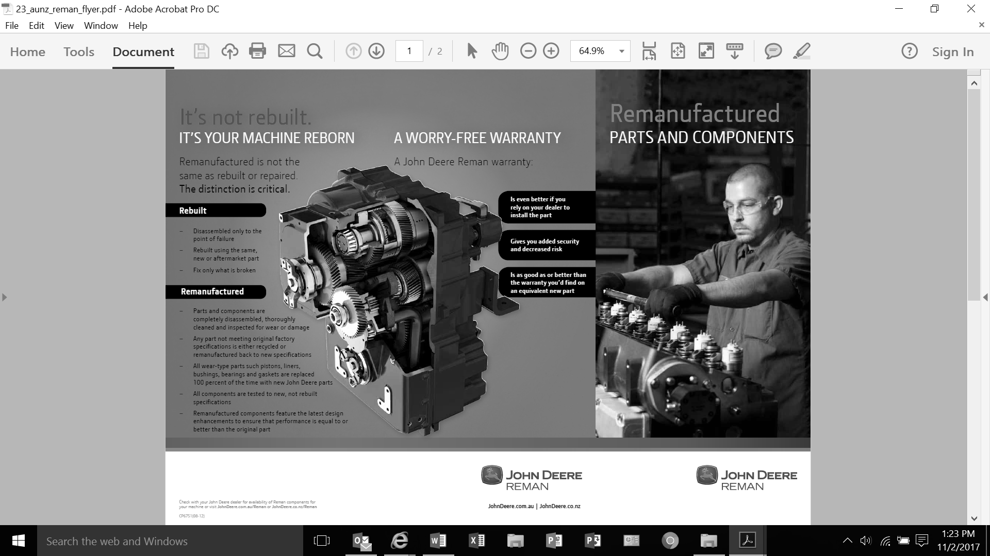

Source: “It’s not Rebuilt: It’s Your Machine Reborn,” John Deere, accessed November 2, 2017, https://www.deere.com/en_ASIA/docs/brochure/parts/reman_parts_and_components/pdf/23_aunz_reman_flyer.pdf.

Exhibit 2: Examples of John Deere Remanufactured Parts

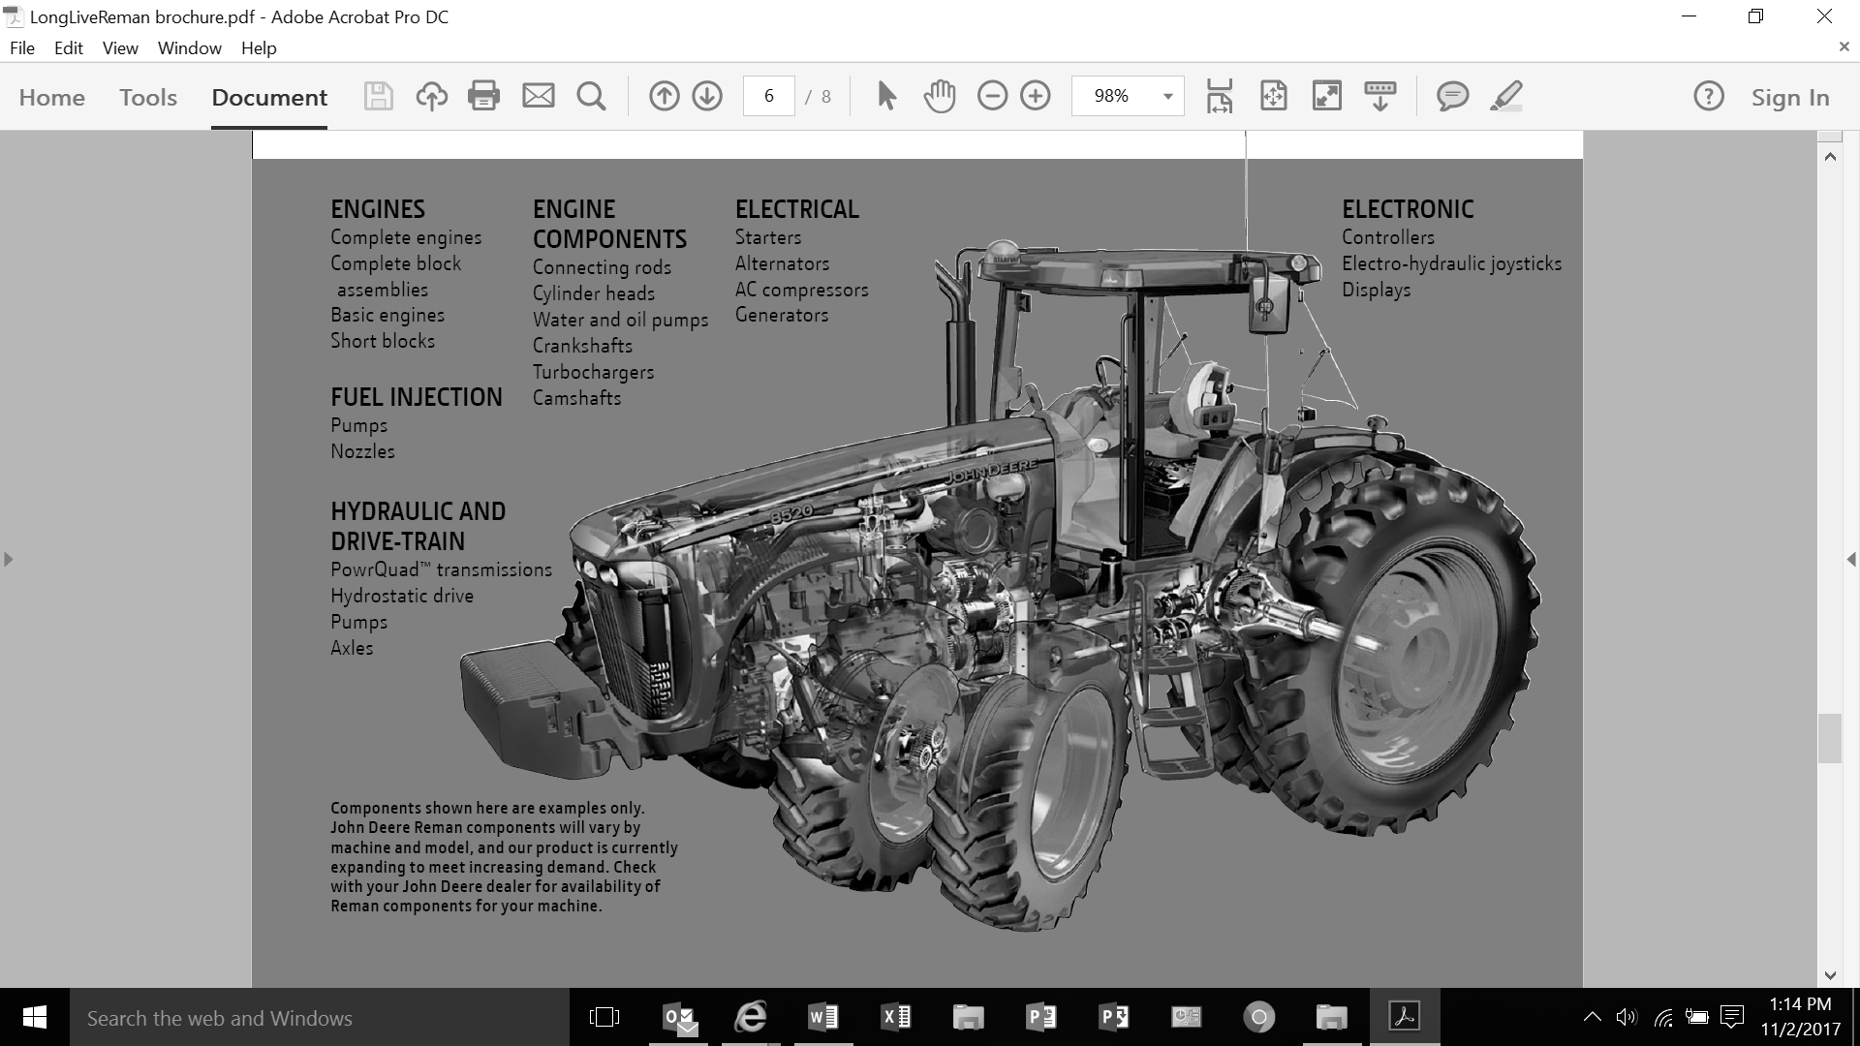

Source: “Long Live Your John Deere: Remanufactured Components for John Deer Equipment,” John Deere, accessed November 2, 2017, <https://www.deere.com/assets/pdfs/common/parts-and-service/parts/LongLiveReman.pdf>.

Exhibit 3: John Deere Reman Process



Source: John Deere company files.

Exhibit 4: Axle Core Return Rates for November 2016 to October 2017

|  |  |  |  |  |  |  |  |  |  |  |  |
| --- | --- | --- | --- | --- | --- | --- | --- | --- | --- | --- | --- |
| **Nov.** | **Dec** | **Jan.** | **Feb.** | **March** | **April** | **May** | **June** | **July** | **Aug.** | **Sept.** | **Oct.** |
| 87% | 88% | 86% | 90% | 88% | 85% | 85% | 80% | 80% | 78% | 70% | 66% |

Source: John Deere company files.

1. John Deere, *Deere & Company 2017 Annual Report*, accessed February 11, 2018, https://s22.q4cdn.com/253594569/files/doc_financials/annual_proxy/2017/2017_John-Deere-Annual-Report.pdf.
2. “Parts: Parts Distribution Operations,” John Deere Parts Fact Book, accessed February 11, 2018, https://s22.q4cdn.com/253594569/files/doc_downloads/books/2017/WW-Parts-Locations_2017.pdf.