

9B18D009

london’s rapid transit initiative[1]

David House wrote this case under the supervision of Elizabeth M. A. Grasby solely to provide material for class discussion. The authors do not intend to illustrate either effective or ineffective handling of a managerial situation. The authors may have disguised certain names and other identifying information to protect confidentiality.

*This publication may not be transmitted, photocopied, digitized, or otherwise reproduced in any form or by any means without the permission of the copyright holder. Reproduction of this material is not covered under authorization by any reproduction rights organization. To order copies or request permission to reproduce materials, contact Ivey Publishing, Ivey Business School, Western University, London, Ontario, Canada, N6G 0N1; (t) 519.661.3208; (e) cases@ivey.ca; www.iveypublishing.ca. Our goal is to publish materials of the highest quality; submit any errata to publishcases@ivey.ca. i1v2e5y5pubs*

Copyright © 2018, Ivey Business School Foundation Version: 2018-06-07

Western University students Amelia Chan and Patrick Lee were making final revisions to their report on the rapid transit initiative proposed for London, Ontario. The report, worth 20 per cent of their final grade, was part of their university course on civil engineering in engineering economics. The assignment stipulated that students, working in pairs, prepare both a financial and a qualitative analysis of the different options for rapid transit currently under consideration by London’s city council. The partners had spent the last two weeks gathering information and evaluating the four options presented. Based on their analysis, the students were to make a recommendation and provide a convincing, well-substantiated argument in support of their decision.

The City of London

Set in the heart of Southwestern Ontario, London was Canada’s 11th largest city and home to more than 365,000 residents, with a metropolitan area population of around 475,000. Although big enough to provide a “big city” experience, London was still far more affordable than many other large Canadian cities. Situated midway between Toronto, Ontario (Canada’s largest city) and Detroit, Michigan in the United States, and with direct access to some of the province’s major highways, London was an attractive place of residence for a variety of people representing a broad range of cultural, religious, ethnic, and socio-economic backgrounds. London was known for its exceptional regional health care and extensive educational facilities, including three leading hospitals and two large, well-recognized post-secondary education institutions, Western University (over 30,000 students) and Fanshawe College (over 15,000 students). Skilled labourers in various sectors were attracted to the different industries within the city, represented in companies such as General Dynamics Corporation, McCormick Canada, Labatt Brewing Company Ltd., Dr. Oetker, London Life, and 3M Canada.

The city also hosted several prominent music and sporting events at Budweiser Gardens, a 9,000-seat sports and entertainment facility. London’s downtown was anchored by Richmond Row, a shopping district with many high-end businesses including nightclubs, restaurants, higher-end clothing retailers, and professional service providers.

The average Londoner was close to 40 years of age and had an average annual household income of CA$73,000,[2] slightly above the Canadian average. Seventeen per cent of London’s population was comprised of baby boomers over the age of 65.

THE LONDON TRANSIT SYSTEM[3]

Background

London’s public transit system operated under the London Transit Commission (LTC). The LTC primarily used buses to transport passengers around the city, providing almost 24 million rides annually at an average fare of $1.36. Of the approximately 168,000 Londoners aged 15 years and over, 76 per cent drove their own vehicles to work. Londoners averaged 1.48 automobiles per household. Despite this, London’s ridership per capita was high when compared to similar-sized cities in Canada. Post-secondary tuition-based pass[4] holders—passes were provided to Western University and Fanshawe College students—represented 47 per cent of riders. Western had an enrollment of almost 30,000 students and Fanshawe had approximately 15,000 students. Forty one per cent of Londoners identified convenience as the primary factor in their selection of travel mode (see Exhibit 1). Cost was the next most important factor, identified by 13 per cent of London’s residents.

Passenger ticket sales covered 52 per cent of the actual cost to operate the LTC’s transit system. The City of London primarily financed the outstanding costs with municipal taxes. The government of Ontario’s gasoline tax funded a small percentage of the costs.

The London Plan

The City of London’s mayor and municipal councillors were reviewing The London Plan, a comprehensive strategic planning document prepared for the next twenty-year period. This plan considered all planning and growth for the city, including residential and retail development, infrastructure requirements (e.g., roads and bike paths), park and recreational development, and environmental and economic development. Since the plan outlined how and where the City of London would grow, it was important for the LTC to coordinate its future plans with The London Plan.

The London 2030 Transportation Master Plan

The London 2030 Transportation Master Plan was prepared by the Transportation Planning & Design group, part of the Engineering and Environmental Services department at London’s city hall. This plan outlined the various travel options available to Londoners and had set a target of 20 per cent of all trips to utilize public transit by 2030. One of the critical pieces to achieving this target was the implementation of a rapid transit system (RTS).

THE RAPID TRANSIT INITIATIVE[5]

One of the cornerstones of The London Plan’s move towards a sustainable city was the development and implementation of an RTS. This proposal would be the largest infrastructure project in the city’s history. The proposed system would be comprised of two interconnected corridors: north–south and east–west. Both routes would travel through the city’s downtown, providing transportation to Western University, Fanshawe College, and the hospitals (see Exhibit 2). The project was planned to start in 2019 with full completion in 2026.

Rapid transit in London was expected to produce many benefits. An RTS would have faster travel times than the current transit system—current transit times were not competitive when compared to automobile travel. An RTS could increase ridership and reduce the public’s reliance on their cars. As well, the capacity of this transportation infrastructure could handle the city’s future population growth. This infrastructure would also be a useful tool for shaping population growth, by increasing residential density in areas close to the public transit system, a process called “intensification.” Intensification, combined with an RTS, would reduce traffic congestion, save the construction costs of building more road infrastructure capacity, save agricultural land, regenerate the downtown core, reduce greenhouse gasses,[6] and conserve energy by reducing private vehicle usage.

The RTS options were to deliver the following:

* Frequent service along the rapid transit corridors, allowing riders to use the service without having to consult a schedule.
* Express service with fewer stops than the current transit service and stops located at major boarding areas.
* Dedicated lanes to physically separate the RTS vehicles from other vehicle traffic.
* Programmed traffic signals to prioritize the movement of the RTS vehicles.
* Stations with large waiting areas, shelter, seating, bike racks, and fee payment equipment.

Canada’s three most populous cities, Toronto, Montreal, and Vancouver, had extensive heavy rail/subway RTSs. Several other Canadian cities established an RTS at a time when their population was comparable to London’s (see Exhibit 3). In August 2014, Kitchener-Waterloo (population 318,000), also in Ontario, had begun construction of its rail-based RTS with completion expected in 2017.

Four Rapid Transit Alternatives

Four alternatives had been proposed to London city council for consideration, described as follows:

Base Bus

Essentially the “do nothing new” option, this alternative proposed that London continue operating public transit in a manner similar to the way it currently did. Existing routes would remain in service with capacity increased based on demand. Express routes would be added along the corridors (see Exhibit 2), but there would be no dedicated lanes for buses. This option would include no attempt to create rapid transit tunnels below railway tracks; consequently, level crossings with existing railways would remain unchanged.

Full Bus

This option focused on the use of buses exclusively for public transit. It would require road widening along the proposed transit corridors. This alternative would also require a number of structural changes to existing infrastructure including building a tunnel under the Canadian Pacific rail crossing on Richmond Street, fully separated lanes on Wellington Road, and a replacement bridge over the Thames River at University Drive on the Western University campus. These changes would allow express buses to use dedicated lanes, leading to shorter commute times than the Base Bus option.

Bus and Light Rail Hybrid

This option proposed the use of light rail instead of buses along the north and east corridors but with the continued use of buses along the south and west corridors. One of the reasons behind this proposal was that the north and east corridors projected higher ridership than the west and south corridors. This option would incorporate street widening along all corridors and would include building a rapid transit tunnel under the Richmond Street train tracks.

Full Light Rail

This alternative would utilize light rail transit, instead of buses, along all of the previously defined corridors. It would also include the widening of these corridors and the same structural improvements discussed in the previous two alternatives.

Economic Evaluation

Operating Costs

The future annual operating costs of the various RTS options included labour, administration, electricity and diesel usage (depending on the option selected), vehicle maintenance, and route maintenance. A summary of annual operating costs for each option included the net present value (NPV) equivalent in perpetuity (see Exhibit 4).

Capital Costs

Capital costs were classified as one-time investment costs. The capital costs for each option (see Exhibit 5) included the widening of roads on the RTS corridors; the construction of waiting stations, underground tunnels, and a maintenance facility; engineering costs; and the purchase of vehicles (buses and trains).

Revenue

Projected revenue was based primarily on RTS fares. Increased revenue was expected due to both population increases and a higher proportion of this population using the transit system (see Exhibit 6). The increased ridership proportion would be the result of the RTS’s increased capacity over the current system and the convenience and improved travel times it offered compared to private automobiles.

Non-Financial Benefits

The following non-financial benefits of the proposed RTS alternatives (see Exhibit 7) were identified:

* An RTS was expected to reduce riders’ travel times by between 3.5 and 5.3 minutes due to express lanes and other infrastructure improvements. This was calculated based on the average trip travel time, the expected number of riders, and an $18.26/hour estimated value of a passenger’s time.
* As commuters shifted from their private automobiles to public transit, the projected number of vehicle collisions was expected to decline, resulting in improved road safety.
* By increasing ridership on the public transit system, the corresponding reduction in the use of private vehicles would reduce traffic congestion and provide travel time savings for the remaining car users.
* Increased ridership in public transit would reduce the use of private automobiles, ultimately reducing for RTS riders the vehicle costs associated with purchase, maintenance, fuel, licensing, and insurance.
* Air quality improvements would result from fewer vehicles exhausting contaminants into the air, likely improving the quality of life for individuals affected by these contaminants.
* The shift from automobiles to public transit would reduce the volume generated of greenhouse gases. This reduction would be improved if the light rail options were chosen (rather than busses) because these options would use electricity produced primarily by the province’s hydro-electric and nuclear power facilities that do not generate these gasses. Environmental guidelines suggested that each tonne of greenhouse gas reduced would provide a benefit value of $155.
* It was discovered that public transit and active transportation were closely connected—typically, a component of a transit user’s total trip was on foot (walking to and from the station). The RTS options were conducive to cycling as well, and the extra daily exercise was expected to provide general health benefits to Londoners.

Other

The construction phase of the RTS was expected to generate between 1,400 and 5,800 person-years of work. Once operating, the RTS would create between 130 and 160 person-years of additional employment annually.

Research had shown a positive correlation with investment in transit and land values near RTS corridors and stations. Land values in these areas had typically risen 10 to 20 per cent after the implementation of an RTS. Retail and business areas also tended to grow along or gravitate toward RTS corridors.

Funding

The capital costs of an RTS would require funding from each of the municipal, provincial, and federal governments. Although the current Liberal governments of both Ontario and Canada tended to favour this type of investment in public infrastructure, funding was by no means guaranteed. Both the provincial and federal governments required a strong business case for their funding. The City was hoping that two-thirds of the funding for the proposed RTS would come from these levels of government. London would likely fund the remaining capital costs through an increase in municipal taxes. Annual operating costs would be funded primarily with fare revenue, but it was anticipated that an increase of less than 1 per cent in municipal taxes would be needed to cover annual operational deficits.

other priorities

In addition to creating an RTS, London had several other improvement plans that competed for funding. London had no ring road system and no expressways, extending commuting times for drivers. Traffic congestion generated significant public support for road improvements and increasing the number of lanes on existing arterial roads. Many Londoners placed a higher priority on these road improvements than on public transit improvements. Additionally, many areas of the city were long overdue for infrastructure servicing, such as adding sidewalks and updating or enlarging older sewer systems.

With the expansion of the population into the city’s outskirts and away from central urban areas, London had been actively seeking ways to rejuvenate its downtown. Many of these plans revolved around creating pedestrian-friendly or pedestrian-only streets. The City also planned to contribute funding to projects that helped achieve these objectives.

There was also significant demand from London’s citizens for additional and improved public recreation facilities such as ice rinks, pools, soccer pitches, and baseball fields. As well, cyclists believed there was a need for the City to add (and fund) bike lanes on major arterial roads.

Decision

Chan and Lee reviewed their report again. The course instructor had a reputation as a tough marker and they wanted to check their calculations and ensure their analysis provided well-written insights, along with thoughtful decisions, based on the facts they had gathered. The partners were prepared to work well into the night.

Exhibit 1: Londoners’ Modes of Transportation to Work

|  |  |
| --- | --- |
| Mode of Transportation | Percentage |
|  |  |
| Drive in personal car | 76 |
| Car pool/passenger in a car | 6.9 |
| Public transit | 8.7 |
| Walking | 5.8 |
| Cycling | 1.7 |
| Other (including taxi, Uber) | ˂ 1 |

Source: “National Household Survey (NHS),” Statistics Canada, October 5, 2011, accessed May 25, 2016, [www23.statcan.gc.ca/imdb/p2SV.pl?Function=getSurvey&SDDS=5178](http://www23.statcan.gc.ca/imdb/p2SV.pl?Function=getSurvey&SDDS=5178).

Exhibit 2: RAPID TRANSIT INITIATIVE MAP

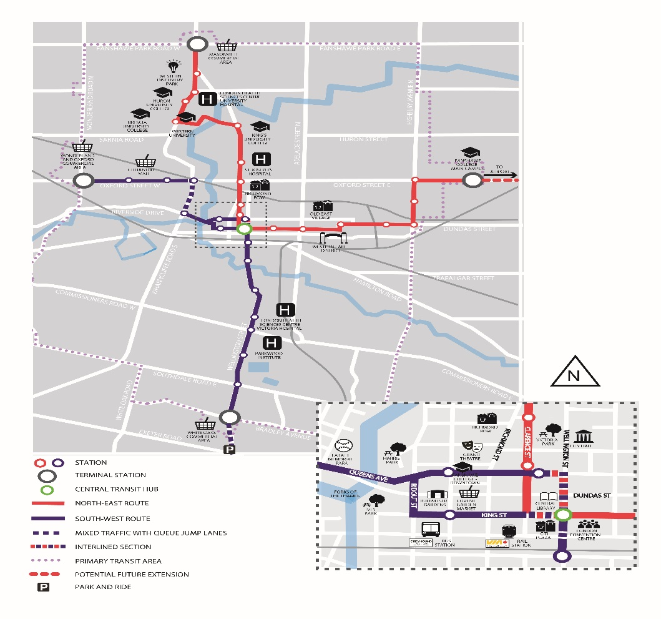

Source: City of London, May 25, 2018, used with permission.

Wonderland Rd

Wellington Rd

White Oaks Mall

Exhibit 3: COMPARABLE CANADIAN CITIES WITH A rapid tranist system

|  |  |  |
| --- | --- | --- |
| City | Date RTS Available | Population at the Time |
|  |  |  |
| Edmonton, Alberta | 1978 | 478,000 |
|  |  |  |
| Calgary, Alberta | 1981 | 590,000 |
|  |  |  |
| Ottawa, Ontario | 1983 | 550,000 |
|  |  |  |
| Waterloo, Ontario | 2017 | 318,000 |
|  |  |  |

Note: RTS = rapid transit system

Source: “Get Involved: Frequently Asked Questions,” London’s Bus Rapid Transit System, London Canada, July 19, 2017, accessed May 25, 2016, www.shiftlondon.ca/q_a.

Exhibit 4: Summary of operating costs (CA$ thousands)

|  |  |  |  |  |
| --- | --- | --- | --- | --- |
| Year | Base Bus RT | Full Bus RT | Hybrid RT | Light Rail RT |
| 2019 | $860 | $860 | $860 | $860 |
| 2020 | 860 | 860 | 860 | 860 |
| 2021 | 860 | 860 | 860 | 860 |
| 2022 | 860 | 860 | 860 | 860 |
| 2023 | 6,040 | 6,040 | 6,040 | 6,040 |
| 2024 | 6,040 | 5,485 | 5,845 | 5,630 |
| 2025 | 6,040 | 5,485 | 5,845 | 5,630 |
| 2026 | 6,040 | 5,485 | 5,845 | 5,630 |
| 2027 | 6,040 | 12,193 | 11,082 | 11,544 |
| 2028 | 13,800 | 12,193 | 11,082 | 11,544 |
| 2029 | 13,800 | 12,193 | 11,082 | 11,544 |
| 2030 | 13,800 | 12,193 | 11,082 | 11,544 |
| 2031 | 13,800 | 12,193 | 11,082 | 11,544 |
| NPV | $264,000 | $234,000 | $215,600 | $224,000 |

Note: RT = rapid transit; NPV = net present value; NPV was calculated using a discount rate of 3.5 per cent, assuming the current year was 2015 and that the operating costs in 2031 continued un-changed in perpetuity.

Source: IBI Group and WSP, “Shift: London’s Rapid Transit Initiative, Business Case,” London, Canada and London Transit, May 2016, accessed February 8, 2018, https://d3n8a8pro7vhmx.cloudfront.net/shiftlondon/pages/129/attachments/original/1464

886814/Shift-Final-Business-Case.pdf?1464886814.

Exhibit 5: summary of capital costs (CA$ thousands)

|  |  |  |  |  |
| --- | --- | --- | --- | --- |
| **Cost Component** | **Base Bus RT** | **Full Bus RT** | **Hybrid RT** | **Light Rail RT** |
| Corridor infrastructure | $129,231 | $262,134 | $415,938 | $538,208 |
| Maintenance facility | 10,000 | 10,000 | 35,000 | 35,000 |
| Engineering | 19,385 | 39,320 | 62,390 | 80,731 |
| Project management | 12,923 | 26,213 | 41,594 | 53,821 |
| Contingency | 68,615 | 135,067 | 221,969 | 283,104 |
| Vehicles | 26,400 | 24,000 | 103,300 | 163,800 |
| **Total** | **$270,000** | **$500,000** | **$880,000** | **$1,150,000** |
| **Net Present Value** | **$249,800** | **$440,200** | **$781,500** | **$1,022,700** |

Note: RT = rapid transit

Source: IBI Group and WSP, “Shift: London’s Rapid Transit Initiative, Business Case,” London, Canada and London Transit, May 2016, accessed February 8, 2018, https://d3n8a8pro7vhmx.cloudfront.net/shiftlondon/pages/129/attachments/original/1464

886814/Shift-Final-Business-Case.pdf?1464886814.

Exhibit 6: Net Present Values of Additional ridership Revenue (CA$ thousands)

|  |  |
| --- | --- |
| Base bus rapid transit | $45,600 |
| Full bus rapid transit | $73,100 |
| Hybrid rapid transit | $83,100 |
| Full light rail rapid transit | $85,600 |

Source: IBI Group and WSP, “Shift: London’s Rapid Transit Initiative, Business Case,” London, Canada and London Transit, May 2016, accessed February 8, 2018, https://d3n8a8pro7vhmx.cloudfront.net/shiftlondon/pages/129/attachments/original/1464

886814/Shift-Final-Business-Case.pdf?1464886814.

Exhibit 7: Net Present Values of Non-Financial Benefits (CA$ millions)

|  |  |  |  |  |
| --- | --- | --- | --- | --- |
| **Benefit** | **Base Bus RT** | **Full Bus RT** | **Hybrid RT** | **Full Rail RT** |
| Transit user time reduction | $520.3 | $787.9 | $787.9 | $787.9 |
| Car time reduction | 41.1 | 65.9 | 75.0 | 77.2 |
| Other car savings | 13.5 | 21.7 | 24.6 | 25.4 |
| Improved car safety | 6.7 | 10.8 | 12.3 | 12.7 |
| Greenhouse gas reductions | 12.8 | 20.5 | 23.3 | 24.0 |
| Air quality improvements | 0.4 | 0.7 | 0.8 | 0.8 |
| Health improvements | 24.0 | 38.0 | 43.0 | 45.0 |

Note: RT = rapid transit

Source: IBI Group and WSP, “Shift: London’s Rapid Transit Initiative, Business Case,” London, Canada and London Transit, May 2016, accessed February 8, 2018, https://d3n8a8pro7vhmx.cloudfront.net/shiftlondon/pages/129/attachments/original/1464

886814/Shift-Final-Business-Case.pdf?1464886814.

1. This case has been written on the basis of published sources only. Consequently, the interpretation and perspectives presented in this case are not necessarily those of the City of London or any of its employees.
2. All currency amounts are in CA$.
3. Information in the section is from the *London Transit Commission 2015–2016 Financial Plan*; *London Transit, 2015*; and *City of London 2013 Transportation Plan Report, 2010*, accessed February 8, 2018, www.london.ca.
4. These passes were given to all Western University and Fanshawe College students and allowed them unlimited LTC rides during the school year. The cost of the pass was included in students’ tuition and fees.
5. Information about London’s rapid transit initiative is from IBI Group and WSP, “Shift: London’s Rapid Transit Initiative, Business Case,” London, Canada and London Transit, May 2016, accessed February 8, 2018, https://d3n8a8pro7vhmx.cloudfront.net/shiftlondon/pages/129/attachments/original/1464886814/Shift-Final-Business-Case.pdf?1464886814.
6. Greenhouse gases included carbon dioxide, methane, and nitrous oxide. These gases absorbed and emitted radiation in the thermal infrared range (8 to 25 micrometres) and contributed to the process of global warming.