

**9B18D010**

**Summit maritime: Facility Location and layout design**

Joshin John, Rajiv K. Srivastava, and Neetha J. Eappen wrote this case solely to provide material for class discussion. The authors do not intend to illustrate either effective or ineffective handling of a managerial situation. The authors may have disguised certain names and other identifying information to protect confidentiality.

*This publication may not be transmitted, photocopied, digitized, or otherwise reproduced in any form or by any means without the permission of the copyright holder. Reproduction of this material is not covered under authorization by any reproduction rights organization. To order copies or request permission to reproduce materials, contact Ivey Publishing, Ivey Business School, Western University, London, Ontario, Canada, N6G 0N1; (t) 519.661.3208; (e) cases@ivey.ca; www.iveycases.com.*

*Copyright © 2018, Ivey Business School Foundation Version: 2018-05-25*

In September 2017, Paulson Joseph, managing director of Summit Maritime Pvt. Limited (Summit Maritime), a marine consulting firm and luxury boat manufacturer based out of Kochi, India, had a dilemma. Two of Summit Maritime’s production units operated at separate locations in the city, and both were a fair distance from the company’s consulting office. The business had grown over the past few quarters, and it had become increasingly difficult for Joseph to manage the operations at the three locations. With plans to open a new retail outlet, Joseph needed to decide on the optimal facility location and layout to restructure the growing business operations.

COMPANY BACKGROUND and business environment

Incorporated in 1987, Summit Maritime, originally a services and trading company, was bought in 2015 by Joseph in an all-cash deal. Joseph, a qualified naval architect with more than 10 years of international experience in the construction of ships, boats, and offshore marine structures, had been planning to start a boat-building and repair division based out of his hometown of Kochi. The port city of Kochi, located on the west coast of India, was the commercial hub of the state of Kerala. Kochi had the unique distinction of being the first Indian city connected by railways, a seaport, an airport, and an interconnected rail metro and water metro system for city transport.

Joseph was well aware of the marine tourism potential in Kerala, which was supported by government investments in infrastructure and logistics, particularly the water metro transport system. A rising trend among local community members, especially those who had waterside properties, was to own and operate boats for leisure. Many expatriates also dreamed about investing in upscale residences with a boat and jetty facility along the beautiful backwaters of Kerala.

Joseph, who himself had been in the Middle East region, was cognizant of the pulse of the luxury boat market and the premium expectations of buyers. His professional and expatriate connections were put to good use, and Summit Maritime soon received custom orders for high-end boats. Summit Maritime’s boats were recognized for their high quality, performance, and compliance with international standards. Summit Maritime also received bulk orders, not only from established water-based tourism businesses in Kerala but also from other states of India such as Goa, Maharashtra, and Uttarakhand, and from the union territory of Andaman and Nicobar Islands in the Bay of Bengal.

In late 2015, in an effort to firm up the company’s foothold in the boat-building market, Summit Maritime took over Arya Marine Pvt. Ltd. (Arya Marine), a popular fibre boat manufacturer in Kerala. Arya Marine was a well-known brand with an appreciable lineage in the small pleasure crafts market in Kerala. The products from Arya Marine were mostly entry-level boats that were affordable and sold well in the economy segment. Arya Marine also supplied fibre-reinforced plastic (FRP) products such as doors and frames to the real estate and construction industries. Thus, as a result of the acquisition, Summit Maritime extended its product range from small, standardized rowboats to high-end custom-made luxury crafts.

In 2017, the competitive landscape looked promising for Summit Maritime. The region had one big player and a few small players; however, Summit Maritime thrived because of its reputation for producing superior-quality boats that were customized and offered at competitive prices. Its customer-centric approach and quick production turnaround time paid off in converting first-time orders to repeat customers. Despite spending little on marketing and advertising, Summit Maritime received several orders through referrals and word-of-mouth publicity by satisfied clientele.

PRODUCTION FACILITIES and operations

Summit Maritime had two production facilities and a consulting office at Kochi (see Exhibit 1). The consulting office (Facility A) was centrally located at Vyttila in the downtown area next to the city’s central road transport hub. It was also along National Highway #66 (NH66), which ran north–south, connecting Kochi with other major cities in the state and beyond. The consulting office was a plush location for business meetings and interactions with clientele. Summit Maritime’s five to six personnel, including consultants, naval architects, engineers, and other office staff, operated out of this office. They facilitated engagements related to not only boat manufacturing but also advisory services for ship designs, marina feasibility studies, marine equipment trading, and ship chartering.

Facility B, which manufactured premium-segment boats, was located on Willingdon Island, India’s largest artificial island, which was sandwiched between the mainland of Ernakulam on the east and Fort Kochi on the west. The production facility was originally a 3,000-square-foot (nearly 280-square-metre) warehouse that had been converted into a boat manufacturing and repair unit. The facility was on lease and could house new builds and repair works for four to five premium-segment boats. However, only two-thirds of the facility was effectively utilized for production activities; the rest of the floor space represented excess for the current production requirements. Based on an estimated forecast, Facility B was needed for the production of, on average, two small boats and one medium or large boat, all in the premium segment.

The operations at Facility B needed dedicated supervision and control. Joseph knew that the success of Summit Maritime’s premium-segment boats was the result of the quality control measures in place during the production process, for which he took direct responsibility. Joseph ensured that no corners were cut during the mould-setting process for the FRP hull or during the surface finishing of exteriors and interiors. High-performance equipment and machinery, including engines, control systems, and entertainment consoles, were procured from reputable international suppliers and installed in the luxury-class boats. Depending on the production demands, Joseph personally dedicated a minimum of three to eight hours a day at Facility B, providing supervision and guidance for the six-member boat-building team to ensure superior workmanship. As a consequence, Joseph was often “missing in action” for crucial meetings at both the office (Facility A) and Arya Marine (Facility C). Because of the rise in customer orders, work at all three facilities would likely become more chaotic if no changes were made.

Facility C was a waterside area that was acquired from Arya Marine as part of the buy-out deal. The property included a small boat launch area, a workshop, and a site office. Facility C was located on the waterfront, on a prime location at Edakochi, a locality in south Kochi, along National Waterway #3 (also known as the West Coast Canal), which stretched approximately 200 kilometres along the picturesque west coast of Kerala. It was strategically important as a gateway to the backwaters of Kerala, which included the scenic lakes of Vembanad, Ashtamudi, and Kayamkulam, in the Kuttanad region.

Operationally, Facility C was a convenient venue for boat launching, speed and performance testing, and transporting new crafts along the waterways to client locations along the coast. The processes and systems at Facility C were generally the practices adopted from Arya Marine, and the unit worked with little supervision. Joseph knew that there was tremendous scope to improve the productivity, systems, and quality standards at Facility C, especially when compared with Facility B, which served as a useful internal benchmark. However, he could not stretch himself any further, as he was already shouldering the multiple responsibilities of client engagement, and legal and commercial activities, in addition to core operations.

As part of Summit Maritime’s routine business, both people and products moved regularly among the three facility locations. For example, the consulting team members frequently visited Facility B to perform inspections, assess production schedules of the premium-segment boats, and communicate design details to the production team members. Visits to Facility C were less frequent, as that facility warranted less supervision than Facility B. Materials were moved between Facilities B and C as part of the raw material inventory sharing between the two production units. Production inventory such as FRP sheets, gel-coats, resins, and outfitting components were moved between the facilities to meet production demands. Based on an internal estimate (see Exhibit 2), the average weekly movement of people or materials, or both, was 30, 12, and 18 trips, respectively, between Facilities A and B, A and C, and C and B.

As a result of the increasing demands of the growing business, Joseph realized that it was no longer possible to work at two job-shops and a consulting office. The company needed proper systems in place so that he could focus more on business development and growth strategy. Although Joseph liked to keep on top of the activities on the shop floor, he needed to free himself from impeding progress. It was time to restructure the business processes, design standard operating procedures for production systems, and streamline the operations.

New developments and relocation plans

For Joseph, one of the important issues that arose from time to time was the need for a retail outlet that could serve as a display facility for the luxury boats. Currently, Joseph would take clients to Facilities B and C to view the boats, after initially engaging them at the consulting centre at Facility A. This schedule led to a lot of travelling in city traffic and loss of time, as the production units were situated far from the downtown area. Clients generally expected an upscale ambience for the display of niche, high-end luxury boats. Summit Maritime’s production facilities unfortunately did not offer a presentable sight because materials, tools, and work-in-process inventory were scattered around the facility. The process layout at the facilities was an impending issue. Over time, Joseph had considered opening a retail outlet near NH66, where several upmarket showrooms were clustered. The location would also increase the company’s visibility, as it was in the vicinity of Summit Maritime’s target customers, which would save travel time, an efficiency that Joseph could no longer ignore.

Meanwhile, the owner of Facility B, which was under lease, had doubled the monthly rent as of September 2017. Joseph was unwilling to comply with the new terms, as he believed the new rate was too high for the location. Summit Maritime entrusted a real estate agent to identify a new facility that met all pertinent factors (see Exhibits 3 and 4). In accordance with the agent’s advice, the firm’s senior management had narrowed down the criteria after several rounds of deliberations employing multi-criteria decision-making techniques.[1] These methods and heuristics[2] were handy for decision making in circumstances where factors affecting the decision were often intangible or unmeasurable on a common scale.

The agent used a vast array of real estate databases to access ready-to-occupy facilities in the city. However, many of these facilities failed to meet the qualifying requirements. Joseph was essentially looking to set up a service factory—a factory that would also function as a showroom. Thus, the facility needed to have regulatory clearances for running as both a service outlet and a production facility. Gaining such clearance was not easy because, depending on the type of business, production facilities needed to comply with the statutory requirements of the pollution control board, including their impact on the residential community, the nature of other businesses in the vicinity, the type of production wastes, and the handling of exhaust gases, if any. In addition to these qualifying conditions, the senior management of the firm expected the new facility to be in accordance with pertinent factors (see Exhibits 3 and 4) as envisaged in the aftermath of the deliberations.

The Real estate scenario and facility considerations

The real estate landscape of the city was wide and varied. As a result of the construction boom in recent years, the establishment of a deep-water trans-shipment hub at Vallarpadam (see Exhibit 5), and the commissioning of new intra-city rail and water metro transport networks, the real estate pricing contours of the city had appreciably altered. New business clusters were formed, and several existing businesses relocated to vital nodal points in the urban landscape of the city. The NH66 along the north–south stretch emerged as a premium business cluster, dotted with more than a dozen high-end showrooms for luxury cars, business-class hotels, multiplexes, shopping malls, fine-dining restaurants, and experiential service centres. As a result of these developments, real estate prices spiked, particularly at several segments along NH66 that intersected with the metro-rail network, which attracted larger crowds, commuters, and potential customers. Vyttila, near Facility A, became one of the principal hotspots among these intersections. It was the central hub for road transport, and a critical junction for the rail and water metro networks, a combination that was rare and unique, significantly increasing the weight of this nodal junction. Most of the intra-state movement along NH66, and most of the inter-city traffic that entered the city of Kochi passed through this critical intersection at Vyttila. Thus, this strip along NH66 had significantly appreciated in real estate value, as it was the primary viaduct connecting the northern and southern regions of the state of Kerala at the Central Business District of Kochi.

On the other hand, at Willingdon Island where Facility B was located, commercial property was experiencing a relative slump in prices. A decade earlier, Willingdon Island had been abuzz with marine, shipping, logistics, and warehousing businesses; however, when the trans-shipment hub was established at Vallarpadam, many of those businesses migrated across the shipping channel to the island of Vallarpadam, closer to the trans-shipment hub. As Vallarpadam developed as an industrial cluster, gaining the special status of a port-based economic zone, the supply–demand gap widened for properties located on Willingdon Island.

In addition to factors connected to proximity and rent, effective space utilization was also a concern. Over time, Joseph noticed that excess floor space not only meant an opportunity cost was incurred on the rental expenses but also led to an undesirable accumulation of inventory, consumables, and production wastes in the vacant spaces, which was counter to the shop floor layout principles for lean production. Based on the demand forecast and production requirements for premium-segment boats, the space requirements for a service factory[3] were assessed (see Exhibit 4). Floor space needed to be allocated for production, finished product display, client engagement (i.e., office space), a workers’ restroom, and tool and equipment storage. In a scheduled meeting with the production team, to discuss matters regarding demand patterns and associated space requirements, the supervisor remarked:

Typically, three to four boats are under construction at any given time in the premium segment. We have orders for small-sized boats that are 15 feet [4.5 metres] long, medium-sized boats that are 20 to 24 feet [6 to 7.3 metres] long, and bigger boats that are longer than 30 feet [9 metres]. But the demand for small-sized boats is more stable.

Joseph noticed that under normal demand conditions, at least one medium or large boat and two small boats were in the production process, requiring dedicated floor space. During peak demand times, when floor space was at a premium, an additional boat could be accommodated, by partially or fully utilizing the display space for finished products. The boats were generally in a fixed position during the construction phase; however, the workers were cross-trained to simultaneously work on multiple products with shared parts and components from common product families. These considerations were factored into the layout requirements of the new production facility (see Exhibit 4).

The agent, who was entrusted with identifying suitable locations, had shortlisted some possible locations for Joseph to consider with the aid of a geographic information system for locational intelligence. The details of the shortlisted facilities including floor size, monthly rental cost, and proximity to NH66 were provided (see Exhibit 6). This information was supplemented with the distances from Summit Maritime’s existing facilities to the proposed locations of the new facility (see Exhibit 2). Also provided was a map of the area showing all new locations under consideration in relation to Summit Maritime’s existing locations (see Exhibit 5).

For Joseph, the decision to relocate had become more urgent, given recent developments. But he considered this situation to be an opportunity to relocate for good, and to consolidate Summit Maritime’s operations under one roof before streamlining the shop floor operations. Using pairwise comparisons,[4] Joseph, in consultation with the company’s senior management, weighed in on his preferences for the factors to be considered when making the location decision (see Exhibit 3). He was keen to occupy a new facility along NH66, not far from his consulting office where he could set up a site office with a meeting room, a display outlet, and production systems—all under one roof, provided that such a facility fit Summit Maritime’s budget.

THE Decision

Joseph pondered the alternatives available to him. Although he was under pressure to relocate, he did not want to make a hasty decision that would affect the production of the high-margin, luxury boats. In selecting the new location, Joseph needed to consider all pertinent issues. When the location was selected, he also needed to work out a preliminary facility layout to plan the production arrangement.

Exhibit 1: summit MARITIME’s Existing Facility locations

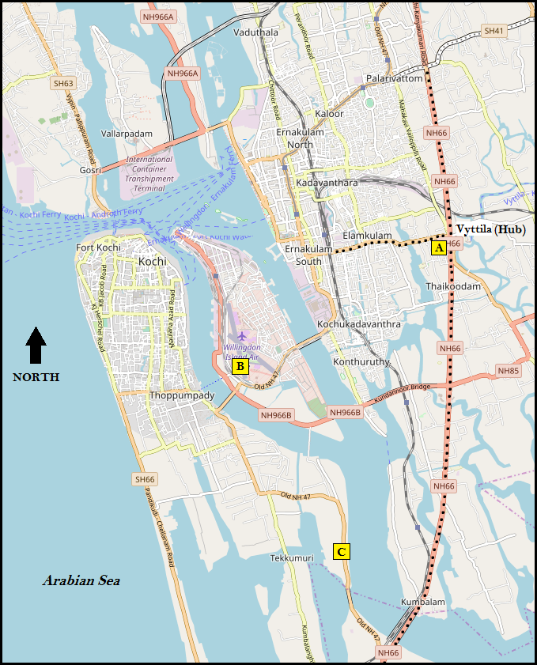

Source: Created by the authors using OpenStreetMap. Used with permission.

Exhibit 2: distance Trip matrix for summit maritime’s new and existing locations

|  |  |  |  |  |  |  |  |  |
| --- | --- | --- | --- | --- | --- | --- | --- | --- |
|  | **A** | **B** | **C** | **X1** | **X2** | **X3** | **X4** | **X5** |
| **A** | **–** | **30 trips** | **12 trips** | **–** | **–** | **–** | **–** | **–** |
| **B** | **9.4 km** | **–** | **18 trips** | **–** | **–** | **–** | **–** | **–** |
| **C** | **13.5 km** | **7.8 km** | **–** | **–** | **–** | **–** | **–** | **–** |
| **X1** | **9.9 km** | **0.5 km** | **8.3 km** | **–** | **–** | **–** | **–** | **–** |
| **X2** | **12.9 km** | **3.5 km** | **11.3 km** | **3.0 km** | **–** | **–** | **–** | **–** |
| **X3** | **3.4 km** | **7.1 km** | **10.1 km** | **7.6 km** | **10.1 km** | **–** | **–** | **–** |
| **X4** | **9.8 km** | **13.3 km** | **6.7 km** | **13.8 km** | **16.3 km** | **6.1 km** | **–** | **–** |
| **X5** | **4.0 km** | **7.7 km** | **10.6 km** | **8.3 km** | **11.3 km** | **0.8 km** | **6.7 km** | **–** |

Note: The upper triangular matrix shows the average number of weekly trips between facilities; the lower triangular matrix shows the distances (in kilometres (km)) between the facilities. X1, X2, X3, X4, and X5 represent the five locations shortlisted by the real estate agent.

Source: Company documents.

Exhibit 3: FACTORS RELEVANT TO LOCATING summit maritime’s SERVICE FACTORY

|  |  |
| --- | --- |
| **Location Factor** | **Weightage (%)** |
| Proximity to downtown (hub) area | 35 |
| Clustered along National Highway 66 | 25 |
| Effective utilization of available space | 15 |
| Unit pricing (per square foot) of floor space | 25 |

Note: Factor scores for a new facility drop linearly with deviation from best choice (100%); total space required (optimal range): 2,000–2,400 square feet (185–223 square metres); annual rental budget (i.e., the top limit) for a new facility: $120,000; A 10-kilometre cut-off boundary may be used while extrapolating distance factor scores.

Source: Company documents.

Exhibit 4: space considerations for summit maritime’s service factory layout

|  |  |  |
| --- | --- | --- |
| **Space Consideration** | **Quantity** | **Sizing** |
| Office space for client engagement | 1 | 150 square feet |
| Construction area for small boats | 2 | 20 × 8 feet |
| Construction area for medium boats | 1 | 28 × 12 feet |
| Construction area for large boats | 1 | 35 × 15 feet |
| New boat (finished product) display area | 1 | 525 square feet |
| Tool rack and equipment storage space | 1 | 100 square feet |
| Workers’ restroom and amenities zone | 1 | 160 square feet |

Note: Office and display areas must be next to each other at the entrance; boats will be in fixed positions during construction; workers are cross-trained to work on all boats; the movement of people and materials during production needs to be minimized; the movement of finished products must be from the rear to the front of the facility; 1 square foot = 0.09 square metres.

Source: Company documents.

Exhibit 5: new facilities considered by summit maritime in relation to current locations and city landmarks

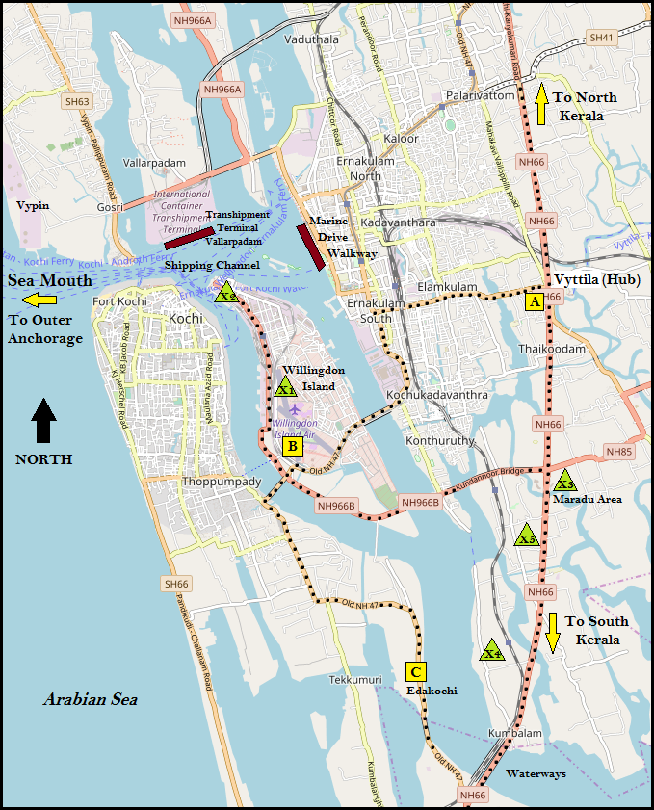

Note: A = Summit Marine’s current consulting office; B = Summit Marine’s current facility for manufacturing premium-segment boats; C = the Arya Marine property; X1, X2, X3, X4, and X5 represent the five locations shortlisted by the real estate agent.

Source: Created by the authors using OpenStreetMap. Used with permission.

Exhibit 6: short list of new locations for Summit Maritime’s consideration

|  |  |  |  |
| --- | --- | --- | --- |
| New Facility | Floor Size | Monthly Rental Fee  (per square foot) | Distance to NH66 |
| X1 | 75 feet x 40 feet | $2.50 | 7.0 km |
| X2 | 100 feet x 60 feet | $2.40 | 10.0 km |
| X3 | 60 feet x 35 feet | $3.50 | 0.1 km |
| X4 | 90 feet x 50 feet | $4.20 | 0.5 km |
| X5 | 75 feet x 54 feet | $5.00 | 0.7 km |

Note: NH66 = National Highway #66; km = kilometres X1, X2, X3, X4, and X5 represent the five locations shortlisted by the real estate agent; entrances (i.e., the street-facing side) for X1, X3 and X4 are along the shorter edge of the facility; entrances (i.e., the street-facing side) for X2 and X5 are along the longer edge of the facility; only one of the five facilities will be selected for relocating the service factory; 1 foot = 0.3 metres.

Source: Company documents.

1. Jacek Malczewski, *GIS and Multicriteria Decision Analysis* (New York, NY: John Wiley & Sons, 1999).
2. Jacek Malczewski and Claus Rinner, *Multicriteria Decision Analysis in Geographic Information Science* (Berlin: Springer, 2016).
3. Richard B. Chase and David A. Garvin, “The Service Factory,” *Harvard Business Review* 67, no. 4 (1989): 61–69. Available from Ivey Publishing, product no. 89402.
4. Jiaqin Yang and Lee Huei, “An AHP Decision Model for Facility Location Selection,” *Facilities* 15, no. 9/10 (1997): 241–254.