

9B18D013

Kiessling-Spedition: Distribution planning for in-night express

[Christian Brabänder](https://iveypubs.my.salesforce.com/003A000001stTdU) wrote this case solely to provide material for class discussion. The author does not intend to illustrate either effective or ineffective handling of a managerial situation. The author may have disguised certain names and other identifying information to protect confidentiality.

*This publication may not be transmitted, photocopied, digitized, or otherwise reproduced in any form or by any means without the permission of the copyright holder. Reproduction of this material is not covered under authorization by any reproduction rights organization. To order copies or request permission to reproduce materials, contact Ivey Publishing, Ivey Business School, Western University, London, Ontario, Canada, N6G 0N1; (t) 519.661.3208; (e)* [*cases@ivey.ca*](mailto:cases@ivey.ca)*;* [*www.iveycases.com*](http://www.iveycases.com)*.*

Copyright © 2018, Ivey Business School Foundation Version: 2018-07-06

Bernhard Brandl was the operations manager for in-night express services at Kiessling-Spedition (Kiessling), a logistic service provider (LSP) in Regenstauf, Germany. The tasks of an operations manager at an LSP were to plan and review the daily distribution fulfilment. Kiessling operated a terminal that offered various logistics services such as hazardous [materials](http://www.dict.cc/englisch-deutsch/materials.html) warehousing, contract logistics, procurement logistics, just-in-time services, and in-night express services. The in-night operations permitted the company to exploit the synergistic effects of using the terminal both in the day and at night. There were separate tours for two large automotive original equipment manufacturers that used the in-night service to supply their repair shops and showrooms with spare parts. However, the major share of distribution was bundled consignments from various consigners in the automotive, agriculture, and construction industries. The majority of consignments were business-to-business (B2B). Furthermore, sensitive deliveries such as pharmaceuticals, horse-breeding sperm, records, and laboratory samples were carried in the in-night network.

In April 2017, Brandl had just returned from a three-week leisure trip. As he arrived at his office one Monday morning, he was approached by one of his staff. Since the previous Thursday, a large consigner, Blum NFZ Teile (Blum), had stopped feeding consignments to the in-night service network from its largest sales area in Regensburg (Ratisbon). Blum, being an important consigner at the time, was the target of a corporate acquisition from one of its competitors. After the acquisition was finalized in December 2015, Blum had planned to continue with the service provided by Kiessling’s in-night network, although in the long run in 2018, it planned to insource in-night distribution. However, since the previous Thursday, some delivery tours had run idle early on due to missing volume from Blum. The use of these tours had decreased significantly. As a result, revenues were estimated to drop €750[1] per night, while operational costs remained at a constant high level.

As a first reaction, Brandl checked the tour delivery times and volumes in the Transportation Management System (TMS). The TMS held all the timestamps and geographic coordinates from delivery and visualized the tour after the fact on an online map. What he saw was indeed alarming. Blum had been a major consigner up to this point. There was a service level agreement in place, which included a two-month period of notice for cancelling the agreement. Blum operated five sales areas in Kiessling’s service area. Four out of five sales areas fed in-night consignments into the in-night network. The Regensburg sales area was the largest one, feeding about one third of Blum’s consignments. From the past year’s TMS data, a first estimate of the devastating consequences was made: The total number of consignments was estimated to drop by 40 per cent per night, and the total number of delivery stops was estimated to drop by 26 per cent. Different tours and zip codes were affected differently.

Due to the tight time schedule, operating in-night distribution was always challenging. Even small interruptions could cause the system to lose its balance and produce unfavourable results such as delayed delivery or unsecure deposited consignments. Over the years, there were smaller challenges, which were fixed locally. Whenever there was an issue with unbalanced tours, tours running idle over a longer period, or tours being delayed for many days in a row, Brandl and his staff found some small adaptations to rebalance things in a smooth and smart way. However, this time, the challenge was no local issue. The cancellation of service by Blum shook the whole distribution and revenue of the in-night express operations. As a result, Blum had to come up with a plan to adapt the distribution system by the end of June 2017. How could Brandl adapt the Kiessling in-night operations to overcome this massive turmoil and adapt to the new situation?

**Background: In-Night Logistics**

In-night logistics was a transportation service characterized by delivery at night. It was different from overnight logistics, which was characterized by parcel delivery the next morning. Overnight service providers performed the line-haul from the origin terminal to the receiving terminal at night. However, transhipment of parcels at the receiving terminal and distribution to recipients were performed the next morning. This procedure had the advantage of face time with the recipients and secure, confirmed receipt. In contrast, in-night service providers (INSPs) performed the line-haul in the evening, transhipment roughly around midnight, and parcel distribution and delivery at night. Customers benefited from in-night services by having the delivered parcels already available at the start of business. This was a competitive advantage whenever parts were necessary at the start of production, or spare parts and tool were required for a handyman’s daily tour. Lack of these parts could result in delayed production, harvest, or departure, and hence, disrupt a production schedule and cause tardiness and idle times. In-night express was a special case of courier, express, and parcel (CEP) service. It could be considered a premium logistics service due to its high-service level, speed, and guaranteed delivery.

Another unique characteristic of in-night logistics was receiptless delivery. Usually, no one was available to accept a delivery and sign for the delivery, so a receipt was not issued. Instead, the driver scanned the parcel. By doing so, both a timestamp and the geographical coordinates[2] of delivery were saved. There were a variety of delivery options offered to customers, including security boxes provided by the in-night service provider and customer facilities such as garages, repair shops, and private locker boxes. Even a car trunk could serve as a depot. If the depot was not a provided security box, the driver took a photograph of the delivered parcel at the destination for the sake of liability. As a result of this variety, the driver needed access to the chosen delivery option: keys, transponders, chip cards, access keys for combination locks, and so on. Every driver carried about 200–300 keys every night. This practice posed a tremendous liability for drivers in terms of customer deposit places. Receiptless delivery and the keys to customers’ deposits and sites were of utmost importance in performing in-night express services.

The standard process of in-night express was straightforward. Consignments were collected in the afternoon. One consignment (shipment) could comprise one or many parcels addressed to the same recipient. Usually, the consigner paid postage per consignment subject to the total weight of all parcels and distance. INSPs used a deadline of 4:00 p.m. or 5:00 p.m., depending on their proximity to the central hub. Thereafter, the consignments were bundled at the regional origin terminals and line-hauled to the national central hub. At the hub, the consignments were sorted by their receiving destination and transhipped to the receiving terminal. Line-haul vehicles arrived in the receiving regional terminals and were unloaded to utility vans for distribution. Finally, consignments were delivered to recipients until the early morning. This network configuration was called a hub-and-spoke network (see Exhibit 1).

Hubs were used in transportation to consolidate and split truckloads. This practice was meant to save direct lines running between every terminal in the network. Similar to conventional cargo carriers, INSPs needed to operate networks covering the distribution area without blank spots on the map. Every consignment was handled four times: (1) regional collection; (2) line-haul from the origin terminals to the hub; (3) line-haul from the hub to the receiving terminals; and (4) regional delivery. An exception was consignments that were sent within service areas. These orders remained in the origin terminal awaiting delivery at night.

The whole national territory was divided into a series of service areas. Every district was assigned to one partner in the in-night network who performed the collection and delivery. Franchisees were regional logistic service providers running a regional terminal in the assigned service area. The assigned service area was further partitioned into fixed tour areas. There were many approaches to partitioning a tour area into several smaller districts. A widely used practice was called “districting.” When consistency was an important consideration, the practices of districting, partitioning, or fixed tour problems could be used.

In 2017, in-night express was already highly consolidated in Germany, with few national in-night networks. In Germany, only nox NachtExpress (nox), Night Star Express (NSE), European Service Logistics Association (ESLA), and transmed Transport had dedicated in-night networks (see Exhibit 2). In terms of the number of consignments, the market leader was nox followed by NSE. The other in-night services were mostly premium options offered to private customers in the business-to-consumer (B2C) segment. Due to this small number of equivalent logistic services and the premium service level, customers were willing to pay a good margin, higher than for other CEP services. This was also the case for corporate customers in the B2B segment, which was mostly served by those INSPs running dedicated networks. Since 2010, several mergers and acquisitions had taken place, fostering the market’s consolidation.

In 2011, the German company LPR GmbH Logistik, the Austrian company Lagermax AED, and other European express service providers started to connect their existing in-night express networks. The co-operation was named the European Service Logistics Association (ESLA).[3] In 2017, the ESLA network operated in 24 European countries by undertaking 832 tours per night and 430 tours per day on average. In 2016, the investment fund Special Situations Venture Partners (SSVP III) acquired 100 per cent of TNT Innight, a subsidiary of the Dutch TNT Express. Later, TNT Innight became nox. In February 2017, nox acquired CAT Deutschland, the German subsidiary of the French CAT Group.[4] In April 2016, Trans-o-flex started in-night express delivery, operating its own hub-and-spoke network with its own vans. This Austrian INSP concentrated on temperature-sensitive parcels and offered industry solutions for pharmaceuticals. In 2017, Trans-o-flex was acquired by the Amberger family and Schoeller Holding[5] (see Exhibit 2).

Most INSPs used utility vans with only one person—the driver—for distribution. Since there were no vehicle-specific speed limits for this vehicle class, they operated at the same speed as passenger cars. This was a competitive advantage over using trucks. Also, because each INSPs used only one person, the size and weight of consignments were usually limited accordingly. However, the limiting resource in distribution was time. There were penalties charged within the in-night network if partners repeatedly failed to deliver a given high quota of on-time consignments. The on-time quota was planned and decided centrally. Since INSPs considered themselves to be premium service providers, the on-time quota was usually between 99 and 100 per cent. The operating costs of a utility van were mostly fixed, since there was a contracted charge per night with the subcontractors. The operating cost per night and vehicle were estimated to be roughly €272 (see Exhibit 3). In local distribution using small vans with a total weight less than or equal to 3.5 tonnes, the personnel cost accounted for 60 to 70 per cent of the total distribution cost. Thus, variable costs were relatively small compared to fixed costs.

It was common practice to engage subcontractors for the distribution. Subcontractors brought their own vehicles and employed drivers. They had one tour area assigned per vehicle and received a daily contracted compensation for their territories. Every fixed tour area was assigned to one subcontractor’s van. The total working time per driver and night was around 9 hours—from 11:00 p.m. until 8:00 a.m. During working hours, the subcontracted drivers waited for the inbound line-haul, assumed consignments addressed to their district, loaded their vehicle, and delivered all consignments. Usually, one tour had about 35 to 50 consignments and between 25 and 35 stops.

The planning activities of an INSP were manifold: Strategically, the INSP needed to locate its terminal and arrange its service area within the hub-and-spoke network. Subcontractors needed to be selected and employed. Further, the service provider needed to make a decision about its degree of operational flexibility. This meant somehow defining which processes were going to be flexible and which processes would better remain consistent over time. On a mid-term tactical level, an INSP designed its fixed tour areas, which remained fixed for some time. Smaller local changes could take place in order to adapt to new circumstances, keeping the majority of the plan robust. The subcontractors and their drivers were then assigned to the tour areas. In order to achieve high familiarity and local knowledge, the assignment remained consistent for as long as possible. On a day-by-day planning level, the tours in every tour area were routed. Routing meant computing a desirable order of stops that minimized the total duration of delivery. In case of any disruption, the operator needed to “fight the fire.” Depending on the level of flexibility, there could be some switching plans ready for execution. For example, a driver could take over a designated part of another driver’s tour in a flexible way in order to achieve overall punctuality.

**Background: in-night distribution in Regenstauf, Germany**

Kiessling was a member of a multinational in-night express network. There were several other partners and franchisees across Germany. In practice, being part of this network meant feeding consignments into the system and receiving consignments from other partners and franchisees.

Brandl was the operations manager at Kiessling, responsible for the in-night business. Therefore, he was concerned with customer acquisition and transport operations in the Kiessling terminal in Regenstauf. Regenstauf was located north of Regensburg in Eastern Bavaria in the south of Germany. It was close to the borders of the Czech Republic and Austria, and within one kilometre (km) of the A93 motorway (German Autobahn).

The Kiessling terminal operated a service area that included more than 440 zip (postal) codes comprising the municipalities of Regensburg, Passau, Landshut, Straubing, and Weiden (see Exhibit 4). The largest city in the area was Regensburg with about 146,000 people. The in-night distribution was organized into geographical districts (i.e., territories or fixed tour areas). There were 29 vehicles and tours, each having an assigned tour area. Every tour area was a cluster of several zip codes. In Germany, five-digit zip codes had been in use since 1993. For historic reasons, every tour area had a three-digit identifier, which had no semantic value anymore. However, the TMS required a three-digit identifier; hence, the information technology (IT) department kept the numbers anyway.

Most drivers had been subcontractors for Kiessling for years, and were familiar with their tours, customers, and duties. They knew all the shortcuts, dangers, difficulties, hidden customer depots, and localities of frequent addressees by heart. Subcontractors received a fixed contracted charge per tour and night, independent of the daily volume, weight, or delivery time. The average charge was negotiated in long-term contracts and depended on average stop number and density, as well as the general ease or intricacy of a delivery area. For example, a delivery area having curvy, narrow roads, bad winter road maintenance, or that was simply far off any primary highways was considered intricate. The subcontracted drivers arrived between 11:00 p.m. and 12:00 a.m. at the Regenstauf terminal with their utility vans to await the inbound lines. When an inbound line arrived, it was unloaded and the parcels were transhipped by the drivers themselves.

Consignments had a destination address, including a zip code. Since shippers fed their consignments into the system using electronic data interchange, there were many different names, spellings, and errors in data fields such as “addressee,” “street,” and “place,” which were string type fields. Nevertheless, the 5‑digit zip codes were usually correct and therefore of great organizational value. Data integrity and validity was always an issue, one that was common to the whole CEP industry. For example, identifying addresses was difficult due to different spellings and names of the same address, such as “KfZ Dillinger,” “Dillinger KfZ Werkstatt,” “Autowerkstatt Dillinger,” and “Automobile Dillinger.” These four names could all semantically mean an auto repair shop having the family name Dillinger.[6] For this reason, distinctive data attributes, such as the geographical coordinates and zip code, were the primary information used for planning and routing.

The consignments arrived in the Regenstauf terminal using any of four different inbound routes. The first inbound route was a line-haul from the central hub, which was located close to Frankfurt am Main.[7] This line-haul arrived around 1:00 a.m., but could be delayed until 3:00 a.m. The one-way travel distance from the terminal to the hub was roughly 300 km. Usually, there were two vehicles on the line. These two were the same drivers and vans that brought the outbound consignments from collection to the central hub. In the case of too little capacity, there was a third stand-in vehicle located close to the hub, subcontracted by Brandl. In rare cases, there were further stand-ins subcontracted by the hub operator. The second inbound route option was a direct line that arrived from a handful of other terminals, such as Augsburg, Berlin, and Stuttgart. The third inbound route option was a line-haul from the regional hub (rather than the central hub), which was reserved for southern Germany and was located close to Nürnberg (Nuremberg). There was only one line-haul on this link. The fourth inbound route was a direct line-haul from Blum.

On arrival, the drivers jointly unloaded the arriving vans and sorted the consignments into their vans. Depending on when the last inbound van arrived, distribution started around 2:30 to 3:15 a.m. The expected time of departure was 2:45 a.m. Drivers had a recommended, optimized route that had been calculated by an in-house-developed routing tool. The computed schedule was displayed interactively on a smartphone, and both the optimized tour and the actual driven tour were documented. The tour areas varied in size (see Exhibit 5). The average size was 675 square km. Differences in size were due to different approaching times to get there in the first place, different density of stops,[8] and different productivity of drivers.

A usual stop was processed as follows: stop at address, find parcel in van, find secure depot at customer site, open depot with physical or digital key, insert parcel in depot, scan parcel and depot barcode. If drivers considered the depot unsecure or were not sure about the right place, they took a photograph. The stop was finalized by locking the depot and restarting the van’s engine.

The final stop had to be completed by 8:00 a.m. However, there were also a few premium 7:00 a.m. deliveries, which were usually addressed to general repairs workers who ordered the spare parts they needed to take with them on their own day tour. Nevertheless, from time to time, tours could not be completed on time for various reasons: bad weather and road conditions causing delay; too many stops adding up so that tours were infeasible; difficulties, and therefore wasted time, finding a customer depot; and inexperienced stand-ins being less familiar with the district, customers, and process. Brandl had to explain any delays on behalf of Kiessling, because the company had to reach a high quota of on-time delivery. There was a severe penalty for every delayed parcel beyond a given threshold. On average, all tours finished on time, around 7:30 a.m. However, there were some returning problems in the distribution. Most problems occurred in the summer, due to peaks in volume, and in the winter, due to bad weather and poor road conditions.

**Problem: Losing a major consigner**

Until April 2017, Blum had operated its own delivery tours in the daytime to supply repair shops and showrooms with auto parts. For in-night delivery, Blum outsourced the in-night express service with Kiessling. Consignments were ordered by the Blum sales areas in Regensburg, Amberg, Passau, and Weiden. The fifth sales area, Straubing, did not feed consignments into the system. All the consignments were directly shipped from the Pilsen, Czech Republic logistics centre to Regenstauf using a designated vehicle.

In December 2015, Blum was acquired by a major competitor. This acquisition was a horizontal fusion. Both companies were wholesalers of automotive spare parts for the utility sector, operating in Germany and other European countries. In December 2016, Brandl was informed that the acquirer would continue to work with Kiessling until December 2017 and in-night distribution would be moved in-house starting from January 2018. The newly-merged company planned to exploit existing synergies. Blum had already performed daytime distribution and was able to serve most repair shops or showrooms more than once a day. However, in April 2017, the Regensburg sales area suddenly cancelled the service agreement, and the other sales areas were to follow. After some negotiations, Brandl got notice of the cancellation at the end of April 2017. As a result, he had to come up with a plan to adapt the distribution system by the end of June 2017.

First, Brandl decided to conduct a comprehensive analysis of the Blum share of total volume and stops, in order to find out how much room for re-optimization there would be after June (see Exhibit 6). Roughly 40 per cent of total volume and 26 per cent of total stops were expected to be lost. This share varied across the fixed tour areas due to different customer structures, urban and rural infrastructures, and the Blum sales areas. The Blum share was analyzed. The consignments were aggregated to stops, and stops were categorized into three types: (1) Blum, (2) mixed, and (3) other stops. “Blum stops” were stops where only consignments from Blum were delivered. At “mixed stops”, both Blum and other consignments were delivered. All stops receiving one or many consignments from anywhere but Blum were labelled as “other stops” (see Exhibit 6).

Brandl knew he had to come up with a set of changes to implement by the end of June—in two months’ time. Otherwise his in-night express division would lose its margin and its strong position in the area. However, making changes in the distribution system was difficult. How many stops would remain in existing tours after the Blum volume was lost? Would the drop factor decrease, increase, or remain unchanged? The art of computing good tour areas was difficult due to the uncertainty in the daily volume and the location of recipients. How many of the 29 tours should remain? If Brandl significantly increased the tour area of remaining tours, would the subcontractors be able to operate their tours economically, or would they re‑negotiate the rate per tour? Would larger tours having a lower density of stops be feasible at all?

**Alternative courses of action**

After two days of collecting data, talking on the phone with Blum, and conducting plausibility checks, Brandl knew there would be no way back. Blum was going to cancel, and all other things staying the same, approximately 26 per cent of the revenue from in-night services was going to leave with this consigner. Brandl called for a small team to plan the change, including Brandl himself, IT, customer service, and external consultants. In their first meeting, the decision alternatives were laid out.

**Greenfield Planning (Option 1)**

The team would use historical data and exclude all consignments from Blum from that data. In this first approach, they would need to plan the distribution from scratch: fixed tour areas, possible changes in disposition, selection, assignment, and re-negotiation with the subcontractors. Districting, as a bridge between strategic and operational planning, would stay the paradigm of distribution planning.

**Re-Optimization of Existing Fixed Tour Areas (Option 2)**

Some tour areas worked well because the drivers were familiar with them; others did not work well for different reasons. The team would need to look into all tours, assess their use, and come up with smaller local changes that would improve them. For example, tours could be merged or split up between other tours. The borders between neighbouring fixed tours could be shifted to improve productivity and use. The overall goal was to decrease the total number of vehicles in order to save some money. Therefore, the team needed to identify tours that could be dropped and fill the blank spots on the map by dividing it among the neighbouring tour areas.

**Introduce Variable Routing and Drop the Districting Paradigm (Option 3)**

Using software variable routes with no fixed tour area was optimized flexibly on a daily basis. There would not be any tactical districting anymore. As soon as the daily volume and destinations were known, the daily routes were computed. Drivers would not have assigned fixed tour areas any more but would receive an optimized route on their smartphones every day. This optimization problem was commonly called the vehicle routing problem. An advantage of daily routing was that it could be determined based on the exact known volume and destinations.

**Change the Terminal Structure (Option 4)**

Until now, all consignments had been shipped to the Regenstauf terminal first. This was a problem, as consignments to the western areas passed by their destination and were carried back. Other consignments took a detour to Regenstauf, which was not the direct way from the hub to the destination. The terminal structure could be made the subject of a greenfield network optimization. The variables to be optimized would be the number and location of additional terminals or cross docks. The team could think about using more than one terminal, or at least two or three transhipment points (cross docks) somewhere in the west and south. This alternative would decrease detour mileage and increase the time available for distribution.

**decision time**

Brandl argued in favour of re-optimized fixed tour areas (option 2), which was supported by customer service. Fixed tours had many advantages in terms of consistency, while the daily routes within the tour remained flexible. Also, from Brandl’s point of view, the fixed areas were mandatory due to the fixed assignment of customer keys. For reasons of liability, swapping keys was a difficult and time-consuming issue.

The in‑house IT administration, while not countering Brandl’s argument, argued that the in-house solution had already been capable of online routing. Therefore, option 3 was not too big a technical issue for them. The TMS routing engine could exploit the higher degree of freedom to compute better daily routes. Hence, full flexibility in daily routing would lead to lower costs, because the vans would be better used and travel times would be minimized.

It was pointed out that the main issue was the late time of departure. Since all drivers needed to wait for the last inbound van, all tours could be late on high-volume days. One of the consultants argued that this issue could be tackled by pre-sorting the consignments onto the line-haul vans in the central hub and routing them to three cross docks across the service area. As a result, the expected time of departure could be scheduled earlier and the distance from the terminal to the tour area could be shortened.

Customer service was concerned about the willingness of drivers and the flexibility of other personnel to accept major changes. It was assumed that drivers would favour a re‑optimized solution over a greenfield solution. Despite this argument, Brandl remembered that local re‑optimization in the past had led to a suboptimal division of tour areas. Therefore, this turmoil could be the chance to get rid of all the old structures and start fresh. He expected to see better results from this option in terms of minimizing cost.

Nevertheless, everyone agreed that some changes were necessary and that they would need to find a good configuration that worked consistently from July onward. This solution should somehow balance the optimality of costs (minimize the number of tours per night and the travel time per route) and consistency over time (reinforce the familiarity of drivers and limit the systematic changes to a sufficient level).

The team members first needed to decide which alternative to choose and then develop a plan for executing the chosen course of action. Due to the tight time schedule, they needed to plan and implement a solution fast.

**Exhibit 1: In-Night Hub-and-Spoke Network**

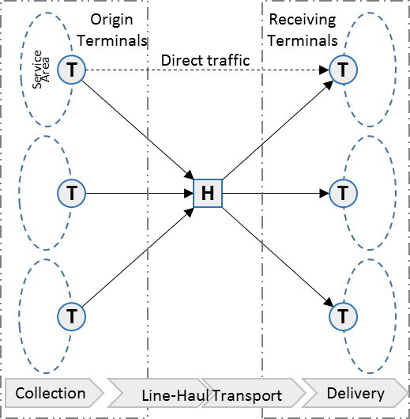

Source: Company documents.

**Exhibit 2: Overview of In-night service providers operating in Germany**

|  |  |  |  |  |  |  |
| --- | --- | --- | --- | --- | --- | --- |
|  | Offered National In-Night Service | Number of Shipments | Number of Drivers | Number of Terminals | 2016  Revenue | Background |
| nox NachtExpress (previously TNT Innight) | Night express | 150,000 daily | 1,000 employees | 25 | €240 million | nox was formerly known as TNT Innight, a German subsidiary of TNT Express. In 2016, FedEx acquired TNT and sold the Innight subsidiary to the SSVP III Investment fund. nox is the market leader in in-night services in Germany by volume. It operates its own network dedicated to in-night services. |
| Night Star Express | Night express | 5.36 million per year (2016) | 700 vehicles | 22 | €200 million (2015), €107 million (2015 national shipments, Germany) | Night Star Express is a joint venture of seven shareholders/partners and several franchisees. It operates in Germany, the Netherlands, Belgium, Luxembourg, Austria, and Switzerland. It operates its own network dedicated to in-night services. |
| United Parcel Service (UPS) | UPS Express Plus (until 9:00 a.m.) | 18.3 million daily (2016) | – | 72 distribution centres | US$61 billion (UPS total) | UPS is an international courier, express, and parcel logistic service provider. |
| GO! Express & Logistics | GO! Early Delivery | 5.5 million per year (Europe, 2016) | > 3,000 carriers | 1 central hub + 3 regional hubs > 100 Go! stations | > €300 million | GO! offers early delivery in many economic centres until 8:00 a.m. It is a co-operation of many small and mid-sized courier and express logistic service providers in Germany. |
| Dynamic Parcel Distribution (DPD) | DPD 8:30 a.m. | 350 million per year (of which 1/3 is B2C) | – | 77 depots | €6.2 billion  (GeoPost total) | DPD is owned by the French company GeoPost S. A. It offers time critical services on behalf of GeoPost. |
| Deutsche Post DHL | DHL domestic express before  8:00 a.m. | 4 million daily | – | – | €57.3 billion (DHL) €14 billion  (DHL Express) | – |

|  |  |  |  |  |  |  |
| --- | --- | --- | --- | --- | --- | --- |
|  | Offered National In-Night Service | Number of Shipments | Number of Drivers | Number of Terminals | 2016  Revenue | Background |
| European Service Logistics Association | Night express | – | – | 40 hubs + 102 regional depots in 24 countries | – | The European Service Logistics Association is a network of several European express service providers. Among others, the German company LPR GmbH Logistik and the Austrian Lagermax AED have operated the network since 2011. |
| General Logistics Systems (GLS) | Time definite  services | – | – | Hub and 154 stations | €2.5 billion (GLS total) | GLS is based in Amsterdam and has a network of 18 European subsidiaries. |
| transmed Transport | Night service | – | > 3,000 (of which 350 are “Pharma Mobile”) | 24 | €166 million | transmed is based in Regensburg and focused on the pharmaceutical branch and opticians, but also serves auto parts. |
| trans-o-flex ThermoMed | Overnight transport | – | – | – | €490 million (trans-o-flex total) | trans-o-Flex is based in Weinheim, Germany. It is concentrated on temperature-sensitive deliveries, especially pharmaceuticals (ThermoMed). Other industry-specific services are beauty and consumer electronics. Since April 2016, trans-o-flex has operated its own star-shaped nightliner network. |

Note: € = EUR = euro; €1 = US$1.07 on April 21, 2017.

Source: Created by author based on “More than 50 Years of Experience to Contribute to Your Success,” nox NachtExpress, accessed April 18, 2018, <https://www.nox-nachtexpress.de/en/about-us/company/>; “Company,” Night Star Express, accessed April 18, 2018, <https://www.night-star-express.de/en/company>; “UPS Express Plus,” UPS, accessed April 18, 2018, <https://www.ups.com/de/en/shipping/international/services/express-plus.page?loc=en_DE>; “Home Page,” GO! Express & Logistics, accessed April 18, 2018, <https://www.general-overnight.com/de-en>; “Speed Up Your Parcels. With Our Express-Service,” DPD, accessed April 18, 2018, <https://www.dpd.com/de_en/sending_parcels/our_shipping_services/express_services>; “Time Definite – Express Shipment throughout Germany,” DHL, accessed June 6, 2018, https://www.dhl.de/en/express/domestic-services/time-definite.html; “TimeDefiniteServices,” GLS, accessed April 18, 2018, <https://gls-group.eu/AT/en/services-overview/time-definite-services>; “Let’s Spend the Night Together,” European Service Logistics Association, accessed April 18, 2018, www.esla.info/; “Transport Management Is Our Business,“ transmed, accessed April 18, 2018, <https://www.transmed.de/en/>; “Welcome to trans-o-flex ThermoMed,” trans-o-flex, accessed April 18, 2018, www.thermomed.eu/en/home.

**Exhibit 3: operational cost of a utility van used in local distribution**

“The market is turning: Costs for subcontractors in groupage services and CEP will rise. Line-Hauling is affected as well as regional distribution.”*

**A Market Volume of €10 Billion**

With €6 billion in regional transport and €4 billion in long-distance line-hauling, more than half of domestic German revenues in general groupage cargo and CEP networks are generated by subcontractors. No other cost item has greater influence on their profitability and on freight rates, as these costs will be passed on to the customers eventually. How will the costs develop in the coming years?

To answer this question, an understanding of the subcontractors’ costs is necessary. These include the typical fixed costs for the provision of the various truck types (realistic depreciation rates and residual value rates, moderate rate of return on the capital employed, motor vehicle taxes, and insurance costs).

In addition, variable costs need to be considered (fuel consumption, repair and maintenance costs, and tolls, assuming the average daily routes and driving hours in the domestic logistics networks). Despite the differences in the vehicle fleets and operational conditions, the vehicle costs of the different networks are generally comparable.

The situation is more complicated regarding personnel costs. These account for 60 to 70 per cent of total costs for local transport and 30 to 40 per cent of total costs for main legs. The reasons for this are the considerable regional differences: The industry-specific wage level in some areas of eastern Germany is as low as 25 per cent below the German average, while the wage level in the most expensive metropolitan areas can be as high as 20 per cent above the German average.

Based on the average labour expenses for drivers in Germany of roughly €24 per hour (including employer contributions, paid absences from work, and so on), one “Sprinter” transporter < 3.5t with driver leads to an operational cost of approximately €272 for a typical day shift. For a medium-heavy general groupage cargo vehicle, the operational cost amounts to €377 per day shift. The cost for a swap-body vehicle or semi-trailer truck, based on half of the fixed costs, amounts to €378 per day shift for regional transport. For line-haulage, a robust benchmark can be estimated at €550 to 600 (calculated based on half of the fixed costs and assuming nine driving hours per day).

|  |  |  |  |  |
| --- | --- | --- | --- | --- |
| Typical Costs Per Truck Per Day** | | | | |
|  | Transporter  < 3.5 tonnes | Truck  12–18 tonnes | Semi-Trailer Truck  32–40 tonnes | Semi-Trailer Truck  40 tonnes |
| Short-distance CEP distribution, day shift*** | General groupage cargo pick-up and delivery, pallet goods | Short-distance WB pick up/delivery,  day shift**** | Long-distance Full-Truck-Load transport,  night shift |
| Fixed Costs per Shift | 40 | 80 | 80 | 98 |
| Variable Costs per Shift | 39 | 81 | 82 | 246 |
| Personnel Costs per Shift | 193 | 216 | 216 | 216 |
| Total Direct Costs | 272 | 377 | 378 | 560 |
| Average Distance Travelled per Shift (in Kilometres) | 200 | 200 | 150 | 450 |

Notes: * Excerpt from “The End of Self-Exploitation Is Near” (translated from German by the case author); ** average values for Germany in €, assuming nine working hours per day; *** CEP = courier, express, and parcel; **** WB = Way Bill ; € = EUR = euro; €1 = US$1.07 on April 21, 2017.

Source: Peter Klaus and Andreas Otto, “Das Ende der Selbstausbeutung naht,” *DVZ Verkehrs-Zeitung,* no. 67 (2017): 9, accessed April 18, 2018.

**Exhibit 4: Map of Kiessling’s service area with zip codes**

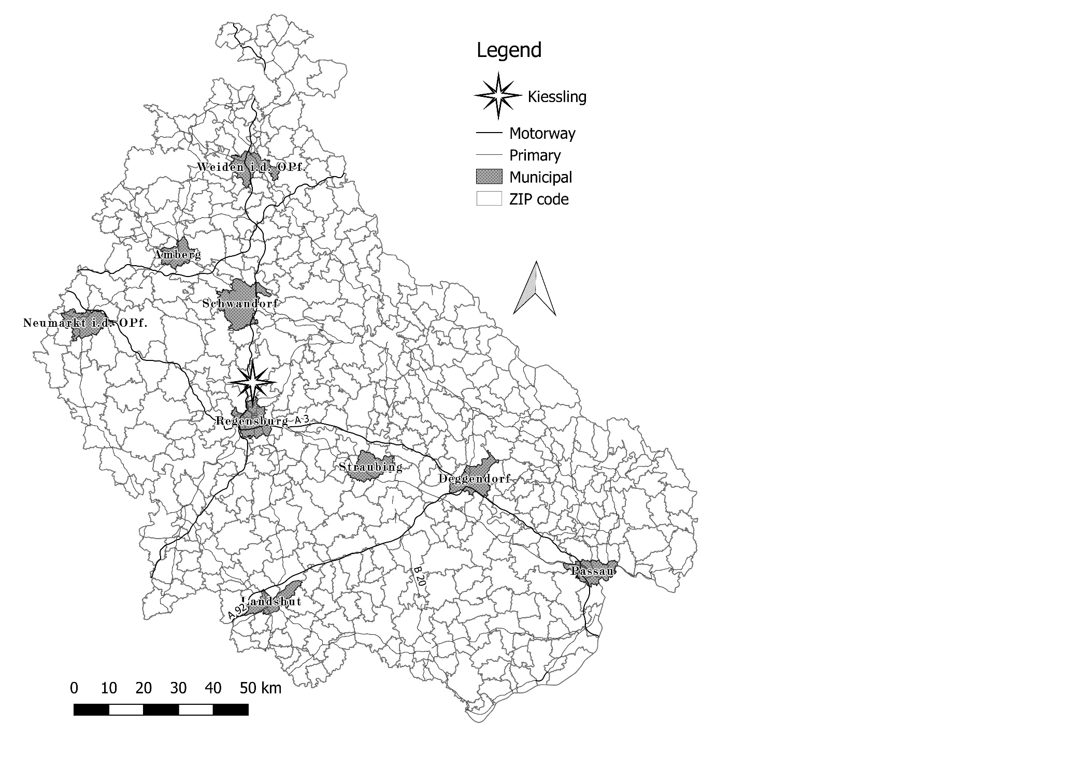

Source: Created by the author based on the geodata source OpenStreetMap, accessed April 18, 2018, https://www.openstreetmap.org.

**Exhibit 5: Map of fixed tour areas BEFORE BLUM’S cancelation**

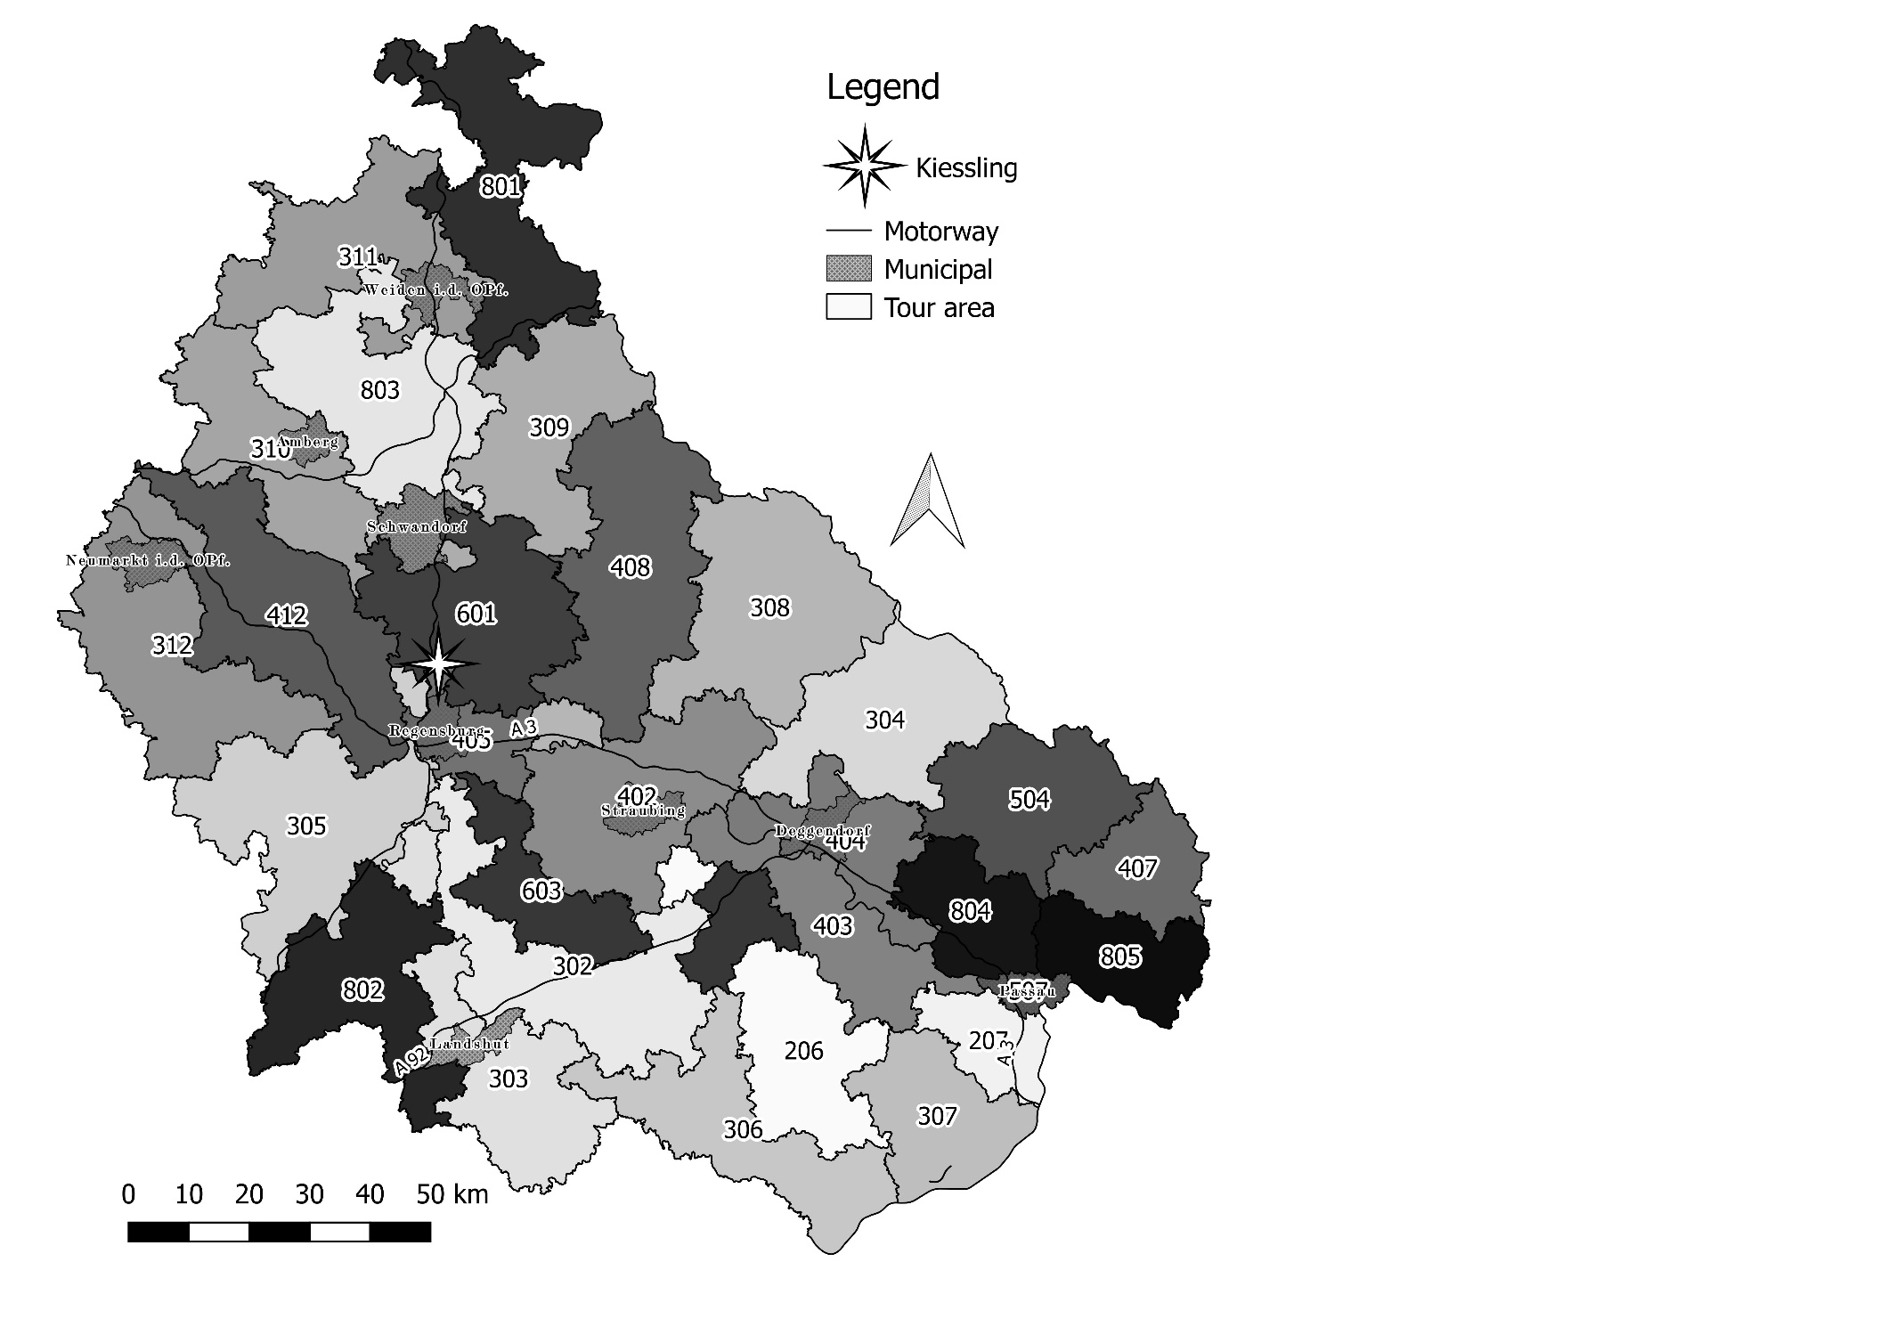

Source: Created by the author based on the Geodata Source Openstreetmap, accessed April 18, 2018, https://www.openstreetmap.org.

**Exhibit 6: Share of Blum, mixed, and other stops per tour area**

|  |  |  |  |
| --- | --- | --- | --- |
| **Tour** | **Blum** | **Mixed** | **Other** |
| 206 | 13.1% | 0.5% | 86.4% |
| 207 | 34.7% | 4.1% | 61.2% |
| 302 | 18.5% | 1.0% | 80.5% |
| 303 | 3.0% | 0.7% | 96.3% |
| 304 | 21.8% | 2.7% | 75.6% |
| 305 | 43.4% | 4.1% | 52.5% |
| 306 | 6.6% | 0.1% | 93.3% |
| 307 | 18.0% | 5.4% | 76.7% |
| 308 | 17.8% | 3.1% | 79.1% |
| 309 | 26.6% | 6.7% | 66.7% |
| 310 | 22.6% | 8.8% | 68.6% |
| 311 | 25.9% | 8.5% | 65.6% |
| 312 | 25.8% | 5.8% | 68.4% |
| 402 | 4.0% | 0.7% | 95.3% |
| 403 | 20.2% | 14.6% | 65.2% |
| 404 | 15.3% | 2.6% | 82.1% |
| 405 | 29.6% | 8.4% | 62.0% |
| 407 | 53.9% | 10.8% | 35.3% |
| 408 | 2.1% | 0.1% | 97.8% |
| 412 | 48.8% | 4.8% | 46.4% |
| 504 | 40.0% | 5.6% | 54.4% |
| 507 | 17.4% | 1.6% | 81.0% |
| 601 | 43.6% | 7.8% | 48.6% |
| 603 | 24.5% | 3.9% | 71.6% |
| 801 | 46.5% | 3.5% | 50.0% |
| 802 | 11.3% | 4.8% | 83.9% |
| 803 | 36.1% | 11.3% | 52.6% |
| 804 | 45.2% | 6.5% | 48.3% |
| 805 | 33.5% | 7.3% | 59.2% |
| Total | 25.9% | 5.2% | 68.9% |

Note: For example, in tour number 206, there are, on average, 13.1% of all stops per night receiving consignments from Blum only, 0.5% have both Blum and other consignments, and 86.4% of all stops receive no consignments from Blum.

Source: Company document.

1. € = EUR = euro; all currency amounts are in € unless otherwise specified; €1 = US$1.07 on April 21, 2017.
2. Geographical coordinates were a tuple of angles (latitude and longitude) forming a central angle and pointing to some point on the globe’s surface.
3. *“*Neues europäisches Nachtexpress-Netz,” *DVZ Verkehrs-Zeitung,* October 18, 2011, 125, accessed June 6, 2018, www.wiso-net.de/document/DVZ__pw125rok-ESLA-565136-new.
4. *“*Nox Nachtexpress übernimmt CAT Deutschland,” *Verkehrs Rundschau,* 2016, 51–52, accessed June 6, 2018, https://www.verkehrsrundschau.de/nachrichten/nox-nachtexpress-uebernimmt-cat-deutschland-1862449.html.
5. Eva Hassa, “Harter, aber fairer Sanierer,” *Verkehrs Rundschau*, 2017, 13/14, accessed April 18, 2018, https://www.wiso-net.de/document/VR__041707023.
6. “KfZ“ was the German abbreviation for motorcar; the German word “werkstatt” meant repair shop.
7. Many logistic networks in Germany operated their central hub in this area due to its national centrality.
8. Density of stops was the ratio of stops on a tour divided by the geographical area covered.