

9B18D014

Kamaths Ourtimes Ice Creams: Eliminating the Bottleneck Effect

[Amol S. Dhaigude](https://iveypubs.my.salesforce.com/003A000001tIvnm), [Debmallya Chatterjee](https://iveypubs.my.salesforce.com/003A0000021gYnK), and [Saptarshi Chakrabarti](https://iveypubs.my.salesforce.com/003A0000023XA96) wrote this case solely to provide material for class discussion. The authors do not intend to illustrate either effective or ineffective handling of a managerial situation. The authors may have disguised certain names and other identifying information to protect confidentiality.

*This publication may not be transmitted, photocopied, digitized, or otherwise reproduced in any form or by any means without the permission of the copyright holder. Reproduction of this material is not covered under authorization by any reproduction rights organization. To order copies or request permission to reproduce materials, contact Ivey Publishing, Ivey Business School, Western University, London, Ontario, Canada, N6G 0N1; (t) 519.661.3208; (e)* [*cases@ivey.ca*](mailto:cases@ivey.ca)*;* [*www.iveycases.com*](http://www.iveycases.com)*.*

Copyright © 2018, Ivey Business School Foundation Version: 2018-07-05

On a warm Monday morning in April 2017, Girish Pai, the director of operations of Kamaths Ourtimes Ice Creams Pvt. Ltd. (KOI), was sitting in his office, studying the live closed-circuit television footage of the ice cream production process in his factory. The company’s board of directors had given its approval for the annual capacity expansion of ice cream production by five tonnes. Pai was assigned the task of designing an appropriate strategy to effectively execute the plan. Although the company’s processes were adequate to handle the existing production, there had been a spate of delayed deliveries recently. Before designing the new blueprint, Pai wanted to identify and address the existing inefficiencies, which could otherwise have a negative effect on the company’s reputation and revenues during the company’s expansion. The board meeting, during which he would be presenting the design blueprint, was scheduled for the next day. Pai had less than 24 hours to design his strategy.

Kamaths Ourtimes Ice Creams: Company History

KOI launched operations in 1984 under the brand name Natural Ice Cream and soon became a strong competitor in this industry. What set it apart from its competition was its unique selling proposition—using natural fruit flavours in the ice cream. KOI did not add any artificial flavours to its products, a fact that was well received and appreciated by its customers. Founded by R.S. Kamath, KOI had always remained a family-run business. It was Kamath who first sensed that a market existed for natural fruit-flavoured ice creams with no artificial additives. His concept proved right and was approved by customers in and around Mumbai. KOI went on to receive numerous awards and testimonials of support for its products.

KOI followed a simple two-stage sales channel structure. The ice cream was sold in 125 stores, of which 4.8 per cent were owned by the company and the rest were franchised. The business followed a flat organizational structure (see Exhibit 1). KOI had a single manufacturing unit located at Charkop, Mumbai (India), with an installed capacity of 15 tonnes. This plant also served as a base to supply ice cream via rail to 50 retailers outside Mumbai (outstation outlets) and via truck transport to 75 retailers in the city (see Exhibit 2).

KOI had witnessed a steady rise in demand in its most recent quarters (see Exhibit 3), prompting the board to advise an expansion of the production capacity. However, KOI had also witnessed various delays in its order execution in recent years (see Exhibit 4), a fact that was not well received by the franchisees and the end-customers. Pai was aware that the existing capacity could satisfactorily deliver current orders, so he knew that the delays were not due to capacity but rather to inefficiencies in the processes. Therefore, in order to improve efficiencies, lower costs, and improve the company’s return on investment, it was imperative that he identify the gaps and fix them before initiating expansion in production.

Ice cream production process

The ice cream manufacturing operation was spread across three phases: procurement, production, and dispatch. The company followed a strict quality assurance policy and was very specific about the quality of products procured (see Exhibit 5), which included milk, sugar, fruit, and nuts. The production process used 12 batch freezers to make the ice cream, which normally took about six minutes to complete. The fruit was sourced from the local market and stored until it was washed and cut. The fruit was then mixed with sugar, pasteurized, and converted into pulp, which was then stored cold. Milk was received twice each day and stored in silos that held 10,000 litres each. It was then pasteurized and treated using two different processes to make a sweet drink called *rabdi*. The first process mixed sugar with 30–50 per cent of the milk. The second process did not use sugar. The two types of rabdi were then stored in vats.

The pulp obtained from fruit was mixed with an appropriate quantity of milk stored in batch freezers. After the six-minute operation to make ice cream, the product was stored in plain packets of 500 grams each for local delivery, durable plastic packets of 500 grams for outstation delivery only, and 1.5-kilogram packets. All packets were then sent to the spiral freezer to undergo a 72-minute chilling treatment at –30 degrees Celsius. After the chilling, the ice cream was sent to the sorting area. It was then stored in crates and sent to cold storage, where it was kept for a day for quality control. This was the beginning of the dispatch operation (see Exhibits 6A and 6B).

The company received customer orders through its enterprise resource planning software, which operated continuously. A printed copy of the order form was then given to the dispatch supervisor. The finished product was packaged for delivery in two different forms: boxes and tubs (see Exhibit 7). The boxes were used to pack ice cream for delivery to outstation stores; the tubs were used for the stores in Mumbai. Two different formats of dry ice were used for the shipments: bars for the local market and nuggets for the outstation shipments (via train). The box preparation process ran in parallel to the shipping process. The average demand for the boxes was 23,135 per month (for 25 working days each month), and this was forecast to increase in the near future. The process was in operation for eight hours each day, excluding a break of one hour. The workers reported to work at 8:00 a.m. and began work on the box operation. Average worker absenteeism was close to 20 per cent (see Exhibit 8). Pai attributed this relatively high rate to personal reasons and the monotony of the work, which did not allow the use of multi-skilled workers due to the high workload. Management followed a simple fixed job role policy that assigned the workers to each of the three processes, especially the box preparation process.

Packaging and Shipment process

In the dispatch operations, box preparation marked the beginning of the packaging and shipment process and ran parallel to the production process. Box preparation was one of the most crucial areas. It affected shipment timing and went through the stages of taping, covering, thermocol insertion, pouch preparation, and pouch insertion (see Exhibit 9). The raw materials required for the different stages of box preparation were cardboard, outer covering (white jute bags), thermocol, and plastic pouches. The pouches were visually inspected by the operators for abnormalities, such as length variations and pores. Those found with abnormalities were rejected. Similarly, thermocols were also inspected and rejected if they lacked uniformity or durability. Rejected components contributed to the inefficiency level and added to the rate of loss.

The operators, under the guidance of the supervisor, staged the delivery orders for packing. The staging was followed by packing, which was done by three operators working together to pack the product units in boxes and tubs. The product was then taken to the conveyor belt, where processes such as dry ice insertion, thermocol insertion, taping, and strapping were done. The package was then prepared for dispatch.

Pai identified various inefficiencies in the production processes. First, the shop floor was always busy with activity. Second, multiple locations for pouches made it impossible to maintain a standardized logistical flow (see Exhibit 9). Third, there was neither a fixed period for ordering nor a fixed target inventory for the raw materials required for the box preparation process. Fourth, the box preparation raw material storage area was used 30 per cent of the time, on average. Fifth, after they were procured, the pouches were kept in locations that seemed relatively vacant, which ignored the company’s first-in, first-out rule. Sixth, the box preparation process was carried out in a shed in the factory’s premises. Given the hot and humid Mumbai climate, workers found it difficult to cope with the weather, a problem that was compounded during the monsoon seasons.

After being prepared in the box preparation area, the boxes were taken to the staging area, where they were loaded with 500-gram and 1.5-kilogram ice cream packets. These boxes were then sent to the conveyor belt area, where dry ice was added to the operation. Their lids were closed and sealed for shipping. The sealed boxes were then loaded into the vehicles for dispatch.

Pai thoughtfully sipped his freshly brewed coffee. Based on previous experience, he knew that these inefficiencies required immediate attention. If they were not addressed, they could have an adverse effect on the company’s bottom line. However, if the delays were only isolated incidents, they could proceed without immediate attention and he could focus on the expansion without wasting time on minor delay issues. Time was running out, and he had to make his decision one way or the other. He was reminded of the saying, “You can close your eyes to the things you don’t want to see, but you can’t close your heart to the things you don’t want to feel.”

EXHIBIT 1: Ourtimes Ice Creams Pvt. Ltd. ORGANIZATIONAL STRUCTURE

CEO

Director of Operations & HR

Director of Retail

Director of Finance

Maintenance Supervisor

Plant Manager

Production Supervisor

Store Supervisor

Shipping Supervisor

Team Members

Team Members

Team Members

Team Members

Retail Team

Finance Team

Note: CEO = chief executive officer; HR = human resources.

Source: Company documents.

EXHIBIT 2: Ourtimes Ice Creams Pvt. Ltd. RETAIL OUTLETS IN INDIA

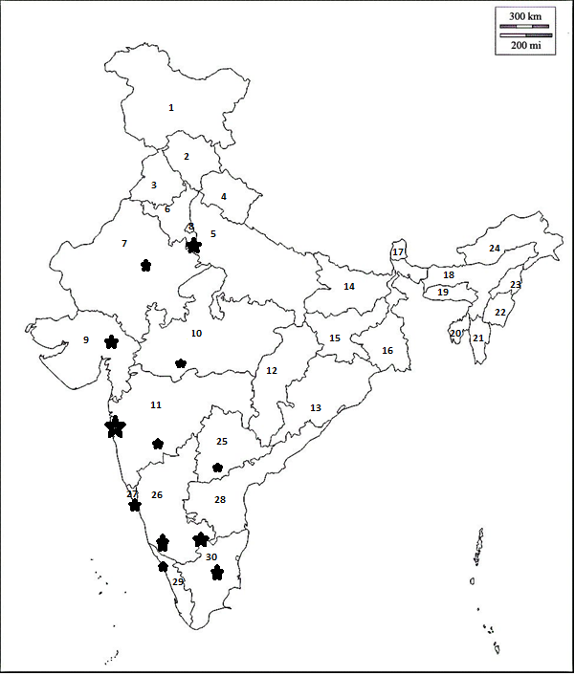

|  |  |  |  |  |
| --- | --- | --- | --- | --- |
| 1. Jammu &  Kashmir | 2. Himachal  Pradesh | 3. Punjab | 4. Uttarakhand | 5. Uttar Pradesh |
| 6. Haryana | 7. Rajasthan | 8. Delhi | 9. Gujarat | 10. Madhya  Pradesh |
| 11. Maharashtra | 12. Chattishgarh | 13. Orissa | 14. Bihar | 15. Jharkhand |
| 16. West Bengal | 17. Sikkim | 18. Assam | 19. Meghalaya | 20. Tripura |
| 21. Mizoram | 22. Manipur | 23. Nagaland | 24. Arunachal  Pradesh | 25. Telengana |
| 26. Karnataka | 27. Goa | 28. Andhra  Pradesh | 29. Kerala | 30. Tamil Nadu |

Note: The size of the stars in the diagram indicated the density of the retail outlets.

Source: Company documents.

EXHIBIT 3: AVERAGE DEMAND FOR BOXES PER MONTH

Note: ’16 = 2016; ’17 = 2017; ’18 = 2018; (E) = end of month

Source: Company documents.

EXHIBIT 4: DELAY IN SHIPMENTS (2013 to 2017)

Source: Company documents.

EXHIBIT 5: REJECTION IN DIFFERENT AREAS

Source: Company documents.

EXHIBIT 6A: PROCESS FLOW DIAGRAM (ICE CREAM PRODUCTION, PACKAGING, and SHIPping)

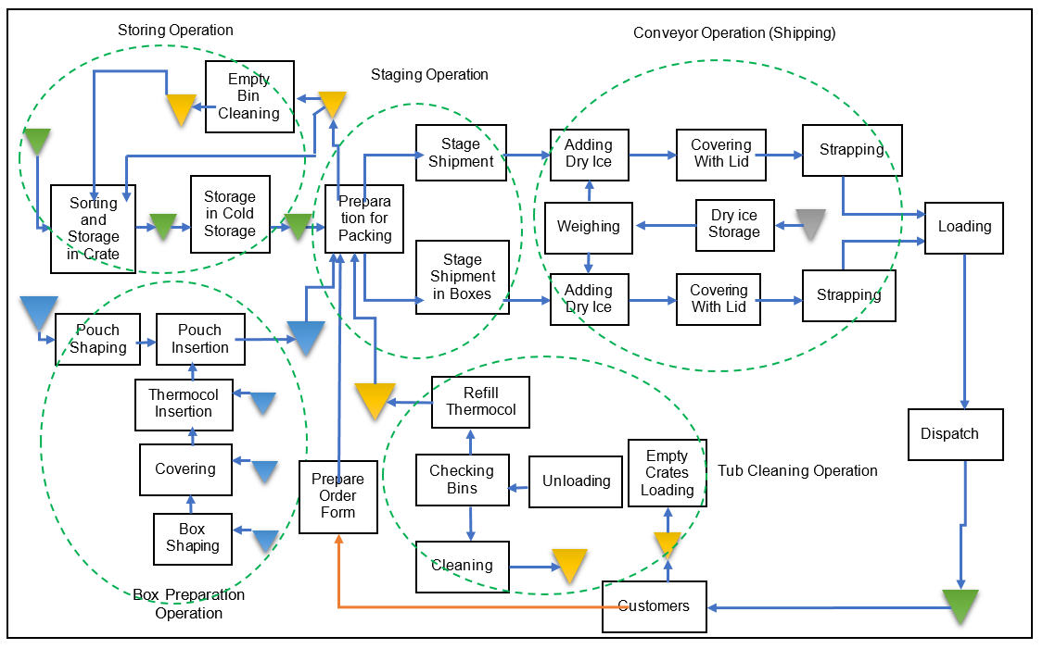

Source: Company documents.

EXHIBIT 6B: RESOURCES REQUIRED FOR ICE CREAM PRODUCTION, PACKAGING, and SHIPping

|  |  |  |
| --- | --- | --- |
| **Process** | **Labour Content (in Seconds)** | **Number of Operators** |
| 1. Packing | 72.0 | 3 |
| **2.1 Conveyor Operation (Nuggets):** |  |  |
| 2.1.1 Conveyor Control | N/A | N/A |
| 2.1.2 Dry Ice Weighing and Insertion | 52.0 | 2 |
| 2.1.3 Folding | 20.0 | 1 |
| 2.1.4 Labelling | 11.0 | 1 |
| 2.1.5 Lid Insertion and Inner Taping | 21.0 | 1 |
| 2.1.6 Outer Taping | 22.0 | 1 |
| 2.1.7 Strapping | 11.0 | 1 |
| **2.2 Conveyor Operation (Dry Ice Bars):** |  |  |
| 2.2.1 Conveyor Control and Labelling | 11.0 | 1 |
| 2.2.2 Dry Ice Weighing | 56.0 | 2 |
| 2.2.3 Dry Ice Insertion | 12.0 | 1 |
| 2.2.4 Paper and Thermocol Insertion | 7.0 | 1 |
| 2.2.5 Lid Insertion and Strapping | 14.0 | 1 |
| **3. Box Preparation:** |  |  |
| 3.1 Box Shaping | 25.4 | 1 |
| 3.2 Covering | 26.1 | 1 |
| 3.3 Thermocol Insertion | 52.0 | 2 |
| 3.4 Pouch Insertion | 45.0 | 1 |
| 3.5 Pouch Shaping | 24.8 | 1 |
| 4. Tub Preparation | 80.0 | 3 |

Source: Company documents.

EXHIBIT 7: ICE CREAM PACKING BOX DIMENSIONS

0.4 m

0.6 m

0.6 m

0.35 m

Top View of Box

Front View of Box

0.6 m

0.4 m

0.6 m

Top View of Tub

Front View of Tub

0.3 m

Note: m = metre

Source: Company documents.

EXHIBIT 8: AVERAGE MONTHLY WORKER ABSENTEEISM

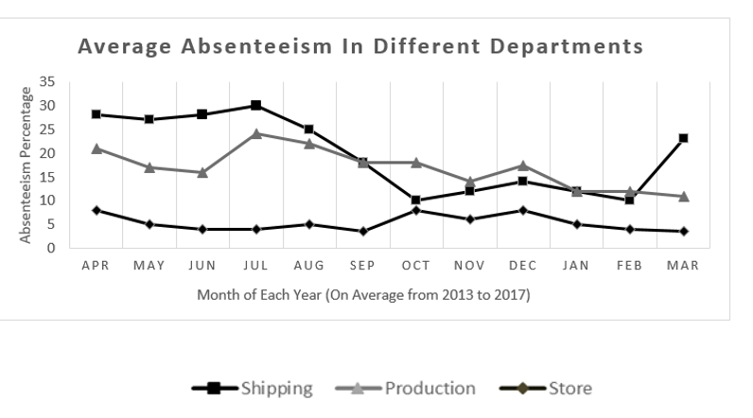

Source: Company documents.

EXHIBIT 9: PROCESS FLOW OF BOX PREPARATION

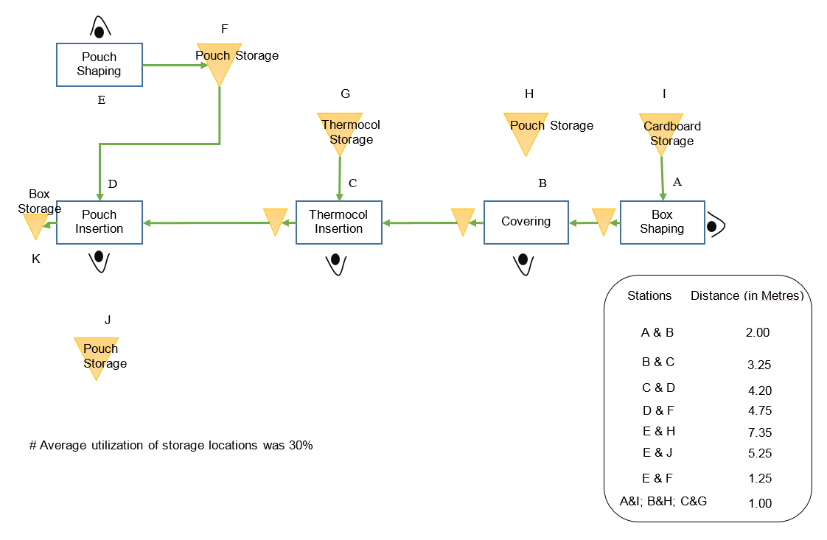

Source: Company documents.