

9B18D020

world tailors: stitching together a plan for growth

Kelsey Taylor wrote this case under the supervision of Professor Robert Klassen solely to provide material for class discussion. The authors do not intend to illustrate either effective or ineffective handling of a managerial situation. The authors may have disguised certain names and other identifying information to protect confidentiality.

*This publication may not be transmitted, photocopied, digitized or otherwise reproduced in any form or by any means without the permission of the copyright holder. Reproduction of this material is not covered under authorization by any reproduction rights organization. To order copies or request permission to reproduce materials, contact Ivey Publishing, Ivey Business School, Western University, London, Ontario, Canada, N6G 0N1; (t) 519.661.3208; (e)* [*cases@ivey.ca*](mailto:cases@ivey.ca)*;* [*www.iveycases.com*](http://www.iveycases.com)*.*

Copyright © 2018, Ivey Business School Foundation Version: 2020-01-08

As the December holiday season rapidly approached, Donna Teeple, director of World Tailors, wondered how all of the company’s high-quality aprons, napkins, and market bags would be completed in time. During the past seven years, World Tailors’ reputation had grown in the local community, and demand for its products had steadily increased from craft markets, online orders, and retail stores. How should World Tailors change its current operations to meet this new demand?

World Tailors was more than a local manufacturer of aprons. The company’s primary objective was to support courageous women, who had recently arrived in Canada as refugees and immigrants, during their integration into the community. For example, these women were able to develop their English skills, build friendships with other women, and learn workplace skills. World Tailors essentially operated as a collection of independent contractors coordinated by volunteers. Would reorganizing as a business co-operative better balance the unique social mission of the organization?

Company History

In the early 2000s, a church in London, Ontario, launched a learn-to-sew program for refugee women and immigrants. After five years of classes and fruitful sewing projects, the women who had participated clearly did not want the program to end. The participants had formed strong friendships and learned new skills that they were eager to continue using. Out of this early program, World Tailors emerged.

After considering many options, Teeple decided that a reversible chef’s apron would be the best choice for expanding and formalizing this early program (see Exhibit 1). This product did not require sizing, and the process was simple for women who lacked production-line sewing experience. These aprons could be sold at craft markets with all profits returning to the women who sewed them. Based on this idea, sample aprons were sewn and brought to a church craft market. An astounding 42 orders were paid for in advance, providing the necessary funding to purchase fabric and other materials. Teeple explained:

From the start, we’ve been a self-sustaining organization: we didn’t get any seed money from the church. We had a facility to do our work in, and we had some sewing machines. We had one storage closet and had to stow away all of our materials at the end of every week. Those 42 aprons took us two months. Then over the next two years, another volunteer and I were the bank of World Tailors. We would lend them money and then get reimbursed as sales arrived. Eventually, a community member stepped up and did some fundraising, which provided us with CA$10,000[1] of seed money. That really launched us!

developing skills and Building relationships

To help support women who had recently arrived in Canada as refugees and immigrants, each production day began with a half-hour social time, where the women shared what was going on in their lives and gave and received emotional support. In the organization’s early days, four women completed the bulk of the sewing. Since then, the group had grown to upward of 20 women working as contractors at any given time; however, the actual number who participated varied greatly each production day. New staff typically required about one month to become proficient sewers at a basic level.

Women heard about World Tailors primarily through word of mouth—for example, when women on the team talked about their experiences to friends, family, and classmates in their English as a Second Language (ESL) program. Teeple noted that more than 100 women had participated at some point in World Tailors. She reflected on their reasons for being involved: “The women come here to learn English and gain confidence. Because of the skills they learn here, they are able to go get a job. Some people stay here, and some people use it as a launching pad. They’ll gain what they can here, then off they go.”

Product Positioning in the Local market

Several specialty retailers in London, Ontario, focused on kitchen textiles and accessories, and similar products were carried by major retailers such as Walmart. As domestic manufacturers struggled to compete with low-cost imports, World Tailors needed to stand out in a crowded marketplace. To do so, World Tailors took great pride in the quality and unique styling of its aprons. The Master Cook apron was the only reversible apron available in London, and all of World Tailors’ products were made from 100 per cent cotton. In addition to competing on quality, World Tailors clearly communicated the local origin of its products and its social mission to both retailers and customers, which increased the appeal of its products to consumers.

In addition to sales at craft markets throughout the year, Teeple and other sales volunteers developed strong relationships with five specialty retailers in London. These retailers promoted the story behind the product to their customers and accounted for 46 per cent of revenue. Retailers applied a markup of only 33 per cent for all of World Tailors’ products (i.e., wholesale price was $30 for the Chef’s Apron), rather than the more usual 50 per cent, to allow for competitive pricing against similar high-end kitchen products. Orders were also taken from restaurants for customized aprons, which presented a new market opportunity for growth.

Production Process

One of the most important decisions World Tailors made was designing its product line. For operations, a reversible Master Cook’s apron allowed the use of a single pattern that was straightforward to apply in a production-line setting. Simplicity was key, as all of the women needed to be trained in sewing.

World Tailors’ production facility included two rooms, namely a cutting room and an assembly room (see Exhibit 2). The cutting room also served as the primary storage area for raw materials, work-in-process inventory, and finished goods. The assembly room housed all of the sewing machines, a pinning table, ironing stations, and the charts used to track progress toward production goals. The full process consisted of six major stages (see Exhibit 3), each of which encompassed several steps at one or more stations. Materials and components frequently moved back and forth between stages and stations.

Cutting Materials

Each apron began as a large roll of cotton fabric, with each apron requiring approximately 2 square metres. Fabrics were purchased in small volumes, which did not permit wholesale pricing. Fortunately, a few distributors discounted some of the fabric sold to World Tailors because they supported the organization’s mission. As a result, the colours and patterns of their aprons changed frequently, creating products that suited a wide range of tastes and preferences. Inventory fabric, thread and zippers, and other items were about $5,000.

The first stage of the production process was cutting. Large rolls of fabric were spread out on an industrial cutting table in the cutting room, and stencils were laid onto the fabric. These stencils ensured a uniform shape and size for all pieces and allowed the cutting room staff—usually one team member and one volunteer—to cut the apron components quickly.

The aprons were reversible, so different fabrics were used on the front and back panels of the apron, and each front and back panel required multiple components. The amount of time needed to cut all components depended on the fabric being used. For example, compared with solid-colour fabrics, fabrics with text required stencils to be placed with greater care to ensure that the text was legible when the apron was worn. A single apron comprised nine different components, some of which required two pieces (e.g., straps), resulting in a total of 13 pieces of fabric for a finished apron. After the apron components were cut, each type of apron piece (e.g., strap, body panel) was sorted into its own bin.

Apron Assembly

The remaining stages took place in the assembly room, with each apron passing through multiple iterations of ironing, pinning, and sewing during assembly. Team members needed to have a high degree of flexibility and to understand what was expected for each component at each stage. For example, a sewer might be primarily responsible for sewing straps during one shift but also might quickly sew several pockets if the need arose.

The first people on the assembly team to receive materials from the cutting room were the ironers. They pressed creases into the two pieces that would later form each pocket; creases also were ironed into the two pieces that formed each strap. Next, pinners aligned and attached the two pieces for each pocket and strap using metal pins, using these creases as a guide. Third, sewers permanently attached the two pieces of each pocket and each strap.

Sewn straps and pockets were returned to pinners, who pinned the front pocket and all three straps onto the front panel of the apron. The front panel was then passed back to sewers who permanently attached the pinned parts. Similarly, a back pocket was pinned to a back panel before being attached by sewers.

Next, the front and back panels of the aprons (complete with sewn pockets and straps) were returned to the pinners to pin the front panel and back panel together, inside out. The sewers completed the seams on three of the four sides. Before completing the last side, pinners turned the apron right-side out, and ironers carefully pressed all sewn seams to ensure a professional, finished appearance for each apron. Sewers then completed the apron by topstitching the fourth side.

After the apron was completed, a quality inspection took place to ensure all hems had been finished appropriately and all components of the apron were securely attached. If a problem was discovered (less than 5 per cent of the time), the apron was placed in a rework bin in the cutting room and later repaired offsite by an experienced volunteer. Reworking these aprons was time-consuming but necessary so World Tailors could uphold its reputation for quality. After passing inspection, the apron was wrapped in twine, a World Tailors’ tag was attached, and the finished product was placed in a marked bin in the cutting room, ready for sale.

Additional Products

In addition to the Master Cook aprons, which were its most popular product, World Tailors also offered Junior Cook and Wee Cook aprons for children, a Garden Bistro apron, and a Market Bag (see Exhibit 1). Fortunately, all of World Tailors’ products required the same basic skills, and the women were able to easily transition from producing one product to another. Each product had a slightly different production process, with the Master Cook apron being the most labour-intensive. For example, the Market Bag had a much simpler shape, only a single pocket, and two straps. The need to cut and sew long, straight lines made straps the most difficult component in the entire process. Removing a single strap from the design translated into significant savings. Lower costs tended to be reflected in lower retail prices (see Exhibit 4).

Production Scheduling

The organization’s ability to meet demand depended heavily on the availability of team members, yet scheduling was complicated by the unique needs of World Tailors’ workforce. Most of the women who worked at World Tailors were actively engaged in demanding ESL classes, so production schedules were set to avoid conflicts. In addition to language classes, many of the women had young children or were the primary caregivers for older relatives. Consequently, absenteeism continued to be a key challenge and a major source of production delays.

Operations were initially scheduled one half day per week (i.e., 3.5 hours for production) but subsequently expanded to two half days to meet growing demand. To further expand sales, the women had collectively decided to introduce a third half day for a total of 10.5 hours of production each week. A full team comprised 16 workers (see Exhibit 3), with women being assigned to tasks based on their sewing ability and preferences. At least one additional volunteer was present to help manage the production flow and troubleshoot issues that might arise with the equipment or materials. However, because of absenteeism, the production team usually ranged from 12 to 16 women, not counting volunteers, but some days, the number dropped to eight.

Sales experienced a dramatic seasonal spike in demand leading up to the December holiday season. During the initial years, a 10-month schedule had been sufficient, with no production in summer. In the past July, the women broke with tradition and chose to continue to use a two-day schedule to build inventory ahead of the holiday season. However, as demand continued to increase, little inventory buildup actually occurred.

Although the bulk of the production work was done by newcomer women, many of the sales, administrative, training, and managerial tasks were completed by about 20 unpaid volunteers, who also helped with production when needed. With so much of the day-to-day work coordinated by volunteers, long-term planning was difficult.

Financial success

While profit was not a central aspect of World Tailors’ mission, it was important that the working women share all the profits from their work (see Exhibit 5); the company’s success was reflected in a 50 per cent increase in sales over the past two-year period. Organizationally, each member of the team was considered a subcontractor, due to the flexible schedule. For accounting purposes, each person was paid on a quarterly basis, prorated by the number of hours contributed during that quarter. Although the amount earned by each woman was modest, this payment was often each woman’s first experience generating her own income.

Moving Forward

As their busiest time of the year was coming to a close, Teeple had the opportunity to reflect on how to better organize World Tailors’ products, processes, and schedules for the coming year. Several challenges needed her immediate attention. First, the production space was provided without a rental fee, but its future availability was uncertain. Given the limited profits, how could World Tailors afford to pay rent, and what would be the implications of any move for the team?

Second, Teeple believed that if production capacity could be maintained, significant opportunities remained to grow sales. But how should this objective be balanced against the social mission and the unique needs of the women? Moreover, the desires of the local volunteers working behind the scenes also had to be considered. A long-time World Tailors volunteer described her experience, observing, “World Tailors was a great joy in my life, but it is a huge commitment from volunteers. Is that sustainable for five more years? As the organization continues to grow, so do the responsibilities.”

Third, with volunteers already overstretched, Teeple believed that additional production days would need to be managed differently. Could World Tailors shift greater oversight to team members? She observed:

From the start, we’ve been trying to develop leaders who could manage the production floor. I have two women now who do that. They do a really good job. For a year now, they’ve been managing Friday afternoons all by themselves. I give direction on what they should make, but they are responsible for getting it through the production line and troubleshooting. I can’t ask anything more of the volunteers. We’ve got an amazing group of volunteers and I don’t want to burn them out.

Finally, Teeple wondered whether restructuring the organization might allow World Tailors to replicate its success in another location—given the demonstrated impact on the lives of refugees and new immigrants. Rather than operate as a collection of independent contractors, World Tailors could reorganize as a co-operative organization (co-op). The primary purpose of a co-op was to meet the needs of its members, whatever those needs might be, rather than maximizing profit.[2] Also, closely aligned with World Tailors’ own values, a co-op involved all members in key decisions by assigning one vote per member rather than basing votes on the number of shares held.[3] The democratic structure of a co-op would encourage the women to take greater ownership of and responsibility for the organization. Was this the right time to make such a major change?

The Ivey Business School gratefully acknowledges the generous support of the Ernst & Young Fund in the development of this case.

Exhibit 1: WORLD TAILORs’ PRODUCTS

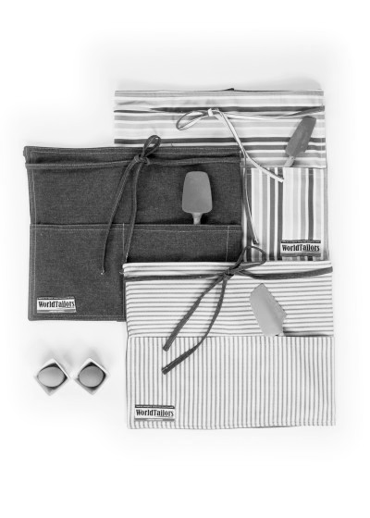

*Garden Bistro Apron*

*Master Cook Apron*

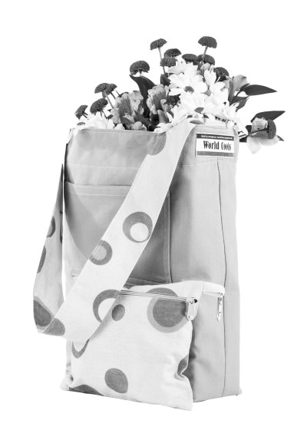

*Market Bag*

Source: Company files.

Exhibit 2: world tailors’ FACILITY LAYOUT

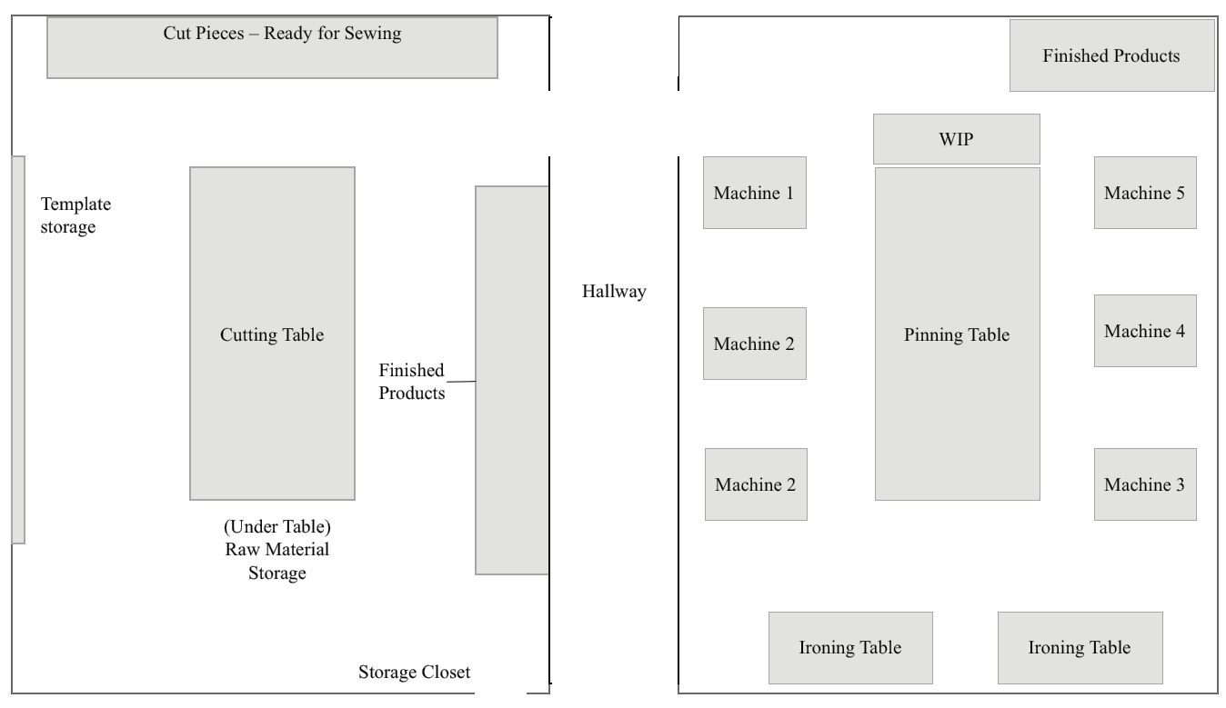

Assembly room

Cutting room

Note: WIP = work in progress

Source: Company files.

Exhibit 3: world tailors’ AVERAGE PRODUCTION TIME BY STAGE

|  |  |  |  |  |
| --- | --- | --- | --- | --- |
| **Process Stage** | | **Steps** | **Minutes per Apron (for one person)** | **Staffing** |
| 1. | Cutting | Lay out templates. Trace and cut pieces, including:   * Front * Back * Facing * 2 Pockets (4 pieces total) * 3 Straps (6 pieces total) | 25 | 2* |
| 2. | Ironing | 1. Iron components. Pieces to iron:  * Pockets * Straps  1. Iron semi-finished apron. | 14 | 2 |
| 3. | Pinning | 1. Pin components together.  * Pin two pockets (2 pieces per pocket). * Pin three straps (2 pieces per straps).  1. Pin components to apron panels.  * Pocket and three straps to front panel. * Pocket to back panel.  1. Pin apron panels and facing together (inside out). | 25 | 3 |
| 4. | Sewing components | Trim thread. Components to sew:   * Pockets (2) * Straps (3) | 60 | 5 |
| 5. | Sewing apron | 1. Sew pocket and three straps to front panel. 2. Sew pocket to back panel. 3. Sew apron panels together (inside out). | 30 | 3 |
| 6. | Quality inspection & labelling | Inspect that all components are well sewn.  Examine evenness of stitching.  Make minor repairs if needed.  Tie with twine and attach tag for sale. | 4 | 1 |
|  | Transit | Move pieces from cutting room to sewing.  Move pieces between pinning, ironing, and sewing stations. | Shared among  all team members | |

Note: *One volunteer typically works together with one team member.

Source: Company files.

Exhibit 4: world tailors’ PRODUCT OFFERINGS (in CA$)

|  |  |  |
| --- | --- | --- |
| **Item** | **Retail Price* ($/unit)** | **Inventory (units)** |
| Master Cook Apron | $39 | 6 |
| Junior Cook Apron | $29 | 14 |
| Market Bag | $35 | 10 |
| Garden Bistro Apron | $29 | 8 |

Notes: *Retailers, which accounted for 46 per cent of sales, allowed for a markup of about 30 per cent, e.g., wholesale price for the Chef’s Apron was $30; In contrast, sales at craft markets and online allowed World Tailors to receive the full retail price.

Source: Company files.

Exhibit 5: world tailors’ income statement (in CA$)

|  |  |
| --- | --- |
| **Sales (by product)** |  |
| Master Cook Apron | $ 15,000 |
| Junior Cook Apron | $   2,250 |
| Market Bags | $   9,250 |
| Garden Bistro Apron | $   1,600 |
| ***Total sales*** | $ 28,100 |
|  |  |
| **Cost of goods sold** |  |
| Fabric | $ 10,500 |
| D-Ring | $        50 |
| Thread | $      250 |
| Labels | $   1,000 |
| General Supplies | $      150 |
| Zippers | $      750 |
| Sewing Machines | $   1,000 |
| Office Expenses | $   1,100 |
| Service Fees (PayPal & Square) | $      350 |
| ***Total expenses*** | $ 15,150 |
| **Profit** | $ 12,950 |

Source: Company files.

1. All currency amounts are in Canadian dollars.
2. Government of Canada, “Canada Business Ontario: Starting a Cooperative,” May 28, 2015, accessed March 12, 2018, www.cbo-eco.ca/en/index.cfm/starting/getting-started/starting-a-co-operative/.
3. Ontario Co-operative Association, “Co-op Comparisons: Legal Characteristics of Co-operative, Private and Not-for-Profit Corporations,” April 2012, accessed March 12, 2018, www.ontario.coop/cms/documents/1/Co-op_Biz_Comparisons_and_legal_combin.ed_April2012.pdf.