

9B18D021

KAPS FOODS INDIA Pvt. LtD.: DATA MISMANAGEMENT

Ritu Singh and Vinay Kalakbandi wrote this case solely to provide material for class discussion. The authors do not intend to illustrate either effective or ineffective handling of a managerial situation. The authors may have disguised certain names and other identifying information to protect confidentiality.

This publication may not be transmitted, photocopied, digitized, or otherwise reproduced in any form or by any means without the permission of the copyright holder. Reproduction of this material is not covered under authorization by any reproduction rights organization. To order copies or request permission to reproduce materials, contact Ivey Publishing, Ivey Business School, Western University, London, Ontario, Canada, N6G 0N1; (t) 519.661.3208; (e) cases@ivey.ca; www.iveycases.com.

Copyright © 2018, Ivey Business School Foundation Version: 2018-10-26

At the end of December 2016, Kaustubh Dharmadhikary, the sales and marketing head of Kaps Foods India Private Limited (Kaps), was preparing the upcoming year’s marketing plan, which was to be discussed at an interdepartmental meeting scheduled for the following week. To better understand market needs and expectations, he started reviewing the yearly feedback forms he had received from Kaps’ customers. Apart from a few delivery- and invoicing-related issues, the common problem that stood out in most of the feedback was the imbalance between the ice cream variants requested by customers and the variants offered to them. Dharmadhikary was surprised and worried at the same time. He had been under the impression that recent capacity upgrades and expansion had resolved all inventory-related issues. However, this was clearly not the case.

The next morning, Dharmadhikary convened a meeting with the sales team to determine the underlying cause of the problem. When he asked why there was an imbalance between demand and supply of ice cream variants, a sales representative replied that when a particular variant was not in stock, salespeople tried to convince customers to take the available alternatives in the same price range. This practice was common in the industry and was not seen as a major problem. However, this made Dharmadhikary wonder about the implication of the practice: Was this affecting the firm’s performance in any way? Was this bad service, and would customers want to switch to a competitor for this reason? What was Kaps doing wrong?

ICE CREAM INDUSTRY

The Indian ice cream industry had estimated annual sales of over ₹40 billion[1] for the year 2016. With an annual sales growth over the past decade ranging between 15 and 20 per cent, it was projected to reach about ₹62 billion by 2019.[2] This burgeoning growth was attributed to higher purchasing power, evolving consumer preferences, and technological advances in ice cream manufacturing.

Large national brands such as Anand Milk Union Limited, Vadilal Industries Limited, Kwality Wall’s, and Mother Dairy Fruit & Vegetable Private Limited owned approximately half of the market share, and the rest of the market was divided among several small regional players. National brands looked to improve their market share through investments in greater product variety and large-scale advertising campaigns; the establishment of countrywide distribution networks; exponential increases in their outlet numbers; and mergers and acquisitions. The small and regional players worked to stay relevant and profitable in the hyper-competitive landscape. National and regional players were competing against each other on quality, price, faster order cycles, and localized ice cream flavours.

With the advent of advanced technology, manufacturers had been able to mass produce ice cream in the desired size and quantity to cater to a growing market. However, the industry faced the challenge of fluctuating demand due to seasonality. The demand for products was very high during the summer months but was significantly low for the rest of the year, depending on various external factors. Further, because ice cream was a perishable product, it could not be stored over long periods of time, and this forced manufacturers to set up plants that could produce sufficient quantities to fulfill the peak demand.

COMPANY BACKGROUND

In 2001, four graduates of a dairy technology course came together to start Kaps, with seed capital of ₹1 million. Kaps was one of the preeminent ice cream manufacturers in Raipur, Chhattisgarh, in Central India. Established under the government of India’s Rural Employment Generation Programme, Kaps aimed to generate employment in rural areas. The company commenced its operations with 20 employees and a production capacity of 400 litres per day, and manufactured all of its ice cream products through batch processing. The company had successfully carved out a niche in this increasingly competitive space by focusing on manufacturing high-quality ice creams.

The company started as a regional entrant in the central Indian ice cream market and catered to ice cream parlours, hotels, caterers, individuals, and food vendors. The organization had a strong foundation made up of technology experts, competent consultants, trained professionals, and hi-tech equipment. During the peak demand season (March–June), it employed a few temporary employees, who worked with permanent employees to deliver a superior product to customers. To strengthen its market position, Kaps had made swift service to customers its primary emphasis. Consequently, the company secured an image as a reliable manufacturer of ice creams.

The company was certified according to the International Organization for Standardization’s ISO 9001:2008 standard.[3] Kaps’ high-tech production unit spanned about 930 square metres in Raipur, the capital of Chhattisgarh state. The company was also registered with the Food Safety and Standards Authority of India (FSSAI), and its manufacturing units were designed as per FSSAI and ISO norms. The company aimed to ensure a complete hygienic and organized manufacturing setting for producing ice creams. It had established an independent quality-control unit, in order to meet customer demands, and it performed technical assessments of its products to verify that they were acceptable and in line with quality standards.

As the company started to penetrate the market, its manufacturing operations strained to keep up with the demand and sales growth. To maintain this growth, Kaps started to expand its production capacity, in phases, to 20,000 litres per day in February 2016. Along with this expansion, the company also started to improve the manufacturing process, manufacturing most of its ice cream products (except frozen candy bars) through continuous processing.

PRODUCT and CUSTOMER INFORMATION

Like any other ice cream manufacturer in the market, Kaps sold its products in a variety of packages for different ice cream flavours. Unit prices for each product ranged from ₹5 to ₹700, with most selling units in the price range of ₹10–₹50. It used the same base mix (a mixture of milk, milk fat, skimmed milk powder, stabilizers, and emulsifiers) for all ice cream products except frozen candy bars, whose mixes depended on the ice cream flavour. Although the products were first sold in bulk and family packs, Kaps later started selling cups, cones, and bars.

In addition to manufacturing more than 65 different standardized products, each in a different size, shape, or flavour, the company also offered customized containers of ice cream for wholesalers and retailers. Kaps also sold commercial freezers to its distributors to stock ice cream in their warehouses.

Kaps’ major customers included a pool of distributors in central India who in turn supplied the ice cream to local retailers. The company targeted all customer segments, and it owned and managed a few outlets that sold products directly to consumers. It had only one manufacturing unit in Raipur, from where it shipped the products to its distributors. The company also had tie-ups with local restaurants, hotels, and ice cream parlours to sell its products.

MANUFACTURING PROCESS

Ice cream was a cold dessert—an icy combination of sweetened cream blended with supplementary seasonings. It contained at least 10 per cent milk fat and at least 20 per cent total milk solids, along with skimmed milk powder, sweeteners, emulsifiers, stabilizers, water, and seasoning ingredients. At Kaps, the manufacturing process started with making the ice cream base mix by selecting the right ingredients (milk, milk fat, skimmed milk powder, stabilizers, and emulsifiers). After that, the base mix was pasteurized through a high temperature/short time (HTST) process at 73 degrees Celsius (°C). Then, the base mix was homogenized (at a pressure of 2,500 pounds per square inch) to reduce the globule size of the milk fat for better emulsion, which created smoother and creamier ice cream. The homogenization process also guaranteed that the stabilizers and emulsifiers were properly mixed and equally dispersed in the ice cream blend before it was cooled.

After homogenization, the base mix was kept at 4°C overnight to avoid freezing. This made the milk fat partially crystallize and gave the protein stabilizers time to hydrate, which improved the whipping properties of the mix. Different seasonings could be added to the base blend before freezing, and the blend could then be cooled in an individual batch or in a continuous freezer. Cups, cones, and family and bulk packs were frozen in a continuous process, while candy bars were frozen in a batch process. In continuous processing, after the production of the first flavour was finished, the continuous freezer tank was then filled with the next flavour to start the production of a different flavour. In the process, some of the ice cream base mix had to be thrown out because it was a mixture of both flavours and hence could not be used for sale.

Just before the final packing, different kinds of bulky flavourings (e.g., candy pieces and nuts), fruits, and swirls were added to the ice cream, which was then hardened as quickly as possible, keeping the temperature below −35°C. The finished product was stored at −23°C to −29°C in the cold room (see Exhibit 1).

ORDER FULFILLMENT PROCESS

The company appointed sales representatives to interact with the customers and take a note of their orders. Every morning, a list of available inventory for each ice cream variant was compiled and provided to the sales force. A customer would call to place an order, and the sales representative would note down the order in an order sheet, using a different abbreviation for each variant (see Exhibit 2). If the current inventory sheet indicated that a particular ice cream variant was not available, the representative would try to convince the customer to buy an available alternative in the same price range and would then note down the order details accordingly. A final sales record was then created and stored in the computer, and the order sheet was disposed of later.

The orders were usually packed the same day, after sundown, and delivered to customers the next day by a small group of contractors who usually supplied their own vehicles. Kaps also owned and operated a small fleet of its own delivery vehicles, which were primarily used to cater to any bulk or special orders. The production plan for the subsequent day was prepared based on these sales records, so that all the variants that were sold were replenished. Kaps did not have any formal process for revisiting inventory levels. The inventory levels of all the variants were determined using past sales data.

KAPS’ PROBLEM

After the discussion with the sales team, Dharmadhikary raised the issue with other department heads in the internal meeting. He told them that even though production capacity had been sufficiently increased, there was a gap between demand and supply for certain variants. However, the loss of sales was not significant, as sales representatives were successfully negotiating with customers to get them to accept the available alternatives within the same price range in place of missing stock.

The question remained: How was the demand and supply mismatch affecting the firm’s performance? Should Kaps address this problem now, and if so, how?

Exhibit 1: flow chart of the ice cream manufacturing process at Kaps

Note: °C = degrees Celsius; psi = pounds per square inch.

Source: Company documents.

Exhibit 2: Sample Order Sheet

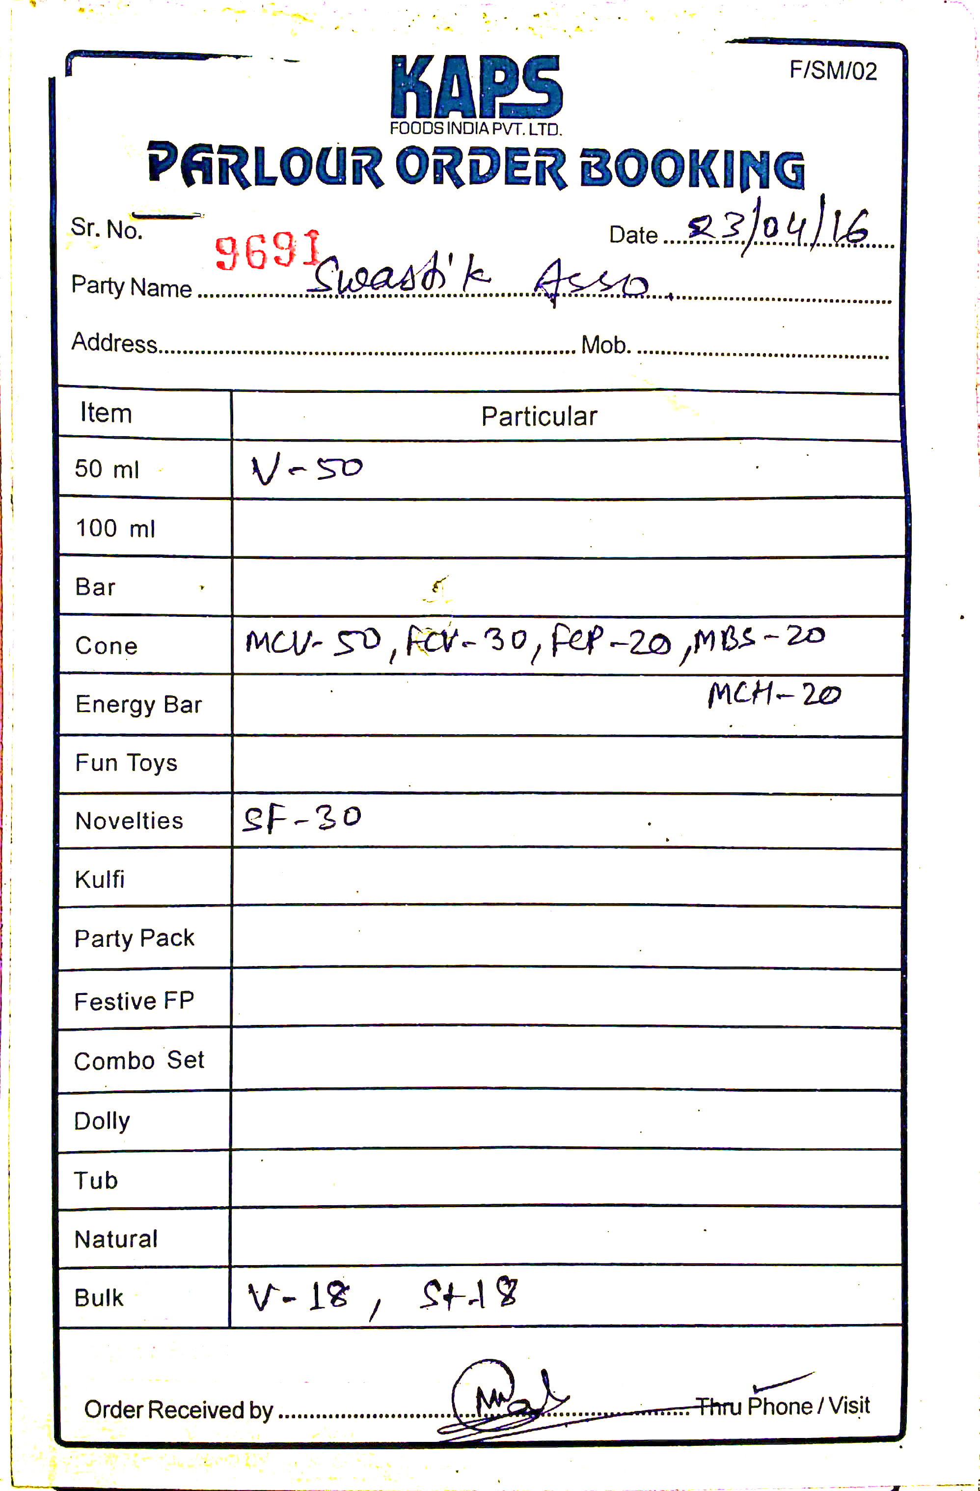

Source: Company documents.

1. ₹ = INR = Indian rupee; US$1.00 = ₹68.20 on December 28, 2016; all currency amounts are in ₹ unless otherwise specified.
2. Research and Markets, “A Study of India's Ice Cream Market 2017 – Research and Markets,” news release, Business Wire, June 12, 2017, accessed March 3, 2017, www.businesswire.com/news/home/20170612005527/en/Study-Indias-Ice-Cream-Market-2017; Research and Markets, “Study of India's Ice Cream Market 2016 – Research and Markets,” news release, Business Wire, August 11, 2016, accessed March 3, 2017, www.businesswire.com/news/home/20160811005927/en/Study-Indias-Ice cream-Market-2016.
3. For detailed information, please see International Organization for Standardization, “ISO 9001:2008: Quality Management Systems—Requirements,” November 2018, accessed July 18, 2018, www.iso.org/standard/46486.html.