|  |  |
| --- | --- |
|  | VLERICK LOGO |

9B18E002

UCB: DATA IS THE NEW DRUG

Stijn Viaene wrote this case solely to provide material for class discussion. The author does not intend to illustrate either effective or ineffective handling of a managerial situation. The author may have disguised certain names and other identifying information to protect confidentiality.

*This publication may not be transmitted, photocopied, digitized, or otherwise reproduced in any form or by any means without the permission of the copyright holder. Reproduction of this material is not covered under authorization by any reproduction rights organization. To order copies or request permission to reproduce materials, contact Ivey Publishing, Ivey Business School, Western University, London, Ontario, Canada, N6G 0N1; (t) 519.661.3208; (e)* [*cases@ivey.ca*](mailto:cases@ivey.ca)*;* [*www.iveycases.com*](http://www.iveycases.com)*.*

Copyright © 2018, Vlerick Business School and Richard Ivey School of Business Foundation Version: 2018-01-26

At the beginning of 2016, Herman De Prins, chief information officer (CIO) at global pharmaceutical company UCB, felt he had made good progress with his data analytics efforts, which focused on neurology and immunology. Since 2014, he had used an “Analytics as a Service” (AaaS) framework to guide his efforts, and had employed a number of projects he called “analytics sprints” to inspire the organization and demonstrate the possibilities of data analytics. Over the past five years, the CIO had worked hard to transform the company’s information technology (IT) culture from one of IT suppliers to one of IT entrepreneurs, based on his vision of the future of IT. Still, he could not help feeling a bit frustrated. The pharmaceutical industry had only begun to use real-world data to create patient value. De Prins had laid a solid foundation for accelerating IT in this direction, but the process was no longer solely in his hands. It seemed like the right time to further pull the analytics competency out of the IT domain.

UCB’s chief executive officer (CEO) had invited De Prins to join the March 2016 executive meeting in Shanghai, China, to discuss the company’s strategy and especially De Prins’s views on digitalization. He pulled a piece of paper out of his desk and started jotting down possible arguments for the following: Why was this the right time for UCB to move to the next stage with analytics? Ideally, which decisions would the executive team make?

Pharma: Moving Beyond the Pill

Rising economic and demographic stresses on health care systems were forcing health care providers to improve their performance. Health care was considered ripe for change, and digital technologies were ready to be part of that change. New competitors such as Apple Inc., Google, Samsung Electronics Co. Ltd., and International Business Machines (IBM) were moving into health care. By 2015, patients had become much less dependent on their doctors for advice, and health had become a major search category on mobile devices. The vast amount of health information available online and in applications (apps)—more than 90,000 items in the iTunes store alone—made patients feel empowered. Governments and payers, driven by economic constraints and aging populations, were putting pressure on pharmaceutical companies to reduce costs; if they wanted to retain market access and premium pricing, companies needed to demonstrate the value of their drugs using real-world data, not only data from controlled trials.

Analysts argued that the use of real-world data would enable companies to tackle major health care challenges such as compliance and chronic disease management, and would help them create hundreds of billions of dollars in value. Digital technologies and data enabled providers to move beyond simply selling drugs to take a more holistic approach to patient health. However, the use of patient data had to comply with global regulations that protected patients and privacy. Pharmaceutical companies like UCB needed authorization from regulatory bodies to leverage the large amounts of data they would be analyzing, combining from multiple sources, and sharing with other organizations. De Prins was well aware that, when it came to their use of data, these companies were strictly regulated. He stated, “Machine learning and data solutions came with all sorts of new challenges for us. For example, cognitive computing algorithms could potentially suggest off-label therapies, although this was the prerogative of doctors. Life science and tech companies would have to tackle this.”

UCB: “Inspired by Patients. Driven by Science”

UCB, a global biopharmaceutical company headquartered in Belgium, focused on developing innovative medicines and therapies for people living with severe diseases of the immune system (for example, osteoporosis and lupus) or the central nervous system (for example, epilepsy and Parkinson’s disease). In 2015, the company generated revenue of €3.88 billion.[1] Four key medicines accounted for 79 per cent of its global net sales. UCB had 7,800 employees in 40 countries and employed over 1,000 research and development (R&D) staff in its two research centres in the United Kingdom and Belgium, spending 27 per cent of its revenues on research.

When Jean-Christophe Tellier became CEO in 2015, the organization introduced its patient value strategy. This transformation reflected a fundamental shift from being paid for the volume of care it delivered to being paid for patient value. Tellier summarized the strategy as “connecting the patient to the science, connecting the science to the solutions, and connecting the solutions back to the patient” (see Exhibit 1). The new business strategy reoriented UCB to strive for long-term patient value outcomes and to integrate patients’ insights throughout the operating model. Growth was centred on four patient value units—neurology, immunology, bone disorders, and new medicines—representing different patient populations. These were supported by unified practice units (centres of excellence), functional units, and global operations (see Exhibit 2).

Innovation leading to differentiated medicines that secured future sustainability continued to be at the heart of UCB. However, Tellier recognized that radical changes were taking place in the health care ecosystem, as adaptive, innovative competitors made use of advanced information technologies. Tellier commented on the importance of growing digital capabilities: “The ‘average patient’ would no longer exist—and data would be the linchpin for realizing this. But we hadn’t integrated digital into the fabric of the business yet. We were just at the beginning of our patient value transformation journey.”

UCB knew it could not become the patient-preferred biopharmaceutical leader by acting alone. Thus, it adopted a network approach to innovation as an important pillar of its new strategy, expanding and strengthening external connections, combining competitive strengths, and learning co-operatively. For example, UCB reinforced existing ties with universities such as Harvard, Cambridge, and University of Leuven. It partnered with companies such as Great Lakes NeuroTechnologies (to collaborate on wearables and data visualization tools), MC10 Inc. (to prototype a device that used wearable sensor patches and a patient diary app to monitor Parkinson’s symptoms), and IMS Health and Synthesio (to advance social listening capabilities to enhance patients’ experiences—for example, by identifying patient issues and monitoring adverse effects). In 2016, UCB opened a new U.S. solution accelerator in Atlanta, extending an earlier collaboration with Georgia Institute of Technology (Georgia Tech) that gave UCB access to the institute’s state-of-the-art machine learning and advanced analytics resources.

A Cultural Foundation: The Future of IT

In a historic event in February 2011, IBM’s supercomputer Watson won the popular television quiz show Jeopardy! against two of the show’s all-time human champions. A few months later, De Prins began to explore using Watson to support clinical decision making in caring for patients with epilepsy, a disease that afflicted 65 million people worldwide. A combined IBM–UCB team developed a prototype system (see Exhibit 3) that translated massive amounts of epilepsy patient data and scientific literature into insights that health care providers could consult at the point of care to inform themselves about alternative treatment decisions. This experience with Watson sparked De Prins to realize that data and analytics would revolutionize health care.

That same year, De Prins introduced a program called The Future of IT to clarify the role of IT at UCB going forward. De Prins wanted to prepare his IT organization for the “new digital normal.” Technologies such as cloud computing, 3D printing, and cognitive computing were ushering in a new age of technology-dominant competition. He was convinced that IT departments that merely consisted of staff and project managers who controlled budgets and supplied business demands would be unsuccessful.

“The Future of IT” program included five principles:

* “We promise quality:” IT’s credibility depends on quality service, so IT needs to continue to emphasize the importance of quality as demand and cost pressures increase.
* “Everyone is a specialist:” IT people cannot know a little about everything. Every employee needs to be a technology specialist—whether it’s in analytics, medical devices, health care IT, or mobile. IT needs to be so good at [its] core business—technology—that [it] cannot be ignored.
* “We work as a team:” A strong foundation of collaboration enables specialists, spanning both IT and business, to combine their best-in-class skills to deliver new customer value.
* “We innovate in a timely manner:” The process of innovation is rapid and end-to-end: brainstorm lots of ideas, develop some into options, evaluate quickly, and get the best solutions to market fast. Everyone has a licence to innovate.
* “We talk value of IT:” IT people are appreciated because they talk about creating business value, not technology resources. IT markets its business value, not just its activities.

With these five principles established, the CIO had a solid basis for moving forward. At the end of 2012, De Prins decided it was time to build an advanced analytics capability. It started small, with an investment in three full-time equivalents on the IT budget, but the ambition ran high.

A Comprehensive Framework: Analytics as a Service

At UCB, a great deal of data was available internally across the entire value chain—from R&D to commercial processes to operations. All internal entities produced data, and some (for example, drug trials, evidence-based medicine, and commercial business intelligence) used it intensively to manage their processes. Still, data was usually exploited only for primary uses—that is, managed in specific contexts for particular purposes. Innovation, such as The Future of IT, aimed to employ advanced analytics methods to make that data available for secondary uses—that is, to explore the potential of the data for value innovation beyond the original context. This entailed working across the many internal data silos.

At the same time, the availability of health care-related data from sources outside the organization was exploding: this included data from health care providers (for example, admissions data, lab results, and genomic data), public and private payers (for example, payment data and information about treatment claims), suppliers (for example, industry intelligence and market research), digital patients (for example, social media and geolocation details), and smart devices (for example, data on gestures and biometrics). UCB’s IT leadership realized early on that true value innovations would come from tapping into this wealth of external data. Big data was important to a patient-centred approach to health care, or patient-centricity (see Exhibit 4). For that reason, UCB needed convenient ways to mix and match external and internal data and to team up with external parties to exploit data in new ways.

In January 2013, a visioning exercise gave rise to a conceptual framework for the AaaS capability (see Exhibit 5). The intention of the capability was captured in three objectives:

* “Data is a corporate asset (Share):” Data is an asset in its own right, managed to be broadly and conveniently accessible, enabling all sorts of collaborations to create valuable solutions. Insights from data and other data products are continuously shared so that they can be reused efficiently by the corporate community.
* “Experimentation is key (Explore):” An environment is provided for swift and agile exploration, allowing analytics initiatives self-service by conveniently pulling in multiple internal and external data sources and using all sorts of analytics tools.
* “Learning is the key (Promote):” Best practices for conducting successful analytics initiatives are actively and constantly scouted out and quickly replicated across the organisation.

To reach these three objectives, three enabling investments were proposed:

* “Amplify portal:” This was meant to be the central point of reference for all analytics initiatives, which would provide the latest news, serve as an app store for data and data products (for example, code, algorithms, and analytics solutions), host data labs, and enable knowledge management.
* “Data labs:” These were sandbox environments where analytics teams could experiment with data. A data lab would exist for a fixed period of time and would be decommissioned once the exploration was complete. The results (for example, project descriptions, documentation, and products) would be documented on Amplify.
* “Method:” An agile data experimentation approach was coupled with a strong delivery model. The method would stimulate searches for business value rather than undirected data exploration and would allow for fast learning and iterative insight building.

A small, dedicated advanced analytics team would take charge of implementing the framework and stimulating its adoption throughout the enterprise.

Sprints: Agile and Opportunistic Method

For the AaaS vision to work, it had to transcend the IT function and challenge conventional ideas about what UCB could and should do in the interests of patients, employees, and shareholders. It was necessary to establish a framework and culture that would encourage innovating with analytics. Arnaud Lieutenant, IT director of advanced analytics, explained:

We made sure everyone understood that we would not build a big “data warehouse,” which would mean spending a lot of time putting a lot of data in one place, establishing all of the enablers, and then asking what we could do with this data. Instead, we would be “opportunistic” and reverse the process: first brainstorm possible value opportunities and then gather data efficiently to explore with analytics techniques. Our roadmap for building the framework would follow suit—and be equally opportunistic.

Installing a culture of innovating with analytics was the real ambition. Lieutenant was convinced that the best way to build this culture was to make people experience the value of analytics early and often. This meant that the AaaS team would sell the value of the framework while building it—one valuable analytics experience at a time.

Using his consulting skills, Lieutenant started by approaching departments throughout the organization—including research, manufacturing, marketing, finance, market access, clinical, and pharmacological—looking for possible quick analytics wins. As it turned out, opportunities were everywhere: for example, R&D could use analytics to select better targets and reduce downstream failures; operations could use it to minimize inventory and respond to unexpected events; and commercial units could use it to optimize the field force and create analytics-driven adherence. Lieutenant ended up with a list of 50 potential projects; he assessed these based on several criteria, including availability of a sponsor, type of data and analytics method, maturity of the team, scope, and the balance between the potential benefit and effort required for success. He was looking for projects that would quickly show people how analytics could be useful—making them receptive to the idea of using new data sources and a new method of data experimentation to address their challenges.

“Sprints,” each limited to 30 days and 50 person-days of work, would be used to drive interest. The process always started by clarifying, from a customer and business-value point of view, the “golden question”: Why should we undertake this project? In a short first phase, the team and the project sponsor(s) scrutinized this value question through a preliminary data scan, which also allowed for an early feasibility check. The project would not proceed to the rest of the sprint process without its value first being sufficiently established (see Exhibit 6).

In June 2013, Lieutenant received a budget of €500,000 for a first set of analytics sprints, targeted to be finished by the end of the year. The money was used to contract a consulting firm to bring in thought leaders and data scientists. Lieutenant commented,

They were the only contender that guaranteed quick and cost-effective on-boarding of delivery resources—data scientists—[who] could work in flexible sprints with very short project lead times. By giving us an extremely good price for top data scientists, they showed that they wanted to invest in this. The money also bought us access to their key experts—also in the life sciences—from all over the world.

The contract with the consultancy was extended twice, and 15 showcase analytics sprints were completed by the end of 2014 (see Exhibit 7).

Value Runs: Analytics with Impact

In September 2014, Lieutenant felt a clear sense of accomplishment. The sprints had captured the imagination of the entire organization, including those in the executive suite: “Everyone had heard of the fancy analytics team in IT. We no longer had to go out; people started coming to us with their ideas.” However, this was hardly enough. A colleague summed things up as follows:

Slide shows were almost all we had come up with. So, people said, “Great, now I understand big data.” But they were not ready to commit to a new way of making decisions. They still had too many questions—“What’s the real impact on my work? Is this really better? How robust is this thing? Could they actually do this themselves? Won’t it just increase my costs?”—and so on. In sum, it was not them innovating.

Lieutenant had clearly felt the business’s reluctance to implement the changes required for exploiting the value demonstrated through these showcases, no matter how powerful the results appeared to be on a slide. As he noted, “People in pharma needed more rigorous proof. That’s why we needed a more elaborate A/B testing, more proof of real impact.” Thus, sprints were extended to include “value runs:” the potential value of a project was demonstrated through an initial sprint; then an A/B test was done to prove that the new decision was better than the old one; and finally, the insights were embedded into the work process (see Exhibit 8).

The use of consultants had provided quick results, but the conclusion was that it did not help UCB employees internalize the learnings. With outsiders performing the data science, the sprints did not inspire the necessary trust in potential business sponsors. To grow closer to the business and engage in deeper co-learning, Lieutenant was granted his own team of five new staff members with strong data science profiles. Project staffing was also reconsidered: data scientists alone could not take projects from prototype to embedded and industrialized end product, so domain experts and legal and compliance staff (and possibly other stakeholders) had to be involved from start to finish to put innovations to work. Solution industrialization—guaranteeing scalability, maintainability, and robustness—required other IT department teams to step in as well. Value runs would be driven by multifunctional teams.

Value runs also needed stronger business ownership—business leaders who were prepared to “go all the way,” take risks, and act as ambassadors of the new culture of using analytics to compete. Gillian Cannon, president of UCB’s North American operations, was one of these leaders:

I believed in data exploration to reinvent our business, to look at value from a broader patient perspective. And I was committed to making it work. But to make it work, you had to solve two problems: First, pharma was a complex high-risk business, but retained relatively high margins, compared to other sectors being disrupted. Creating a sense of urgency was more difficult. Second, we had this culture around data that was challenging: as business people, we didn’t want data, we wanted insights. But as a result, we’d rather buy insights than deal with the complexity of owning data and investing in deriving insights in new ways. The majority of the people in the pharma industry were not yet ready to throw their traditional methods overboard.

If people were not open to using data, they would never see the value of it. Cannon believed that while learning this new, cross-silo way of working with data might at first be expensive, not working this way would almost certainly be devastating in the longer term.

That was not the only cultural hurdle to be overcome. Regulatory compliance was also deeply rooted in organizational routines. Although regulators around the world were also modernizing, they were still far from catching up with the “beyond the pill” business vision. How liberal could UCB really afford to be with data? Since everything around compliance and privacy was still very uncertain, many preferred the status quo. Others, however, wondered whether new entrants such as Google or Apple Inc. would be held to the same strict standards that big pharma was when it came to using patient data.

The advanced analytics team also returned to the AaaS vision: in addition to producing solutions for particular business cases, it used value runs to create data products—reusable data assets that were made available on the open Amplify platform. De Prins explained that this was essential:

I wanted the team to show the business that they were capable of building actual software products. This allowed them to showcase their capabilities, not with reference to projects, but to real products. They ended up filing several software patents. Not that I wanted them to become a software company, but to show that they could do this. The result: the team’s status was upgraded to a credible delivery partner, at least as good as—no, better than—one found on the market.

The ultimate vision was to build a platform that used application programming interfaces (APIs) to make data products available as a pluggable backbone for collaborative development. These APIs—combinations of protocols, routines, and tools—needed to be designed to allow internal and external analytics teams to use the data products themselves. At the start of 2015, to figure out how this worked, UCB became a member of a collaborative platform at Georgia Tech, where multiple companies worked together to co-create innovation.

Communicating and Federating the UCB Network

Transforming UCB into a true digital enterprise entailed more than filtering signals from the data noise; the signals needed to be amplified as well. This task involved creating a technological architecture and data portal. Most importantly, it also involved stimulating broad-based participation on this platform, leveraging the energy, ideas, and skills of analytics amateurs and experts in and around UCB. The ambition was to make analytics skills an integral part of the UCB make-up—democratizing analytics, rather than letting it remain the prerogative of a small group of experts. While these experts owned the foundations of the analytics capability—“things that ensured consistency for a minimum viable structure,” as De Prins put it—they were not the owners of the analytics capability as such. The entire UCB community was needed to realize the transformation.

Shanghai, March 2016: The Next Stage

The meeting in Shanghai was an ideal opportunity for De Prins to prepare the leadership to take UCB to the next stage of capability maturity. The CIO was proud of what Lieutenant and his team had achieved. They were true poster children for The Future of IT. Their work was not complete, but as De Prins glanced over the words he had prepared to summarize their accomplishments, the moment seemed just right for the next evolutionary step.

The context at UCB also seemed right. Since the beginning of 2015, the organization had been reconfigured to match the new CEO’s patient value strategy. Everyone at UCB was in the process of re-thinking patient value and synthesizing their roadmap for the next round of growth. Discussions of digital transformation had become more prominent, and De Prins had surfed this wave productively to drive home the message that “there is no such thing as a digital strategy, just business strategies for a digital world.” Digital-age pharmaceutical companies were good at (1) engaging omnichannel customers, (2) working with connected patients and stakeholders, and (3) competing with analytics and big data. The leadership had heard the CIO.

“Focus?” was the last thing De Prins had written down. With digital capabilities becoming hotter at UCB, significantly more people would want to experiment with data. That was great, the CIO believed, but it was also potentially problematic if not properly managed: “Imagine if everyone at UCB today built their own individual analytics capabilities, hired their own data scientists. . . . The company would end up spending a lot of money but be left with fragmented efforts and shallow competences.”

De Prins needed to figure out how to advise the executive team to reach the next level of impact with analytics, especially in view of this paradoxical relationship between stimulating bottom-up experimentation and guaranteeing enterprise focus. What was the ideal balance between empowerment and control? How would UCB drive resource allocation? Where in the organization would the analytics roles and responsibilities reside? What would be the essential differences between the situation today and this next level?

Exhibit 1: Patient Value Strategy



PATIENT

SOLUTION

SCIENCE

Source: Company documents.

Exhibit 2: organization of Patient Value Strategy

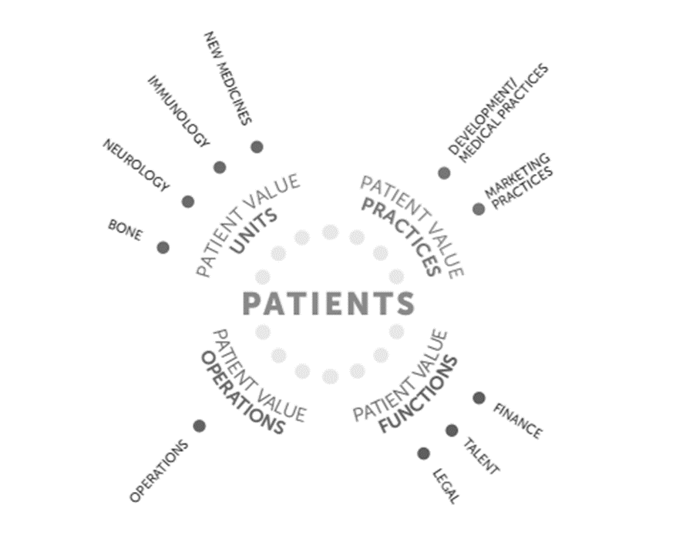

Source: Company documents.

Exhibit 3: Mock-up of an IBM Watson AI assistant (2012)

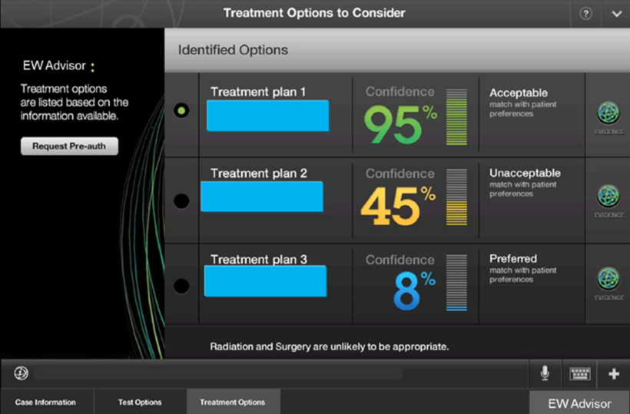

Source: Company documents.

Exhibit 4: Big data for patient-centricity

**Control Cost**

**Optimize Revenue**

*Treatment, Claims, & Payment Data*

*Clinical Outcomes Data*

*Leading Practices Data*

*Program Effectiveness Data*

*Population/Disease Data*

*Prescription Data*

*Lab Data*

*Radiological Data*

*Product Utilization Data*

*Treatment Protocol Data*

*Genomic Data*

*Drug Safety and Efficacy Data*

*Medical Device Efficacy Data*

*Clinical Trial Data*

*Recipe, Sales, & Marketing Data*

*Market Research Data*

*Supply Chain Data*

*Industry Intelligence Data*

*Benchmarking Data*

*Market Research Data*

*Admissions Data*

*Physician Profile Data*

*Benchmarking Data*

*Evidence-Based Meds Data*

*Clinical Research Data*

*Epidemiological Data*

*Patient Profile Data*

*Market Research Data*

*Genomics Data*

*Clinical Trial Data*

*Data from Other Basic Research*

**Quality Outcomes**

**Clinical Evidence**

Source: Company documents.

Exhibit 5: Analytics as a Service (AaaS) framework

**AaaS Framework**

Facilitation

**Share**

**Explore**

**Promote**

Menu on the Door (Data Model)

Data Insight Sharing

**Enablers**

Data Hub & Data Collection

Access Layer

Analytics Insight Generation

Support and Promotion of Effective Use of Analytics

Amplify

Data Lab

Method

**Team**

**Architecture**

Source: Company documents.

Exhibit 6: Analytics sprint method

Experience Data

Explore

Data

Exploit

Data

Insights

Business Outcomes

Experience:

* Identify and understand data to explore.
* Prepare the data and build the lab.

Output: Data Lab

**CONTINUOUSLY BUILD AND IMPROVE**

Explore:

* Explore, discover, …
* Find relations between data.

Output: Insights

* Investigate the relations between data to find new insights.
* Automate for the future.

Output: Business Outcomes

It is all based on a golden question.

Data

**50 PERSON-DAYS**

Exploit:

Source: Company documents.

Exhibit 7: Sample analytics sprint showcases

**Epilepsy Watson — Cognitive computing**

**Prototype of a decision support tool that predicts and recommends the best possible treatment for epilepsy patients.**

Optimize treatment for individual patients.

Increase efficiency of UCB’s complex supply chain.

**Talent identification — Network analytics**

**Scout for the best talent operating in the bone field, science, market access, or commercial capacities.**

Give UCB an edge in the war for talent.

**Patent mining — Network analytics**

**Better qualify competitive patents, go from 20,000 potentially interesting patents to about 200 highly interesting patents.**

Increase control over UCB‘s competitive position.

**Promotor scoring — Text analytics**

**Better understand physician relationships from customer dialogue program verbatim (15 countries). Identify root causes to drive improvement actions.**

Optimize the way UCB interacts with physicians.

**Lead time optimization — Predictive analytics**

**Provide planners with a recommendation engine to evaluate future lead times and decrease risk of out of stock situations.**

Source: Company documents.

Exhibit 8: From sprint to value run

Sprints

A-B test /

Decide

Embed

Hunting the insight

Putting the insight to work

Source: Company documents.

1. € = EUR = euro; €1.00 = US$1.08 on March 31, 2015; all currency amounts are in euros unless otherwise specified.