

9B18E007

TD Bank Group: Building an Effective Enterprise Data Management Policy

Murat Kristal, Glenda Crisp, Connie Bonello, and Katherine Heighington wrote this case solely to provide material for class discussion. The authors do not intend to illustrate either effective or ineffective handling of a managerial situation. The authors may have disguised certain names and other identifying information to protect confidentiality.

*This publication may not be transmitted, photocopied, digitized, or otherwise reproduced in any form or by any means without the permission of the copyright holder. Reproduction of this material is not covered under authorization by any reproduction rights organization. To order copies or request permission to reproduce materials, contact Ivey Publishing, Ivey Business School, Western University, London, Ontario, Canada, N6G 0N1; (t) 519.661.3208; (e)* [*cases@ivey.ca*](mailto:cases@ivey.ca)*;* [*www.iveycases.com*](http://www.iveycases.com)*.*

Copyright © 2018, Ivey Business School Foundation Version: 2018-03-14

In October 2015, Glenda Crisp stepped into her new office on the 17th floor of TD Bank Group’s headquarters. Crisp was the new chief data officer (CDO). She had moved from the 5th floor, where she had been the corporate technology chief intelligence officer at the bank for the past four years. In her new role, Crisp knew she needed to assess, validate, and deliver on promises made by her predecessor. Her main focus was to move the theoretical ideas into tangible results.

Crisp saw issues in a variety of areas, such as organizational structure, the processes used to manage data governance practices, and technology—all of which needed to be identified, prioritized, and then acted upon. In order to be efficient in her implementation, Crisp made it her mission to set deliverable results for each month, but she needed to determine what to prioritize and address first.

Background

The Toronto-Dominion Bank and its subsidiaries, collectively known as TD Bank Group (TD), was one of the top five big banks in Canada and was often ranked as number one or two in terms of total assets, deposits, and market capitalization. The bank was created in 1955 when the Bank of Toronto and the Dominion Bank merged, subsequently declaring its arrival with a new, high-profile head office that marked Toronto’s skyline with what was then the tallest building in Canada.[1]

In 2002, TD started to expand into the United States, leading to significant and continual growth. The market cap increased from CA$18.2 billion[2] in 2002 to $103.5 billion by 2016. The bank more than doubled its business locations, initially 1,328 branches in 2016, by adding many new locations along the east coast of the United States, primarily in the northeast and in Florida. TD focused its expansion into the United States on the retail banking industry, growing through acquisitions of smaller American banks. As a result of the expansion, TD would also more than double its number of employees, growing from 42,817 employees in 2002 to over 85,000 in 2016.

In 2015, TD Bank Group announced a seventh consecutive year of record adjusted earnings ($8.8 billion), which was driven by TD’s strong performance in retail businesses and good results in the wholesale segment. TD also had positive shareholder returns in fiscal 2015, which made it one of two Canadian banks to achieve this result. TD had strong growth in operations, financial positions, share value, and financial ratios (see Exhibit 1).[3]

Identifying the Need for a Data Transformation Program

Prior to embarking on its data transformation program in 2013, TD, like many large organizations, faced some key data challenges. It had well-established policies, processes, and controls covering privacy and the security of data, but the emerging hypothesis within the bank was that more could be done to meet growing customer expectations that the bank use the data available to enhance and add value to the customer’s experience and relationship with the bank.

In order to gain a deeper understanding of its data challenges, TD conducted interviews with over 200 of its key business and technology leaders. Several key themes emerged from these interviews. While data was managed primarily at the business level, the data quality processes, goals, and governance needed to be formalized at an enterprise level. Also at an enterprise level, TD could enhance its ability to identify data sources and trace the flow of data. This was particularly relevant because data usually needed to be extracted from multiple systems to gain insight that was valuable. Finally, keeping analytics within each business line and dispersing reporting among several teams and systems resulted in inefficiencies and ineffective data management.

These challenges created operational inefficiencies and resulted in underutilized employee capabilities. The business implications and the ever-growing amount of data warranted the need for TD to embark on a data transformation program. TD needed to examine the way it managed and governed its data to realize its full business benefit. The data transformation journey required TD to develop an enterprise data strategy, build a team of people to govern and oversee the data, design and implement data standards and policies, and implement processes and tools to monitor and enforce the data management policies and overall governance of its data.

TD was the first of the five major banks in Canada to establish a CDO role, created at TD in 2013. The CDO was responsible for enterprise-wide data governance and the use of information as an asset. The CDO was also responsible for driving enterprise innovation, transformation, and market-facing competitive advantage through the combination of data and analytics. As a member of the senior management team at TD, the CDO was able to monitor and to contribute to the strategic priorities of the organization. This helped to align the enterprise data strategy with business priorities, and ensure that the data implications of these priorities were understood and considered when prioritizing the key business initiatives.

Upon joining TD in 2013, the previous CDO established the Office of the Chief Data Officer (OCDO) with a presence both in Canada—in Toronto, Ontario— and in the United States—in Mount Laurel, New Jersey. The OCDO worked with multiple lines of business across the bank to establish data governance policies and ensure that the departments adhered to these policies and regulations.

The first task was to develop the enterprise data strategy; establish data stewardship roles within the lines of business; and pilot the data issue, change, and quality management processes. These activities were critical to establishing the foundation for the management and governance of enterprise data. TD enlisted external analytical and technical expertise from a variety of consulting firms. Throughout the data transformation journey, IBM had been a key partner in implementing the applications and doing the related process work (see Exhibit 2).

Executive sponsorship and commitment to the data transformation program were important to ensure resources were committed and expectations managed. In addition to appointing a CDO, TD also engaged senior executives from each line of business as an “executive data sponsor” to ensure that the lines of business data strategies were aligned with the enterprise data strategy and policy. The executive data sponsor role was to provide funding, drive data governance and quality, escalate issues, and appoint data stewards.

Competitors

Many organizations were drowning in a sea of data but were unable to leverage this data for business insight. Banks, in particular, were dealing with increasing amounts of available data as mobile and online services increased the amount of personalized data collected from customers. The question was how to capitalize on the potential value in the data. Data underpinned every transaction, operation, and interaction in an organization, but the ability to extract the power and value of the data and convert it into real actionable business insight remained elusive to many organizations. TD was determined to be an industry leader with its analytical capabilities and technological developments.

Deloitte Touche Tohmatsu Limited (Deloitte) evaluated the banks across Canada and the United States, looking at their data management and analytical capabilities by breaking them down into six areas: (1) data governance evaluated how the bank owned and managed data across the organization, including how it controlled access to the data; (2) data management evaluated how effectively the bank managed master data, the quality of the data, and metadata; (3) data acquisition measured the bank’s ability to acquire data from multiple sources and how efficiently it did this; (4) data preparation assessed how the bank prepared data from multiple sources and what formats it used for consolidation; (5) data consumption looked at the bank’s ability to use the data to reveal insights; and (6) data analytics evaluated the business value the bank gained from its data analytics.

According to Deloitte, TD was developing its ability to govern, manage, and acquire data, but it was in the infancy stage of its ability to prepare, consume, and measure the data. TD had yet to develop mature capabilities in any of the six functions. While TD was ahead or on par with the majority of Canadian banks, the assessment concluded that it fell behind its American competitors.

Regulation Requirements

Other challenges that TD faced were the risk management regulations involving data management, such as the Basel Committee on Banking Supervision’s regulation number 239 (BCBS-239).[4] The Basel Committee was an international risk management committee that issued international regulations and guidelines for financial institutions. BCBS-239 was issued in 2013 to address risk involving data aggregation and reporting. The regulation consisted of 14 principles that spanned four main topics: overarching governance and infrastructure, risk data aggregation capabilities, supervisory review, and tools and co-operation (see Exhibit 3).[5] The Canadian Office of the Superintendent of Financial Institution required that all Canadian banks adhere to the regulation and its principles by 2017.

More urgently, because TD had such a large presence in the United States, Crisp was anticipating that U.S. regulators would review TD’s plans to meet the new regulations imposed in the United States by the Dodd-Frank reforms.[6] The *Dodd-Frank Wall Street Reform and Consumer Protection Act* was signed into American federal law in August 2010 as a response to the 2008 financial crisis. One component of the reform imposed regulations on data record keeping and reporting requirements.[7]

Redefining Employee Roles and Responsibilities

Before Crisp accepted the role as CDO, the position had been vacant for nine months. The extended period without a leader had left the department fragmented and without direction. Many of the team members were focused on other goals and priorities, which affected the cohesiveness of the department. Being a seasoned executive, Crisp recognized that successful data transformation was going to require input from all stakeholders. She needed to bring her team members together, and bring them together with other stakeholders across the different lines of business to modify and implement an effective data strategy.

One method that TD used to ensure that data management was consistent across the large organization was to designate data stewards. TD had over 300 data stewards among the lines of business. They “lived the issues” and played a critical role in executing TD’s data governance and management standards and in realizing project delivery outcomes. They were responsible for identifying critical data elements, managing data issues and data changes across their line of business, and executing the data quality standards.

To ensure success, the data stewards needed to be accountable for and committed to resolving data issues, willing to drive measurable results, have the appropriate level of involvement, and understand that data was a valuable corporate asset. To progress with data transformation, the data stewards needed to have clearly defined responsibilities and accountabilities, an essential set of capabilities, and a data-driven culture that allowed them to make the right impact. Success also depended on having the right processes and tools to enable these professionals to manage, care, protect, and govern enterprise data successfully as an enterprise asset.

Initially, when the first CDO assumed the role, data stewards had other duties in their lines of business and typically spent only 25 per cent of their time on data governance and data management. And because the CDO position had been vacant for nine months, some departments had shifted what resources had been committed to data governance and management to other tasks. Thus, when Crisp started implementing new policies, the data stewards’ workload drastically increased.

To ensure a consistent approach across the lines of business, policy now required certain processes for data management. Among the changes, data quality processes were required to be completed on an annual basis. Data impact assessments were also required of all large projects across the bank to provide evidence that the projects aligned with the enterprise data strategy. The new policy implementations and the increasing number of data-related projects placed more demands on the data stewards, who were providing expertise and assistance. As their roles and responsibilities expanded, Crisp knew she needed to find a way to address their increasing workload. The challenge, however, was that none of the data stewards reported directly to the CDO; rather, they reported to the manager in their specific line of business.

Restructuring of TD’s Data Capabilities

In 2015, TD launched wide-scale restructuring, which included the enterprise data capabilities and resulted in Crisp having to establish new types of relationships with changed departments. She also had difficulties collecting the data necessary for the key performance indicators. For example, the prior CDO’s mandate had included an advanced analytics department; however, with restructuring, the advanced analytics department had been realigned under marketing (see Exhibit 4). Also, the enterprise analytics department changed the metrics for reporting data. The consequence was the OCDO did not have access to the proper data and metadata, which meant it could not properly measure the key performance indicators.

Because the role of CDO was fairly new in all organizations, the position lacked consistently defined responsibilities. Crisp therefore needed to work continuously with other executives to differentiate what fell under her domain from what fell under theirs. For example, data life cycle management, which included current records retention, could fall under the domains of the chief risk officer, chief information officer, chief operating officer, general counsel, or the CDO. Crisp recognized that TD’s data life cycle management policy needed updating to reduce costs and risks associated with keeping files and data longer than necessary. And although Deloitte had recommended that the responsibility fall under the domain of the CDO, Crisp was unsure if she should take on the task or, for that matter, how her fellow executives would react if she did.

Simplifying Processes

Before Crisp stepped into the CDO position, she made a point of meeting with the executive data sponsors across the lines of business to see what needed to be addressed. The primary piece of advice she received was to be more direct and concise with policy and how it was documented to ensure the lines of business would adopt the processes.

The OCDO was responsible for producing the enterprise data governance policies, standards, and processes. These policies provided a common approach across the organization for effective data management. TD had implemented a number of common processes, programs, and tools to enable a consistent approach to data governance and management. These included a data issue and change governance process, data quality management process, and a data impact assessment for projects. The data issue and change governance process ensured a single, consistent approach to manage and govern data issues and changes across all business lines. The data quality and management process assessed the quality of critical data elements across the enterprise, and the data impact assessment for projects ensured the projects aligned with the enterprise data strategy. It also assisted the data stewards in assessing typical areas of challenge in projects. When Crisp evaluated the original data quality process document, she noted that it was 141 pages long, including 46 steps. She saw what the executive data sponsors were referring to and noted areas where the document could be more concise and streamlined.

Crisp could engage IBM for a full-day “Design Thinking” workshop, which would lead some experienced data stewards through exercises to help them simplify the data quality management process. Crisp needed to determine if that was the best approach to streamlining the documentation, or if she should use only internal expertise.

Technology

Another of the CDO’s important responsibilities was to determine the correct and effective technology to use. Technology and tools were important enablers for driving data quality, traceability, lineage, monitoring, and accountability. TD took both a “build your own” approach and a licensed solution approach for tools to manage its data. For example, TD chose to build its own data issue and change governance tool, which was an enterprise repository of all data issues and proposed data changes. This tool enabled the CDO to see across the organization and identify thematic issues that, solved once, would benefit multiple parts of the organization.

For metadata management and data quality tooling, TD chose to implement IBM’s InfoSphere®[8] Information Governance Catalog and its InfoSphere Information Analyzer. The governance catalogue was a metadata management, business glossary, and data lineage solution that encouraged a standardized approach to understanding data assets. The information analyzer profiled data quality and classified data for analysis, which helped the bank derive more meaning from enterprise data, reduced its risk of proliferating incorrect information, facilitated the delivery of trusted content, and helped to lower data integration costs. These tools could handle large volumes of data and were robust and scalable, allowing them to handle drastic growth in data.

Next Steps

In her review of the industry and internal and external pressures at the bank, Crisp needed to prioritize and create an action plan for the various issues she identified. She needed to address impending regulation requirements in both the United States and Canada, and align the people, processes, and technology for consistent enterprise data management across the organization. She also needed to manage and address the expanding role of data stewards, and work with her colleagues to define the responsibilities of the OCDO. And, not least, Crisp needed to simplify the overly complex enterprise data governance policies to ensure they were adopted and followed across the bank’s various lines of business.

Taking into account the need for compliance, increased efficiency, and maximized value from the data, Crisp had to not only address the issues but also devise an effective implementation plan. With TD’s operations in both Canada and the United States, Crisp needed to determine whether to devise a plan that would be initially implemented in both countries or in just one country at a time.

This case was made possible with the contributions of Social Sciences and Humanities Research Council (SSHRC) Grant Number 430-2014-00487.

exhibit 1: TD Bank Group, Key Financial

|  |  |  |  |
| --- | --- | --- | --- |
| Key Financial Metrics1 |  |  |  |
|  | **2013** | **2014** | **2015** |
| Results of operations (CA$ millions) |  |  |  |
| Total revenues—reported | 27,259 | 29,961 | 31,426 |
| Total revenues—adjusted2 | 27,188 | 29,681 | 31,437 |
| Net income—reported | 6,640 | 7,883 | 8,024 |
| Net income—adjusted2 | 7,136 | 8,127 | 8,754 |
| Financial positions at year end (CA$ billions) |  |  |  |
| Total assets | 862.0 | 960.5 | 1,104.4 |
| Total deposits | 541.6 | 600.7 | 695.6 |
| Total loans net of allowance for loan losses | 444.9 | 478.9 | 544.4 |
| Per common share (CA$, except where noted) |  |  |  |
| Diluted earnings—reported | 3.44 | 4.14 | 4.21 |
| Diluted earnings—adjusted2 | 3.71 | 4.27 | 4.61 |
| Dividend payout ratio—adjusted2 | 43.5% | 43.0% | 43.3% |
| Total shareholder return (1 year)2 | 22.3% | 20.1% | 0.4% |
| Closing market price (fiscal year end)4 | 47.82 | 55.47 | 53.68 |
| Financial ratios (%) |  |  |  |
| Common Equity Tier 1 Capital ratio5,6 | 9.0 | 9.4 | 9.9 |
| Tier 1 Capital ratio5,6 | 11.0 | 10.9 | 11.3 |
| Total Capital ratio5,6 | 14.2 | 13.4 | 14.0 |
| Efficiency ratio—reported | 55.3 | 55.1 | 57.5 |
| Efficiency ratio—adjusted | 52.9 | 53.4 | 54.3 |

Note: 1Certain comparative amounts have been restated, where applicable, as a result of the implementation of the 2015 IFRS Standards and Amendments; 2Refer to footnote 3; 4Toronto Stock Exchange (TSX) closing market price; 5The 2015 IFRS Standards and Amendments were not incorporated into the regulatory capital disclosures presented prior to fiscal 2015. (For more information on the 2015 IFRS Standards and Amendments, refer to Note 4 of the 2015 Consolidated Financial Statements.); 6Effective the third quarter of 2014, each capital ratio has its own risk-weighted assets (RWA) measure due to the scalar prescribed by the Office of the Superintendent of Financial Institutions (OSFI) for inclusion of the credit valuation adjustment (CVA). Effective the third quarter of 2014, the scalars for inclusion of the CVA for Common Equity Tier 1 (CET1), Tier 1, and Total Capital RWA are 57%, 65%, and 77% respectively. For fiscal 2015, the scalars are 64%, 71%, and 77% respectively.

Source: TD Bank Group, *Building the Even Better Bank: 2015 Annual Report,* accessed August 27, 2017, www.td.com/document/PDF/ar2015/ar2015-Complete-Report.pdf

Exhibit 2: IBM Suggested Data Transformation Journey

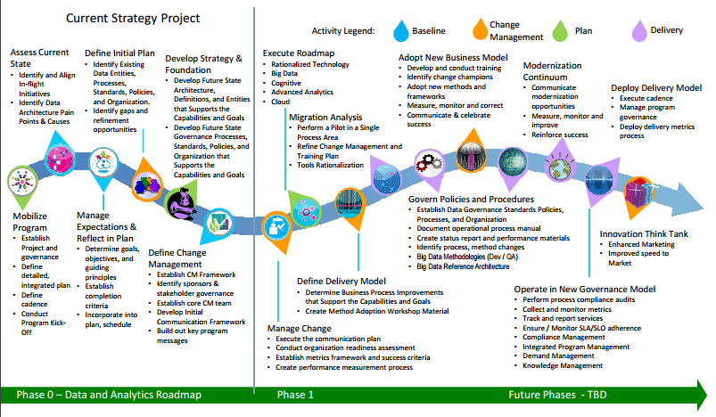

Source: Connie Bonello, *IBM Data Strategy* (Toronto, ON: IBM, 2017). Used with permission.

Exhibit 3: Summary of the Basel Committee on Banking Supervision,

regulation 239

|  |  |
| --- | --- |
| **Principles** | **Explanation** |
| Governance | A bank’s risk data aggregation capabilities and risk reporting practices should be subject to strong governance arrangements consistent with other principles and guidance established by the Basel Committee. |
| Data Architecture and IT Infrastructure | A bank should design, build and maintain data architecture and IT infrastructure that fully supports its risk data aggregation capabilities and risk reporting practices not only in normal times but also during times of stress or crisis, while still meeting the other Principles. |
| Accuracy and Integrity | A bank should be able to generate accurate and reliable risk data to meet normal and stress/crisis reporting accuracy requirements. Data should be aggregated on a largely automated basis so as to minimize the probability of errors. |
| Completeness | A bank should be able to capture and aggregate all material risk data across the banking group. Data should be available by business line, legal entity, asset type. For instance, the Basel Committee’s Principles for Enhancing Corporate Governance (October 2010) and Enhancements to the Basel II framework (July 2009). Industry, region and other groupings, as relevant for the risk in question, that permit identifying and reporting risk exposures, concentrations and emerging risks. |
| Timeliness | A bank should be able to generate aggregate and up-to-date risk data in a timely manner while also meeting the principles relating to accuracy and integrity, completeness and adaptability. The precise timing will depend upon the nature and potential volatility of the risk being measured as well as its criticality to the overall risk profile of the bank. The precise timing will also depend on the bank-specific frequency requirements for risk management reporting, under both normal and stress/crisis situations, set based on the characteristics and overall risk profile of the bank. |
| Adaptability | A bank should be able to generate aggregate risk data to meet a broad range of on-demand, ad hoc risk management reporting requests, including requests during stress/crisis situations, requests due to changing internal needs and requests to meet supervisory queries. |
| Accuracy | Risk management reports should accurately and precisely convey aggregated risk data and reflect risk in an exact manner. Reports should be reconciled and validated. |
| Comprehensiveness | Risk management reports should cover all material risk areas within the organization. The depth and scope of these reports should be consistent with the size and complexity of the bank’s operations and risk profile, as well as the requirements of the recipients. |
| Clarity and Usefulness | Risk management reports should communicate information in a clear and concise manner. Reports should be easy to understand yet comprehensive enough to facilitate informed decision-making. Reports should include an appropriate balance between risk data, analysis and interpretation, and qualitative explanations. Reports should include meaningful information tailored to the needs of the recipients. |
| Frequency | The board and senior management (or other recipients as appropriate) should set the frequency of risk management report production and distribution. Frequency requirements should reflect the needs of the recipients, the nature of the risk reported, and the speed at which the risk can change, as well as the importance of reports in contributing to sound risk management and effective and efficient decision-making across the bank. The frequency of reports should be increased during times of stress/crisis. |
| Distribution | Risk management reports should be distributed to the relevant parties and while ensuring confidentiality is maintained. |
| Review | Supervisors should periodically review and evaluate a bank’s compliance with the eleven Principles above. |
| Remedial Actions and Supervisory Measures | Supervisors should have and use the appropriate tools and resources to require effective and timely remedial action by a bank to address deficiencies in its risk data aggregation capabilities and risk reporting practices. Supervisors should have the ability to use a range of tools, including Pillar 2. |
| Home/Host Co-operation | Supervisors should cooperate with relevant supervisors in other jurisdictions regarding the supervision and review of the Principles, and the implementation of any remedial action if necessary. |

Source: Bank for International Settlements, “Summary of the Principles,” Annex 2 in *Basel Committee on Banking Supervision: Principles for Effective Risk Data Aggregation and Risk Reporting* (report, 2013), accessed December 4, 2017, www.bis.org/publ/bcbs239.pdf.

Exhibit 4: restructuring of TD’s Enterprise Data Capabilities

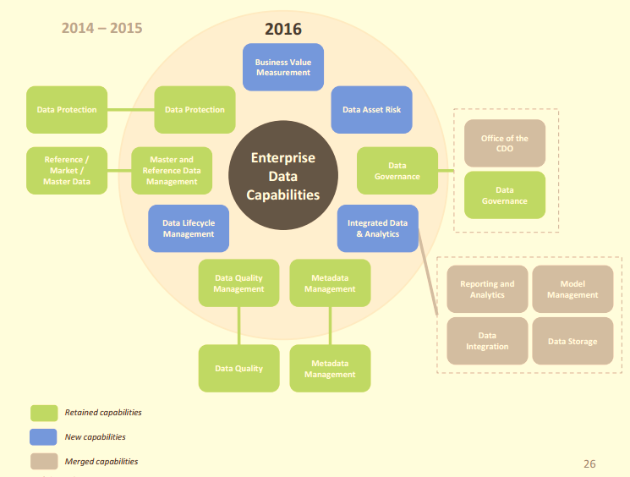

Source: Company documents.

1. “From the Beginning,” Toronto-Dominion Bank, accessed December 4, 2017, www.td.com/about-tdbfg/corporate-information/tds-history/from-the-beginning.jsp.
2. All dollar amounts are in CA$ unless otherwise indicated.
3. TD Bank Group, *Building the Even Better Bank: 2015 Annual Report,* 3, accessed August 27, 2017, www.td.com/document/PDF/ar2015/ar2015-Complete-Report.pdf.
4. Basel Committee on Banking Supervision,“Principles for Effective Risk Data Aggregation and Risk Reporting*,*”Regulation 239 (2013), accessed December 4, 2017, www.bis.org/publ/bcbs239.pdf.
5. Bank for International Settlements, “Summary of the Principles,” Annex 2 in *Basel Committee on Banking Supervision: Principles for Effective Risk Data Aggregation and Risk Reporting* (report, 2013), accessed December 4, 2017, www.bis.org/publ/bcbs239.pdf.
6. *Dodd-Frank Wall Street Reform and Consumer Protection Act*, Pub. L. No. 111-203, H.R. 4173, 111th Congress, accessed December 5, 2017, www.sec.gov/about/laws/wallstreetreform-cpa.pdf.
7. “Final Rules, Guidance, Exemptive Orders, and Other Actions,” U.S. Commodity Futures Trading Commission, May 31, 2016, accessed March 12, 2017, www.cftc.gov/LawRegulation/DoddFrankAct/Dodd-FrankFinalRules/2016-12612.
8. IBM and InfoSphere were trademarks of International Business Machines Corp., registered in many jurisdictions worldwide. Other product and service names might be trademarks of IBM or other companies. A current list of IBM trademarks is available at “Copyright and Trademark Information,” IBM (website), accessed December 4, 2017, www.ibm.com/legal/copytrade.shtml.