

9B18E010

JioMoney M-Wallet: a cure for the digital economy?[1]

Poonam Garg, Rashmi Kumar Aggarwal, and Vaibhav Garg wrote this case solely to provide material for class discussion. The authors do not intend to illustrate either effective or ineffective handling of a managerial situation. The authors may have disguised certain names and other identifying information to protect confidentiality.

*This publication may not be transmitted, photocopied, digitized, or otherwise reproduced in any form or by any means without the permission of the copyright holder. Reproduction of this material is not covered under authorization by any reproduction rights organization. To order copies or request permission to reproduce materials, contact Ivey Publishing, Ivey Business School, Western University, London, Ontario, Canada, N6G 0N1; (t) 519.661.3208; (e)* [*cases@ivey.ca*](mailto:cases@ivey.ca)*;* [*www.iveycases.com*](http://www.iveycases.com)*.*

Copyright © 2018, Ivey Business School Foundation Version: 2018-07-17

On November 8, 2016, at 8:00 p.m. Indian Standard Time, the Prime Minister of India announced in a televised address to the entire nation of 1.34 billion that two high-value currency notes— ₹500[2] and ₹1,000—would be demonetized as of midnight, November 9, 2016.[3] The move was considered to be a deterrent to corruption, terrorism, and drug peddling. As of March 31, 2016, the total Indian currency in circulation amounted to ₹16,415 billion, out of which 38.6 per cent were ₹1,000 notes (₹6,326 billion) and 47.8 per cent were ₹500 notes (₹7,854 billion).[4] Together, the high-value denominations accounted for 86 per cent of the value of the notes in circulation. In effect, India pulled 86 per cent of its cash out of circulation in an economy that was 95 per cent cash-reliant.[5]

New currency notes of ₹500 and ₹2,000 were introduced, and the old Indian currency notes had to be returned to the banks by December 30, 2016.[6] From time to time, banks were notified of strict exchange limits and weekly withdrawal limits. The country had 200,000 automated teller machines (ATMs), which were not fully calibrated to dispense the new ₹500 and ₹2,000 notes.[7] As well, the banks did not have sufficient newly printed currency to redeem the cancelled notes; therefore, the ATMs and banks ran out of cash.

The decision to demonetize put the people of India in limbo: they faced a sudden cash shortage in an economy that required they have cash to meet their daily needs. To fill the vacuum created by the lack of cash in the economy, millions of citizens were pushed into an ever-evolving digital economic grid.

In May 2016, Reliance Jio Infocomm Limited (Jio) launched JioMoney, a mobile wallet (m-wallet) service, along with fourth generation (4G) voice and data services and 4G smartphones manufactured by Reliance LYF.[8] With JioMoney, users could make utility bill, insurance, and offline payments; conduct e-retail transactions; and send and receive money. JioMoney was a new entrant in the m-wallet industry, thus far dominated by established services such as MobiKwik, Paytm, Oxigen, and many others. Could JioMoney successfully compete with these existing competitors? Could JioMoney use demonization to its advantage and leverage a network backed by 4G wireless services, or was demonetization a one-time opportunity for the company to scale up its business?

Reliance Jio Infocomm Limited: Company Background

Jio was incorporated in 2007 as Infotel Broadband Services Limited, a subsidiary of Reliance Industries Limited. Headquartered in Mumbai, India, Jio adopted its current company name in January 2013.

In August 2015, Jio received a payments bank licence from India’s central bank, the Reserve Bank of India (RBI).[9] The licence had been granted to “Jio Payments Bank,” a joint venture between Jio and the State Bank of India (SBI), India’s largest public sector bank.[10] SBI had a network of over 13,000 branches and five associate banks located in the remotest parts of India.[11]

Jio acquired a range of telecommunications radio waves (a spectrum) in 1800 megahertz (MHz) that crossed 14 local calling zones (circles), and a spectrum in 2300MHz across 22 circles.[12] The spectrums were capable of providing 4G wireless services to the highly underserviced Indian market. With an integrated ecosystem, Jio planned to use the latest technology to provide high-quality access to digital content, applications (apps), and services.[13] Jio was the only operator to deploy spectrum across India in a low-power, high-range band, which was especially suited for devices such as industrial lighting, metering, and other hardware operating on the Internet of Things.[14]

In May 2016, it launched its value-added service JioMoney when it launched its 4G LTE network.[15] The company had yet to make a profit, but its financial position was slowly improving (see Exhibit 1).

On September 5, 2016, Jio launched its 4G welcome offer to consumers.[16] Initially, the company offered free access to voice, data, and video until December 31, 2016. Later, the company extended the offer until March 2017.[17] The company’s total investment in the telecommunications project was approximately US$12.5 billion.[18]

Digital India and the M-Wallet Market

In 2016, India was the world’s second most populous country with a population of 1.34 billion. Approximately 65 per cent of its population was under the age of 35. Approximately 72 per cent of the Indian population lived in villages—638,000 of them. The remainder lived in 5,480 towns and urban agglomerations.[19] The literacy rate was 75 per cent.[20]

In 2017, the number of smartphone users in India was estimated to have reached 299.24 million, with an expectation that the number would increase to 442.5 million by 2022 (see Exhibit 2).[21] Internet users numbered 331.8 million; this was projected to increase to 511.89 million by 2022 (see Exhibit 3). The majority of Internet users accessed the Internet with their mobile phones.[22] This group, numbering 320.6 million,[23] represented 23.9 per cent of India’s total population; this was expected to increase to 34.85 per cent of India’s population by 2022 (see Exhibit 4).[24]

With the rise of smartphones, the digital payment market in India was growing exponentially. The market was worth an estimated $86 million in 2011 and was expected to grow to $1.15 billion in 2016, representing a compound annual growth rate (CAGR) of 68 per cent.[25] Google LLC and the Boston Consulting Group estimated that the market would further reach $500 billion by 2020, constituting about 15 per cent of the total gross domestic product.[26]

In a short span of time, the size of the m-wallet user base had grown significantly in India, with m-wallets being more popular among the younger population. According to the RBI, m-wallets had already surpassed mobile banking in volume. According to market research company TechNavio, the m-wallet market was expected to grow at a CAGR of 140 per cent by 2018 in India, compared to a CAGR of 34 per cent by 2020 in the global market.[27]

The Nature of M-Wallets

An m-wallet was a type of payment service through which individuals and businesses could send and receive payment using a mobile device. There were several types of m-wallets, classified according to their nature and ownership. Four types were based on the nature of the m-wallet: closed, semi-closed, open, and semi-open.[28] A closed m-wallet was limited to buying goods and services (making payments) or receiving refunds exclusively from the same company, for example, Flipkart Pvt. Ltd. and Jabong.com. Cash withdrawals were not permitted through closed e-wallets. In a semi-closed m-wallet, the money could be loaded and used to make payments at multiple places, but cash withdrawals and cash redemptions were not permitted. Some financial services could be performed at listed locations. JioMoney and Paytm were semi-closed m-wallets.

Open m-wallets allowed money to be loaded to purchase products and services, and cash withdrawals could be made by using ATMs. Masterpass was an open wallet system that worked with a Mastercard account to make payments or withdraw cash. Visa had a similar system that worked through the m-wallet resident in a smartphone, such as Apple Pay. RuPay was a domestic payment system that involved almost 600 international, regional, and local banks across India.[29] Semi-open m-wallets allowed users to transact with merchants that had a contract with the company issuing the wallet. Airtel Money and Axis Bank’s and Visa’s pre-paid gift cards were examples of semi-open m-wallets. Users could not withdraw cash or get a redemption through a semi-open m-wallet.[30]

There were four types of digital wallets classified on the basis of ownership: bank, telecommunication company (telco), device resident, and technology. Bank m-wallets were designed by banks for their customers and could be used to pay for multiple services. SBI Buddy, for example, was the SBI’s mobile wallet. M-wallets owned by telcos were designed for their subscribers and could be used for any of a range of services that contracted with the telco; for example, Airtel Money. Device resident apps and technology apps were similar in that they functioned as part of the mobile device. The difference was that device resident apps were built into the hand-held device—Apple Pay was one of the best-known examples of this type of wallet—and technology m-wallets were apps in an operating system or created by a third-party that could be added to a mobile device. Paytm was a third-party technology m-wallet.[31]

Payment Transactions through Semi-Closed M-Wallets

Mobile wallet payment transactions involved the participation of a buyer or customer; the electronic, offline merchant; and the m-wallet system (see Exhibit 5). The customer and merchant were required to download the app from the m-wallet service and register as a user. During the registration process, users chose whether to sign up as a standard m-wallet user (a customer) or as a business user (a merchant). Consumers could only make payments from their m-wallet accounts if the account was suitably charged, either by depositing funds to the account or having the account connected to another financial source, such as a bank or credit account.

RBI limited consumer m-wallet transactions to a total of ₹20,000[32] (about $300) per month, but the limit could be raised to a maximum of ₹100,000 (about $1,500) per month if the account was supported with documents verifying the identity of the account holder (know your customer, or KYC documents).[33] The transaction limit for merchants was ₹50,000 (about $725) per month with a signed self-declaration, but it could be raised to ₹100,000 (about $1,500) per month if the merchant’s account was supported by KYC documents. The m-wallet system was mainly responsible for executing the payment process. It also controlled the flow of transactions between the buyer and the merchant.

Three types of transactions were conducted using m-wallets: adding money to the m-wallet, making a merchant or individual payment, and transferring money to a merchant’s bank. Customers could add money to their m-wallets through various modes like credit cards, debit cards, and Internet banking.[34] RBI guidelines required semi-closed m-wallet service providers to deposit the wallet-user’s deposit to the m-wallet in an escrow account with a bank.[35] The m-wallet provider could not access the escrow account unless and until the user made a request for payment through the m-wallet.[36] The escrow process protected customers against misuse of their money by the m-wallet service provider. Money from the escrow account would be credited to the m-wallet service provider when the customer made a digital payment to a merchant. Merchants could also make supplier payments, transfer money between the customer’s bank account, and use digital petty cash at their will.[37]

Offline merchant sites accepted money from m-wallets in three ways: push, pull, and “tap-and-go.”[38] In the push method, the user transferred the money to the merchant by scanning a detailed barcode—a quick response (QR) code—provided by the merchant. The transaction deducted money from the user’s m-wallet and credited it to the merchant’s account. The pull method was a multi-step process: the user provided the merchant with the user’s mobile phone number; the merchant entered the user’s mobile number into the payment terminal, after which the user received a one-time password on the user’s mobile phone; the user provided the merchant with that password, which, once entered into the merchant’s system, pulled money from the user’s m-wallet. In the tap-and-go method, the user made a payment by placing (“tapping”) the mobile phone on or near the merchant’s terminal. Tap-and-go required that both the user’s mobile device and the merchant’s terminal be equipped with the necessary communication protocols, known as near field communication. After the payment transaction was completed, the m-wallet system sent messages to the user and the merchant, and transferred the payment amount from the user’s payment source to the merchant’s acquiring bank.

JioMoney M-Wallet

JioMoney was a semi-closed, telco-based m-wallet to which customers could deposit money to pay for goods and services. JioMoney allowed customers to perform all types of low-value and high-volume digital transactions, including person-to-person and person-to-merchant money transfers, bill and utility payments, mobile and digital satellite television (DTH) service recharges, media and entertainment purchases, toll and transit payments, and online shopping payments. The JioMoney app was platform-independent and thus available for both mobile operating platforms—iOS and Android. Powered by 4G small cell technology—low-powered nodes that accessed radio waves over short distances—the JioMoney app provided users with a ubiquitous platform for reasonable and secure digital payments.[39]

Customers could use JioMoney to instantly and seamlessly pay merchants. The JioMoney Merchant Solutions app, launched on December 5, 2016, allowed merchants to receive payments from customers directly into the merchant’s bank account. Merchants could also use the app to pay suppliers, transfer money between accounts, and use a digital petty cash account.[40] JioMoney’s major focus was the rural population of India, which until then had been oblivious to digital transactions.[41] The company targeted 10 million small merchant retailers across 17,000 towns and 400,000 villages.[42]

Competitors

In India, JioMoney faced prime competition from MobiKwik, Paytm, and Oxigen.

*MobiKwik*:In 2009,Bipin Preet Singh and Upasana Taku launched MobiKwik’s mobile wallet. The company raised funds in three rounds from Sequoia Capital; Tree Line Advisors (Hong Kong) Limited; The American Express Company; GMO Payment Gateway, Inc.; MediaTek Inc.; Cisco Investments; and Net 1.[43] The service had 40 million users and had been accepted by 250,000 merchants.[44]

MobiKwik was a semi-closed m-wallet that allowed users to top up their accounts with a debit card, credit card, Internet banking, or cash paid directly to MobiKwik.[45] The service could be used to recharge mobile accounts and make bill payments, and it was accepted by merchants offering a variety of services, such as cinemas, travel agents, fast food chains, and online shopping portals.

*Paytm*: Vijay Shekhar Sharma established One97 Communications Limited in 2000 to launch the prepaid mobile recharge website Paytm.[46] The company raised capital from the Indian industrialist Ratan Tata in March 2015, then secured funding of $680 million from the Alibaba Group Holding Limited and Ant Financial Services Group. In 2016, Alibaba Group Holding Limited was the single largest shareholder in Paytm with 40 per cent of the shareholdings.[47]

The Paytm m-wallet was launched in 2014 and became India’s largest semi-closed digital wallet. In August 2015, RBI granted Paytm a licence to set up a payment bank in the country, which meant Paytm had three business models: online payments, payment banks, and an e-commerce portal.[48] In 2016, Paytm had over 155 million m-wallet users and 1.5 million offline merchants who accepted payments through Paytm.[49]

*Oxigen*:In 2008, Pramod Saxana, promoter of Oxigen Services Private Limited, launched India’s first virtual mobile wallet,[50] approved by the RBI to facilitate payment through social networks, text messaging (SMS), or email, using any mobile number or bank, even if the recipient was not a registered Oxigen m-wallet user.[51] Oxigen partnered with the National Payment Corporation of India for instant money transfer services.[52] In 2016, Oxigen had 20million users and was accepted at 9,000 merchant locations and 10,000 online sites for e-commerce transactions.[53]

Demonetization and the M-Wallet

The Effect of Demonetization on the M-Wallet Industry

In 2016, India was among the most cash-intensive economies in the world.[54] Demonetization caused a liquid cash crunch in the economy and served as an unexpected boon for India’s leading m-wallet providers, in terms of both a growing user base and the number of transactions reported. According to one study, “The mobile wallet market in India has been greatly benefited by demonetisation and its share in the total mobile payment volume transactions is likely to rise from 20 per cent in FY16 [fiscal year 2016] to 57 per cent by FY22 [fiscal year 2022].”[55]

Mukesh Ambani, chairman and managing director of Reliance Industries Limited and promoter of JioMoney, congratulated India’s prime minister for his bold and historic decision to demonetize old currency. Ambani maintained that digitally-enabled transactions would boost economic growth and bring unprecedented transparency and accountability to India’s monetary system.[56]

Sharma, Paytm’s promoter, was equally enthusiastic about demonetization, tweeting, “Keep the money digital. Superb step by our dear PM @narendramodi. From a bit inconvenience to incredible bold step! #win# The biggest, boldest and the most ambitious surgical strike by any government in the world. Hats off to our PM for removing ₹500/1,000 notes. This is a golden day to be a tech entrepreneur in India. Specially a FinTech one.”[57] Since demonetization was announced, Paytm had acquired over 5 million new users and registered over 7 million transactions in a day[58]—an increase from the previous count of 2.5 million daily transactions.[59]

According to MobiKwik’s co-founder Singh, “Demonetisation has led to a massive shift in how Indians perceive payments. . . . Before demonetisation, [digital] wallets were an option and now they are a need. The entire industry has grown many-fold in November and this unprecedented growth will continue.”[60] MobiKwik reported 100 per cent growth in customer numbers.[61]

Pramod Saxena, Oxigen’s promoter, remarked, “Ever since Prime Minister Narendra Modi’s demonetization announcement, we have suddenly seen a spike in both app downloads and merchant registrations. This spike is now coming from all cities, big and small, pan-India, consisting of small merchants like vegetable vendors, Kirana shopkeepers [small convenience stores], street vendors, rickshaw drivers, taxis etc., who’ve signed onto our Oxigen Wallet app for the merchant payments service.”[62]

From November 8, 2016, until December 2016, JioMoney made the following offers to its users:

* Payment of 10 per cent cashback on shopping done with JioMoney, provided the remittance was to one of the Reliance Fresh or Reliance Smart stores across India. There was no cap on the cashback earned.
* Customers predominantly using cash for shopping could take advantage of cashback by using cash loading terminals in any Reliance Fresh or Reliance Smart store to pay with JioMoney, which would then earn the customer a cashback of 10 per cent on the total invoice.
* The cashback would be credited to the user within two working days of the purchase.
* To help alleviate the problem with making change for the new ₹2,000 currency note, cash loading terminals were provided in stores, allowing customers to shop and pay for items of any value.
* Unused money in a customer’s JioMoney account could be transferred back into the customer’s bank account. Money loaded into JioMoney could be used for digital payments to 50,000 online merchants and more than 70 services (which include utilities payments like electricity and water and/or gas, insurance payments, e-commerce transactions, and offline store payments).[63]

Challenges for the M-Wallet in the Demonetized Economy

India’s monetary system was regulated and controlled by the RBI, India’s central bank. RBI had given licences to many m-wallet services. The biggest challenge for m-wallet companies was the presence of so many competitors in the market, making it difficult to attract and retain customers and merchants for a long period. Profit margins were slim and barely covered the cost of partnering with merchants and retaining customers. Another key challenge for m-wallet companies was a lack of interoperability. Unlike ATMs in India, m-wallets could not work across systems.[64]

There were also gaps in infrastructure, such as poor or failed connectivity. Weak mobile network service resulted in frozen payments and lost connections. Further, a large segment of the target population was not comfortable with technology. As a result, those consumers and merchants did not understand or trust the m-wallet system. Security was also a challenge that needed to be addressed for the success of mobile money services. RBI guidelines required mobile banking service providers to comply with strict document control, such as KYC requirements, to prevent money laundering and funding of terrorism. The amount of money that could be deposited or spent through an m-wallet was low, and the low limit per transaction hindered business-to-business payments, which often exceeded the transaction ceiling. Finally, a huge population in the remote and rural areas of India were still without bank accounts. This was an opportunity with a challenge: could mobile wallet services bring the unbanked population into mainstream banking?

Opportunities with the Unbanked Population

After the Indian prime minister announced demonetization on November 8, 2016, ₹500 and ₹1,000 currency notes were removed from circulation, a new ₹2,000 note was introduced, and the ₹500 note was changed. The value of the currency remained the same. The finance minister announced that not all scrapped currency would be remonetized.[65] Instead, the Indian government would incentivize digital payments.[66] However, 72.2 per cent of India’s population of 1.3 billion people lived in villages, many functioning in the economy with cash only.[67] Approximately 166 million people did not have bank accounts, and over 93 per cent of people in rural India had no experience with digital transactions.[68] Of those that did have mobile phones, many were using 2G technology—two generations behind the current 4G system. The 2G phones were cost effective, but they were not nearly sufficient for the kind of data transfer required for mobile payments because of their slow data rate.[69]

If India was going to move from being a cash economy to a “less cash economy” and then to a cashless economy, a transformation in mindset would be required among a large portion of the population to vest confidence in digital transactions. Could JioMoney bring this population on board, and was it critical for the company’s survival to do so? Was the business environment even conducive to exploring new markets? How could the company use demonetization to its advantage and leverage its network-backed 4G LTE services?

Exhibit 1: Reliance Jio Infocomm Ltd., Balance Sheet (₹ ‘000,000)

|  |  |  |  |
| --- | --- | --- | --- |
| **As of year-end March 31** | **2014** | **2015** | **2016** |
| Share Capital | 2,307,200 | 3,012,500 | 4,512,500 |
| Share Warrants and Outstanding | 0 | 0 | 0 |
| Share Warrants | 0 | 0 | 0 |
| Total Reserve | −2,739 | −5,083 | −7,471 |
| Shareholders’ Funds | 2,304,461 | 3,007,417 | 4,505,029 |
| Secured Loans | 645 | 151,167 | 900,637 |
| Unsecured Loans | 1,508,611 | 2,611,313 | 3,736,320 |
| Total Debts | 1,509,256 | 2,762,480 | 4,636,957 |
| Total Liabilities | 3,813,717 | 5,769,897 | 9,141,986 |
| APPLICATION OF FUNDS |  |  |  |
| Gross Block | 77,627 | 102,561 | 118,252 |
| Less: Accumulated Depreciation | 6,504 | 13,983 | 24,279 |
| Less: Impairment of Assets | 0 | 0 | 0 |
| Lease Adjustment Account | 0 | 0 | 0 |
| Capital Work in Progress | 3,366,531 | 7,229,777 | 11,834,987 |
| Pre-Operative Expenses Pending | 0 | 0 | 0 |
| Assets in Transit | 0 | 0 | 0 |
| Investments | 614,087 | 503,076 | 875,656 |
| Current Assets, Loans, and Advances |  |  |  |
| Inventories | 0 | 0 | 0 |
| Sundry Debtors (Debtors) | 3 | 3 | 1 |
| Cash and Bank | 3,746 | 2,701 | 1,531 |
| Other Current Assets | 49,486 | 9,276 | 5,417 |
| Loans and Advances | 86,122 | 368,098 | 761,098 |
| Total Current Assets | 139,357 | 380,078 | 768,047 |
| Less: Current Liabilities and Provisions |  |  |  |
| Current Liabilities | 376,668 | 2,429,791 | 4,426,687 |
| Provisions | 713 | 1,821 | 3,990 |
| Total Current Liabilities | 377,381 | 2,431,612 | 4,430,677 |
| Net Current Assets | −238,024 | −2,051,534 | −3,662,630 |
| Miscellaneous Expenses Not Written Off | 0 | 0 | 0 |
| Deferred Tax Assets/Liabilities | 0 | 0 | 0 |
| Total Assets | 3,813,717 | 5,769,897 | 9,141,986 |
| Contingent Liabilities | 0 | 0 | 0 |

Source: ACE Knowledge Portal, accessed July 10, 2018, www.acekp.in/

Exhibit 2: Number of smartphone users in India

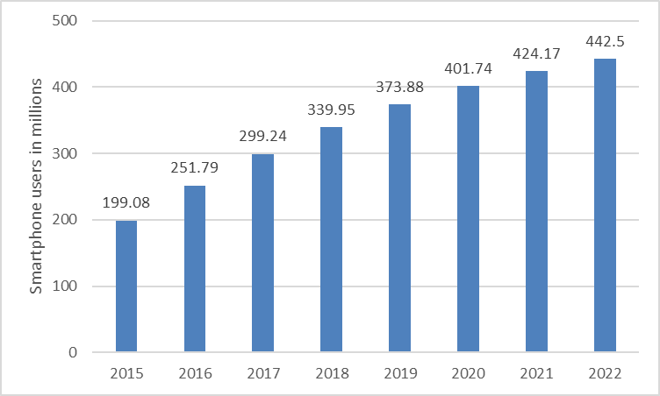

Source: “Number of Smartphone Users in India from 2015 to 2021 (in millions),” Statista, accessed June 14, 2018,

www.statista.com/statistics/467163/forecast-of-smartphone-users-in-india/.

Exhibit 3: Number of Internet users in India

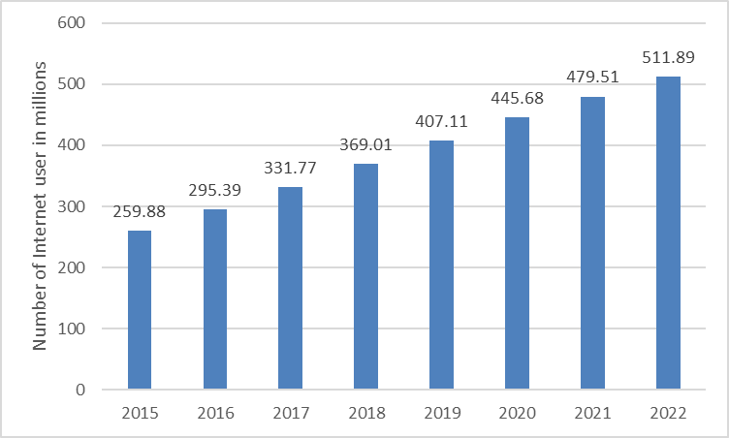

Source: “Number of Internet Users in India from 2015 to 2021 (In Millions),” Statista, accessed June 14, 2018, www.statista.com/statistics/255146/number-of-internet-users-in-india.

Exhibit 4: percentage of Mobile phone internet users in India, 2015 to 2022

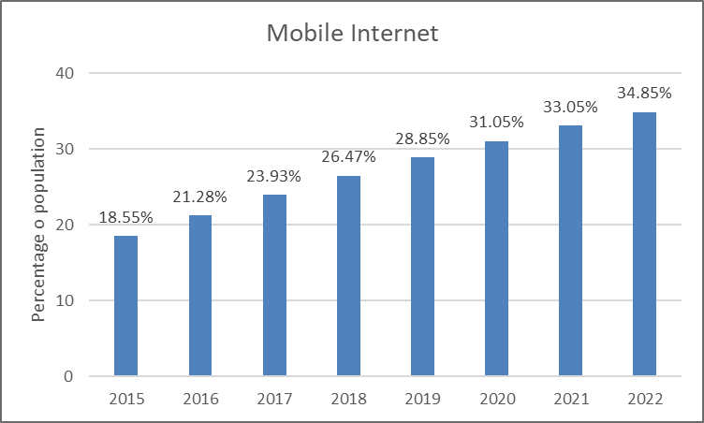

Source: “Mobile Phone Internet User Penetration in India from 2015 to 2021,” Statista, accessed June 14, 2018, www.statista.com/statistics/309019/india-mobile-phone-internet-user-penetration.

Exhibit 5: Schematic diagram of payment transaction on semi-closed M-Wallet

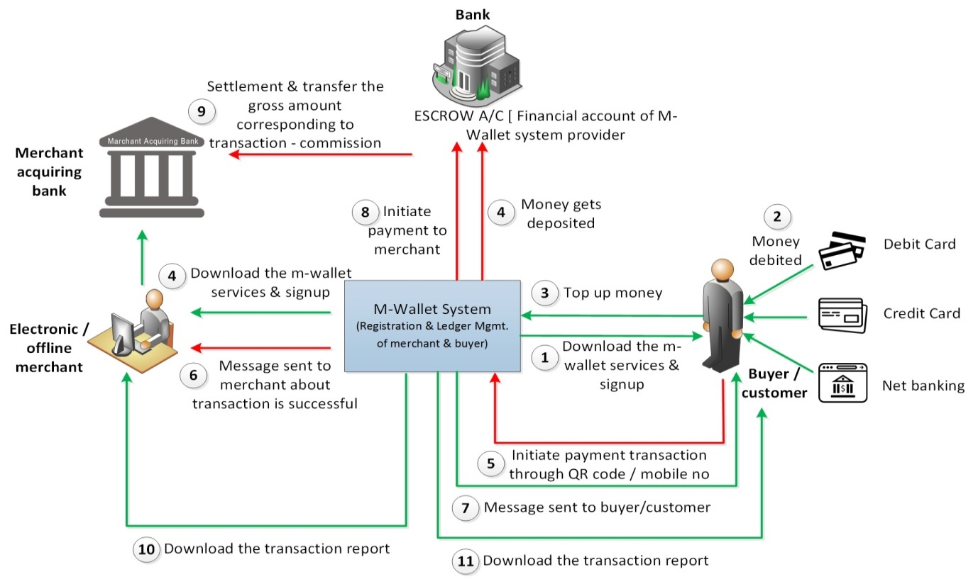

Note: A/C =Account ; QR = quick response

Source: Created by the case authors.

ENDNOTES

1. This case has been written on the basis of published sources only. Consequently, the interpretation and perspectives presented in the case are not necessarily those of Reliance Jio Infocomm Limited.
2. ₹ = INR = Indian rupee; US$1 = ₹68.6072 on November 30, 2016.
3. “Rs 500, Rs 1000 Currency Notes Stand Abolished from Midnight: PM Modi,” *Indian Express*, November 10, 2016, accessed November 25, 2016, indianexpress.com/article/india/india-news-india/narendra-modi-prime-minister-address-to-the-nation4364609.
4. Charan Singh, “India’s Currency Must Be Held by the Public with Confidence, Not Uncertainty and Fear,” *The Wire*, November 23, 2016, accessed November 25, 2016, www.thewire.in/81736/indias-currency-must-be-held-by-the-public-with-confidence-not-uncertainty-and-fear.
5. Wade Shepard, “A Cashless Future Is the Real Goal of India’s Demonetization Move,” *Forbes*, December 14, 2016, accessed December 15, 2016, www.forbes.com/sites/wadeshepard/2016/12/14/inside-indias-cashless-revolution/#7f81dc2218c7.
6. “Exchange of Rs 500 and Rs 1000 Notes Ends; Can Be Deposited till Dec 30,” *Hindustan Times*, November 24, 2016, accessed November 25, 2016, www.hindustantimes.com/india-news/exchange-of-currency-stopped-use-of-old-notes-for-utility-bills-extended-till-dec-15/story-S9eIPUPtMnrsuMZ2FCXpkJ.html.
7. Anuj Srivas, “Why ATMs are Struggling under the Pressures of Demonetisation,” *The Wire*, November 11, 2016, accessed November 25, 2016, www.thewire.in/79526/atms-struggling-pressures-demonetisation.
8. 4G, or 4G LTE, was the fourth generation of cellular data technology that used a technology known as “long term evolution” for transmitting high-speed data over phones and other mobile devices. The transition from 3G to 4G represented a significant change in how data was transmitted, making it faster, easier, and cheaper to transmit cellular data. To maximize the benefits of 4G, voice and data services and the equipment using them all had to be equipped to handle 4G. (Matt Klein, “What is 4G LTE?,” How-To Geek, October 7, 2016, accessed June 5, 2018, www.howtogeek.com/273745/what-is-4g-lte.)
9. Promit Mukerjee, op. cit.
10. Gopika Gopakumar, “Jio Payments Bank Gets RBI Approval to Start Operations,” LiveMint, March 2, 2017, accessed June 6, 2018, www.livemint.com/Industry/4uRYpj3shR34mzTDZiIlKN/Jio-Payments-Bank-gets-RBI-nod-to-start-operations.html.
11. “Branch Locations,” State Back of India, accessed November 25, 2016, www.sbi.co.in/portal/web/home/branch.
12. Telecomm spectrums were allocated along specific bands of radio waves, usually between 400MHz and 4000MHz (or 4GHz). The most commonly used bands were 800MHz, 900MHz, 1800MHz, 2100MHz, and 2300MHz. The higher the band, the more data that could be transmitted in the same amount of time. (Gopal Sathe, “Tech 101: What is Spectrum, and Why is it Being Auctioned,” Gadgets 360, April 12, 2016, accessed June 5, 2018, gadgets.ndtv.com/telecom/features/tech-101-what-is-spectrum-and-why-is-it-being-auctioned-824721.)
13. “Reliance Jio Infocomm Limited,” Cellular Operators Association of India, accessed November 25, 2016, www.coai.com/content/reliance-jio-infocomm-limited.
14. “Company Overview of Reliance Jio Infocomm Limited,” Bloomberg, accessed November 25, 2016, www.bloomberg.com/research/stocks/private/snapshot.asp?privcapId=108116523.
15. Promit Mukherjee, “Reliance Jio Starts Testing Mobile Wallet Service,” *Live Mint*, October 14, 2016, accessed November 25, 2016, www.livemint.com/Companies/93TZyZqbcsnK4ujIVyEZPM/RJio-starts-testing-Jio-Money-for-merchants.html.
16. “RJio to Launch Services on Sept 5; Voice Calls Free, No Roaming Charges in India, Data Priced at Rs. 50/Gb,” *Hindu Business Line*, September 1, 2016, accessed November 25, 2016, www.thehindubusinessline.com/info-tech/rjio-launches-4g-phones-under-lyf-brands-at-rs-2999/article9059527.ece.
17. Manish Sain, “Jio Welcome Offer Ends on December 3: But Everyone Will Get Free Data until March 31” *India Today*, December 5, 2016, accessed December 7, 2016, www.indiatoday.intoday.in/technology/story/jio-welcome-offer-for-free-data-and-calls-ends-on-december-3-what-happens-next-for-jio-users/1/823149.html.
18. All dollar amounts are in U.S. dollars. Vivek, “Did Ambani Know about Modi’s Demonitization Scheme?,” Rightlog, November 10, 2016, accessed November 25, 2016, www.thefrustratedindian.com/2016/11/reliance-jio-black-money-ambani-demonetization.
19. “Population of India: Population of India 2017,” India Guide, accessed November 30, 2016, www.indiaonlinepages.com/population/india-current-population.html.
20. “Population of India: Literacy Rate in India,” India Guide, accessed November 30, 2016, www.indiaonlinepages.com/population/literacy-rate-in-india.html.
21. “Number of Smartphone Users in India from 2015 to 2021 (in Millions),” Statista, accessed November 30, 2016, www.statista.com/statistics/467163/forecast-of-smartphone-users-in-india.
22. “Number of Internet Users in India from 2015 to 2021 (in Millions),” Statista, accessed June 6, 2018, www.statista.com/statistics/255146/number-of-internet-users-in-india.
23. “Number of Mobile Phone Internet Users in India from 2015 to 2011 (in Millions),” Statista, accessed June 6, 2018, www.statista.com/statistics/558610/number-of-mobile-internet-user-in-india.
24. “Mobile Phone Internet User Penetration in India from 2015 to 2021,” Statista, accessed June 6, 2018, www.statista.com/statistics/309019/india-mobile-phone-internet-user-penetration.
25. Abhutosh Singh, “The Future of Mobile Wallets in India,” *Hindu Business Line*, March 10, 2016, accessed June 6, 2018, www.thehindubusinessline.com/catalyst/the-future-of-mobile-wallets-in-india/article8332085.ece.
26. “Indian Digital Payments Market to Reach USD 500 Bn by 2020,” *Economics Times*, July 26, 2016, accessed November 25, 2016, www.economictimes.indiatimes.com/tech/internet/indian-digital-payments-market-to-reach-500-bn-by-2020/articleshow/53379706.cms.
27. “How Demonetization of Indian Currency Has Led to Increased Use of Mobile Wallets,” TechNavio, November 14, 2016, accessed November 25, 2016, www.technavio.com/blog/how-demonetization-indian-currency-has-led-increased-use-mobile-wallets.
28. Enterslice Team, “Difference Between Closed Wallet & Semi Closed Wallet,” January 10, 2018, accessed June 14, 2018, www.enterslice.com/learning/difference-closed-wallet-semi-closed-wallet/.
29. “Who We Are,” RuPay, accessed June 6, 2018, www.rupay.co.in/who-we-are.
30. Girish Trivedi, “Mobile Payment Landscape 2016: Growth Engine for Digital Payments,” (presentation, Monk Consulting, India, n.d.), accessed November 25, 2016, www.monkconsulting.co.in/wp-content/uploads/2016/03/Monk-Mobile-Payments-20161.pdf
31. Ibid.
32. IANS, “RBI Increases e-wallet Spend Limit to Rs. 20,000,” *The Hindu*, November 23, 2016, accessed June 14, 2018, www.thehindu.com/business/Industry/RBI-increases-e-wallet-spend-limit-to-Rs.-20000/article16686732.ece.
33. Know your customer (KYC) was a process of identifying clients and understanding their financial dealings so the business (usually a bank) could serve its clients better and manage risks prudently.
34. Trivedi, op. cit.
35. An escrow account was a temporary account held by a third party for money deposited during the process of a transaction between two parties—in this case, the merchant and the customer. (“Definition of ‘Escrow Account,’” *Economic Times*, accessed January 3, 2016, www.economictimes.indiatimes.com/definition/escrow-account.)
36. Reserve Bank of India, “Master Circular—Policy Guidelines on Issuance and Operation of Pre-Paid Payment Instruments in India,” policy RBI/2014-2015/105, December 3, 2014, accessed June 5, 2018, rbi.org.in/scripts/NotificationUser.aspx?Id=8993&Mode=0#MC.
37. IANS, “Reliance Jio Money to Launch Merchant App from Dec 5,” ET tech (*Economic Times*), December 1, 2016, accessed June 14, 2018, www.tech.economictimes.indiatimes.com/news/mobile/reliance-jio-money-to-launch-merchant-app-from-dec-5/55725402.
38. “Understanding How E-Wallet Is Changing Definition of Transactions,” Start N Excel (blog), September 23, 2016, accessed June 7, 2018, startnexcel.com/blog/understanding-how-e-wallet-is-changing-definition-of-transactions.
39. “Reliance Jio Money Wallet Silently Launched on Google Play Store,” Gadgets Now, May 10, 2016, accessed December 15, 2016, www.gadgetsnow.com/tech-news/Reliance-Jio-Money-Wallet-silently-launched-on-Google-Play-Store/articleshow/52207235.cms; “Ushering in a Digital Revolution: Creating Magical Lifestyles,” Reliance Industries Limited, accessed December 15, 2016, www.ril.com/ourBusinesses/Jio.aspx.
40. IANS, “Reliance Jio Money to Launch Merchant App from Dec 5,” op. cit.
41. Abhishek Joshi, “Reliance Jio is Coming up with Jio-Money Merchant Solutions for Small Vendors & Businesses,” Trak.in, December 2, 2016, accessed December 15, 2015, www.trak.in/tags/business/2016/12/02/reliance-jio-jio-money-digital-wallet-merchant-solutions.
42. IANS, “Reliance Jio Money to Launch Merchant App from Dec 5,” op. cit.
43. “Mobikwik,” Crunchbase, accessed December 15, 2016, www.crunchbase.com/organization/mobikwik#/entity.
44. “Mobikwik Ties up with Nhai, Customers Can Pay Toll Tax Using M-Wallet,” DNA, November 25, 2016, accessed December 15, 2016, www.dnaindia.com/money/report-mobikwik-ties-up-with-nhai-customers-can-pay-toll-tax-using-M-Wallet-2277004.
45. Nikhil Pahwa, “Paytm, MobiKwik Allocated Prepaid Wallet Licenses by RBI; Flipkart?,” Medianama, August 12, 2013, accessed June 6, 2018, www.medianama.com/2013/08/223-paytm-mobikwik-allocated-prepaid-wallets-by-rbi-flipkart.
46. Company Overview of One97 Communications Limited, Bloomberg, accessed June 14, 2018, www.bloomberg.com/research/stocks/private/person.asp?personId=34301210&privcapId=33673384.
47. Gulveen Aulakh, “Alibaba, Ant Financial Invest about $680 Million in Paytm, up Stake to 40%,” *Economic Times*, September 30, 2015, accessed December 15, 2016, www.economictimes.indiatimes.com/industry/banking/finance/banking/alibaba-ant-financial-invest-about-680-million-in-paytm-up-stake-to-40/articleshow/49148651.cms.
48. Digbijay Mishra, “Paytm’s Valuation Set to Hit $5b in a $300m Funding Round,” *Times of India*, August 29, 2016, accessed December 20, 2016, www.timesofindia.indiatimes.com/venture-capital/Paytms-valuation-set-to-hit-5b-in-a-300m-funding-round/articleshow/53904368.cms.
49. Alnoor Peeremohamed, “Paytm Expects to Add 5,00,000 Offline Merchants in November,” *Business Standard*, November 16, 2016, accessed December 20, 2016, www.business-standard.com/article/companies/paytm-expects-to-add-5-00-000-offline-merchants-in-november-116111601522_1.html.
50. “Oxigen Launches India’s First Mobile Wallet,” Data Quest, August 14, 2014, accessed December 20, 2016, www.dqindia.com/oxigen-launches-india-s-mobile-wallet.
51. “About Oxigen,” Oxigen, accessed December 20, 2016, www.myoxigen.com/about-us/index.php.
52. “Best 5 Mobile Wallets for Online Payments in India,” Ampercent, accessed December 15, 2016, www.ampercent.com/best-5-mobile-wallets-for-online-payments-in-india/16425/.
53. “Oxigen Wallet Dares People to Go Cashless with Its New Campaign,” *Economic Times*, March 4, 2016, accessed December 15, 2016, www.economictimes.indiatimes.com/small-biz/startups/oxigen-wallet-dares-people-to-go-cashless-with-its-new-campaign/articleshow/51257837.cms.
54. Mehak Sharma, “Demonetization Impact: Offline Retailers Play the Digital Card to Counter Drop in Sales,” India Retailing, November 10, 2016, accessed December 15, 2016, www.indiaretailing.com/2016/11/10/retail/demonetization-impact-offline-retailers-play-the-digital-card-to-counter-drop-in-sales.
55. “M-Wallet Spending Witnesses Huge Jump Post-Demonetisation: ASSOCHAM,” Web India 123, December 27, 2016, accessed December 28, 2016, www.news.webindia123.com/news/articles/India/20161227/3021322.html.
56. “Demonetisation: Why Should Paytm Have All the Fun! It's Time for Jio Money,” Business Today, December 2, 2016, accessed December 28, 2016, www.businesstoday.in/sectors/telecom/demonetisation-why-should-paytm-have-all-the-fun-its-time-for-jio-money/story/241512.html.
57. Aparna Piramal Raje, “The Effect of Demonetization: Paytm’s Vijay Shekhar Sharma Claims Huge Increase in Customers,” LiveMint, November 20, 2016, accessed December 28, 2016, www.livemint.com/Leisure/YwOB4yvLYlvB1zQHH4NHgM/The-effect-of-demonetization.html.
58. “Paytm Registers over 7 Million Transactions Worth Rs 120 Crore in a Day,” BGR, November 21, 2016, accessed December 28, 2016, www.bgr.in/news/paytm-registers-over-7-million-transactions-worth-rs-120-crore-in-a-day.
59. Pratik Bhakta, “Post Demonetization, Plastic Transactions Jump 25% Per Month,” AdAge, November 27, 2016, accessed December 28, 2016, www.adageindia.in/marketing/news/post-demonetization-plastic-transactions-jump-25-per-month/articleshow/56199936.cms.
60. Daniel Van Boom, “India's Cash Shortage Leads to Huge Boost in E-Payments,” CNET, December 14, 2016, accessed December 27, 2016, www.cnet.com/news/india-trades-cash-money-for-digital-wallets.
61. Sambit Satpathy, “Demonetization Effect: Rbi Doubles the Limit on Digital Wallets to Rs 20,000 per Month,” BGR, November 23, 2016 accessed December 27, 2016, www.bgr.in/news/demonetization-effect-rbi-doubles-the-limit-on-digital-wallets-to-rs-20000-per-month.
62. WadeShepard, op. cit.
63. Poulomi Das, “Demonetisation Effect: Reliance Jio Offers Crazy Deals to Fight Cash Ban,” Business Insider India, November 22, 2016, accessed December 27, 2016, www.businessinsider.in/Demonetisation-effect-Reliance-Jio-offers-crazy-deals-to-fight-cash-ban/articleshow/55564608.cms.
64. Payments & Cards Network, “Mobile Wallets: The Future of Customer Experience,” *PCM* 3, no. 4, accessed June 14, 2018, www.teampcn.com/downloads/PCM_eMagazine/PCM%20Vol.3%20-%20Issue%204.pdf.
65. “Not All Scrapped Currency Will Be Remonetized,” On Manorama, December 17, 2016, accessed December 25, 2016, www.english.manoramaonline.com/in-depth/demonetization-rs-1000-500-black-money/jaitley-hints-not-all-scrapped-currency-will-be-remonetized.html.
66. “To Boost Cashless India, Government Offers Incentives to Go Digital,” *Asian Age*, December 9, 2016, accessed December 25, 2016, www.asianage.com/india/all-india/091216/to-boost-cashless-india-govt-offers-incentives-to-go-digital.html.
67. “Population of India: Population of India 2017,” op. cit.
68. Rajiv Singh, “Demonetisation: Why the Challenge to Take Digital Payment to Rural India Is as Huge as the Opportunity,” *Economic Times*, November 27, 2016, accessed December 25, 2016, www.economictimes.indiatimes.com/news/economy/policy/sunday-et-making-rural-india-pay-digitally-and-challenges-post-demonetisation/articleshow/55640316.cms.
69. Ananya Bhattacharya, “India is Going to Come Online Using Old-school Feature Phones,” *Quartz India*, March 22, 2017, accessed June 15, 2018, www.qz.com/939349/india-is-going-to-come-online-using-old-school-feature-phones/.