

9B18E011

JSW STEEL LTD.: A LOGISTICS DILEMMA (B)

Amol S. Dhaigude, Debmallya Chatterjee, and Vishnukumar wrote this case solely to provide material for class discussion. The authors do not intend to illustrate either effective or ineffective handling of a managerial situation. The authors may have disguised certain names and other identifying information to protect confidentiality.

This publication may not be transmitted, photocopied, digitized, or otherwise reproduced in any form or by any means without the permission of the copyright holder. Reproduction of this material is not covered under authorization by any reproduction rights organization. To order copies or request permission to reproduce materials, contact Ivey Publishing, Ivey Business School, Western University, London, Ontario, Canada, N6G 0N1; (t) 519.661.3208; (e) cases@ivey.ca; www.iveycases.com.

Copyright © 2018, Ivey Business School Foundation Version: 2018-08-22

On a warm Monday morning, Arun Kumar was having his breakfast when he felt a lump in his stomach. It was the last week of September 2015, and the staff at JSW Steel Ltd. (JSW) was busy planning and setting targets for the next quarter. Kumar had recently been promoted to the post of assistant general manager to spearhead customer relations and logistics planning at JSW. In the next few hours, he needed to submit his report to the board recommending whether to continue transporting steel coils using the company’s own logistics department or to outsource the work to Barn & Co., a convenient yet costlier option.

On the day of any other board meeting, Kumar would not have been nervous, but this time he knew that even the slightest error in logistics planning would mean that customers would leave the company and take their business to foreign competitors. Given the changing competitive landscape and growing uncertainties, Kumar was under immense pressure from the logistics team to outsource the transport of steel coils to Barn & Co. However, his own thoughts were aligned toward JSW continuing to transport the steel coils, keeping JSW’s goodwill in mind. With less than six hours remaining for the meeting, he needed to re-evaluate the options and make a final decision.

THE COMPANY

JSW was one of India’s largest steelmakers, with five manufacturing plants across the nation. The company generated annual revenues of ₹465.5409 billion[1] in 2015 and continued its legacy of being the leader in the steel industry. The company’s largest plant was situated in Toranagallu, a village near the Bellary district in the southern state of Karnataka, India, and stood as a testimony to the company’s commitment and dedication to India’s fast-paced and low-cost steel production. It produced a variety of customized steel products such as hot-rolled (HR) coils, cold-rolled coils, thermo-mechanically treated bars, wire rods, sheets, galvanized sheets, and galvalume sheets. JSW also produced colour-coated sheets in different sizes and texture-forms in its other plants. The Toranagallu plant manufactured special grades of steel that were extensively used in high-end applications, such as the manufacturing of large-diameter pipes, prefabricated metal structures, and components for the auto sector. The plant was strategically located close to the ports of Goa, Chennai, and Mumbai.

In accordance with its corporate vision and core values, the company wanted to be the front-runner in sustainable steelmaking and had best-in-class practices for ensuring quality steel products and services. It had received numerous awards for its initiatives and for inculcating a greener philosophy among its employees, processes, and products. The result of one such initiative was its “green” supply chain, on which the company heavily relied to reduce its carbon footprint and thus contribute constructively to the cause of the environment. The business model helped to create social, societal, and monetary wealth for the company. The company made every possible effort to supply materials to its domestic customers through the existing road and rail networks and the newly adopted sea routes.

STEELMAKING AND PIPE MANUFACTURING

JSW followed the best practices in steelmaking and adopted advanced technologies to optimize its production. The company used iron ore, coke, and limestone in a blast furnace or a Corex,[2] and the end product of this reduction process was molten hot metal and slag. The process of extracting the hot metal and slag from either of these furnaces was called tapping. The tapped slag became the raw material for JSW’s cement production facility, and the tapped hot metal was used to produce steel. The hot metal was further processed by blowing through pure oxygen (liquid oxygen of 99.97 per cent purity) to remove the excess carbon. Numerous alloying elements, such as vanadium, chromium, nickel, cobalt, and titanium, were further added to enhance the steel’s properties and features, such that the resulting processing of this hot steel into slabs, and subsequently into coils and sheets, met the special purposes for which they were intended. The HR coils were then shipped to customers who used them for their business purposes such as manufacturing of pipes and tubes.

The coils received by the pipe-manufacturing customers were put through a flattener and then welded at the edges through a fully automated process that usually consisted of submerged arc welding (SAW). This process required the coils to be clean to avoid strains in the welded joints. Moreover, delivery of the HR coils needed to be as per the schedule, as the set-up of these pipe manufacturers was done on per-order basis. The final products of SAW were pipes that were used to transport water from reservoirs, supply natural gas, and connect fuel lines around the world. Such usage was termed as being critical, which led to precision in manufacturing.

LOGISTICS PLANNING

JSW had partnered with the Indian Railways for the supply of its materials throughout the country. In 2014, JSW developed a sea-route option to ship the majority of its supplies to pipe manufacturers in western India. The operations were mostly centred at the Goa port that was owned by the company. Kumar was instrumental in developing the sea route and was able to achieve the company’s goal of sustainable supply-chain operations. Although the sea route was a giant step toward JSW’s green supply chain, the logistics department faced challenges in operationalizing it.

The major issue associated with the sea route was securing the availability of a suitable barge[3] and dealing with the barge vendors (see Exhibit 1). Barge vendors were divided into two classes: Class I and Class II. Class I barge vendors had barges that could carry up to 10,000 tons,[4] and they kept their barges clean. Although Class I barges delivered on time 80 per cent of the time, the problem was that JSW (and others) had only a 30 per cent probability of securing a Class I barge. The Class II vendors had barges that could carry up to 8,000 tons. These barges were mostly unclean, as they carried materials such as coal and iron ore. Although Class II vendors were available most of the time, unlike the Class I vendors, they presented issues with on-time deliveries (which they accomplished only 35 per cent of the time). Kumar was aware of these facts and always planned accordingly, but due to busy sea traffic, the task was becoming increasingly difficult.

KUMAR’S DECISION

JSW needed to ensure the availability of coils to its customers as per their agreement (see Exhibit 2). In recent years, the domestic market had observed steel dumping from China, and Kumar was aware that any customer dissatisfaction would result in loss of business. Although he had planned the previous deliveries meticulously, the overall pressure on him was growing continuously. In addition, the issues that constantly plagued his mind were the availability of barges, the possibility of late deliveries, and possible damages to the coils during transport. The JSW officials at the Goa port provided information on the availability of different types of barge vendors; however, their accuracy was limited. In March 2015, the company received several complaints regarding order fulfilment, which Kumar attributed to the lack of coordination and lack of information about the availability of barges at the Goa port. JSW’s management was not happy with the incident and had asked Kumar to evaluate the options of outsourcing all logistics to a reliable third party.

During the 2015 Confederation of Indian Industries conference, Kumar came across an agency that was recognized by the port officials and provided information on the availability of barge vendors that had a significantly high record of accuracy (see Exhibit 3). The agency operated throughout the country and provided this information at a premium. After giving much thought to the issue, Kumar concluded that paying a premium to this agency for more accurate information on the availability of the barges could be a more viable option than outsourcing the entire operation. He further felt that he could negotiate the rate for this information from the agency at ₹250 per ton.

In April 2015, Kumar received a letter from Barn & Co., an independent third-party logistics service provider, expressing its desire to handle JSW’s logistics operations. The company had previously done business with JSW, and it had proven its skills in providing vendor-managed supply support during the initial days of JSW’s sea route–based supplies. After a series of discussions, Barn & Co. submitted a proposal to JSW (see Exhibit 4). Kumar felt that the cost involved was a little higher than the present expenses of ₹3,080 per ton, but the proposal, if implemented, could completely take the burden of logistics planning and material supply from the company.

However, Kumar was at a crossroads. On one hand, he felt that going with Barn & Co. could help JSW streamline its operations; on the other hand, he still felt that keeping the operations in-house would benefit JSW. Kumar was lost in thoughts when a beep on his phone drew his attention to the message he had just received. It was from Barn & Co., inquiring about the status of the proposal.

Kumar thought of the following saying, which he could not agree with more: “The mind is more sensible than the heart. If you are sure, listen to your heart; if you are confused, listen to your mind.”

Exhibit 1: Barges used by JSW STEEl LTd. for the Sea route

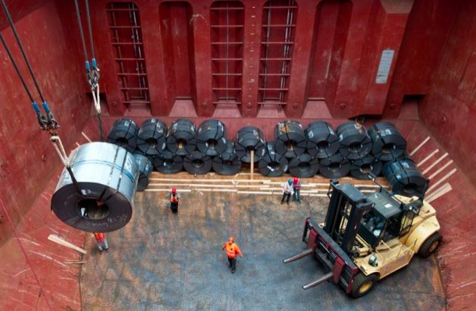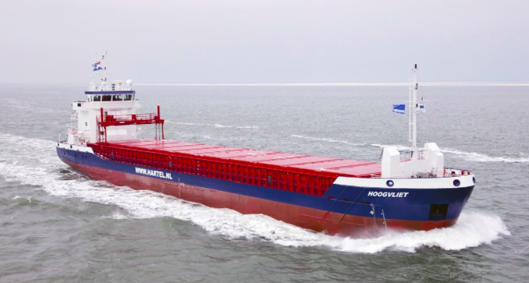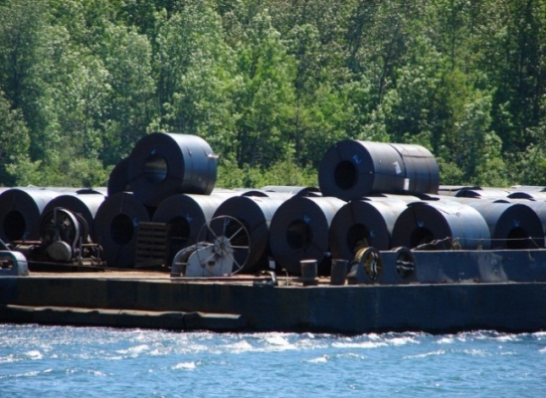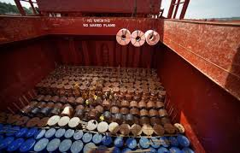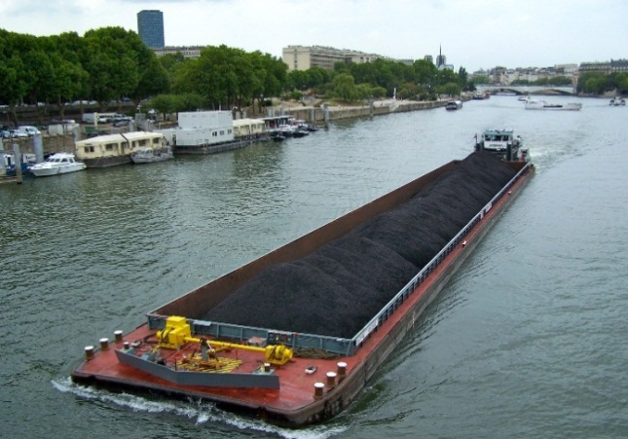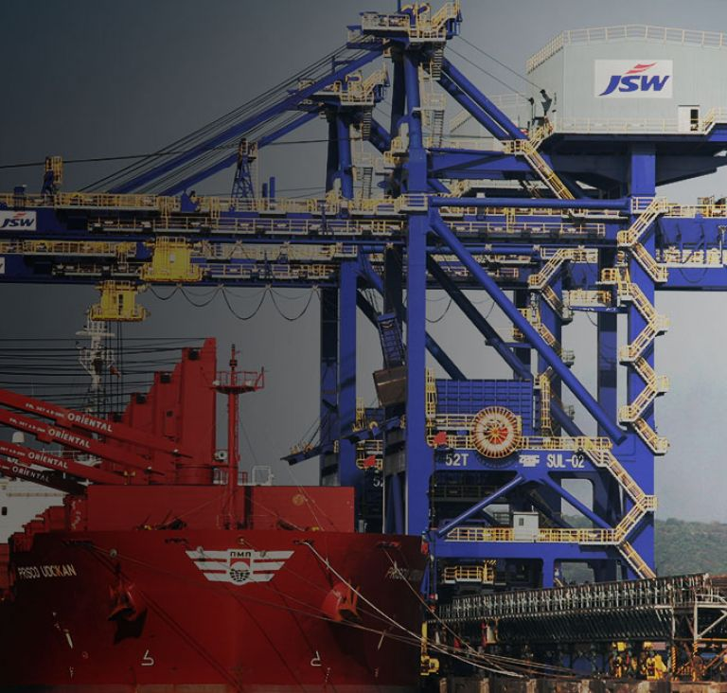

Source: Company files.

Exhibit 2: Agreement between JSW STEEL LTd. and its customer

To whomsoever it may concern:

This letter is issued by XXXXXXX-customer name-XXXXXXX (henceforth mentioned as first party) to JSW Steel Ltd. (henceforth mentioned as second party) in order to put forward the terms and conditions for the material supply at the XXXXXXXX-project name & code-XXXXXXX project.

Material to be provided: Hot Rolled coils (HRC)

Grade of Steel: ASTM A53

Packaging conditions: 2 circumferential and 2 axial steel straps

Labels: 1 on ID (inner diameter) and 1 on OD (outer diameter)

Clause 1: The first party will receive the material provided by the second party, adhering to the following conditions only:

|  |  |
| --- | --- |
| Quantity delivered at the site | Full delivery of the ordered quantity |
| Price of the material (in ₹) | 32,000/ton |

Clause 2: First party claims the rights of accepting the material in clean and acceptable conditions throughout the supply for the project. Any deviation may result in deduction of 5% of the original value of the goods paid to the second party.

Clause 3: The first party also claims the delivery of material on the mutually accepted dates (12 days from the date of order booking and confirmation from second party via email). Any deviation from the above conditions will result in deduction of 10% of the original value of the goods to the second party.

Clause 4: The material will be received at the factory premises only and any handling/transportation charges will be borne by the second party. All the invoices and transit documents should be received by the first party 2 days before the material reaches. This is for discounting of the bills and other financial follow ups.

Clause 5: The first party will pay the second party the entire invoice amount according to the above mentioned clauses on or before 3 days from the date of material received.

Note: ₹ = INR = Indian rupee; US$1.00 = ₹65.4863 on September 30, 2015.

Source: Company files.

Exhibit 3: Historical data on forecasting the accuracy of the type of barge available, 2010–2014

|  |  |  |  |  |  |
| --- | --- | --- | --- | --- | --- |
| Year | Number of Predictions | Predicted Available | | Actual Available | |
| Class I | Class II | Class I | Class II |
| 2010 | 83 | 60 | 23 | 40 | 16 |
| 2011 | 93 | 71 | 22 | 50 | 15 |
| 2012 | 112 | 79 | 33 | 58 | 24 |
| 2013 | 156 | 103 | 53 | 85 | 45 |
| 2014 | 209 | 115 | 94 | 102 | 85 |

Source: Company files.

Exhibit 4: Contract of sale

This letter is issued to JSW Steel Ltd. (henceforth mentioned as first party) by Barn & Co. (henceforth mentioned as second party) in order to put forward the terms and conditions for the planning & transportation of steel coils from first party’s plant at Toranagallu, Karnataka, to Mundra Port, Gujarat.

Material to be provided: Hot Rolled coils (HRC)

Packaging conditions: 2 circumferential and 2 axial steel straps

Labels: 1 on ID (inner diameter) and 1 on OD (outer diameter)

Clause 1: The first party will produce the material and keep it packed and ready for transport 4 hours before actual transportation.

Clause 2: Second party will accept the responsibilities of planning and transporting the packed goods by pre-agreed route and will bill the first party at a rate as mentioned below:

|  |  |  |
| --- | --- | --- |
| **Quantity to be Transported** | **Quoted Price** | **Insurance Charges & Taxes** |
| Minimum 150,000 tons within 10 months of the start of the agreement | ₹5,500/ton | All included in the price quoted |

Clause 3: First party claims the rights of sending the material in clean and acceptable conditions throughout the supply. Any deviation may result in cancellation of the agreement.

Clause 4: The first party also claims the delivery of material to the Mundra port, Gujarat, within 6 days from start of the lifting of coils from Bellary plant. Any deviation from the above conditions will result in cancellation of the agreement.

Clause 5: Said parties of the first party covenants and agrees that it shall abide by all the clauses and the agreement shall be binding upon both the parties under the Laws of State of Karnataka, India.

Note: 1 ton = 2,240 pounds; ₹ = INR = Indian rupee; US$1.00 = ₹65.4863 on September 30, 2015.

Source: Company files.

1. ₹ = INR = Indian rupee; US$1.00 = ₹65.4863 on September 30, 2015.
2. A Corex was an environmentally friendly alternative to the blast furnace, and was exclusively used by JSW in India.
3. A barge was a long flat-bottomed boat for carrying freight on water bodies, either under its own power or towed by another.
4. 1 ton = 2,240 pounds.