



9B18M003

WHITE GOLD IN BENIN: CHINESE INVESTMENT IN COTTON

Zhangfeng Fei, Xiaokang Zhao, Kejing Zhang, and Alex Beamish wrote this case solely to provide material for class discussion. The authors do not intend to illustrate either effective or ineffective handling of a managerial situation. The authors may have disguised certain names and other identifying information to protect confidentiality.

*This publication may not be transmitted, photocopied, digitized, or otherwise reproduced in any form or by any means without the permission of the copyright holder. Reproduction of this material is not covered under authorization by any reproduction rights organization. To order copies or request permission to reproduce materials, contact Ivey Publishing, Ivey Business School, Western University, London, Ontario, Canada, N6G 0N1; (t) 519.661.3208; (e)* [*cases@ivey.ca*](mailto:cases@ivey.ca)*;* [*www.iveycases.com*](http://www.iveycases.com)*.*

Copyright © 2018, Ivey Business School Foundation and Donghua University Version: 2020-08-28

In mid-June 2011, Wang Qijian, president of the China–Benin joint venture Benin Textile Company (Compagnie Béninoise des Textiles, or CBT), was deeply worried as he sat in his office in Cotonou, Benin. Since 2009, CBT had faced significant challenges related to the supply of cotton. In 2010, even though the company had already placed orders for cotton, local Beninese cotton companies were unwilling to deliver cotton at the earlier agreed price due to the rising market price. CBT was forced to stop production for five months and could not deliver on numerous contracts. CBT was unsure whether to stay in West Africa and, if it did, how to improve its situation. Wang had at least four options: maintain the status quo and hope for an improvement, withdraw from West Africa, buy cotton contracts from other countries in order to meet CBT’s cotton demand, or invest in cotton production.

**COTTON**

Cotton was used to make numerous textile products such as clothing. The cotton process involved cultivation and harvesting; preparatory processes; spinning to give yarn; weaving to give fabric; and finally, producing textiles. Cotton was farmed intensively, and it required large amounts of fertilizer and 25 per cent of the world’s insecticides. In 2010–11, the largest cotton producers were China and India, which produced around 30 million bales and 25 million bales, respectively.[1] Much of this cotton was used by their textile industries. In 2007, the foremost exporter of raw cotton was the United States, with US$4.9 billion[2] in sales, followed by Africa, with $2.1 billion in sales.[3] Cotton yields varied significantly by country in 2010–11, from 1,550 kilograms per hectare in Australia and 1,289 kilograms in China to 910 kilograms in the United States, 496 kilograms in India, and 363 kilograms in Benin.[4]

Crops could be harmed by plant diseases, insects, water scarcity or contamination, soil erosion or degradation, and pollution. If weeds overpowered seedling cotton, drastic reductions in yields could result. Farm systems could be diversified to offer not just cotton but also maize and soybean. This diversification could help improve farmers’ economic well-being while simultaneously improving soil fertility and overall ecological resilience. Genetically modified products could increase disease resistance and reduce water requirements. Biotechnology was changing the cotton industry through increased yields.

**Establishment of CBT by CTEXIC**

China Textile Industrial Corporation for Foreign Economic and Technical Cooperation (CTEXIC), a subsidiary of a Chinese central government state-owned enterprise (SOE), was established in 1984. It was the largest enterprise in China specializing in the import and export of textile machinery and technology. “As the key enterprise of China Hi-Tech Group Corporation, it became one of the state’s most important enterprises under the direct administration of the central government of China in 1998.”[5] CTEXIC had been operating textile factories in Benin for more than 30 years, having provided aid to the country beginning in the 1960s and having built factories there in the 1980s.

The main business of CTEXIC included textile machinery, textile products, overseas project contracting, engineering textile product projects, and foreign co-operation. Textile engineering machines were CTEXIC’s most competitive products. Recently, CTEXIC had been facing not only saturating domestic demand but also pressure from international companies from Germany, India, and elsewhere. CTEXIC was devoted to becoming a major international company in the textile industry. CTEXIC contracted overseas textile engineering projects, and had completed projects in Asia, Africa, Latin America, and Europe. In the 1990s, CTEXIC decided to change its involvement in West Africa from foreign aid to local investment. In 2000, CTEXIC invested in a textile company—a Sino–Benin joint venture called Compagnie Béninoise des Textiles (CBT).[6] As of 2011, Wang was the vice-president of CTEXIC and the president of CBT.

The textile factory CBT was created to meet Beninese and West African demand for printed fabric.[7] The Chinese side provided the financial capital and the Beninese side provided the land, water, and electricity. CBT was co-managed by two textile companies (one Beninese, one Chinese).[8] It officially went into operation in October 2002 with registered capital of 1 billion West African CFA francs (about ¥12.5 million).[9] The project comprised a total investment of ¥185 million, including a beneficial loan of ¥150 million from the Export–Import Bank of China; CTEXIC accounted for 51 per cent and Benin’s Ministry of Industry for 49 per cent of the total assets. The project was made up of 24,000 spindles and 768 sets of shuttle looms, with annual capacity of 13.5 million metres of grey cloth. CBT’s products (calico or grey clothes) were sold mainly in local markets. Demand for African print fabric had fallen after CBT’s founding due to increased competition. Up to 2008 and in 2010, CBT ran at a loss. In 2011, CBT produced high-quality cotton yarn, but mainly utilized old shuttle weaving equipment to do so. Benin’s apparel sector basically featured artisanal operations using older domestic sewing machines with limited factory space for the expansion of operations.[10] Despite these challenges, CTEXIC’s investment in West Africa had been considered a good learning experience.

**BENIN**

The Republic of Benin was located in West Africa, to the west of Nigeria (see Exhibit 1). Formerly a French colony, Benin gained independence in 1960. It was renamed the Republic of Benin in 1990, and implemented a multi-party system. While Benin was considered a model of democratic transition in Africa, some questioned whether Benin had seen fundamental change in its political and economic structure.[11] With a nominal gross domestic product (GDP) per capita of $720 in 2011, Benin was one of the world’s poorest countries. The weak industrial base mainly comprised food processing, textiles, and construction materials. Agriculture was critical to Benin’s economy, and cotton was an important crop whose export contributed approximately three-quarters of Benin’s export revenue. Benin was strongly interconnected with Nigeria, which supplied most of its fuel.

The economy of Benin was centred mainly on agriculture and activity at the port of Cotonou. Besides cotton, the country’s main exports were cashews, shea butter, textiles, palm products, and seafood.[12] China was by far its biggest import partner. Trade unions in Benin represented up to three-quarters of the formal workforce, but the informal economy dominated. Problems existed with women’s wage equality and child labour (including for cotton). Little headway had been made in Benin in privatizing SOEs. Benin ranked 169th worldwide in 2009 in ease of doing business. The country was an important player in West African trade through offering internal and international transit services to nearby landlocked nations.[13]

**CHINA AND ITS ECONOMIC RELATIONS WITH AFRICA**

In 2011, China had a population of 1.344 billion, while all of Africa had a population of 1.051 billion.[14] However, with the anticipated rise in the African population, the populations were estimated to reach near-parity by 2100.[15] China and Africa shared anti-colonial sentiment, with China practising a policy of non-interference and respect for African sovereignty.[16] The importance of Africa to China was evident in the Chinese foreign minister’s first foreign visit being always to Africa. Since its founding, the Forum on China–Africa Cooperation had become a key medium for dialogue and a useful way to bolster co-operation between China and African nations.[17]

In 2011, China sought resources for its large population, and African countries sought funds to develop their infrastructure. China, facing shortages in raw materials, relied mostly on imports. In fact, the shortage it faced in cotton, a primary raw material, represented one-third of the demand. International prices of oil and cotton had high volatility and negatively affected China’s textile industry.

Africa and China had $166.3 billion in bilateral trade in 2011. Africa’s largest trading partner was China, which had surpassed the United States in 2009.[18] China sold many manufactured products to Africa, yet the reverse was not true. Africa’s exports to China mainly included mineral fuels, lubricants, and related materials, but Africa also exported iron ore, metals, and other commodities, along with minor quantities of food and agricultural products. In turn, China exported machinery, transportation equipment, communications equipment, and manufactured items to Africa. China played a role in Africa’s energy, mining, and telecommunications sectors, and funded the building of roads, railways, ports, airports, hospitals, schools, and stadiums.[19]

China’s labour and raw material costs were increasing. Due to the expansion of industries, it was now more challenging to hire low-cost labour. Compared with neighbouring countries, many regions in China lacked competitive labour costs and therefore possessed less of a competitive advantage in textile products. As a result, many textile orders had shifted to neighbouring nations such as Vietnam and India. West Africa, on the other hand, had lower labour and land costs.

West Africa had low taxes on Chinese investments in order to attract new investment. West African nations had also established comprehensive labour laws in order to protect the rights of employers and employees. China’s investments in Africa were popular among African countries and peoples; however, some saw these investments as an act of manipulating the economy and plundering resources. CTEXIC’s investment in West Africa was an example of how China extended its soft power and promoted a friendly image, by increasing local work opportunities and improving local industries, to combat these misconceptions (see Exhibit 2).

**the TEXTILE INDUSTRY[20]**

Textile manufacturing involved transforming fibre into yarn and yarn into fabric. Subsequently, fabric was printed or dyed and made into clothing. Among the various kinds of fibre used to make yarn, cotton was the most crucial natural fibre. In 2009, global textile and apparel exports totalled $211 billion and $316 billion, respectively. The textile and clothing industries were buyer-driven and under the control of significant retailers, branded manufacturers, and marketers that influenced global production networks and supply specifications. Buyers were increasingly choosing suppliers that endorsed non-production considerations such as social compliance and environmental standards. Social compliance encompassed freedom of association, fair wages, working hours, and social benefits; bans on child labour; equal-opportunity employment; and safe work environments. Environmental regulation was triggering extensive product reformulation.

The world textile and apparel industry had undergone several production migrations since the 1950s. The first was from North America and Western Europe to Japan in the 1950s and early 1960s, when Western textile and clothing production was displaced by a sharp rise in imports from Japan. The second shift was from Japan to Hong Kong, Taiwan, and the Republic of Korea. In the late 1980s and the 1990s, there was a third migration. In the 1980s, production moved principally to mainland China and several Southeast Asian countries and Sri Lanka. In the 1990s, new suppliers included South Asian and Latin American apparel exporters.[21]

**The Chinese Textile Industry**

China was the largest textile producer and exporter in the world. From 2000 to 2010, average growth in the industry was 18.8 per cent. The proportion of exports as a value of total industry output had greatly dropped, though, from beyond 30 per cent in 2000 to below 17 per cent in 2011—textiles and apparel were no longer integral to China’s economy.[22]

A proposal for the twelfth five-year plan was approved by the National People’s Congress in March 2011. China planned to progressively move toward increased production of advanced textiles, and to decrease production of apparel. By the end of 2015, apparel was forecasted to comprise 48 per cent of total textile and apparel industry output, versus 51 per cent in 2011, while the proportion of technical textiles was anticipated to rise. To prevent jobs from leaving China, the federal government wanted textile and apparel manufacturers on the east coast to relocate their factories inland, where the local economy was at an earlier stage of industrialization and inexpensive labour was more plentiful. Fostering local demand for textiles and apparel was another high priority in China.[23]

**Development of the Chinese Textile Industry’s Outward Foreign Direct Investment**

China’s textile industry had experienced a comparative advantage for years, particularly due to its own low labour costs. Recently, in the face of resource and environmental constraints related to pollution, and due to a constant increase in domestic production costs and the drive of development of the industry, a growing number of textile companies had started looking for foreign investment opportunities.

Foreign investment in China’s textile industry closely paralleled the development of the world’s textile industry. China’s textile industry had experienced three stages. The first ranged from the 1950s to the 1960s, in which China’s investment in the industry mainly came through economic aid to African countries to develop their textile projects. The second stage resulted from China’s economic reform and opening up in 1978, when China’s textile industry enjoyed rapid development as large-scale textile enterprises expanded and invested abroad. The third stage began with China’s accession to the World Trade Organization in 2001 until the present. Since the country’s accession to the World Trade Organization, Chinese textile enterprises had begun to invest abroad after accumulating sufficient experience.

**West African Textiles and Cotton**

The modern West African textile industry began in the colonial era, when Britain, France, and other countries built textile enterprises. Between the 1960s and 1980s, China provided foreign aid to build spinning, weaving, and dyeing factories in Mali, Benin, and Niger. Due to serious smuggling problems, local market disorder, lack of government support, and poor business management, the development of the textile industry in West Africa slowed down, especially in the first five years of the 21st century. Many local companies ceased production or closed.

Africa was the world’s third-largest cotton-producing continent after Asia and North America, producing 7 per cent of global output. The annual output of ginned cotton in the eight cotton-producing countries in West Africa was about 850,000 tons. Burkina Faso, Mali, Benin, and Chad, four major cotton-producing countries, were known as the C-4, with Burkina Faso being the largest cotton producer in Sub-Saharan Africa, followed by Benin. As a result of Africa commencing industrialization and the weakening price advantages in developed countries, Africa was beginning to show considerable potential in the cotton market. West Africa had a large market for textiles, with cotton fabric being a popular choice among West Africans, so local demand was significant (see Exhibit 3). The foremost cotton producers in West Africa were not significant producers of yarn, fabric, and other textile inputs. Mostly, textile production was carried out using dated equipment that spun yarn and wove fabric for African cloth and for bale wrap for the cotton sector. The progress of the textile industry in West Africa was hindered by low-quality infrastructure—particularly, unreliable and expensive electricity and a lack of clean water. Producers of yarn and fabric encountered powerful increased competition from importers of lower-priced print cloth originating in China, and of imports of used clothing.

West African countries had tried to bolster quality and lessen contamination in domestic cotton, with uneven results. In 2006, the United States started the West African Cotton Improvement Program, which strove to improve yields of (and incomes from) West African cotton. West African countries could possibly export traditional print cloth under favourable market circumstances.[24]

The cotton trade greatly lessened poverty in some African countries. To boost their economic growth, many of these nations had undertaken reforms to improve the quality of cotton and compete better internationally. Those efforts, though, had been frustrated by the steep cotton subsidies that had been adopted in the United States and other countries, which were claimed to have distorted world cotton prices. One of the key goals of the Doha Development Agenda, launched in December 2001, was to make it easier for developing countries to sell products in rich countries.[25] A complaint had been lodged against U.S. cotton subsidies by Brazil in 2002, with support by Benin and Chad.[26] Oxfam had determined that the removal of American cotton subsidies would raise average West African household incomes by almost 10 per cent—enough to feed 1 million people.[27]

**Beninese Cotton[28]**

Cotton, the “white gold” of Benin, was a key political and economic resource for politicians. Export performance in Benin was sensitive to price fluctuations of a single commodity and to global demand shocks. Over the past decade, Benin had taken steps to liberalize the cotton sector; however, recent efforts had resulted in an excessive concentration of a large portion of the sector, and declining cotton harvests. The cotton sector framework had entered into force in 2009 as the culmination of a decade-long reform effort to privatize cotton production and trade. During that period, the state progressively withdrew from organizing, buying, ginning, and trading cotton. By 2009, the role of the state was essentially reduced to providing subsidies for inputs (e.g., fertilizers, herbicides, and pesticides). The private sector’s control of the sector was centred on the Professional Association of Cotton (Association interprofessionnelle du coton, or AIC). Cotton was mostly produced on small family plots, and was grown by farmers who had minimal access to the financial system. Cotton production had steadily declined from an all-time high of 427,000 metric tons in 2004–05. The government noted that the privatization of the sector, rather than fostering competition, resulted in the vertical concentration of the sector into the hands of one group, leading to a private monopoly.

The cotton sector had historically accounted for a significant proportion of GDP and dominated formal exports in Benin, as in other West African states. Cotton production attracted policy-makers for several reasons beyond its significant economic weight. Cotton farming involved a large number of rural workers who did not otherwise participate in the formal economy, and the government provided significant input subsidies that were distributed as support to the cotton sector, but also went to other crops. The banking sector was also heavily implicated, as it provided seasonal credit. Most importantly, the government played a critical role in alleviating significant market failures inherent to the production process, including input provision and access to credit.

The Beninese economy was becoming less dependent on the cotton sector, and the economic importance of cotton had declined steadily over the past two decades. The final value of cotton for export, representing almost all of the total value of cotton products in Benin, had declined from 77 per cent of exports in 1995 to 17 per cent in 2011, and from 8.4 per cent of nominal GDP to 1.6 per cent during the same period. These trends could be explained by the long-term decline in the real price of cotton, a history of payment delays to farmers, and stagnant yields per hectare compared with overall productivity growth. Only 2 per cent of Benin’s cotton was consumed domestically. International cotton prices spiked dramatically in 2010 and 2011, peaking at 250 per cent above the average 2006–2009 price. However, the average sales price of Benin’s high-quality cotton was typically slightly below the international price for mid-quality cotton (see Exhibit 4).

**CBT’S OPERATIONS IN WEST AFRICA**

CBT was initiated in 1998, construction of the factory began in 2000, and production commenced in 2002. In the initial years, CBT performed poorly and faced serious losses. At one point, CTEXIC submitted an application to China’s Ministry of Commerce and the Ministry of Foreign Affairs to stop CBT’s production and file for bankruptcy. However, the Chinese government requested that CTEXIC, as an SOE, respect the interests of China, and rejected its request for withdrawing investment from Benin. Instead, it lent support in the form of a zero-interest loan and working capital. CBT persevered through 2007, and with substantial appreciation of the renminbi and an increase in workers’ wages in China, the advantage of investing in West Africa gradually increased. From 2007, the company’s orders increased and its profit improved as it entered 2008.

In the early days of CBT’s establishment, the company purchased local cotton on credit. At that time, the local cotton company was owned by the Beninese government and offered preferential prices based on market prices; an agreement on the supply of cotton had been signed when CTEXIC decided to invest in West Africa. Between 2009 and 2010, the situation changed with a surge in the international cotton price from ¥18,000 per ton to over ¥30,000 per ton. CBT signed a purchasing order for a whole year in early 2010. However, the local cotton companies sold all their cotton to an international cotton dealer at a higher price and broke their contracts.

**RECENT DEVELOPMENTS**

The Beninese cotton industry had previously been a state-controlled industry with a relatively sound managerial and operational system. But in about 2008, owing to the political intervention of the World Bank and other external forces, privatization of the industry began. After privatization, the interests of farmers were not effectively guaranteed, leading to a drastic cotton production decline year by year. CBT was treated equally with the other international private cotton companies. It sold cotton contracts in accordance with the forecast cotton output and reduced supply accordingly.

The international price of cotton soared in 2011, when China’s cotton prices reached ¥30,000 per ton. CBT faced a severe shortage of cotton, but was able to maintain production that year by importing 1,100 tons of cotton from Ivory Coast, meeting cotton supply for five months. That year, great changes occurred in the West African textile industry. Uniwax, a brand produced by Holland’s Vlisco, emerged as a dominant player, and CBT improved the quality of its products. CBT and Uniwax were able to benefit from the exchange rate, transportation privileges, and other advantages. It was possible to buy cotton from neighbouring countries in the case of cotton shortages in Benin. Of course, the transportation of cotton from neighbouring countries and resulting customs tariffs added significant costs versus using Beninese cotton.

**ENSURING THE SUPPLY OF COTTON**

Wang remembered clearly that the supply of cotton had been assured when CBT’s factory was constructed in 2000. However, the Beninese government’s privatization of the cotton system in 2009 had hampered the supply of cotton with huge barriers. Currently, CBT’s supply of cotton was facing a crisis. Taking into account the Beninese government’s policy continuity, political preferences (i.e., pro-Chinese or pro-Western), and administrative efficiency, the risks for CBT were considerable, even if a government was friendly to Chinese interests. Wang was concerned with how to get out of this tricky situation. The key to the supply of cotton was to control the source of the cotton industrial chain. But was West Africa still a viable location? Was it time to pull out of the region? Electricity, cotton prices, and labour costs were increasing, while labour productivity was low. The CBT union was vocal, and workers sometimes went on strike to protest the temporary closure of the factory or to demand increased wages, the return of terminated employees, or the establishment of new commissions with greater powers for workers. On top of this, West African cotton production was decreasing. It was possible to introduce new cotton varieties, along with modified hybrid cottonseeds, to improve farm yields. Local entrepreneurs could then be trained to establish a commercial operation of cotton production and processing to gradually increase control of cotton resources.

As for the prospect of withdrawing from Benin, doing so would be very difficult due to not only economic factors but also the relationship between Benin and China. Benin’s government was unlikely to allow a business to transfer funds and remove equipment from the country. Wang had at least four options to deal with the situation: maintain the status quo and hope for an improvement, withdraw from West Africa, buy cotton contracts from other countries in order to meet CBT’s cotton demand, or invest in cotton production.

The authors would like to thank Professor Elie Chrysostome for his input on this case study.

**Exhibit 1: Map of Benin within West Africa**

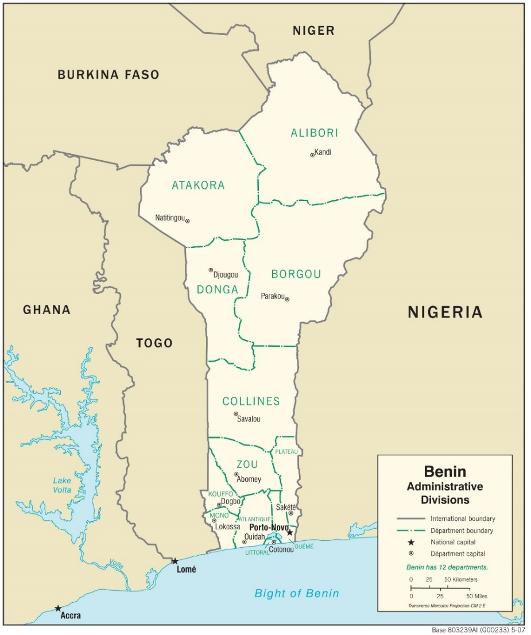

Source: Central Intelligence Agency, accessed August 31, 2017, https://www.cia.gov/library/publications/resources/cia-maps-publications/map-downloads/benin_transportation.jpg/image.jpg.

**Exhibit 2: Chinese SOE Behaviour in West Africa**

Chinese aid projects to Africa in the Mao era, especially in the 1970s, formed the initial connection between Chinese provinces and Africa. Africa became the natural and only choice for provincial construction enterprises to internationalize after 1978, whereas Beijing-based SOEs focused their international development on more affluent regions in the 1980s and 1990s. The Export–Import Bank (Exim Bank) of China, set up in 1994, was wholly owned by the Chinese government and was considered a foreign policy instrument, especially in Africa, through the provision of concessional loans. It was estimated that over half of Exim Bank’s lending had gone to Africa since 2001. More Chinese SOEs became interested in the African market following the introduction of the Chinese going-out policy in 2001, especially after the Beijing summit of the Forum on China–Africa Cooperation in 2006.

Though Chinese SOEs were “state-owned,” the role of the state had evolved considerably and varied greatly in terms of ownership and control. The policymaking process in China was a negotiation between the Chinese central government and lower-level government actors. SOEs in Ghana and Benin often did not receive much resource support from the Chinese state. Chinese SOEs in Africa were predominantly from landlocked and less affluent provinces, or were bureaus from interior provinces of Chinese central SOEs.

Less resourceful and competitive provincial SOEs could grow in Africa without needing to compete directly with larger Chinese enterprises.

With a less developed economy (almost four times smaller) than Ghana’s, Benin attracted fewer Chinese companies. The lifespan of a Chinese SOE in Benin was often short. Many Chinese SOEs in light industry that had been active in Benin and Ghana had exited. The closing of Chinese SOEs in Benin and Ghana was due in part to weak Chinese central state support.

The fierce competition among Chinese SOEs reflected the lack of coordination and control by the Chinese central government. Price wars between Chinese companies indicated that the Chinese state did not play as controlling a role in the globalization of Chinese SOEs as might be presumed. The Chinese cost advantage often became an advantage more for locals than for Chinese.

In Benin, Chinese SOEs often exited after their first or second co-operation project. Chinese companies mostly competed against other Chinese companies, but when competitors were local and received government support, the Chinese companies often lost out eventually, as in the textile sector in Benin. Chinese companies often needed to meet extremely tight schedules if they wanted to win government clients. For example, they might face pressure to complete a project before an election or a country’s anniversary.

Developing business in Africa required patience. SOEs in Benin and Ghana often emphasized that they had to rely on themselves, not on the Chinese state. Established SOE management frequently built social relationships with local elites. Daily implementation of projects could face problems with local authorities at lower levels, even when a Chinese SOE had received high-level political backing. Corruption could occur in the form of road checks and excessive document inspection, although these could be perceived by locals as transaction costs rather than corruption.

The longer an SOE remained in Benin or Ghana, the more it learned to function in the local context. The success of SOEs made them further dependent on local resources. Overall, for Chinese enterprises going abroad for the first time, understanding local laws, culture, and religion was key. The ethic of “work more, earn more” was not always present in Africa nor supported by law, and the poverty of locals could put pressure on business owners. Because Africa had previously been subject to European colonial rule, its laws and ways of thinking had been deeply influenced by the sovereign state. Workers could be easy to manage on an individual basis, but they were heavily unionized.

Note: SOE = state-owned enterprise; FOCAC = Forum on China–Africa Cooperation

Source: Created by authors based on information from Katy Ngan Ting Lam, Chinese State-Owned Enterprises in West Africa (London, UK: Routledge, 2016).

**Exhibit 3: Significance of Clothing and Textiles in Benin**

It had been said that history in Africa could be “read, told, and recorded in cloth.” Textiles constituted one of the most important industries in Benin due to socio-economic factors deeply rooted in Benin’s culture. These factors explained why the textile business had been attractive for many businesspeople and companies. One of these factors was that the Beninese celebrated many important socio-cultural occasions such as births, baptisms, marriages, and funerals. Often, the Beninese attending these celebrations carefully chose their textiles—which could be very expensive.

The weaving of cloth had historical significance in Africa, as did the use of natural dyes, including indigo (the colour of blue jeans). Traditional garments included dashikis, kaftans, and wrappers (or pagnes). African wax prints (also known as Dutch wax prints)—popular clothing materials in West Africa—were textiles that used pure cotton fabric and vibrant colours, and that were printed industrially using dyes and wax resins. African wax print designs encompassed pop culture and art references, geometrical shapes, and everyday items. The designs presented a means of communicating stories, impressions, and beliefs. African markets featured many shops that sold both original and knock-off Nigerian or Chinese print designs of lower quality and cost. Africa had many skilled designers and makers of textiles, but it was still under-represented in the world fashion industry.

Source: Created by authors based on information from “A History of African Wax Prints,” Mazuri Designs, February 4, 2016, accessed August 31, 2017, http://mazuridesigns.com/blog/2016/2/4/a-history-of-african-wax-prints; Chris Spring, *African Textiles Today* (Washington, DC: Smithsonian Books, 2012); Liam Freeman, “African Textiles in the Fashion Industry,” *Financial Times*, March 3, 2017, accessed August 31, 2017, https://www.ft.com/content/3f02a48e-fda5-11e6-8d8e-a5e3738f9ae4?mhq5j=e7.

**Exhibit 4: Cotton prices in Benin, 1995–2010, and world cotton prices, 2006–2011**

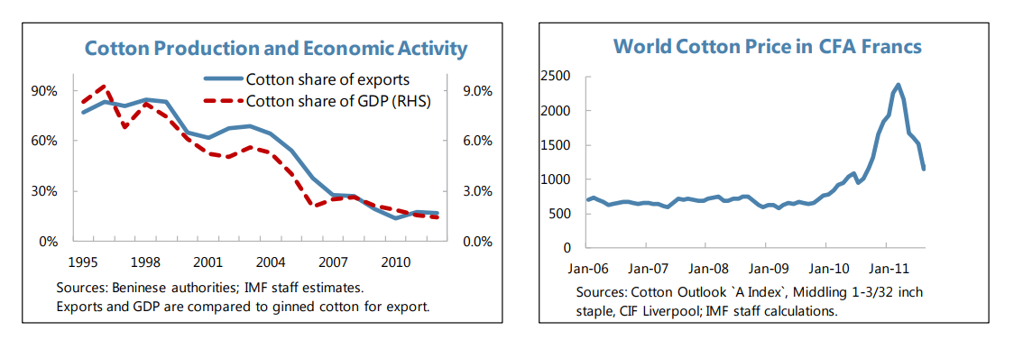

Note: GDP = gross domestic product; RHS = right-hand side; IMF = International Monetary Fund; the West African CFA franc was pegged to the euro; €1 = 655.957 CFA francs

Source: Created by case authors based on information from International Monetary Fund, *Benin: IMF Country Report*,13/9, January 2013, accessed August 31, 2017, www.imf.org/external/pubs/ft/scr/2013/cr1309.pdf.

**Endnotes**

1. United States Department of Agriculture, Cotton: World Markets and Trade, December 2011, accessed August 31, 2017, http://usda.mannlib.cornell.edu/usda/fas/cotton-market//2010s/2011/cotton-market-12-09-2011.pdf.
2. All currency amounts are in U.S. dollars unless otherwise specified.
3. G. Pascal Zachary, “Out of Africa: Cotton and Cash,” New York Times, January 14, 2007, accessed August 31, 2017, www.nytimes.com/2007/01/14/business/yourmoney/14duna.html.
4. United States Department of Agriculture, op. cit.
5. China Textile Industrial Corporation for Foreign Economic and Technical Cooperation, “About Us: Company Profile,” accessed August 31, 2017, www.ctexic.com/tm/second_exim/index.aspx?nodeid=168.
6. China Textile Industrial Corporation for Foreign Economic and Technical Cooperation, “Main Business: Foreign Cooperation—Economic & Technical Cooperation Cases,” accessed August 31, 2017, www.ctexic.com/tm/content_exim/index.aspx?nodeid=143.
7. United States International Trade Commission, Sub-Saharan African Textile and Apparel Inputs: Potential for Competitive Production, May 2009, accessed August 31, 2017, https://www.usitc.gov/publications/332/pub4078.pdf.
8. Katy Ngan Ting Lam, Chinese State-Owned Enterprises in West Africa (London, UK: Routledge, 2016).
9. ¥ = CNY = Chinese renminbi; US$1 = ¥6.48 on June 1, 2011; CFA refers to Communauté Financière Africaine (African Financial Community); the West African CFA franc was pegged to the euro; €1 = 655.957 CFA francs. Membership in the CFA Franc Zone offered some currency stability and access to French economic support. Benin, Burkina, Mali, Senegal, and Togo shared a common currency.
10. United States International Trade Commission, op. cit.
11. Lam, op. cit.
12. One World Nations Online, “Benin,” accessed August 31, 2017, www.nationsonline.org/oneworld/benin.htm.
13. United States International Trade Commission, op. cit.
14. Population Reference Bureau, 2011 World Population Data Sheet, 2011, accessed August 31, 2017, www.prb.org/pdf11/2011population-data-sheet_eng.pdf.
15. Ashley Kirk, “What Africa Will Look Like in 100 Years,” Telegraph (UK), March 11, 2016, accessed August 31, 2017, http://s.telegraph.co.uk/graphics/projects/Africa-in-100-years.
16. Eleanor Albert, “China in Africa,” Council on Foreign Relations, July 12, 2017, accessed August 31, 2017, https://www.cfr.org/backgrounder/china-africa.
17. African Union, “Second Forum on China-Africa Cooperation (FOCAC) Summit,” accessed August 31, 2017, https://au.int/en/newsevents/20151204.
18. Fred Dews, “8 Facts about China’s Investments in Africa,” Brookings, May 20, 2014, accessed August 31, 2017, https://www.brookings.edu/blog/brookings-now/2014/05/20/8-facts-about-chinas-investments-in-africa.
19. Albert, op. cit.
20. A. H. H. Saheed, What Is the Future of Global Textile and Apparel Industry?, PTJ, January 2011, accessed August 31, 2017, www.ptj.com.pk/Web-2011/01-2011/PDF-January2011/Apparel-and-Knitwear-AHH-Saheed.pdf.
21. Raphael Kaplinsky, “Export Processing Zones in the Dominican Republic: Transforming Manufactures into Commodities,” World Development 21, no. 11 (1993): 1851–1865; Gary Gereffi, “Commodity Chains and Regional Divisions of Labor in East Asia,” in *The Four Asian Tigers: Economic Development and the Global Political Economy*, ed. Eun Mee Kim (San Diego, CA: Academic Press, 1998), 93–124.
22. Sheng Lu and Marsha A. Dickson, “Where Is China’s Textile and Apparel Industry Going?,” China Policy Institute, July 24, 2015, accessed August 31, 2017, https://cpianalysis.org/2015/07/24/where-is-chinas-textile-and-apparel-industry-going.
23. Ibid.
24. United States International Trade Commission, op. cit.
25. Zhou Siyu, “China Looks to Africa for an Alternative Source of Cotton,” ChinaDaily.com.cn, December 16, 2011, accessed August 31, 2017, www.chinadaily.com.cn/business/2011-12/16/content_14278735.htm.
26. International Centre for Trade and Sustainable Development “African Countries Call for Progress in WTO Cotton Negotiations,” December 3, 2014, accessed August 31, 2017, www.ictsd.org/bridges-news/bridges-africa/news/african-countries-call-for-progress-in-wto-cotton-negotiations.
27. Fairtrade Foundation, The Great Cotton Stitch-Up, November 2010, accessed August 31, 2017, https://www.fairtrade.net/fileadmin/user_upload/content/2009/resources/2010-11_FT_cotton_policy_report.pdf.
28. International Monetary Fund, Benin: IMF Country Report, 13/9, January 2013, accessed August 31, 2017, www.imf.org/external/pubs/ft/scr/2013/cr1309.pdf.